**A project**

**On**

**Development**

**of the Minesweeper Game**

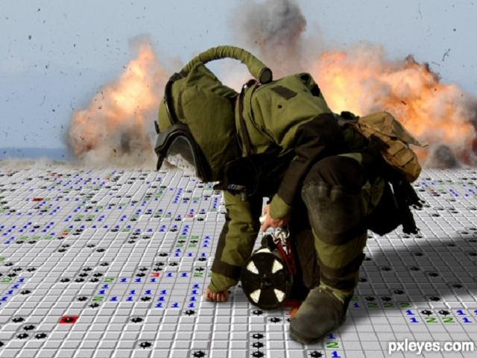

**Submitted By:**

**Prateik Pokharel(068/BEX/431)**

**Rupak Khatiwada(068/BEX/437)**

**Sujan Bhattarai(068/BEX/443)**

**ACKNOWLEDGEMENT**

We would like to acknowledge the support shown by our C++ programming teacher Mr. Uttshav Gyawali for his support in helping us to select proper type of project and his invaluable support for preparation of the project. Also we are grateful to the Department of Electronics and Computer Engineering for providing an excellent working environment during the lab sessions.

**TABLE OF CONTENTS**

1. Acknowledgement
2. Abstract
3. Introduction
4. Objectives
5. Application
6. Literature Survey
7. Existing System
8. Methodology
9. Implementation

1. Block Diagram

1. Problems Faced And Solutions
2. Limitations And Future Enhancement
3. Conclusions And Recommendations
4. References

**INTRODUCTION**

Minesweeper Game we developed is a Two-Dimensional Single player arcade video game. The player starts with the main menu where he gets to select anyone of the three difficulty levels. After selecting a specific level he is presented with a square array of blocks (rectangular for “Hard” difficulty level). The player has to extract each of the blocks carefully making sure he doesn’t click on the hidden mines. When a block is clicked and if there isn’t a mine, then the number of mines around the block is shown. As far as it goes this is the only hint the player gets. On clicking the first block, the timer is instantiated measuring how much time has elapsed until the completion of the game. Now the game is completed in two simple ways i.e. when the player clicks on a hidden mine or when he safely extracts all the mines.

**OBJECTIVES**

1. To learn the techniques of developing a game using C++ language.
2. To learn the various features of C++ language like classes, objects inheritance, polymorphism e.t.c and to master them for the required purpose.
3. To learn the usage and compatibility of SDL.
4. To develop the strategic capability of the player.
5. To provide the people with a means of entertainment and a quality game to play.

**EXISTING SYSTEM**

Versions of Minesweeper are frequently bundled with operating systems and GUIs, including Minesweeper in Windows, KMines in KDE (Unix-like OSes), Gnomine  inGNOME and Mine Hunt in Palm OS. Apart from the bundled versions, a huge number of clones of all shapes and sizes can be found on the Internet.

. 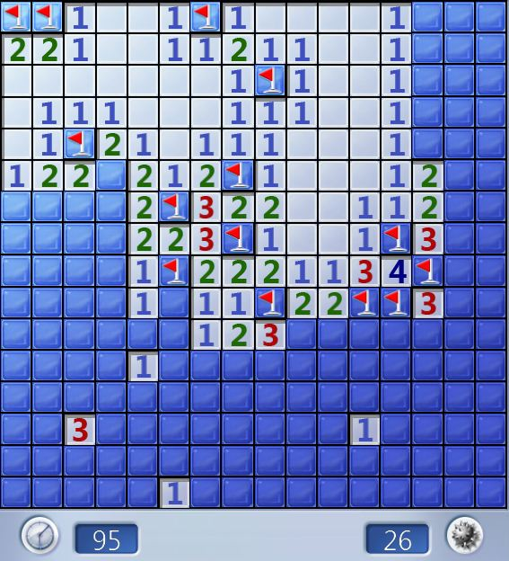

Minesweeper in Windows 7

Variants of the basic game generally have differently shaped mine fields in two and three dimensions, or various two-dimensional layouts, such as triangular or hexagonal grids, or possibly more than one mine per cell. For example, X11-based XBomb adds triangular and hexagonal grids, and Professional Minesweeper for Windows includes these and others.

Another derivative of Minesweeper is Tentaizu, which could be described as a Minesweeper with some squares initially revealed, where the player doesn't reveal any squares, only mark them, and whose objective is to mark all mines correctly. Tentaizu puzzles usually have a unique solution.

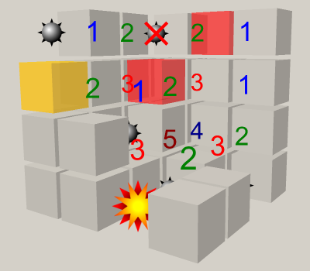

3D version of minesweeper

**LITERATURE SURVEY**

Minesweeper has its origins in the earliest mainframe games of the 1960s and 1970s. The earliest ancestor of Minesweeper was Jerimac Ratliff's *Cube*. The basic gameplay style became a popular segment of the [puzzle game](http://en.wikipedia.org/wiki/Puzzle_game) genre during the 1980s, with such titles as *Mined-Out* ([Quicksilva](http://en.wikipedia.org/wiki/Quicksilva), 1983), *Yomp* ([Virgin Interactive](http://en.wikipedia.org/wiki/Virgin_Interactive), 1983), and *Cube*. Cube was succeeded by *Relentless Logic* (or *RLogic* for short), by Conway, Hong, and Smith, available for MS-DOS as early as 1985; the player took the role of a private in the [United States Marine Corps](http://en.wikipedia.org/wiki/United_States_Marine_Corps), delivering an important message to the U.S. Command Center. *RLogic* had greater similarity to *Minesweeper* than to *Cube* in concept, but a number of differences exist:

* In *RLogic*, the player must navigate through the minefield, from the top left right angled corner to the bottom right right angled corner (the Command Center).
* It is not necessary to clear all non-mine squares. Also, there is no mechanism for marking mines or counting the number of mines found.
* The number of steps taken is counted. Although no high score functionality is included, players could attempt to beat their personal best score for a given number of mines.
* Unlike Minesweeper, the size of the minefield is fixed. However, the player may still specify the number of mines.
* Because the player must navigate through the minefield, it is sometimes impossible to win — namely, when the mines block all possible paths.

The gameplay mechanics of Minesweeper are included in a variety of other software titles, including:

* The mini-game Vinesweeper implemented into the [MMORPG](http://en.wikipedia.org/wiki/MMORPG) [*RuneScape*](http://en.wikipedia.org/wiki/RuneScape); in this iteration (written by [Jagex](http://en.wikipedia.org/wiki/Jagex) developer Danny J), the Minesweeper gameplay is given a large multiplayer aspect and the "game board" adopts a continually resetting timer. This allows for a never-ending game of Minesweeper where the skill is awarded assessed in points rather than "game completion".
* The PC game Mole Control (developed by Remode); in this game, the minesweeper mechanic is integrated into a puzzle adventure game based in a village called Molar Creek, which has been overrun with exploding moles. You play the local inventor's assistant, who is tasked with clearing the village of exploding moles, and you can also take part in the Molar Creek Annual Mole Control competition in a Time Attack Mode.