

DATA1204-02

Durham College

Statistical Pred Modelling

Professor: Fatma Tetikoglu

Assignment 2-Advertising Analysis

Submitted by: **Mary Prathyusha Basani, 100956233**

**Table of contents:**

1. **Hypothesis Statement** -----------------------------------------------------3
2. **Hypothesis Testing**----------------------------------------------------------3-5
3. **Analysis using R**-------------------------------------------------------------6
4. **Summary and Conclusion**-------------------------------------------------7
5. **R-Code**-------------------------------------------------------------------------8
6. **References**--------------------------------------------------------------------9

Recently, Samsung has been trying out a new ad to increase their respective sales in the new Galaxy S23 Ultra (the ads can be seen in Appendix A). Currently Ad1 has a mean sale of 55,000 units per week. Over the past 20 weeks Samsung has collected the sales data for Ad2 and stored it in the SamsungAdAnalysis.xlsx Excel file. They believe that Ad2 has an increase effect on sales and want to test whether the average sales for Ad2 have increased and are more than 55,000 units.

1. **State the Hypothesis Statement (by using an ‘if’ statement) that helps solve the research question.**If Ad2 has effect on Sales of New Galaxy S23 then there will be change in average sales of New Galaxy S23.
2. **Provide a written step-by-step outline (in a total of 5 steps) on how you would prove (or dis-prove) your hypothesis statements that you developed above.**

Steps in hypothesis testing:

* + - 1. State the hypothesis
      2. Determine the significance Level
      3. Test Statistics
      4. Find P-Value and make decision
      5. Conclusion

1.**State the hypothesis**:

**Null hypothesis**:

If Ad2 has an increase effect on Sales of New Galaxy S23 then

there will be increase in average sales of New Galaxy S23.

$H_{0}:μ>55,000$**Alternative hypothesis**:

2)**Significance Level(α):**

Significance level is used in hypothesis testing to determine whether to reject the null

hypothesis.

$$α=0.05$$

**3)Test Statistics:**

To test the statistics, I am using **T-test** because standard deviation is not given and the   
 sample size is less than 30.  
 I am using one-tailed test because we are testing the increased value, and one-sample   
 test as we are having the data of only one item. Paired data because we are comparing   
 the sales of same phone.  
  
Finally, we are using Paired One-sample T-test

$T=\frac{\left(μ-μ0\right)}{\left(\frac{s}{\sqrt{n}}\right)}$ $Sample mean\left(μ\right)=55999.5\left(from R\right)$

$Population mean\left(μ0\right)=55,000\left(Given\right)$

$Sample Standard deviation\left(s\right)=5000.049\left(from R)\right)$

$number of rows in excel\left(n\right)=20\left(from data\right)$

$T=\frac{55999.5-55000}{\frac{5000.049}{\sqrt{20}}}$

$T=0.89397121649$

4**) P-Value and Decision Making**

$PValue=0.1913(from R)$

Decision Making:

P-Value is 0.1913 which is greater than the Significance level(α). So, we failed to reject the null hypothesis $H_{0}$.

5)**Conclusion:**

We failed to reject the null hypothesis. Since the p-value=0.1913, which is greater than the significance level of 0.05. That means at a 5% significance level, we failed to reject the null hypothesis which states that If Ad2 has an increase effect on Sales of New Galaxy S23 then there will be increase in average sales of New Galaxy S23. We have enough evidence to say there is an increase in average sales after Ad2.

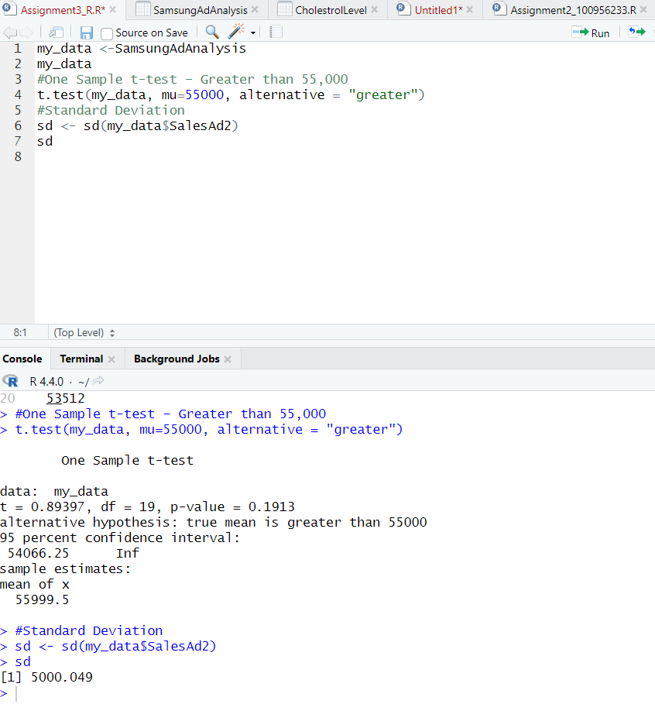

**3. Conduct the analysis you outlined in #2 in R.**my_data <-SamsungAdAnalysis

my_data

#One Sample t-test – Greater than 55,000

t.test(my_data, mu=55000, alternative = "greater")

#Standard Deviation

sd <- sd(my_data$SalesAd2)

sd



**4.Create a “Summary of Findings and Conclusion” section for your analysis.**

Summary:

1. **Significance Level (α)**: 0.05
2. **Test Statistic (T-test)**:
$$T=\frac{μ-μ_{0}}{\frac{s}{\sqrt{n}}}=\frac{55999.5-55000}{\frac{5000.049}{\sqrt{20}}}=0.89397121649$$

3. **P-Value Calculation**:

$PValue=0.1913(from R)$

**Decision Making**

Since the P-Value is greater than the significance level $(α = 0.05),$ we failed to reject the null hypothesis $\left(H_{0}\right).$

**Conclusion:** As the P-Value is greater than significance level, we failed to reject the null hypothesis $\left(H_{0}\right).$**We have enough evidence to say that there is an increase in average sales after Ad2**