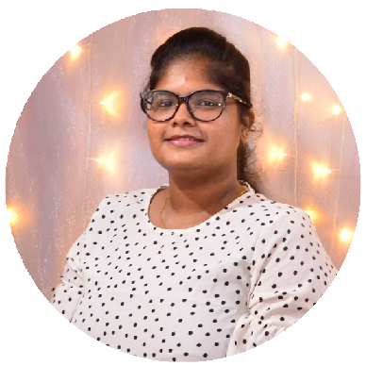**CONT ACT**

J AT HURSHA

PAT PANAT HAN

 +94 774 860 442

**PROF ESSI ONAL PROF I LE**

 [jathunathan98@gmail.com](mailto:jathunathan98@gmail.com)

111-4/2, College Street, Colombo 13

[linkedin.com/in/jathursha-](https://www.linkedin.com/in/jathursha-patpanathan-6479a4219) [patpanathan-6479a4219](https://www.linkedin.com/in/jathursha-patpanathan-6479a4219)

NIC No 988201219V

# LANGUAGE

English Language

Full professional proficiency

Sinhala Language Working proficiency

Tamil Language

Native or bilingual proficiency

# EXT RACURRI CULAR ACT I VI T I ES

* Editor of Tamil Students' Committee of USJ (2020-2021)
* An Event Manager at Gavel club of USJ (2019-2021)
* Served as prefect in school (2016-2017)
* Vice President of Science Union (2015-2016)
* Treasurer of Drama Union (2015-2016)

Self-motivated, passionate and team oriented individual, driven by the personal objective in quick learning new technologies, advancing soft skills, with expertise in utilizing analytical thinking and to ensure that the business enjoys a sustainable business result.

**EDUCAT I ON**

## B.Sc. (General) in Physical Science 2019 - 2022

University of Sri Jayewardenepura

 Major in Computer Science, Mathematics and Applied Mathematics with overall gpa 2.66

## GCE Advanced Level Examination 2015 - 2017

Ramanathan Hindu Ladies College

 Physical Science A, 2C

 General English, GIT A

 General Knowledge 77%

## GCE Ordinary Level Examination 2013 - 2014

Ramanathan Hindu Ladies College

 8A, C

## Primary & Secondary Education 2004 - 2017

Ramanathan Hindu Ladies College

# SOF T SKI LLS

**T ECHNI CAL SKI LLS**

Teamwork

Time Management Leadership

Verbal & Written communication

Flexibility Responsibility

Programming Languages

## Java/C/Php

Web Development

## HTML/CSS/JavaScript

Databases / Office Suites

## MySQL / MS office

Frameworks

**React/Angular/Laravel**

# REF ERENCES

**WORK EXPERI ENCE**

**DR. Ravindra De Silva (Ph.D)**

Senior Lecturer, Department of Computer Science.

University of Sri Jayewardenepura.

**Probodha Madusanka** Assistant Manager OWA (pvt) Ltd.

## Intern - Software Engineer (March 2023 - To date)

Insharp Technologies - Maharagama

## Teaching (2019 - To date)

Mathematics and ICT for G.C.E Ordinary Level Students

**NOT ABLE PROJ ECT S**

## Project Management System (project for SOC)

A web based project management system for small organizations

Technology used : MEAN stack

**ACHI EVEMENT S**

* Successfully completed an online bootcamp for front-end web development with Javascript and ReactJs
* Participated in 'Speech Master' all island public speaking competition (2019)
* First runner up in intra university mathematics competition (2019)
* Whole Island level Bronze medal winner in an all island chemistry essay competition organized by Sri Lanka section of Royal Society of Chemistry (2016)
* First runner up in chess inter school competition (2016)