# **Drone:**

**Definition:**

In my opinion, drone refers to a type of aircraft that can autonomously i.e. through software controlled, working in relation with onboard sensors and GPS and remotely guided.

**History:**

In the history of drone, the earliest unmanned aerial vehicle was seen in 1839, when the city of Venice was attacked by Austrian soldiers through balloons that is filled with explosives. In 1935 the first drone appeared as a full-size retooling of the de Havilland DH82B “Queen Bee” biplane that is fitted with radio and servo-operated controls in backseat.

**Types of Drone:**

The drone platforms have two main types:

* Rotor – including single-rotor or multi-rotor (such as tricopters, quadcopters, hexacopters and octocopters.)
* Fixed wing – include hybrid VTOT (vertical takeoff and landing) drones that don’t require runways.

### **Technology, features and components:**

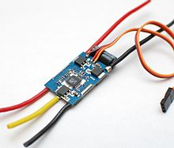Drone consists number of technological components. Some of them are:

* **Electronic Speed Controllers (ESC)**

It is an electric circuit that regulates a motor speed and direction.

* 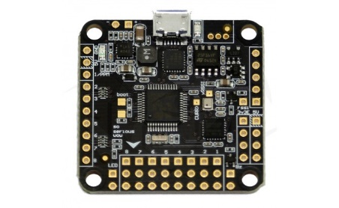**Flight** **Controller**

To achieve flight drone consists of many other things i.e. power source, battery or fuel, rotors, propellers, and a frame. Flight controller is the brain of drone. Basically, it is a circuit board with different sensors that helps to changing orientation of your drone. The main function of flight controller is to receive user commands and controls associated motors.

* 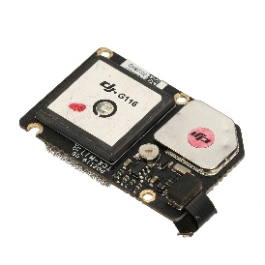**GPS Module (works on process of triangulation)**

The GPS module on drone helps to communicate its accurate location with controller.

* 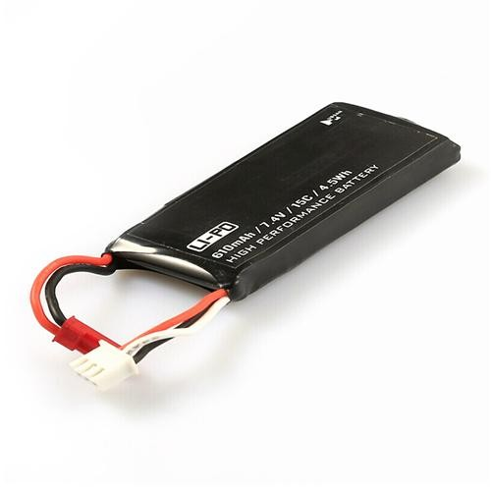**Battery**

Battery used in drone is Lithium battery and Intelligent battery.

Lithium battery is regular, bare, open type and there is no protection electrically and mechanically. Overcharge results in explosion and over-discharge results in dead.

Two types of Lithium Battery: LiPO and LiHV

LiPO battery has fully charged voltage of 4.2V whereas LiHV battery has fully charged voltage of 4.35V at full charge.

Intelligent battery is mechanically robust and there is protection regarding over charge and discharge. Battery is inbuilt in BMS (Battery Mechanism System) and health monitoring.

Precautions:

* Use balance chargers
* Know polarity
* Timely monitoring

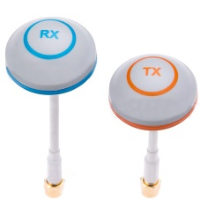

* **Antenna**

An Antenna helps to convert electrical power into electromagnetic waves and vice-versa. An Antenna is also known as transducer. The same antenna can used for both transmission and reception in two-way communication.

* 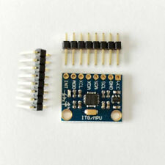**Accelerometer**

Accelerometer in drone helps to measures speed of drone.

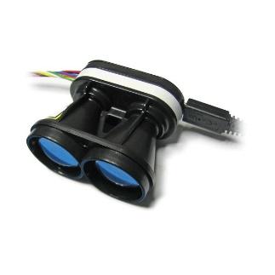

* **Altimeter**

Altimeter in drone helps to measures altitude of drone.

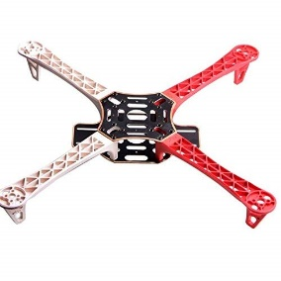

* **Frame**

The drone frame is typically lightweight, composite materials to reduce weight. So that the drone is moved freely during flight.

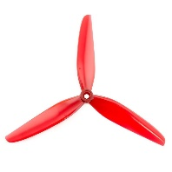

* **Propellers**

Propellers are the important parts of drones. Propellers are mainly used to maintain and generate thrust and torque to keep drone flying. The thrust generated by propellers measured in pounds and grams.

**Note:**

A controller required by drones which is remotely controlled by an operator to launch, navigate and land it.

**Why we need drone?**

* The two main function of drone are **FLIGHT** and **NAVIGATION**.
* Professional photography and filming
* Safety and security consulting
* Land surveying
* Search and rescue operations, as well as crime scene operations
* Aerial image- and data-capturing at construction sites, for use with Building Information Modeling (BIM)

**Risks:**

* Lack of knowledge and training about drone.
* Misuse of drone i.e. drone may be used as weapons.