

Examining the Impact of COVID-19 on Unemployment Dynamics: A Comparative Analysis of Labor Market Responses in Emerging Nations

## Under the Guidance of Dr. Aswini Kumar Mishra

**And Kamesh Anand K.**

Submitted By:

Pranjal Lal(2021B3A71055G)

Satvik Narula(2021B3A72482G)

Ali Kausar Kaamran(2021B3A72246G)

Nikhil Bhat(2021B3A72541G)

Shubhang Prakhar(2021B3A82866G)

COURSE: Applied Econometrics (ECON F321)

**(i)Highlights**

1)Data was used from 2001 to 2023 for 11 countries

2) 6 models were used

3) For short term hybrid models performed better but for long term primitive models were better

**(ii)Abstract**

Using data from 11 Emerging economies which detail the unemployment indices over a period of 23 years from 2001-2023, we try and see how Covid 19 has truly impacted them. By using different models such as ARNN, ANN, SVM and hybrid models, we show which model is better for predicting unemployment rates in emerging economies.

**(iii)JEL Classification:** C32,C53,E24

C32:Time Series Models

C53:Forecasting and Prediction Methods

E24 Unemployment

I15 - Health and Economic Development

**(iv)Keywords:**

ACF:autocorrelation function

AIC:Akaike information criterion

ANN:artificial neural networks

ARIMA:autoregressive integrated moving average

ARNN:autoregressive neural network

BIC:Bayesian information criterion

MAE:mean absolute error

MAPE:mean absolute percent error

PACF:partial autocorrelation function

RMSE:root mean square error

SVM:support vector machine

**1.Introduction:**

Predicting the unemployment rate is an essential task for analysts as it becomes an important indicator of the state of the job market as well as monetary market. As observed in the past, crises worsen the unemployment rate of a country but the technological advancements definitely help. Although the impact of crises is miserable for the entire world, its effects are particularly bad and unpredictable in emerging nations. The impact of crises on unemployment and other financial variables have been a few of the biggest topics of interest for economists and policymakers. Unemployment affects the nation’s economy adversely as it shakes the industry’s confidence. It also affects the individual's life and can have a heavy impact on cultural and social aspects, as it can affect social and economic equality, too.

The COVID-19 pandemic has caused unprecedented disruptions to global economies, with emerging nations facing unique challenges in their labor markets. Understanding the multifaceted impacts of the pandemic on unemployment dynamics across these countries is crucial for informing policy interventions and promoting economic recovery. This research aims at analyzing the existing models and combination of models to analyse the effects of crises like COVID-19 on unemployment.

The nations we will be using data from and analysing are Argentina, Brazil, Chile, Mexico, Peru, Russia, South Africa, Saudi Arabia, Thailand, and Turkey, Indonesia. These nations have a high developing trajectory. In recent years, a lot of informal markets in these countries have been turned to formal, resulting in easier collection of data and also higher numbers. Moreover, the advancement in econometric tools and the accuracy of predictions of neural networks help immensely in analysis of causes and working of policies and decision making. Many statistical and econometric techniques have been used in the past to analyze in predicting different variables, but almost all the studies have focussed largely on developed countries because of the abundance of data. Moreover, different seasonal relationships, impact of other variables on unemployment have also been established.

Reasons for less exposure are not only less availability of data but also because of the pendulum nature of data because of developing country trap.

**Objective**

This paper will focus on relatively simpler aspects. Aim is to investigate how accurately the primitive models predict the unemployment rate in emerging nations and how much better can we do if we try to make a hybrid of neural network models and ARIMA model. Hypothesis statements for this research study are as follows:

1. Hybrid models will have higher accuracy than primitive models in predicting the unemployment rate in emerging nations.
2. Different datasets will give different accuracy of prediction for all the models
3. Fluctuations in the unemployment rate data of emerging countries is not completely random but rather seasonal

The models used in this paper are ARIMA, ARNN, SVM, Hybrid ARIMA-ANN, Hybrid ARIMA-ARNN. The data used in this paper lie from 2001 to 2023. Two forecasts were done, one with six years of corresponding comparison data and the other with two years of forecast and comparison data. Hybrid models will utilise the non-linear analysis ability of neural networks and linear time series analysis ability of ARIMA to predict unemployment. Although expectations are that the model will leverage its linear and non-linear methods for high accuracy. There is still scope of other methods performing better.

**2. Literature Review:**

Previous research indicates that the ARIMA model was useful for evaluating the unemployment rates of european countries( Vicente, López-Menéndez, & Pérez, 2015)

It was seen for monthly short term estimation of the unemployment indexes in the United States direct models proved to be inferior to non linear models. An Autoregressive neural network is used in creation of a Feed Forward Neural Net. As compared to an artificial neural network model it helps in a more predictable result .Artificial neural network model proved to be more accurate than its counterparts in predicting unemployment during industrial phase of countries.

The hybrid model proves to be more effective for predicting unemployment in Europe (Jiang et al. 2021)

Covid-19 had a heterogeneous impact on unemployment across different countries and regions(Raimo, N.; Martínez-Córdoba 2021). Studies conducted in Brazil and Argentina have emphasized the importance of gender-specific policies in addressing the pandemic's effects on labor force participation, with particular attention to vulnerable demographic groups. Similarly, research in Chile has examined the consequences of lax economic policies(Espinosa 2023) on unemployment dynamics and macroeconomic indicators, shedding light on the role of fiscal and monetary interventions in shaping labor market outcomes.

In China and India, analyses have focused on the resilience of vocational high school graduates and the effectiveness of government interventions in supporting employment during the pandemic(Liang et al 2022). Indonesia and Malaysia have seen studies exploring sector-specific responses to COVID-19 and the impact of containment measures on employment patterns.

Moreover, research in Russia and South Africa has examined the long-term effects of the pandemic on labor market dynamics and evaluated policy effectiveness in mitigating.

Furthermore, studies in Saudi Arabia, Thailand, and Turkey have investigated the evolving skill requirements of the workforce and the implications for employment opportunities post-COVID-19(Al-Youbi et al.2020). Overall, the literature underscores the need for comprehensive analyses of COVID-19's impact on unemployment in emerging nations, considering both macroeconomic factors and socio-demographic characteristics to inform targeted policy responses and promote inclusive economic recovery.

We have applied all the models discussed above to our data set, and have reported the observations.

**3. Data sources**

We accessed Bloomberg Terminal on our campus for the data on unemployment. We have found different amounts of data for different countries. We have used the following indexes for the data obtained from the Bloomberg Terminal.

**EHUPMXY** Index for **Mexico** unemployment data (Bloomberg)

**EHUPBRY** Index (R1) for **Brazil** unemployment data (Bloomberg)

**EHUPARY** Index (R1) for **Argentina** unemployment (Bloomberg)

**CNUERATE** Index (R1) for **China** unemployment data (China national record)

**INUNCIA** Index (L1) for **India** unemployment data

**EHUPIDY** Index (R1) for **Indonesia** unemployment data (Bloomberg)

**MALSRATE** Index (R4) for **Malaysia** unemployment data (Malaysia national record)

**EHUPPHY** Index (R1) for **Philippines** unemployment data (Bloomberg)

**THLMUERT** Index (R2) for **Thailand** unemployment data

**RUUER** Index (R1) for **Russia** unemployment data

**CHUETOTL** Index (L4) for **Chile** unemployment data

**EHUPZA** Index (R1) for **South** **Africa** unemployment data (Bloomberg)

**EHUPSAY** Index (R3) for **Saudi** **Arabia** unemployment data (Bloomberg)

**TUUNR** Index (L3) for **Turkey** unemployment data

**EHUPPE** Index (R1) for **Peru** unemployment data (Bloomberg)

**4. Methodology**

**ARIMA**

An autoregressive integrated moving average, or ARIMA, is a statistical analysis model that uses time series data to predict future trends.

A statistical model is autoregressive if it predicts future values based on past values

The ARIMA (p, d, q) where:

* *p*: the number of lag observations in the model, also known as the lag order.
* *d*: the number of times the raw observations are differenced; also known as the degree of differencing.
* *q*: the size of the moving average window, also known as the order of the moving average.

x**t =**β**0+**φ**i**x**t-i+**ε**t+**β**j**ε**t-j**

where indicates the estimation at point t, is error at point t, ∅i , are the coefficients. Tools like autocorrelation plots (ACF) and partial autocorrelation plots (PACF) can be used to identify the appropriate values for p and q. These plots reveal patterns in the data's lags that can inform the model parameters.

**Support vector machines**

The support vector machines (SVMs) are derived from structured risk minimization . They try decreasing upper bound of generalization error on trained as well as untrained data for practicality. SVM models produce a decision boundary based on mixture of linear functions to maximize the difference between different labels of data. The SVM regression function can be constructed like this:

ϕ(y) is seen as the characteristic, ie non linear planned from the participation gap y. w and a can be predicting by evaluating these:

(A)

=0 Others

(B)

where both C and ε are prescribed parameters. The first term Lε(d, z) is called the ε-intensive loss function. The di is the price in the ith period. This indicates that errors below ε are not penalized. The term is the empirical error. (½)||w||2 measures the flatness . Trade off between the empirical risk and the flatness is calculated by using C. Positive slack variables γ , γ* are the magnitude of distance between the true values to the respective boundary values on the ε tube. (A) can be written as:

(5)

Subjected to

(6)

Finally, introducing Lagrangian multipliers and maximizing the dual function of Equation (5) changes Equation (5) to the following form:

(8)

with the constraints

(9)

(10)

(11)

In Equation (8), αi and α*i are called Lagrangian multipliers. They satisfy the equalities

(12)

**Autoregressive Neural Network Models:**

An Autoregressive Neural network model perceives any neural net design as a collection of neurons, carefully distributed in the information layer, concealed layer and the yield layer. The Autoregressive model eventhough is derived from a neural network model class is specially intended for the time arrangement informational collection that uses a pre decided number of neurons in its engineering. ARNN (p,k) is a non direct feed forward neural netting model among one shrouded coating a concealed unit in the shrouded layer. is calculated by utilizing all the available z**t-j1,.....,**z**t-jp** are participations. We can illustrate the model through the following mathematical equation

Here indicates the concerning weights is the creation task. ARNN(p,k) model utilizes p as a lag for an AR(p) model and k is frequently set to for non-cyclic time series data.

**Hybrid Models**

To make a hybrid model is a 2 step process, first we model the linear elements using Autoregressive integrated moving average or SVN and a set of predictions are made.Additonally the Autoregressive integrated moving average outliers are modelled with a non linear ANN model.ANN can process available auto-correlations in the outstandings that are not possible for a primitive ARIMA model. This is noteworthy since the linear ARIMA model cannot be used for the disorders in the unemployment rate time series. Hence when the error series is modelled for the next iteration the predictors' performance can be slightly enhanced.

**Holt-Winters model**

Holt-Winters seasonal method is divided into multiple steps in which first, after preparation of data, we decompose data into multiple smoothing equations, first three which can be predicted as level, trend and seasonal components using smoothing parameters α, β and γ and the last part as randomness. Then, by adjusting the values of these parameters we can see the training data and try to fit the graph on it. There are two types of seasonality that are observed, first additive in which the seasonality cycle size stays fixed throughout the duration and second multiplicative in which seasonal variations size are changing proportional to the series level.

**Model performance evaluation**

The models are evaluated based on 3 metrics. Mean absolute error(MAE) which signifies complete inaccuracy, mean absolute percent error (MAPE) and the root means square error (RMSE).

Mi is the actual unemployment rate, mi hat is the predicted rate and n is the number of statistics. The lower the value of these metrics, the better the model.

**5. Results and Discussions**

Mexico

| model |  | 2 years forecast |  |  | 6 year forecast |  |  |
| --- | --- | --- | --- | --- | --- | --- | --- |
|  | MAE | MAPE | RMSE | MAE | MAPE | RMSE |  |
| ARIMA | 0.707 | 0.23 | 0.8206 | 0.631 | 0.153 | 0.848 |  |
| ARNN | 0.88 | 0.3054 | 1.08 | 0.55 | 0.1658 | 0.65 |  |
| SVM | 0.831 | 0.462 | 0.893 | 0.653 | 0.176 | 0.897 |  |
| HYBRID ARIMA ARNN | 0.742 | 0.249 | 0.850 | 0.623 | 0.152 | 0.834 |  |
| HYBRID ARIMA ANN | 0.413 | 0.120 | 0.529 | 0.698 | 0.194 | 0.841 |  |
| HOLT-WINTERS | 0.317 | 0.967 | 0.413 | 0.6559 | 1.4085 | 0.7659 |  |

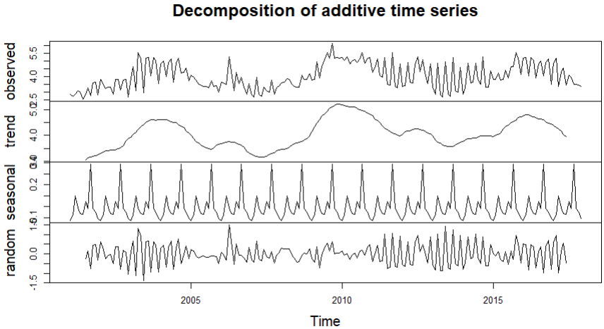

|  |  | | |  | | |
| --- | --- | --- | --- | --- | --- | --- |
|  |  |  |  |  |  |  |
|  |  |  |  |  |  |  |
|  |  |  |  |  |  |  |
|  |  |  |  |  |  |  |
|  |  |  |  |  |  |  |
|  |  |  |  |  |  |  |
|  |  |  |  |  |  |  |

Brazil

| MODEL |  | 2 YEAR FORECAST |  |  | 6 YEAR FORECAST |  |
| --- | --- | --- | --- | --- | --- | --- |
|  | MAE | MAPE | RMSE | MAE | MAPE | RMSE |
| ARIMA | 1.924 | 0.175 | 2.653 | 2.365 | 0.329 | 3.177 |
| ARNN | 3.33 | 0.4034 | 3.8 | 1.95 | 0.2044 | 2.52 |
| SVM | 2.363 | 0.139 | 4.116 | 2.991 | 0.265 | 4.531 |
| HYBRID ARIMA ARNN | 2.002466 | 0.1814 | 2.742 | 2.363 | 0.33 | 3.186 |
| HYBRID ARIMA ANN | 2.245 | 0.225 | 2.813 | 6.126 | 0.843 | 31.389 |
| HOLT-WINTERS | 1.981 | 0.121 | 2.489 | 2.129 | 0.135 | 2.592 |

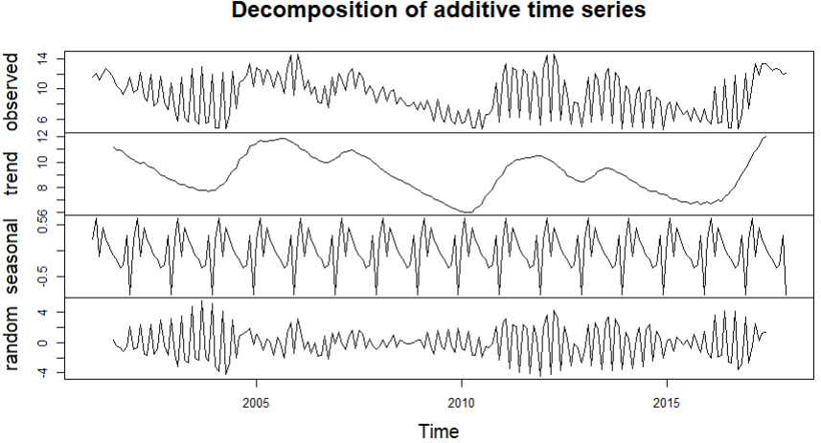

Argentina

| MODEL |  | 2 YEAR FORECAST |  |  | 6 YEAR FORECAST |  |
| --- | --- | --- | --- | --- | --- | --- |
|  | MAE | MAPE | RMSE | MAE | MAPE | RMSE |
| ARIMA | 3.972 | 0.288 | 5.768 | 3.279 | 0.255 | 4.704 |
| ARNN | 3.33 | 0.5177 | 3.43 | 2.05 | 0.2239 | 2.39 |
| SVM | 2.899 | 0.416 | 2.116 | 2.896 | 0.176 | 2.48 |
| HYBRID ARIMA ARNN | 3.9833 | 0.289 | 5.776912 | 3.339 | 0.256 | 4.811 |
| HYBRID ARIMA ANN | 3.167 | 0.231 | 5.546 | 3.05 | 0.265 | 4.369 |
| HOLT-WINTERS | 2.453 | 0.133 | 4.681 | 3.62 | 0.153 | 5.124 |

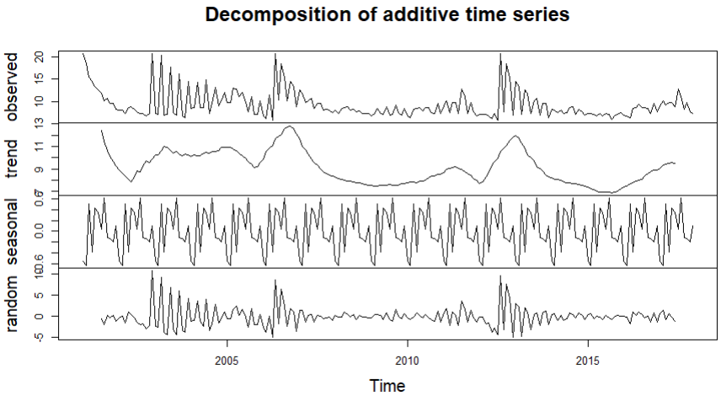

CHINA

| MODEL |  | 2 YEAR FORECAST |  |  | 6 YEAR FORECAST |  |
| --- | --- | --- | --- | --- | --- | --- |
|  | MAE | MAPE | RMSE | MAE | MAPE | RMSE |
| ARIMA | 0.914 | 0.222 | 0.922 | 0.509 | 0.112 | 0.573 |
| ARNN | 0.36 | 0.0888 | 0.4 | 0.2 | 0.054 | 0.25 |
| SVM | 0.471 | 0.151 | 0.348 | 0.763 | 0.099 | 0.398 |
| HYBRID ARIMA ARNN | 0.9293 | 0.2259 | 0.9369 | 0.514 | 0.114 | 0.575 |
| HYBRID ARIMA ANN | 0.1475 | 0.035 | 0.1735 | 0.561 | 0.128 | 0.631 |
| HOLT-WINTERS | 0.492 | 0.146 | 0.91 | 0.85 | 0.885 | 0.93 |

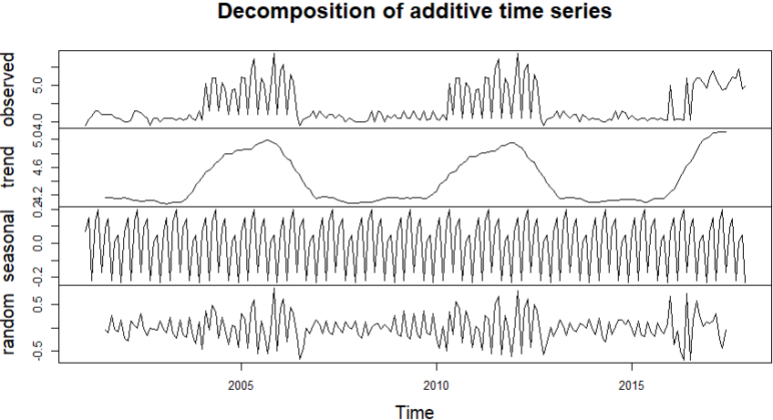

PHILIPPINES

| MODEL |  | 2 YEAR FORECAST |  |  | 6 YEAR FORECAST |  |
| --- | --- | --- | --- | --- | --- | --- |
|  | MAE | MAPE | RMSE | MAE | MAPE | RMSE |
| ARIMA | 0.600 | 0.077 | 0.772 | 1.029 | 0.1546 | 1.444 |
| ARNN | 1.87 | 0.4191 | 2.02 | 1.74 | 0.2143 | 3.12 |
| SVM | 1.126 | 0.192 | 2.86 | 1.139 | 0.4294 | 2.928 |
| HYBRID ARIMA ARNN | 0.6336 | 0.0824 | 0.8001 | 1.042 | 0.155 | 1.449 |
| HYBRID ARIMA ANN | 0.5008 | 0.064 | 0.6988 | 1.336 | 0.183 | 1.699 |
| HOLT-WINTERS | 0.766 | 0.135 | 1.384 | 1.172 | 0.234 | 1.591 |

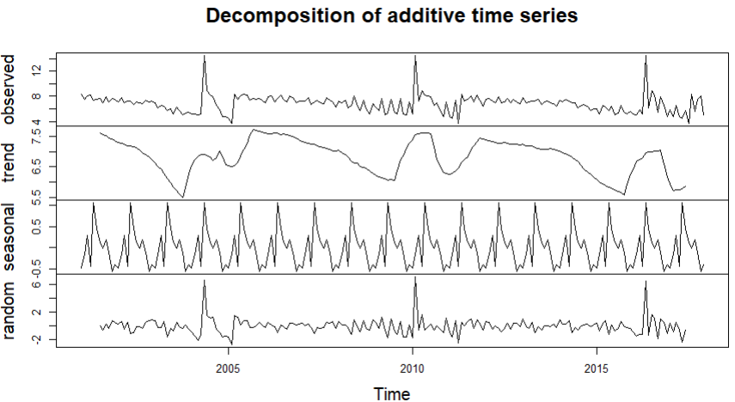

THAILAND

| MODEL |  | 2 YEAR FORECAST |  |  | 6 YEAR FORECAST |  |
| --- | --- | --- | --- | --- | --- | --- |
|  | MAE | MAPE | RMSE | MAE | MAPE | RMSE |
| ARIMA | 1.005 | 0.348 | 1.358 | 0.727 | 0.371 | 1.044 |
| ARNN | 0.57 | 0.4966 | 0.6 | 0.32 | 0.2048 | 0.45 |
| SVM | 0.87 | 0.321 | 0.791 | 0.923 | 0,183 | 1.065 |
| HYBRID ARIMA ARNN | 0.349 | 1.008 | 1.360 | 0.735 | 0.372 | 1.053 |
| HYBRID ARIMA ANN | 0.816 | 0.356 | 1.0857 | 0.690 | 0.500 | 0.916 |
| HOLT-WINTERS | 0.641 | 3.123 | 0.741 | 0.634 | 5.758 | 0.887 |

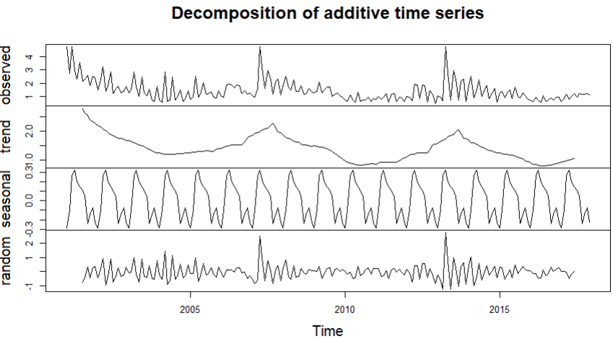

RUSSIA

| MODEL |  | 2 YEAR FORECAST |  |  | 6 YEAR FORECAST |  |
| --- | --- | --- | --- | --- | --- | --- |
|  | MAE | MAPE | RMSE | MAE | MAPE | RMSE |
| ARIMA | 4.288 | 0.502 | 4.332 | 3.797 | 0.469 | 3.838 |
| ARNN | 1.95 | 0.5777 | 2.09 | 1.01 | 0.2595 | 1.17 |
| SVM | 2.234 | 0.224 | 3.095 | 2.454 | 0.382 | 2.867 |
| HYBRID ARIMA ARNN | 4.237 | 0.496 | 4.291 | 3.79026 | 0.4678 | 3.83457 |
| HYBRID ARIMA ANN | 0.629 | 0.073 | 0.823 | 0.698 | 0.09 | 0.924 |
| HOLT-WINTERS | 3.263 | 0.173 | 2.103 | 3.551 | 0.572 | 3.582 |

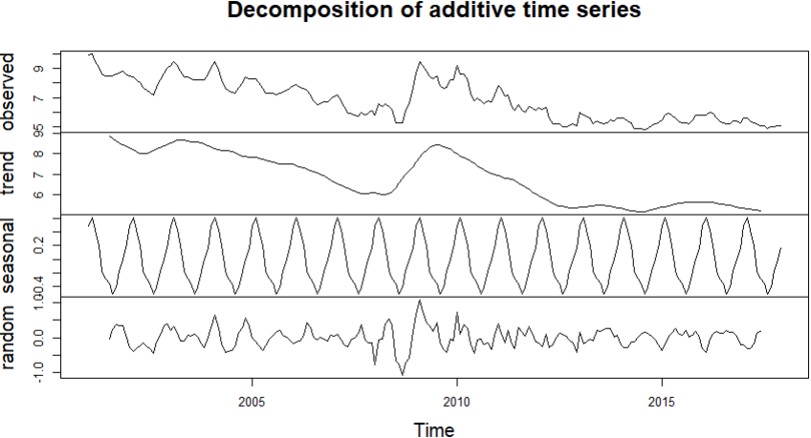

CHILE

| MODEL |  | 2 YEAR FORECAST |  |  | 6 YEAR FORECAST |  |
| --- | --- | --- | --- | --- | --- | --- |
|  | MAE | MAPE | RMSE | MAE | MAPE | RMSE |
| ARIMA | 2.791 | 0.280 | 2.871 | 2.126 | 0.075 | 2.835 |
| ARNN | 1.79 | 0.2105 | 2.08 | 1.58 | 0.1653 | 2.22 |
| SVM | 1.919 | 0.3652 | 2.873 | 2.578 | 0.429 | 3.149 |
| HYBRID ARIMA ARNN | 2.8103 | 0.282 | 2.9047 | 3.038222 | 0.313 | 3.217321 |
| HYBRID ARIMA ANN | 0.7122 | 0.0716 | 0.853 | 1.796 | 0.184 | 1.991 |
| HOLT-WINTERS | 1.281 | 0.305 | 1.265 | 1.976 | 0.169 | 2.175 |

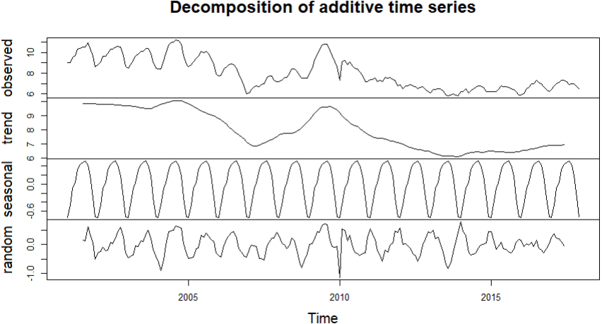

SOUTH AFRICA

| MODEL |  | 2 YEAR FORECAST |  |  | 6 YEAR FORECAST |  |
| --- | --- | --- | --- | --- | --- | --- |
|  | MAE | MAPE | RMSE | MAE | MAPE | RMSE |
| ARIMA | 3.111 | 0.111 | 3.870 | 2.125 | 0.0749 | 2.835 |
| ARNN | 3.67 | 0.1123 | 3.85 | 3.72 | 0.1154 | 4.46 |
| SVM | 2.619 | 0.052 | 3.097 | 3.025 | 0.256 | 3.457 |
| HYBRID ARIMA ARNN | 3.123 | 0.112 | 3.866 | 2.125 | 0.075 | 2.8308 |
| HYBRID ARIMA ANN | 2.944 | 0.104 | 3.877 | 2.955 | 0.113 | 3.417 |
| HOLT-WINTERS | 1.718 | 0.327 | 2.937 | 1.724 | 0.152 | 2.683 |

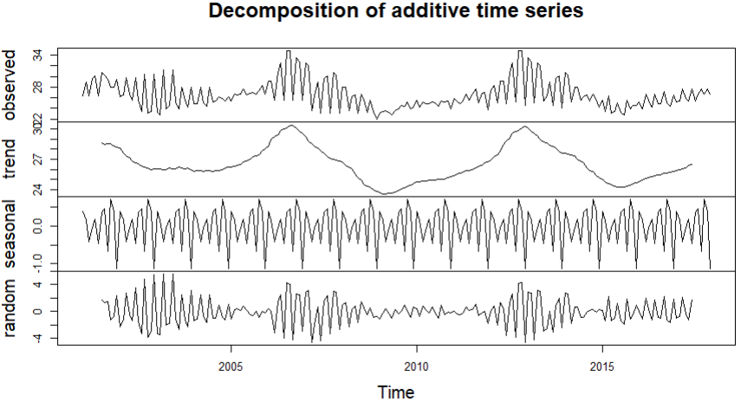

TURKEY

| MODEL |  | 2 YEAR FORECAST |  |  | 6 YEAR FORECAST |  |
| --- | --- | --- | --- | --- | --- | --- |
|  | MAE | MAPE | RMSE | MAE | MAPE | RMSE |
| ARIMA | 2.133 | 0.237 | 2.320 | 1.406 | 0.142 | 1.749 |
| ARNN | 1.78 | 0.1794 | 1.86 | 2.54 | 0.2069 | 3.1 |
| SVM | 1.406 | 0.133 | 2.12 | 1.61 | 0.453 | 2.531 |
| HYBRID ARIMA ARNN | 2.101 | 0.233 | 2.114 | 1.5413 | 0.1545 | 1.9406 |
| HYBRID ARIMA ANN | 2.015 | 0.212 | 2.559 | 1.51 | 0.157 | 1.799 |
| HOLT-WINTERS | 0.456 | 0.281 | 1.147 | 0.981 | 0.367 | 1.312 |

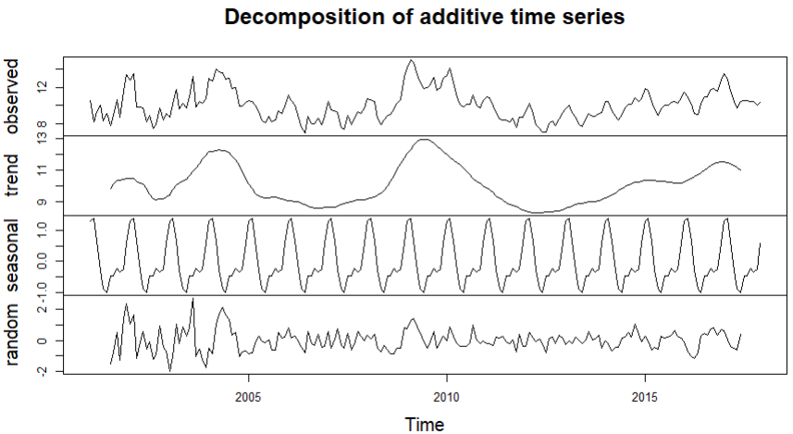

PERU

| MODEL |  | 2 YEAR FORECAST |  |  | 6 YEAR FORECAST |  |
| --- | --- | --- | --- | --- | --- | --- |
|  | MAE | MAPE | RMSE | MAE | MAPE | RMSE |
| ARIMA | 0.885 | 0.092 | 1.117 | 1.760 | 0.189 | 2.276 |
| ARNN | 0.42 | 0.057 | 0.48 | 2.38 | 0.2087 | 3.85 |
| SVM | 1.136 | 0.155 | 1.754 | 2.198 | 0.275 | 3.277 |
| HYBRID ARIMA ARNN | 0.918 | 0.096 | 1.148 | 1.819202 | 0.19446 | 2.351549 |
| HYBRID ARIMA ANN | 0.861 | 0.091 | 1.162 | 1.226 | 0.14 | 1.746 |
| HOLT-WINTERS | 0.921 | 0.112 | 1.7413 | 2.01 | 0.27 | 2.478 |

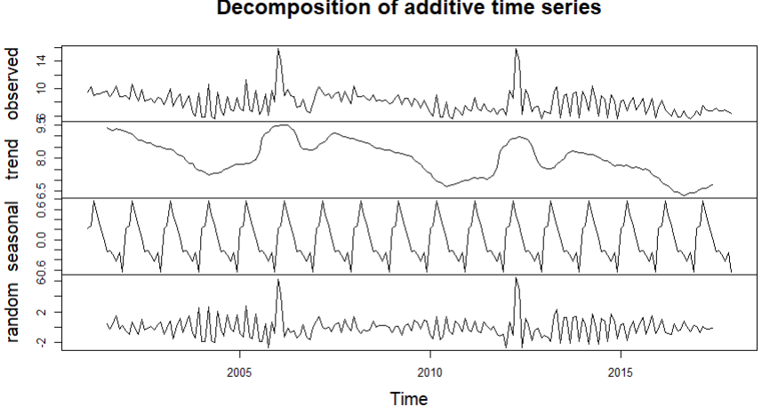

we obtain the following results and inferences

In Mexico, hybrid ARIMA-ANN is the best for 2 year forecast while for 6 year forecast hybrid ARIMA ARNN is best,

(In Mexico holt-winters performed better than best generic model)

(No seasonality found)

In Brazil ARIMA model is best for 2 year forecast while for 6 year forecast ARNN model is best,

(In brazil holt winters outperforms the best generic model in case of 2 year forecast but is a weaker metric in case of 6 year one)

(From the decomposed graph we can see there is not much seasonality present)

In Argentina, hybrid ARIMA-ANN model is better for 2 year forecast while ARNN is best for 6 year forecast

(In argentina Holt winters is able to outperform ARIMA-ANN for 2yr forecast but is a weaker metric for the 6yr forecast)

( not much of seasonality is present)

In China, hybrid ARIMA-ANN is better FOR 2 year forecast while ARNN IS BETTER FOR 6 YEAR FORECAST

(Here holt winters proves to be a weaker metric for both cases)

(This is a case of a seasonal graph)

In Philippines, hybrid ARIMA-ANN is better for 2 year forecast while ARIMA is better for 6 years

(Here holt winter proves to be a weaker metric in both cases)

(not much of seasonality is present)

In Thailand ,hybrid ARIMA-ARNN is better for 2 year forecast while ARNN is better for 6 years forecast

(Here holt winter proves to be a weaker metric)

(This is a case of a seasonal graph)

In Chile, hybrid ARIMA ANN is better for 2 year forecast, while all are equal for 6 years

(Here holt winter is not useful for 2 year forecast but is the best option in case of 6 years forecast)

(Has seasonality in the beginning )

In South Africa hybrid ARIMA ANN IS better for 2 years forecast while ARIMA,and HYBRID ARIMA-ARNN is best for 6 year forecast

(Here holt winter is a superior model in both cases)

(Some instances of seasonality can be seen)

In Turkey, ARNN is better forecast for 2 years while ARIMA is better for 6 years

(Here holt winter is a superior model in both cases)

(Some instances of seasonality can be seen)

In Peru, ARNN is better forecast for 2 years while Hybrid ARIMA-ANN IS better for 6 years

(Here holt winter proves to be inferior in both cases)

(Not seasonal)

**6. Conclusion**

We used various models for predicting unemployment rates in the context of emerging economies. The model works for both linear and non linear data.

We find that different models are better for different countries. However, in the short term, ARIMA ANN is the best forecast model followed by ARNN model. we also find that in the long forecast, ARNN model is better followed by ARIMA . We see that for short term the hybrid models are better at anticipating changes to the unemployment rate while for longer term the primitive models are better for predicting unemployment rates.

No one model is better for emerging countries and the model effectiveness shifts over time.

We also found that the data doesn’t follow seasonality for emerging economies and it is comparatively random.

This extreme and unpredictable fluctuations can be due to various reasons. Few probable reasons being:

1. Prevalence of primary sector- As primary sector may still be the biggest sector in most of these emerging nations, the impact of crises can look far worse than countries with service sector as main sector.
2. Developing nation trap- Like Malthusian trap, this can also impact unemployment rate. The population density of these countries are higher than developed countries, resulting in more chances of poverty and unemployment.
3. Informal sector- Many of these countries have more informal sector than formal and data of informal sector is not readily available. Hence, this randomness and fluctuations.

The unemployment rate is a major economic indicator and has implications for both investors as they may use suitable policy taking into account the unemployment rate and policy makers as they seek to improve the economy

For future research, more data points will help to fine tune the models even further.

**7. References**

* Ahmad, M., Khan, Y. A., Jiang, C., Kazmi, S. J. H., & Abbas, S. Z. (2023). The impact of COVID‐19 on unemployment rate: An intelligent based unemployment rate prediction in selected countries of Europe. *International Journal of Finance & Economics*, *28*(1), 528-543
* Zhang, G. P. (2003). Time series forecasting using a hybrid ARIMA and neural network model. *Neurocomputing*, *50*, 159-175.
* Pai, P. F., & Lin, C. S. (2005). A hybrid ARIMA and support vector machines model in stock price forecasting. *Omega*, *33*(6), 497-505
* Chakraborty, T., Chakraborty, A. K., Biswas, M., Banerjee, S., & Bhattacharya, S. (2021). Unemployment rate forecasting: A hybrid approach. *Computational Economics*, *57*(1), 183-201.
* Fernandez Jr, P. L., & Co, J. M. (2017). Time-Series Link Prediction Using Support Vector Machines.
* Blanchard, O. J., & Leigh, D. (2013). Growth forecast errors and fiscal multipliers. *American Economic Review*, *103*(3), 117-120.
* Chakraborty, T., & Ghosh, I. (2020). Real-time forecasts and risk assessment of novel coronavirus (COVID-19) cases: A data-driven analysis (preprint).
* Raimo, N.; Martínez-Córdoba, P.-J.; Benito, B.; Vitolla, F. The Impact of the COVID-19 Pandemic on the Labor Market: An Analysis of Supply and Demand in the Spanish Municipalities. *Sustainability* **2021**, *13*, 12996. <https://doi.org/10.3390/su132312996>
* Vicente, M. R., López-Menéndez, A. J., & Pérez, R. (2015). Forecasting unemployment with internet search data: Does it help to improve predictions when job destruction is skyrocketing?. *Technological Forecasting and Social Change*, *92*, 132-139.
* Proietti, T. (2003). Forecasting the US unemployment rate. *Computational Statistics & Data Analysis*, *42*(3), 451-476.
* Espinosa, V.I. The perils of lax economic policy: The case of Chile during the COVID-19 pandemic. *Rev Austrian Econ* (2023). <https://doi.org/10.1007/s11138-023-00619-x>
* Faraway, J., & Chatfield, C. (1998). Time series forecasting with neural networks: a comparative study using the air line data. *Journal of the Royal Statistical Society Series C: Applied Statistics*, *47*(2), 231-250.
* Liang, X., Rozelle, S., & Yi, H. (2022). The impact of COVID-19 on employment and income of vocational graduates in China: Evidence from surveys in January and July 2020. *China Economic Review*, *75*, 101832.
* Vicente Cateia, J., Savard, L., & de Oliveira Almeida, E. (2022). Impact of covid-19 on labor force participation in Brazil. *Cogent Economics & Finance*, *10*(1), 2116788.
* Mertehikian, Y. A., & Parrado, E. A. (2024). The Gendered Impact of the COVID-19 Pandemic on Employment in Argentina: The Mediating Role of the Public vs. Private Sectors. *Social Sciences*, *13*(2), 123.
* Espinosa, V. I. (2023). The perils of lax economic policy: The case of Chile during the COVID-19 pandemic. *The Review of Austrian Economics*, 1-18.
* Bertulfo, D. J. (2020). COVID-19 labour market impact in the Philippines: Assessment and national policy responses. *International Labour Organization (ILO)*.
* Tian, T., Yang, C., Long, X., Kong, F., Fu, Y., Liu, F., ... & Qiao, J. (2023). The Long-Term Impacts of COVID-19 on Physical and Psychological Health—Beijing Municipality, China, December 2022–April 2023. *China CDC Weekly*, *5*(40), 894.
* Rodionov, D., Ivanova, A., Konnikova, O., & Konnikov, E. (2022). Impact of COVID-19 on the Russian labor market: comparative analysis of the physical and informational spread of the coronavirus. *Economies*, *10*(6), 136.
* Yu, D., Botha, J., & Nackerdien, M. F. (2023). Examining the South African labour market during the COVID-19 lockdown period. *Development Southern Africa*, *40*(6), 1343-1364.
* Al-Youbi, A. O., Al-Hayani, A., Rizwan, A., & Choudhry, H. (2020). Implications of COVID-19 on the labor market of Saudi Arabia: The role of universities for a sustainable workforce. *Sustainability*, *12*(17), 7090.
* Prawoto, N., Priyo Purnomo, E., & Az Zahra, A. (2020). The impacts of Covid-19 pandemic on socio-economic mobility in Indonesia.
* Maurizio, R., Monsalvo, A. P., Catania, M. S., & Martinez, S. (2023). Short-term labour transitions and informality during the COVID-19 pandemic in Latin America. *Journal for Labour Market Research*, *57*(1), 15.
* LIM, B. F. Y. (2022). Impact of the COVID-19 Pandemic on Malaysian Labour Market and Policy Responses. *Japan Labor Issues*, 37.
* Rodionov, D., Ivanova, A., Konnikova, O., & Konnikov, E. (2022). Impact of COVID-19 on the Russian labor market: comparative analysis of the physical and informational spread of the coronavirus. *Economies*, *10*(6), 136.
* Varona, L., & Gonzales, J. R. (2021). Dynamics of the impact of COVID-19 on the economic activity of Peru. *Plos one*, *16*(1), e0244920.
* Morris, W., Correa, A., & Leiva, R. (2023). Impact of COVID-19 containment measures on unemployment: A multi-country analysis using a difference-in-differences framework. *International Journal of Health Policy and Management*, *12*.
* Shi, L., Khan, Y. A., & Tian, M. W. (2022). COVID-19 pandemic and unemployment rate prediction for developing countries of Asia: A hybrid approach. *PloS one*, *17*(12), e0275422.
* Chakraborty, T., Chakraborty, A. K., Biswas, M., Banerjee, S., & Bhattacharya, S. (2021). Unemployment rate forecasting: A hybrid approach. *Computational Economics*, *57*(1), 183-201.