Opinion Analysis

Opinion Analysis is an application that is designed to analyze and classify user opinion. You as programmer are asked to build the application. There are some requirements that must be fulfilled:
- In the beginning, the application will check whether there is “file.pickle” file in the application directory
  - If the file exists, the application will read and load the data training from the file
  - Otherwise, the application will train opinion’s data with Naive Bayes from NLTK data opinion sample (‘positive-words.txt’ for positive words, and ‘negative-words.txt’ for negative words).
- The application will show the menus. There are 3 menus, and 1 view:
- Insert Opinion
- Analyze Opinion
- Exit
- The application will show all opinions that has been inputted by the user. If there is no opinion, then the application will show “No opinion inserted”
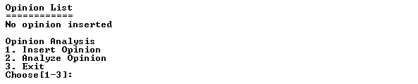
Figure 1 Screen of Main Menu
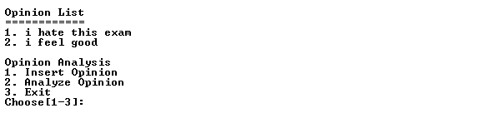
Figure 2 Screen of Main Menu with opinions

- The user can only choose menu between 1 and 3 and must be numeric
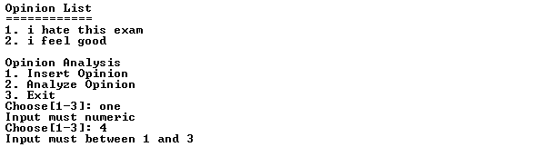
Figure 3 Screen of input menu
  - If the user chooses menu 1 ‘Insert Opinion’, then the application will ask the user to input opinion. The opinion length must be between 5 and 30 characters. Then the opinion will be inserted to the opinion list.
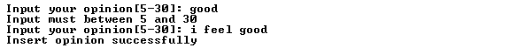
Figure 4 Screen of input opinion
- If the user chooses menu 2 ‘Analysis opinion’, then:
  - If there is no opinion in the list, the application will show “Insert opinion first”
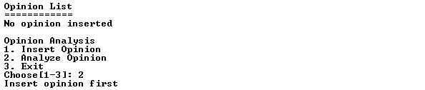
Figure 5 Screen of no opinion
  - If the user has already insert opinion, then:
    - Ask the user to choose opinion to be analyzed. The input must be between 1 and last opinion index.
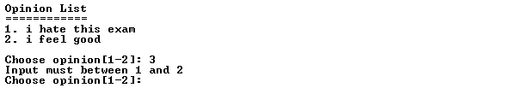
Figure 6 Screen of choose opinion
    - Then the application will classify every word on the selected opinion based on this rule:
      - If total of positive word is more than total of negative word, then the opinion is Positive
      - If total of negative word is more than total of positive word, then the opinion is Negative
      - If total of positive word is equals to total of negative word, then the opinion is Neutral
    - After that ask the user to show analysis result or not. The input must between yes or no (case sensitive)
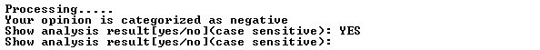
Figure 7 Screen of classifier result and input show analysis result
    - If the user choose yes, then the application will show table Frequency Distribution, Pos Tagging, Antonyms (using Wordnet) and Named Entity Recognition,
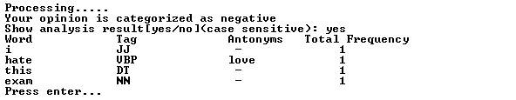
Figure 8 Screen of Frequency Distribution, Pos Tagging and Antonyms
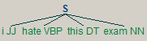
Figure 9 Screen of Named Entity Recognition
- If the user chooses menu 3 ‘Exit’, then the application will exit and save the classification with pickle as “file.pickle”

Please run the EXE for more details

