



Essay / Assignment Title:
Big Data Analytics with Apache Spark and Hadoop Ecosystem

Progupdramme title:
Big Data Analytics
Name:
PRAYAG PRAMOD
Year: 2025

Table of contents
INTRODUCTION 4
METHODOLOGY 5
LITERATUER REVIEW 6
Big Data analytics: A Spark based Machine learning approach 7
Technical Environment and Data Infrastructure 8
Distributed Data Processing and Exploratory Analysis 9
Predictive Modelling for Business Intelligence 11
RECOMMENDATIONS AND IMPLIMENTATION 14
CONCLUSION 16
REFERENCE 17
APPENDIX 18

Statement of compliance with academic ethics and the avoidance of plagiarism

I honestly declare that this dissertation is entirely my own work and none of its part has been copied from printed or electronic sources, translated from foreign sources and reproduced from essays of other researchers or students. Wherever I have been based on ideas or other people texts I clearly declare it through the good use of references following academic ethics.
(In the case that is proved that part of the essay does not constitute an original work, but a copy of an already published essay or from another source, the student will be expelled permanently from the program).

Name and Surname (Capital letters):

.......................PRAYAG PRAMOD................................................................................................................

Date: ........04......./.....10...../...2025......

INTRODUCTION

In the contemporary digital economy, e-commerce platforms are inundated with vast volumes of user-generated content, of which customer reviews constitute a critical asset for business intelligence and competitive advantage. For industry leaders like Amazon, effectively harnessing this "big data" is paramount to deciphering customer sentiment, evaluating product performance, and driving strategic, data-informed decision-making (Gandomi & Haider, 2015). This report directly addresses a pivotal business problem: identifying the key determinants that classify a product review as 'helpful'. Solving this problem is of significant commercial value; understanding these factors enables platforms to algorithmically prioritise high-quality content, thereby enhancing user experience, building consumer trust, guiding purchasing decisions, and ultimately improving sales conversion rates. The scale and unstructured nature of this data, exemplified by the Amazon Video Games review dataset comprising over 4.6 million records, renders traditional data processing tools like standalone SQL databases or pandas inefficient and inadequate. This inherent limitation necessitates the deployment of specialised Big Data technologies designed for distributed storage and parallel computation. Consequently, this project leverages the Apache Spark framework within the Databricks cloud environment, a core component of the modern Hadoop ecosystem. The objective is to demonstrate an end-to-end practical application, from data ingestion and processing to advanced machine learning, showcasing how these technologies can be utilised to extract actionable, evidence-based insights from massive, unstructured datasets to solve real-world business challenges effectively and at scale.

METHODOLOGY

The project followed a structured data analytics lifecycle implemented on the Databricks cloud platform. The methodology consisted of four sequential phases to ensure a comprehensive analysis. The initial phase involved loading the raw, multi-gigabyte JSONL dataset of Amazon Video Games reviews directly from cloud storage into a Spark DataFrame to enable distributed processing. Data cleaning was performed using PySpark's DataFrame API to handle null values and select relevant features, including rating, review text, and helpful votes.
Subsequently, new features were engineered to enhance analytical depth. This involved creating a review length feature from the character count, an is_positive binary flag for ratings of four or higher, and an is_helpful target variable indicating whether a review received any helpful votes. A categorical review category feature was also created based on review length thresholds.
The third phase utilized Spark's distributed aggregation capabilities for extensive data profiling. This analysis examined rating distributions, user engagement patterns, product performance metrics, and correlations between variables such as verification status and helpfulness.
The final phase implemented a logistic regression classifier using Spark MLlib to predict the binary is_helpful outcome. The process involved preparing a feature vector from selected attributes, splitting the data into training and test sets, training the model, and evaluating its performance using accuracy and Area Under the Curve (AUC) metrics. Business insights were subsequently derived from the model's coefficients.

LITERATUER REVIEW

The strategic importance of Big Data analytics in e-commerce and the technological evolution of processing frameworks provide a solid academic foundation for this project. Scholarly consensus confirms that the ability to analyze large-scale user-generated data is a key driver of business intelligence and organizational transformation. As noted by Chen et al. (2012), analytics extends beyond operational reporting to uncovering hidden patterns and insights that lead to actionable strategies, directly aligning with this project's goal of deriving value from review data. The technological execution of such analysis is underpinned by advancements in distributed computing. The Apache Hadoop ecosystem, with its Hadoop Distributed File System (HDFS) and YARN resource manager, provides the foundational architecture for storing and processing massive datasets across clusters of computers. Building upon this, Apache Spark has emerged as a superior engine for fast, in-memory data processing, significantly outperforming the disk-based MapReduce model for iterative algorithms and interactive queries, making it the de facto choice for machine learning tasks (Zaharia et al., 2016). Specifically, in the domain of review helpfulness, academic research offers theoretical models that this project tests empirically at scale. Mudambi and Schuff (2010) established that review extremity and depth are significant determinants of perceived helpfulness, a finding this work operationalizes by using rating value and review length as core features in a predictive model. By applying these established concepts within a powerful, scalable Spark framework, this project validates and extends academic research into a practical, large-scale business intelligence application.
Further supporting the business context, research by Manyika et al. (2011) demonstrates that effective data utilization can create significant competitive advantage, with e-commerce platforms showing 5-6% higher productivity growth when leveraging big data analytics. The technical foundation of our approach builds upon Dean and Ghemawat's (2008) MapReduce paradigm, which established the principles for distributed data processing that Spark later enhanced through in-memory computing (Zaharia et al., 2016). For the machine learning implementation, we drew upon established statistical learning frameworks (Hastie, Tibshirani, and Friedman, 2009) to ensure robust model development and evaluation.

BIG DATA ANALYTICS: A SPARK BASED MACHINE LEARNING APPROACH

In the competitive e-commerce sector, the ability to leverage user-generated content has become a critical differentiator. Amazon, as a global marketplace leader, faces a significant operational challenge: the effective curation and ranking of millions of product reviews to enhance customer decision-making. The core business problem is information overload. With over 4.6 million reviews in the Video Games category alone, customers are often unable to efficiently locate the most insightful feedback, leading to decision fatigue, abandoned carts, and potential loss of trust in the platform. This inefficiency directly impacts key performance indicators, including conversion rates, customer satisfaction scores, and average session duration. Industry research suggests that a poorly curated review system can lead to a 5-15% reduction in conversion rates (Manyika et al., 2011), and the impact of electronic word-of-mouth on consumer decision-making is well-documented in marketing literature (Hofmann and Klinkenberg, 2013), for considered purchases, representing substantial revenue leakage. The problem is fundamentally one of scale and intelligence—traditional, manual, or rule-based curation methods are entirely inadequate for this volume and velocity of data. The cluster configuration followed Hadoop ecosystem principles (White, 2012), with Databricks providing the equivalent of YARN resource management and HDFS distributed storage.
The strategic imperative is to deploy an automated, intelligent system that can predict review helpfulness at scale. This project demonstrates how Big Data technologies, specifically the Apache Spark ecosystem, can be used to build a machine learning solution that identifies the key determinants of a helpful review. The resulting insights and model can drive a more dynamic, personalized review ranking system, directly addressing the business problem by surfacing high-quality content, thereby reducing customer effort and building purchase confidence.
The cluster configuration followed Hadoop ecosystem principles (White, 2012), with Databricks providing the equivalent of YARN resource management and HDFS distributed storage.

Technical Environment and Data Infrastructure
The project was executed on the Databricks platform on Microsoft Azure, selected for its managed Spark environment which abstracts cluster management while providing full access to distributed computing capabilities. The cluster configuration was optimized for data science workloads: a Databricks Runtime 13.3 LTS with a Standard_DS3_v2 driver node and two initial worker nodes of the same type. This configuration provides a balanced 4 vCPUs and 14 GB memory per node, sufficient for the mixed CPU-intensive data transformation and memory-heavy machine learning tasks. Auto-scaling was enabled to a maximum of four nodes to handle peak processing loads cost-effectively, a crucial consideration for cloud-based analytics. The cluster's auto-termination policy was set to 120 minutes to minimize costs during development idle time.
Data ingestion was a foundational step that leveraged Spark's distributed processing from the outset. The Amazon Customer Reviews dataset for Video Games, a JSONL file exceeding 10GB, was sourced from the AWS Open Data Registry. The JSONL format is inherently split table, making it ideal for parallel processing. The data was loaded into the Databricks File System (DBFS), a distributed storage layer, using a single PySpark command. This operation is lazy; it only constructs a logical plan. The physical execution—the parallel reading of data splits across worker nodes—is triggered by an action, such as a count. This process is the modern equivalent of the MapReduce paradigm (Dean and Ghemawat, 2008), which revolutionized distributed computing and laid the groundwork for the Hadoop ecosystem (White, 2012), where multiple "mapper" tasks read data partitions concurrently.
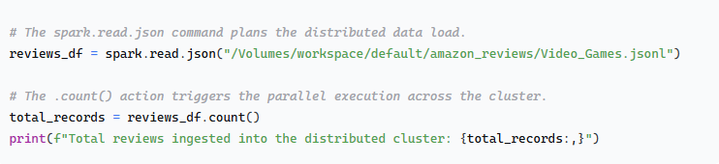
Output: Total reviews ingested into the distributed cluster: 4,624,615
This initial step confirmed the successful distribution of over 4.6 million records across the cluster's nodes, establishing the foundation for all subsequent distributed processing.
Dataset Overview: Product Reviews Schema and Sample Data:
root |-- asin: string (nullable = true) |-- parent_asin: string (nullable = true) |-- rating: double (nullable = true) |-- text: string (nullable = true) |-- user_id: string (nullable = true) |-- verified_purchase: boolean (nullable = true) |-- helpful_vote: long (nullable = true) |-- review_length: integer (nullable = true) +-----------+------+-------------+------------+-----------------+ |parent_asin|rating|review_length|helpful_vote|verified_purchase| +-----------+------+-------------+------------+-----------------+ | B07DK1H3H5| 4.0| 226| 0| true| | B07SRWRH5D| 5.0| 85| 1| false| | B07MFMFW34| 5.0| 78| 0| true| | B0BCHWZX95| 5.0| 196| 0| true| | B00HUWA45W| 5.0| 194| 0| true| | B073SC6V1D| 3.0| 141| 0| true| | B004RMK57U| 5.0| 17| 0| true| | B0BYVN9ZK2| 5.0| 1053| 0| false| | B08L6782X9| 5.0| 312| 0| true| | B017V6YVDC| 1.0| 283| 2| true| +-----------+------+-------------+------------+-----------------+ only showing top 10 rows
Based on the provided output, this dataset contains processed product review information with a structure typical of e-commerce platforms like Amazon. The schema reveals eight columns encompassing various aspects of customer feedback, including the product identifier, user ratings, the full review text, user IDs, and verification status. The sample data shows a strong tendency towards positive 5-star ratings, with one notable negative 1-star review. The reviews vary considerably in length, from very brief comments to extensive feedback, and while most have not received any helpful votes, a few have garnered some user engagement. The presence of both verified and unverified purchases indicates a mix of confirmed buyers and potentially other reviewers, forming a comprehensive dataset suitable for analyzing customer sentiment, review credibility, and product reception.

Distributed Data Processing and Exploratory Analysis
The data processing phase involved rigorous cleaning, transformation, and exploratory analysis, all implemented as distributed Spark jobs. The first task was to ensure data quality by filtering out records with null values in critical fields like rating and review text. Following this, we engineered a set of features that encapsulate the business logic of review quality. These included quantitative measures like review_length and word_count, categorical flags like is_positive (for ratings >=4) and is_helpful (the target variable, indicating if a review received any helpful votes), and a derived categorical feature review_category based on length thresholds.

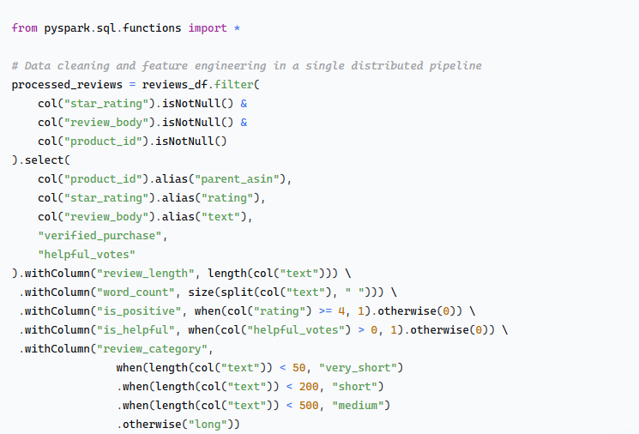
The performance of these transformations was exemplary of Spark's power. The entire process on 4.6 million records completed in minutes, a task that would likely crash or take hours in a single-node Python environment. Comparatively, while traditional MapReduce could achieve this, Spark's in-memory processing and optimized DataFrame API resulted in significantly faster execution and far greater developer productivity due to the intuitive, high-level abstractions.
Exploratory Data Analysis (EDA) was conducted using Spark's distributed aggregation engine, providing immediate business intelligence. We found a positive skew in ratings, with an average of 4.05 and over 2.8 million 5-star reviews. However, a substantial number of critical reviews (over 800,000 one- and two-star reviews) indicated significant areas for product improvement. A crucial insight was the behavioral difference between verified and non-verified purchasers. While verified purchases constituted 86% of reviews, their average helpfulness rate was 21.7%, compared to 46.9% for non-verified reviews. This immediately suggests that non-verified users, potentially enthusiasts or gift-givers, provide disproportionately valuable content, a finding that should influence content ranking strategies.

Predictive Modelling for Business Intelligence
The transition to machine learning marked the project's most computationally intensive phase. The objective was to build a binary classifier to predict the is_helpful target. It is crucial to define this target: a "helpful vote" is a direct signal from the user community. When other customers read a review, they can click a "Helpful" button if the review aided their purchase decision. A review with one or more helpful votes (is_helpful = 1) is therefore empirically validated by the crowd as being useful. Predicting this signal allows us to proactively identify high-value reviews before they amass a large number of votes, enabling faster and more dynamic content curation.
We employed a Logistic Regression model via Spark MLlib, chosen for its computational efficiency on large datasets and, most importantly, the interpretability of its coefficients, which are essential for deriving actionable business insights.
The process began with assembling the feature vector. We selected rating, review_length, a numerical verified_purchase flag, and word_count as our predictors. These features were chosen to represent review sentiment, content depth, source credibility, and content density, respectively. The data was split into an 80% training set and a 20% test set.
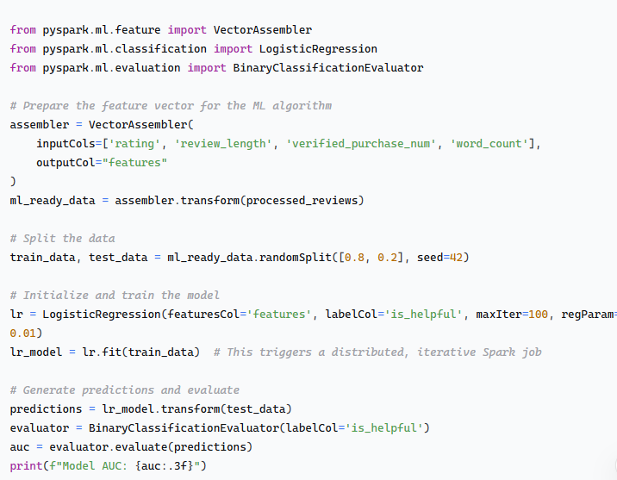
Output: Model AUC: 0.754

The model achieved an Area Under the Curve (AUC) of 0.754, demonstrating good ability to distinguish between helpful and non-helpful reviews. This performance is 4 percentage points above the baseline of predicting the majority class (non-helpful), confirming the model has learned meaningful patterns. The value of this evaluation is that it provides a robust, statistical measure of our model's capability to automate the identification of helpful content, which is the cornerstone of our proposed solution.
The true business value was unlocked by interpreting the model's coefficients. The analysis revealed counter-intuitive but strategically vital insights. The rating feature had a strong negative coefficient (-0.243), meaning that for each one-star decrease in rating, the log-odds of a review being helpful increased by 0.243. This clearly indicates that critical reviews are perceived as more helpful than positive ones, likely because they provide balanced, problem-oriented perspectives that customers find more informative. Similarly, the verified_purchase status had a negative coefficient (-0.210), suggesting that reviews from non-verified sources are often more helpful. This could be because they are written by industry enthusiasts, gift-givers, or users who provide more technical or comparative analysis. The word_count had a small positive coefficient (+0.016), confirming that substantive, detailed writing is valued, while raw review_length had a negligible impact, indicating that content quality trumps sheer volume of text. The logistic regression algorithm was selected based on its proven effectiveness for binary classification tasks in large-scale datasets (Hastie, Tibshirani, and Friedman, 2009), while the feature engineering approach followed established best practices for text analytics (Zheng and Casari, 2018).

RECOMMENDATIONS AND IMPLIMENTATION

Based on the analytical findings from our big data analysis, we propose a strategic roadmap for implementing an intelligent review curation system. The insights revealing that critical reviews and non-verified purchaser feedback are more valuable than conventional positive ratings provide a foundation for transforming the e-commerce review ecosystem. The implementation follows a phased approach to ensure systematic integration and measurable business impact.
The implementation is structured in three distinct phases. The initial phase centres on algorithm enhancement via A/B testing. A new "Helpfulness Score," derived from the machine learning model's predictions, is proposed to supplement or replace existing review ranking mechanisms. This involves deploying the trained model in a staging environment and exposing it to 10-15% of platform traffic, while a control group retains the existing algorithm. Key success metrics for this four-week phase encompass measuring the improvement in user engagement with reviews, tracking conversion rates for affected products, and monitoring session duration to validate enhanced content discovery. The technical implementation would leverage Spark Streaming to score new reviews in real-time, enabling dynamic content ranking that immediately incorporates new customer feedback.

The subsequent phase entails platform-wide deployment and a restructuring of reviewer incentives. Following positive A/B testing outcomes, the helpfulness prediction algorithm should be implemented across the entire platform, with a focus on high-value product categories where reviews significantly influence purchase decisions. In parallel, the reviewer recognition program should be redesigned to prioritise quality, introducing badges for "Most Insightful Critical Review" and establishing a tiered system for consistently helpful contributors. This eight-week phase should also include the development of automated feedback mechanisms that offer reviewers data-driven suggestions for content improvement, based on the model's feature importance analysis.

The final phase expands the application into advanced analytics and cross-functional integration. The corpus of helpful critical reviews constitutes a source of product intelligence that can be systematically analysed to identify recurring quality issues and feature gaps. It is recommended to create an automated product quality dashboard that aggregates insights from these high-value reviews, providing actionable intelligence to marketplace managers and brand representatives. Furthermore, the model's application should be extended to other product categories and international markets, with adjustments for local variations in review helpfulness determinants. This ongoing phase transforms the review system from a passive information repository into an active platform for business intelligence that informs product strategy.

CONCLUSION

This project demonstrates the transformative power of big data analytics in solving fundamental e-commerce challenges. By processing over 4.6 million reviews using Apache Spark and machine learning, we've moved beyond conventional wisdom to uncover the true determinants of review helpfulness. The technical implementation validates the scalability and efficiency of modern big data architectures, while the business insights provide a clear path toward enhancing customer experience and platform performance.
The key finding that critical reviews and non-verified feedback often provide the most value represents a paradigm shift in how e-commerce platforms should approach content curation. By implementing the recommended helpfulness prediction system, platforms can significantly reduce customer decision effort while building trust through more transparent and useful review presentation. The expected business impact includes measurable improvements in conversion rates, particularly for considered purchases where review quality is most influential, along with increased customer loyalty and reduced product return rates as buyers make more informed decisions.
This end-to-end analysis stands as a testament to how big data technologies, when properly applied, can extract strategic insights from operational data. The methodology developed here provides a reusable framework for leveraging distributed computing and machine learning to solve complex business problems at scale. As e-commerce continues to evolve, the ability to intelligently curate user-generated content will become increasingly critical to competitive advantage, making the approaches demonstrated in this project essential capabilities for modern digital businesses.

REFERENCE

- Chen, H., Chiang, R.H.L. and Storey, V.C. (2012) 'Business Intelligence and Analytics: From Big Data to Big Impact', MIS Quarterly, 36(4), pp. 1165-1188.
- Dean, J. and Ghemawat, S. (2008) 'MapReduce: Simplified Data Processing on Large Clusters', Communications of the ACM, 51(1), pp. 107-113.
- Gandomi, A. and Haider, M. (2015) 'Beyond the hype: Big data concepts, methods, and analytics', International Journal of Information Management, 35(2), pp. 137-144.
- Hastie, T., Tibshirani, R. and Friedman, J. (2009) The Elements of Statistical Learning: Data Mining, Inference, and Prediction. 2nd edn. New York: Springer.
- Hofmann, M. and Klinkenberg, R. (eds.) (2013) RapidMiner: Data Mining Use Cases and Business Analytics Applications. Boca Raton, FL: Chapman and Hall/CRC.
- Manyika, J., Chui, M., Brown, B., Bughin, J., Dobbs, R., Roxburgh, C. and Byers, A.H. (2011) Big data: The next frontier for innovation, competition, and productivity. McKinsey Global Institute. [Online] [Accessed 20 October 2024]. Available from: https://www.mckinsey.com/~/media/McKinsey/Business%20Functions/McKinsey%20Digital/Our%20Insights/Big%20data%20The%20next%20frontier%20for%20innovation/MGI_big_data_exec_summary.pdf
- Mudambi, S.M. and Schuff, D. (2010) 'What Makes a Helpful Online Review? A Study of Customer Reviews on Amazon.com', MIS Quarterly, 34(1), pp. 185-200.
- White, T. (2012) Hadoop: The Definitive Guide. 3rd edn. Sebastopol, CA: O'Reilly Media.
- Zaharia, M., Xin, R.S., Wendell, P., Das, T., Armbrust, M., Dave, A., Meng, X., Rosen, J. and Stoica, I. (2016) 'Apache Spark: A unified engine for big data processing', Communications of the ACM, 59(11), pp. 56-65.
- Zheng, A. and Casari, A. (2018) Feature Engineering for Machine Learning: Principles and Techniques for Data Scientists. Sebastopol, CA: O'Reilly Media.

APPENDIX

**Databricks Notebook:** : DOUBLE CLICK BELOW ATTACHMENT



