Create 2 group 1 for apahe2 and 1 for nginx  
  
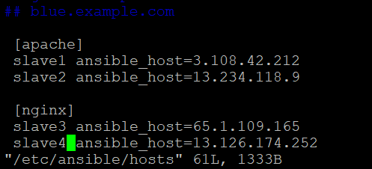

Create 3 roles   
  
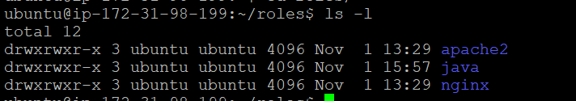

Now create playbook for nginx , apache and java  
  
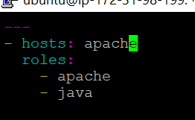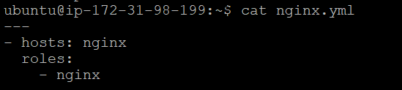

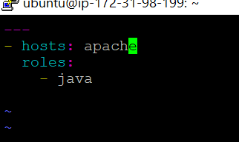

Now create the main.yml file in all  
  
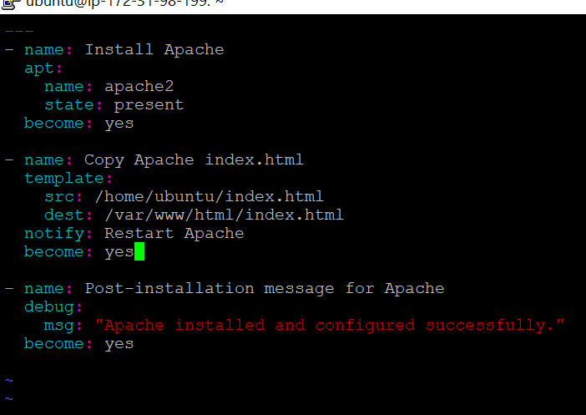

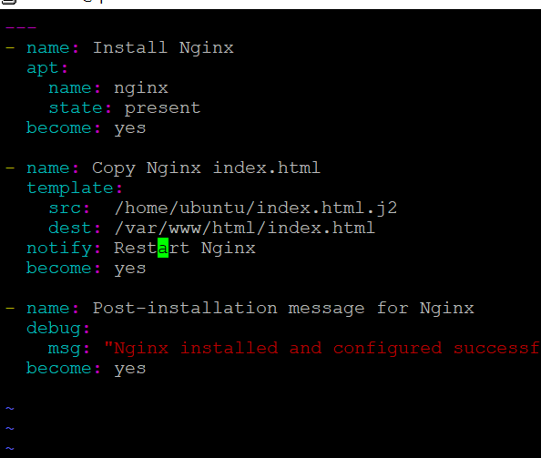

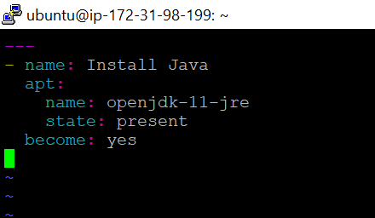

Now run the playbooks   
  
  
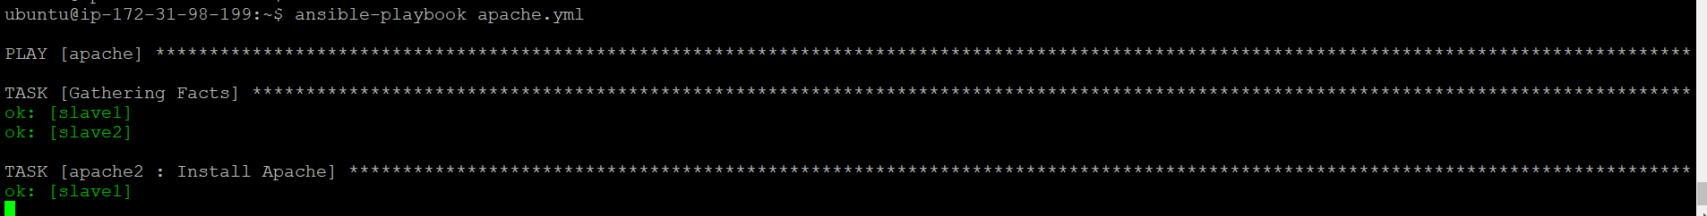

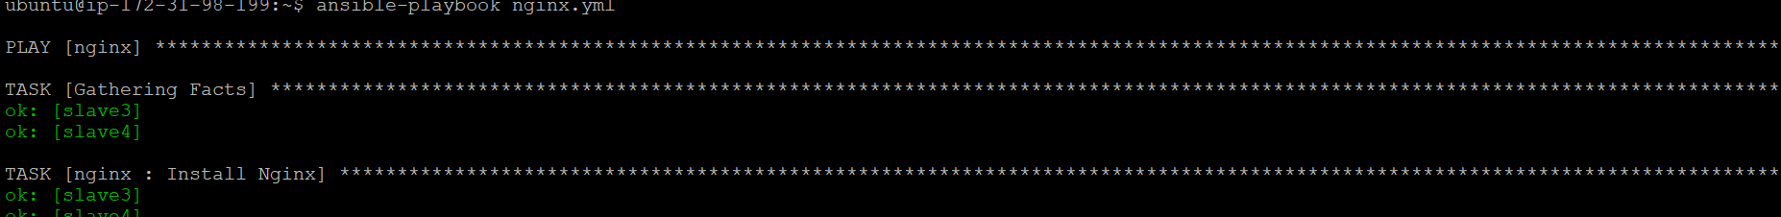

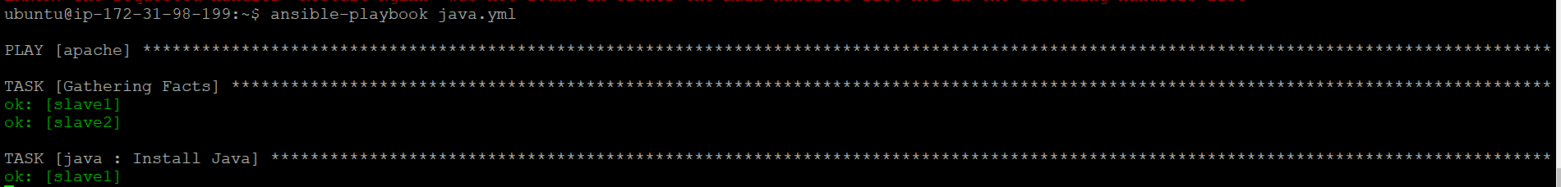  
  
All 3 Task executed Successfully