**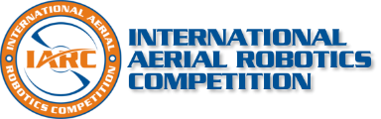 * 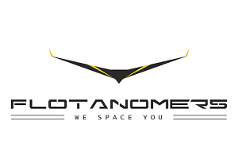***

**IARC (INTERNATIONAL AERIAL ROBOTICS COMPETITION)**

It’s an international event held in USA and CHINA.

<http://www.aerialroboticscompetition.org/> (Here is the link for more details).

**IARC has been releasing different problem statement. We are working on MISSION 8.**

<http://www.aerialroboticscompetition.org/assets/downloads/mission8rules_2.0.pdf> (Here is the link of the problem statement we are working on).

These are the some concepts we will be going through to achieve the goal.

* MARKOV Prediction model.
* Trajectory prediction on DRONES.
* Vision based perception.
* SWARM optimization.
* RRT Algorithm.
* Backtracking MSTC-AREA.
* C-CAPT Algorithm.
* CNN based architecture.
* GAZEBO-Simulator.

<https://drive.google.com/drive/folders/1QokHnoTUYu6iURO-NirWclVQVipV6jFO?ogsrc=32>

hcuahcudj

[A-Markov pdf](IARC.docx) [Markov based algoA- Markov based algo](../IARC%202020/A-%20Markov%20based%20algo.pdf)