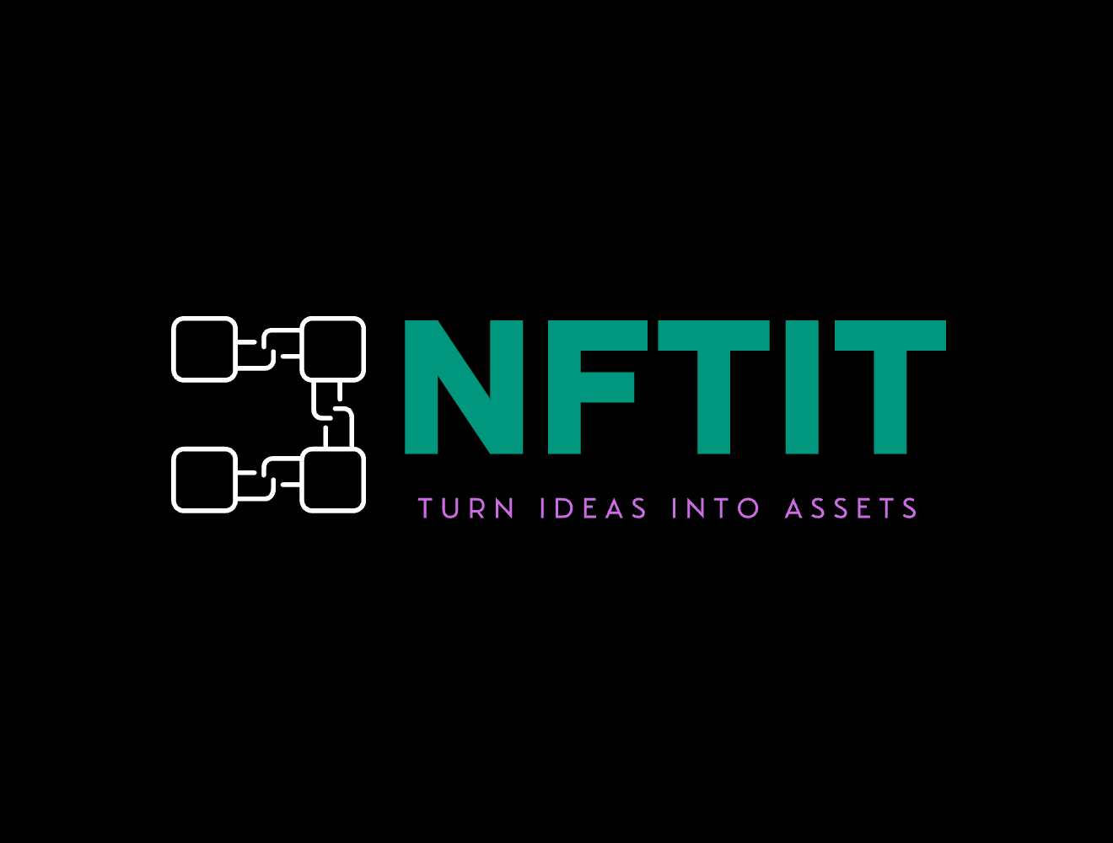

# **NFTiT- Create.Mint.Own**

*From imagination to ownership*

|  |  |
| --- | --- |
| **Name** | **Student ID** |
| Sahil Gurnani | 101542507 |
| Prayag Tandon | 101571637 |

**Table of Contents**

|  |  |  |
| --- | --- | --- |
| **Sr. No.** | **Section** | **Page No.** |
| 1 | Executive Summary | **3** |
| 2 | Introduction | **4** |
| 3 | Background on NFTs and IPFS | **6** |
| 4 | Role of AI in Content Generation | **9** |
| 5 | Motivation: Why Make NFTIt? | **10** |
| 6 | Relations between Crypto Market and NFT Market | **12** |
| 7 | Objectives | **13** |
| 8 | Features | **15** |
| 9 | Architecture / System Design | **16** |
| 10 | User Journey | **19** |
| 11 | Financials | **25** |
| 12 | Target Audience | **29** |
| 13 | Challenges & Future Scope | **30** |
| 14 | Conclusion | **31** |
| 15 | References | **32** |

**Executive Summary**

As digital ownership becomes more significant, we started paying more attention to how NFTs are changing the way people engage with digital assets. NFTs help prove authenticity and value online. But, we noticed that for many creators, especially those without technical or artistic backgrounds, the process of making NFTs can be difficult.

This led us to build NFTIt. It is a platform that makes it easier to turn creative ideas into digital assets. Users can generate images through artificial intelligence, which offers a variety of styles. There is also the option to upload original content. We aimed to make it useful for both experienced artists and newcomers who are just getting started.

One of the important features of NFTIt is its use of IPFS. This is a decentralized way to store files. It allows users to keep their work and its metadata safe. It also prevents tampering and ensures the data stays accessible. This method shows our belief in the importance of open and secure systems within Web3.

The platform also simplifies the process of minting NFTs. Users can mint directly on the Polygon blockchain in just a few steps. Smart contracts take care of metadata and ownership. Alternatively, NFTIt also supports other test networks like Ethereum Sepolia. This gives creators more flexibility.

In the end, NFTIt represents our goal to make digital asset creation more accessible. We want to remove barriers that hold people back from creating and owning their work. Whether it is an artist, a musician, or an educator, everyone should have a chance to be part of this digital space. This report explains the platform, the technology behind it, and how it can support a more open and creative digital future.

### 

**Introduction**

In today’s digital world, NFTs introduced a new way to think about owning things online. They let people prove something is original and belongs to them, whether it’s art, music, videos, virtual spaces or items used in games. Unlike regular cryptocurrencies where every coin is the same, each NFT is different. That’s what makes them special. It’s kind of like a digital certificate that shows something is one of a kind.

NFTs first started gaining attention around 2017. Over the next few years they became a big deal. By 2021, they were everywhere. Celebrities were talking about them, big sales were making headlines and the total market value reached close to 40 billion dollars. This rise showed just how powerful NFTs could be in changing how digital things are made, sold and collected.

One of the best things about NFTs is how they give creators new ways to earn. Artists, musicians, writers and game developers started turning their work into NFTs and selling them online. Platforms like OpenSea and Rarible made it easier for people to share art and connect with buyers across the world. These sites also helped creators make money not just once, but every time their work is resold. That’s a big shift from how things used to work and gave creators more control over what they made.

But even with all the growth, making and managing NFTs is still kind of hard for many. The tech part can be confusing. You have to understand blockchain, how to use storage like IPFS, and what smart contracts do. If you’re not super technical, that can feel like too much.

The tools people use to make NFTs are also all over the place. You need one app to make your content, another to store it, and something else to mint it on a chain. It’s not easy, especially if you don’t know how to code or design stuff yourself.

That’s why we built NFTIt. We saw a lot of people with great ideas getting stuck because the process felt way too complicated. NFTIt brings everything together in one place. It uses AI to help users create images in all kinds of styles, even if they’re not artists. You just type an idea, and the AI turns it into something visual. So even if you can’t draw, you can still make cool stuff.

We also made sure NFTIt saves files in a secure way using IPFS. This helps keep your work safe and stops others from changing it. It doesn’t rely on one company’s servers, which means your files are less likely to be lost or removed. That really matters if you want to prove where your content came from and keep it online long term.

Minting NFTs is simple too. With a few clicks, the platform does the rest. It works with the Polygon blockchain by default. But if you want, you can use Polygon Amoy or Ethereum Sepolia instead. That way you can pick what’s best for you based on fees or what kind of support the network has.

What makes NFTIt different is that it’s made for everyone, not just experts. Whether you’re an artist, a hobbyist, or someone just trying something new, you can use NFTIt without needing to know all the tech stuff. Everything’s in one place. You can create, save, and mint your NFTs without jumping between ten different tools.

To sum it up, while NFTs opened up some exciting new opportunities, they also made things harder for people who are just getting started. NFTIt is our way of fixing that. We tried to make the process simple and clear so that anyone can join the world of digital creation. With tools that are smart but easy to use, we want more people to turn their ideas into something real and share it with the world. Through NFTIt, we hope to make digital ownership something more people can actually be a part of.

### **Background on NFTs and IPFS**

### **NFT Overview**

NFTs have changed how we think about owning things online. In the past, digital files could be copied endlessly, which made it hard to prove what was original. NFTs solve this problem by giving each digital item a unique ID that gets stored forever on a blockchain. That ID acts like a digital proof that shows who owns the file and confirms that it’s authentic, even if others can still copy the image or file itself.

Technically, NFTs are made using smart contracts. These are small programs that follow preset rules to create, send, and manage tokens. On Ethereum, standards like ERC-721 and ERC-1155 have become common ways to make NFTs. These standards help different platforms work together and keep everything secure and decentralized. Other blockchains like Polygon are also used now because they cost less and work faster. NFTs today are found across lots of industries, from digital art and music to games and even virtual real estate. Some musicians are creating limited-edition audio NFTs, and game makers are turning in-game items into NFTs that players can trade with each other. It opens up new ways for people to own and use digital things.

### **NFT Creation Process**

Making an NFT takes a few steps that connect a piece of content to the blockchain. First, someone creates a digital file. This could be an image, video, song, animation, or anything else that can be stored digitally. After that, the minting process starts. The file gets uploaded, and a smart contract creates a token linked to it. This token includes information like the title, description, and who owns it. This data helps track the NFT's history and shows that it’s real and hasn’t been changed.

Minting also follows certain rules so that the NFT works properly on different platforms. Smart contracts can include features like royalties, so the creator earns money every time the NFT is sold again. That’s something that’s been hard to do with regular art or media before. Because the blockchain records every transfer or sale, the whole history of the NFT stays public and can’t be changed or deleted.

### **IPFS Overview**

IPFS stands for InterPlanetary File System. It’s a way to store digital content across a large group of computers instead of relying on one server. Traditional storage usually depends on a single company or data center, which can crash or be hacked. IPFS splits files into small parts and spreads them out over many nodes in the network. When someone uploads a file, IPFS creates a unique content ID, or CID, that acts like a fingerprint. Anyone with that CID can get the file from the network.

### **Advantages of IPFS in the NFT Ecosystem**

IPFS helps avoid problems that come with regular online storage. Since files are copied to many places, they’re not easy to lose if one part of the network goes offline. It’s also harder to take something down or censor it because no one person or group controls the whole system. That makes it safer and more reliable for storing media tied to NFTs.

Another big reason IPFS is useful is the cost. Blockchains are expensive if you try to store big files directly on them. With IPFS, you just save the CID on the blockchain and store the file itself on the network. That way, it's cheaper and easier to scale. Even if the original website disappears, the NFT’s media stays on the IPFS network, which means the file won’t be lost. This setup keeps the content available and trustworthy over the long term.

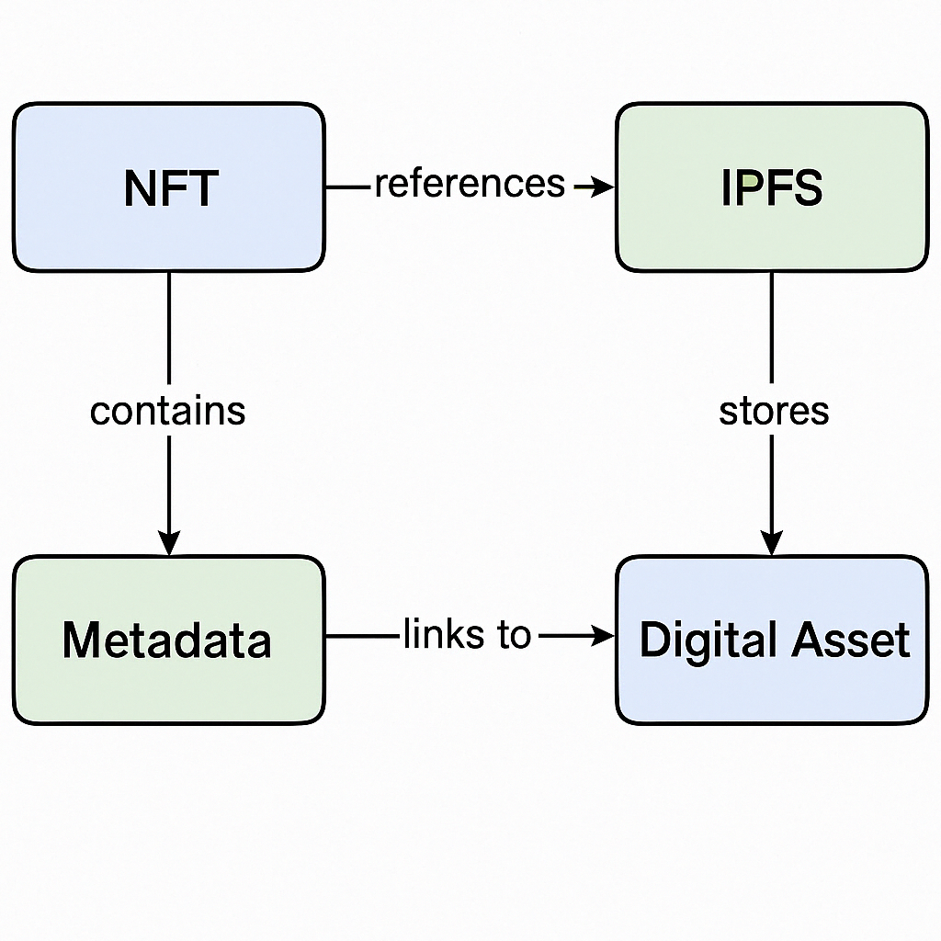

### **Integration of NFTs and IPFS**

When someone mints an NFT, the media file (like an image or audio clip) is uploaded to IPFS first. After that, IPFS creates a CID that points to the file. This CID gets stored in the NFT's metadata using a smart contract. That links the NFT directly to a decentralized storage system.

Because of this, anyone can check the authenticity of the NFT by using the CID, and they don’t have to depend on the original site or server to do it. Even if the platform that created the NFT shuts down, the media still exists on IPFS. Also, since it’s not controlled by one company, it’s harder for anyone to change or delete it. This setup gives more confidence to buyers and creators and makes the whole system more secure and reliable.

### 

### 

### **Role of AI in Content Generation**

### **AI Overview**

Artificial intelligence has grown a lot in the past few years. It’s now helping people create things in new and interesting ways. AI tools have made digital art easier to make. They can do complicated stuff that used to take a lot of time. Now you can write a few words and the AI can turn it into an image, a video or even sound. This makes it easier for more people to get creative, even if they never learned how to use design programs before.

Some of the tools like DALL E from OpenAI or Stability AI show how far this tech has come. They can turn ideas into art that looks real. Sometimes it’s hard to believe a computer made it. These tools learn by looking at tons of images and learning patterns. They get better over time and can copy different art styles or come up with something totally new. You don’t need to give it perfect instructions either. Just a short sentence can be enough

### **Deep Learning Techniques in Visual Content Generation**

The way this works is through something called deep learning. It’s a kind of machine learning where the AI looks at a lot of examples. Thousands or maybe even millions of images. It learns what makes an image look good. Things like colors, shapes, and styles. When you type a prompt, the AI remembers what it saw during training and tries to match it. So if you say "TTC subway flying near CN Tower" it figures out what that might look like and builds something close.

It also lets you make changes. You can tell it to use different colors or switch the style. That way you can get something that feels more personal. Even if the first version is not perfect, you can try again and adjust until it feels right.

### **AI Tools for NFT Creation**

When it comes to NFTs, AI helps in a big way. It lets people make original art without needing to draw or code. That’s important because not everyone has those skills. You just type out your idea and the AI takes care of the rest.

For example, if someone types “city with glowing towers,” the AI can turn that into an image. Some platforms even let you try different versions of the same idea. You can pick the one you like or mix a few together. It’s much faster than making it all by hand. And more people can join in.

### **Enhancing Creative Freedom and Accessibility**

Integrating AI into digital content creation tools brings a level of flexibility that was once the sole place of experienced artists. Creators can continuously refine their outputs by providing additional descriptors, choosing alternative styles, or modifying existing creations. This process encourages experimentation and creates an environment where a range of creative ideas can be born. Even users with no formal design background can produce original artwork by simply interacting with an interface that handles all complexities. By allowing rapid prototyping and easy generations, AI tools make it possible for more creators to contribute their work to the digital marketplace.

### **Motivation: Why Make NFTIt?**

### **Empowering Non-Creators**

One of the main reasons we started working on NFTIt was to make NFT creation open to everyone. Most platforms today are made for people who already know how to use blockchain or have experience in digital design. That leaves out a lot of people. There are musicians, teachers, gamers, and other creative minds who have ideas but no easy way to turn them into NFTs.

The tools and steps involved can be confusing. Things like smart contracts, digital wallets, or IPFS storage are hard to figure out if you haven't used them before. Even just knowing where to start can be overwhelming. We noticed this problem early on and wanted to fix it.

So NFTIt was made with a simple goal. Keep the experience smooth and remove the pressure of learning all the tech. The platform takes care of the hard parts in the background. You only focus on the creative side. You don’t need to know how the system works to use it.

This makes it easier for people who never made NFTs before. You don’t need to be a coder or artist to try. More people can now share their ideas and add something new to the digital space. That brings in more variety and helps grow the whole NFT community.

NFTIt also works for different use cases. You could be sharing digital art, putting out a music file, or creating something for a game. Whatever it is, the tools are ready. You don’t have to jump between platforms or figure out what file goes where. It’s already built to handle that for you.

### **Simplifying NFT Creation**

Before platforms like NFTIt, creating NFTs used to take a lot of time and effort. First you needed to make the content using design tools. Then you had to learn about blockchain. You had to upload files to a special storage system and fill out details in the right format. Each step had its own issues. Missing just one thing could ruin the process.

With NFTIt, you don’t have to do all that. You start with a simple prompt. Something like a short sentence describing what you want. Then the platform uses AI to turn that idea into a digital file. You don’t need to upload it or write out extra data. NFTIt prepares everything for you.

It also hides most of the complex parts. Things like storage or smart contracts are still there, but you don’t have to deal with them directly. You just go step by step, and the platform handles the setup. This makes it much easier for people who are trying NFTs for the first time.

### **Unified Platform for Content and Minting**

Another common issue is that creators usually need to work across several tools. One for making the image, another for storing it, and something else to mint the NFT. Switching between these can be slow and frustrating. And when tools don’t work together well, it makes the process harder than it needs to be.

NFTIt puts everything in one place. You can create your content, store it safely, and mint the NFT without leaving the platform. You don’t need to paste links or upload files again and again. Every part works together and guides you through the steps.

This makes things feel a lot smoother. You’re not left wondering if you did it right. The process is connected from start to finish. And for someone who’s new, that helps build trust. You can try it out without needing to take a course or read pages of guides. Just type your idea, pick the options, and you’re done.

NFTIt makes sure that anyone with an idea can join the world of NFTs. No special training. No extra tools. Just a clear path from creation to minting that feels simple and works the first time.

**Relations between Crypto Market and NFT market**

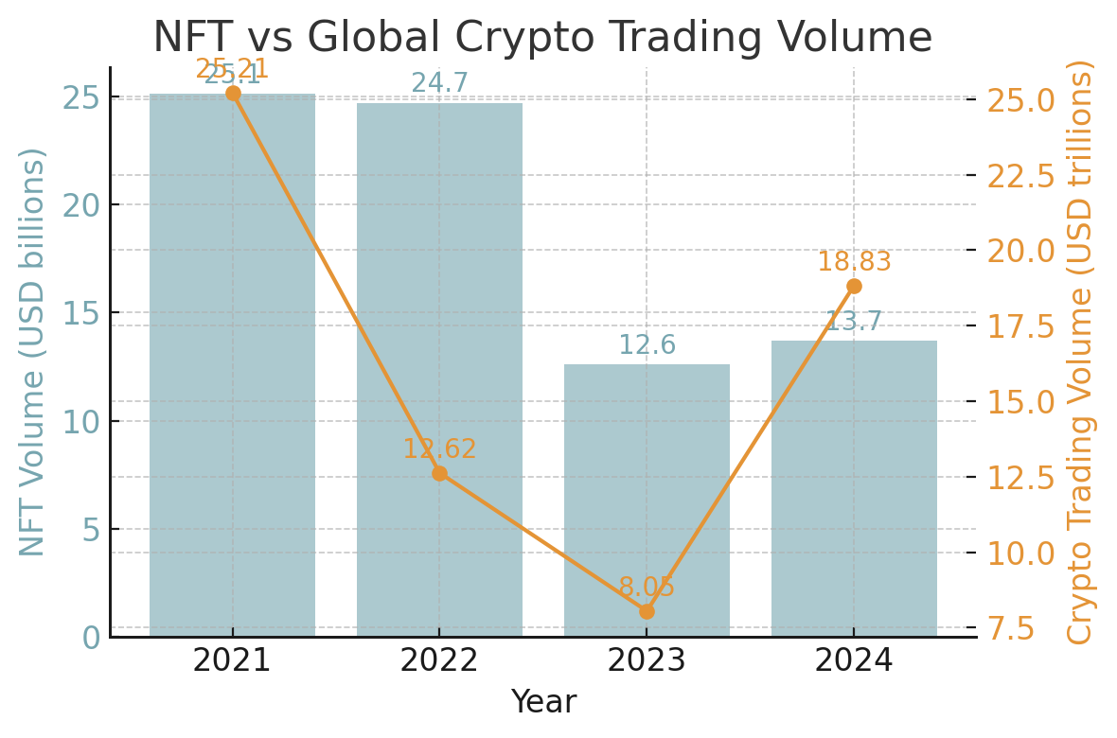

Back in 2021, both crypto and NFTs grew fast. The NFT boom happened right alongside a huge crypto bull run. The global crypto market was close to 3 trillion dollars. Bitcoin and Ethereum hit their highest prices ever. With so much excitement and trust in the market, a lot of money moved into digital assets, including NFTs.

NFT trading exploded. It jumped from less than 100 million dollars in 2020 to over 25 billion in 2021. This was driven by viral projects like Bored Ape Yacht Club and some big public auctions. A lot of new people joined in. There were almost twice as many buyers as sellers. That showed just how big the hype was at the time.

In 2022, things changed quickly. The crypto market crashed after problems with major companies like Terra and FTX. Prices dropped and people started selling off their assets. Trading volume in crypto went down by almost half. But NFTs stayed strong for a while. They still reached around 24.7 billion dollars in volume, mostly because the momentum from 2021 carried over into early 2022. Platforms like OpenSea and LooksRare were still very active during that time.

As the year went on and crypto kept falling, interest in NFTs also started to fade. The buyer-to-seller gap began to shrink. It was no longer just buyers driving the market. This shift pointed to a market that was starting to settle down and become less hype-driven.

By 2023, the effects of the crypto crash were clear in the NFT space too. Crypto activity stayed low. NFT sales were cut in half and dropped to around 12.6 billion dollars. More people were trying to sell NFTs than buy them. This was the first time the buyer-to-seller ratio dropped below one. That meant there were now more sellers than buyers.

A lot of NFT projects lost value. People who used to flip NFTs for quick profit stopped doing it as much. The hype faded. While crypto had a stable base of long-term users, NFTs saw a bigger drop as casual collectors and speculators left the space.

In 2024, the crypto market bounced back. Trading volumes doubled and the total market value went up again. NFTs did recover a bit but not in a big way. Sales went up to about 13.7 billion dollars, just a small improvement from the year before. The buyer-to-seller ratio also got better and was around 1.2 to 1.

New formats like Bitcoin Ordinals and gaming NFTs helped bring some fresh interest. But overall, NFTs didn’t return to their peak. The numbers showed that while NFTs still follow crypto trends, they also move on their own path. Higher crypto prices alone aren’t enough to bring back the same kind of NFT boom we saw in 2021.

**Objectives of our Project:**

### **AI-Based Image Generation**

### One of the main goals of the platform is to help people make cool artwork just by using simple text. You type in a description and the AI does the rest. The system uses tools like Stability AI and DALL E to turn your ideas into images. You don’t need to know how to draw or use design programs. There are lots of styles and themes to choose from, and the images are all unique. You can even change parts of the output to match what you’re looking for. It’s a creative way to bring ideas to life without needing any design background. It also makes the whole process way easier compared to traditional design tools.

### **Upload User-Generated Media**

### The platform also lets you upload your own media. This can be images, videos, or even music. It supports files like JPG, PNG, MP4, and MP3. Once you upload a file, it gets saved to IPFS, which is a decentralized storage network. Every file gets a special code called a CID. This CID is linked to the NFT so that the file can’t be changed or lost later. Since it’s stored across a network and not in one place, the file stays online and is safe from being taken down or edited without permission. You always have access to your original file, no matter what.

### **NFT Minting with Custom Metadata**

### You can also mint your NFT with details that you write yourself. That means you get to add a title, description, or tags to your digital asset. These little details help tell the story behind what you made and help people find it later. The CID from your upload is added to the NFT’s info, which links the media to the token. This makes sure the file is stored safely, and it also adds more meaning and trust to what you’re sharing.

### **Lowering Barriers for Creators**

### Another big goal is to make NFT creation easy, even for people who don’t know much about tech. The platform is made with a clean and simple design so anyone can figure it out. It’s meant to feel as easy as posting something on social media. By removing complicated steps, more people can start creating and sharing NFTs. It doesn’t matter if you’re a teacher, an artist, or just someone trying something new. You don’t need to learn coding or use hard software. You just follow the steps and get your NFT out there.

### **Gateway to IPFS Interaction**

### The last thing we focused on is making IPFS easier to use. Normally it’s pretty technical, but we built a simple tool that lets you upload and manage your files without doing anything complicated.You can upload a file, get the CID, and use it however you want. The file stays stored across the IPFS network and is always reachable. This gives you full control and makes sure your digital files are safe, even if a website or service goes offline. It’s a big part of keeping your content secure and long lasting.

### 

### **Features of the Project**

### **AI Image Generator**

### This tool makes it easy for anyone to create digital art using just a few words. You write a short text, and the AI takes that idea and turns it into an image. The system uses strong models that can handle lots of different styles. Whether you want something abstract or realistic, it can create a result that matches what you imagined. You can try out different styles and play around with how the final image looks. The tool also lets you change things like colors, textures, and layout to better match what you had in mind. You don’t need to know how to design or draw. The AI handles the hard part, and you just focus on being creative. It’s a mix of technology and imagination that makes the whole process feel smooth and fun.

### **IPFS Integration**

### The platform also works with IPFS, which is a way to store files in a decentralized system. This means the files aren’t saved on one server but are shared across a network. You can upload images, videos, and audio files in formats like JPG, PNG, MP4, or MP3. Once uploaded, the system breaks the file into pieces and spreads it out across the IPFS network. Each upload gets a unique code called a CID. This code links the file directly to your NFT. It helps make sure your content stays safe and doesn’t get lost or changed later. Since it’s stored on IPFS, the file is always available, even if one part of the network goes offline. This keeps your digital work secure and easy to access whenever you need it.

### **NFT Minting**

### Minting an NFT is super simple with this platform. You don’t have to deal with any of the usual blockchain stuff. You just click a button and the system takes care of the rest. It uses the Polygon testnet to handle everything in the background. When you mint, the platform starts the smart contract for you, collects the fee, and adds your file’s CID along with other details like the title and description. All of this info gets stored on the blockchain. The process is fast and doesn’t ask for any special skills, which means anyone can do it

### **NFT Gallery**

### The platform also gives you a place to display everything you’ve created. There’s a built-in gallery that shows all your NFTs in one spot. Each one comes with its title, description, and a direct link to the file saved on IPFS. This makes it easy to share your work with others. It also helps prove that your NFT is real. Since each NFT shows its metadata and has a CID link, people can check the details themselves. That adds trust and makes your creations feel more official.

### 

### **Architecture / System Design**

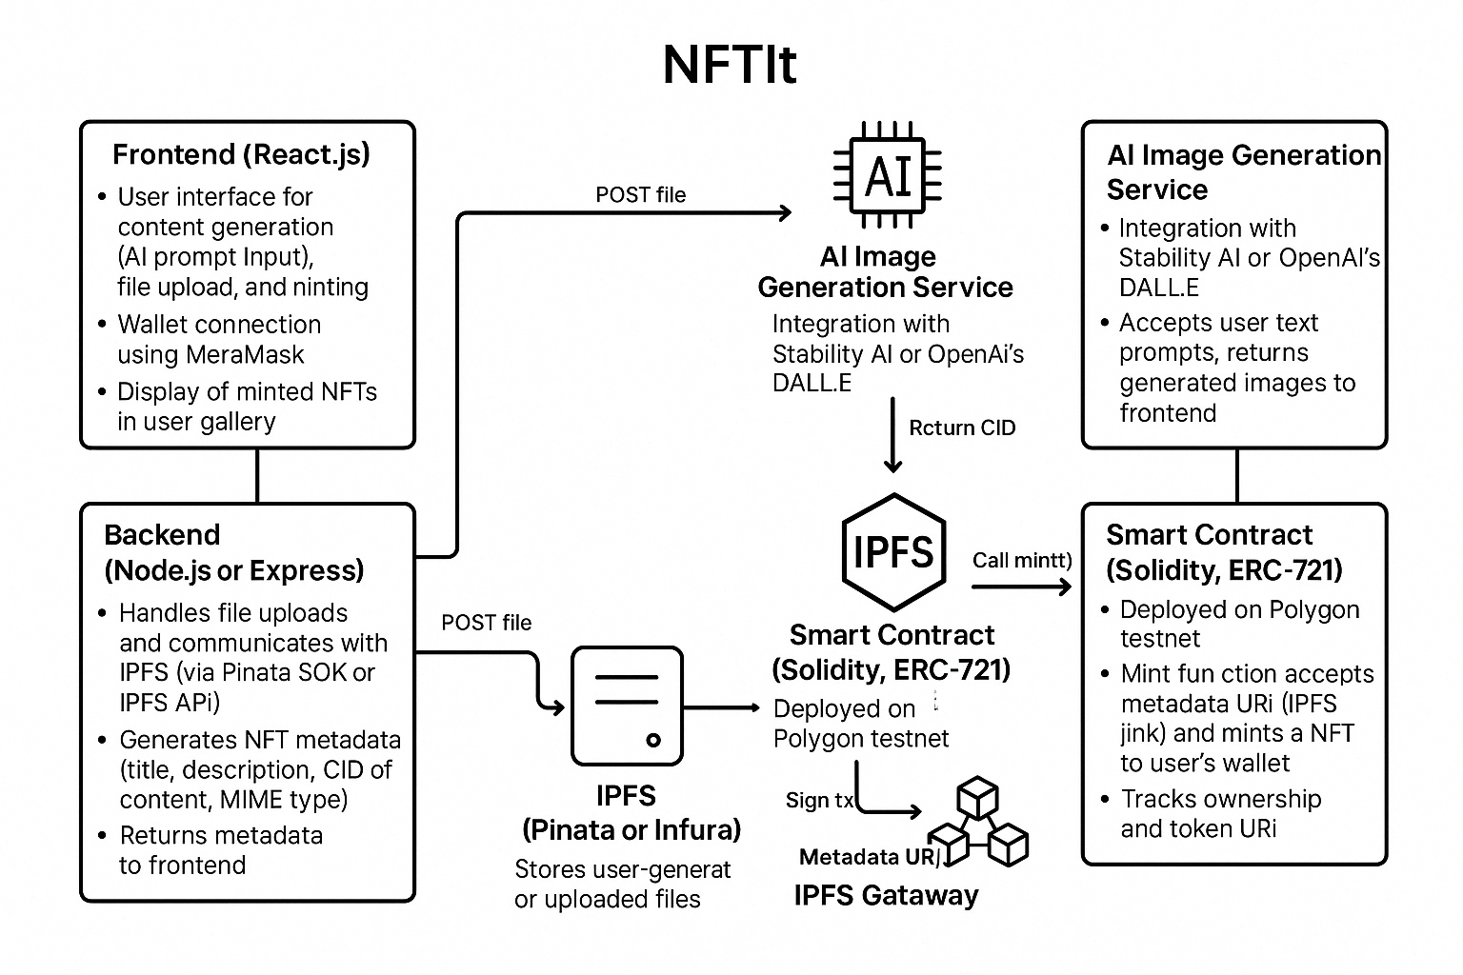

The overall system design of NFTIt consists of several interconnected components that work in unison to deliver a seamless user experience from content creation to NFT minting and management.

**Frontend** The user interface is developed using React.js, providing an intuitive and responsive experience for users. The frontend is responsible for:

* Rendering the platform's visual elements, including forms for text input, media uploads, and galleries displaying minted NFTs.
* Allowing users to interact with the AI image generator, trigger media uploads, and initiate NFT minting with a few clicks.
* Providing real-time feedback, status updates, and error messages to guide users smoothly through the creative and minting processes.

**Backend** The backend serves as the central hub that orchestrates interactions among various services. Key responsibilities include:

* Managing API requests from the frontend and routing them to the appropriate internal services.
* Integrating with AI services to process text prompts and generate high-quality digital artwork.
* Handling communication with IPFS for secure and decentralized media storage, including file segmentation and the retrieval of unique content identifiers (CIDs).
* Interfacing with the blockchain network to execute NFT minting transactions and store metadata, ensuring that all operations are logged and secure.

**IPFS Integration** IPFS is utilized to store user-generated digital content in a decentralized manner. This component is vital for:

* Splitting media files into smaller segments and distributing them across the IPFS network, ensuring resilience and availability.
* Generating a unique CID for each uploaded file, which serves as a permanent reference to that file.
* Linking these CIDs to the NFT metadata, allowing for secure and verifiable retrieval of content without reliance on centralized servers.

**Blockchain Component** The Polygon blockchain is employed to manage the minting and ownership of NFTs based on the ERC-721 standard. Its role includes:

* Processing minting transactions initiated by the backend, ensuring that NFTs are created in compliance with the ERC-721 specifications.
* Storing metadata which includes the IPFS CID and other NFT details on the blockchain to provide an immutable, transparent record of ownership.
* Handling interactions related to token transfers and integration with external marketplaces, thereby ensuring broader adoption.

### **Smart Contract Design**

The smart contract is the core mechanism that binds the NFT creation process to the blockchain. This section outlines the specifics of the contract design within the NFTIt ecosystem.

**Contract Name: NFTItToken**

* The smart contract is designated as NFTItToken, serving as the digital representation of minted assets within the platform.

**Standard Compliance: ERC-721**

* The contract adheres to the ERC-721 standard, which is a widely adopted framework for non-fungible tokens.
* This compliance ensures that NFTs minted via NFTIt are compatible with major marketplaces and can be easily integrated into other applications, leveraging a consistent set of metadata and transfer protocols.

**Custom Minting Logic**

* In addition to standard functionality, the smart contract incorporates custom logic designed specifically for NFTIt.
* A key aspect of this custom logic is the minting fee, where each minting transaction requires the collection of 1 POL. This fee mechanism is enforced within the contract, ensuring that the operational costs associated with minting are automatically managed.

### **User Journey**

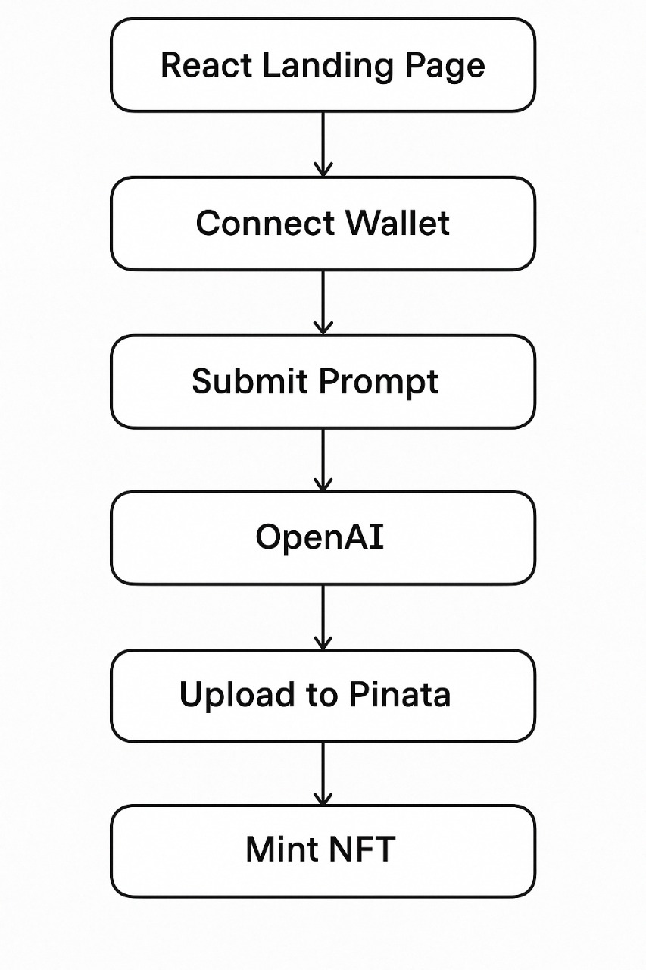

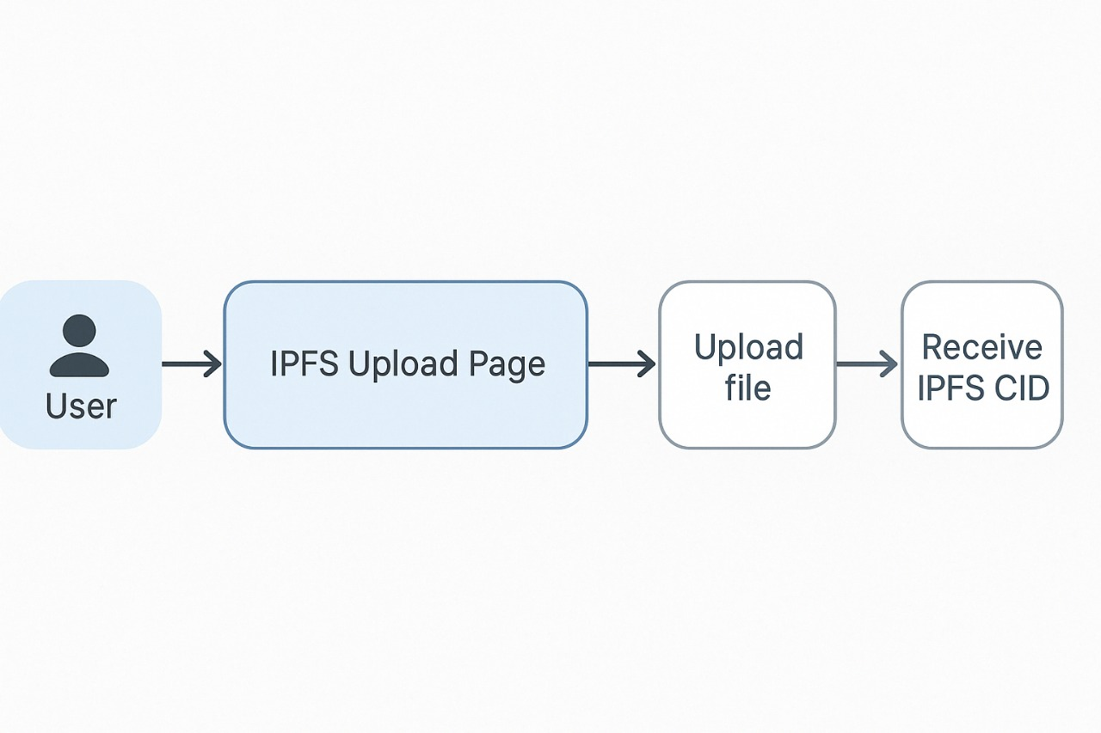

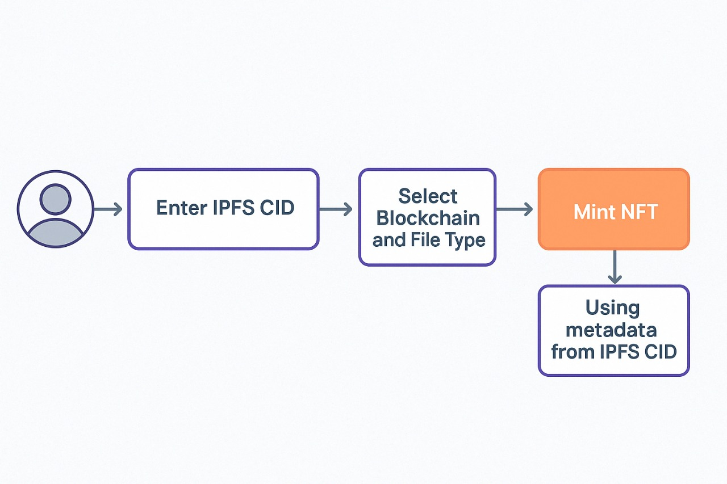

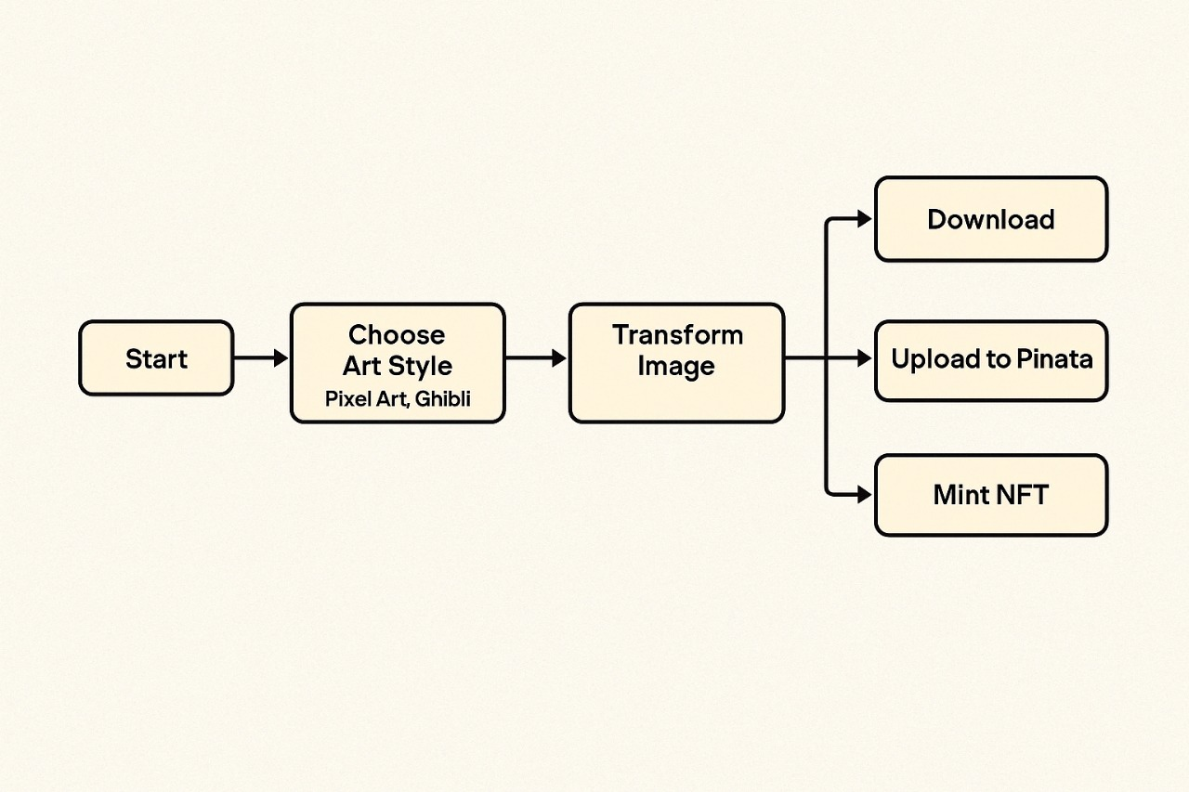

### 

### 

When users want to create something on the platform, they can pick how they want to start. If they choose the **generate** option, they just need to type a short sentence like *a sunset over a mountain*. The AI reads that description and turns it into an image. It gives a few different styles so people can see multiple versions of their idea. The tool makes it easy to explore ideas even if the user doesn’t have any design experience. They can test out different looks and get creative without worrying about using complicated software.

If they prefer to work with something they already made, they can use the **upload** option. The upload tool is simple to use and accepts formats like JPG, PNG, MP4 and MP3. Users just select the file from their device, and the platform handles the rest. It’s made so that even someone with no technical skills can upload their content without any stress.

### **Processing and IPFS Storage**

After the image or file is made or uploaded, the system sends it to a special kind of storage called IPFS. This is a decentralized way of storing files so they aren’t tied to one single server. Instead, the file gets broken into pieces and shared across many points on the network.

Each file gets a code called a CID. This code makes it easy to find the file again later. The CID never changes, so even if the original site goes down, the file stays online and safe. It’s a way to make sure that people always have access to what they created.

### **Metadata Creation**

Once the file has its CID, the next step is to add some details. This includes stuff like the title, a short description and maybe a few tags. These things help tell the story behind the NFT and make it easier for others to understand what it is. All of this data is combined with the CID to form something called metadata. This helps prove who made the NFT and gives buyers more confidence in what they are seeing. It also makes it easier to search and share later on.

### **Minting the NFT**

After the file and metadata are ready, the user can mint the NFT. This part is very easy. Just one click and the platform handles everything in the background. It works with the Polygon testnet to create the NFT. The platform sets up the smart contract, collects the minting fee and saves the data to the blockchain. The title, description and CID are all included in the final NFT. It’s done in a way that feels quick and simple, even if someone has never used blockchain before.

### **Viewing and Sharing**

Once the NFT is minted, it shows up right away in the user’s wallet and inside their gallery on the platform. This gallery keeps all the NFTs in one place. Each NFT shows its name, a short description and a link to the file on IPFS. Users can look through their collection and check all the details. The layout is clean and easy to use. It also works like a personal gallery that they can share with others. They can send the link to potential buyers or post it on social media or even on other marketplaces.

### **User Engagement**

The final part of the journey is about staying active and connected. Users are encouraged to share what they’ve made, list NFTs for sale and join the wider NFTIt community. The platform has tools to help with updates, social sharing and organizing collections. It’s built for people who want to keep exploring, grow their digital presence or just enjoy making stuff. Whether they want to build a brand or simply try something new, the platform makes it easy to stick around and keep creating.

### **Artists and Non-Designers Minting AI-Generated Work**

NFTIt is great for people who want to create art but don’t know how to design. They can write simple ideas like *a futuristic city at night*, and the AI will turn that into an image. If they want, they can change a few things to get the perfect look. When they’re happy with it, they can mint it into an NFT and show it to the world. This makes it possible for anyone to become a digital artist.

### **Musicians Uploading Audio NFTs**

NFTIt also helps musicians who want to release audio as NFTs. It works with full songs, loops, or even voice clips. The NFT shows that the music belongs to the artist and can’t be copied without proof. Artists can sell rare or special editions of their tracks and still keep ownership. Fans also get something they know is real and limited.

### **Creators Selling IPFS-Hosted Video Content**

People who make videos can use NFTIt to mint their content as NFTs. This works well for vloggers, short film creators or online teachers. The videos are stored on IPFS which keeps them safe from being changed or removed. They can sell unique versions or limited releases. The system makes sure the video stays available and linked to its creator.

### **Gamers or Streamers Minting Highlights**

NFTIt is also perfect for gamers and live streamers. They can take clips from gameplay or stream highlights and turn them into NFTs. These could be fun moments, big wins or just cool memories. The NFTs can be sold or given away to fans. It’s a new way to share and even make money from the content they create while gaming.

### 

### **Financials :**

### **4-Year ROI Report for NFTIt**

### Revenue Model Summary

|  |  |  |
| --- | --- | --- |
| **Monetization Channel** | **Price (POL)** | **USD Equivalent (1 POL = $0.20)** |
| NFT Minting | 1 POL | $0.20 |
| AI Image Generation | 0.4 POL | $0.08 |
| AI Image Editing | 0.7 POL | $0.14 |
| Premium Subscription | – | $100/year (flat fee) |

### 

### **Platform Costs per Usage**

|  |  |
| --- | --- |
| **Item** | **Cost (USD)** |
| AI Generation (per use) | $0.02 |
| AI Editing (per use) | $0.04 |
| Minting | Negligible |

### 

### **Fixed and Recurring Costs**

|  |  |  |  |
| --- | --- | --- | --- |
| **Type** | **Year** | **Amount** | **Notes** |
| Development (one-time) | Y1 | $10,000 | Initial build (React, Node, Solidity) |
| Maintenance | Y2 | $10,000 | Includes hosting, updates, bug fixes |
| Maintenance | Y3 | $12,000 | 20% YoY increase |
| Maintenance | Y4 | $14,400 | 20% YoY increase |

### 

### 

### 

### **User & Usage Growth Forecast**

|  |  |  |  |  |
| --- | --- | --- | --- | --- |
| **Year** | **Active Users** | **NFTs Mint/User** | **Ai Gen/User** | **Ai Edits/User** |
| Y1 | 5,000 | 4 | 7 | 3 |
| Y2 | 20,000 | 5 | 10 | 4 |
| Y3 | 40,000 | 6 | 12 | 5 |
| Y4 | 60,000 | 7 | 15 | 6 |

### 

### **Premium Subscriber Forecast**

### **Assuming 2.5% conversion to paid subscribers(Paid Subscriber would get their own contract address with your own Title and NFT token name) each year.**

|  |  |  |  |
| --- | --- | --- | --- |
| **Year** | **Subscribers (2.5%)** | **Annual Subscription Fee** | **Revenue from Premium** |
| Y1 | 125 | $100 | $12,500 |
| Y2 | 500 | $100 | $50,000 |
| Y3 | 1,000 | $100 | $100,000 |
| Y4 | 1,500 | $100 | $150,000 |

### 

### **Detailed Financial Breakdown (All Figures in USD)**

### **Year 1 Revenue:**

### **NFT Minting:** 5,000 × 4 × $0.20 = $4,000

### **AI Generation:** 5,000 × 7 × $0.08 = $2,800

### **Image Edits:** 5,000 × 3 × $0.14 = $2,100

### **Subscriptions:** 125 × $100 = $12,500

### **Total Revenue = $21,400**

### 

### **Costs:**

### **Development:** $10,000

### **AI Generation:** 35,000 × $0.02 = $700

### **AI Edits:** 15,000 × $0.04 = $600

### **Total Cost =** $11,300

### **Net Profit (Y1) = $10,100**

### 

### **Year 2 Revenue:**

### **Minting:** 20,000 × 5 × $0.20 = $20,000

### **AI Gen:** 20,000 × 10 × $0.08 = $16,000

### **Edits:** 20,000 × 4 × $0.14 = $11,200

### **Subscriptions:** 500 × $100 = $50,000

### **Total Revenue =** $97,200

### **Costs:**

### **Maintenance:** $10,000

### **AI Gen:** 200,000 × $0.02 = $4,000

### **AI Edits:** 80,000 × $0.04 = $3,200

### **Total Cost =** $17,200

### **Net Profit (Y2) = $80,000**

### 

### **Year 3 Revenue:**

### **Minting:** 40,000 × 6 × $0.20 = $48,000

### **AI Gen:** 40,000 × 12 × $0.08 = $38,400

### **Edits:** 40,000 × 5 × $0.14 = $28,000

### **Subscriptions:** 1,000 × $100 = $100,000

### **Total Revenue =** $214,400

### **Costs:**

### **Maintenance:** $12,000

### **AI Gen:** 480,000 × $0.02 = $9,600

### **AI Edits:** 200,000 × $0.04 = $8,000

### **Total Cost =** $29,600

### **Net Profit (Y3) = $184,800**

### 

### **Year 4**

### **Revenue:**

### **Minting:** 60,000 × 7 × $0.20 = $84,000

### **AI Gen:** 60,000 × 15 × $0.08 = $72,000

### **Edits:** 60,000 × 6 × $0.14 = $50,400

### **Subscriptions:** 1,500 × $100 = $150,000

### **Total Revenue =** $356,400

### **Costs:**

### **Maintenance:** $14,400

### **AI Gen:** 900,000 × $0.02 = $18,000

### **AI Edits:** 360,000 × $0.04 = $14,400

### **Total Cost =** $46,800

### **Net Profit (Y4) = $309,600**

### 

### **Final 4-Year Financial Summary**

|  |  |  |  |
| --- | --- | --- | --- |
| **Year** | **Total Revenue** | **Total Cost** | **Net Profit** |
| Y1 | $21,400 | $11,300 | $10,100 |
| Y2 | $97,200 | $17,200 | $80,000 |
| Y3 | $214,400 | $29,600 | $184,800 |
| Y4 | $356,400 | $46,800 | $309,600 |
| **Total** | **$689,400** | **$104,900** | **$584,500** |

### 

### **ROI Analysis**

|  |  |
| --- | --- |
| **Metric** | **Value** |
| Total Revenue (4 yrs) | $689,400 |
| Total Cost (4 yrs) | $104,900 |
| Net ROI | $584,500 |
| ROI % | +557% |
| Break-even Point | Early Year 2 |

### 

### **Strategic Notes**

### Even at only 2.5% subscription adoption, the model is highly profitable.

### The minting and AI usage model alone covers development costs by Year 2.

### Upside potential remains huge if:

### User base exceeds 60K in Year 4

### We offer additional premium tiers

### Enable multi-chain minting, marketplace, or NFT royalties

### 

### 

### 

### 

### 

### 

**Target Audience**

NFTIt is made for a wide mix of users. Whether someone is just getting started or already working in tech or creative fields, the platform has something useful for them.

1. **Creators with No Design Skills:** A lot of folks have great ideas but don’t know how to use design tools or software. That shouldn’t stop them from making something cool. NFTIt lets them type a few words and turn those words into unique, good-looking images. The AI does the hard part. They don’t need to learn anything complicated or pay for expensive tools. This makes it easier for people to express their ideas and even earn from their creativity.
2. **NFT Newcomers:**For those who want to get into NFTs but feel overwhelmed by all the tech stuff, NFTIt keeps it simple. They don’t need to know how smart contracts work or how to set up a wallet. The platform handles most of the hard stuff behind the scenes. That way, new users can focus on being creative instead of trying to figure out how blockchain works. It helps build confidence and makes the space feel more welcoming.
3. **Web3 Developers:**Developers who are already building in Web3 can also use NFTIt to test and create faster. The backend is already set up, so they don’t need to build everything from scratch. They can experiment with different NFT ideas and test how it works without needing to worry about setting up blockchain connections or storage. NFTIt makes it easier to prototype and get things moving quickly.
4. **Indie Artists / Musicians:**Artists and musicians can use NFTIt to share their work with a bigger audience. They can either upload something they’ve already made or generate something new using AI. After that, they can mint their creations and show them off or sell them. The process is quick and doesn’t ask for any tech knowledge. It’s a way for creative people to earn from what they love doing, without needing to learn coding or complex platforms.
5. **Educators Experimenting with Verifiable Media:**Teachers and trainers can also use NFTIt in smart ways. They can create digital certificates, lessons or other learning materials and mint them as NFTs. These can be used to prove someone finished a course or learned a skill. It helps cut down on fake certificates and makes it easier to share real achievements online. It’s a modern way to handle education and credentials using digital tools.

By helping all these different groups, NFTIt opens the door for more people to be part of the NFT world. It makes the process less scary and more exciting. Whether someone is a total beginner or already knows the space, NFTIt helps them create, share and explore in their own way.

**Challenges & Future Scope**

Even though NFTIt makes it easier to create NFTs, there are still some things to improve and new ideas to explore in the future.

* **IPFS Gateway Limitations:**IPFS is great for keeping files safe and decentralized, but sometimes it takes a while to load files. If certain parts of the network go down or aren’t working well, it can slow things down. One way to fix this could be by using more than one IPFS gateway at a time. That way if one has issues, others can help out. NFTIt could also look at other storage options like Arweave. That might make files load faster and stay available for longer without problems.
* **Dynamic NFTs:**Most NFTs stay the same once they are made. But there’s a new idea called dynamic NFTs. These can update based on real-life stuff. For example, a sports NFT could show a player’s current score. Or a game item might change as you play. NFTIt could explore adding this feature in the future. It would make NFTs more fun and interactive. People would come back to check on them because they change and grow.
* **Royalties, Transfers, and Marketplace Integration:**It’s important that creators keep earning even when their NFTs are sold again. NFTIt could add automatic royalty payments so that creators get a small amount every time their NFT is resold. This helps artists stay motivated and keep making new work. It would also be helpful if users could list their NFTs on places like OpenSea or Rarible right from inside NFTIt. That would save time and make the whole process smoother.
* **Multichain Minting:**Right now, NFTIt works with the Polygon Amoy network. It’s fast and cheap, but not everyone wants to use it. Some people prefer Ethereum or Solana or even Binance Smart Chain. Each one has its own pros and cons. In the future, NFTIt could let users choose where they want to mint their NFTs. That gives more freedom and helps reach more people in different communities.

The future of NFTIt depends on how well it can keep growing and solving problems. If it keeps listening to users and adding useful features, it can become one of the top tools for creators and collectors. The goal is to stay flexible and keep up with how the digital world is changing.

### 

### 

**Conclusion**

NFTIt has grown into a complete platform that makes it much easier to create, mint and manage NFTs. It brings together smart tools like AI content generation, secure storage through IPFS and simple blockchain minting. By doing this, it takes away many of the hard parts that usually come with making NFTs.

The platform helps all kinds of creators. Whether someone is an artist, musician, teacher or gamer, they can use NFTIt to share their work with people all over the world. You don’t need to know how to code or use fancy design software. The AI helps turn simple ideas into great-looking digital art, and the process feels quick and clear.

Storing files through IPFS makes sure they stay safe and can be accessed anytime. This helps keep your NFTs real and trustworthy. And minting them on the blockchain, like on Polygon, means they get recorded in a way that can’t be changed later. Everything is set up to work together so users don’t have to figure it out themselves.

As the platform grows, there’s a lot to look forward to. Features like dynamic NFTs that can change with real-world events, better royalty systems so artists earn from resales, and support for more blockchains will make the platform even more useful. These updates will help NFTIt reach more people and give creators more tools to succeed.

In the end, NFTIt stands for what NFTs are really about. It gives more people a chance to create and share digital work without getting stuck on the tech side. By keeping things easy, secure and open, it supports creators from all backgrounds and helps push the future of digital ownership in a more creative and inclusive direction.

**Reference :**

*Contracts - OpenZeppelin Docs*. (2017). Openzeppelin.com. https://docs.openzeppelin.com/contracts

‌*IPFS Documentation | IPFS Docs*. (n.d.). Docs.ipfs.tech. https://docs.ipfs.tech/

‌Entriken, W., Shirley, D., Evans, J., & Sachs, N. (2018, January 24). *EIP 721: ERC-721 Non-Fungible Token Standard*. Ethereum Improvement Proposals. https://eips.ethereum.org/EIPS/eip-721

‌Labs, P. (2024). *Polygon Knowledge Layer*. Polygon.technology. https://docs.polygon.technology/

‌*NEOS - Ausgabenverteilung 2022| Statista*. (2022). Statista. https://www.statista.com/statistics/1255816/nft-market-size/

‌OpenSea. (2024). *OpenSea: Buy Crypto Collectibles, CryptoKitties, Decentraland, and more on Ethereum*. OpenSea. https://opensea.io/

‌*Quickstart - Pinata Docs*. (2025). Pinata.cloud; Pinata Docs. https://docs.pinata.cloud/

‌