WASTEWISE
AI-Powered Smart Waste Scanner
A practical implementation and comparative study of image-classification models
🌿
TECHNICAL PROJECT REPORT
Prepared by: Prayas Mangrati
B.Tech – Computer Science and Engineering
Sikkim Manipal Institute of Technology
November 2026
An evidence-based account of the prototype, model experiments, evaluation and limitations.

Abstract

WasteWise is a prototype AI-assisted waste-identification application designed to classify an uploaded or camera-captured image into one of nine waste categories and return basic disposal guidance. The project combines a YOLOv8n image-classification model, a Python/FastAPI backend, a React frontend and SQLite-based scan history. Work began with a nine-class waste-segregation dataset and a baseline model (V1). A second image collection was mapped into the same class scheme, augmented and used for fine-tuning to produce V3. Both models were evaluated by direct image-by-image inference on the same 957-image original test directory. V1 achieved 91.43% top-1 accuracy (875/957), while V3 achieved 89.86% (860/957). V3 improved recall for several classes but regressed on Plastic, Paper and Textile Trash. A focused error analysis found 21 Plastic images predicted as Metal by V3; V1 correctly classified 16 of those same images. The findings show that a larger and more balanced training set does not automatically improve generalisation. V1 was therefore retained as the application model.
Keywords: waste classification; computer vision; YOLOv8n-cls; transfer learning; data augmentation; FastAPI; React; SQLite.

Executive Summary

The project delivered a web-based waste-scanning prototype and a model-comparison experiment. V1 was the stronger checkpoint on the shared original test set. V3's 93.4% validation accuracy did not translate into better performance on the full original test set. V1 remains selected; V3 is retained as an experimental checkpoint.

1. Introduction
Waste segregation depends on identifying material types before disposal. WasteWise explores whether a compact image-classification model can provide a useful first indication from a photograph, together with simple disposal information. It is an educational decision-support prototype, not a certified waste-management system. The model recognises image patterns; it does not chemically identify materials, determine local recycling acceptance or guarantee recyclability.

1.1 Aim and objectives
- Build an image classifier for nine waste categories.
- Train and evaluate a YOLOv8n baseline.
- Investigate a second dataset, class mapping and augmentation.
- Compare V1 and V3 on the same original test images.
- Integrate the selected model with a web interface and disposal mapping.
- Document errors, limitations and future work.

2. System Overview and Architecture
React sends an image file to FastAPI. The backend calls YOLO through predictor.py, maps the predicted class through waste_info.py, and returns JSON. Accepted predictions are stored in SQLite and exposed through a history endpoint.
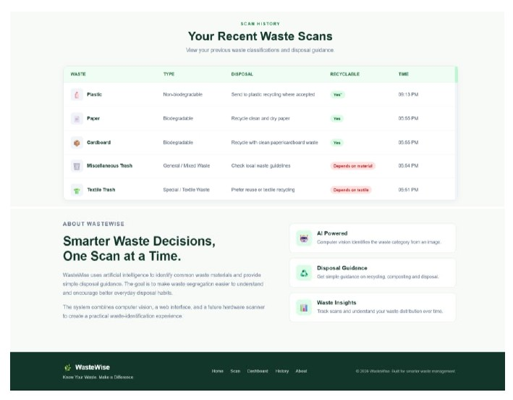
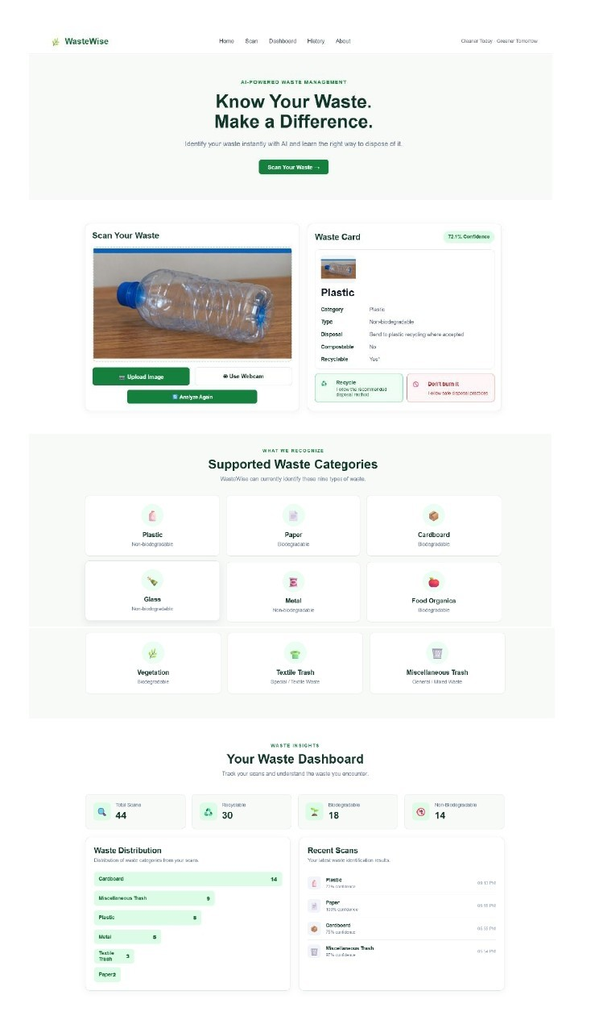

Figure 1. WasteWise interface concept

Layer | Technology / module | Responsibility
Frontend | React 19, Vite, JavaScript, CSS | Image upload/capture and result presentation.
API | FastAPI, Uvicorn, CORS | /predict and /history endpoints.
Inference | Ultralytics YOLOv8n-cls, PyTorch | Top-1 class and confidence.
Mapping | waste_info.py | Waste type and disposal guidance.
Storage | SQLite | Accepted scan metadata and timestamps.

2.1 Prediction workflow
- User selects an image or captures a webcam frame in React Scanner.
- Frontend sends the image as multipart form data to POST /predict.
- FastAPI temporarily writes the upload and calls predict_waste().
- The model returns a class and confidence; waste_info.py supplies guidance.
- Predictions below the 0.70 threshold are marked uncertain and are not stored as successful scans.
- Accepted predictions are inserted into SQLite and returned to the frontend.
- GET /history returns stored records.

3. Dataset 1 and Baseline Model (V1)
The original Kaggle dataset contains nine classes, 3,808 training images and 957 test images. The original test directory was reserved for evaluation. An 80/20 split of the original training set was used for training and validation. Two corrupt Vegetation images were skipped during one recorded dataset recreation, leaving 3,040 usable training images in that run.
Class | Original train | Original test
Cardboard | 376 | 95
Food Organics | 328 | 83
Glass | 336 | 85
Metal | 632 | 158
Misc. Trash | 396 | 99
Paper | 400 | 100
Plastic | 736 | 185
Textile Trash | 254 | 64
Vegetation | 350 | 88
Total | 3808 | 957

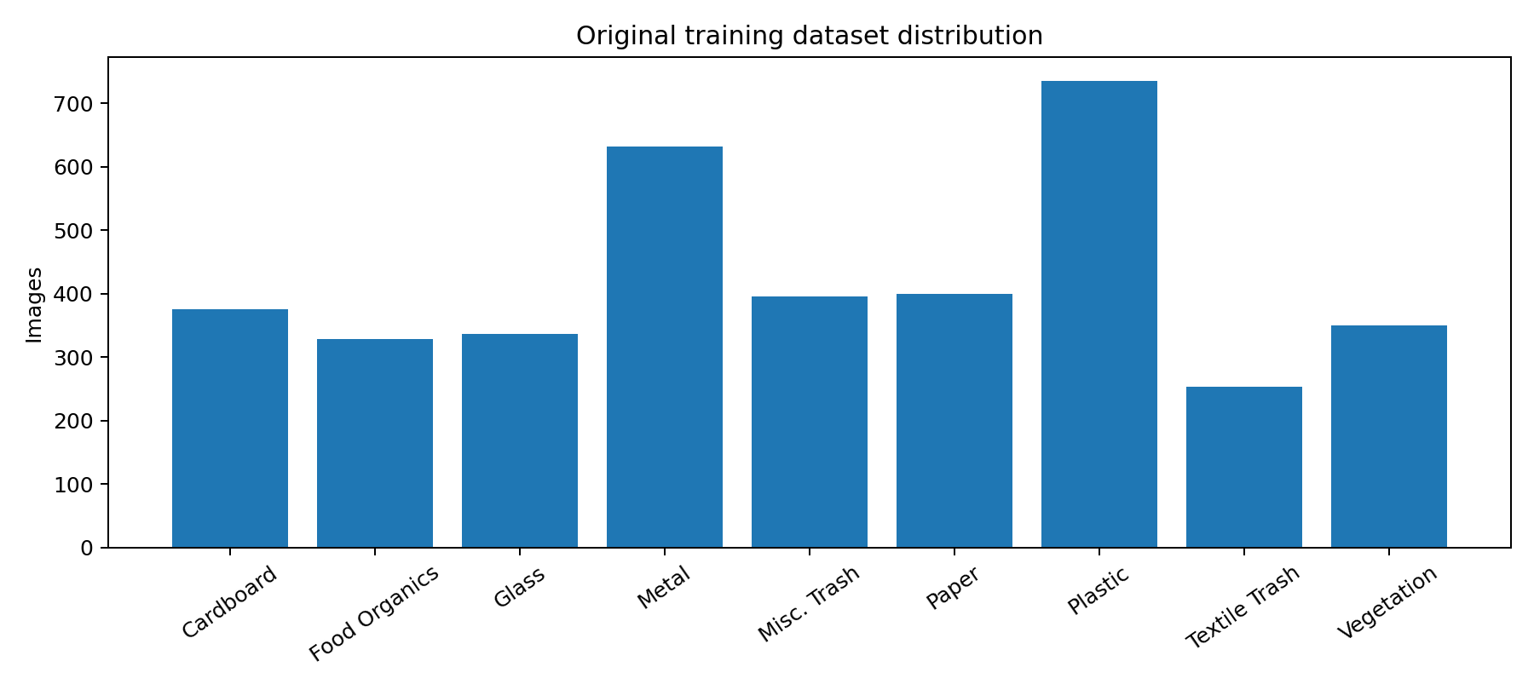
Figure 2. Original training-set class distribution.

3.1 V1 training configuration
Parameter | V1 configuration
Architecture | YOLOv8n-cls image classification
Initial weights | yolov8n-cls.pt
Epochs | 30
Image size | 224 × 224
Batch size | 32
Compute | Kaggle GPU; Tesla T4
Framework | Ultralytics / PyTorch

The model predicts one class for the entire image. It is not an object detector and does not localise or separately classify multiple objects in one photograph.

3.2 V1 test results
V1 recorded 91.43% top-1 accuracy, corresponding to 875 correct predictions out of 957. The notebook recorded approximately 99.9% top-5 accuracy. Top-5 means the correct class appears among the five highest-scoring labels; it does not mean the top prediction is correct.
Class | Precision | Recall | F1 | Support
Cardboard | .87 | .92 | .89 | 95
Food Organics | .94 | .96 | .95 | 83
Glass | .95 | .95 | .95 | 85
Metal | .91 | .91 | .91 | 158
Misc. Trash | .91 | .87 | .89 | 99
Paper | .96 | .86 | .91 | 100
Plastic | .87 | .92 | .90 | 185
Textile Trash | .92 | .89 | .90 | 64
Vegetation | .98 | .95 | .97 | 88

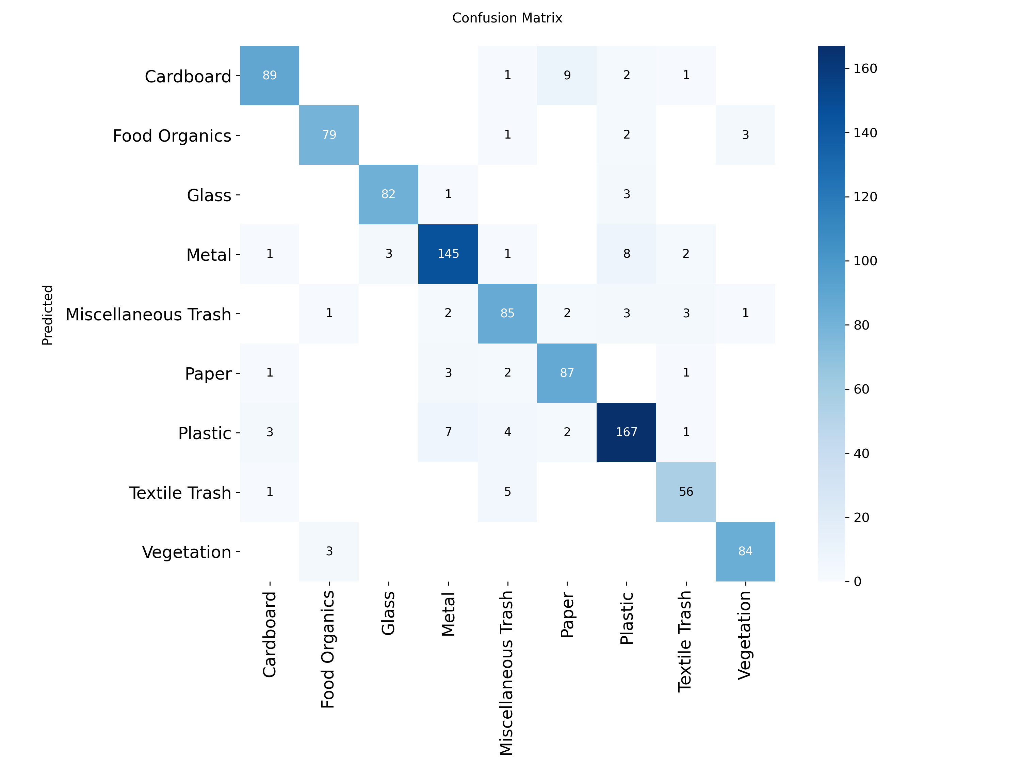
Figure 3. V1 confusion matrix

4. Intermediate Balanced Experiment (V2)
An intermediate experiment balanced training counts to roughly 400 images per class and used 51 validation images per class, then fine-tuned V1. It was exploratory and was not selected. Project notes indicate that balancing alone did not meaningfully improve performance on the original test set.

5. Dataset 2 and V3 Development
Garbage Classification V2 contained 12,259 images across battery (756), biological (699), cardboard (1,411), clothes (1,892), glass (1,736), metal (930), paper (1,336), plastic (1,597), shoes (1,449) and trash (453).
The project mapped cardboard to Cardboard, biological to Food Organics, clothes and shoes to Textile Trash, trash to Miscellaneous Trash, and retained glass, metal, paper and plastic. Battery was excluded because e-waste was outside the nine-class label scheme. The mapped usable collection contained 11,503 images. A SHA-256 check found zero exact duplicate files against the original dataset; near-duplicates were not ruled out.

Source category | Mapped class | Images
cardboard | Cardboard | 1,411
biological | Food Organics | 699
glass | Glass | 1,736
metal | Metal | 930
paper | Paper | 1,336
plastic | Plastic | 1,597
clothes + shoes | Textile Trash | 3,341
trash | Miscellaneous Trash | 453
battery | Excluded | 756

Albumentations 2.0.8 was used for horizontal flip, rotation, brightness/contrast adjustment, hue/saturation/value shifts, Gaussian blur and random scaling. The final V3 training folder was balanced to 1,500 images per class (13,500 total). The validation folder remained class-imbalanced; one corrupt image was ignored. A potential Vegetation train/validation duplication was discovered and corrected before the final training set was rebuilt.

5.1 V3 training configuration
Parameter | V3 configuration
Starting checkpoint | V1 best.pt
Architecture | YOLOv8n-cls
Epochs | 30
Image size | 224 × 224
Batch | 32
Optimizer | AdamW
Initial learning rate | 0.0005
Patience | 7
Seed | 42
Compute | Tesla T4

Best V3 validation top-1 accuracy was 93.4% (top-5 99.8%) at epoch 28. This was a validation result, not the final test comparison.
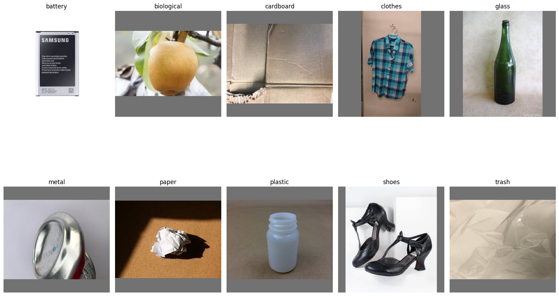
Figure 4. Representative examples from the second dataset, showing source categories including battery, biological, cardboard, clothes, glass, metal, paper, plastic, shoes and trash.

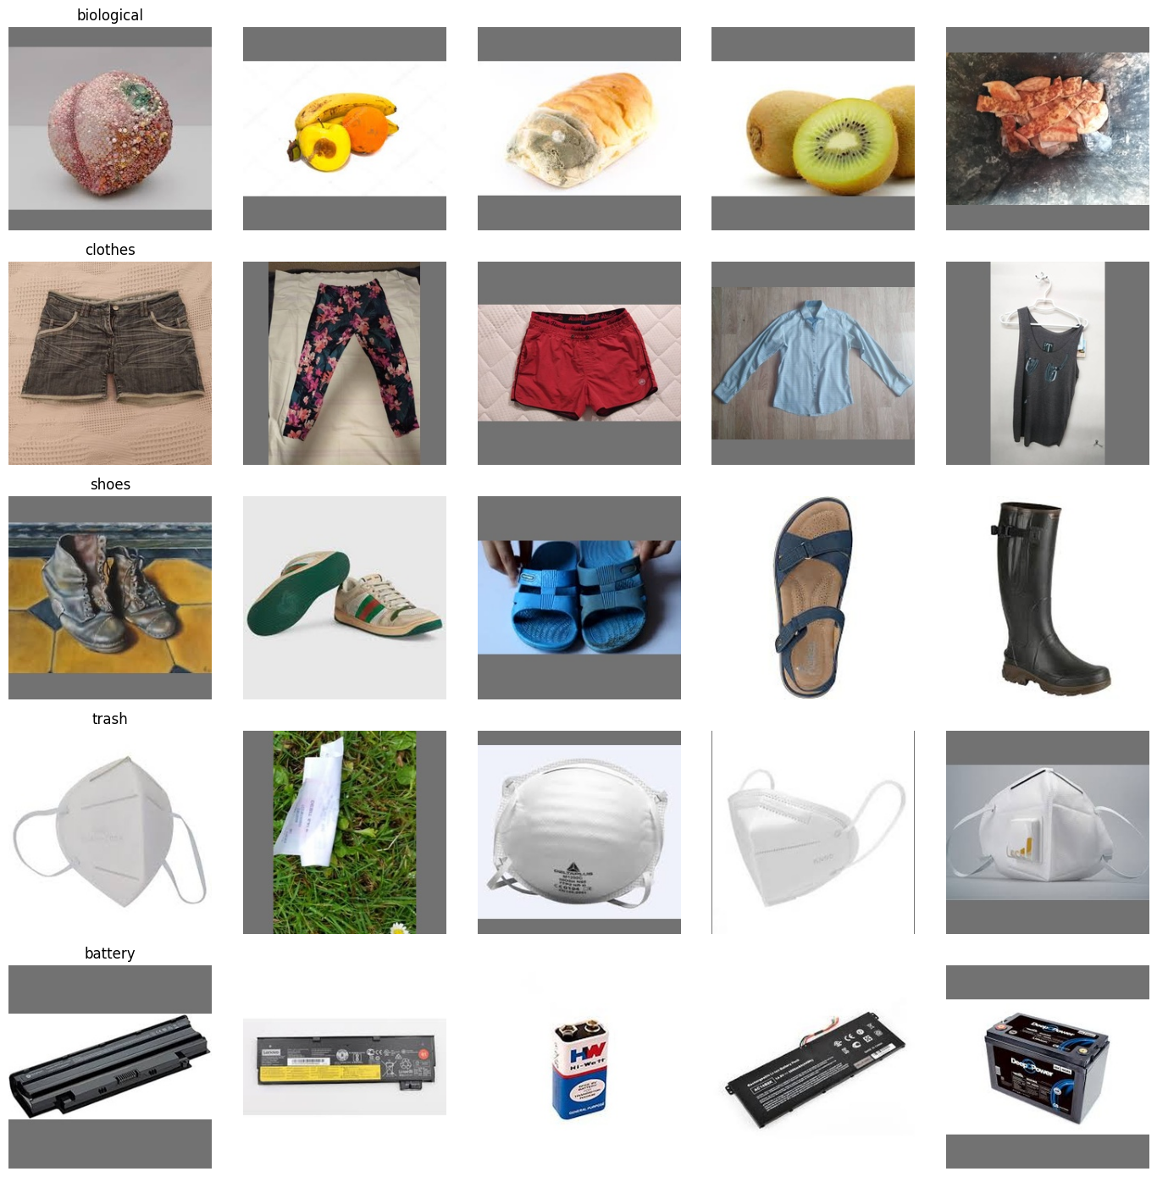
Figure 5. Additional sample images from the second dataset, illustrating variation within biological, clothes, shoes and trash categories.

6. Comparative Evaluation: V1 vs V3
An initial Ultralytics validation call automatically split the copied test folder into 764 training and 193 validation images. That run was not used as the final comparison. The final evaluation collected all 957 image paths and used direct model.predict() inference, comparing predictions with the parent-folder labels.
Metric | V1 | V3
Images evaluated | 957 | 957
Correct predictions | 875 | 860
Incorrect predictions | 82 | 97
Top-1 accuracy | 91.43% | 89.86%
Macro F1 | 0.9181 | 0.90

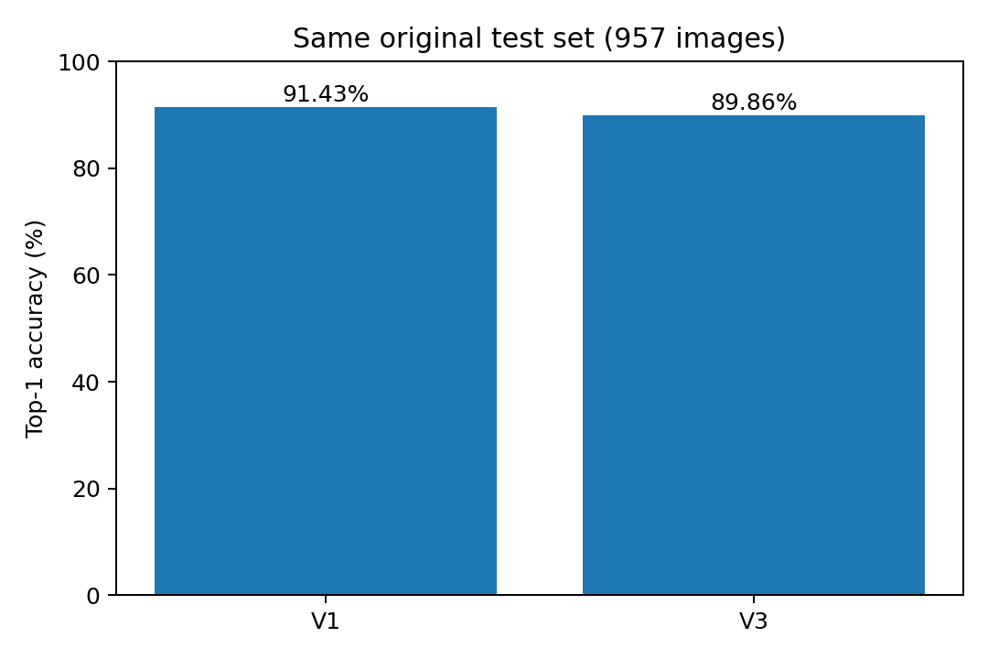
Figure 6. Top-1 accuracy on the same 957 original test images.

6.1 Class-wise recall
Class | V1 recall | V3 recall | Change (pp)
Cardboard | 0.92 | 0.94 | +2
Food Organics | 0.96 | 0.96 | +0
Glass | 0.95 | 0.99 | +4
Metal | 0.91 | 0.96 | +5
Misc. Trash | 0.87 | 0.90 | +3
Paper | 0.86 | 0.83 | -3
Plastic | 0.92 | 0.81 | -11
Textile Trash | 0.89 | 0.81 | -8
Vegetation | 0.95 | 0.94 | -1

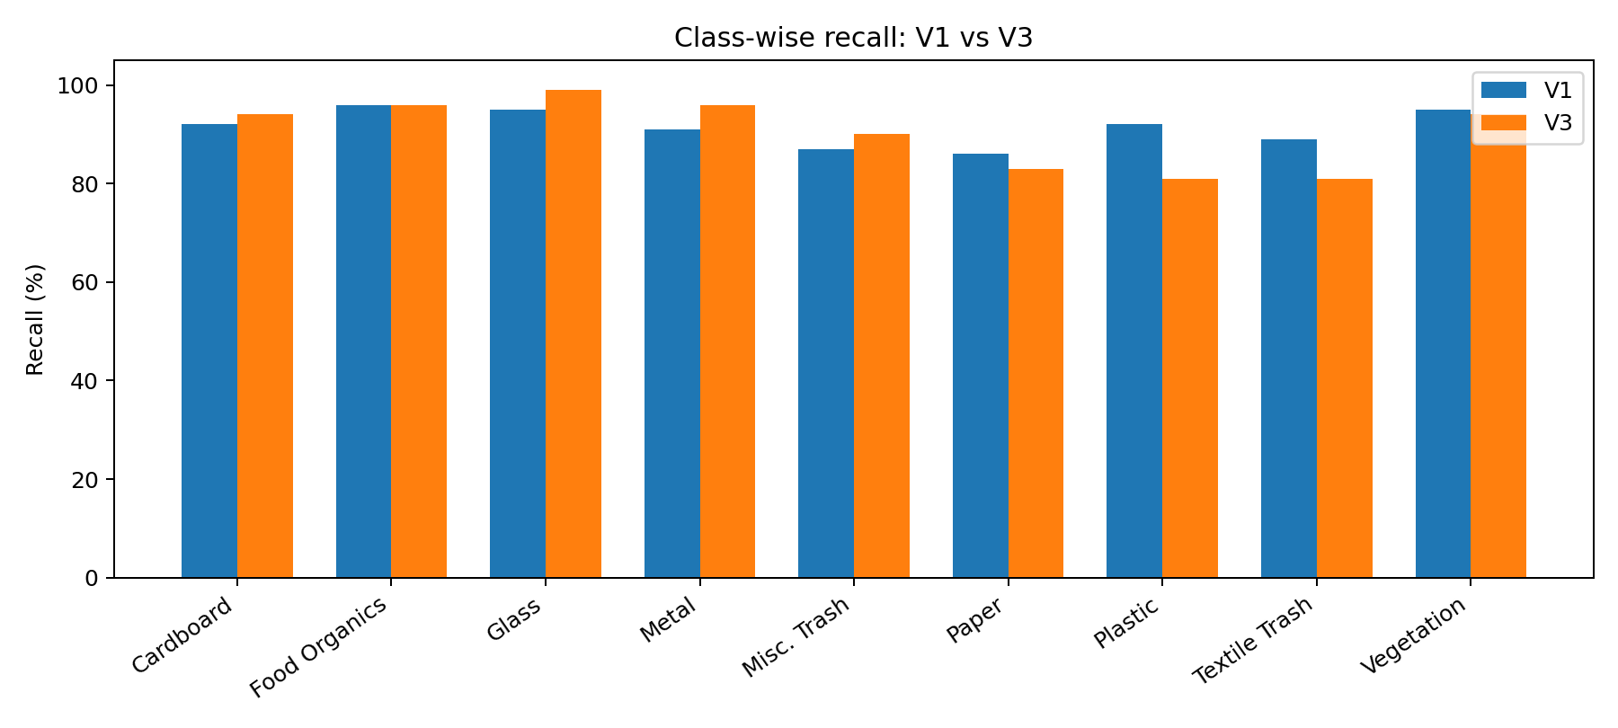
Figure 7. Class-wise recall comparison, based on the recorded rounded reports.
V3 improved recall for Cardboard, Glass, Metal and Miscellaneous Trash. Food Organics was approximately unchanged. Recall declined for Paper, Plastic, Textile Trash and slightly for Vegetation. Metal recall increased from 0.91 to 0.96, while Metal precision decreased from 0.91 to 0.84, consistent with a greater tendency to predict Metal.

6.2 Confusion matrix and dominant errors
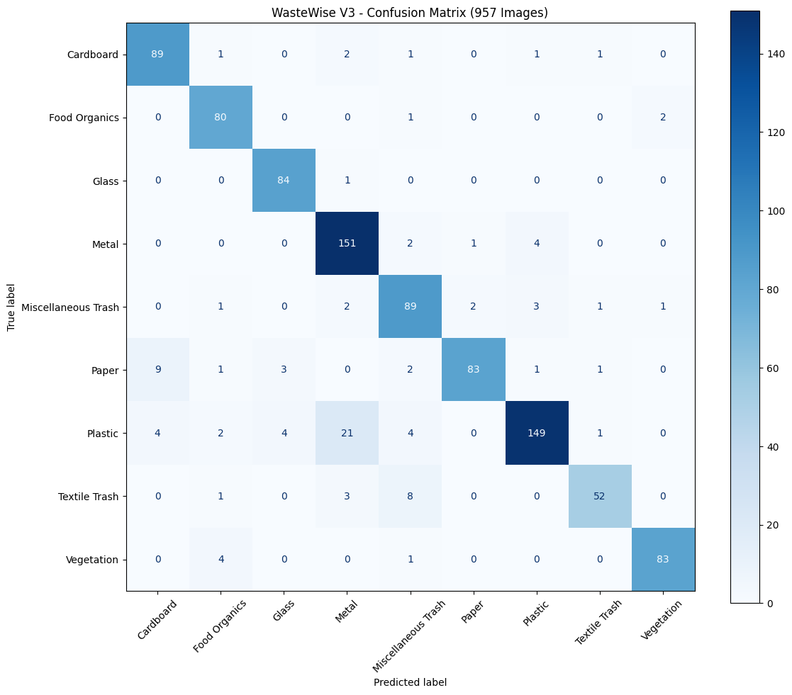
Figure 8. V3 confusion matrix calculated from all 957 direct predictions; rows are actual classes and columns are predicted classes.
The most frequent V3 errors were Plastic→Metal (21), Paper→Cardboard (9) and Textile Trash→Miscellaneous Trash (8). V3 produced 97 incorrect predictions in total.

6.3 Focused investigation: Plastic predicted as Metal

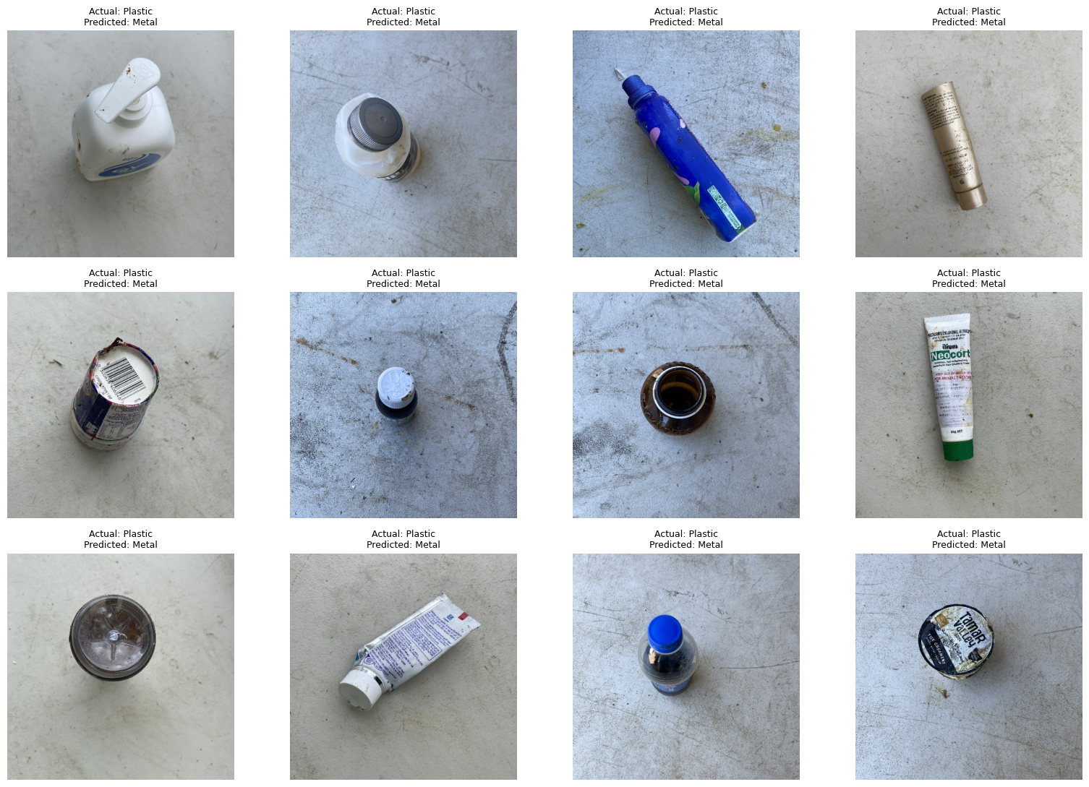
Figure 9. Twelve examples from the 21 Plastic images predicted as Metal by V3.
The mean V3 confidence across these 21 incorrect predictions was 84.07%; several errors exceeded 95% confidence. On the same 21 images, V1 correctly predicted Plastic 16 times, whereas V3 correctly predicted none. This shows that confidence is not a guarantee of correctness and that fine-tuning introduced or amplified a regression on this subset.
Model | Correct Plastic predictions on the same 21 images
V1 | 16 / 21
V3 | 0 / 21

7. Software Implementation
The supplied source archive contains backend/app.py, predictor.py, waste_info.py and database.py. FastAPI exposes GET /, POST /predict and GET /history. The uploaded image is temporarily saved, passed to the predictor and deleted in a finally block. The backend applies a 0.70 confidence threshold: below-threshold predictions are returned as uncertain and are not stored as successful scan records.
predictor.py loads the YOLO checkpoint from models/best.pt and returns the top-1 class and confidence. waste_info.py separates disposal guidance from inference. SQLite stores class, confidence, waste type, recyclable status, compostable status, disposal text and timestamp.
The React frontend is organised into Navbar, Hero, Scanner, Categories, Dashboard, History and About components. Scanner supports image selection and browser webcam capture, sends images to the local FastAPI endpoint and displays prediction or uncertainty states. History requests records from the backend. Dashboard and history UI details should be checked against the current running build before claiming every metric is live.
Endpoint | Method | Purpose
/ | GET | API status message
/predict | POST | Image inference, guidance mapping and accepted scan storage
/history | GET | Stored scan records

8. Findings and Discussion
- V1 exceeded V3 by 1.57 percentage points on the shared test set.
- V3's higher validation accuracy did not transfer to the original test set.
- Balancing counts does not guarantee better generalisation; data diversity, labels, augmentation and domain similarity matter.
- Fine-tuning can shift class boundaries. The observed regression is clear, but the exact causal mechanism is not proven by this experiment.
- High-confidence mistakes show that the confidence score should not be interpreted as a calibrated probability of correctness.
- The model classifies visible image appearance, not material chemistry or local recycling acceptance.

9. Limitations
- No separate, systematically collected real-world phone-camera benchmark was reported.
- Exact hashes do not detect near-duplicate images.
- Mapping shoes to Textile Trash is a project convention for a mixed-material item.
- V3 validation remained class-imbalanced and one corrupt image was ignored.
- The earlier 91.19% result came from an automatic 193-image split and is not the full-test result.
- The classifier predicts one class for the whole image; multiple objects and composite materials remain difficult.
- Recycling acceptance varies by local facilities and item condition.

10. Conclusion
WasteWise demonstrates an end-to-end prototype linking image classification, a web interface and disposal-information mapping. On the same 957 original test images, V1 achieved 91.43% top-1 accuracy and V3 achieved 89.86%. V3's stronger validation result did not translate to better original-test performance. It improved some class recalls but showed a notable decline for Plastic and Textile Trash. The focused error analysis found 21 Plastic images predicted as Metal by V3; V1 correctly classified 16 of those images. On the available evidence, V1 is the more suitable checkpoint for the current application, while V3 remains an informative experiment.

11. Future Work
- Collect an independently labelled real-world phone-camera dataset across lighting, backgrounds, angles and distances.
- Review ambiguous and mixed-material labels.
- Maintain separate training, validation and final test sets.
- Run controlled fine-tuning experiments changing one factor at a time.
- Evaluate confidence calibration and unknown-class rejection.
- Test application latency, usability and error handling.
- Treat ESP32-CAM and TFT integration as future work until implemented and tested.

12. Reproducibility, artefacts and references
The supplied materials include the 122-cell Kaggle notebook, the WasteWise source ZIP, the separately saved V3 checkpoint and evaluation outputs. The source archive contains backend/models/best.pt as the application checkpoint; the separate V3 checkpoint should remain experimental. Preserve exact dataset versions, package versions, seeds, model hashes and evaluation scripts.
- Ultralytics YOLO classification documentation: https://docs.ultralytics.com/tasks/classify/
- Albumentations documentation: https://albumentations.ai/docs/
- FastAPI documentation: https://fastapi.tiangolo.com/
- React documentation: https://react.dev/
- SQLite documentation: https://www.sqlite.org/docs.html
- Kaggle: Waste Segregation dataset by Samarth Kaushal (https://www.kaggle.com/datasets/smarthkaushal/waste-segregation).
- Kaggle: Garbage Classification V2 by sumn2u
(https://www.kaggle.com/datasets/sumn2u/garbage-classification-v2).

Appendix A. Selected implementation excerpts
model = YOLO("models/best.pt")
result = model.predict(source=image_path, verbose=False)[0]
predicted_class = result.names[result.probs.top1]
confidence = float(result.probs.top1conf)
POST /predict → predict_waste(temp_path) → waste_info mapping → SQLite insert
GET /history → SELECT scan records ORDER BY id DESC

Appendix B. Model class order
Index | Class
0 | Cardboard
1 | Food Organics
2 | Glass
3 | Metal
4 | Miscellaneous Trash
5 | Paper
6 | Plastic
7 | Textile Trash
8 | Vegetation

THANK YOU

