
ShelfWise
Simple Product Management System – Project Documentation
Project Title | ShelfWise – Simple Product Management System
Student Name(s) | Prayas Sharma
College / Institution | Techspire College
Subject / Course | React JS
Instructor Name | Saman Thakuri
Submission Date | 28 September 2026

1. Project Introduction

What it does: ShelfWise is a React web app designed for easy product management. A user signs up, logs in, and accesses a dashboard where products (name, price, category) can be added, viewed, modified, removed, and searched.

Issue resolved: Storing items in a notebook or random spreadsheet becomes disorganized and difficult to find. ShelfWise presents every product as a card that can be edited or deleted with a single click, featuring a search box that filters results dynamically as you type.

Reason for my selection: It serves as a functional CRUD (Create, Read, Update, Delete) project that employs fundamental React principles without requiring a backend.

Target audience: Owners of small shops or individuals with a limited range of products, as well as students studying React.

2. Objectives
Create a single-page app utilizing React components.
• Handle data using useState and distribute it via the Context API.
• Design regulated forms that include validation and transparent error notifications.
• Utilize immutable array methods to implement add, edit, delete, and search functionalities.
• Implement conditional rendering to change screens and form modes.
• Ensure the design adapts for both desktop and mobile devices

3. Technologies Used
Technology | Purpose
React 19 | Component-based UI with hooks (useState, useContext)
Vite 8 | Development server and build tool
JavaScript (ES6+) | Application logic and array methods
JSX / HTML | Page structure inside components
CSS | Styling with variables, flexbox, grid and a media query
Context API | Sharing state between components
Oxlint | Code checking (npm run lint)
npm, Git / GitHub | Dependencies, version control and hosting

4. System Requirements
- Software: Windows, Linux or macOS; Node.js 20.19+ (includes npm); VS Code or any editor; a modern browser; Git.
- Hardware: Dual-core processor, 4 GB RAM, about 200 MB free storage.
- Internet: Only needed once, for npm install.

5. Project Features
The system provides the following features:
Feature | Description | File
User registration | Validates name, email and password; rejects duplicate emails | Register.jsx
User login | Checks email and password against registered users | Login.jsx
Dashboard | Welcome message, product count, form, search and list; Logout button | Dashboard.jsx
Add product | Form with name, price and category | Dashboard.jsx
View products | Responsive grid of cards; shows “No products found.” when empty | ProductList.jsx
Edit product | Loads a product into the same form. | Dashboard.jsx
Delete product | Removes the product immediately. | Dashboard.jsx
Search | Case-insensitive, partial name match as you type | Dashboard.jsx
Form validation | Specific error message for each broken rule | All forms
Responsive design | Auto-fill grid, wrapping form, mobile media query | App.css

6. Project Structure
product-app/
├── public/favicon.svg
├── src/
│ ├── components/
│ │ ├── Brand.jsx Dashboard.jsx Login.jsx
│ │ └── ProductList.jsx Register.jsx
│ ├── context/AppContext.jsx
│ ├── App.jsx App.css main.jsx
├── index.html package.json vite.config.js

components/ – Brand (logo), Login, Register, Dashboard (form, search, handlers) and ProductList (cards).
AppContext.jsx – creates the shared context. App.jsx – holds all state and chooses the screen. main.jsx – entry point. App.css – all styling.

7. Application Screens / UI
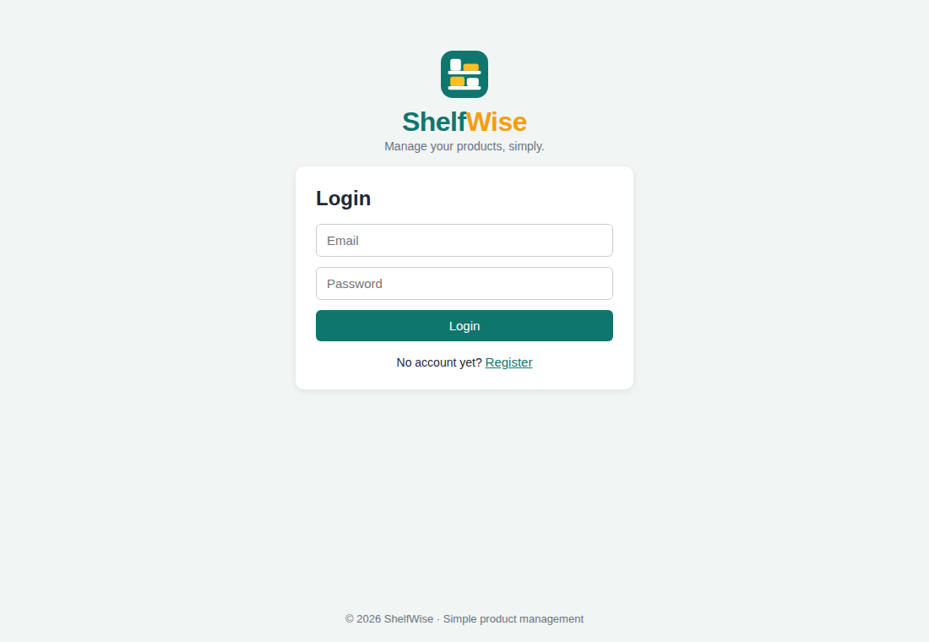  Figure 1: Login page | 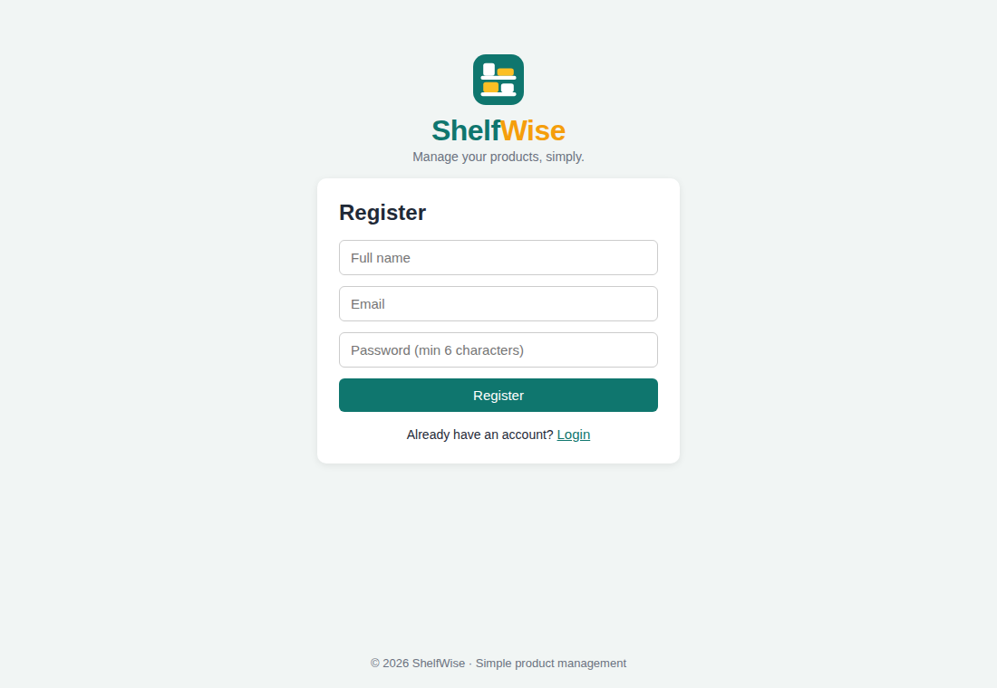  Figure 2: Register page
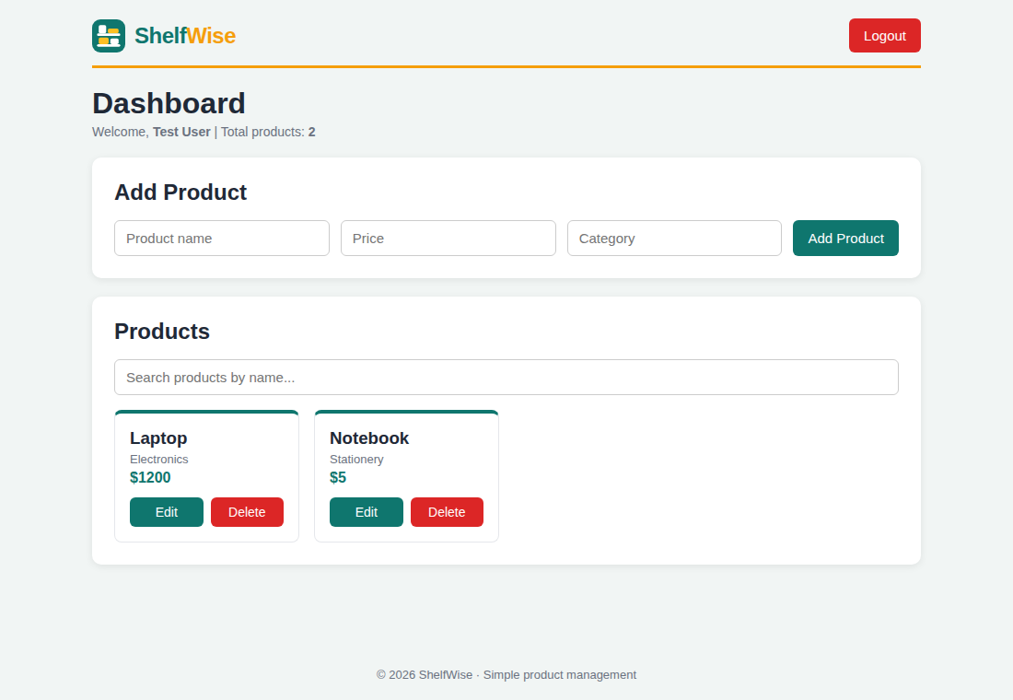  Figure 3: Dashboard | 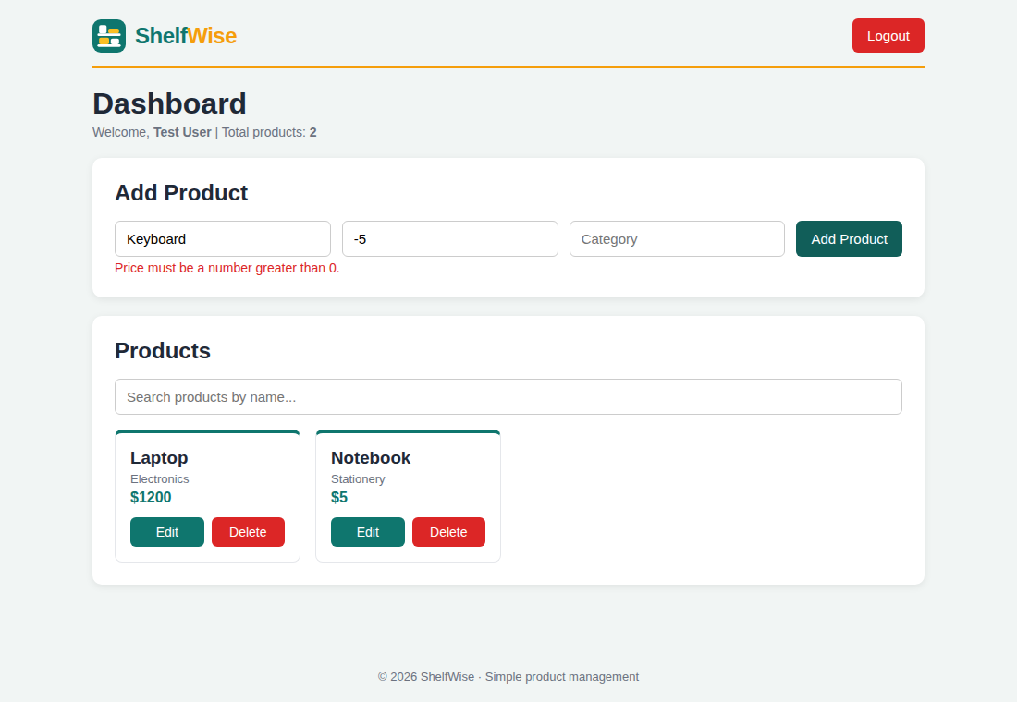  Figure 4: Validation error
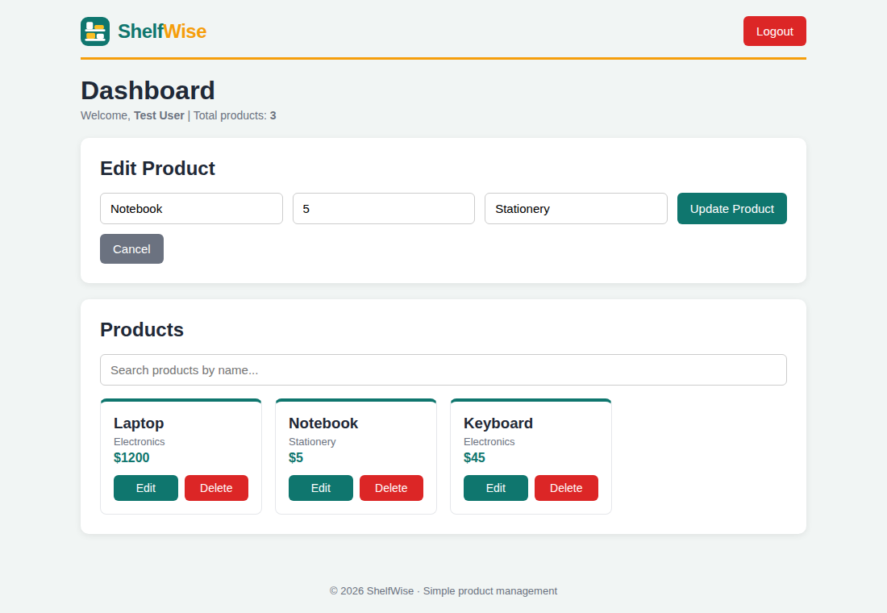  Figure 5: Edit mode | 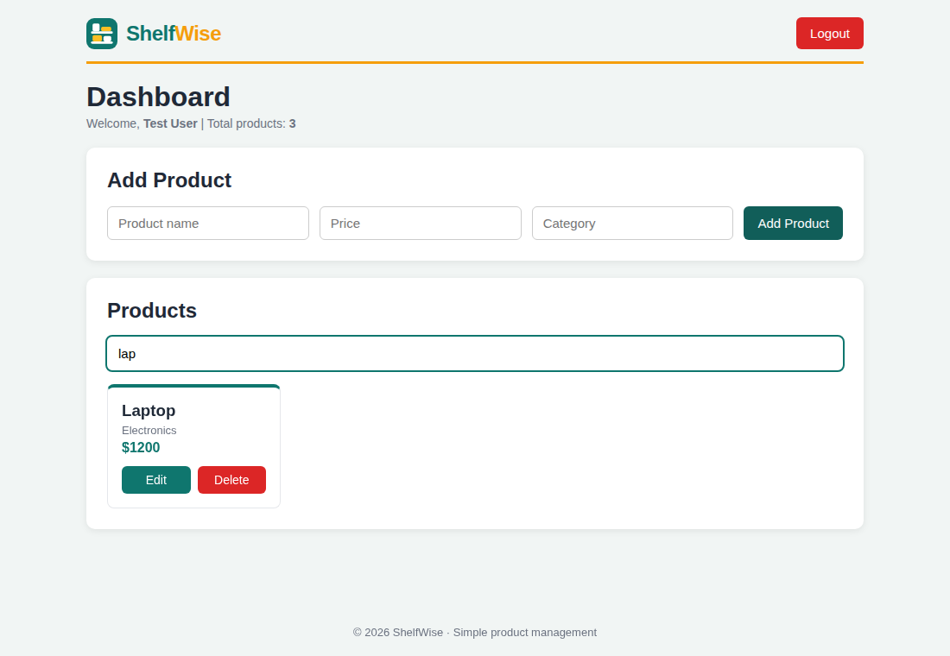  Figure 6: Search for “lap”

The login page displays the logo and a link for Registration. The dashboard contains the product form, search field, and product grid. Mistakes show up in the form, and Edit mode alters the button to “Update Product.” On phones, the arrangement shifts into a single column.

8. React Concepts Used
• Elements: Application, Brand, Sign In, Sign Up, Dashboard, and Product List, each with a specific role. The brand is utilized in two dimensions.
• Props: Transfer data downward and functions upward, for example, ProductList gets products, onEdit, and onDelete.
• useState: Holds products, users, currentUser, form data, and error notifications.
• Context API: The application supplies users, currentUser, and products; Login, Register, and Dashboard access them through useContext.
• Conditional rendering: Use ternary and && to display either the dashboard or the login, along with error messages and the Cancel button.
• Keys and lists: .map() displays product cards, each assigned a distinct key.
• Events and managed types: onChange, onSubmit, and onClick; inputs derive their value from state.
Not utilized: useEffect, React Router, and external API requests..

9. Important Code Explanation
Shared state and Provider (App.jsx)
const [products, setProducts] = useState([...]);
<AppContext.Provider value={{ users, setUsers, currentUser,
setCurrentUser, products, setProducts }}>
State is created once in App and shared with all child components through the Provider.
Login (Login.jsx)
const foundUser = users.find(u => u.email === email && u.password === password);
if (!foundUser) { setError("Invalid email or password."); return; }
setCurrentUser(foundUser);
find() returns the matching user. Setting currentUser makes App show the Dashboard; setting it to null logs out.
Add / update product (Dashboard.jsx)
if (editingId === null) setProducts([...products, { id: Date.now(), name, price: Number(price), category }]);
else setProducts(products.map(p => p.id === editingId ? { ...p, name, price: Number(price), category } : p));
One form does both jobs. editingId decides between adding (spread) and updating (map). Number() converts the price string.
Delete and search (Dashboard.jsx)
setProducts(products.filter(p => p.id !== id));
const filteredProducts = products.filter(p => p.name.toLowerCase().includes(search.toLowerCase()));
filter() removes one product without changing the original array. The search result is calculated on each render, so clearing the search shows everything again.

10. API Documentation
No external API or backend is used. All data is kept in React state, so there are no HTTP endpoints. The in-memory operations below take their place.
Operation | CRUD | Code
Register user | Create | setUsers([...users, newUser])
Login check | Read | users.find(...)
Add product | Create | setProducts([...products, newProduct])
Show products | Read | products.map(...)
Update product | Update | products.map(p => p.id === editingId ? {...p, ...} : p)
Delete product | Delete | products.filter(p => p.id !== id)
Data model: User { id, name, email, password }; Product { id, name, price, category }.

11. Application Flow
- The app opens on the Login screen; new users click Register.
- After registering, the user logs in and currentUser is set.
- The Dashboard opens with the product form, search box and list.
- The user adds, edits, deletes or searches products.
- Logout sets currentUser to null and returns to Login.
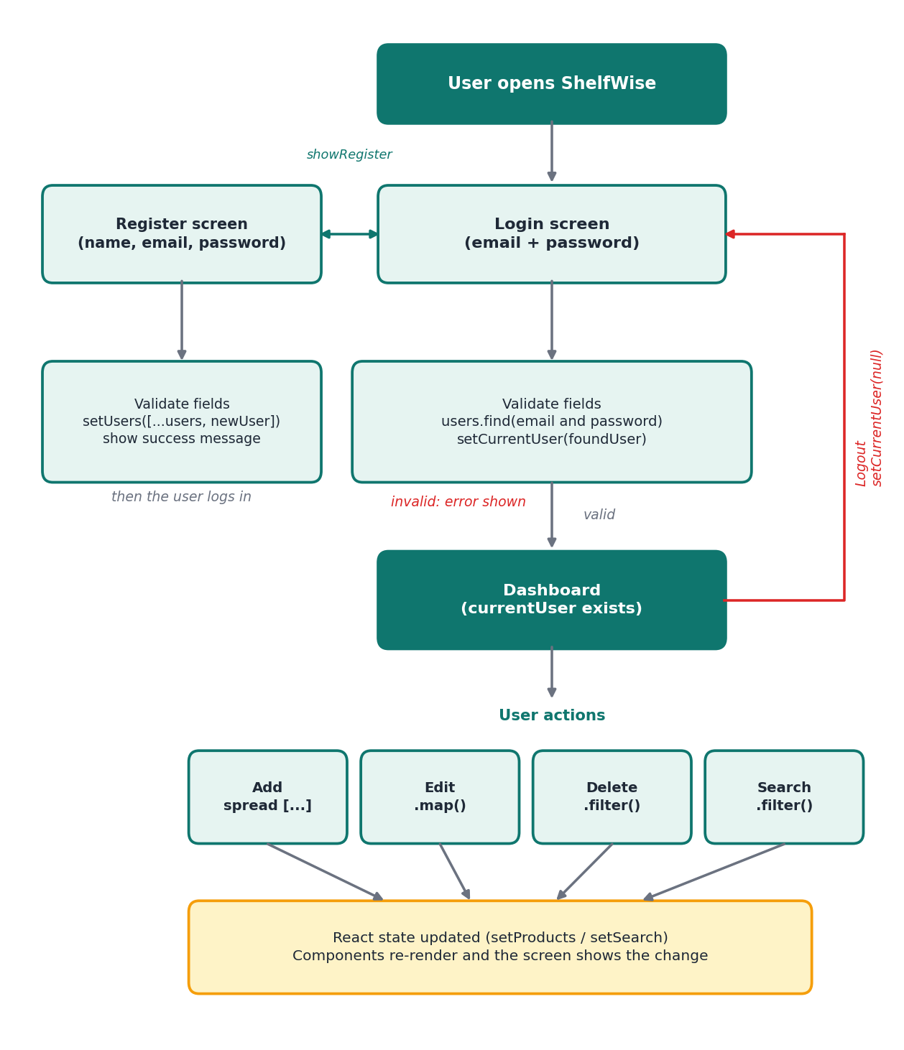
Figure 7: Application flow diagram

12. Challenges Faced
- Unique product IDs: products.length + 1 creates duplicates after a delete, so Date.now() is used.
- Sharing data: Context API instead of long prop chains.
- Login/Register switching without a router: a showRegister state with function props.
- One form for add and edit: an editingId state (null means adding).
- Updating state safely: always create new arrays with spread, map and filter.
- Input values are strings: the price is converted with Number().

13. Limitations
- When you refresh the page, the created accounts and then the data is gone.
- Passwords are stored in plain text, it is a limitation in security
- Once a product is made, it is shared by all the users.
- Email Validation is not there, only surface level detection is implemented.

14. Future Enhancements
- I will add a backend database with Rest API to make the users permanent.
- I will add the password section to be hashed so theres more security.
- Give each user their own products and add React Router pages.
- Add more search algorithms like sorting and filters.

15. Conclusion
ShelfWise is areact based web application that can register a user, and then have that user create or edit a product. It is a web application focusing on the management of products and services. It is generally a prototype level software, there are future advancements planned and theres more to update on.

16. GitHub Repository
Repository:
The repository includes the source code, package.json, a README with setup steps, and a .gitignore. No secrets or .env files are used.
To run: git clone <repository-url>, cd product-app, npm install, npm run dev, then open http://localhost:5173. This is how we will start the web application.

