**ea-april-2024-spring-data-2 Report**

Student: Ngoc But Bui, Tanusha Ayer, Prayash Shrestha

Sample data

|  |  |  |
| --- | --- | --- |
| User | Product | Review |
| 100 | 1,000 | 1,000,000 (1,000 for each product) |

Populate the database with sample data

* Write an application to create CSV files for user, product and review.
* Import CSV files to database.

Performance of getting all products

|  |  |  |  |  |  |
| --- | --- | --- | --- | --- | --- |
| Fetch mode | Fetch | No of SQL query | Execution time (s) | Memory usage | Data Transfer |
| SELECT | EAGER | 1001 | 12.02 | 1.55GB | 35.13MB |
| SELECT | LAZY | 1001 | 10.84 | 1.91MB | 35.13MB |
| JOIN | EAGER | 1 | 17.76 | 1.74GB | 35.13MB |
| SUBSELECT | EAGER | 2 | 15.02 | 1.57GB | 35.13MB |
| SUBSELECT | LAZY | 2 | 14.79 | 8.82MB | 35.13MB |
| BATCH (100) | EAGER | 11 | 10.63 | 1.54GB | 35.13MB |
| BATCH (100) | LAZY | 11 | 10.39 | 9.7MB | 35.13MB |
| BATCH (10) | EAGER | 101 | 10.19 | 1.54GB | 35.13MB |
| BATCH (10) | LAZY | 101 | 9.61 | 10.73MB | 35.13MB |

Conclusion

@Fetch(FetchMode.SELECT)->Eager

@Fetch(FetchMode.SELECT) -> Lazy

@ Fetch(FetchMode.JOIN)

@Fetch(FetchMode.SUBSELECT)->Eager

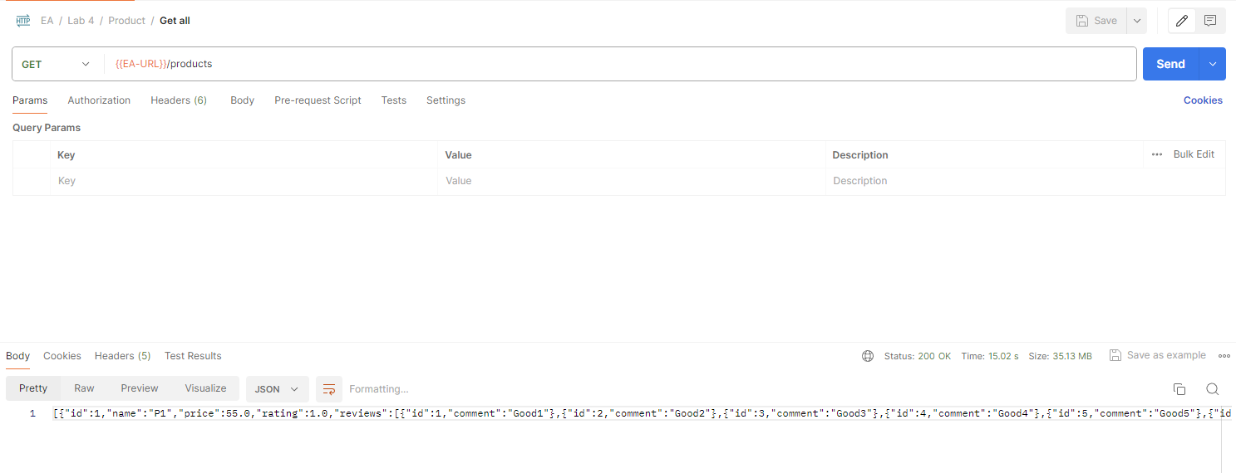

@Fetch(FetchMode.SUBSELECT)->LAZY

@Fetch(FetchMode.BATCH)->EAGER BATCHSIZE= 100

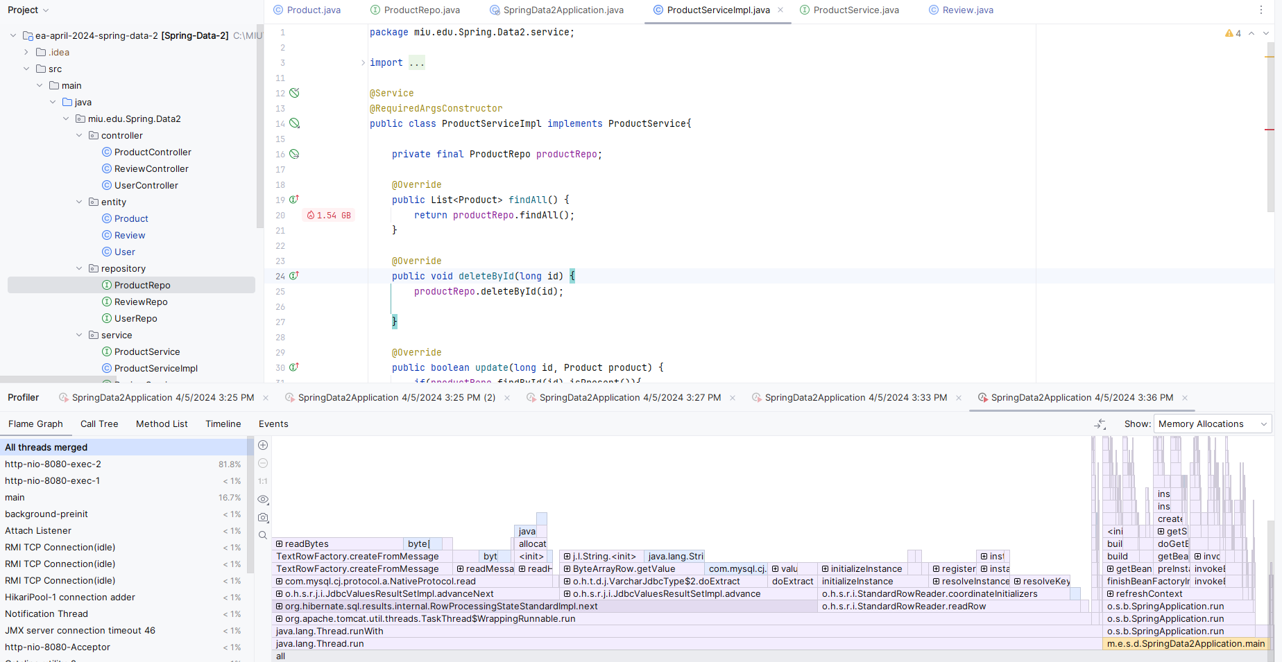

@Fetch(FetchMode.BATCH)->LAZY BATCHSIZE= 100

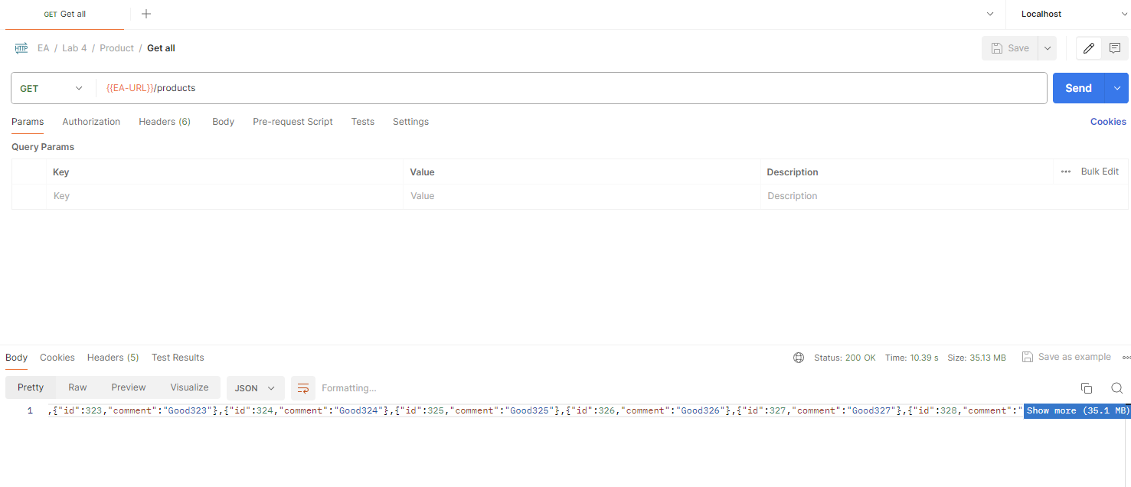

@Fetch(FetchMode.BATCH)->EAGER BATCHSIZE= 10

@Fetch(FetchMode.BATCH)->LAZY BATCHSIZE= 10



