Department of Master of Computer Application
Session 2025-2026
Progress Report of Mini-Project work – 1
Name of the Projectees | Shiwani Amrute, Prayas Gotefode
Name of the Guide | Prof. Rahul Lilhare
Department | Master of Computer Application
Date of submission | 23-09-2025
Title | Online Notes Sharing System
Report for the Period | 13-08-2025 to 23-09-2025

Precise Report of the Project work done during the above period (Brief)
1 | Study the various things related to research area  • Reviewed platforms like Google Classroom, OneNote, and Ever note for inspiration.  • Studied features of open-source note sharing websites.  • Understood the need for role-based access control (different access for admin, teachers, and students).  • Identified common challenges in note-sharing systems such as file security, duplication, and categorization of notes.
2 | Find out the various Techniques / Tools  • Selected HTML, CSS, JavaScript, React.js for building responsive and modular frontend components.  • Planned integration of Node.js/Express.js for backend and MySQL/MongoDB for database.  • Considered JWT (JSON Web Token) for authentication and role management.  • Decided on Bootstrap / Tailwind CSS for styling and improved UI/UX.
3 | Analysis of existing systems and its weaknesses  • Existing systems often require paid subscriptions to access study material.  • Some platforms do not support multi-role management effectively (admin/teacher/student separation missing).  • Lack of real-time dashboards for tracking notes and user activities.  • Inconsistent categorization and search features in many systems.  • Some websites lack mobile-friendly UI, reducing accessibility for students.
4 | Analysis of existing systems with our system  • Our system will allow universal access for viewing notes without login.  • Teachers and Admins will have exclusive upload & management rights.  • Planned dashboard for monitoring uploads and keeping track of user contributions.  • System will be lightweight and mobile-friendly for easy student access.  • Use of categorization & search filters to organize notes by subject, semester, or teacher.
5 | Publish the Introductory/ Survey paper on research topic: Yes/No  No
6 | Explore the flow of system  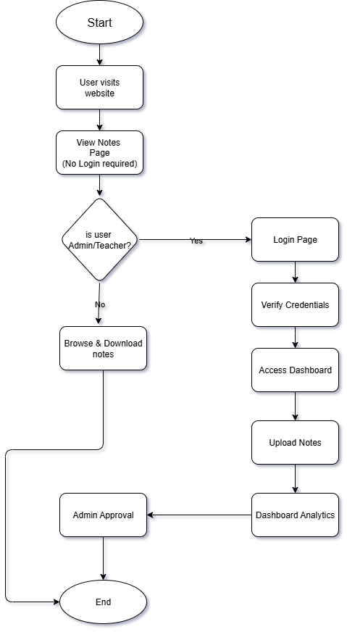  Flow of System (Frontend Process Implemented so far)  Frontend Implemented:  - Created Index, Home, About Us, Signup, Login, Notes pages with navigation.  - Notes Display Page allows all users to browse available notes.  - Any user (student/guest) can view or download notes.  - Responsive design tested on both desktop and mobile.  Planned Authentication (Future Scope):  - Teachers/Admins will sign up and log in.  - Credentials verified against backend database.  - Successful login provides access to upload panel and dashboard.  Upload & Management (Future Scope):  - Teachers/Admins upload notes (PDF/DOC/PPTX, etc).  - Notes categorized by subject, semester, and uploader.  - Admins can approve, edit, or delete uploaded notes.  Dashboard (Future Scope):  - Admin dashboard for managing teachers and tracking all uploads.  - Teacher dashboard to track their own uploaded notes and student engagement.  - Statistics (e.g., number of uploads per teacher, most viewed notes).  Error Handling & Validation:  - Invalid logins show error messages (planned).  - Frontend input validation implemented for forms (signup/login).
7 | Research Papers Published in the refereed/national/international journals in this duration (please attach copy): Yes/No  No
8 | Research Papers Published in Conference Proceedings/ Seminars in this duration (please attach copy) Yes/No  No
9 | Conferences/Seminars/workshops attended in this duration: Yes/No  Yes
10 | Any other achievements  No

Signature of students Signature of Guide Signature of Project In charge

