ATHARVA EDUCATIONAL TRUST
ATHARVA COLLEGE OF ENGINEERING MALAD, MUMBAI

A MINI PROJECT REPORT ON
“PIZZA CAFE CHATBOT”
SUBMITTEDBY:
RUSHIKESH KEDARI (35)
ABHISHEK KSHATRIYA (42)
PRAYAS MORE (48)
UNDER THE GUIDANCE OF:
Prof. Poorna Pimpale
DEPARTMENT OF INFORMATION TECHNOLOGY (2020-2021)

CERTIFICATE
This is to certify that the project entitled “PIZZA CAFE CHATBOT SYSTEM” is a bonafide work of RUSHIKESH KEDARI (ROLL NO:35), ABHISHEK KSHATRIYA(ROLL NO:42), PRAYAS MORE (ROLL NO:48) submitted to the University of Mumbai in partial fulfilment of the requirement for the award of the degree of “BEIT” in “ARTIFICAL INTELLIGENCE”.
(GUIDE SIGNATURE) (HOD SIGNATURE)

DECLARATION
I declare that this written submission represents my ideas in my own words and where others' ideas or words have been included, I have adequately cited and referenced the original sources. I also declare that I have adhered to all principles of academic honesty and integrity and have not misrepresented or fabricated or falsified any idea/data/fact/source in my submission. I understand that any violation of the above will be cause for disciplinary action by the Institute and can also evoke penal action from the sources which have thus not been properly cited or from whom proper permission has not been taken when needed.
--------------------------------------
RUSHIKESH KEDARI (35)
--------------------------------------
ABHISHEK KSHATRIYA (42)
--------------------------------------
PRAYAS MORE (48)
Date:

INDEX
1. ABSTRACT
2. INTRODUCTION
3. LITERATURE SURVEYED
4. AIM AND OBJECTIVES
5. SCOPE
6. BLOCK DIAGRAM
7. DETAILS OF SOFTWARE
8. CONCLUSION
9. REFERENCE

ABSTRACT

A chat-bots aims to make a conversation between both human and machine. The machine has been embedded knowledge to identify the sentences and making a decision itself as a response to answer a question. The Pizza Cafe inquiry chat bots will be built using artificial algorithms that analyze user's queries and understand user's message. The response principle is matching the input sentence from a user. The User can ask the question about any service-related to pizza through the chat-bot without physically available to the cafe for inquiry. The System analyses the question and then answers to the user. With the help of artificial intelligence, the system answers the query asked by the user.

INTRODUCTION
Pizza Cafe Chat Bot project will answer to customer's questions that are related to cafe services. First bot analyzes customer’s queries and understands the customer’s message, based on bot knowledge bot provides answers to the queries of the customer. Customers can ask questions related to food, location details, etc. This bot will help you to find out the pizza prices and home delivery information and other queries etc.

LITERATURE SURVEYED

1. Antoine Raux, Yi Ma, Paul Yang, and Felicia Wong b4.ai / botbotbotbot ,Inc. , 3225 Ash Street, Palo Alto, CA, USA

This paper describes PizzaPal, a voice-only agent for ordering pizza, as well as the Conversational AI architecture built at b4.ai. Based on the principles of high-density conversational AI, it supports natural and flexible interactions through neural conversational language understanding, robust dialog state tracking, and hierarchical task decomposition.

2. Xi Yu Leung , Han Wen, Department of Hospitality and Tourism Management, University of North Texas, 1155 Union Circle, #311100, Denton, TX, 76203-5017, USA

The purpose of this study was to explore customers’ perceptions and behaviors when using chatbots in restaurant takeout orders. Built on the social presence theory, this study conducted a lab experiment to examine and compare three ordering methods in quick-service and full-service restaurants. Results revealed that phone ordering and online ordering were both better than chatbot ordering in terms of satisfaction and behavioral outcomes. The findings offer new insight for restaurant practitioners into designing and adopting chatbots.

AIM
This project aims to develop a system in which a Chat bots which provides a text-based user interface, allowing the user to type commands and receive text.Chat-bots are usually stateful services, remembering previous commands in order to provide functionality. It can be utilized securely by an even larger audience when chat-bots technology is integrated with popular web services. The Pizza Cafe chatbotwill be built using artificial algorithms that analyze user's queries and understand the customer's message.

OBJECTIVES
• A Pizza Cafe Chat Bots project is built using artificial algorithms that analyzes customer’s queries and understand customer’s message.
• This System is a web application which provides answers to the query of the customer very effectively.
• Customers just have to query through the bot which is used for chatting.
• Customers can chat using any format, as there is no specific format that the user has to follow.

SCOPE
The system analyzes the question and then answers thecustomer. This project makes it easy to understand cafe services, food, location of cafe etc. The customer does not have to personally go to the cafe forenquiry. This system provides stateful and user friendly service.

BLOCK DIAGRAM

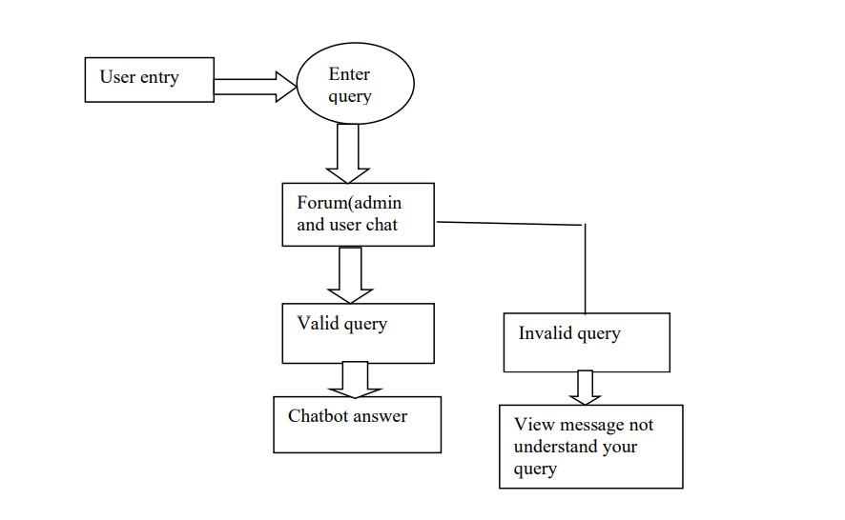
DETAILS OF SOFTWARE:
• Visual Studio Code
• Windows 10 OS

CONCLUSION
Many responses can be automated using our Chabot that can efficiently carry out basic requests for information. Our Pizza Cafe Chatbot is better than out of-office responses.The System uses built in artificial intelligence to answer the query. The answers are appropriate to what the customer queries. We create the chatbot for providing the best experience for the customer and knowing more about our cafe services.

REFERENCE

1. Shivashish Thakur from CORE posted an article on May 04, 2020 on his blog AI Zone Tutorial where he made a tutorial on how to build a python chatbot project
2. Shawar, Bayan & Atwell, Eric. (2007). Chatbots: Are they Really Useful?. LDV Forum. 22. 29-49.
3. Antoine Raux, Yi Ma, Paul Yang, and Felicia Wong b4.ai / botbotbotbot,Inc. , 3225 Ash Street, Palo Alto, CA, USA
4. Xi Yu Leung , Han Wen, Department of Hospitality and Tourism Management, University of North Texas, 1155 Union Circle, #311100, Denton, TX, 76203-5017, USA
https://dzone.com/articles/python-chatbot-project-build-your-first-python-pro
https://templates.botstar.com/chatbot-template/pizza-delivery-chatbot

