**ENGINEERING STUDENT PARTNER**

A Project Report

submitted in partial fulfillment of the requirements

of

…………….Code Unnati Certificate……

by

**Prayesh Godhani (AIDS)**

**Rohit Kunjadiya (AIDS)**

**Uttam Kheni (IT)**

**Meet Vekariya (IT)**

**Saroj Kapil (MCA)**

Under the Esteemed Guidance of

**Prof. Praful Vinayak Bhoyar**

**ACKNOWLEDGEMENT**

We would like to take this opportunity to express our deep sense of gratitude to all individuals who helped us directly or indirectly during this thesis work.

Firstly, we would like to thank my supervisor, Prof. Praful Vinayak Bhoyar, for being a great mentor and the best adviser I could ever have. His advice, encouragement and critics are source of innovative ideas, inspiration and causes behind the successful completion of this dissertation. The confidence shown on me by him was the biggest source of inspiration for me. It has been a privilege working with him from last one year. He always helped me during my thesis and many other aspects related to academics. His talks and lessons not only help in thesis work and other activities of college but also make me a good and responsible professional.

With immense gratitude,

#### Prayesh, Rohit, Uttam, Meet, Saroj

#### ABSTRACT

Engineering students often face challenges in navigating their career paths due to a lack of structured guidance and overwhelming information. The **Student Partner LMS** aims to address this issue by providing a comprehensive platform that includes personalized roadmaps, skill-building modules, and mentorship opportunities.

A user-friendly interface supports seamless communication between students and mentors, fostering an engaging learning environment. The LMS also ensures enhancing compatibility and scalability. Performance testing and user feedback have been incorporated to refine the system's usability and reliability.

This project empowers engineering students to achieve career readiness with confidence by providing a structured and interactive learning experience.

**TABLE OF CONTENTS**

Abstract 3

**Chapter 1.**  **Introduction**  **5**

1.1 **Problem Statement** 5

1.2 **Problem Definition** 5

1.3 **Expected Outcomes** 5

1.4 **Organization of the report** 6

**Chapter 2.**  **Literature Survey**  **7**

**Chapter 3.**  **Proposed Methodology** **8**

3.1 **Registration** 10

3.2 **Recognition** 10

3.3 **Module Used** 11

3.4 **Data Flow Diagram** 12

3.5 **Advantages** 16

3.6 **Requirement Specification** 16

**Chapter 4.**  **Implementation and Results**   **17**

**Chapter 5.**  **Conclusion**   **18**

5.1 **Advantages** 18

5.2 **Scope** 19

**Github Link .................................................................................................................... 20**

**Video Link ...................................................................................................................... 20**

**References** 20

**CHAPTER 1**

**INTRODUCTION**

1. **Problem Statement:**

**Engineering students often lack clear guidance to achieve career goals due to unstructured resources.**

1. **Problem Definition:**

* Engineering students struggle to find clear career guidance.
* Existing platforms provide generic content that doesn’t match individual needs.
* Lack of mentorship and progress tracking makes learning harder.
* Students face difficulty in developing the right skills for their career goals.
* The project aims to solve this by offering personalized learning paths and mentor support.

1. **Expected Outcomes:**

* Students will receive personalized learning roadmaps.
* Improved skill development through interactive modules.
* Better career guidance with direct mentor support.
* Increased student engagement and progress tracking.
* Enhanced career readiness and confidence among students.

1. **Organization of the Report**

The remaining report is organized as follows:

* **Literature Review** – Discusses existing solutions, research findings, and the need for improvement in career guidance platforms.
* **Methodology** – Explains the design, development process, and technologies used in building the LMS.
* **Implementation** – Details the system architecture, key features, and how different components work together.
* **Results and Discussion** – Presents the outcomes, performance analysis, and user feedback.
* **Conclusion and Future Scope** – Summarizes key findings and suggests potential improvements and future developments.
* **References** – Lists the sources and materials consulted during the project.

**CHAPTER 2**

**LITERATURE SURVEY**

1. Existing LMS Platforms: Most existing LMS platforms provide general content that does not align with individual learning needs, leading to low engagement and poor skill development.
2. Personalized Learning: Adaptive learning systems that adjust content based on user progress and preferences have been shown to improve motivation and retention.
3. Mentorship and Career Guidance: Direct interaction with mentors helps students set clear goals and receive valuable insights, improving career readiness.
4. Skill-Based Learning: Practical, hands-on projects and assessments enhance job readiness and real-world understanding, which traditional LMS platforms often lack.
5. Gaps in Current Systems: Existing systems lack integrated career guidance, real-time feedback, and tailored learning paths, which the proposed LMS aims to address.

**CHAPTER 3**

**PROPOSED METHODOLOGY**

* Requirement Analysis:  
  Identify the key challenges faced by students in career guidance and skill development. Collect data through surveys and feedback from target users.
* System Design:  
  Design the platform architecture, including the user interface (UI), database, and APIs. Create wireframes and prototypes to define the user flow.
* Development:  
  Develop the front-end using responsive design principles. Build the back-end to handle user data, learning modules, and mentor interactions. Integrate APIs for real-time data synchronization.
* Personalization and Recommendation:  
  Implement machine learning algorithms to generate personalized learning roadmaps and recommend relevant skills and career paths based on user profiles.
* Testing and Deployment:  
  Conduct functional and user acceptance testing to identify and fix bugs. Optimize system performance and deploy the platform for real-world use.
* Feedback and Improvement:  
  Collect user feedback post-deployment to improve the system’s functionality and user experience through continuous updates.

**System Design**

* **Architecture:**  
  The platform follows a modular architecture, consisting of a front-end interface, a back-end server, and a centralized database. The front-end handles user interaction, while the back-end manages data processing and business logic.
* **User Interface (UI):**  
  The UI is designed using responsive design principles to ensure compatibility across different devices. It includes dashboards, learning modules, and mentor communication features.
* **Database Design:**  
  A relational database stores user profiles, progress data, learning modules, and feedback. Data is structured to enable quick retrieval and scalability.
* **API Integration:**  
  RESTful APIs are used to enable communication between the front-end and back-end, ensuring real-time data synchronization and dynamic content updates.
* **Security:**  
  User authentication and data encryption are implemented to protect sensitive information and ensure secure access.

**3.1 Registration**:

* **User Input:**  
  The registration module allows users to sign up using their name, email, password, and other relevant details such as educational background and career goals.
* **Validation:**  
  Input validation is applied to ensure that the user provides correct and complete information. Email verification is used to confirm the user's identity.
* **Database Storage:**  
  Once the data is validated, it is securely stored in the database. Passwords are encrypted to ensure data security and privacy.
* **Role Assignment:**  
  The system assigns roles (e.g., student, mentor) based on user input, which determines access permissions and available features.
* **Confirmation and Login:**  
  After successful registration, the user receives a confirmation email and can log in to access personalized learning paths and mentorship features.
  1. **Recognition:**
* **User Performance Tracking :**

The system monitors user progress through completed modules, quizzes, and assignments. Performance data is logged and analyzed.

* **Skill Recognition:**The system identifies key skills acquired by users and updates their profile with recognized competencies.
  1. **Modules Used**

**1. Digital Footprint :**

* **Users can link their LinkedIn, GitHub, Naukri, and Hugging Face profiles to showcase their skills and projects.**
* **The system tracks user activity and updates the digital footprint automatically.**

**2. Courses :**

* **A recommendation system suggests courses based on user skills, interests, and career goals.**

**3. Communication Skills :**

* **Videos and website links are provided to help users improve their communication skills.**
* **Users can track their learning progress and get feedback to enhance their skills.**
  1. **Data Flow Diagram**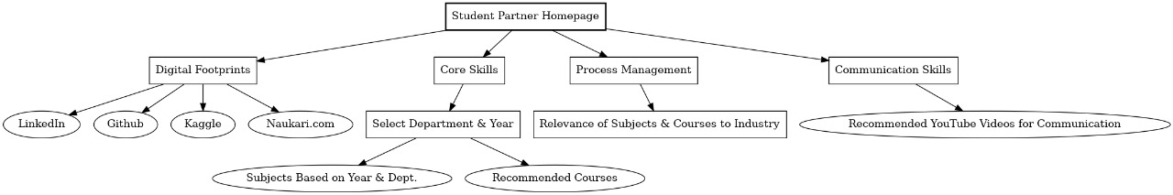

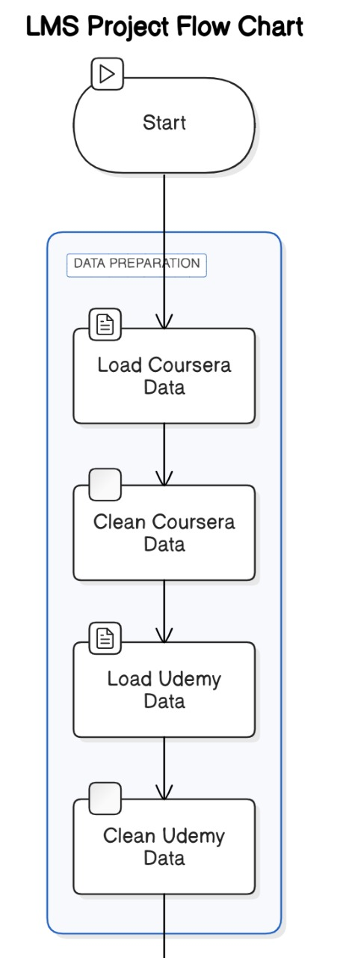

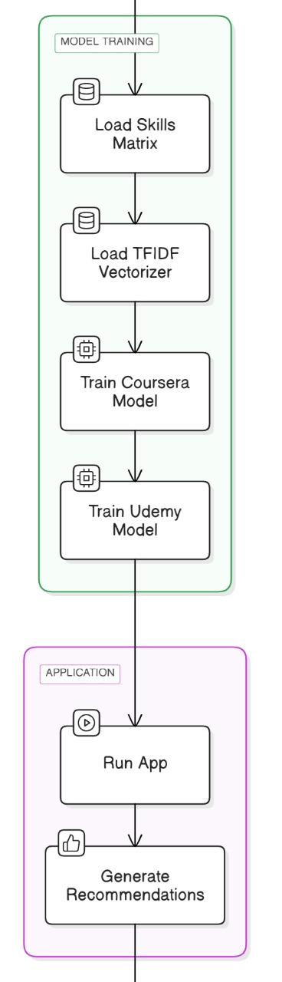

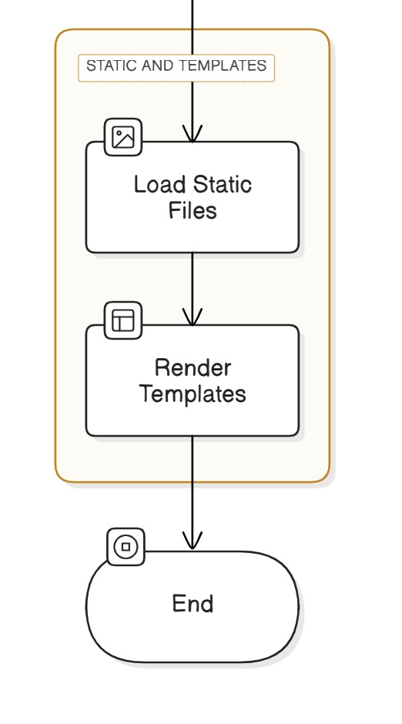

* 1. **Advantages**
* **Personalized Learning:** The recommendation system provides tailored course suggestions based on user skills and goals, improving learning efficiency.
* **Skill Enhancement:** The platform helps users build both technical and soft skills through targeted courses and resources.
* **Improved Career Readiness:** Digital footprint integration (LinkedIn, GitHub, etc.) allows users to showcase their achievements and connect with recruiters.
* **User Engagement:** Interactive learning modules and feedback mechanisms keep users motivated and engaged.
  1. **Requirement Specification**

**1. Functional Requirements**

* **User registration and profile management.**
* **Personalized course recommendations based on user data.**
* **Provide communication skill resources (videos, links).**
* **Track user progress and give feedback.**

**2. Non-Functional Requirements**

* **Fast and accurate recommendations.**
* **Secure user data and prevent unauthorized access.**
* **Handle multiple users without performance issues.**
* **24/7 platform availability.**
* **Simple and responsive user interface.**

**CHAPTER 4**

**IMPLEMENTATION & RESULT**

**Implementation :**

* The project was developed using HTML, CSS, Basic JavaScript and Flask for the project development.
* A course recommendation system was implemented using user profile data (skills, interests, career goals).
* Digital footprint integration allowed users to link LinkedIn, GitHub, Naukri, and Hugging Face profiles.
* Communication skills module provided helpful resources like videos and website links.

**Result :**

* The system successfully provided accurate course recommendations based on user profiles.
* Users were able to manage their digital footprint and showcase their achievements.
* The communication skills module helped improve user soft skills through targeted resources.
* The system successfully generated **personalized roadmaps** based on user skills and career goals.

**CHAPTER 5**

**CONCLUSION**

The project successfully created a personalized learning platform that helps students improve their skills and achieve career goals. The course recommendation system, digital footprint integration, and communication skills module provided a complete learning experience. The platform offers clear guidance and effective learning paths to help students succeed in their careers.

**5.1 ADVANTAGES:**

* **Personalized Learning: Tailored course recommendations based on user skills and goals.**
* **Skill Development: Improved technical and communication skills through targeted resources.**
* **Professional Visibility: LinkedIn, GitHub, and other profile integration enhance career opportunities.**
* **Progress Tracking: Users can monitor their learning progress and receive feedback.**
* **User Engagement: Interactive learning and feedback increase motivation and retention.**

**5.2 SCOPE:**

* **Expanded Course Library: Adding more courses covering a wider range of skills and industries.**
* **AI-Based Recommendations: Improving course recommendations using advanced machine learning algorithms.**
* **Global Reach: Expanding the platform to support multiple languages and regions.**
* **Enhanced Mentor Interaction: Introducing live sessions and direct Q&A with mentors.**
* **Certification and Job Placement: Providing recognized certificates and helping users connect with job opportunities.**

**GITHUB LINK**

[**Prayesh13 (Prayesh Godhani) · GitHub**](https://github.com/Prayesh13)

**PROJECT LINK**

[**https://d.docs.live.net/4a01b6b600939579/Desktop/Report.docx**](https://d.docs.live.net/4a01b6b600939579/Desktop/Report.docx)

**REFERENCES**

**Udemy recommendation dataset link** [**https://www.kaggle.com/datasets/yusufdelikkaya/udemy-online-education-courses/data**](https://www.kaggle.com/datasets/yusufdelikkaya/udemy-online-education-courses/data)

**Coursera course recommendation dataset**

[**https://www.kaggle.com/datasets/khusheekapoor/coursera-courses-dataset-2021/data**](https://www.kaggle.com/datasets/khusheekapoor/coursera-courses-dataset-2021/data)

**Roadmap :**[**https://roadmap.sh/**](https://roadmap.sh/)