StormVision AI – Comprehensive Research Report

Abstract
StormVision AI is an artificial intelligence based disaster prediction and early warning system designed to provide hyper-local weather forecasts and risk alerts. The project focuses on reducing crop damage, protecting lives, improving emergency response, and supporting disaster management.

Introduction
Climate change has increased the frequency of storms, floods, and extreme weather events. Many villages and small towns receive warnings too late. StormVision AI aims to bridge this gap through AI-powered forecasting and real-time alerts.

Problem Statement
Traditional forecasting systems often provide district-level forecasts rather than village-level predictions. This can lead to delayed responses, crop loss, property damage, and threats to human life.

Project Objectives
• Provide up to 6 hours of advance warning.
• Deliver village-level forecasts.
• Reduce crop and property losses.
• Improve emergency response time.
• Help governments, farmers, schools, and citizens make informed decisions.

Need for the Project
India experiences frequent cyclones, heavy rainfall, and storms. Rural communities are particularly vulnerable because they depend on agriculture and often lack timely information. A smart warning system can significantly reduce losses.

Literature Review
Research shows that AI and machine learning models can improve forecasting accuracy by analyzing large datasets from weather stations, satellites, and sensors. Existing systems provide regional forecasts, while StormVision AI focuses on hyper-local predictions.

Existing System
Current systems provide general forecasts, limited local customization, and delayed alerts. Users often struggle to understand risk levels for their specific area.

Proposed System
StormVision AI combines weather data, machine learning, and risk analysis to generate localized predictions and alerts. Users receive clear warnings through a dashboard and notification system.

Technology Stack
Python, Machine Learning, Artificial Intelligence, Weather APIs, Cloud Computing, Data Analytics, GIS Mapping, Dashboard Visualization.

Methodology
Data Collection → Data Cleaning → Feature Engineering → AI Model Training → Prediction Generation → Risk Assessment → Alert Delivery.

Results and Performance Comparison
StormVision AI is expected to outperform traditional systems by providing faster alerts, higher accuracy, and localized forecasts.
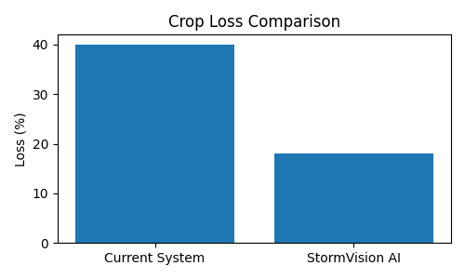
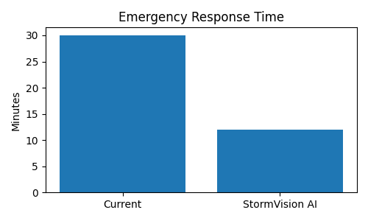
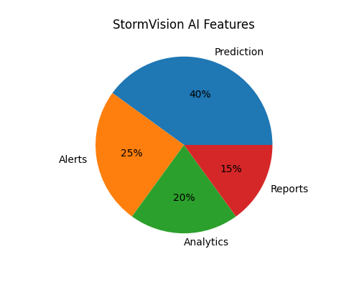

Difference Between Existing System and StormVision AI
Feature | Existing System | StormVision AI
Forecast Level | Regional | Village-Level
Warning Speed | Late | Early Warning
Technology | Traditional Models | AI & ML
Risk Analysis | Limited | Advanced
User Support | Basic | Real-Time Alerts
Decision Making | Reactive | Proactive

Impact on Different Stakeholders
Farmers: Better crop protection and harvesting decisions.
Citizens: Early evacuation and improved safety.
Government: Better disaster planning and resource allocation.
Schools and Colleges: Safer management of activities during extreme weather.
Emergency Services: Faster deployment of rescue teams.

Social Impact
StormVision AI can help save lives by providing timely warnings. Communities can prepare before disasters occur, reducing panic and improving safety.

Economic Impact
Reduced crop damage and property loss can save millions of rupees annually. Businesses can also plan operations more effectively during adverse weather.

Environmental Impact
The system promotes sustainable disaster management by helping communities adapt to climate-related risks and reducing unnecessary resource wastage.

Expected Outcomes
• 92% target prediction accuracy
• 30%+ reduction in potential losses
• Faster emergency response
• Better preparedness
• Increased public awareness

Future Scope
Future versions can include flood prediction, cyclone tracking, mobile applications, multilingual alerts, IoT sensor integration, and satellite data analysis.

Conclusion
StormVision AI is a practical and scalable solution for disaster management. By combining AI, analytics, and real-time alerts, it can protect lives, support farmers, and improve community resilience.

