
Getting Started with R and R-Instat – Chapter 2
Contents
1. introduction 1
2. An example of experimental data 1
Correcting the data 4
Examine the corrected data 7
3. A survey on maths anxiety 9
Entering Data 10
Changing the column names 13
Positive and negative questions 15
A Likert graph 16
4. Another set of experimental data 19
Using a transformed variable 22
Reversing the Ranks 24
5. Graphs and summaries 25
A scatterplot 26
More scatterplots 30
Multiple plots 32
Tables and graphs are similar 34
6. Reflections 39

introduction
This chapter develops practical skills for working confidently with real data. Through experimental and survey examples, we inspect, check, correct, reshape, label, transform, and explore data using pivot tables and graphs.
Data is at the centre of data science. Too often, teaching starts with tools and methods, so real data can feel like a shock. Real datasets are often messy, unevenly structured, and full of decisions. We begin, as in Chapter 1, with the data and the practical work they require.
Chapter 1 introduced the habits; Chapter 2 practises them in new situations. The examples are specific, but the skills are general. As you work through them, focus not only on which buttons to press, but on the wider habits: looking carefully, checking what the software produces, correcting problems, and choosing displays that help you understand the data. Throughout the chapter, factors provide much of the structure that makes the exploration possible.

An example of experimental data
In this section: We introduce experimental data through a bamboo trial, using it to show how R-Instat supports data import, checking, correction and early exploration.
As in chapter 1,
- Start R-Instat and select Import from Library.
- Click on the down-arrow in the From Package control, Fig. 1.
- Go up to the package called agridat,
- This package provides many datasets. Scroll down to one called jayaraman bamboo, Fig. 1.
- Press Ok.
Fig. 1: Import from Library dialog | Fig. 2: The bamboo data
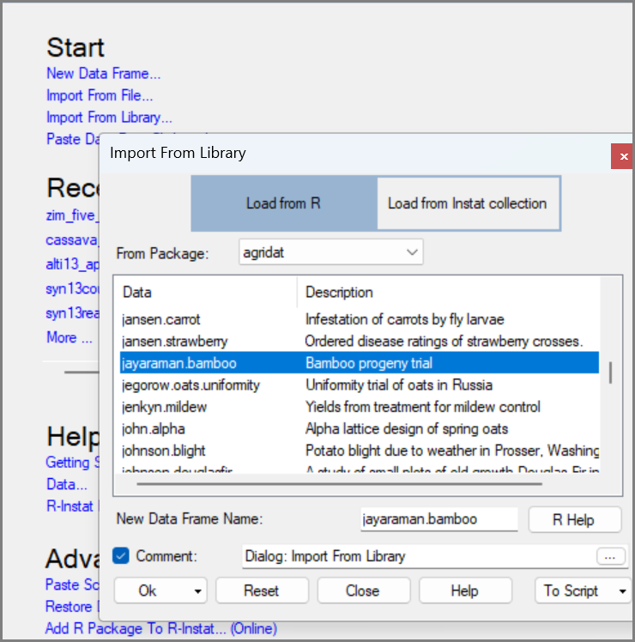 | 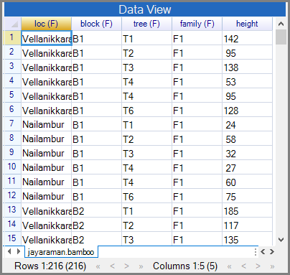
As usual, start by looking at the data. There are 216 rows and 5 variables. Four of the variables are factors. They give information on the layout of the trial. That’s in the variables loc, block and tree. Then the treatments are the different families of bamboo.
Look at the data in a pivot table.
Pivot tables/charts are a great way to look at and analyse your data in a spreadsheet. If you use a spreadsheet with your data, and don’t use pivot tables, then you missing their best feature.
We hope you are pleasantly surprised that R also has pivot tables.
We have more materials on pivot tables here.
- Use Describe > Two/Three Variables > Pivot Table, Fig. 3.
- Put the 3 variables loc, bloc and family into the rows.
- Click in the second (column) receiver and put tree.
- Click the variable checkbox and include the heights, Fig 4.
- Press Ok. Then click on Maximise in the Output Window
Fig. 3: Describe > Two/Three Variables > Pivot Table | Fig. 4: The Pivot Table dialog
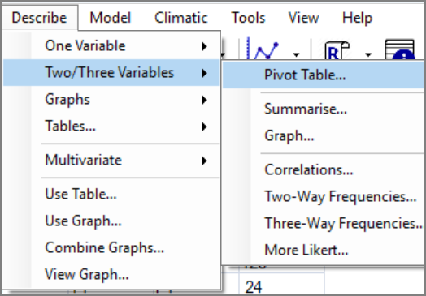 | 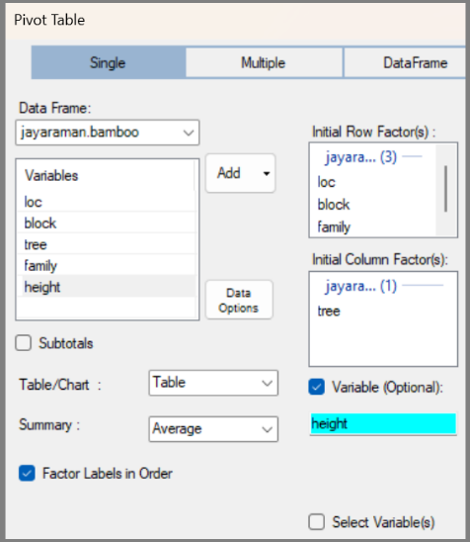
Fig. 5 is a convenient layout to continue exploring the heights.
- Click the down-arrow in the top left corner, Fig. 5 and change Table to Heatmap.
The data now go from white for low values, to red for large values. This helps to show the pattern and to spot outliers.
Fig. 5: Pivot Table | Fig. 6: Heatmap
 | 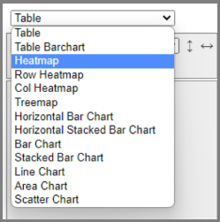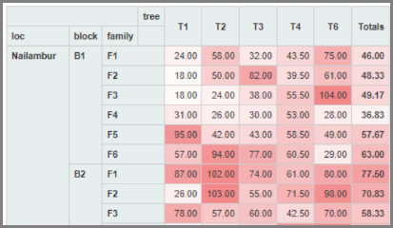
As a data detective, have you yet noticed anything odd about the data? The tree numbers are given as T1, T2, T3, T4 and T6. There is no T5.
We have included all the factors in the pivot table. So, we should be examining individual data values. But are we?
- Click on the down arrow by Average, Fig. 7, and change it to Count.
The result is clear. The good news is that the error is consistent, i.e. the frequency of T4 is always 2, for every site, block and family. This is clearly a mistake and should be easy to correct?
- Close the window to return to the data
Fig. 7: Change Average to Count | Fig. 8: By Count
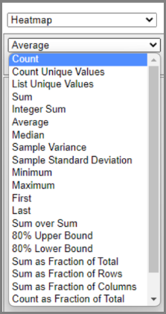 | 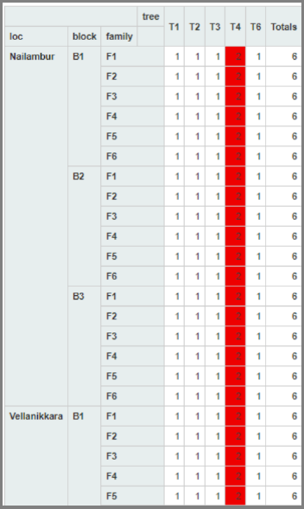
Returning to the data, the error is clear, Fig. 9. There are duplicate T4 values, the second of which should be changed into T5. Of course, R has everything you need to correct this.

Correcting the data
- Use Prepare > Check Data > Duplicate Rows, Fig 10
Fig. 9: The duplicate values | Fig. 10: Prepare > Check Data > Duplicate Rows
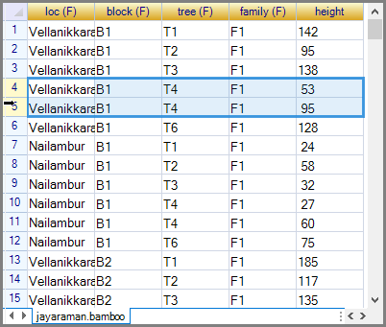 | 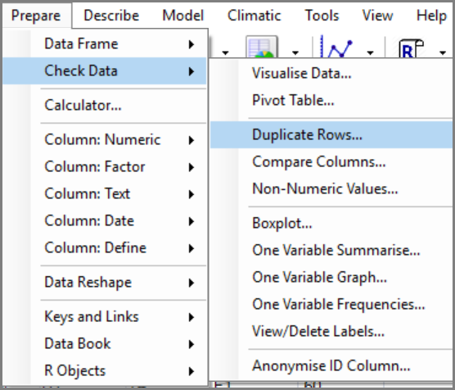
- Include all the factors. Then use the third radio button to get the index number of each duplicate, Fig. 11. Press Ok.
This produces a new variable, called dup, that is 2 in each row where T4 is to be changed into T5.
- So, right click and choose the option to Filter rows, Fig 12.
Fig. 11: Duplicate Rows dialog | Fig. 12: Right-click > Filter Rows
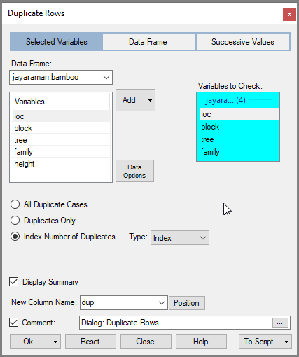 | 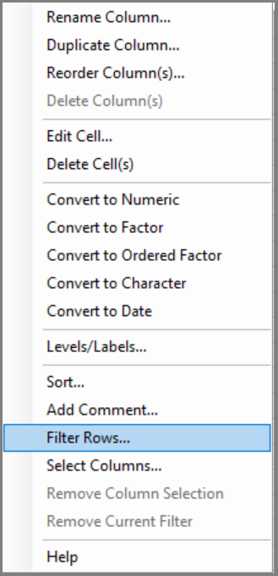
- In the filter dialog press the Define New Filter button.
- In the sub-dialog, select dup. Choose the == condition and add 2. Fig 13.
- Press Add Condition, then Return.
- Back in the main Filter dialog press Ok.
Now look carefully at the filtered data, Fig. 14.
The left-hand column is now coloured red, to indicate a filter is applied. At the bottom, there are stated to be 36 filtered rows. That is 1 in 6 of the 216 rows overall, so as expected.
- Now right-click to (temporarily) make the Tree variable of character type, Fig. 14.
We often make character columns into factors. This time we go "the other way" because it is easier to add the missing T5 to a character column than a factor column. Then we can switch it back to a factor where its complete levels are recognised correctly.
Fig. 13: Filter dialog and sub-dialog | Fig. 14: The filtered data  Right-click > Convert to Character
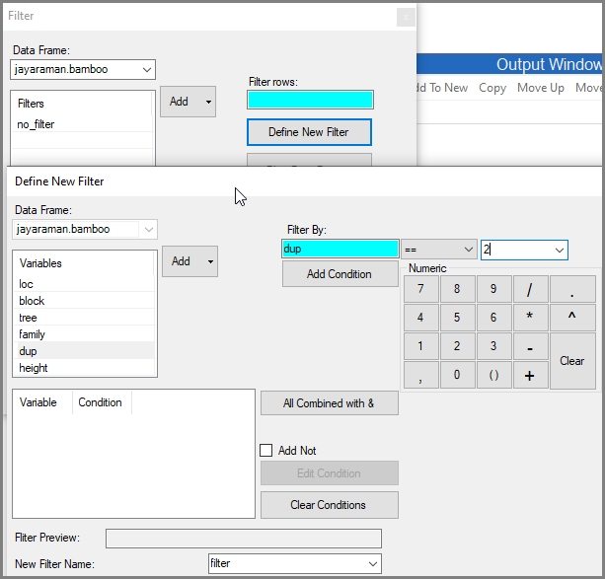 | 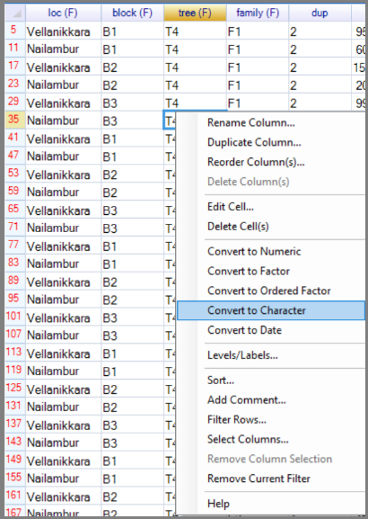
- Use Prepare > Data Frame > Replace Values, Fig. 15.
- Select the variable tree. For the old Value, put T4. In the New section choose the Value button and put T5. Press Ok.
Now we have T5 in the data, Fig. 16! Just a couple of tidying steps are needed now, to finish the correction.
- Right-click anywhere and use the option Remove Current Filter, Fig. 17.
Fig. 15: Replace Values dialog | Fig. 16: Right-click > Remove Current Filter
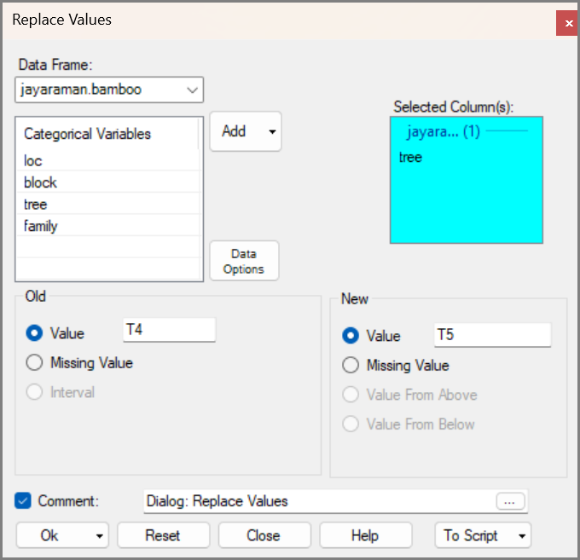 | 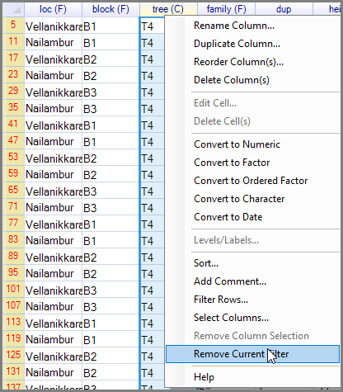
- Right-click from within the tree column and Convert to Factor.
- Then check, by right-clicking in the tree column again and choosing Levels/Labels, Fig. 17.
The results show there are now 6 levels and also that each has 36 replicates. This is, as we would expect, given the simple design of this trial.
Delete the extra column, called dup, as it is no longer needed.
- Right-click in the name dup and choose Delete Column(s). Answer Yes to the confirming question.
Fig. 17: Right-click > Levels/Labels | Fig. 18: Levels/Labels dialog
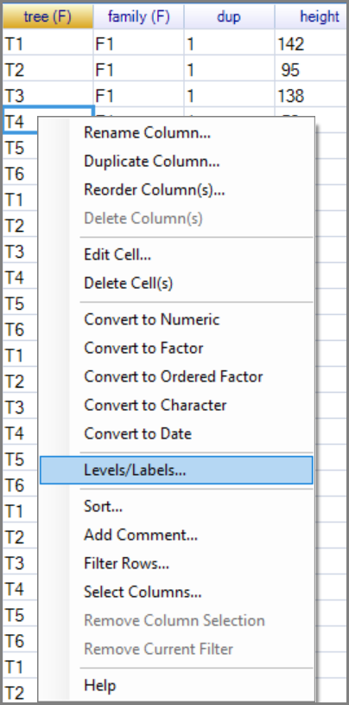 | 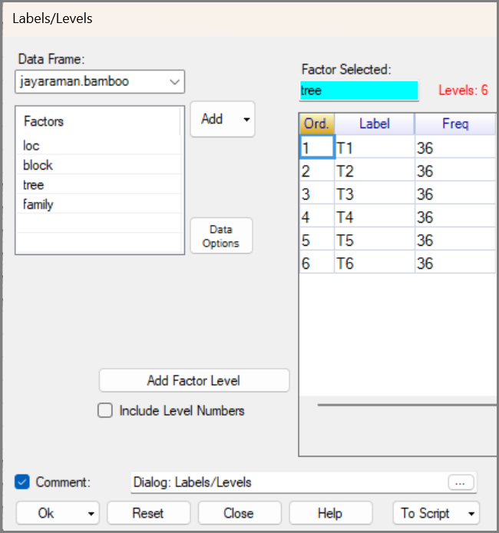
Phew! Now quickly check all the factor columns. An easy way is via the Summarise dialog.

Examine the corrected data
- Use Describe > One Variable > Summarise. Use the Add down, button, and Add All, Fig. 19.
- Press Ok.
Fig. 19: One Variable Summarise dialog | Fig. 20: The Summary
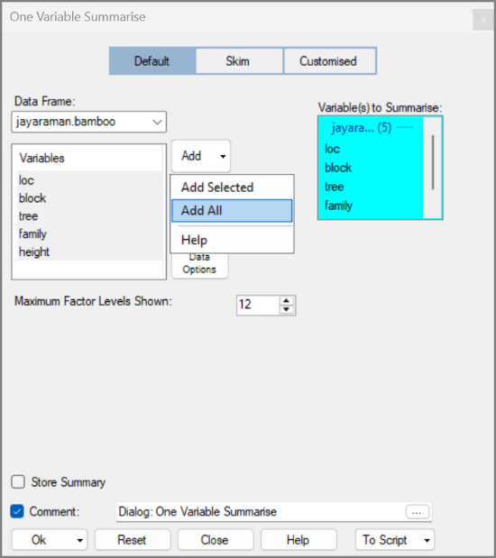 | 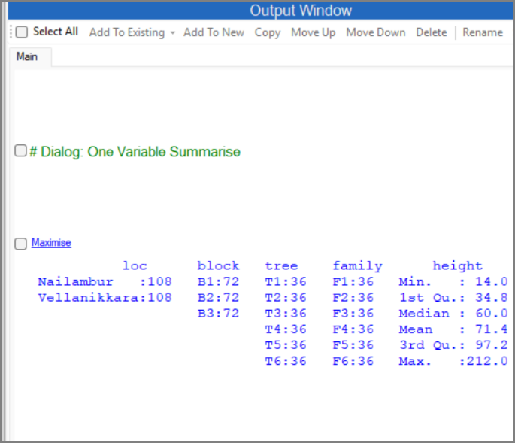
This summary gives a nice view of the trial’s layout. It was equally split over two locations, each of which were divided into 3 blocks. The tree and family factors look sensible, and the heights of the trees range from 14 to 212.
Now we still want to show the heights in a pivot table. Last time we were distracted by the omission of T5.
- Return to the Pivot Table dialog. This is just as you left it, Fig, 21, so simply press Ok.
- Click on Maximise.
- Before continuing, change the summary to Count once more to confirm that each combination now occurs only once, Fig. 22.
Fig. 21: Pivot Table dialog | Fig. 22: The Count
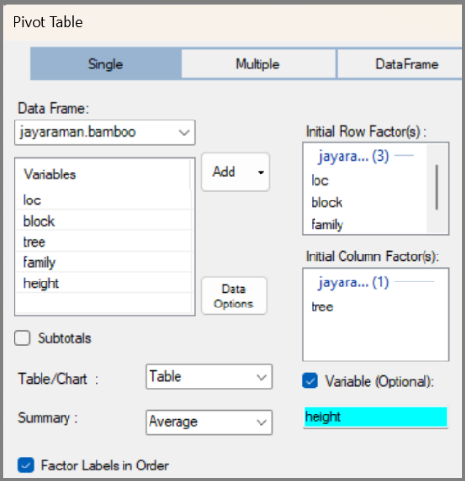 | 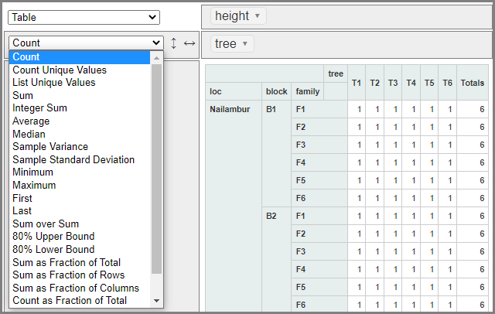
This confirms that you are looking at individual data values, and the trial is nicely balanced.
- Return to the average heights and to a Heatmap, Fig. 23.
Examine the data briefly. For example, all the really high trees are in the second location, but some there remain very low. And that includes the smallest tree with a height of 14, (as noted in the Summarise results in Fig. 20).
Fig. 23: The heatmap
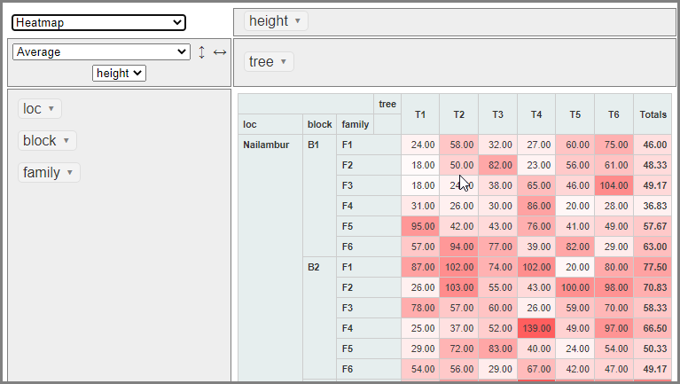

Close the window once you have finished.
- Use File > Save As > Save Data As and save a copy of your corrected data file.
- Use File > Close Data Book and confirm Yes.
The bamboo data have now been checked, corrected and saved, ready for later analysis. This example is more than a correction exercise. It shows a common workflow: start by looking at the data, use a table or graph to reveal structure, check anything that looks odd, make a careful correction, and then check again.

A survey on maths anxiety
In this section: You turn from an experiment to a survey. A small maths anxiety dataset introduces ordered factors and the practical issue of handling long column names. The MICS example in Chapter 1 showed why names, labels, and types matter in larger datasets. Here we apply the same idea on a smaller survey: the full questions are useful as labels, but shorter names make the data easier to work with.
- File > Import from Library.
- Choose the likert package, Fig. 25, and select the mass dataset. Fig. 25.
Fig. 25: Import from Library dialog | Fig. 26: The Maths Dataset
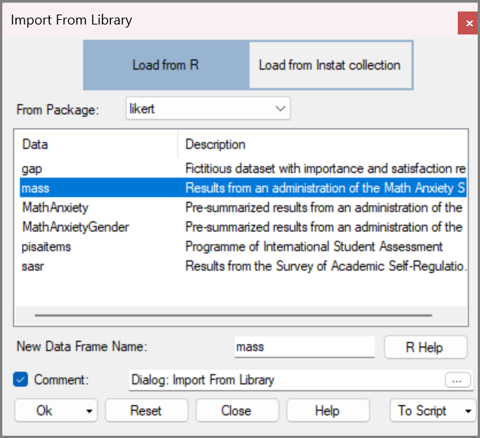 | 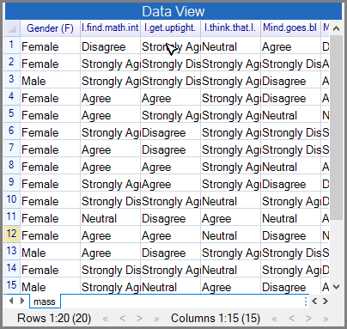
These data are from a small survey, where 20 respondents gave their views on maths.
There are 14 questions in the survey, and each gives the result on a 5-point scale. In R these are each Ordered Factors, going from Strongly Disagree to Strongly Agree. There is therefore an (O.F) after the variable names, in Fig. 26.
The column names are also quite long, because they double as the questions.

Entering Data
R-Instat is not primarily a data-entry system, but small additions and corrections can be made directly. Here we add your own responses to the survey.
Start by adding an extra row to the data.
- Use Prepare > Data Frame > Insert Columns/Rows, Fig. 27.
- Press the Insert Rows button Fig. 28.
By default, this is set up to add one row at the bottom of the data set. You can choose to add more rows and place them in a specific place. But in our case the default is fine.
- Press Ok, Fig. 30.
Fig. 27: Prepare > Data Frame > Insert Columns/Rows | Fig. 28: Insert Columns/Rows
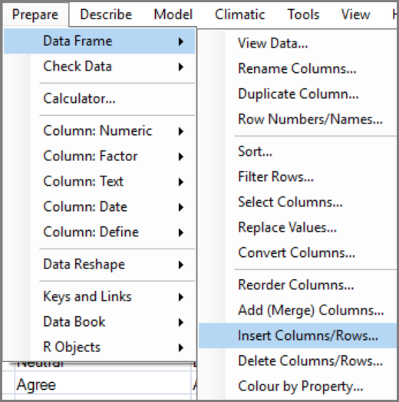 | 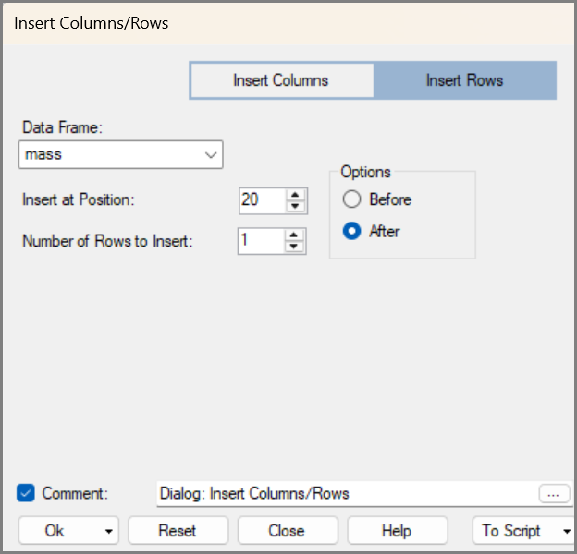
This makes a 21st row, currently filled with all missing values.
- Right-click in the NA in the Gender column and choose Edit Cell, Fig. 29.
- Click the down arrow on New Value and select the level. For us it was Female. Press Ok.
Fig. 29: Right-click > Edit Cell | Fig. 30: Edit Cell dialog
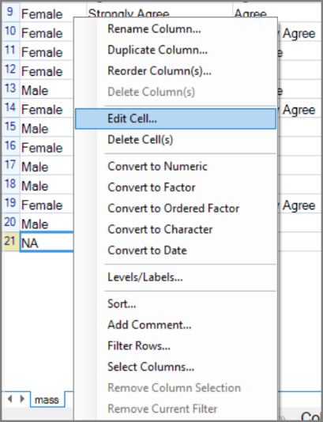 | 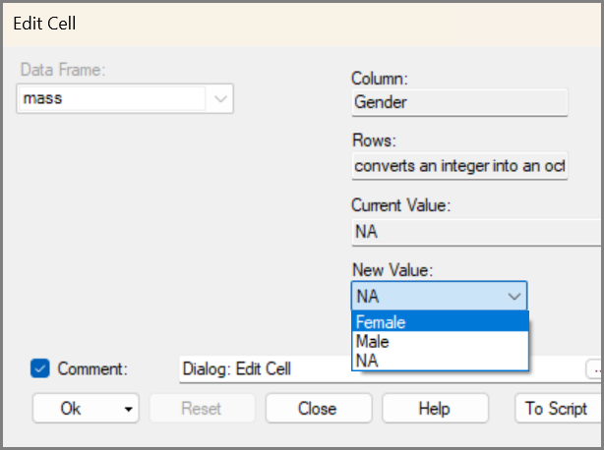
- Repeat for the first question, “I find math interesting”, Fig 31. We chose “Strongly Agree”!
- Repeat again for the second question “I get uptight during math tests”, Fig. 32. We chose “Strongly Agree”.
Fig. 31: Edit Cell dialog | Fig. 32: Edit Cell dialog
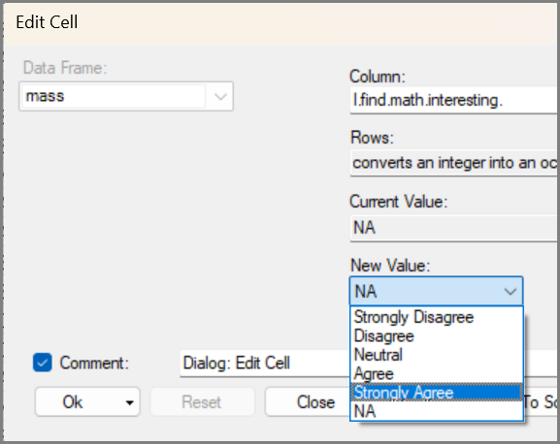 | 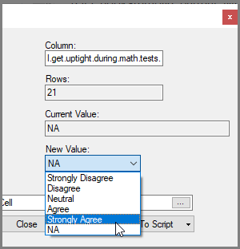
- Click on the 6th toolbar icon 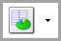; this shows the output.
Now the whole R-Instat window shows the data.
- Enlarge the variables in turn, Fig. 33, to show each question in full.
- Complete the answers to each question.
- Either click on icon again, or use the curly arrow, to return to the 2 windows.
- Use File > Save As > File Save Data As, Fig. 24, and save your copy of these data.
Fig. 33 : The Expanded Data View
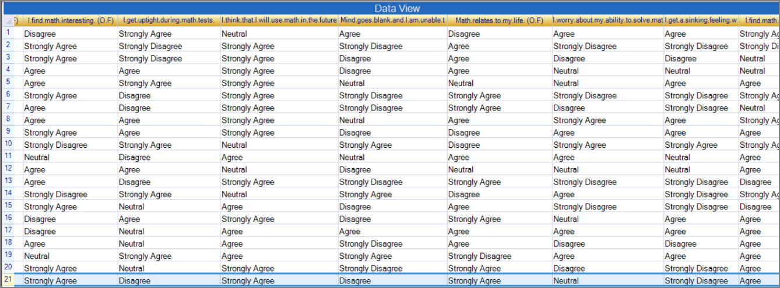
This short exercise shows how R-Instat can be used to add and edit data directly. Notice that you could only enter one of the 5 levels of the factor. And you chose rather than typed them. Had they not been defined as factors, you would have had to type – and then it is easy to make mistakes.
Data are often entered into spreadsheets. We often find data there are often typed, and then arrive with many errors. It is easy to set up a template so categorical data can be entered easily, just as we did above. We strongly suggest that time be devoted to setting up a suitable template, whenever a spreadsheet is used for data entry.

Changing the column names
The top row of each data frame shows the column names and data types. These names are part of the data structure: they appear at the top of each data frame and in the data selector in every dialog. Tidying data therefore includes checking the names and editing them when needed. R has strong tools for naming and renaming columns, and these underlie the Rename dialog used in R-Instat.
In this dataset, the column names contain the full survey questions. This information should be retained, but the questions are too long to work well as column names. We therefore store them as variable labels instead, and substitute short, meaningful names. This is consistent with the names and questions in the MICS survey, described in Chapter xxx.
So, as usual, we have some data tidying to do, before analysing the data.
- Right-click in the data, and choose the first option, to Rename Column.
- Choose the Multiple button at the top. Click the checkbox to include variable labels.
- Select the whole New Name column by clicking on its name, Then, press <ctrl>C to copy to the clipboard.
- Click on the top of the Label column and press <ctrl>V to paste into the labels, Fig. 35
- Press Ok.
Fig. 34: Output Icon | Fig. 35: Rename Columns dialog
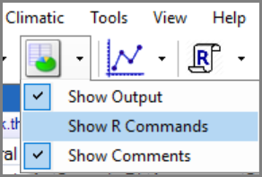 | 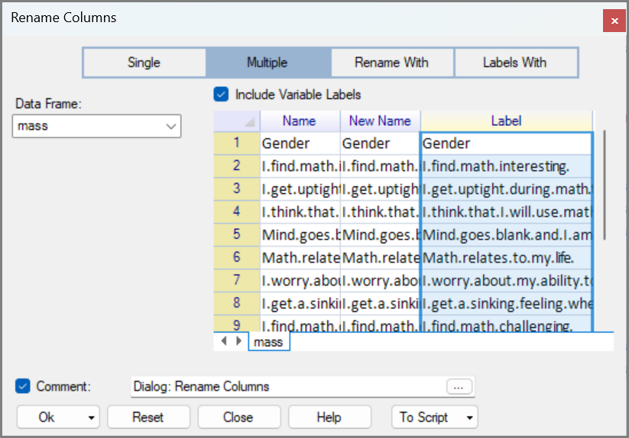
For the next step it is convenient to use the column metadata view of the data.
- Click the down arrow next to the data icon. Choose to Swap Data with the Column Metadata, Fig. 36.
- The metadata shows the (long) names are now also copied into the variable labels.
- Make the names column quite wide, and the labels column very wide, Fig. 37.
We change the column names here, rather than in a dialog. We describe in detail for the first name, because care is useful here:
- Double-click in the first long name, to edit it. Then press <ctrl> A to mark the whole name.
- Type interesting as the new name. Then press <Enter> or click on the next name.
- Repeat for each name, i.e. double-click to edit, then <ctrl> A to change the whole name, then type the new name.
If you get an error message telling you it is not a valid name, check that you haven’t put a space in there somewhere. Spaces are not allowed in names. If you want to use two words, then separate them with an underscore, or a dot.)
- The second question could be named uptight and the third could become future, Fig. 37.
Fig. 36: Swap Data with Column Metadata | Fig. 37: Column Metadata
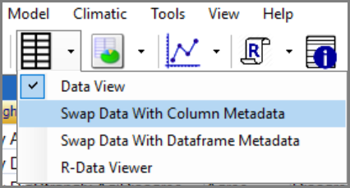 | 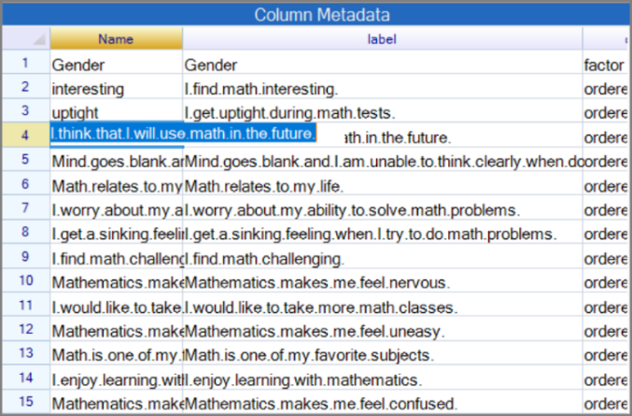
Finally, we can also improve the new variable labels. The questions currently have a dot between each word, because spaces are not allowed in a column name. But they are fine in a label so we get rid of all the dots.
- Return, via the toolbar, to the Rename dialog. Press the final top option, Label With.
- Choose Edit. Then the final option in the drop down, namely Contains All, Fig. 38.
- Then Replace dot, by <space>, Fig. 38. Then Ok.
Fig. 38: Rename Columns dialog
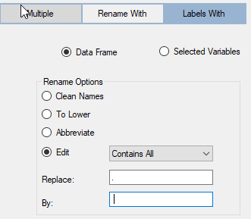
This is not just housekeeping. In R-Instat, column names and types are part of the structure of the data. Clear, consistent names make later analysis easier, especially when a study has several related data frames or sheets.

Positive and negative questions
Six of the 14 questions, e.g. “I find maths interesting”, are positive. The other 8 are negative. We split the variables into two sets.
- Right-click and choose Select Columns. Choose Define New Selection
- In the sub-dialog Add gender, and the 6 positive variables, namely interesting, future, life, more, favorite and enjoy, Fig. 39. Check 7 variables are selected.
- Press Add Condition and call the select positive. Then press Return and Ok.
Fig. 39: Columns Selection dialog
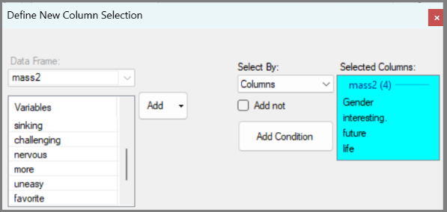
Examine the data. The column names are now red to confirm a select is being used. The bottom-line states that you are now using 7 out of the 15 variables.
Earlier, e.g. Fig. 14, when a filter was used, the left row was red. So, a select is for a temporary subset of the columns, just as a filter is for a temporary subset of the rows.
- Right-click and use Select Columns again.
- Repeat as above for the 8 negative variables. So, Define New Select
- In the sub-dialog Add gender, then, uptight, blank, to confused. Check you have 9 variables.
- Add Condition. Call the select negative, then Return and Ok.
The resulting subset is in Fig. 40. The preparation is now done and we move to the analysis.
It is even easier to apply a Select in a spreadsheet. Mark the columns you don’t want to show, then right click and choose Hide from the menu. The main difference in R-Instat is that a Select is kept as an Object. Hence you can make multiple selects and apply them, when needed. We give an example in Fig. 43, below.

A Likert graph
- We start with the positive variables. Right-click and Select Columns again, Fig. 42.
- Add the select called positive and press Ok.
Fig. 40: Negative Selection | Fig. 41: Column Selection dialog
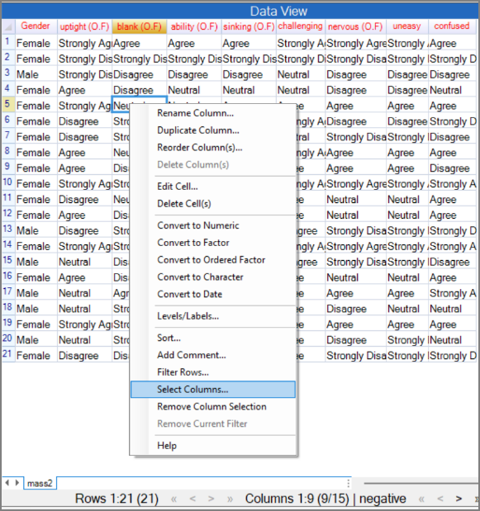 | 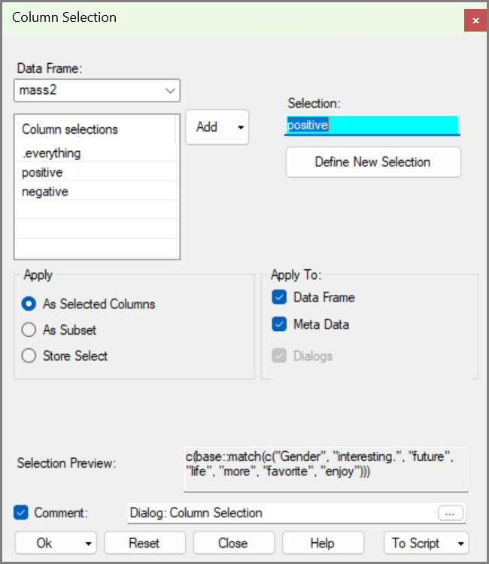
Fig. 44 shows the 7 variables in the positive select.
- Use Describe > Two/Three Variables > More Likert. Add all the variables, except Gender, into the receiver, Fig 42.
- Press Ok, then Maximise.
Fig. 42: More Likert Graph dialog | Fig. 43: Likert Graph
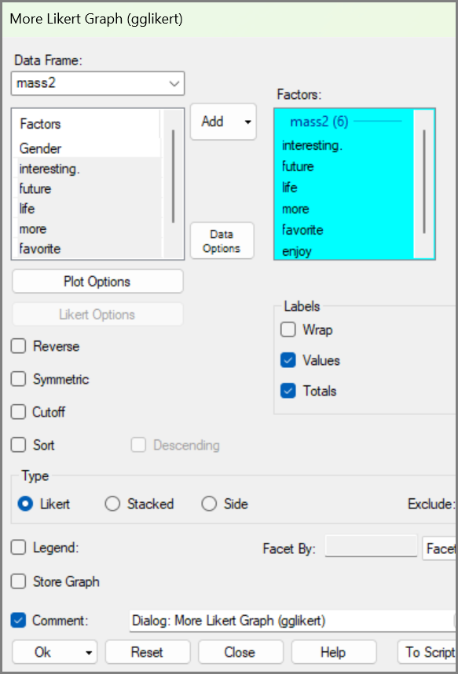 | 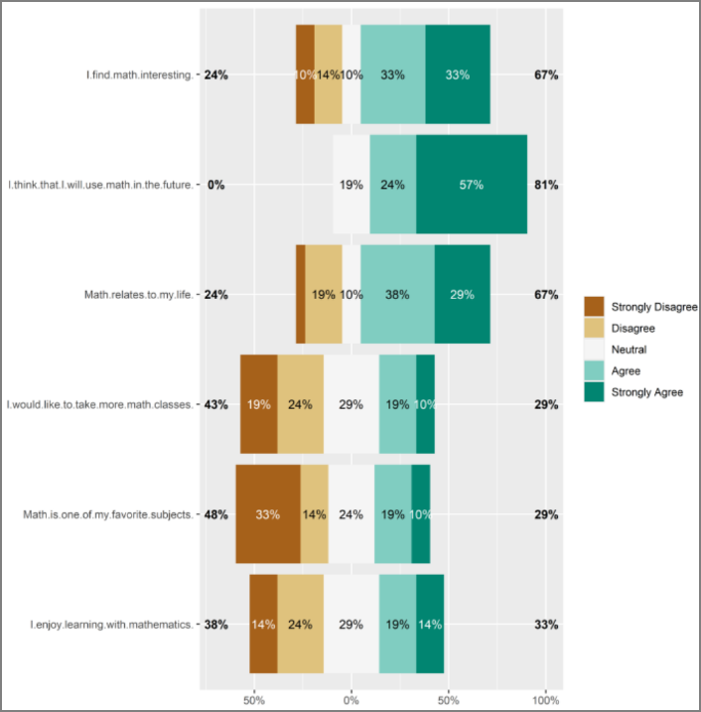
The results are in Fig. 43. We see that Likert graphs are basically bar charts. Compared to ordinary bar charts (in R) they are “on their side”.
At the bottom of the chart we see there is a zero in the middle. The values on the x-axis are positive percentages each side.
Bar charts in R also summarise the data, and chart the summaries. For example, the data in the column called interesting in Fig. 43 shows 7 Strongly Agrees out of 21, and 2 Strongly Disagrees. Those are presented as 33% and 10% in the top bar-chart in Fig. 43.
One detail we like is in the third graph, on the question “Maths relates to my life”. Just one person Strongly disagreed and the number in that (very narrow) box is omitted. The value is easy to find, if needed, because the Disagreed is 19% and the Negative total is 24%. The missing value is therefore 5%.
It would be good to split the results by gender – though the percentages will then be based on an even smaller sample.
- Return to the dialog. Click in the Facet receiver and Add Gender.
- Check the Legend checkbox as well and choose Bottom for the legend position. Press Ok.
Fig. 44: Likert Graph | Fig. 45: Likert Graph Comparing Male and Female
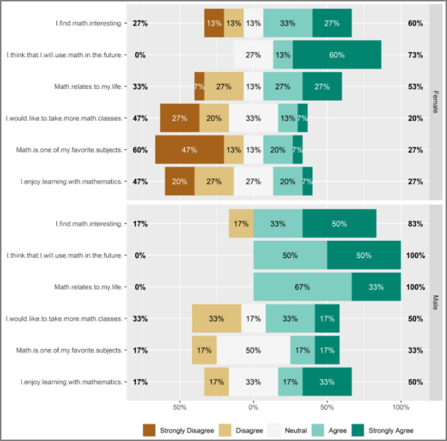 | 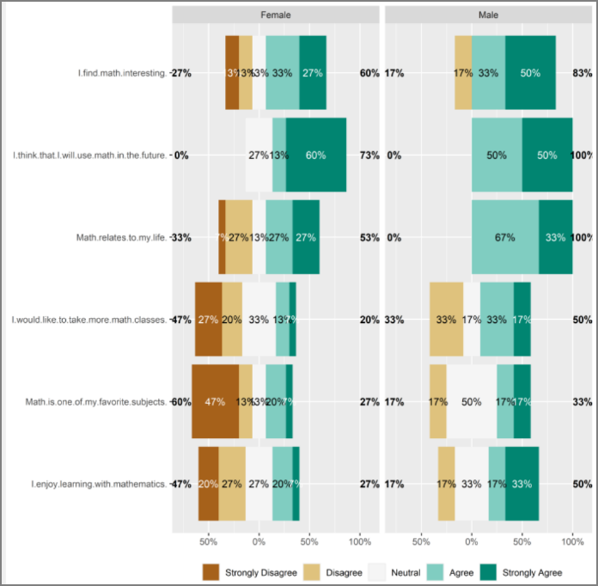
The graph in Fig. 44 is impressive. That’s because R is really impressive, and the graphs are excellent.
But, as a new results detective, you could do better. The main reason for Fig. 44 is to compare males and females. This is quite tricky with the layout in Fig. 44.
- Return to the dialog. Press the down arrow at the bottom right, where it says Facet Wrap and select Facet Col instead. Press Ok, and Maximise.
That layout in Fig. 45 makes the comparisons much easier. One result is that men were more enthusiastic than the women about maths, at least on the positive questions.
Next, look at the results for the negative questions. Changing a filter, or a select, is needed so often, that it can be done from within each dialog.
- Return to the Likert dialog and press the Data Options button.
- At the top, choose columns, and change the select to negative, Fig. 46. Press Return.
- Then simply press Ok.
Fig. 46: More Likert Graph dialog | Fig. 47: Likert Graph dialog
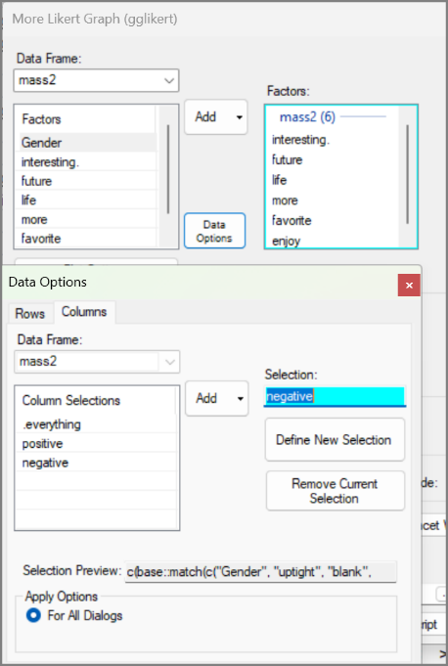 | 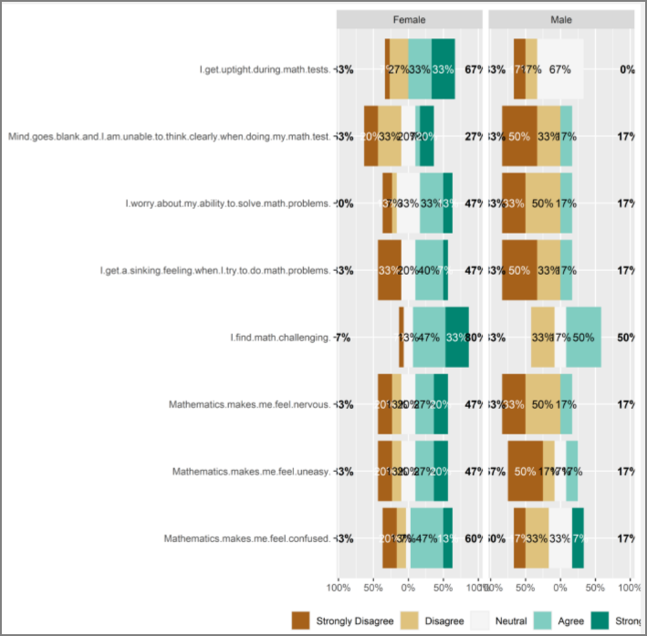
One conclusion from here, though just for the small sample, is that the enthusiasm for maths is confirmed as being more for the men compared to the women.
If you are so far used to tables having just numbers, (and maybe being dull) while graphs are pictures, and fun, then these Figures might make you wonder what they are?

Another set of experimental data
In this section: You return to experimental data through an incomplete block trial. We use pivot tables and heatmaps to explore the design and compare varieties across locations. Turning the yield column into a rectangular display makes patterns, gaps and unusual values easier to see.
- Use Import from Library.
- Go back to the agridat package and choose the cochran.bib data. Press Ok.
Fig. 48: Import from Library dialog | Fig. 49: The incomplete block data
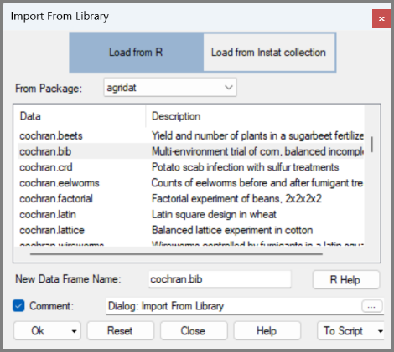 |  | 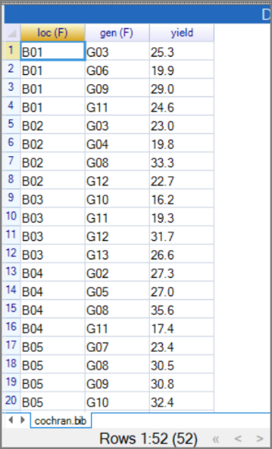
The data come from 13 blocks, B01 to B13, which we will refer to as locations. There are also 13 genotypes, G01 to G13, which we will refer to as varieties. In Fig. 49 there are 52 rows, because just 4 of the varieties were used at each location. There was just one measurement, namely the corn (maize) yield in pounds per plot. (A pound is an old UK unit, and is about half a kg.)
A pivot table shows the design. It gives a nice visual sense of the structure of the experiment.
- Use Describe > Two/Three Variables > Pivot Table.
- Make loc the row factor, gen the column factor and press Ok.
Fig. 50: Pivot Table of Layout
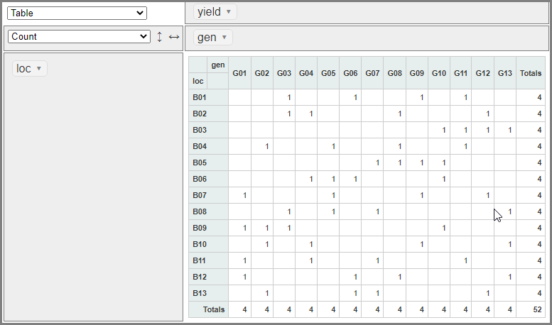
This shows that each location had 4 varieties, for example B01 grew varieties 3,6,9 and 11. Similarly, each variety was grown in 4 locations, so G01 was in locations 7,9, 11 and 12.
- In the pivot-table, Fig. 50, click the down-arrow that has Count and select Average. Use the yield column.
- Choose Row Heatmap instead of Table, Fig. 51.
Fig. 51: Row Heatmap
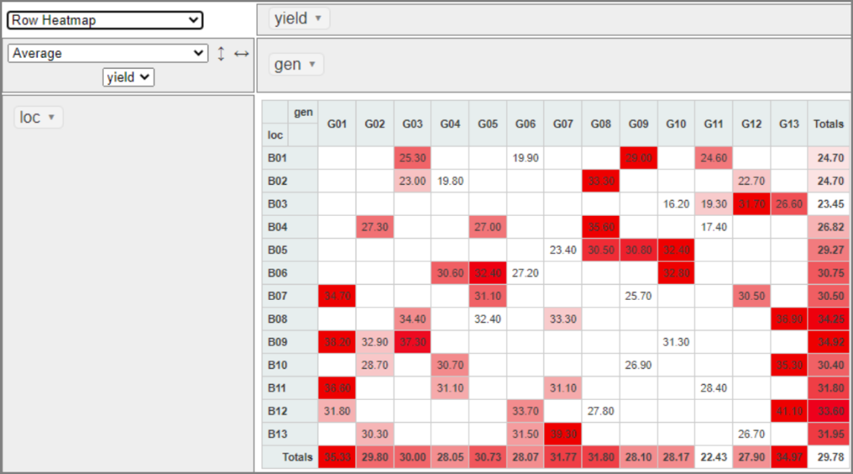
Now dark red indicates the highest (best) yield in that location and the lowest yield remains without colour.
The results show:
  - that genotype 1, in the first column, was the best (darkest red) in 3 of its 4 locations. The exception was location B12, where the yield of 31.90 was 3rd best there.
  - Similarly, in the last column in Fig. 51, before the totals, variety 13 was the best (darkest red) in 3 of its 4 locations. Its yield, of 26.6, was also the 2nd highest in the 4th location, namely B03.
  - The bottom row in Fig. 51 also shows varieties G01 and G13 have the highest mean yields.
One of the best features of pivot tables is how quickly and easily you can make changes and move things around.
- Change the Row Heatmap above, to just heatmap, Fig. 52.
Now look for the highest and lowest yields overall, see Fig. 52. This is the darkest red and is 41.1, from genotype 13 at location 12. That’s the only yield of over 40.
Fig. 52: Heatmap
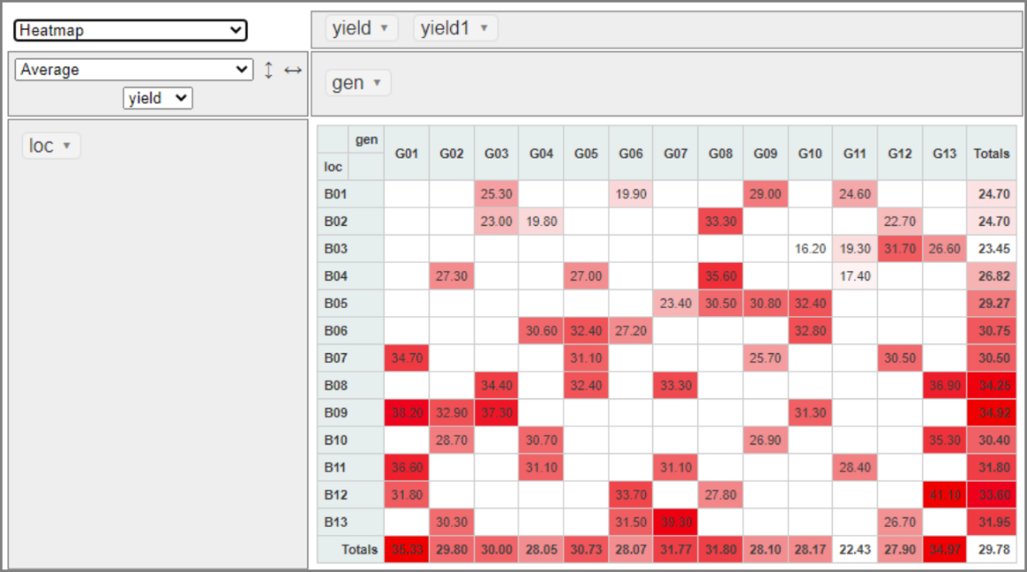
This trial shows how this pivot tables and heatmap has revealed both the experimental design and the strongest and weakest variety-location combinations—patterns that are difficult to see in a long column of data.

Using a transformed variable
It is often useful to transform data before analysis. The new variables may be used alongside the original values, or sometimes instead of them. In this example, we transform the yields into ranks: each yield is replaced by its position from lowest to highest. This gives a different view of relative performance. The wider point is that transformations are useful because they can reveal patterns, put values onto a more useful scale, or provide another way to compare the same data.
- Use Prepare > Column: Numeric > Transform.
- Press the third button at the top, called Rank. Select the yield variable. Call the new column ranks, Fig. 53, and press Ok.
Fig. 53: Transform yields to ranks | Fig. 54: Rank 1 | Fig. 55: Rank 52
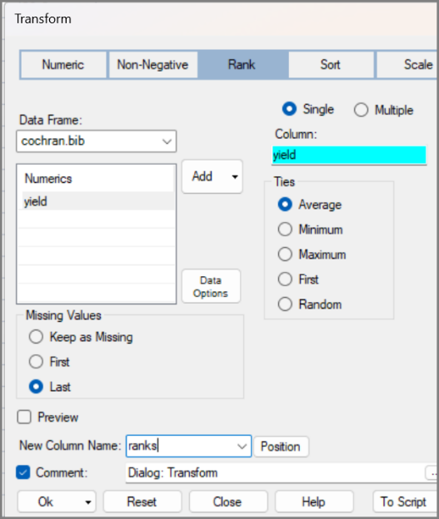 | 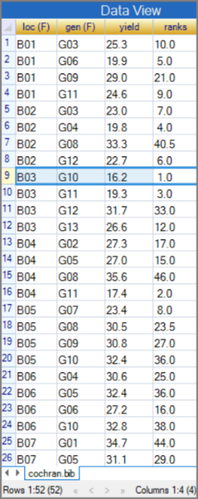 | 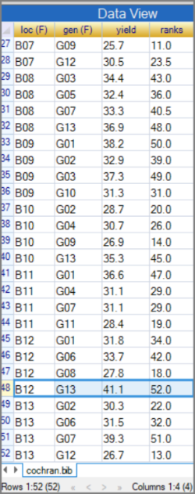
This produces a new variable, Fig. 56. This shows, for example, that row 9, with rank 1, has the lowest yield. That’s 16.2, for genotype 10 in location B03. The highest yield, with rank 52, Fig. 55 is in row 48. It is the 41.1 for genotype 13 in location B12.
- Return to the Pivot Table dialog
- Tick the Variable checkbox and add ranks.
- Change the Table/Chart to heatmap, Fig. 56. Press Ok.
- Then, press Maximise.
The resulting heatmap is in Fig. 57
Fig. 56: Pivot Table dialog | Fig. 57: Pivot Table Heatmap Layout
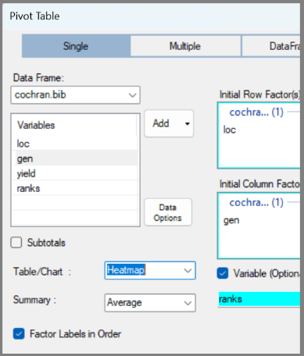 | 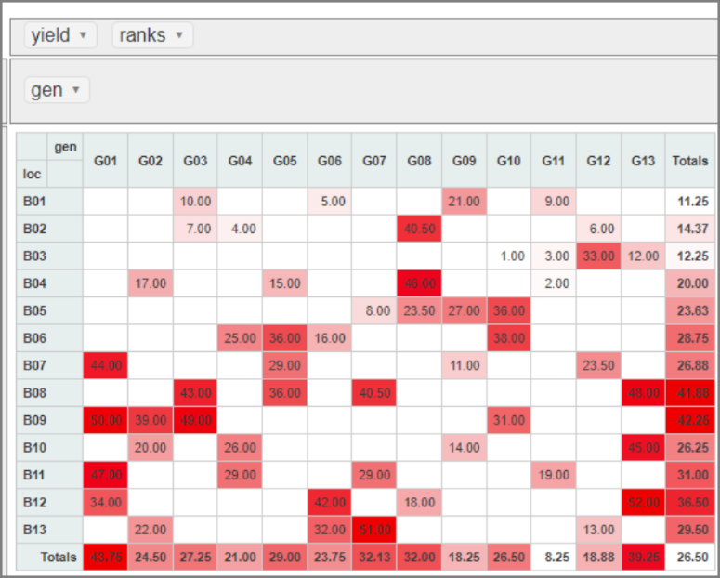

Reversing the Ranks
These ranks go from 1 to 52, with the largest yield having the highest rank. Suppose you prefer the reverse, so the best is in first place, i.e. with a rank of 1
The transform dialog is special because it includes an option to show the R command before running it, and allows you to edit it. This is a way to access some of the greater flexibility of R within the safety of the dialog.

- Return to the Transform dialog. Click on Preview.
You now see your first R command, namely rank(yield). All R-Instat dialogs generate R commands, but Transform has a Preview window where you can also see and edit the command.
- Click the Edit checkbox and add a minus, in front of yield. (R doesn’t mind spaces, so we added some; they are optional).
- Call the new column ranks1 and press Ok.
Fig. 58: Editing the code | Fig. 59: The reversed ranks
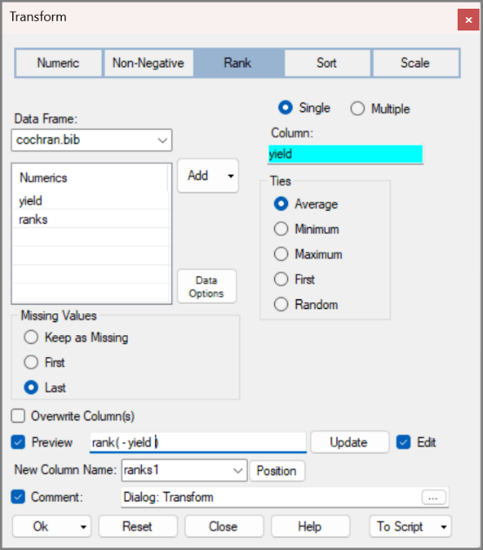 | 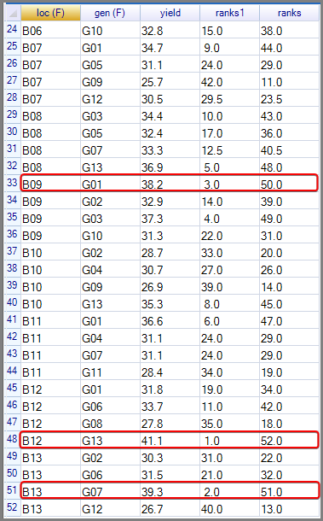
The ranks1 column now has the ranks in the opposite order, Fig. 59.
The ranks show that G01 and G13 perform better overall, but in different ways. All four G01 yields receive relatively high ranks, while G13 combines several very high ranks with one low rank of 12. G01 is therefore the more consistent performer, whereas G13 shows greater variation between locations. The original yields are still needed to show the size of these differences.

Graphs and summaries
In this section: Anscombe’s Quartet is a famous example of why graphs matter: its four datasets are very different but have identical summary statistics. It shows why numerical summaries should not be used alone. Here the aim is not simply to reproduce famous graphs. It is to practise using R-Instat to question numerical summaries, build graphs step by step, and decide whether the display supports the analysis; while showing a little of the power of R’s Grammar of Graphics system through ggplot2.
- Use File > Close Data Book
Then:
- Use File > Import from Library, from the usual front screen.
- You may be in the datasets package. If not press Reset.
- Select the anscombequartet file Fig. 60.
- Press Ok.
Fig. 60: Import from Library dialog | Fig. 61: anscombequartet data
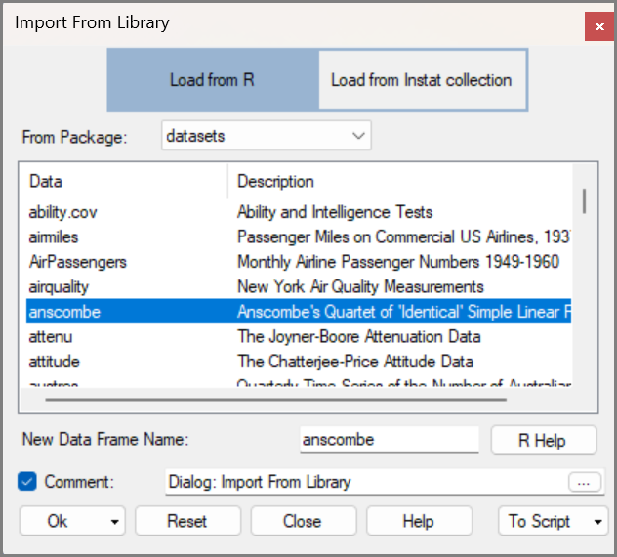 | 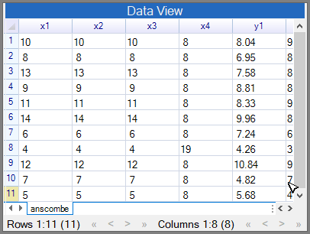
As usual, start by looking at the data. There are 8 variables each with 11 observations. From the column names we assume they are to be considered as 4 pairs, with y1, x1, etc.
- Use Describe One Variable > Graph. Add All Variables, Fig. 62, and press Ok.
The results are in Fig. 63. The first 3 boxplots look the same. Looking back at the data, Fig. 61, shows that the 3 variables (x1, x2 x3) are identical.
Then x4 has just 2 values. It is always 8 except for a 19. And y3 and y4 each have one large value, namely 12.74 and 12.5. The 12.5 in y4 is on the same row as the 19 in x4. But the 12.74 in y3 is not on the same row as the largest value in x3.
Fig. 62: One Variable Graph dialog | Fig. 63: The One Variable Graph
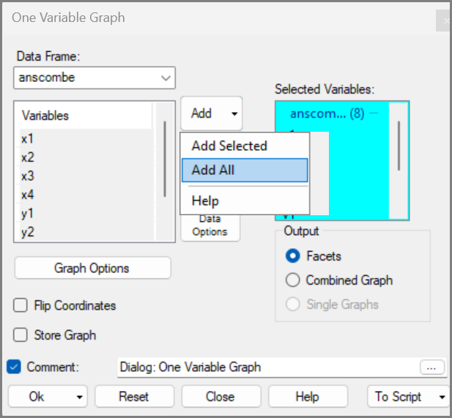 | 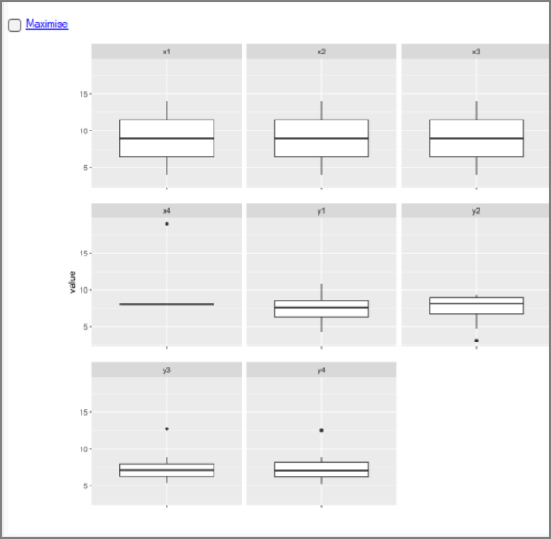

A scatterplot
- Use Describe > Graphs > Scatterplot
- Add the variable y1 into the top receiver. Then x1 into the x receiver.
- With just 11 points, make the points larger, by checking the size box and changing it to 3, Fig. 64.
- Press Ok.
Fig. 64: Point Plot dialog | Fig. 65: The Scatter Plot
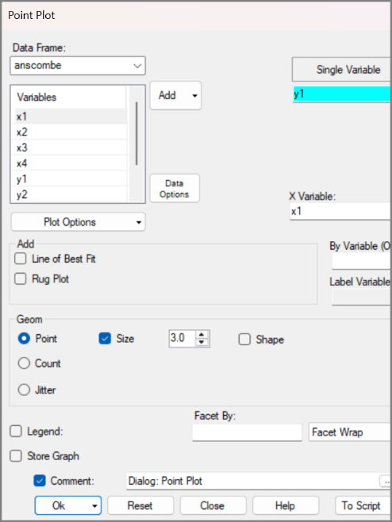 | 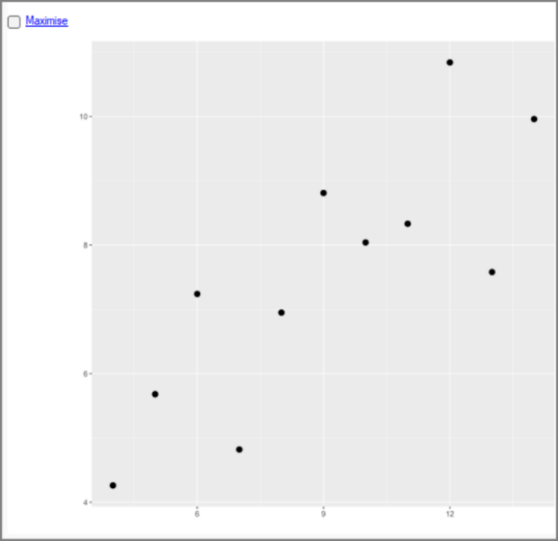
It looks sensible to add a line. So:
- Return to the scatterplot (also called point plot) dialog.
- Check the Line of Best Fit checkbox, and also the With Standard Error checkbox.
- Press Ok.
The graph in Fig. 66 looks better, but it would be nice to include the equation of the line.
- Return to the dialog.
The equation option is not available from the main dialog. R-Instat tries to keep the main dialogs as simple and uncluttered as possible. There are more options from the sub-dialogs.
- So, press the Plot Options button.
- Choose the Layers Tab, Fig. 67
Now reflect on the information in Fig. 67. In ggplot terms, your current graph has 2 layers. In the grammar of graphics, layers use geoms, or geometric shapes.
The first layer is the 11 points, and that’s the geom_point, in Fig. 67.
The second layer is the fitted line, plus the shaded area. And that is geom_smooth in Fig. 67. Your task is to add a 3rd layer, containing the equation of the line.
- Click on Add in Fig. 67.
Fig. 66: Scatterplot with Line of Best Fit | Fig. 67: Plot Options sub-dialog
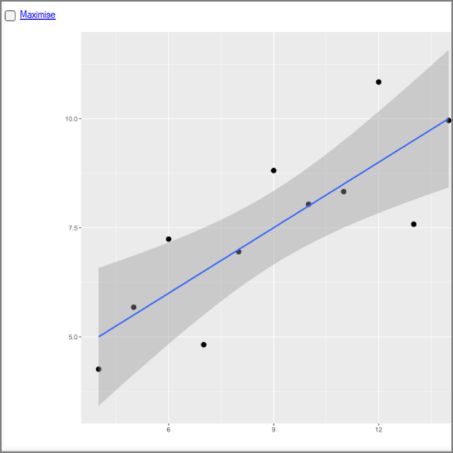 | 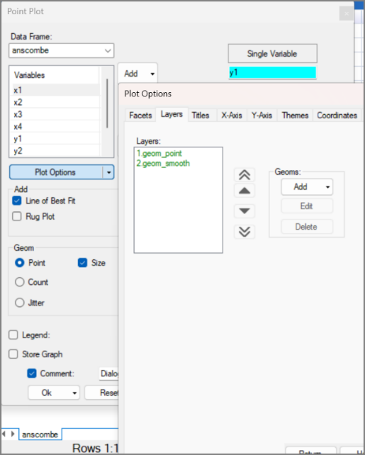
- Click on Add to open the Layer Options. Fig. 68. Press the down-arrow for the type of layer.
- Choose stat_regline_equation. Then press Return.
- You are back in the Layer Tab and see you now have 3 layers. Press Return again. Then Ok.

Fig. 68: Layer Options sub-dialog | Fig. 69: Scatterplot with the equation
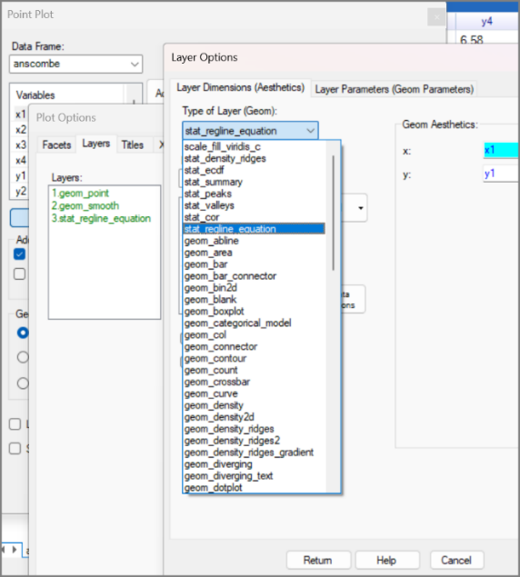 | 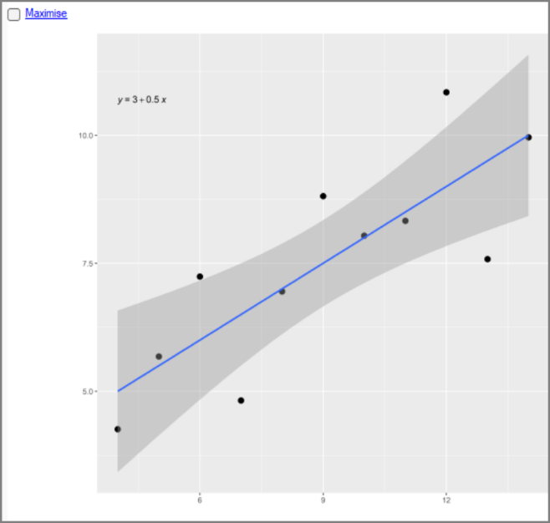
You now see the fitted line is y1 = 3 + 0.5x1. So, the slope is a half!
This seems a very small change in the graph for all that effort. But remember our main aim, here, is for you to master the R ggplot2 graphics system. You have just used the most complicated set of dialogs in R-Instat, by far.
We hope you are happy so far, because we now propose to add the correlation, as a 4th layer.
- Back to the dialog. Then Plot Options again. Now Add again on the Layer Tab.
- Then down arrow again in the Layer options, and choose stat_cor. Then Return.
- In Fig. 70 you now have 4 layers. Press Return and then Ok.
It worked, Fig. 71. The fourth layer has been added, but the equation and correlation overlap and are difficult to read.
One easy solution is to delete the less important summary. Do you prefer correlation or regression?
Let’s try to do better. Could we move the correlation down in the graph, in Fig. 71, to say where y = 10?
Fig. 70: Plot Options sub-dialog | Fig. 71: Scatterplot with additional layers
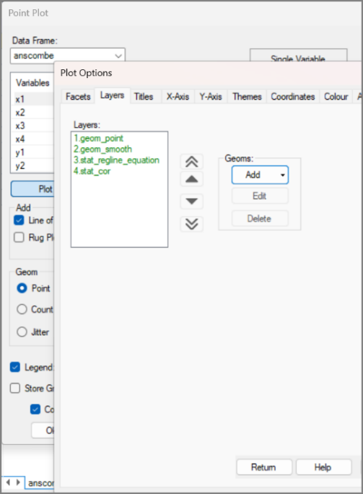 | 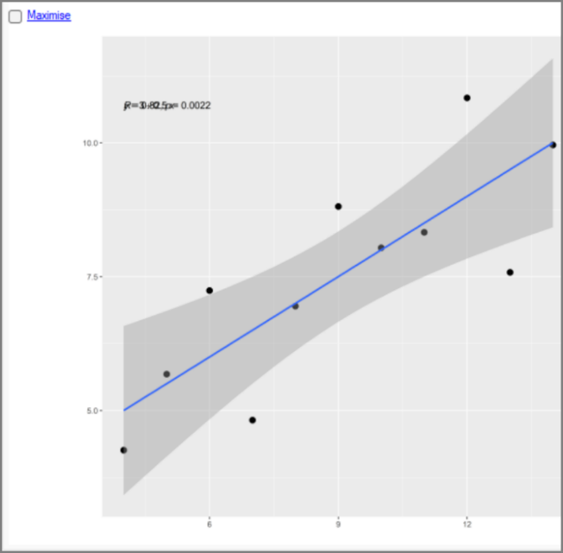
- Return to the dialog. Press Plot Options again, choose the stat_cor layer and, this time, press Edit.
- Now notice that each Layer Option has 2 tabs. Press on the 2nd, Layer Parameters, Fig. 73.
Fig. 72: Plot Options sub-dialog | Fig. 73: Layer Options sub-dialog
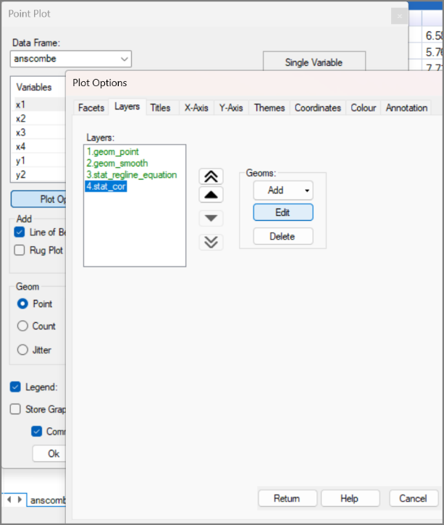 | 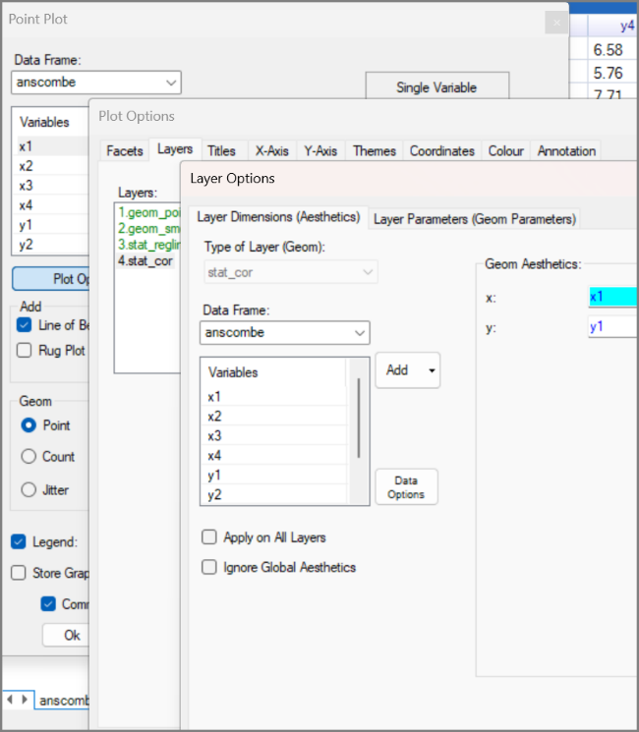
- Wow, that’s a lot of options for just this layer! The label.y sounds sensible to try.
- Click this option and make it 10. Then Return and Return again and Ok.
The resulting graph, Fig. 75, shows it worked! The correlation is 0.82, and the small p-value provides strong evidence that the slope is not zero Fig. 75, assuming the linear model is appropriate.
Fig. 74: Adding label.y | Fig. 75: The Resulting graph
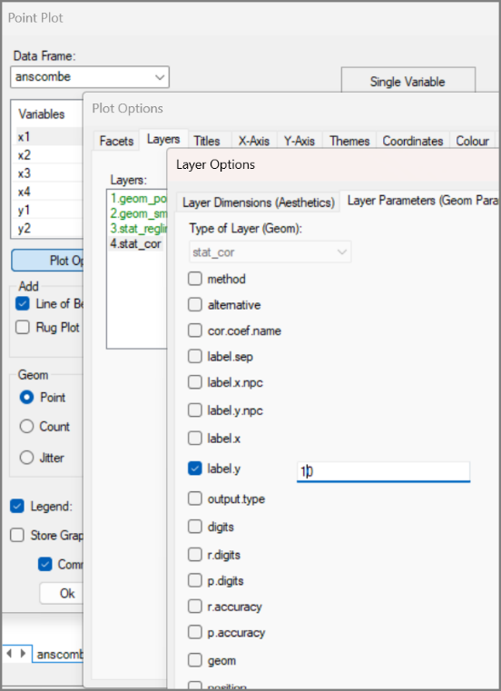 | 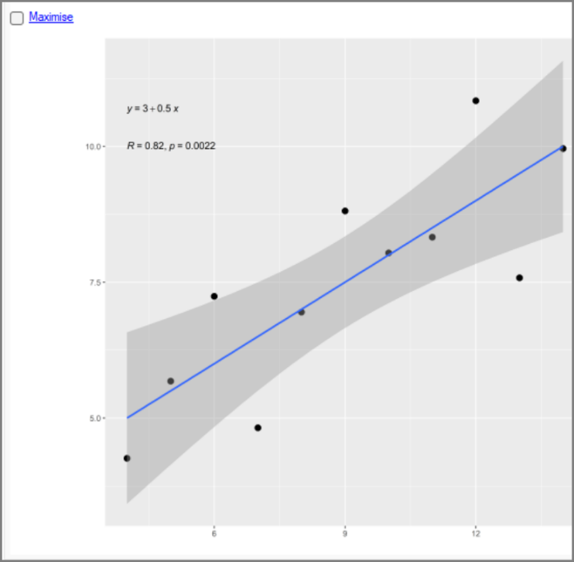

More scatterplots
Now, for the “payoff” with these data.
- Return to the dialog and choose y2, instead of y1. Then Press Ok.
The result, in Fig. 76, shows the value of this very clever set of data. With the second set, as soon as you see the data, you know that fitting a straight line is a ridiculous summary. But notice also that the summary statistics, both the equation, and the correlation are identical to the first set.
- Return to the dialog. Choose y3 this time, and press Ok.
Fig. 76: Scatterplot for y2 | Fig. 77: Scatterplot for y3
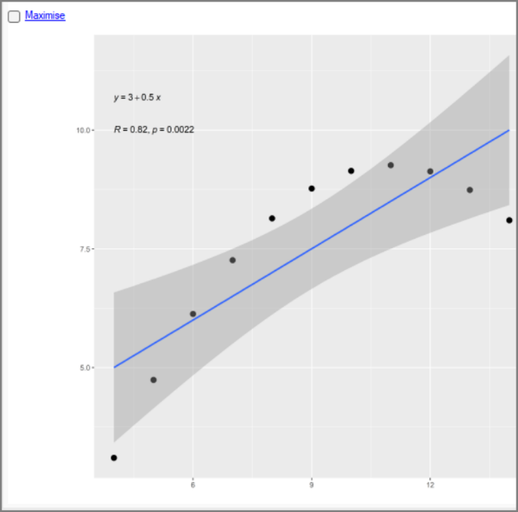 | 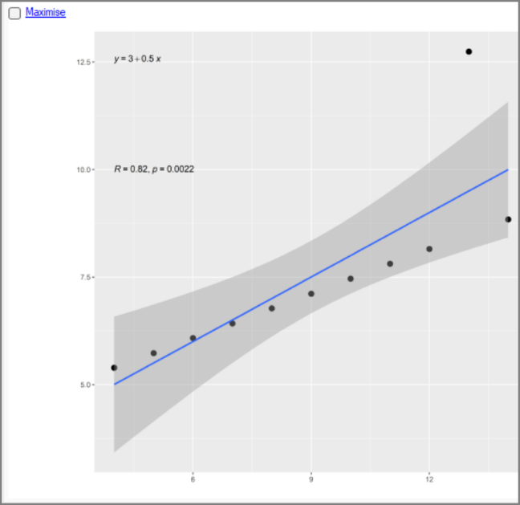
Same model and again ridiculous. You now understand the large 12.74 value we mentioned earlier. These data are in a perfect straight line, except for an obvious outlier.
- Back again for the 4th set. Use y4.
- This time the x’s are also different, so change to x4 as well, Fig. 78. Press Ok.
Fig. 78: Point Plot dialog | Fig. 79: Scatterplot with y4 and x4
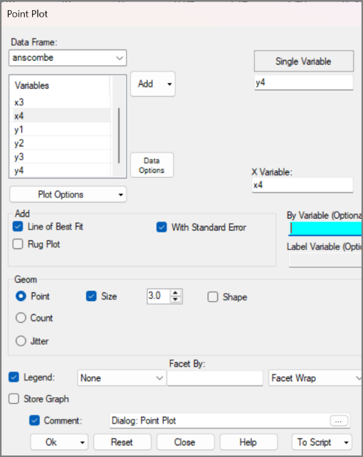 | 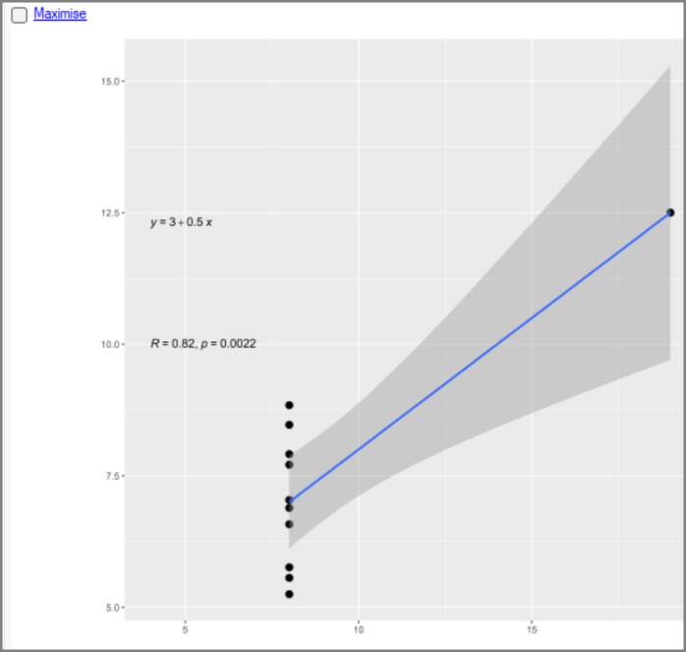
This time it is obvious you should not be using regression at all. Without the single outlying point at $x=19$, all the remaining x-values are 8, so a regression line cannot be estimated.

Multiple plots
One more step would be useful. It would be nice to put the 4 graphs together in a single figure. There is a Combine Graphs dialog, but we can do better.
First change the shape of the data – bringing in a factor column – of course!
- Use Prepare > Data Reshape > Stack (Pivot Longer).
- Add all the columns, Fig. 80 and tick the checkbox to Stack multiple column sets.
- Change the Factor Variable to be called set and press Ok.
- Right-click on the set column and Convert to Factor.
Fig. 80: Stack dialog | Fig. 81: The stacked data
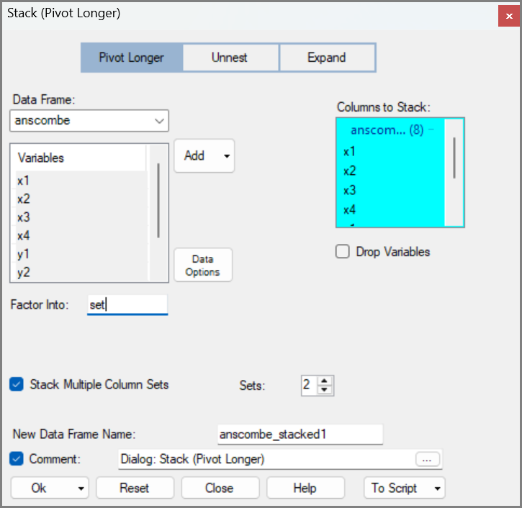 | 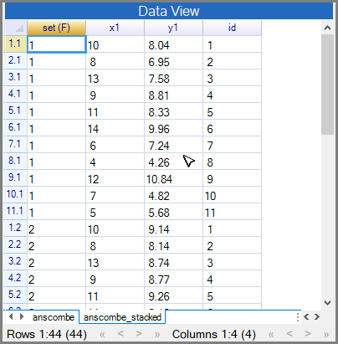
The 4 sets of data, in Fig. 81, are now one below the other. So, there are now 44 rows of data.
- Return to the Scatterplot dialog. Proceed carefully now!
Note the data Frame (top left) is coloured red. This indicated that you should check which data frame you are working on, as the one selected in the dialog is not the one you are looking at in the data window.
- Use the down-arrow and move to the new data frame, Fig. 82
- Put y1 into the top control and x1 into the x variable.
- Then click on the Facet By box and add the set variable. Press Ok.
Fig. 82: Point Plot dialog | Fig. 83: The resulting graphs
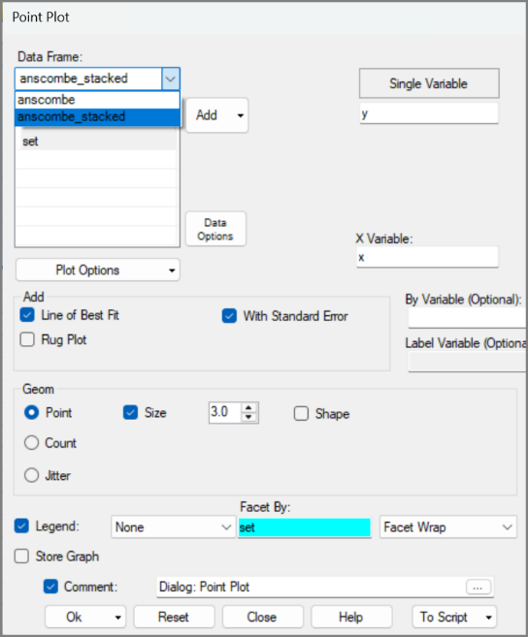 | 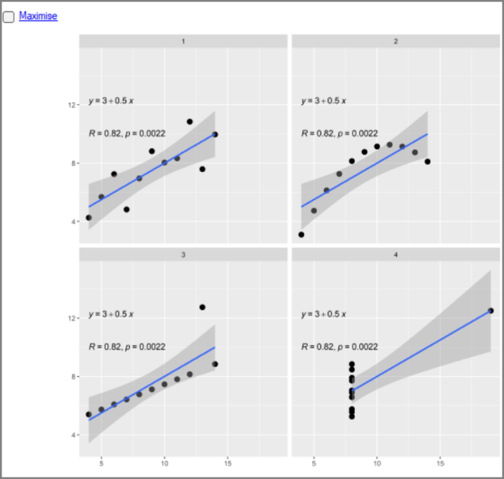
The resulting 4 graphs are in Fig. 83. They combine the graphs, by default they have the same x-axis and y-axis for each graph. So, the axis labels are only at the bottom and left of the set of graphs in this case there is no need for them anywhere else.
Now you have the set factor in the data, you may wonder if it fits anywhere else in the dialog?
- Return to the dialog. Delete the set factor from the Facet control and put it in the By Variable instead. Press Ok.
Fig. 84: The Graph without facets | Fig. 85: The graph by variable and faceted
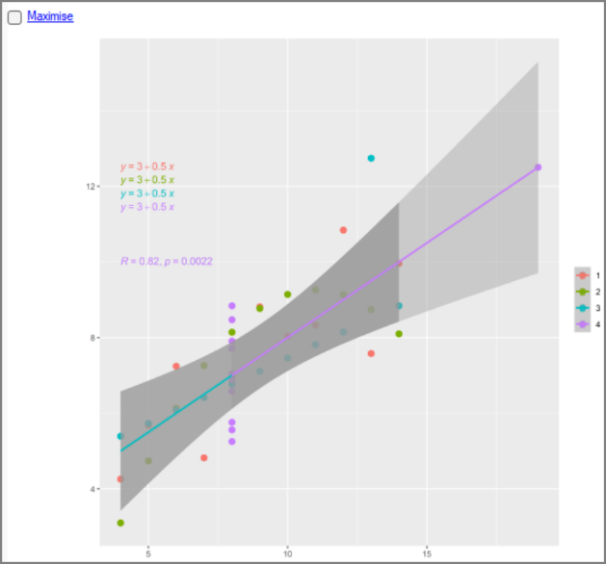 | 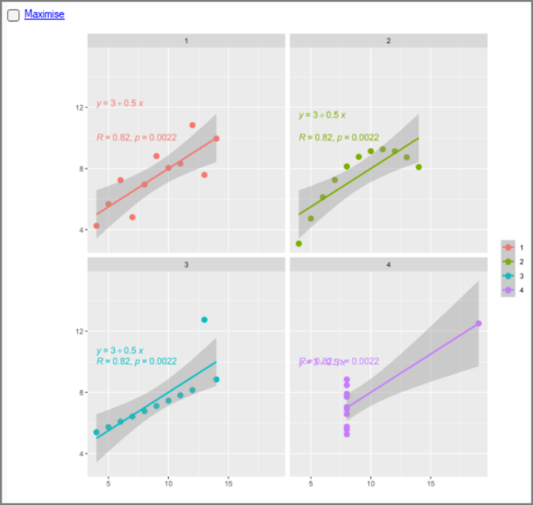
Putting the set factor in this position creates a single graph with all sets together but adds colour to distinguish each of the sets. It has also separated the 4 equations nicely. However, the 4 correlations are all together, because you specified earlier, they should be where y = 10. Luckily, they are the same each time so this is fine.
- Return to the dialog. Put the set factor back as a facet and keep it in the By Variable too.
- Press Ok.
The resulting graphs are nicely in colour. But the different position of the regression equation, which was fine in Fig. 83, is a problem with the facets, and particularly with the last graph.
Fortunately, you know how to correct this. Also, the legend is no longer needed in Fig. 85.
- Return to the dialog and to Plot Options.
- Edit the stat_regline_equation layer, to change the Label y layer to 12.5.
- Return to the main dialog.
- Check on the Legend checkbox, to set it to None, Fig. 86. Press Ok.
Fig. 86: Point Plot dialog | Fig. 87: Improved look of the graph
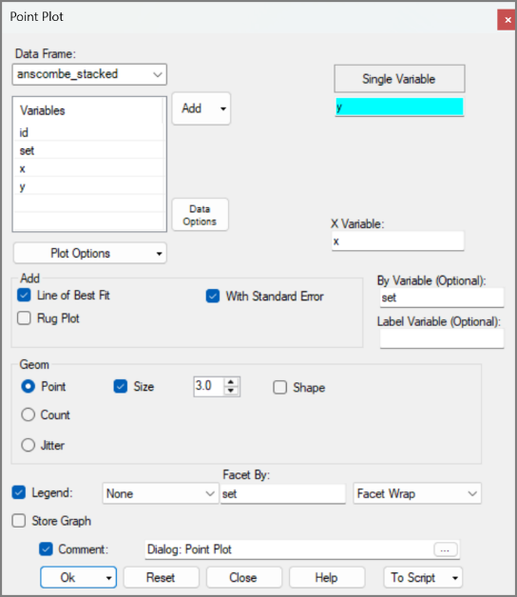 | 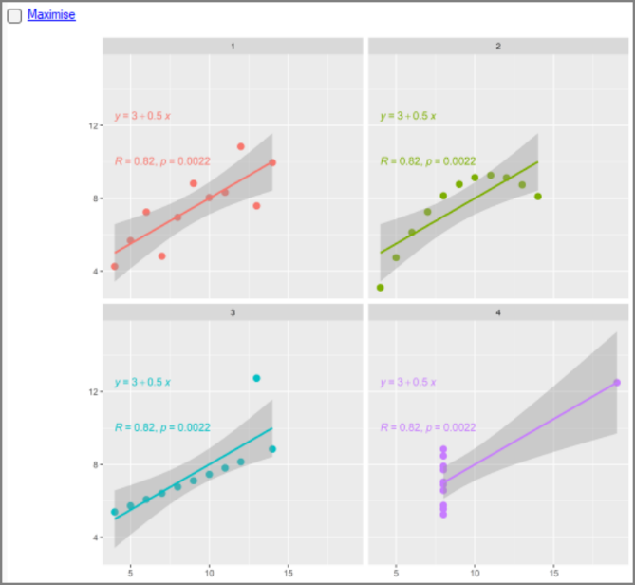
This example combines two of R’s greatest strengths: factors and (ggplot) graphs. The factor identified the four groups in the data, while ggplot2 uses it for the facets.

Tables and graphs are similar
In this section: You have seen both tables and graphs. Now we consider them together. Faceted graphs can be understood like tables, with factors defining the cells and margins providing overall views.
- Return to the scatterplot dialog. Press Reset.
- Add the Y and X to the first 2 controls and put set as the By variable.
- Tick to include the line of best fit and the Standard Error too.
- Include set in the Facet By, Fig. 88. Press Ok.
Fig. 88: Scatter Plot dialog | Fig. 89: The resulting graph
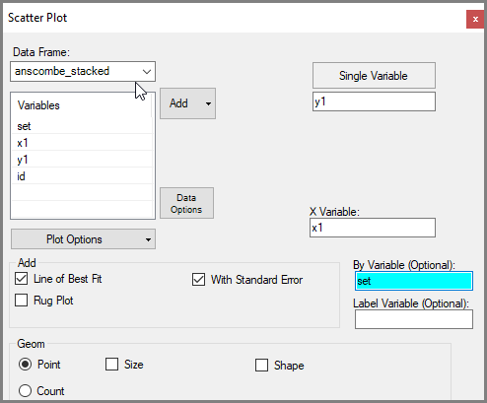 | 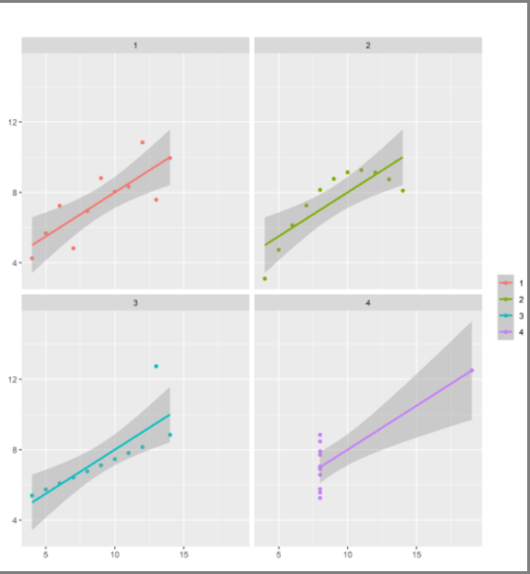
Figure 89 shows the four graphs in a two-by-two arrangement. Although it looks like a two-way table, it is a one-way display because its four cells are defined by the four levels of a single factor: set.
- Return to the dialog. Tick on the Legend, to omit it.
- Use the down arrow by Facet wrap and use Facet Column + O. (O is for overall), Fig. 90.
- Press Ok.
Fig. 90: Scatter Plot dialog | Fig. 91: Resulting graph
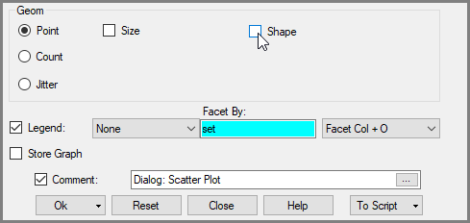 | 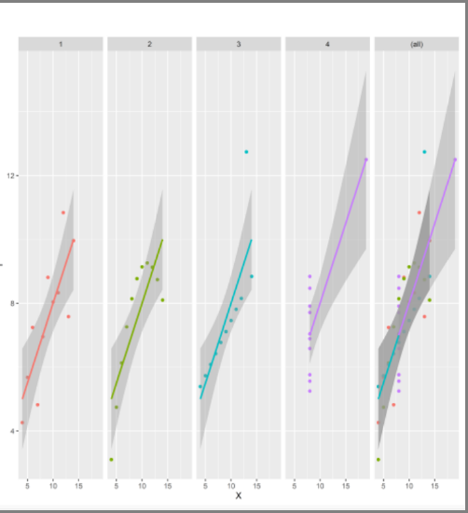
The all panel on the right of Fig. 91 plays the same role as a total column in an ordinary table.
Most tables used in data analysis are rectangular and are indexed by two factors—one defining the rows and the other the columns. Our current display is a one-way table because its four graphs are defined by the four levels of the single factor set.
The four datasets have properties that allow us to replace this four-level factor with two factors, each with two levels:
- Suitability for a straight line: Fitting a straight line is sensible for sets 1 and 3, although the outlier in set 3 would first have to be removed. In contrast, set 2 follows a curved pattern, while nearly all the x-values in set 4 are identical. We call this factor linear.
- Presence of an outlier: Sets 3 and 4 each have an obvious outlier, while sets 1 and 2 do not. We call this factor simple.
By reorganising the four datasets according to these shared properties, the two new factors can define the rows and columns of a two-way table of graphs.
- Use Prepare > Column: Factor > Recode Factor. Add set.
- In the New Label column make 1 and 2 into linear. Then 3 and 4 into outlier, Fig. 92.
- Call the new column name linear and press Ok.
This adds a new factor, called linear to your data.
- Return to the dialog. This time label levels 1 and 3 as simple and 2 and 4 as not.
- Call the new column simple, Fig. 93. Press Ok.
Check that both factors have two levels, with 22 observations at each level.
Fig. 92: Recode Factor dialog | Fig. 93: Recode Factor dialog
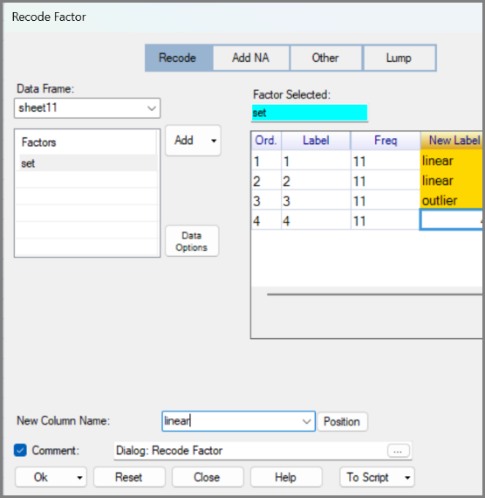 | 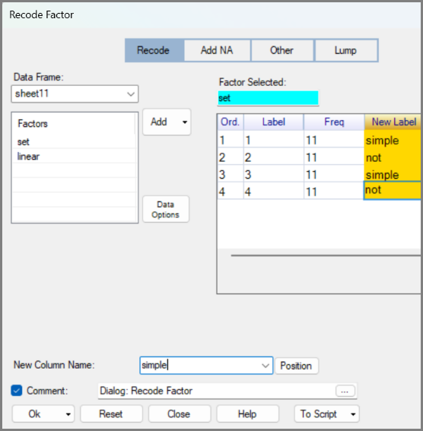
- Right-click in the new linear column and use Levels/Labels. Check it has just 2 levels.
- Close and repeat with the new simple column, Fig. 94.
Correct any recoding errors before continuing.
- Return to the scatterplot dialog.
We would like to use both new factors as facets. However, the main dialog only allows one.
- Press Plot Options. On the Facet tab you now see you can include both factors.
- Add the two new 2-level factors, Fig. 95. Also check margins are ticked.
- Press Return then Ok.
Fig. 94: Levels/Labels dialog | Fig. 95: The Scatter Plot dialog
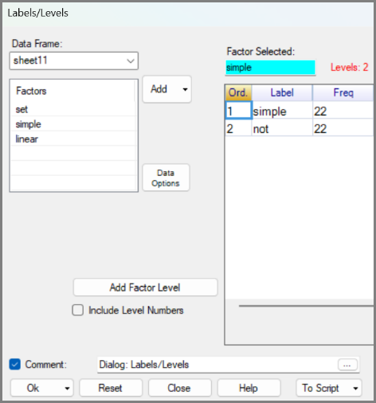 | 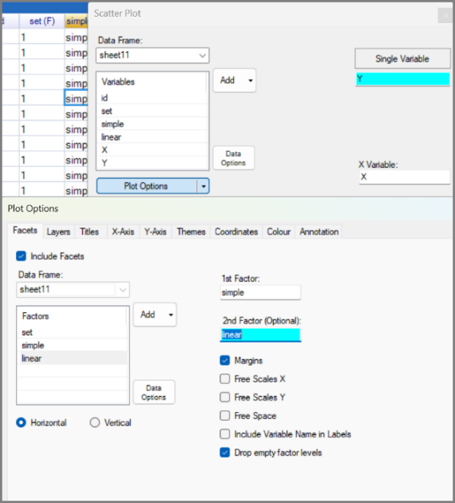
The results are in Fig. 96.
You now see a two-way table of graphs indexed by two factors. Adding the margins is like adding an additional level to each factor, so there are 9 cells in the resulting table.
Fig. 96: The resulting graph
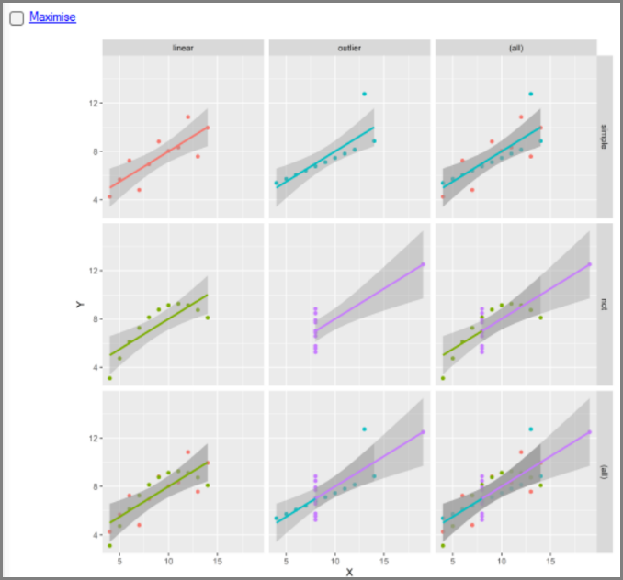
The resulting display is a two-way table of graphs, defined by the factors linear and simple. Each factor has two levels, giving four main graphs in a two-by-two arrangement. Adding margins creates an extra row for the 2 levels of linear, and a column for each level of simple. The bottom-right cell shows the overall graph. So, there are nine cells in total.
This has shown the main graph dialog can handle a single faceting factor. Plot Options allows us to use two factors. This raises a further question, namely is that the limit or can ggplot2 extend the same table-like structure to three or more factors? The answer is yes, but it needs more than the dialogs. Chapter 3 goes beyond the standard dialogs, and extends the graphs through the underlying ggplot2 commands.

Reflections
The examples in this chapter were different, but the underlying steps are the same as in Chapter 1: looking carefully at data is an important part of data analysis. The datasets were chosen as practice cases to demonstrate general skills and typical preliminary steps that readers can transfer to their own data.
Factors and graphics are two closely connected strengths of R. Factors describe structure in the data. Graphs then use that structure through colour, grouping, facets, and comparisons. Together, they help make complex patterns easier to organise, explore, understand, and present.
Data preparation or tidying is part of analysis, not a separate chore. Users often arrive ready to analyse their data, only to discover that they first need to check, correct, rename, recode, transform, or reshape it. This process is important in its own right and has the added benefit that it helps to understand the data well enough to carry out a sound analysis. The Prepare menu in R-Instat makes much of this essential work accessible.
Column names and data types are part of data preparation. This is often new for spreadsheet users. In R-Instat, column names have pride of place in a special row, and the column type is shown with the name. Names and types are therefore not cosmetic details; they are part of the data structure.
Consistent names, labels, and types matter even more in large studies with multiple sheets or data frames. They make it easier to move between related data frames, compare them, reshape them, and analyse them together.
Many projects benefit from keeping more than one version of the data for different tasks. In the Anscombe example, the original wide data frame was retained while a second, longer data frame was created for faceted graphics. R-Instat’s databook structure makes it easy to work with multip,le data frames, while keeping each one simple and suited to its purpose.
R’s richness presents a challenge for menu-driven software. Including every option would make the menus unmanageable, so R-Instat focuses on making key areas, including data preparation and graphics, comprehensive and practical. Even so, there are times when more flexibility is useful. The glimpse of your first R command, in this chapter, showed that commands do not have to be intimidating.
The menus and dialogs are not intended to replace R commands and scripts. They allow users to accomplish substantial work before needing to view or edit R code. Chapter 3 builds on
this idea and shows that commands, and even scripts, can often be used quite simply when you do not have to write them from scratch.

