In the hindsight: investigation of causes for pathogenicity in Escherichia coli strains involved in 2011 HUS outbreak in Germany

Yury V. Malovichko12, Anton E. Shikov13

1 Bioinformatics Institute, Saint-Petersburg, Russia
2 Saint-Petersburg State University, Department of Genetics and Biotechnology
3 Saint-Petersburg State University, Department of Plant Physiology and Biochemistry

Abstract. Although being a major resident of gut microbiome, Escherichia coli species comprises vast amount of highly pathogenic strains causing different hazardous diseases such as traveler’s diarrhea (TD) or haemolytic uremic syndrome (HUS). Diversity of these strains is provided by high evolutionary rate boosted by horizontal gene transfer (HGT) by means of transmitted mobile elements and viruses and selective pressure created by reckless usage of antibiotics. Here we investigate a particular case of epidemic outburst of HUS in Germany in 2011 caused by an enteroaggregative haemorrhagic E. coli (EAHEC) strain O104:H4 TY2482. Though the case is assumed to be solved, we followed a standard pipeline including de novo genome assembly, annotation and automatized virulence and resistance factor search. We found that the strain in question shows high resemblance to another EAEC strain, 55989, and that both factors are likely to have been acquired via HGT.

1. Introduction
Enteroaggregative haemorrhagic E. coli (EAHEC or EHEC) form a specific group of enteroaggregative E. coli (EaggEC or EAEC) strain subset called after their ability of forming aggregate via interaction of special fimbria (the so-called AA phenotype) [1][2]. On a larger scale, haemorrhagic EaggEC are hybrids between EaggEC and Shiga toxin-producing Escherichia coli, or STEC, which produce a cytotoxin similar to that of Shigella dysenteriae serotype 1 [3]. These strains are capable of inducing bloody diarrhea in humans, as well as some interrelated complex syndrome such as haemolytic uremic syndrome (HUS) [4]. STEC are typically marked by presence of one or more prophages integrated in the chromosomal DNA; to make the situation worse, these prophages can either bring their own or activate preexisting mobile genome elements [5].
The strict accordance between prophage presence and pathogenic status in different strains raises the idea that pathogenicity may be transmitted by means of horizontal gene transfer [6]. Indeed, numerous cases indicate that viruses can transmit fragments that, once integrated, form pathogenicity islets (if less than 10 Kb) or islands [7]. In case of mobile elements (namely, IS and transposones) this activity is conducted by consequent acts of integrating in the conjugative element or transformation fragment and then into recipient’s chromosome [8][9]. In the case of bacteriophages specificity, the situation seems even simpler: here HGT of pathogenicity is restricted only by virus’ host specificity.
The fact that such gene transfer occur quite frequently in the microevolution of pathogenic forms raises the question whether mapping onto a reference is plausible when assembling a potential pathogen’s genome. Indeed, long-range insertions and altered genome organization may lead to decrease of synteny between reference and experimental genomes. However, de novo assembly allows to define genome’s true organization and capture medium- and large-scale differences [10].

2. Materials and Methods.
Information provided below describes only the approach and programs we used. All executable scripts and precise full commands are presented in the lab report or in the supplementary material in git-hub.
1. Source data
6 fastq files referring to one pair-end and two mate-pair libraries, respectively, were benevolently provided for E. coli O104:H4 str. TY-2482 by Mike Raiko of Theodosius Dobzhansky Center for Genome Bioinformatics. Files were inspected using FastQC first for basic statistics (Table 1) and then for raw quality estimation [11].

File | Library type | Read number
SRR292678
R1 | Pair-end | 5499346
R2 | Pair-end | 5499346
SRR292770
R1 | Mate-pair | 5102041
R2 | Mate-pair | 5102041
SRR292862
R1 | Mate-pair | 5102041
R2 | Mate-pair | 5102041

Table 1. Read number for provided libraries according to FastQC. R1 stands for forward reads and R2 stands for reverse reads.

Quality of the provided files was found to be more than plausible (Fig. 1, S1) so that no trimming was performed.
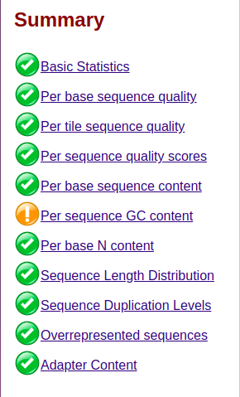

Fig 1. Quality statistics overview for SRR292678 R1 reads

2.2. K-mer score and genome size assessment
To determine genome size by its k-mer score, we used Jellyfish k-mer counter using count option with k equal to 31 onto pair-end library ends [12]. Before that, all six .fastq files were converted into .fasta format by using shell script (S2). After counting, dump and histo were sequentially performed onto output files. All three operations were automatized with respective shell scripts (S3, S4) Histograms were plotted in Rstudio with custom ggplot2-based scripts (S5) [13][14]. Genome size was estimated by the following formulas:
N = (M*L)/(L-K+1), Genome_size = T/N,
where N is depth of coverage, M is k-mer peak, K is k-mer size, L is average read length, and T is total bases in the library

2. 3. Genome assembly

2.3.1 Genome assembly from paired reads and error correction
To assembly genomes, hereupon we used SPAdes v.3.11.1 [15]. All runs were launched on server of ARRIAM, Pushkin, Saint-Petersburg. First, we used default settings to test the assembler on our files. An output comprising of two .fasta files with contigs and scaffolds, respectively, were analyzed via QUAST online tool for all contigs (that is, for contigs longer than 0 bp) [16]. Next we launched the same SPAdes command but in careful mode. Corrected reads from SPAdes output underwent k-mer profiling similar to that for raw reads (see 2.2). Resulting histograms were built in Rstudio with the same script.

2.3.2. Impact of reads with large insert size
The third SPAdes launch was performed with all three libraries and default settings. This time assembly took approximately 10 minutes longer than in the first two cases. Once the genome was assembled, we performed QUAST quality control similar to that described in 2.3.

2.4. Genome annotation
For genome annotation, we used Prokka installed on the same cluster [17]. Initial launch was performed with default settings. However, we found output .gbf file to be incompatible with the following workflow (see lab report), so that we added option --compliance to remedy the situation. This, however, raised another error, so we ended up using RAST[18] annotation of the same genome provided by Mike Raiko. We also uploaded our own RAST job, but due to heavy job overload we did not obtain results in time.

2.5. 16S rRNA gene extraction and closest relative search
To find 16S rRNA sequences in the genomes in question, we ran Barrnap onto scaffold-containing file from 2.3.2 [17]. Resulting file contained information about all rRNA entries within the scaffolds in a .gff-like manner. These entries were written into separate file and used for sequence extraction via bedtools [19]. Resulting file contained information about four copies of 16S rRNA loci, of which we used the first for our further analysis.
Next, obtained sequence was used to find the closest relative strain by aligning it against Reference Genome Sequences database using blastn [20]. Results were filter by Entrez option 1900/01/01:2011/01/01[PDAT] which means that only results which had been submitted by 2011 were represented. The most accurate match was chosen by all the three metrics: gap score, identity percentage and E-value. After that, genome for reference strain was downloaded in .fasta format.

2.6. Visualizing alignments with Mauve
Reference genome and .gbf output gained on 2.4. were used for progressive alignment in Mauve 2015-02-13 [21]. For that purpose, sequences were added in the ‘Align with progressive Mauve’ pop-up window, then ‘Align’ button was pressed. For the resulting alignment, shiga-related genes were found in ‘Find the annotation feature’ window by query ‘shiga’ in the ‘Product’ field with non-stringent ‘contains’ option. Matches were zoomed in to visualize neighboring regions (Fig. 2). Similar workflow was to find genetic context of resistance-associated genes.

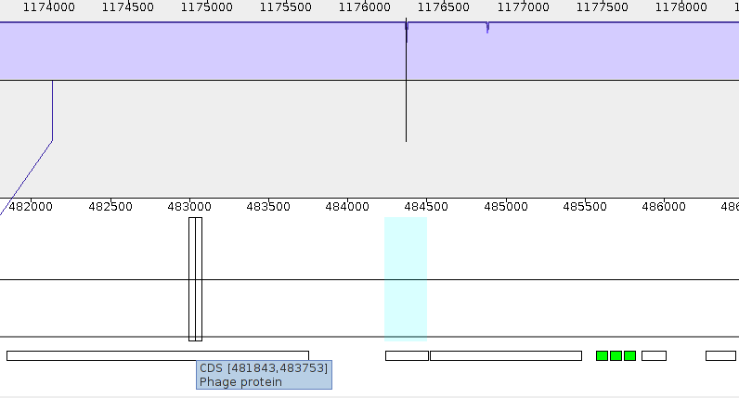
Fig. 2. An example of Mauve gene location

2.7. Resistance assessment
Putative antibiotic resistance was assessed with ResFinder online interface [22]. Scaffolds obtained on 2.3.2. were uploaded; ID threshold was set on 90%, minimum length was set on 60% and all possible options were chosen in the ‘Select Antimicrobial configuration’ field. The same was performed onto O104:H4 55989 reference genome.

3. Results
3.1 Sequencing data information
Mate-pair libraries had equal number of reads and head brilliant quality. That is not astonishing as far as appropriate genome assembly for mate-pair library requires perfect quality and congruency.
N50 for one library for both scaffolds and contigs was 105346. For three libraries results differed: N50 was 151071 for contigs and 740922 for scaffolds. As we know scaffold are orientated arrays of contigs. Because illumine reads are relatively short it could be quite complicated to assemble all scaffolds from contigs. For this reason, an approach of using circularized DNA and subsequent read ends sequencing can provide information about sequences relative location, thus, facilitating scaffolds assembly, which results in better N50 metrics value.
3.2 K-mer spec estimation
According to jellyfish analysis and k-mer spec histogram visualization, we can estimate E.coli genome size:
L=90, M = 62, K=31.
N = (M*L)/(L-K+1)=62*90/(90-31+1)=93
size = T/N= 5499346*90/93=5.32 Mb
5.32 Mb is quite normal for average E.coli genome size (for example E. coli O157:H7 size is 5.44 Mb [23])
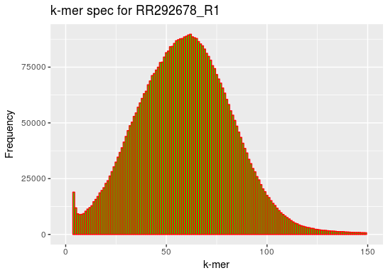

Fig. 3. An example of k-mer spec histogram for pair-end library
We also visualized k-mer spec for corrected reads (--careful mode of spades):

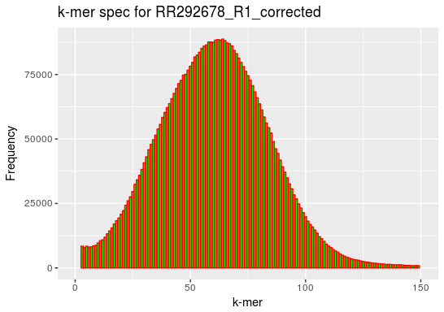

Fig. 4. An example of k-mer spec histogram for corrected pair-end library
As we can infer from histograms k-mer peak does not differ between corrected library and the uncorrected one, but generally, histogram was smoother and had less noise then the uncorrected.

3.3 16S rRNA information
According to Barrnap 16 rRNA genes were found, including 4 16S genes. That is not surprising because rRNA genes are gathered throughout the genome in clusters. See supplementary data for estimating all founded genes sizes. Reference strain (one gathered highest similarity score in blastn run with 16S rRNA sequence) was assessed as O104:H4 55989 which agrees with empirical data [32].

3.4 Resistance assessment
ResFinder showed that investigated E.coli strain contained at least 5 antibiotic resistances (for sulphonamide, tetracycline, trimethoprim, amimoglycoide and beta-lactam). However, reference strain contained only one transparent resistance (for tetracycline). In discussion session we will try to interpret obtained result.

3.5 Gene context for bla and Shiga-related toxin genes
Using Mauve we found exact location of both pathogenicity and resistance markers. The former (two genes for Shiga-related toxin subunits) lurked between a syntenic row of bacteriophage-derived genes, though also flanked by three tRNA sequences (see lab report) in 3’ region; at the same time, the latter (two non-neighboring bla genes) we surrounded by transposone-related genes, mostly at 5’ side. This raises grounds to suspect whether both markers were acquired by TY2482 by means of HGT.

4. Discussion
As it was already mentioned in introduction session, phage integration into bacterial genome often leads to pathogenic strain originating. In case of O104:H4 TY2482 strain acquiring a plasmid with fimbrial adherence genes happened in case of phage (containing stx/vtx2 gene) infection. As a result a new aggressive enteroaggregative haemorrhagic E. coli strain occurred. Notably, the set of syndromes of this strain is similar to EHEC O157:H7 [24][25]. Locus of enterocyte effacement (LEE), which is a pathogenic island is required for colonization of ingesting resulting in diarrhea symptoms in humans [26][27] . Interestingly, LEE regulative genes and chaperones are inserted into united pathogenic island forming a system, responsible for bacterial aggregation [26]. Another typical virulent genes presented in investigated strain are aggR, aaiC, sepA, aatA, wich are obtained from a Verocytotoxin (Vtx) subtype 2a (vtx2a) containing vtx2-converting bacteriophage [28].
It was also shown that vtx2-phage acquisition Is a classical mechanism of EAggEC strains occurrence and our case is not a conclusion [29].
Vtx2-phage are often considering as launching signals, resulting in diverse pathogenic strains formation. It depends on the ancestral strain infected by the phage. For this reason a list of hemorrhagic E. coli serotypes exists. In case of O104:H4 TY2482 strain it is very intriguing to compare it to the most similar O104:H4 55989 strain, which contained only one mechanism of antibiotic resistance. Thus, it could be speculated that Vtx2-phage infection of O104:H4 TY2482 somehow accompanied with resistance genes transfer. That is a common mechanism of DNA HGT called transduction [30]. It could have been happened with the following hypothesis. Vtx2-phages exist in bacterial genome in quiescent prophage form, nevertheless, creating phage particles with following expression of vtx(stx) and final cell lysis is induced by antibiotics [31]. For this reason, uncontrolled using of antibiotics could have provoked phage particles releasing from resistance strains. After that vtx2-phages with resistant genes caused lysogenic conversion of O104:H4 55989 strain resulting not only in pathogenic properties obtaining, but also in simultaneous antibiotic resistance occurring.
Supplementary materials
A full list of supplementary materials is given lower. All supplements, including lab report containing detailed account on particular commands used, can be found at GitHub repository: https://github.com/PreacherCasy/Malovichko_Shikov_Project3

S1. A tar.gz archive with six html-flavored FastQC reports on initial read files.
S2. A shell script for .fastq to fasta conversion.
S3. A shel script for automatized Jellyfish count operation over numerous files.
S4. A shell script for automatized Jellyfish dump and Jellyfish histo operation over numerous files.
S5. An R script for k-mer specter histogram plotting.

References
1. Nataro JP, Yikang D, Yingkang D, Walker K. AggR, a transcriptional activator of aggregative adherence fimbria I expression in enteroaggregative Escherichia coli. J Bacteriol. 1994;176:4691–4699.
2. Chattaway MA, Jenkins C, Rajendram D, Cravioto A, Talukder KA, et al. Enteroaggregative Escherichia coli have evolved independently as distinct complexes within the E. coli population with varying ability to cause disease. PLoS One. 2014;9:e112967 doi: 10.1371/journal.pone.0112967.
3. Gyles CL. Shiga toxin-producing Escherichia coli: an overview. J Anim Sci. 2007 Mar; 85(13 Suppl):E45-62.
4. Farrokh C, Jordan K, Auvray F, Glass K, Oppegaard H, Raynaud S, Thevenot D, Condron R, De Reu K, Govaris A, Heggum K, Heyndrickx M, Hummerjohann J, Lindsay D, Miszczycha S, Moussiegt S, Verstraete K, Cerf O. Review of Shiga-toxin-producing Escherichia coli (STEC) and their significance in dairy production. Int J Food Microbiol. 2013 Mar 15; 162(2):190-212.
5. Karch H. The role of virulence factors in enterohemorrhagic Escherichia coli (EHEC)--associated hemolytic-uremic syndrome. Semin Thromb Hemost. 2001 Jun; 27(3):207-13.
6. Grande L, Michelacci V, Tozzoli R, Ranieri P, Maugliani A, Caprioli A, Morabito S. Whole genome sequence comparison of vtx2-converting phages from Enteroaggregative Haemorrhagic Escherichia coli strains. BMC Genomics. 2014 Jul 8;15:574. doi: 10.1186/1471-2164-15-574.
7. Gyles C, Boerlin P. Horizontally transferred genetic elements and their role in pathogenesis of bacterial disease. Vet Pathol. 2014 Mar;51(2):328-40. doi: 10.1177/0300985813511131. Epub 2013 Dec 6.
8. Frost LS, Leplae R, Summers AO, et al. Mobile genetic elements: the agents of open source evolution. Nat Rev Microbiol 2005;3: 722–732
9. Ochi S, Shimizu T, Ohtani K, et al. Nucleotide sequence analysis of the enterotoxigenic Escherichia coli Ent plasmid. DNA Res. 2009;16:299–309.
10. Al-Okaily AA. HGA: de novo genome assembly method for bacterial genomes using high coverage short sequencing reads. BMC Genomics. 2016 Mar 5;17:193. doi: 10.1186/s12864-016-2515-7.
11. Andrews S. (2010). FastQC: a quality control tool for high throughput sequence data. Available online at: http://www.bioinformatics.babraham.ac.uk/projects/fastqc
12. Guillaume Marcais and Carl Kingsford, A fast, lock-free approach for efficient parallel counting of occurrences of k-mers. Bioinformatics (2011) 27(6): 764-770 (first published online January 7, 2011) doi:10.1093/bioinformatics/btr011
13. RStudio Team (2015). RStudio: Integrated Development for R. RStudio, Inc., Boston, MA URL http://www.rstudio.com/.
14. H. Wickham. ggplot2: Elegant Graphics for Data Analysis. Springer-Verlag New York, 2009.
15. Anton Bankevich, Sergey Nurk, Dmitry Antipov, Alexey A. Gurevich, Mikhail Dvorkin, Alexander S. Kulikov, Valery M. Lesin, Sergey I. Nikolenko, Son Pham, Andrey D. Prjibelski, Alexey V. Pyshkin, Alexander V. Sirotkin, Nikolay Vyahhi, Glenn Tesler, Max A. Alekseyev, and Pavel A. Pevzner. SPAdes: A New Genome Assembly Algorithm and Its Applications to Single-Cell Sequencing. Journal of Computational BiologyVol. 19, No. 5. Published Online: 7 May 2012https://doi.org/10.1089/cmb.2012.0021
16. Alexey Gurevich, Vladislav Saveliev, Nikolay Vyahhi and Glenn Tesler. QUAST: quality assessment tool for genome assemblies. Bioinformatics (2013) 29 (8): 1072-1075. doi: 10.1093/bioinformatics/btt086 First published online: February 19, 2013
17. Seemann T. Prokka: rapid prokaryotic genome annotation. Bioinformatics. 2014 Jul 15;30(14):2068-9. PMID:24642063
18. Aziz RK, Bartels D, Best AA, DeJongh M, Disz T, Edwards RA, Formsma K, Gerdes S, Glass EM, Kubal M, Meyer F, Olsen GJ, Olson R, Osterman AL, Overbeek RA, McNeil LK, Paarmann D, Paczian T, Parrello B, Pusch GD, Reich C, Stevens R, Vassieva O, Vonstein V, Wilke A, Zagnitko O. The RAST Server: Rapid Annotations using Subsystems Technology. BMC Genomics. 2008 Feb 8;9:75. doi: 10.1186/1471-2164-9-75.
19. Aaron R. Quinlan and Ira M. Hall. BEDTools: a flexible suite of utilities for comparing genomic features. Bioinformatics. 2010 Mar 15; 26(6): 841–842. Published online 2010 Jan 28. doi: 10.1093/bioinformatics/btq033
20. Altschul, Stephen; Gish, Warren; Miller, Webb; Myers, Eugene; Lipman, David (1990). "Basic local alignment search tool". Journal of Molecular Biology. 215 (3): 403–410. doi:10.1016/S0022-2836(05)80360-2
21.Aaron C.E. Darling, Bob Mau,Frederick R. Blattner, and Nicole T. Perna. Mauve: Multiple Alignment of Conserved Genomic Sequence With Rearrangements. Genome Res. 2004 Jul; 14(7): 1394–1403. doi: 10.1101/gr.2289704
22. Identification of acquired antimicrobial resistance genes. Zankari E, Hasman H, Cosentino S, Vestergaard M, Rasmussen S, Lund O, Aarestrup FM, Larsen MV. J Antimicrob Chemother. 2012 Jul 10. PMID: 22782487 doi: 10.1093/jac/dks261
23. http://www.biology-pages.info/G/GenomeSizes.html
24. Beutin L, Hammerl JA, Reetz J, et al. Shiga toxin-producing Escherichia coli strains from cattle as a source of the Stx2a bacteriophages present in enteroaggregative Escherichia coli 336 Veterinary Pathology 51(2) Downloaded from vet.sagepub.com at FLORIDA INTERNATIONAL UNIV on August 27, 2014 O104: H4 strains [published online August 16, 2013]. Int J Med Microbiol.
25. Beutin L, Martin A. Outbreak of Shiga toxin-producing Escherichia coli (STEC) O104: H4 infection in Germany causes a paradigm shift with regard to human pathogenicity of STEC strains. J Food Prot. 2012;75:408–418.
26. Wong AR, Pearson JS, Bright MD, et al. Enteropathogenic and enterohaemorrhagic Escherichia coli: even more subversive elements. Mol Microbiol. 2011;80:1420–1438.
27. Schmidt MA. LEEways: tales of EPEC, ATEC and EHEC. Cell Microbiol. 2010;2:1544–1552.
28. Bielaszewska M, Mellmann A, Zhang W, Köck R, Fruth A, Bauwens A, Peters G, Karch H. Characterisation of the Escherichia coli strain associated with an outbreak of haemolytic uraemic syndrome in Germany, 2011: a microbiological study. Lancet Infect Dis. 2011;11(9):671–676. doi: 10.1016/S1473-3099(11)70165-7.
29.Mellmann A, Harmsen D, Cummings CA, Zentz EB, Leopold SR, Rico A, Prior K, Szczepanowski R, Ji Y, Zhang W, McLaughlin SF, Henkhaus JK, Leopold B, Bielaszewska M, Prager R, Brzoska PM, Moore RL, Guenther S, Rothberg JM, Karch H. Prospective genomic characterization of the German enterohemorrhagic Escherichia coli O104:H4 outbreak by rapid next generation sequencing technology. PLoS One. 2011;6(7):e22751. doi: 10.1371/journal.pone.0022751.
30. Bru¨ssow H, Canchaya C, Hardt WD. Phages and the evolution of bacterial pathogens: from genomic rearrangements to lysogenic conversion. Microbiol Mol Biol Rev. 2004;68:560–602.
31. McGannon CM, Fuller CA, Weiss AA. Different classes of antibiotics differentially influence shiga toxin production. Antimicrob Agents Chemother. 2010;54:3790–3798.
32. Brzuszkiewicz E, Thürmer A, Schuldes J, Leimbach A, Liesegang H, Meyer FD, Boelter J, Petersen H, Gottschalk G, Daniel R. Genome sequence analyses of two isolates from the recent Escherichia coli outbreak in Germany reveal the emergence of a new pathotype: Entero-Aggregative-Haemorrhagic Escherichia coli (EAHEC). Arch Microbiol. 2011 Dec; 193(12):883-91.

