3.04.2018, 20:08
Downloading all Fastqc files
-/-, 20:13
FastQC report for all files
Estimatng reads number for further investigation.
According to quality estimation no trimming is required, probably, libraries were already trimmed. It also should be noticed, that mate-pair libraries had equal number of reads. See table for reads number content.
SRR292678
R1 | 5499346
R2 | 5499346
SRR292770
R1 | 5102041
R2 | 5102041
SRR292862
R1 | 5102041
R2 | 5102041

-/-, 20:25
simple bash-script (fasta_conv.sh) was written to convert all fastq-files to fasta files, as trying to run it with fastq files ended with what ( ) error. All scripts are presented in git repository.
-/-, 20:55
Yet another bash-script (script.sh) was written to count all k-mers. We had some autistic sreeching episode because we did not write full path to fasta files. Bash programming always require patience.
execute counting k-mers with jellyfish:
jellyfish count -m 21 -s 100M -t 10 -C -o ~/Downloads/Project3/jellyfish_output/results_$file.jf /home/reverend_casy/Downloads/Project3/fastas/extracted_SRR292678sub_S1_L001_R1_001.fastq.fasta
-/-, 21:18
Bash-script (histo_plot.sh) for making histograms for each output jf file was written and executed.
Files with k-mers specs were obtained.
-/-, 22:00
Visualizing k-mer histograms in R-studio. Histograms were made only for pair-end library (SRR292678).
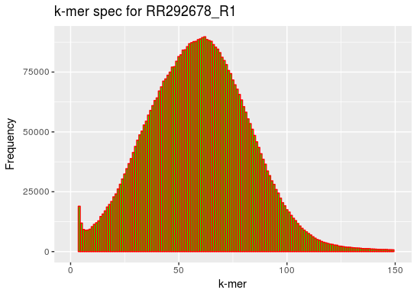

-/-, 22:40
files were uploaded to ARRIAM server in order to assemble genome quickly using MobaXTirm interface.
-/-, 22:50
Runing SPAdes on server with default parameteres:
spades.py -1 SRR292678sub_S1_L001_R1_001.fastq -2 SRR292678sub_S1_L001_R2_001.fastq -o SRR292678sub_S1
-/-, 22:59
Estimating genome complexity. As far as peaks in both R1 and R2 libraries were equal, we decided to use only one library for further calculations. L=90, M = 62, K=31.
N = (M*L)/(L-K+1)=62*90/(90-31+1)=93
size = T/N= 5499346*90/93=5.32 Mb (looks pretty normal for E.coli)
-/-, 23:11
Downloading scaffolds and contigs from server.
-/-, 23:15
Uploading scaffolds and contigs to QUAST online service.
-/-, 23:25
Running SPAdes with two-step mode
spades.py —careful -1 SRR292678sub_S1_L001_R1_001.fastq -2 SRR292678sub_S1_L001_R2_001.fastq -o SRR292678sub_S1
-/-, 23:34
Analysing QUAST report
Assembly | contigs_SRR292678 | scaffolds__SRR292678
# contigs (>= 0 bp) | 520 | 502
# contigs (>= 1000 bp) | 151 | 147
# contigs (>= 5000 bp) | 84 | 83
# contigs (>= 10000 bp) | 69 | 67
# contigs (>= 25000 bp) | 51 | 51
# contigs (>= 50000 bp) | 32 | 33
Total length (>= 0 bp) | 5315630 | 5317053
Total length (>= 1000 bp) | 5204951 | 5205324
Total length (>= 5000 bp) | 5039847 | 5046566
Total length (>= 10000 bp) | 4936170 | 4936433
Total length (>= 25000 bp) | 4640244 | 4686147
Total length (>= 50000 bp) | 3936232 | 4027012

N50 105346 105346

-/-, 23:46
Obtaing corrected reads from server
-/-, 00:08
Executing counting k-mers with jellyfish for corrected reads
~/Downloads/jellyfish-2.2.9/bin/jellyfish count -m 31 -s 100M -t 10 -C -o ~/Downloads/Project3/corrected/SRR292678sub_S1_L001_R1_001.00.0_0.cor_extracted.jf ~/Downloads/Project3/corrected/SRR292678sub_S1_L001_R1_001.00.0_0.cor_extracted.fasta
-/-, 00:18
Making histogram with jellyfish histo:
~/Downloads/jellyfish-2.2.9/bin/jellyfish histo SRR292678sub_S1_L001_R1_001.00.0_0.cor_extracted.jf > SRR292678sub_S1_L001_R1_001.00.0_0.cor_extracted_hist
-/-, 00:21
visualising corrected reads in R studio:
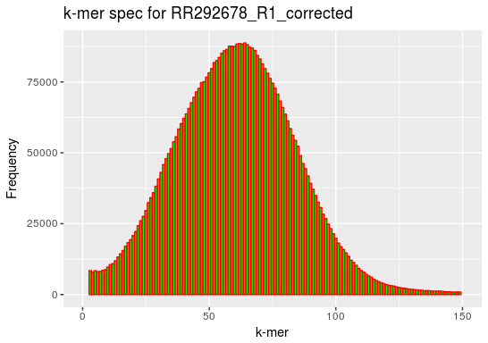

It could be inferred from the plot that corrected is more smooth and contains less noise. Nevertheless, k-mer peak does not differ from uncorrected one.
-/-, 00:30
Running spades with pair-mate library:
spades.py —pe1-1 SRR292678sub_S1_L001_R1_001.fastq —pe1-2 SRR292678sub_S1_L001_R2_001.fastq —mp1-1 SRR292862_1.fastq —mp1-2 SRR292862_2.fastq —mp2-1 SRR292770_1.fastq —mp2-2 SRR292770_2.fastq -o SRR292678mate
-/-, 01:07
Obtaining files from SPAdes. Uploading files to QUAST. Analysing QUAST report.
Assembly contigs scaffolds
# contigs (>= 0 bp) 574 496
# contigs (>= 1000 bp) 130 67
# contigs (>= 5000 bp) 66 17
# contigs (>= 10000 bp) 52 16
# contigs (>= 25000 bp) 41 13
# contigs (>= 50000 bp) 29 12
N50 151071 740922
As we can see, N50 has dramatically risen because mait-pair library helps to assemble contigs as a result of extra information about reads orientation.
-/-, 01:14
Executing procca service on server:
prokka -o annotated SRR292678mate/scaffolds.fasta
-/-, 01:39
Obtaining gbf file after procca executing.
-/-, 01:50
Using barrnap for finding 16S RNA:
./barrnap —quiet ~/Downloads/Project3/scaffolds.fasta > ~/Downloads/Project3/barrop.gff
-/-, 01:59
Indexing fasta file with samtools:
samtools faidx scaffolds.fasta
Get 16-S RNA sequenses with the help of bedtools:
bedtools getfasta -fo whatever.fasta -fi scaffolds.fasta -bed barrop.gff
-/-, 02:05
Blasting extracted sequences with nucleotide blast.
-/-, 02:15
Identified closest relative strain: Escherichia coli B7A (immunogenic according to article Levine MM, Nalin DR, Hoover DL, Bergquist EJ, Hornick RB, Young CR. Immunity to enterotoxigenic Escherichia coli.Infect Immun. 1979 Mar;23(3):729-36.)
ACCESSION NZ_AAJT02000023 NZ_AAJT00000000
VERSION NZ_AAJT02000023.1
Downloading fasta file as reference file.
-/-, 02:33


Wrong database was choosen (Ref Seq Genomes) instead of desirable Ref Seq reference genomes
Another blast attempt → 55989 strain was founded and downloaded
ACCESSION NC_011748
VERSION NC_011748.1
-/-, 02:55
In task it was not clear that we should have been saved gbk file (it was mentioned about gbf), for this reason we launched procca again.

And again we should not have done that again, because our procca version did not provide gbk output.
-/-, 03:25
Another procca try with special tag crucial for further Mauve visualisation:
prokka -o annotated —compliant —locustag Z SRR292678mate/scaffolds.fasta
Nevertheless, that did not fix the problem with Mauve, so we eventually decided to use annotated gbk file.
-/-, 04:06
Aligning with Mauve
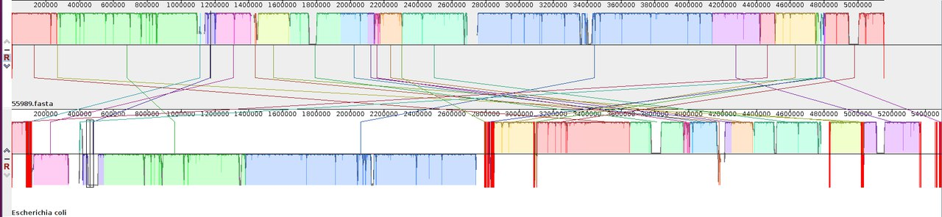
05.04.18, 11:04
Shiga-like toxin related gene names, IDs and locations collected from Mauve visualization of alignment

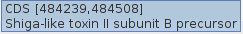

11:07
Shiga-related genes gene context was inspected on a larger scale in Mauve. 5’-region (assuming we are looking on a coding strand) contains a large cluster of phage/prophage genes and 3’-region contains a few phage/prophage genes separated from genes of interest by three tRNA loci (Arg-TCT, Arg-TCG and Mt-CAT).

11:14
ResFinder job was uploaded with e-mail notification enabled.

11:35
ResFinder results obtained
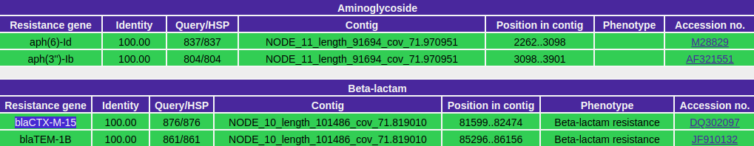
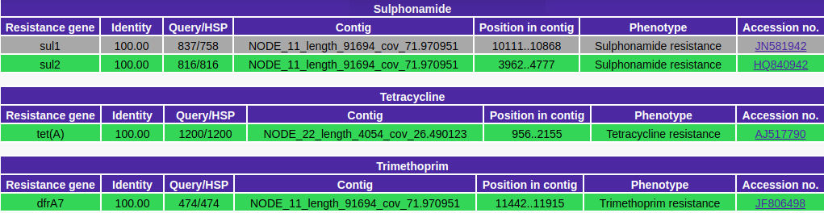

11:40
Two beta-lactamase genes were chosen judging by their suspicious context
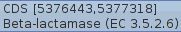

13:40
ResFinder results for reference strain (O104:H4 55989)
