COURSE CODE: CSC 316
COURSE TITLE: System and Analysis Design
Dr. Babatunde Sawyer

TITLE OF CASE STUDY:
Design of an Integrated Substation Management Platform (ISMP) for Fault Detection and GIS-Based Monitoring at NEPA Akoka, University of Lagos

MATRIC NUMBER AND STUDENT NAMES
Matriculation Number | Names | Roles
230805158 | AKINOLA PELUMI PRECIOUS | Senior Analyst
230805120 | ‎OYELEYE OLAMIDE JOHNSON | Data Model Designer
230805117 | ‎ARONINUOLA FOLUKE GLORY | Software Designer
230805135 | ‎UWAEGBU KENNESHA CHIDERA | Logistics Manager
230805160 | YUSUFF WARITH ADEBOLA | Secretary

SESSION: 2025/2026

ACKNOWLEGEMENT
We would like to express our sincere gratitude to our course coordinators and lecturers, Dr. Babatunde Sawyer and Dr. Doyin, for their guidance, support, and for making this project possible. Their commitment to teaching and emphasis on practical learning through system analysis and design provided us with valuable exposure and a peek into solving real world problems. This project has greatly enhanced our understanding of system analysis and encouraged effective collaboration among team members.
Special appreciation to all members of the project team for their cooperation, dedication, and teamwork throughout the duration of the project. The smooth coordination and collective effort contributed significantly to the successful progress of the work.
Furthermore, we would like to thank the organization, NEPA Akoka, for their cooperation and willingness to support this project. Their openness in sharing information, providing necessary resources, and granting approval for the study made this project both feasible and meaningful.
Overall, we are grateful to everyone who contributed in one way or another to the successful completion of this project.
TABLE OF CONTENT
1.0 Introduction
1.1 Background of the Study
1.2 Statement of Problem
1.3 Objectives
1.4 Project’s Scope and Constraints
1.5 Alternative Solutions
1.6 System Description
1.7 Feasibility Assessment
1.7.1 Economic Analysis
1.7.2 Technical Analysis
1.7.3 Schedules, Timeline and Resource Analysis
1.8 Recommendation
2.0 Analysis of the Existing System
2.1 Process Description of the System (using context and DFDs)
2.1.1 Current Physical Data Flow Diagram (CPDFD)
2.1.2 Current Logical Data Flow Diagram
2.2 Data Dictionary
2.3 Data Description of the System (using ERDs)
2.4 RMU Overview
2.5 Problem Areas
3.0 Design of the Proposed System
3.1 System Overview
3.2 Process Specification
3.2.1 Required Logical Data Flow Diagram
3.2.2 Data Dictionary
3.2.3 Decision Tables
3.3 Data Specification
3.3.1 Entity Relationship Diagram (ERD)
3.3.2 Database Design (Tables from ERDs)
3.4 Screen Layout/Specification
3.5 Report/Form Specifications
3.6 Program/Module Specifications
3.7 Test Plans
4.0 Conclusion
APPENDICES
Sample codes if any, reports, results, inputs and outputs, etc.
Each report should be prepared using the following format:
1. Font type should be Times New Roman.
2. Report title should be font size 22pt.
3. Heading 1 font size should be 16pt.
4. Heading2 font size should be 14pt.
5. Body of text font size should be 12pt.
6. The paragraphs should have double line spacing.
INTRODUCTION
1.1 Background of the Study
1.2 Statement of Problem
1.3 Objectives
1.4 Project’s Scope and Constraints
1.5 Alternative Solutions
1.6 System Description
1.7 Feasibility Assessment
1.7.1 Economic Analysis
1.7.2 Technical Analysis
1.7.3 Schedules, Timeline and Resource Analysis
1.8 Recommendation
  - BACKGROUND STUDY

The electrical power infrastructure at the University of Lagos, Akoka, serves as a critical lifeblood for academic, research, and residential activities, operating as a complex 11kV distribution network designed primarily as a Ring Main System. This configuration is strategically organized into four primary rings comprising eight distinct feeders, utilizing approximately 24 kilometers of high-tension (HT) armored cables to ensure a degree of redundancy and path diversity. At the heart of this system, the university receives its primary supply from the national grid through a dedicated 132kV/33kV/11kV substation located in close proximity to the campus control room. This high-voltage supply is subsequently stepped down via numerous transformer substations equipped with Ring Main Units (RMUs), which facilitate the distribution of 415V/400V power to various load centres, including laboratories, faculty buildings, and residential quarters.

Despite the robust physical layout of the UNILAG network, the current operational framework for monitoring and fault management remains heavily reliant on manual intervention, which introduces significant systemic vulnerabilities. In the existing setup, the detection of electrical faults, such as short circuits, overloads, or insulation failures, is often reactive, occurring only after a visible disruption in service is reported by end-users. Personnel must then physically patrol extensive cable routes or manually inspect underground substations to isolate the source of the problem, a process that is inherently time-consuming and prone to human error. This manual approach is particularly problematic for UNILAG’s underground substations, where physical access is restricted and environmental factors can mask early warning signs of equipment fatigue, leading to prolonged downtimes that disrupt critical university functions.

The inefficiency of manual fault detection at the Akoka campus has direct and far-reaching consequences on the university’s primary mission of education and research. Frequent and prolonged power outages, often resulting from delayed fault localization, have been shown to adversely affect academic performance, with many students reporting delays in project completion and the loss of unsaved digital work. Furthermore, the lack of real-time data on transformer health and load distribution means that the system often operates near its thermal limits without the knowledge of operators, risking catastrophic equipment failure. Transitioning from this traditional, "fail-and-fix" manual model to an automated monitoring system is no longer a luxury but a necessity for maintaining a resilient and sustainable learning environment that can support the university's growing technological demands.

1.2 STATEMENT OF PROBLEM

The primary deficiency in the current power distribution framework at the University of Lagos, Akoka, is the total absence of a centralized real-time monitoring architecture. Currently, grid operators and site engineers possess no remote visibility into the instantaneous health of the 11kV/400V transformers or the integrity of the Ring Main Units (RMUs). This lack of telemetry means that critical electrical parameters such as phase imbalances, thermal overloads, and oil level depletion, go unnoticed until a catastrophic failure occurs. Operating such a high-voltage network without a localized Supervisory Control and Data Acquisition (SCADA) or IoT-based interface forces the university to manage its power assets in a state of "operational blindness," where the system's stability is constantly at risk from undetected transient faults that could have been mitigated through early digital warnings.

The existing protocol for fault management is fundamentally reactive and labor-intensive, relying on physical site visitations to diagnose and isolate feeder disruptions. When a blackout occurs, engineers must be dispatched to various substations, often under hazardous conditions or during late-night hours, to manually test switchgear and fuses across the 24 kilometers of high-tension (HT) armored cabling. This manual "trial-and-error" method of fault localization is not only prone to human error but also significantly inflates the Mean Time to Repair (MTTR). In a sprawling campus like Akoka, where many substations are underground or located in restricted areas, the time lost in transit and physical inspection directly translates into prolonged outages, causing systemic inefficiency and placing an unnecessary physical burden on the technical staff.

The cumulative effect of these monitoring gaps is a marked reduction in the reliability and availability of the campus power supply. Frequent disruptions caused by delayed fault detection have a cascading negative impact on the University’s core mission, affecting sensitive laboratory experiments, disrupting ICT-driven examinations, and compromising the safety of residential quarters. Furthermore, the constant stress placed on transformers by undiagnosed faults accelerates equipment depreciation, leading to frequent and costly replacements that strain the university's maintenance budget. Without a transition to an automated, sensor-driven fault detection mechanism, the university’s power infrastructure remains a bottleneck to its technological growth and an unreliable foundation for its expanding academic activities.

1.3 OBJECTIVES

GENERAL OBJECTIVES
The primary goal of this research is to design and develop a robust, integrated digital framework for the real-time monitoring and automated fault detection of the 11kV/400V power distribution substations at the University of Lagos, Akoka. This system seeks to replace existing manual, reactive protocols with a proactive, data-driven architecture that ensures the continuous reliability of the campus power grid by providing operators with instant visibility into the health of the network’s transformers and RMUs.

SPECIFIC OBJECTIVES
- DESIGN A GIS-BASED MAPPING SYSTEM FOR SUBSTATION VISUALIZATION:
This objective involves leveraging Geographic Information System (GIS) technology to create a precise digital twin of the University's power assets. By mapping the exact geographical coordinates (longitude and latitude) of all substations and underground HT cable routes, the system will provide a spatial interface that allows engineers to visualize the entire network hierarchy. This spatial awareness is critical for navigating to specific underground substations or identifying exactly which sections of the ring main system are affected during a localized outage.
- DEVELOP A CENTRALIZED, REAL-TIME MONITORING INTERFACE:
The project aims to design a centralized monitoring dashboard that aggregates live telemetry data from IoT-enabled sensors installed at each substation. This system will continuously track vital electrical and physical parameters including phase voltages, load currents, transformer oil temperatures, and humidity levels, presenting this information in a unified, user-friendly web or mobile interface. This removes the need for physical site visitations for routine checks, allowing the control room to oversee the entire campus grid from a single location.

- DESIGN AN AUTOMATED FAULT DETECTION AND ALERT MECHANISM:
This objective focuses on creating an intelligent logic layer capable of identifying anomalies such as short circuits, overloads, or phase failures the moment they occur. The system will be programmed with specific threshold values for safe operation; any deviation from these parameters will trigger an immediate GSM or Wi-Fi-based alert sent directly to the maintenance team’s mobile devices. These alerts will include the nature of the fault and its precise location on the GIS map, dramatically reducing the time spent on fault isolation and repair.
- IMPROVE MAINTENANCE PLANNING THROUGH SYSTEM DATA ANALYTICS:
By logging historical performance data, the system will provide a foundation for Predictive Maintenance (PdM) rather than traditional "break-fix" maintenance. This objective involves analyzing data trends such as recurring thermal spikes or frequent voltage fluctuations, to identify equipment that is at risk of imminent failure. Using these insights, university engineers can schedule interventions during low-load periods, effectively extending the lifespan of expensive transformers and minimizing the economic impact of unplanned blackouts on the academic community.

1.4 PROJECT’S SCOPE AND CONSTRAINT

SCOPE
The scope of this research is meticulously bounded to the architectural and technical design of an Integrated Substation Management Platform specifically for the NEPA Akoka substation network at the University of Lagos. This study does not encompass the physical construction or deployment of hardware; rather, it provides a comprehensive digital blueprint for a system that can be implemented in the future. The scope of this design phase includes:

- GEOSPATIAL ASSET MAPPING: The primary focus is the mapping of approximately 40 to 50 substations across the Akoka campus. Utilizing Geographic Information System (GIS) technology, the project will document the precise longitude and latitude of these nodes, including the complex array of underground substations and buried high-tension (HT) cable routes. This spatial layer is essential for creating a "digital twin" of the campus grid.

- SYSTEM MODULE ARCHITECTURE: The project covers the detailed design of functional modules, including a Real-Time Monitoring Module for tracking load and temperature, a Fault Detection Module for identifying phase failures or short circuits, and a Data Analytics Module for evaluating long-term equipment health.

- TECHNICAL SYSTEM MODELING: To ensure the structural integrity of the software design, the scope includes the development of high-level system models. This involves Data Flow Diagrams (DFDs) to map the movement of information between field sensors and the central server, and Entity Relationship Diagrams (ERDs) to define the logical connections between different data entities such as transformers, maintenance logs, and fault alerts.

DATABASE AND INTERFACE DESIGN: The study will produce a robust schema for the system’s relational database, ensuring that every RMU, switch fuse, and step-down transformer () is uniquely indexed. Furthermore, it includes the User Interface (UI) design for the management dashboard, providing a visual prototype of how engineers will interact with the GIS map and system alerts

CONSTRAINT
The execution of this study is shaped by several significant institutional and technical constraints that reflect the current "pre-digital" state of the university’s electrical department.

- ABSENCE OF EXISTING DIGITAL INFRASTRUCTURE: A major constraint identified during the preliminary phase is the complete lack of a pre-existing digital presence or online monitoring system. There is no centralized database, website, or digital registry for the campus’s electrical assets. Consequently, all baseline data including the very locations of the substations, had to be manually harvested through physical field surveys and on-site interviews, as no digital map currently exists to guide maintenance teams.
- PROHIBITIVE MANUAL DATA ENVIRONMENT: The university currently operates on a purely manual logging system where fault records and load data are captured intermittently in physical logbooks. This creates a "data vacuum" for the researcher, as there is limited high-fidelity historical data to feed into predictive models. The study is therefore constrained to using simulated data or snapshots of manually collected field readings to validate the proposed design logic.
- LACK OF REAL-TIME SENSOR ACCESS: Due to budgetary and administrative limitations, the project does not involve the physical deployment of real-time sensors (such as CTs or VTs) onto the live 11kV lines. The design must therefore rely on theoretical parameters and manufacturer specifications for the transformers and RMUs rather than live-streamed operational data.
- LOGISTICAL AND ENVIRONMENTAL HURDLES: The presence of underground substations presents a physical constraint, as these areas are often difficult to access for measurement without specialized safety gear or formal outages. Furthermore, the strict academic timeline for project completion limits the ability to perform a 100% exhaustive audit of every individual low-voltage distribution board, forcing a focus on the most critical 11kV nodes.
1.5 ALTERNATIVE SOLUTIONS
In the process of conceptualizing the Integrated Substation Management Platform (ISMP), several established methodologies for grid management were critically evaluated. Each alternative presents varying degrees of technological sophistication, cost-effectiveness, and operational feasibility within the context of the NEPA Akoka distribution network.
1.5.1 Conventional Manual Monitoring and Physical Inspection
The baseline alternative is the status quo currently utilized across the University of Lagos campus. This approach relies entirely on the physical presence of electrical engineers and technicians to perform routine "rounds" across the 40–50 substation sites. Under this model, communication is purely verbal or via paper-based logbooks, where faults are only identified after a total blackout triggers a complaint from the faculty or residential quarters.
- CRITICAL LIMITATIONS: While this method requires zero capital investment in software, it is inherently reactive rather than proactive. In a sprawling campus with underground substations, manual inspection is dangerously inefficient. The time lost in physically traveling to a remote RMU or switch fuse to diagnose a blown component leads to extended "Mean Time to Repair" (MTTR), causing significant academic and administrative disruptions. Furthermore, human error in logging electrical parameters often leads to inaccurate data, making long-term load forecasting impossible.
1.5.2 Static Digital Logging and Offline Record-Keeping
A mid-tier alternative considered was the transition from paper logbooks to a Partial Digital Logging System. This would involve maintenance staff using mobile devices or computers to manually input substation data (voltage, current, and oil levels) into a centralized spreadsheet or a basic offline database at the end of each shift.
- CRITICAL LIMITATIONS: While this approach significantly improves the archival and retrieval of historical records compared to paper files, it fails to address the core problem of real-time fault detection. Because the data is entered "after the fact," the system cannot provide instantaneous alerts during a phase failure or a transformer overload. This "semi-digital" approach remains a retrospective tool; it documents the failure of the grid but does nothing to prevent or accelerate the isolation of faults as they occur on the 11kV lines.
1.5.3 Full-Scale SCADA (Supervisory Control and Data Acquisition)
At the highest technological level is the implementation of a full-scale SCADA system, which is the industry standard for national power grids. SCADA provides high-fidelity, real-time monitoring and, more importantly, remote control capabilities, allowing operators to open or close circuit breakers from a central control room without visiting the substation.
- CRITICAL LIMITATIONS: For the specific needs of the Akoka campus, a traditional SCADA system presents extreme financial and logistical hurdles. The cost of specialized SCADA hardware, proprietary software licenses, and the high-bandwidth communication backbone required (such as fiber optics to every underground substation) is prohibitively expensive for a university-managed grid. Additionally, SCADA systems are notoriously complex to maintain and require a level of specialized cyber-physical security that the current manual environment at NEPA Akoka is not yet equipped to support.
1.5.4 Rationale for the Proposed ISMP
The proposed Integrated Substation Management Platform (ISMP) is designed as a "middle-path" solution that bridges the gap between these extremes. By focusing on GIS-based mapping and conceptual IoT monitoring, the ISMP provides the real-time visibility of a SCADA system at a fraction of the cost and complexity. It moves beyond the limitations of manual and partial digital systems by introducing automated fault-logic, yet it remains feasible for the University's current infrastructure by utilizing cost-effective data models and existing spatial coordinates. The ISMP represents a strategic leap toward a Smart Campus Grid, providing a scalable foundation that can eventually be upgraded as resources become available.

1.6 SYSTEM DESCRIPTION
The proposed Integrated Substation Management Platform (ISMP) is conceptualized as a comprehensive, multi-layered digital ecosystem designed to revolutionize the operational oversight of the NEPA Akoka distribution network. Unlike traditional management tools, the ISMP functions as a unified "command and control" interface that synchronizes physical infrastructure data with advanced digital logic. The platform is architected to transition the University’s power management from a state of "blind reactive maintenance" to one of "informed proactive management". By integrating spatial intelligence with real-time telemetry models, the system ensures that every transformer, RMU, and switch fuse within the 11kV/400V network is accounted for and monitored.
The architectural framework of the ISMP is built upon five core functional modules, each designed to address a specific deficiency in the current manual system:
1.6.1 GIS Mapping and Geo-spatial Visualization Module
The GIS Mapping Module serves as the primary visual layer of the ISMP, providing a high-definition digital representation of the campus power assets. Utilizing Geographic Information System (GIS) technology, this module plots the exact coordinates (latitude and longitude) of all 40–50 substations, including the notoriously difficult-to-locate underground chambers. By layering this data onto a digital map of the University of Lagos, Akoka, the module allows engineers to visualize the connectivity of the Ring Main System. This spatial awareness is critical during a fault event, as it enables maintenance teams to identify the shortest route to a compromised node and understand the topological relationship between different feeders.
1.6.2 Real-Time Monitoring and Status Tracking Module
The Monitoring Module acts as the "sensory organs" of the platform. It is designed to capture and display the live operational status of each substation node. Conceptually, this module aggregates data points such as Phase Voltages (V), Load Currents (I), and Transformer Oil Temperatures (T). Instead of engineers manually visiting sites to read analogue gauges, the Monitoring Module presents this data in a centralized dashboard. This provides "instant-at-a-glance" visibility into the health of the grid, allowing operators to detect load imbalances or overheating components before they reach a critical failure point.

1.6.3 Intelligent Fault Detection and Alerting Module
The Fault Detection Module is the core logic engine of the ISMP. It is programmed with predefined electrical thresholds and "safe-operating" parameters. When the system detects an anomaly such as a short-circuit current spike, a phase failure, or an unauthorized RMU opening, this module automatically triggers the fault logic. It instantly categorizes the severity of the issue and broadcasts an automated alert via GSM (SMS) or web-based push notifications to the mobile devices of the technical crew. These alerts include the specific fault signature and the precise GIS location, effectively eliminating the "search-and-find" delays associated with manual fault localization.
1.6.4 Predictive Health Analytics and Trend Module
The Health Analytics Module moves the system beyond mere monitoring and into the realm of Condition-Based Maintenance (CBM). This module continuously evaluates historical performance data to identify long-term trends and "stress patterns" in the hardware. By analyzing recurring thermal fluctuations or frequent voltage sags, the analytics engine can generate "health scores" for each transformer. This allows the university to predict which assets are nearing their end-of-life or are at risk of imminent failure, enabling the scheduling of repairs during low-load periods and avoiding the high costs of emergency "break-fix" interventions.
1.6.5 Reporting and Decision-Support Module
The Reporting Module is designed to transform raw technical data into actionable intelligence for university management and lead engineers. It automatically generates periodic Performance Reports, documenting total uptime, frequency of outages per feeder, and the efficiency of the response teams. These reports serve as a vital tool for Strategic Decision-Making, providing the empirical data needed to justify infrastructure upgrades, budget allocations for new transformers, or the expansion of the ring main system to accommodate new campus developments.
By synchronizing these five modules, the ISMP creates a robust, scalable, and highly visible management environment that drastically reduces response times, protects expensive power assets, and ensures a stable supply of electricity to the University’s academic and research facilities.
1.7 FEASIBILITY ASSESSMENT
A Feasibility Assessment is a structured, multi-dimensional evaluation conducted during the project initiation phase to determine if a proposed plan is practical, viable, and worth the investment. It serves as a "gatekeeper" that helps stakeholders decide whether to move forward, modify the approach, or abandon a project before significant resources are committed.
1.7.1 ECONOMIC ANALYSIS
The economic feasibility of the Integrated Substation Management Platform (ISMP) is evaluated based on its ability to transition the University’s power expenditure from an "emergency-repair" model to a "managed-maintenance" model. While the initial design and eventual deployment phase require a capital outlay, the system is engineered to provide a significant Return on Investment (ROI) by mitigating the massive indirect costs associated with the current manual oversight.
The economic benefits of the proposed system are categorized into four primary cost-saving areas:
- REDUCTION IN OPERATIONAL EXPENDITURE (OPEX) FOR MANUAL INSPECTIONS:
The current reliance on physical patrols for the 40–50 substations at Akoka consumes significant human resources and transportation costs. Engineers and technicians must be mobilized daily for routine checks, many of which yield no actionable data. By centralizing this through the ISMP Monitoring Module, the university can reallocate technical labor to active repairs rather than passive observation. The reduction in "man-hours" spent on basic status-checking represents a direct and immediate saving in operational overhead.
- MINIMIZATION OF DOWNTIME AND "ECONOMIC OPPORTUNITY LOSS":
Power outages at a premier institution like the University of Lagos have a high "shadow cost." Delayed fault detection in underground substations can lead to blackouts lasting several hours or even days. These disruptions halt high-stakes research, interrupt ICT-based examinations (CBT), and force the massive deployment of expensive diesel-powered backup generators. By utilizing the Fault Detection and Alerting Module, the ISMP slashes the Mean Time to Repair (MTTR). Every hour of downtime saved translates into thousands of Naira saved in diesel fuel costs and the preservation of academic productivity.
- CAPITAL EXPENDITURE (CAPEX) PRESERVATION THROUGH PREDICTIVE MAINTENANCE:
The most significant economic risk in the UNILAG grid is the catastrophic failure of an 11kV transformer or a Ring Main Unit (RMU). Replacing a burnt-out transformer is a multi-million Naira expense that often arises because minor issues (like an oil leak or a slight phase imbalance) were not detected manually. The Health Analytics Module provides "early warning" signals, allowing for minor, inexpensive repairs (like topping up oil or tightening connections) before they escalate into total equipment loss. Extending the lifespan of these heavy assets by even 20% provides a massive long-term capital saving for the university.
- DATA-DRIVEN BUDGETING AND RESOURCE ALLOCATION:
Currently, the university’s power department must estimate budget needs based on anecdotal evidence from logbooks. The Reporting Module of the ISMP provides empirical data on which feeders are overloaded and which transformers are underperforming. This allows the University management to make precision-guided investments in infrastructure. Instead of broad, expensive upgrades, funds can be targeted exactly where the data shows a bottleneck, ensuring that every Naira spent on the power grid yields the maximum possible improvement in stability.
In conclusion, while the implementation of the ISMP involves an upfront cost for software and conceptual hardware, the Total Cost of Ownership (TCO) is significantly lower than continuing with the inefficient, error-prone manual system. The system pays for itself through the prevention of a single major transformer failure and the drastic reduction in daily operational waste.
1.7.2 TECHNICAL FEASIBILITY ANALYSIS
The technical feasibility of the Integrated Substation Management Platform (ISMP) is rooted in the strategic selection of mature, globally recognized technologies. Rather than proposing the invention of new, unproven protocols, the ISMP architecture leverages a synergy of existing Geographic Information Systems (GIS), robust Relational Database Management Systems (RDBMS), and standardized Industrial IoT (IIoT) monitoring frameworks. This ensures that the design is not only practical and implementable but also highly scalable for future campus expansions.
The technical viability is anchored in the following three technological pillars:
I. GEOSPATIAL ENGINEERING AND GIS PLATFORMS
The mapping component of the ISMP is technically supported by established platforms such as QGIS (Quantum GIS). These tools are industry standards for spatial data management and are fully capable of handling the complex coordinate mapping required for the 40–50 substations at UNILAG.
- TECHNICAL ADVANTAGE: These platforms allow for the overlay of substation coordinates onto high-resolution satellite imagery of the Akoka campus. They support the creation of "layers", allowing engineers to toggle between surface-level structures and underground cable routes. The compatibility of these GIS tools with mobile GPS data ensures that the mapping process is accurate and that the spatial data can be easily updated as the grid evolves.
II. HIGH-INTEGRITY DATABASE ARCHITECTURE
The data management core of the system is designed to run on high-performance database engines such as MySQL or PostgreSQL. These systems are technically optimized to handle thousands of concurrent data entries, making them ideal for logging continuous streams of voltage, current, and temperature data from multiple RMUs.
- TECHNICAL ADVANTAGE: By utilizing Structured Query Language (SQL), the ISMP can maintain complex relationships between different entities, linking a specific fault alert to a specific transformer’s maintenance history and its exact GIS location. This ensures data integrity and allows for the rapid retrieval of historical records required for the Health Analytics Module, all within a secure and stable software environment.
III. CONCEPTUAL SCADA AND IOT MONITORING FRAMEWORKS
While a full-scale physical SCADA deployment is a constraint, the logic of the ISMP design is built upon the MQTT (Message Queuing Telemetry Transport) and Modbus protocols, which are the backbone of modern industrial automation.
- TECHNICAL ADVANTAGE: The system is designed to be "hardware-agnostic," meaning it can eventually interface with a wide variety of sensors and Remote Terminal Units (RTUs). By following the architectural principles of SCADA-lite systems, the ISMP provides a sophisticated monitoring logic that can be hosted on standard university servers. This removes the need for proprietary, high-cost infrastructure, making the transition from manual logging to digital monitoring technically seamless and low-risk.
IV. TECHNICAL PRACTICALITY AND MAINTAINABILITY
A key factor in this analysis is the maintainability of the proposed stack. Because the ISMP relies on widely used open-source and enterprise-level technologies, the University’s existing ICT and Electrical Engineering departments possess the foundational knowledge required to manage the system. There is no dependency on "black-box" proprietary technologies; instead, the system utilizes a modular design where individual components (like the reporting module or the GIS layer) can be upgraded or repaired independently without crashing the entire platform.
In summary, the ISMP is technically feasible because it is an integration project rather than an invention project. By utilizing the best-in-class tools for mapping, data storage, and communication logic, the design provides a sophisticated solution that is entirely within the reach of current engineering capabilities at the University of Lagos.
1.7.3 SCHEDULES, TIMELINE AND RESOURCE ANALYSIS
The successful delivery of the Integrated Substation Management Platform (ISMP) design is predicated on a strictly disciplined timeline and the efficient mobilization of specific analytical resources. Given that the project is categorized as a Design-Phase Study, the schedule is optimized to prioritize data acquisition, system modeling, and architectural validation within the constraints of a single academic session.
I. STRATEGIC PROJECT TIMELINE AND SCHEDULING
The project is divided into four distinct phases, each aligned with the milestones of the University of Lagos academic calendar. This phased approach ensures that the "blind spots" in the manual system are systematically addressed:
- PHASE 1: SITE SURVEY AND GEO-SPATIAL DATA HARVESTING:
The initial weeks are dedicated to the physical audit of the NEPA Akoka network. Since no digital maps exist, this phase involves physically visiting each of the 40–50 substations to capture GPS coordinates. This is the most labor-intensive stage, as it requires navigating the campus to locate underground RMUs and buried cable markers.
- PHASE 2: SYSTEM ARCHITECTURE AND LOGIC MODELING:
Following data collection, the next step is focused on the technical design of the system's "brain." This involves the creation of Data Flow Diagrams (DFDs) to map how a fault signal travels from an 11kV feeder to the central dashboard, and Entity Relationship Diagrams (ERDs) to structure the database.
- PHASE 3: GIS INTEGRATION AND INTERFACE PROTOTYPING:
During this phase, the captured spatial data is imported into the mapping environment. The user interface (UI) for the monitoring dashboard is designed, ensuring that the Fault Detection and Alerting Module is visually intuitive for the maintenance team.
PHASE 4: VALIDATION, DOCUMENTATION, AND FINAL REPORTING:
The final weeks are reserved for "stress-testing" the design logic using simulated fault scenarios. This phase culminates in the production of the comprehensive hardcopy technical report, ensuring all design specifications meet the university’s engineering standards.

GANTT CHART FOR SCHEDULING
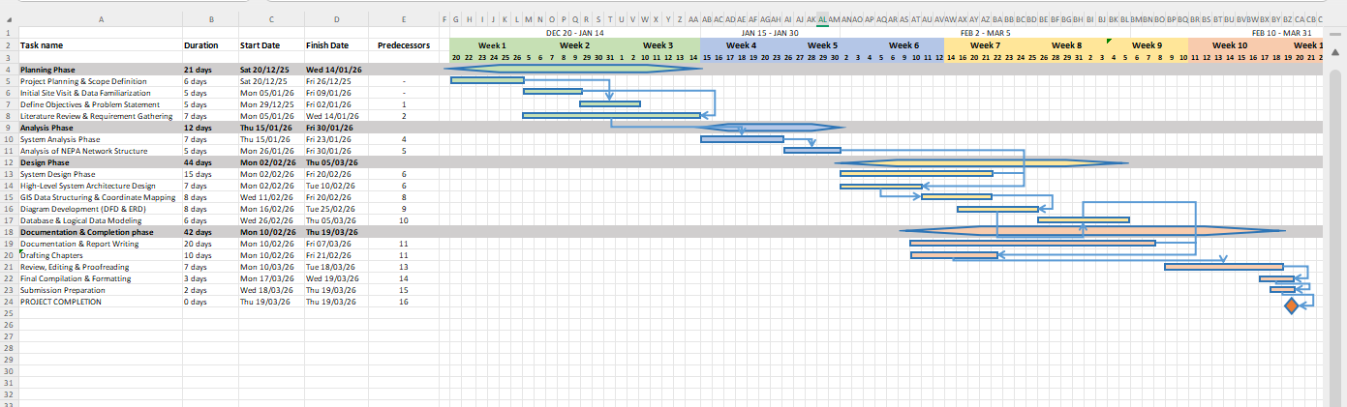

TIMELINE ANALYSIS

Program Evaluation and Review Technique (PERT) Estimation
Task | Optimistic (O) Weeks | Realistic (R) Weeks | Pessimistic (P) Weeks | Expected Time (ET) Weeks
Project Planning | 1 | 1 | 2 | 1
System Analysis | 1 | 2 | 3 | 2
System Design | 2 | 3 | 4 | 3
GIS Data Collection & Structuring | 1 | 2 | 3 | 2
Diagram Development (DFD, ERD) | 1 | 2 | 3 | 2
Documentation & Report Writing | 1 | 2 | 3 | 2
Review and Final Compilation | 1 | 1 | 2 | 1
TOTAL | 8 | 13 | 20 | 13 Weeks
EXPECTED TIME (ET) = (O + 4R + P) /6

II. RESOURCE REQUIREMENTS AND ANALYTICAL TOOLS
The feasibility of the ISMP is further supported by its reliance on accessible, high-performance analytical tools. The project does not require expensive physical laboratory hardware, as its primary "laboratory" is the digital design environment. The essential resources include:
- GEOSPATIAL ANALYSIS SOFTWARE (QGIS):
As the primary tool for the GIS Mapping Module, QGIS (Quantum GIS) provides the professional-grade environment needed to create the multi-layered digital map of the Akoka grid. It allows for the integration of satellite imagery with the manually harvested coordinates of the step-down transformers.
- SYSTEM MODELING AND DIAGRAMMING SUITES:
Tools such as Lucidchart, Microsoft Visio, or Draw.io are utilized to construct the technical blueprints of the platform. These resources are critical for visualizing the complex interactions between the Health Analytics and Reporting Modules, ensuring the system logic is clear and implementable.
- DATABASE MANAGEMENT SYSTEMS (DBMS):
A local installation of MySQL or PostgreSQL serves as the testing ground for the system’s data architecture. This allows for the creation of the database schema that will eventually house the records for every RMU and switch fuse in the campus ring main.
- DOCUMENTATION AND TECHNICAL WRITING TOOLS:
The final output relies on advanced word-processing and citation management software to ensure the hardcopy submission meets the academic rigor expected of a final-year engineering project.
III. CONSTRAINTS MANAGEMENT AND TIME BUFFERS
Recognizing the Time Constraints of the academic session, the schedule includes "buffer periods" to account for the difficulty in accessing some of the underground substations or potential delays in obtaining technical manuals from the university’s physical planning department. By focusing strictly on the Design Phase and excluding physical implementation, the project remains highly feasible and realistic, ensuring a high-quality delivery within the stipulated timeframe.

1.8 RECOMMENDATION
Based on the extensive technical, economic, and operational analysis conducted throughout this study, the Integrated Substation Management Platform (ISMP) is formally recommended as the most viable and transformative solution to the systemic challenges currently facing the NEPA, Akoka power distribution network. The transition from a purely manual, reactive oversight model to a data-driven, GIS-integrated architecture is no longer a luxury but a technical necessity for maintaining the University's status as a leading research institution.
To ensure the successful adoption and long-term sustainability of the proposed system, the following specific recommendations are put forward:
- ADOPTION OF A PHASED IMPLEMENTATION STRATEGY:
It is recommended that the University of Lagos Physical Planning and Works Department adopt a phased approach to deploying the ISMP. Given the current Manual Operational Environment, the institution should first implement the GIS Mapping Module to digitize the locations of all 40–50 substations. This provides immediate value for fault localization before the more complex real-time sensor integration (IoT) is initiated.
- PRIORITIZATION OF UNDERGROUND SUBSTATION MONITORING:
A critical recommendation is to prioritize the installation of monitoring nodes within the underground chambers. As these locations are the most difficult to inspect manually and are prone to environmental hazards like flooding or overheating, they represent the highest risk to the 11kV ring main system. Automating the oversight of these "blind spots" will yield the fastest improvement in overall grid reliability.
- INVESTMENT IN TECHNICAL CAPACITY BUILDING:
For the ISMP to be effective, there must be a parallel investment in the human capital of the university's electrical maintenance team. It is recommended that staff undergo specialized training in GIS data management and basic digital dashboard operation. This ensures that the transition from paper logbooks to a centralized monitoring interface is met with high operational competency and minimal internal resistance.
- ESTABLISHMENT OF A CENTRALIZED POWER COMMAND CENTER:
To fully leverage the Monitoring and Fault Detection Modules, the University should establish a dedicated control room equipped with a centralized server and display terminals. This hub will serve as the "nerve center" where live alerts from the 11kV to 400V transformers are monitored 24/7, allowing for an instantaneous response to any phase failures or RMU anomalies reported by the system.
- STANDARDIZATION OF CONDITION-BASED MAINTENANCE (CBM):
Finally, it is recommended that the University shift its maintenance policy from "break-fix" to the Predictive Maintenance model enabled by the ISMP’s Health Analytics Module. By using the system’s data to schedule repairs based on actual equipment stress rather than arbitrary calendar dates, the University can significantly extend the operational lifespan of its multi-million Naira transformers and switchgear.
In conclusion, the implementation of the Integrated Substation Management Platform represents a strategic investment in the University’s infrastructure. It offers a clear path toward a Smart Campus Grid, ensuring that power distribution (the bedrock of all academic and research activities) is managed with modern precision, transparency, and maximum efficiency.
2.0 Analysis of the Existing System
2.1 Process Description of the System (using context and DFDs)
2.1.1 Current Physical Data Flow Diagram (CPDFD)
2.1.2 Current Logical Data Flow Diagram
2.2 Data Dictionary
2.3 Data Description of the System (using ERDs)
2.4 RMU Overview
2.5 Problem Areas
2.1 Process Description of the System (using context and DFDs)
The current power monitoring and fault management framework at the NEPA station in Akoka, University of Lagos, is characterized by a fragmented, manpower-heavy operational model that lacks the digital integration required for a modern smart campus. While the physical infrastructure, comprising 11kV/400V step-down transformers, switch fuses, and Ring Main Units (RMUs), is robust, the management layer remains rooted in outdated, paper-based protocols. This "analog" oversight of a high-voltage distribution network creates significant gaps in visibility, particularly where the university utilizes underground substations to protect equipment from environmental exposure.
Operational Architecture: The Manual Patrol Model
At present, the monitoring of the 40–50 substations distributed across the Akoka campus is conducted through periodic physical inspections. Maintenance engineers and technicians are dispatched on routine "rounds" to manually check oil levels, thermal signatures, and load readings on analogue gauges.
- THE VISIBILITY GAP: Because these inspections are intermittent, there is no way to capture transient faults or sudden voltage spikes that occur between patrol cycles.
- DATA INTEGRITY ISSUES: Readings are captured by hand in physical logbooks, a process that is not only prone to human error but also makes historical data analysis nearly impossible. Without a centralized database, the university cannot easily track the "Mean Time Between Failures" (MTBF) for specific high-tension (HT) cables or transformers.
Reactive Fault Detection and "Citizen-Led" Reporting
The most critical failure of the existing system is its reactive nature. In the absence of an automated alerting mechanism, the NEPA station is often the last to know when a fault occurs.
- THE NOTIFICATION CHAIN: Currently, the "fault detection system" is essentially the university community itself. A fault such as a blown fuse in a localized RMU, is typically only identified after a total blackout triggers a complaint from a faculty office or a residential hall.
- LOCALIZATION DELAYS: Once a fault is reported, engineers must manually isolate the affected feeder by physically visiting multiple substations to test for continuity. This "trial-and-error" approach to fault localization is particularly grueling for underground substations, where access is restricted and environmental factors can mask early signs of insulation failure or cable punctures.
Challenges in Managing Underground Infrastructure
UNILAG’s strategic use of underground substations presents a unique set of management hurdles that the current manual system cannot overcome.
- PHYSICAL INACCESSIBILITY: These chambers are often difficult to inspect during inclement weather or late-night shifts.
THERMAL AND HUMIDITY RISKS: Underground environments are prone to heat buildup and moisture ingress, both of which accelerate the degradation of transformer oil and switchgear insulation. Without real-time sensors, the technical team is "blind" to these environmental stressors until they cause a catastrophic failure, leading to expensive and unplanned "break-fix" interventions.
Challenges in Managing Underground Infrastructure
UNILAG’s strategic use of underground substations presents a unique set of management hurdles that the current manual system cannot overcome.
- PHYSICAL INACCESSIBILITY: These chambers are often difficult to inspect during inclement weather or late-night shifts.
- THERMAL AND HUMIDITY RISKS: Underground environments are prone to heat buildup and moisture ingress, both of which accelerate the degradation of transformer oil and switchgear insulation. Without real-time sensors, the technical team is "blind" to these environmental stressors until they cause a catastrophic failure, leading to expensive and unplanned "break-fix" interventions.
Inefficiencies in Maintenance and Resource Allocation
The current system operates on a Calendar-Based Maintenance schedule rather than a Condition-Based one. This means that assets are serviced based on arbitrary dates rather than their actual operational health.
- ECONOMIC IMPACT: This results in two types of waste:
1. Performing maintenance on equipment that doesn't need it
2. Missing critical signs of wear on overworked transformers.
- DECISION-MAKING HURDLES: Without a GIS-based visualization tool, the management at the NEPA station lacks a "Big Picture" view of the network. This makes it difficult to plan for future campus expansions or to identify which sections of the ring main system are consistently overloaded and require immediate upgrading.

2.1.1 Current Physical Data Flow Diagram (CPDFD)
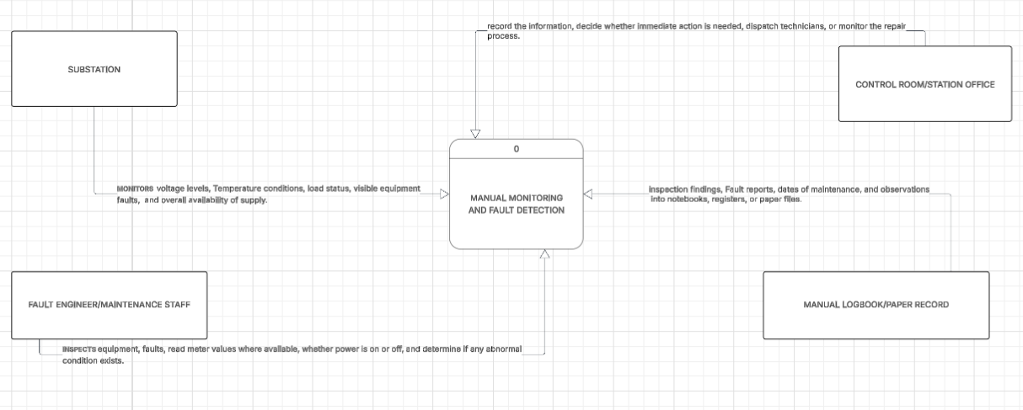
2.1.2 Current Logical Data Flow Diagram
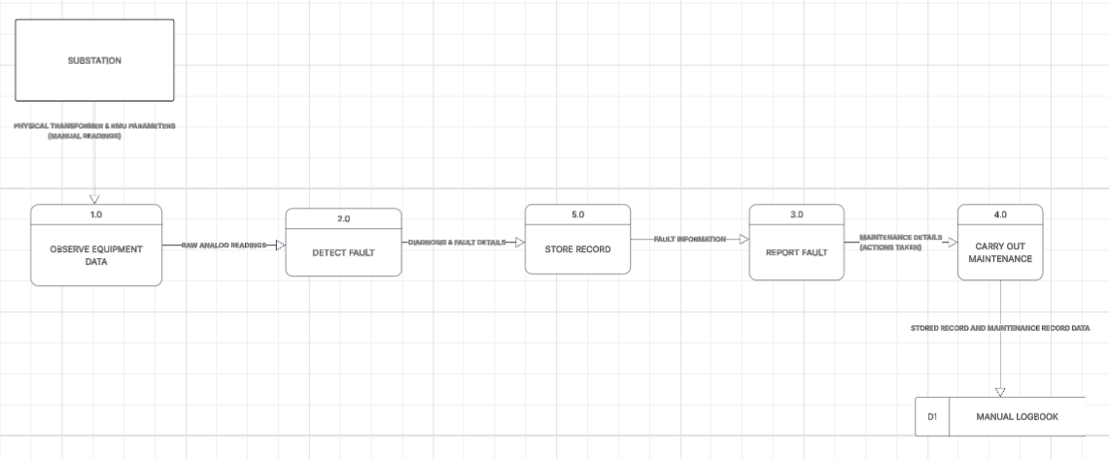
2.2 Data Dictionary
Data Element | Meaning
Substation_ID | Unique identifier for each substation
Station_Name | Name of the substation
Ring | Ring group or classification of the substation
Capacity | Transformer capacity of the substation
Status | Current condition of the substation, such as ON, OFF, or Faulty
Voltage_Level | Voltage reading measured at the substation
Temperature | Temperature reading of the transformer or equipment
Load_Status | Load condition of the substation
Communication_Status | Indicates whether communication is active or failed
Fault_ID | Unique identifier for each fault
Fault_Type | Type of fault, such as overload or cable fault
Severity | Degree of fault, such as minor or critical
Timestamp | Date and time a fault occurred or was detected
Fault_Status | Indicates whether the fault is active or resolved
Maintenance_ID | Unique identifier for each maintenance activity
Maintenance_Date | Date maintenance was carried out
Maintenance_Type | Type of maintenance, such as inspection, repair, or replacement
Description | Details of the maintenance work performed
Staff_ID | Identifier of the engineer or maintenance staff responsible
Log_ID | Unique identifier for each manual log entry
Record_Type | Type of record, such as fault, inspection, or maintenance
Entry_Date | Date the record was entered into the logbook
Remarks | Additional notes or comments about the record

2.3 Data Description of the System (using ERDs)
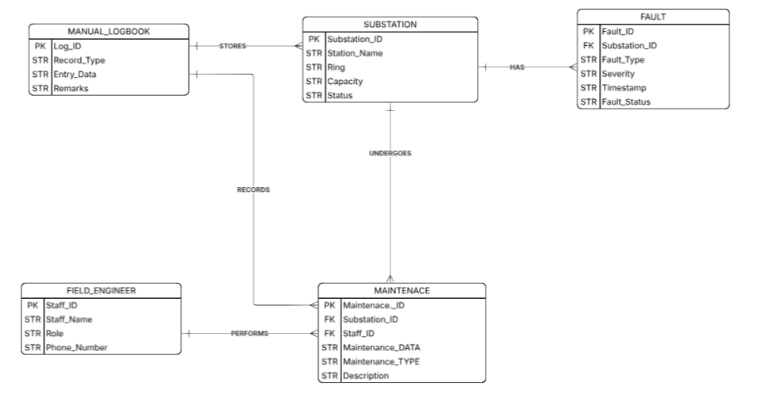
The ERD of the existing system shows the main data entities involved in the manual substation monitoring process. The central entity is the substation, which is associated with fault and maintenance records over time. Field engineers perform maintenance activities, while manual logbooks are used to store fault and maintenance information. The diagram highlights that although the existing system has recognizable data relationships, these relationships are not managed through a centralized digital database, leading to fragmented records and inefficient data handling
2.4 RMU Overview
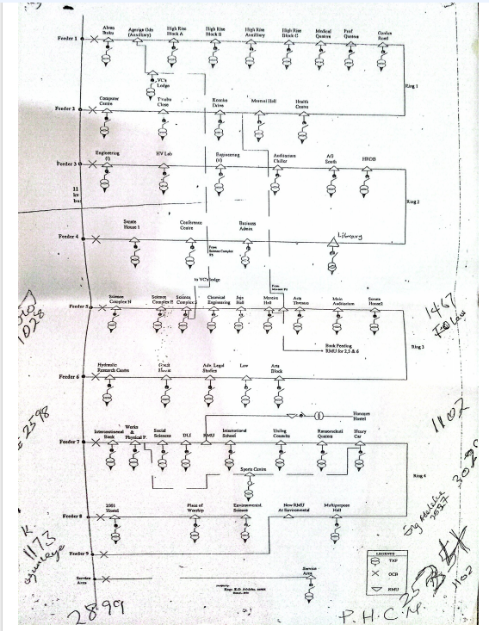

2.5 Problem Areas
1. Lack of Centralized Monitoring System
There is no centralized platform for monitoring all substations. Engineers cannot view the status of multiple substations from a single interface, making system management difficult and inefficient.

2. Manual Fault Detection
Faults are detected manually through physical inspection or user complaints. This reactive approach leads to delays in identifying issues and increases downtime.

3. Delayed Fault Response
Because engineers must physically locate and inspect substations, especially underground ones, response time to faults is significantly delayed.

4. Poor Data Management
All records are stored manually in logbooks or paper files. This results in:
- difficulty retrieving information,
- data inconsistency,
- and lack of proper data organization.

5. No Real-Time Visibility
The system does not provide real-time information about substation conditions. Engineers cannot monitor voltage, temperature, or load status remotely.

6. Inefficient Communication
Communication between field engineers and the control room is manual and informal, often relying on phone calls or verbal reports. This leads to delays and miscommunication.

7. Lack of Predictive Maintenance
The system does not analyze historical data to predict potential failures. Maintenance is only performed after faults occur.

8. Difficulty in Monitoring Underground Substations
Underground substations are harder to access and monitor, making fault detection even more challenging.
3.0 Design of the Proposed System
3.1 System Overview
3.2 Process Specification
3.2.1 Required Logical Data Flow Diagram
3.2.2 Data Dictionary
3.2.3 Decision Tables
3.3 Data Specification
3.3.1 Entity Relationship Diagram (ERD)
3.3.2 Database Design (Tables from ERDs)
3.4 Screen Layout/Specification
3.5 Report/Form Specifications
3.6 Program/Module Specifications
3.7 Test Plans
3.1 SYSTEM OVERVIEW
The proposed system, known as the Integrated Substation Management Platform (ISMP), is designed to address the limitations identified in the existing substation management system at the NEPA station, Akoka. The system provides a centralized, intelligent, and structured approach to monitoring, fault detection, and management of substations distributed across the University of Lagos.
The ISMP integrates multiple functional modules into a single platform, enabling real-time visibility, improved fault detection, and efficient data management. A key feature of the system is the integration of Geographic Information System (GIS) technology, which allows substations to be visualized spatially on a digital map. This enhances the ability of engineers to quickly identify and locate faults, especially in underground substations where physical inspection is difficult.
The system operates by conceptually receiving data from substations through monitoring devices such as sensors or Remote Terminal Units (RTUs). This data is transmitted to a central server where it is processed, analyzed, and stored. The processed information is then presented to users through a dashboard interface and a GIS-based map.
The ISMP is composed of the following major modules:
- GIS Mapping Module
- Monitoring Module
- Fault Detection and Alert Module
- Health Analytics Module
- Reporting Module
These modules work together to provide a comprehensive solution for substation management.
3.2 Process Specification
S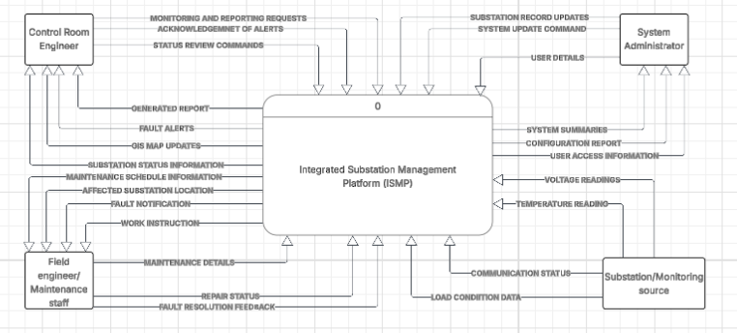
Context diagram for proposed system

The context diagram of the proposed system presents the Integrated Substation Management Platform (ISMP) as a single high-level process interacting with four major external entities: the Control Room Engineer, Field Engineer/Maintenance Staff, System Administrator, and Substation/Monitoring Source. The diagram shows how operational data enters the system from substations, while alerts, reports, and monitoring outputs are delivered to relevant users. This representation establishes the system boundary and summarizes the major interactions between the ISMP and its operating environment.

3.2.1 Required Logic Data Flow Diagram
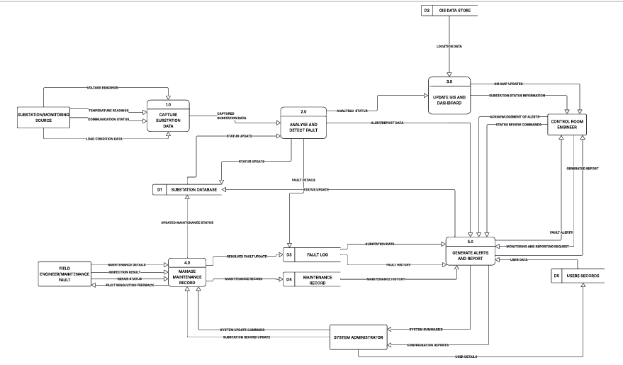
The standard Data Flow Diagram of the proposed Integrated Substation Management Platform decomposes the system into five major processes: substation data capture, fault analysis, GIS/dashboard update, maintenance and fault record management, and alert/report generation. Operational data enters the system through the monitoring source and is analyzed to determine the status of each substation. The results are stored in the appropriate data stores and then used to update the GIS map, support maintenance tracking, and generate alerts and management reports. This structure ensures that the system supports centralized monitoring, rapid fault visibility, and structured record keeping
3.2.2 Data Dictionary
Data Element | Description
Substation_ID | A unique identifier assigned to each substation in the system
Station_Name | The descriptive name of the substation or RMU location
Ring | The ring classification of the substation, such as Ring 1, Ring 3, or Ring 4
Capacity | The transformer or substation capacity measured in kVA
Longitude | The east-west geographic coordinate used for GIS plotting
Latitude | The north-south geographic coordinate used for GIS plotting
Status | Current operating condition of the substation, such as Normal, Fault, or Maintenance
Voltage_Level | Measured or recorded voltage condition of the substation
Temperature | Transformer or equipment temperature reading
Communication_Status | Indicates whether communication with the substation is active or lost
Fault_ID | Unique identifier for each fault record
Fault_Type | Nature of fault detected, such as overload, overheating, voltage abnormality, or communication failure
Severity | Classification level of a fault, such as minor or critical
Timestamp | Date and time when an event occurred or was recorded
Maintenance_ID | Unique identifier for each maintenance record
Maintenance_Date | Date on which maintenance activity was performed
Maintenance_Type | Type of maintenance carried out, such as inspection, repair, or replacement
Staff_ID | Unique identifier assigned to each system user or technical staff member
Staff_Name | Full name of the staff member
Role | User role, such as engineer, supervisor, or administrator
Alert_ID | Unique identifier for each alert generated
Alert_Message | Description of the alert generated by the system
Health_Score | Computed indicator showing the operational condition of the substation

3.2.3 Decision Tables
Conditions:
Voltage Level High
Transformer Temperature High
Communication Status Lost

Actions:
System operates normally
Generate minor fault alert
Generate critical fault alert
Report communication failure
CONDITION STUBS | Conditions / Courses Of Actions | RULES
CONDITION STUBS | Conditions / Courses Of Actions | RULE 1 | RULE 2 | RULE 3 | RULE 4
CONDITION STUBS | Voltage High | No | Yes | Yes | No
CONDITION STUBS | Temperature High | No | No | Yes | No
CONDITION STUBS | Communication Lost | No | No | No | Yes
ACTION STUBS | Normal Operation | X
ACTION STUBS | Minor Fault Alert |  | X
ACTION STUBS | Critical Fault Alert |  |  | X
ACTION STUBS | Communication Failure |  |  |  | X
RULES SPECIFIED
· Rule 1:
When voltage, temperature, and communication are all normal, the system continues normal operation.
· Rule 2:
If voltage is high but temperature and communication are normal, the system generates a minor fault alert.
· Rule 3:
If both voltage and temperature are high, this indicates a serious issue, and the system generates a critical fault alert.
· Rule 4:
If communication is lost, regardless of other conditions, the system reports a communication failure, as monitoring data cannot be trusted.

3.3 Data Specification
Main Entities
1. Substation
This is the central entity in the system. It stores the basic details of each substation, including its identifier, name, ring, capacity, and status.
2. Fault
This entity stores records of faults detected in the system. Each fault is linked to a particular substation and contains details such as fault type, severity, and timestamp.
3. Maintenance
This entity records maintenance activities performed on a substation. It includes the date of maintenance, description of work done, and staff responsible.
4. Staff
This entity stores details of the engineers, supervisors, or administrators who use the system or carry out maintenance activities.
5. GIS_Record
This entity stores the geospatial coordinates of the substation and may contain map-related fields such as longitude, latitude, and location type.
6. Monitoring_Record
This entity stores periodic monitoring data such as voltage, temperature, and communication status for each substation.

3.3.1 Entity Relationship Diagram (ERD)
few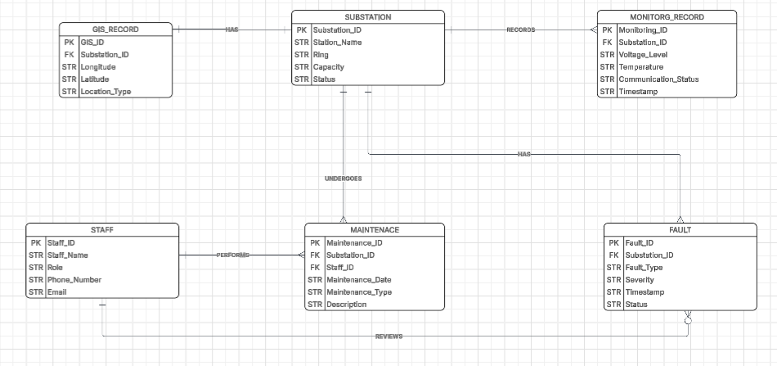
3.3.2 Database Design (Tables from ERDs)
SUBSTATION: Substation_ID (PK), Station_Name, Ring, Capacity, Status

GIS_RECORD: GIS_ID (PK), Substation_ID (FK), Longitude, Latitude, Location_Type

MONITORING_RECORD: Monitoring_ID (PK), Substation_ID (FK), Voltage_Level, Temperature, Communication_Status, Timestamp

FAULT: Fault_ID (PK), Substation_ID (FK), Fault_Type, Severity, Timestamp, Status

MAINTENANCE: Maintenance_ID (PK), Substation_ID (FK), Staff_ID (FK), Maintenance_Date, Maintenance_Type, Description

STAFF: Staff_ID (PK), Staff_Name, Role, Phone_Number, Email

3.4 Screen Layout/Specification
WELCOME PAGE
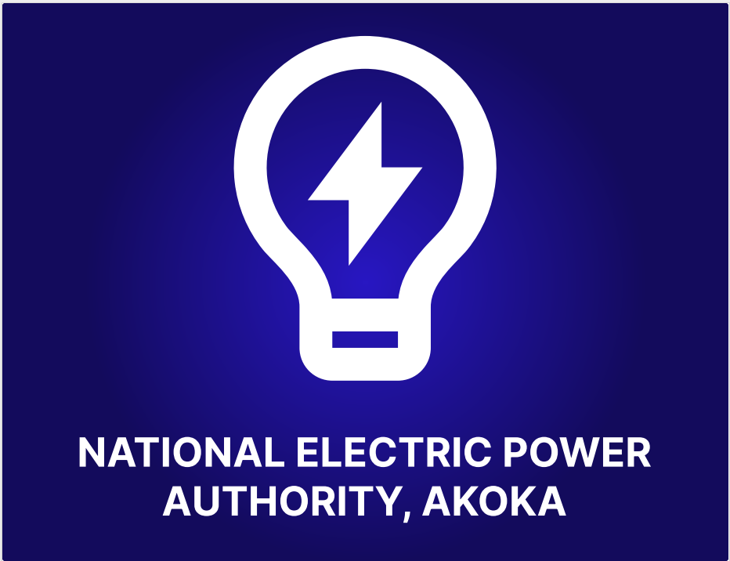
SIGN IN PAGE
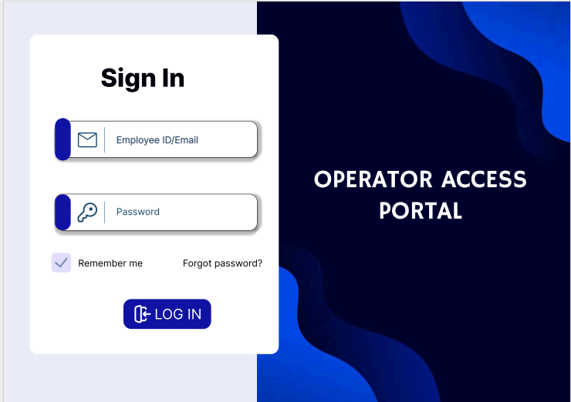
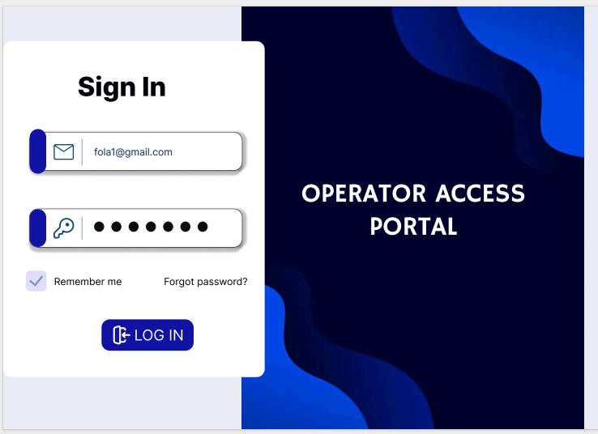
DASHBOARD
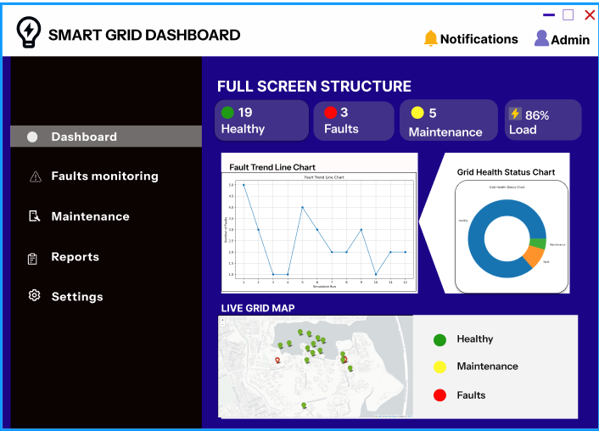
FAULT HISTORY SIMULATION
simulation_run | fault_count | healthy_count
1 | 5 | 17
2 | 3 | 19
3 | 1 | 21
4 | 1 | 21
5 | 4 | 18
6 | 3 | 19
7 | 2 | 20
8 | 2 | 20
9 | 3 | 19
10 | 1 | 21
11 | 2 | 20
12 | 2 | 20
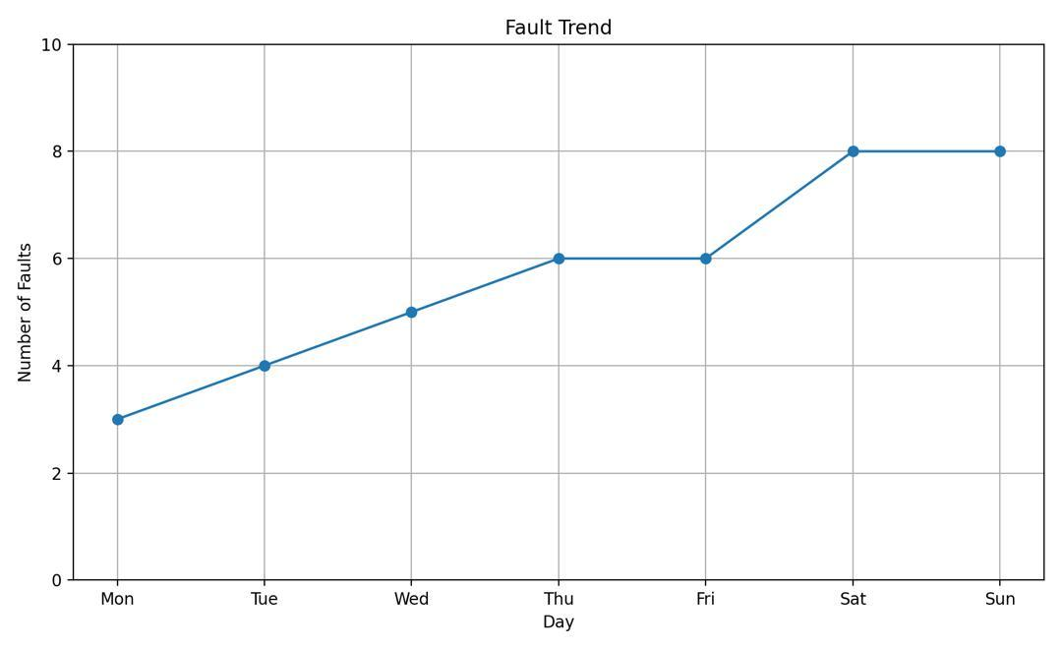
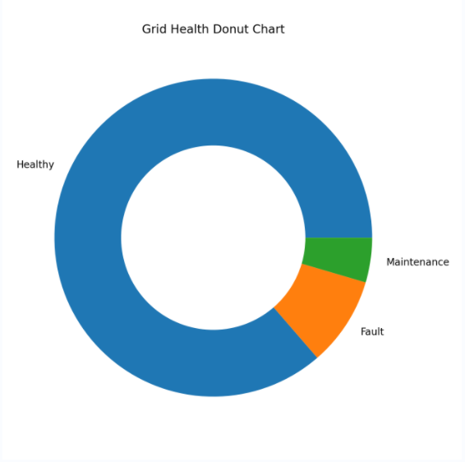
COLLECTED RMU DATA
station_id | ring | capacity | longitude | latitude
HIGH-RISE-BLKA-RMU | RING 1 | 315 | 3.2415 | 6.3027
HIGH-RISE-AUX-RMU | RING 1 | 1000 | 3.2349 | 6.3023
JAJA-RMU | Ring 3 | 1000 | 3.235 | 6.3046
MEDICAL-QTRS-RMU | Ring 1 | 500 | 3.2344 | 6.3041
VC-LOUNGE-RMU | RING 1 | 100 | 3.2351 | 6.3041
FIRST-BANK-RMU | RING 4 | 1000 | 3.3971 | 6.5183
ACCESS-BANK-RMU | RING 4 | 0 | 3.3968 | 6.5182
GUEST-HOUSE-RMU | RING 3 | 0 | 3.3968 | 6.519
UNILAG-CONSULT-RMU | RING 4 | 0 | 3.3919 | 6.5182
SPORT-CENTRE-RMU | RING 4 | 1000 | 3.3883 | 6.5202
MULTI-HALL-RMU | RING 4 | 0 | 3.3895 | 6.5205
CHAPEL-RMU | RING 4 | 1000 | 3.3879 | 6.5182
ISL-RMU | RING 4 | 1000 | 3.3915 | 6.5121
OZOLUA-ROAD-RMU | RING 1 | 300 | 3.391 | 6.522
KOSOKO-DRIVE-RMU | RING 1 | 300 | 3.3922 | 6.5218
TINUBU-CLOSE-RMU | RING 1 | 300 | 3.3934 | 6.5212
AGERIGE-ODO-RMU | RING 1 | 300 | 3.3941 | 6.5209
ALVAN-IKOKU-RMU | RING 1 | 500 | 3.3928 | 6.5204
CITS-RMU | RING 1 | 500 | 3.3937 | 6.5195
SODEINDE-RMU | RING 4 | 750 | 3.3927 | 6.5192
FAGUNWA-RMU | RING 4 | 1000 | 3.392 | 6.5198
GTBANK-RMU | RING 3 | 1000 | 3.3978 | 6.5171

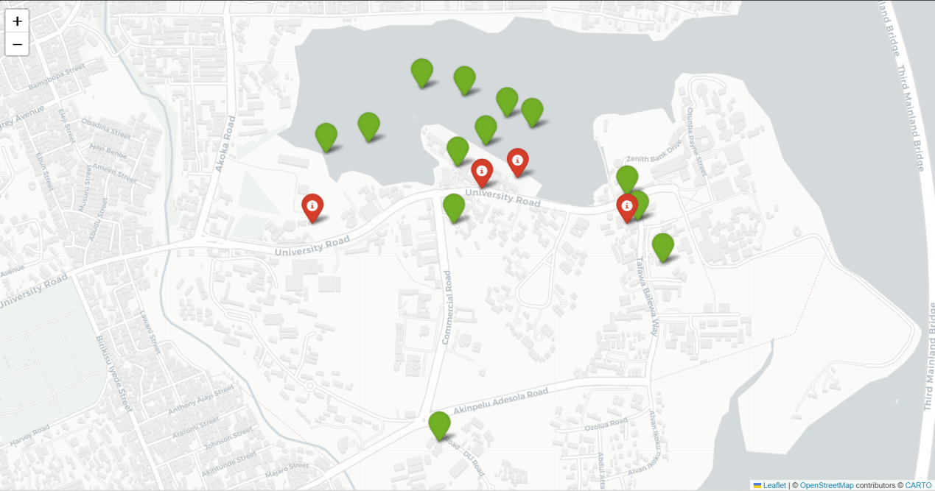
OVERVIEW OF SUBSTATIONS LOCATION
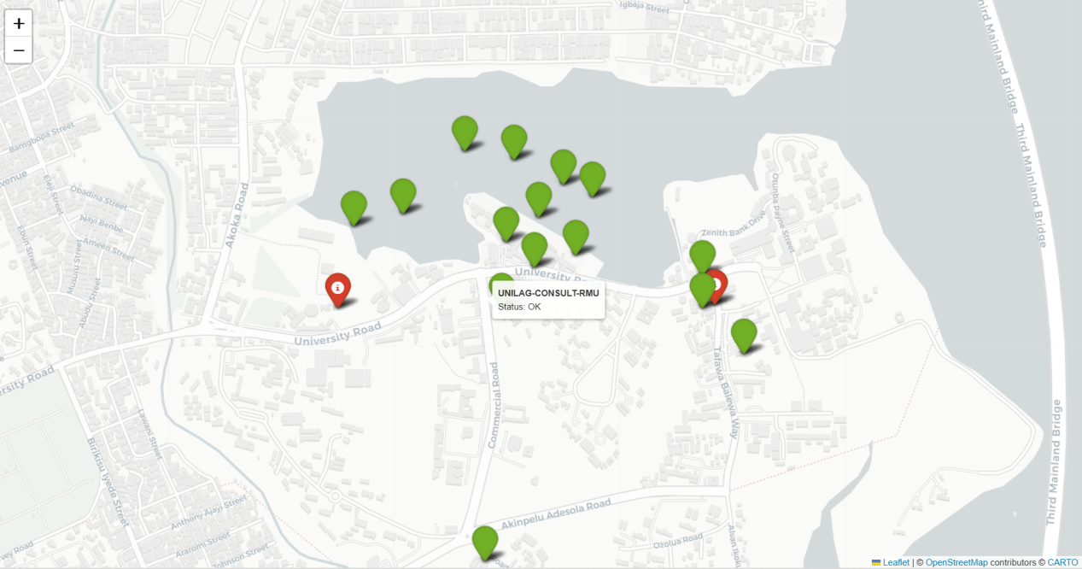SHOWS STATUS OF FAULTLESS SUBSTATION WHEN HOVERED ON
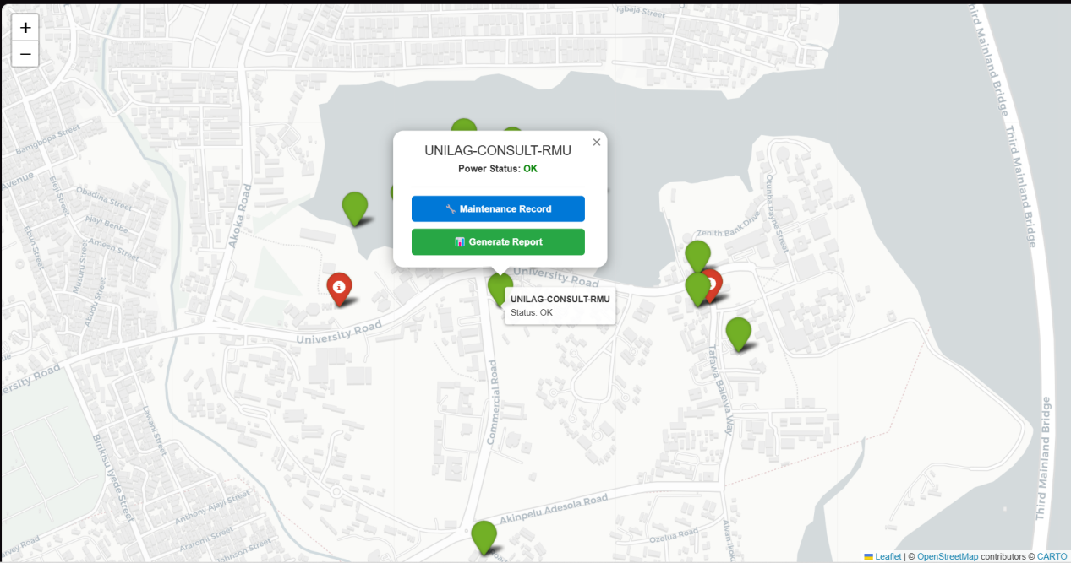
SHOWS MORE INFORMATION WHEN YOU CLICKED
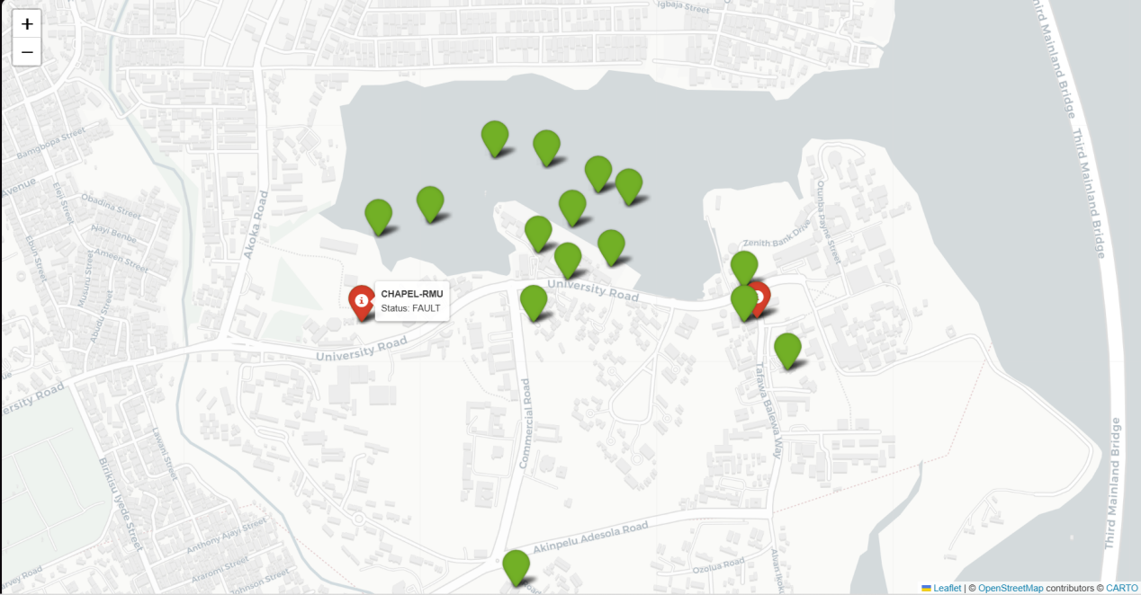SHOWS A FAULTY SUBSTATION WHEN HOVERED ON
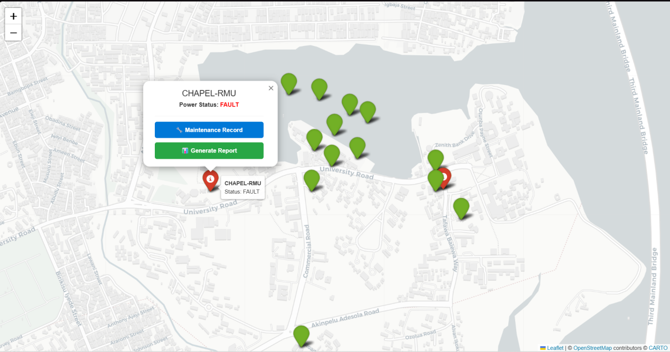
SHOW MORE INFORMATION WHEN CLICKED

FAULTS MONITORING SCREEN
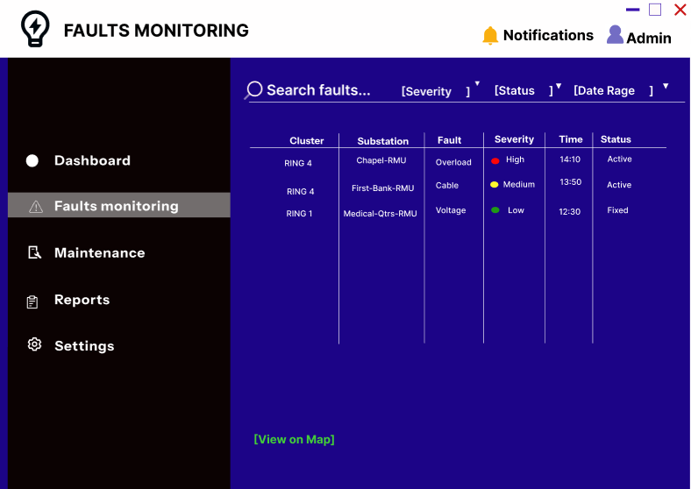
MAINTENANCE RECORD SCREEN
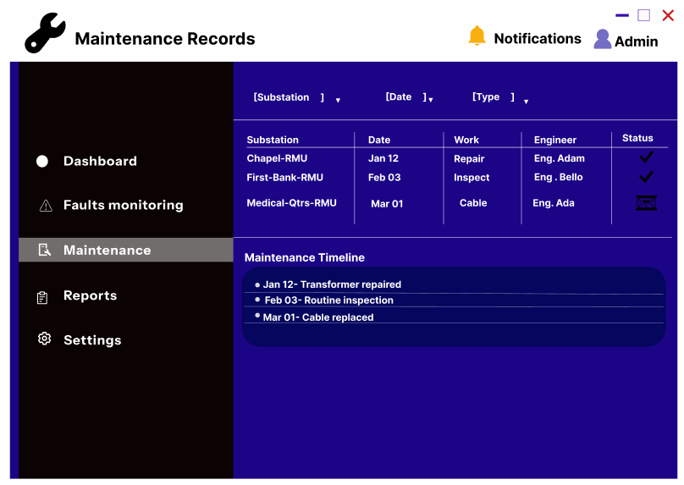
REPORT GENERATION SCREEN
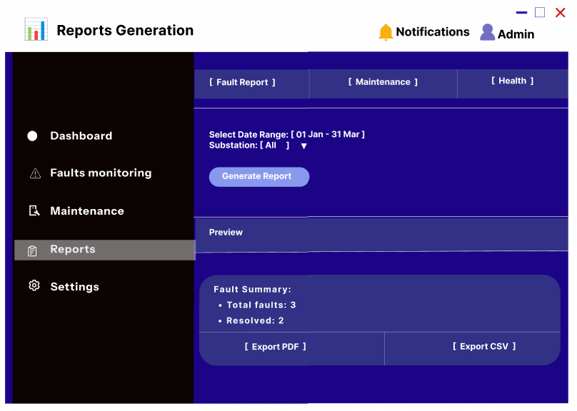

3.5 Report/Form Specifications
Forms
1. Substation Registration Form
Used to capture or update substation details such as name, ring, capacity, and location type.
2. Fault Logging Form
Used to record a detected fault manually where necessary. It contains fields such as substation ID, fault type, severity, date, and remarks.
3. Maintenance Entry Form
Used to record maintenance activities carried out on substations.

Reports
1. Fault Report
Contains details of all faults detected within a selected period, including substation, type of fault, severity, and timestamp.
2. Maintenance Report
Summarizes maintenance activities performed on substations within a chosen time period.
3. Substation Status Report
Shows the operational status of all substations, including healthy, faulted, and maintenance states.
4. Health Analytics Report
Displays health scores, recurring fault trends, and at-risk substations.

3.6 Program/Module Specifications
1. GIS Module
Responsible for map rendering, coordinate plotting, and visualization of substation status.

2. Monitoring Module
Handles the capture and display of operational parameters such as voltage, temperature, and communication state.

3. Fault Detection Module
Evaluates data against system rules and determines fault classification and alert generation.

4. Maintenance Management Module
Stores and manages maintenance records for substations and supports maintenance planning.

5. Reporting Module
Generates periodic and on-demand reports for engineers and administrators.

6. User Management Module
Controls user access, roles, and system permissions.
The modular structure of the proposed system supports maintainability, flexibility, and future scalability. Each module performs a distinct function while interacting with the shared database and central logic of the platform.

3.7 Test Plans
i. Functional Test
To verify that each module performs its intended task. For example, the GIS module should display correct substation locations, and the fault module should classify faults correctly.

ii. Data Accuracy Test
To verify that substation records, coordinates, and maintenance logs are stored and retrieved correctly.

iii. Fault Detection Logic Test
To test whether the system generates the correct alert under different combinations of voltage, temperature, and communication conditions.

iv. Interface Test
To verify that users can navigate between screens, input data correctly, and retrieve information without confusion.

v. Report Generation Test
To verify that reports are produced accurately and include the expected fields.

vi. Security / Access Test
To verify that unauthorized users cannot access protected functions or modify records they are not permitted to change.

Test Item | Objective | Expected Result
Login Test | Verify user authentication | Authorized user gains access
GIS Display Test | Verify mapping accuracy | Correct substation appears on map
Fault Detection Test | Verify decision logic | Correct alert generated
Report Test | Verify report generation | Accurate report displayed
Maintenance Entry Test | Verify data capture | Maintenance record saved successfully

4.0 CONCLUSION
This project focused on the analysis and design of an improved system for monitoring and managing electrical substations within the NEPA station at Akoka, University of Lagos. The study identified significant limitations in the existing system, particularly the reliance on manual fault detection, lack of centralized monitoring, absence of real-time data visibility, and inefficient maintenance coordination. These challenges result in delayed fault response, increased operational costs, reduced reliability of power supply, and overall inefficiency in system management.
To address these issues, the project proposed the design of an Integrated Substation Management Platform (ISMP), a centralized system that combines GIS-based mapping, real-time monitoring, automated fault detection, maintenance tracking, and reporting functionalities. The system was carefully structured using standard system design methodologies to ensure clarity, consistency, and feasibility. These methodologies included the use of context diagrams and Data Flow Diagrams (DFDs) to model system processes, Entity Relationship Diagrams (ERDs) to define data structure and relationships, and database design techniques to organize and manage system data effectively.
The GIS component of the system plays a critical role by providing spatial visualization of all substations, including underground units. This enables engineers and system operators to quickly identify the exact location of faults, thereby reducing response time and improving operational efficiency. In addition, the monitoring and fault detection modules allow for continuous tracking of key parameters such as voltage levels, temperature, and communication status. This ensures that abnormalities are detected early and classified appropriately, enabling timely intervention.
Furthermore, the maintenance management component of the system provides a structured approach to recording inspection results, repair activities, and maintenance history. This improves accountability, enhances planning, and supports predictive maintenance strategies. The reporting and alert modules also ensure that relevant stakeholders, including control room engineers and field personnel, receive timely and accurate information for decision-making.
Although this project is limited to system design and does not include full implementation, the proposed solution demonstrates a practical and scalable framework that can be adopted in real-world power distribution systems. The design is flexible and can be extended to accommodate additional features such as advanced analytics, machine learning-based fault prediction, and integration with smart grid technologies.
In conclusion, the Integrated Substation Management Platform provides a robust and efficient solution to the identified problems in the existing system. By improving visibility, enhancing fault detection, and streamlining maintenance operations, the proposed system has the potential to significantly improve power reliability, operational efficiency, and decision-making within the University of Lagos power network and similar environments.
APPENDICES
MAP GENERATOR CODE
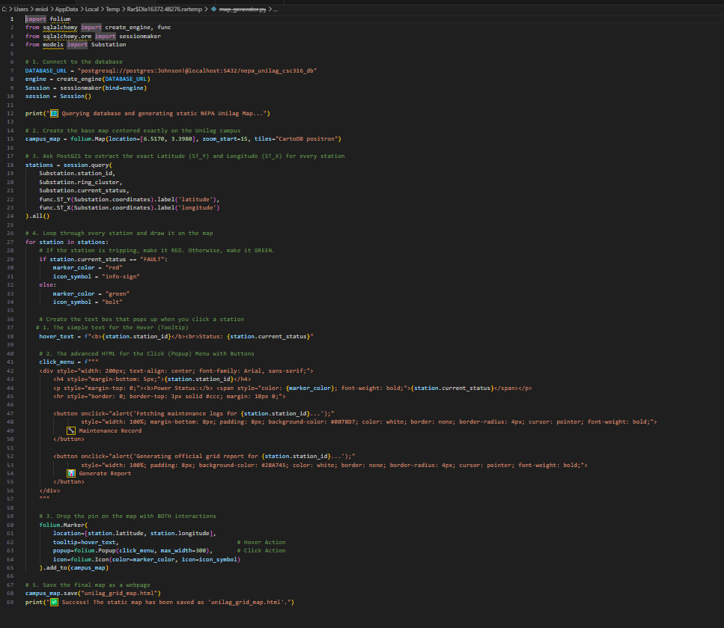

FAULT SIMULATION CODE
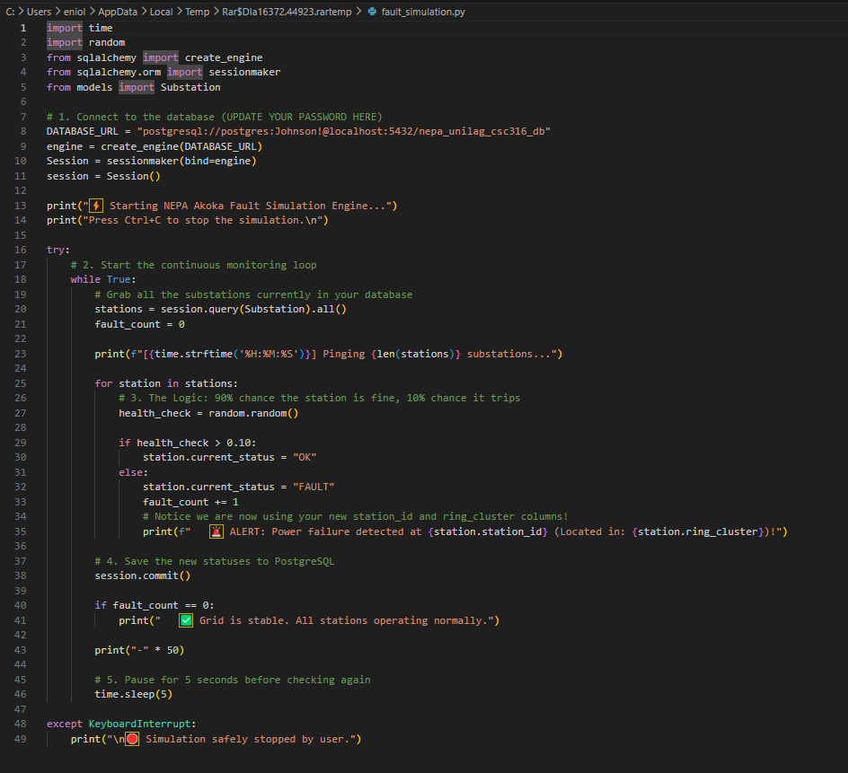

MODEL
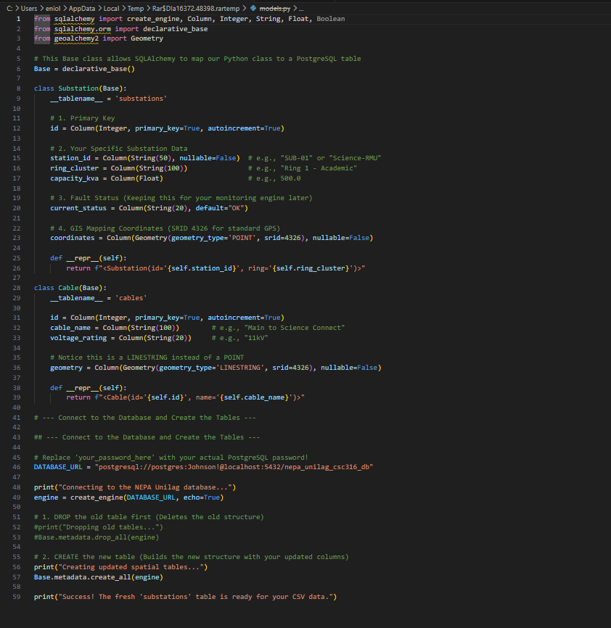
SEED SCRIPT
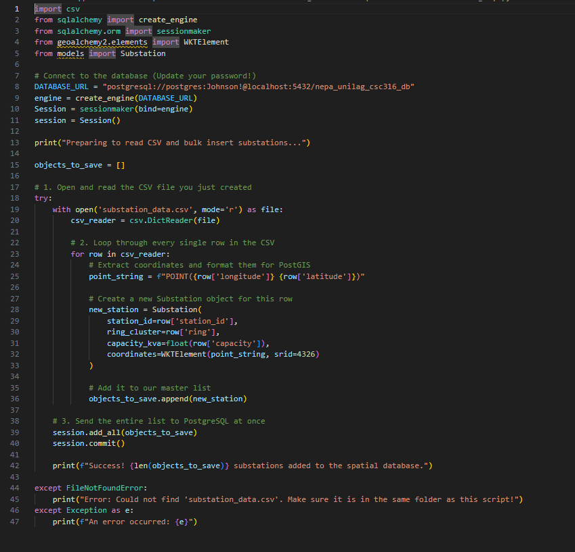
MINUTES OF MEETINGS
Meeting 1 — Onboarding
Opening
The first meeting of the group was called to order on 20th December 2025 via Google Meet
Attendance
- AKINOLA PELUMI PRECIOUS
- ‎OYELEYE OLAMIDE JOHNSON
- ‎ARONINUOLA FOLUKE GLORY
- ‎UWAEGBU KENNESHA CHIDERA
- YUSUFF WARITH ADEBOLA
Introduction
All members proceeded to introduce themselves, sharing details such as their names, a photograph, skills, tech interest etc.
Agendas
❖ Group name:
The initial discussion centered on selecting a name for the group, during which
three options were proposed: EchoWork, PingPro, and ProCom and ProLink. After a vote, EchoWork emerged as the preferred choice.
❖ Choosing A Company:
Three organizations were proposed for the system analysis and design project:
1. Khayotech Nigeria Limited located at Akoka
2. Mastermind Design located at UNILAG consult building
3. NEPA located in UNILAG
4. NORD automobiles located in UNILAG
We decided to research on these organizations and report back next meeting
❖ Assignment of roles:
The need for Assigning roles came up to which everyone was
- assigned a role:
➢ Senior Systems Analyst/ Project Leader: AKINOLA PELUMI PRECIOUS
➢ Secretary: YUSUFF WARITH ADEBOLA
➢ Software Designer: ‎ARONINUOLA FOLUKE GLORY
➢ Data Model Designer: ‎OYELEYE OLAMIDE JOHNSON
➢ Logistics: UWAEGBU KENNESHA CHIDERA
Action Items
Background of study: A comprehensive research of the organizations would be conducted, involving an in-depth analysis of their structure, operations, and requirements to ensure a great fit for the project.
Adjournment
The meeting was adjourned to a later date.
Meeting 2
Opening
The meeting was called to order on 22th December 2025 via Google meet
Attendance
- AKINOLA PELUMI PRECIOUS
- ‎OYELEYE OLAMIDE JOHNSON
3. ‎ARONINUOLA FOLUKE GLORY
4.‎UWAEGBU KENNESHA CHIDERA
5. YUSUFF WARITH ADEBOLA
Summary Of Previous Meeting Minutes
Minutes of the previous meeting were read by the secretary and approved by all members. We introduced ourselves, chose a group name, assigned roles to each member and decided on researching organizations so as to pick a good fit for the project.
Agendas
❖ Chosen Organization:
➢ Each member spoke about their researches on the listed organization in the previous meeting. NEPA was chosen as the best fit for the project.
❖ Contacting The Organization:
➢ A letter of request to be sent to NEPA was agreed on by each member. The member in charge of Logistics will deliver the letter.
Action Items
❖ Deliver the letter to NEPA

Adjournment
The meeting was adjourned to a later date.
Meeting 3
Opening
The meeting was called to order on 24th December 2025 Google meet.
Attendance
- AKINOLA PELUMI PRECIOUS
- ‎OYELEYE OLAMIDE JOHNSON
3. ‎ARONINUOLA FOLUKE GLORY
4.‎UWAEGBU KENNESHA CHIDERA
5. YUSUFF WARITH ADEBOLA.
Summary Of Previous Meeting Minutes
Minutes of the previous meeting were read by the secretary and approved by all members. An organization was chosen(NEPA) and a letter of request was agreed to be sent.
Agendas
❖ Organization Approval:
➢ The project received formal approval from the Organization, authorizing its
commencement and allocation of necessary resources.
❖ Analysis of project and institution:
➢ An analysis of both the project and the organization was conducted, involving a
detailed examination of the organization structure, operational workflows, and
specific requirements, as well as an assessment of the project’s scope, objectives,and feasibility. This comprehensive evaluation aimed to align the project’s goals
with the institution’s needs and ensure the successful implementation of the
proposed solutions.
❖ Representative meeting:
➢ A meeting was held with the organization representative, Engineer O.O. Ajiboye to discuss project details and align on objectives. He highlighted several key challenges affecting the current system( manual fault detection, physical movement of engineers, lack of centralized monitoring system, absence of predictive capability).
❖ Conclusion Of Meeting:
➢ The meeting provided an in-depth view into the operational challenges faced by the NEPA system at the University of Lagos. The issues identified during this interaction directly informed the design of the proposed system, particularly the need for a centralized monitoring platform, automated fault detection, and predictive maintenance capabilities.
Action Items
❖ Assess the problem scope
❖ Study Existing System.
❖ Research on the best solution.
Adjournment
The meeting was adjourned to a later date.
Meeting 4
Opening
The meeting was called to order on 16th January 2026 at Faculty of Science, University of Lagos.
Attendance
- AKINOLA PELUMI PRECIOUS
2‎. OYELEYE OLAMIDE JOHNSON
3. ‎ARONINUOLA FOLUKE GLORY
4.‎UWAEGBU KENNESHA CHIDERA
5. YUSUFF WARITH ADEBOLA
Summary Of Previous Meeting Minutes
Minutes of the previous meeting were read by the secretary and approved by all members. The organization approved letter of request, an analysis of project and institution was done, a meeting with organizational representative was held by Systems Analyst.
Agendas
❖ Possible Solutions:
➢ The team presented the proposed Integrated Substation Management Platform (ISMP) as a solution to the identified system gaps. The platform is designed to provide centralized monitoring, fault detection, and GIS-based visualization of substations. It aims to improve fault response time and overall system efficiency.
❖ Feasibility Study:
➢ The feasibility of the proposed system was discussed, focusing on the availability of required resources, including technical tools, data, and manpower. The evaluation confirmed that the system is achievable within the project scope and can be implemented using accessible technologies.
Action Items
❖ System Analysis.
❖ System Description.
❖ System Design.
Adjournment
The meeting was adjourned to a later date.
Meeting 5
Opening
The meeting was called to order on 27th January 2026 via a WhatsApp call.
Attendance
- AKINOLA PELUMI PRECIOUS
2‎. OYELEYE OLAMIDE JOHNSON
3. ‎ARONINUOLA FOLUKE GLORY
4.‎UWAEGBU KENNESHA CHIDERA
5. YUSUFF WARITH ADEBOLA
Summary Of Previous Meeting Minutes
Minutes of the previous meeting were read by the secretary and approved by all members. A solution was presented and the feasibility study of the proposed system was discussed.
Agendas
❖ System Analysis:
➢ The team conducted a detailed analysis of the existing substation monitoring system, focusing on how operations are currently carried out. This included identifying manual processes, system limitations, and inefficiencies. The findings helped clarify the key areas that require improvement.
❖ Identification Of System Requirements:
➢ The functional and non-functional requirements of the proposed system were discussed based on information gathered during analysis. This included monitoring capabilities, fault detection features, and user interaction needs. The aim was to define what the new system must achieve.
❖ Data Requirements and Structure:
➢The types of data required for the system were identified, including substation data, fault records, and maintenance logs. The team discussed how this data would be organized and managed. This forms the foundation for database design and system modeling.
Action Items
❖ Description of the System
❖ Definition of System Modules
❖ User Roles and Responsibilities
Adjournment
The meeting was adjourned to a later date.
Meeting 6
Opening
The meeting was called to order on 30th January 2026 via a WhatsApp call.
Attendance
- AKINOLA PELUMI PRECIOUS
2‎. OYELEYE OLAMIDE JOHNSON
3. ‎ARONINUOLA FOLUKE GLORY
4.‎UWAEGBU KENNESHA CHIDERA
5. YUSUFF WARITH ADEBOLA
Summary Of Previous Meeting Minutes
Minutes of the previous meeting were read by the secretary and approved by all members. System Analysis was done, we identified system requirements, we listed the data requirements and structure of system.
Agendas
❖ System Description:
➢ The team discussed the overall description of the proposed system, including its purpose, components, and how it will operate. The system was defined as an integrated platform for monitoring substations, detecting faults, and managing maintenance activities. This provided a clear understanding of the system’s functionality.
❖Definition Of System Modules:
➢The major modules of the system were identified, including the monitoring module, fault detection module, GIS mapping module, and reporting module. Each module’s role within the system was briefly outlined. This helped in organizing the system structure.
❖User Roles and Responsibilities:
➢ The major modules of the system were identified, including the monitoring module, fault detection module, GIS mapping module, and reporting module. Each module’s role within the system was briefly outlined. This helped in organizing the system structure.
Action Items
❖ System Design
❖ Development of System Diagrams
❖ Interface Design Planning
Adjournment
The meeting was adjourned to a later date.
Meeting 7
Opening
The meeting was called to order on 2nd February 2026 via WhatsApp call.
Attendance
- AKINOLA PELUMI PRECIOUS
2‎. OYELEYE OLAMIDE JOHNSON
3. ‎ARONINUOLA FOLUKE GLORY
4.‎UWAEGBU KENNESHA CHIDERA
5. YUSUFF WARITH ADEBOLA
Summary Of Previous Meeting Minutes
Minutes of the previous meeting were read by the secretary and approved by all members. We described the system, defined system modules, user roles, and responsibilities.
Agendas
❖ System Design Overview:
➢ The team reviewed the overall design of the proposed system, focusing on how different components interact. The structure of the system architecture was outlined. This marks the transition from analysis to design.

❖ Development of System Diagrams:
➢ The team discussed the creation of design diagrams such as context diagrams, DFDs, and ERDs. These diagrams help to visually represent system processes and data flow. They form a key part of system documentation.

❖ Interface Design Planning:
➢ The layout and structure of the system interface were discussed. This includes dashboards, navigation panels, and visualization components. The goal is to ensure a user-friendly design.

Action Items
❖ Data Specifications
❖ Data Organization and Classification
❖ Data Flow and Storage
Adjournment
The meeting was adjourned to a later date.
Meeting 8
Opening
The meeting was called to order on 20th February, 2026 via WhatsApp call.
Attendance
- AKINOLA PELUMI PRECIOUS
2‎. OYELEYE OLAMIDE JOHNSON
3. ‎ARONINUOLA FOLUKE GLORY
4.‎UWAEGBU KENNESHA CHIDERA
5. YUSUFF WARITH ADEBOLA
Summary Of Previous Meeting Minutes
Minutes of the previous meeting were read by the secretary and approved by all members. We reviewed the system design overview, the development of system diagrams and interface of deisgn planning.
Agendas
❖ Data Specifications:
➢ The team identified the types of data required for the system, including substation data, fault data, and maintenance records. The structure and format of this data were discussed. This ensures proper data handling within the system.

❖ Data Organization and Classification:
➢ Data elements were grouped into categories for better management and understanding. This includes operational data, historical data, and system logs. Proper classification supports efficient data usage.

❖ Data Flow and Storage Considerations:
➢ The team discussed how data will move within the system and where it will be stored. This includes input sources, processing points, and output formats. This step supports system efficiency and reliability.

Action Items
❖ Database Design
❖ Entity Relationship Modeling
❖ Data Integrity and Validation
Adjournment
The meeting was adjourned to a later date.
Meeting 9
Opening
The meeting was called to order on 26th February, 2026 via Google meet.
Attendance
- AKINOLA PELUMI PRECIOUS
2‎. OYELEYE OLAMIDE JOHNSON
3. ‎ARONINUOLA FOLUKE GLORY
4.‎UWAEGBU KENNESHA CHIDERA
5. YUSUFF WARITH ADEBOLA
Summary Of Previous Meeting Minutes
Minutes of the previous meeting were read by the secretary and approved by all members. We discussed the data specification, data organization and classification, and we looked into the data flow and storage considerations.
Agendas
❖ Database Design:
➢ The structure of the database was discussed, including tables, fields, and relationships. The aim was to ensure that all system data is properly stored and easily accessible. This forms the backbone of the system.

❖ Entity Relationship Modeling:
➢ The team reviewed how different data entities relate to each other. Relationships such as one-to-many connections between substations and faults were identified. This supports logical database design.

❖ Data Integrity and Validation:
➢ Measures to ensure data accuracy and consistency were discussed. This includes validation rules and proper data entry methods. This helps maintain reliable system data.

Action Items
❖ Project Progress Review
❖ Callenges Encountered
❖ System Security Considerations
❖ System Updates and Improvements
❖ Deployment and Hosting Considerations
Adjournment
The meeting was adjourned to a later date.
Meeting 10
Opening
The meeting was called to order on 18th March 2026 via WhatsApp call.
Attendance
- AKINOLA PELUMI PRECIOUS
2‎. OYELEYE OLAMIDE JOHNSON
3. ‎ARONINUOLA FOLUKE GLORY
4.‎UWAEGBU KENNESHA CHIDERA
5. YUSUFF WARITH ADEBOLA
Summary Of Previous Meeting Minutes
Minutes of the previous meeting were read by the secretary and approved by all members. We looked into the database design, integrity and entity relationship modeling.
Agendas
❖ Project Progress Review:
➢ The team reviewed the overall progress of the project, including completed sections and pending tasks. This ensured that the project remains on track. Milestones achieved were highlighted.

❖ Challenges Encountered:
➢ The team discussed challenges faced during the project, including technical and design-related issues. Possible solutions were proposed to address these challenges. This helped improve the workflow.

❖ System Security Considerations:
➢ Basic security measures such as user authentication and data protection were discussed. The importance of securing system access and data integrity was emphasized. This ensures system reliability.

❖ System Updates and Improvements:
➢ The team reviewed updates made to the system design and documentation. Suggestions for improvements were discussed. This ensured continuous refinement of the project.

Deployment and Hosting Considerations:
➢ The possibility of hosting the system on a web platform was discussed. This includes accessibility and usability considerations. This adds practical relevance to the project.

Action Items
❖ Final testing and optimization before deployment.
❖ Staff training to ensure smooth operation and user adoption.
❖ Preparation for Submission
Adjournment
The meeting was adjourned to a later date.
Meeting 11 — Conclusion
Opening
The meeting was called to order on 19th March 2026 at Faculty of Science, University of Lagos.
Summary Of Previous Meeting Minutes
Minutes of the previous meeting were read by the secretary and approved by all members. A project progress review was done. We spoke about challenges encountered, considered the system security, reviewed updates and improvements.
Agendas

❖ Project Conclusion:
➢ The team reviewed the overall outcome of the project and confirmed that all objectives were achieved. The effectiveness of the proposed system was highlighted. This marks the completion of the project.

❖ Final Review of Documentation:
➢ All sections of the project report were reviewed to ensure accuracy and completeness. Corrections and final adjustments were made. This ensures a polished final submission.

❖ Recommendations and Future Work:
➢ Suggestions for future improvements and possible system extensions were discussed. This includes scalability and real-world implementation possibilities. This adds depth to the project.

❖ Preparation for Submission:
➢ The team finalized all necessary materials for submission, including reports and supporting documents. Responsibilities were assigned to ensure timely submission. This completes the project process.

Action Items
● Printing of project and preparation for defence.
Close of meeting
Appreciation was expressed to the organization and all team members for their active participation, commitment, and valuable contributions toward the success of the project. Their efforts in ensuring steady progress and alignment with the project objectives were duly acknowledged.
It was agreed that effective communication would be maintained among all stakeholders, with subsequent meetings scheduled as necessary to review progress, address emerging challenges, and ensure the successful completion of the project.
The meeting was formally brought to a close by the Systems Analyst.
Additionally, continuous communication and coordination were maintained via WhatsApp group chat.

