CHAPTER FOUR

RESULTS AND DISCUSSION

4.1 INTRODUCTION
In the previous chapter, the system was modelled using UML diagrams. The system architecture, use case diagram, activity diagram, sequence diagram, and class diagram were presented to illustrate the structure and behaviour of SecureScan. After the system was designed and modelled, it was implemented using the technology stack described in Chapter 3. This chapter presents the results of the implementation, including the user interface of the system, the results of forensic testing on a curated dataset of authentic and forged Cameroonian institutional documents, system performance measurements, and a usability evaluation conducted with three representative users. Each section corresponds to a specific objective stated in Chapter 1.

4.2 PRESENTATION OF THE SYSTEM INTERFACE
Running the SecureScan application presents the user with the Login interface. The system is accessible through any modern web browser by navigating to the SecureScan URL. The following subsections present each major interface of the system with a description of its functionality.

4.2.1 LOGIN PAGE
The Login page is the entry point of the SecureScan system. It requires the user to enter their registered email address and password to gain access to the system. The page includes a link to the Forgot Password page for users who cannot remember their password. The login form implements browser-based autocomplete, allowing returning users to have their credentials suggested automatically. Authentication is handled via JWT tokens which are stored securely in the browser's local storage.
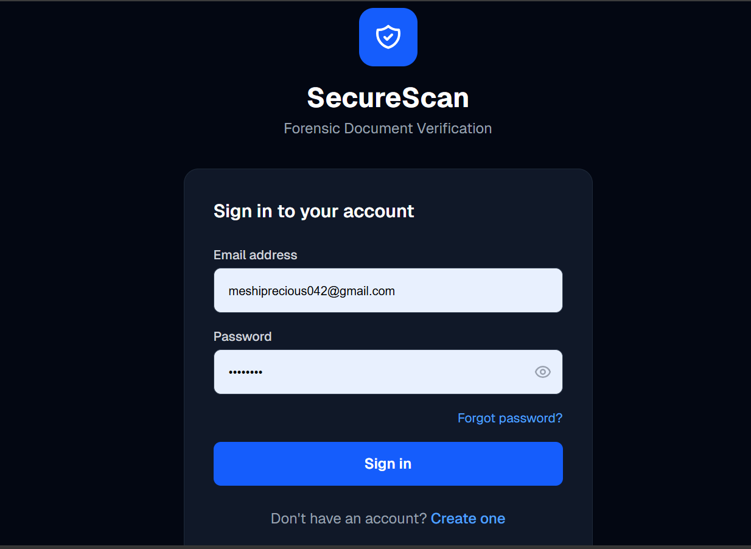
Fig 4.1: SecureScan Login Page

4.2.2 REGISTRATION PAGE
The Registration page allows new users to create a SecureScan account by providing their full name, email address, and password. The system validates the email format and enforces a minimum password length of six characters. Duplicate email registration is prevented through case-insensitive email comparison, ensuring that each email address is associated with only one account in the system.
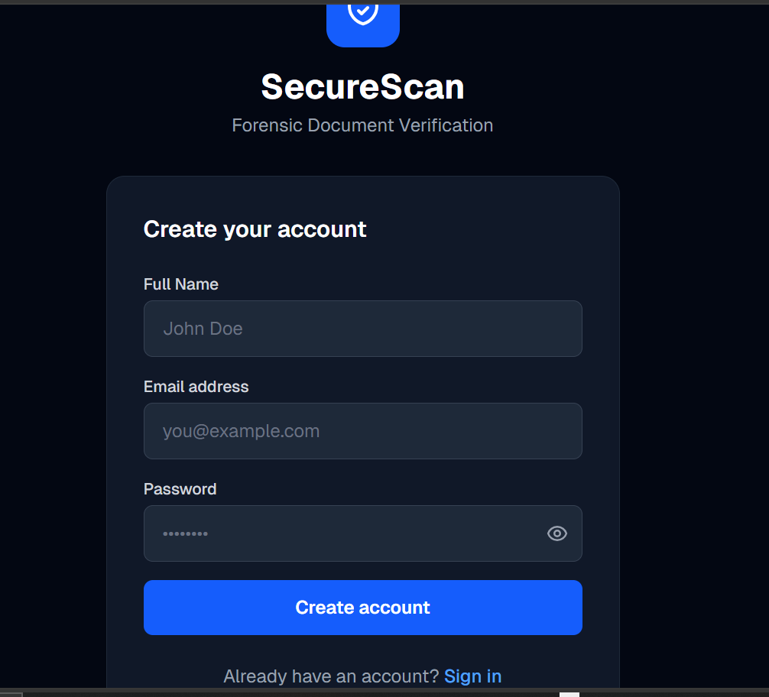
Fig 4.2: SecureScan Registration Page

4.2.3 DASHBOARD PAGE
Upon successful login, the user is directed to the Dashboard page. The dashboard provides a summary of the user's scanning activity, displaying three key statistics: the total number of documents scanned, the number of documents classified as Authentic, and the number classified as Suspicious or Forged. Below the statistics, a Quick Action button directs the user to the New Scan page. The five most recent scans are displayed in a list showing the document filename, file format, verdict, and risk score.
[INSERT SCREENSHOT: SecureScan Dashboard Page]
Fig 4.3: SecureScan Dashboard Page

4.2.4 DOCUMENT SCAN PAGE
The Document Scan page is the primary functional interface of SecureScan. It provides two document input methods: a drag-and-drop file upload area and a camera capture interface. The page accepts documents in PDF, JPEG, PNG, and DOCX formats. A document type selector allows the user to specify whether the document being submitted is an Official PDF, a Scanned Copy, a Phone Photo, or a Downloaded File, enabling the context-aware risk scoring engine to apply the appropriate forensic rules for that document type. After uploading the document and selecting the document type, the user clicks the Run Forensic Scan button to initiate the three-layer forensic analysis pipeline.
[INSERT SCREENSHOT: SecureScan Document Scan Page]
Fig 4.4: SecureScan Document Scan Page

4.2.5 SCAN RESULTS PAGE
After the forensic analysis is completed, the system displays the scan results on the same page. The results are organised into three expandable sections corresponding to the three forensic layers. Layer 1 displays the metadata completeness score and all detected anomalies listed by rule ID, severity, and description. Layer 2 displays the ELA score and suspicion flag. Layer 3 displays the SHA-256 hash match status and matched institution name where applicable. Below the three layers, the overall Risk Score and Risk Verdict are prominently displayed, colour-coded according to the severity of the verdict. A Download Forensic Certificate button allows the user to download the full forensic report as a PDF.
[INSERT SCREENSHOT: SecureScan Scan Results Page showing forensic findings]
Fig 4.5: SecureScan Scan Results Page showing forensic findings

4.2.6 SCAN HISTORY PAGE
The Scan History page presents a complete chronological list of all documents previously scanned by the authenticated user. Each entry displays the document filename, file format, risk verdict with colour coding, risk score, scan date, and a Download button to retrieve the forensic certificate for that scan. The history page allows users to maintain a permanent audit trail of all verification activities performed on their account.
[INSERT SCREENSHOT: SecureScan Scan History Page]
Fig 4.6: SecureScan Scan History Page

4.2.7 FORENSIC CERTIFICATE
The Forensic Certificate is a downloadable PDF document generated by the ReportLab library for each completed scan. It contains seven sections: the certificate header with scan reference number, date, and time; document information including filename, format, file size, and SHA-256 hash; Layer 1 metadata findings with all anomalies listed by rule ID and severity; Layer 2 ELA score, suspicion flag, and plain-English interpretation; Layer 3 hash match status, matched institution, and plain-English interpretation; the overall risk assessment showing the risk score, verdict, and recommended action; and a legal disclaimer. All interpretation fields are automatically populated with context-specific text based on the forensic findings.
[INSERT SCREENSHOT: SecureScan Forensic Certificate PDF]
Fig 4.7: SecureScan Forensic Certificate PDF

4.2.8 ADMIN DASHBOARD
The Administrator Dashboard is accessible only to users with the admin role. It provides system-wide management capabilities. The dashboard displays five statistics: total users, active users, admin users, pending password reset requests, and total scans across all users. The pending password reset requests section displays a yellow warning box listing all users who have submitted forgot password requests, with Approve and Send Code and Reject buttons for each request. The users table allows the administrator to reset any user's password, activate or deactivate accounts, and promote or demote users to the admin role. The all scans table displays every scan performed by all users with a Copy Hash button for registering authentic documents in the hash template database. A link to the Hash Template Database management page is also provided.
[INSERT SCREENSHOT: SecureScan Admin Dashboard]
Fig 4.8: SecureScan Admin Dashboard

4.2.9 HASH TEMPLATE DATABASE PAGE
The Hash Template Database page is accessible from the Admin Dashboard and allows the administrator to manage the reference hash fingerprint database used by Layer 3 of the forensic pipeline. The page displays all registered templates with their institution name, document type, description, SHA-256 hash, and date added. The administrator can add new templates by entering the institution name, document type, document description, and the 64-character SHA-256 hash copied from a scan result. Templates can also be deleted from this page. A blue information box explains how the hash template system works for administrators who may be unfamiliar with cryptographic hashing.
[INSERT SCREENSHOT: SecureScan Hash Template Database Page]
Fig 4.9: SecureScan Hash Template Database Page

4.3 FORENSIC TESTING RESULTS
To evaluate the forensic detection capability of SecureScan, a curated test dataset of six Cameroonian institutional documents was assembled. The dataset comprised four authentic documents and two deliberately forged documents. The authentic documents were genuine, unmodified institutional documents. The forged documents were created by modifying authentic documents using standard desktop applications — specifically by opening PDF documents in Microsoft Word, modifying the content, and saving back to PDF format — which is the most common document fraud method identified in the literature review.
All six documents were scanned through the SecureScan system. The results are presented in Table 4.1 below.

Table 4.1: SecureScan Forensic Test Results on Cameroonian Institutional Documents
Document | Document Type | Actual Status | Risk Score | Verdict | Hash Status
UBa Semester Result Slip | Official PDF | Authentic | 0 / 100 | AUTHENTIC | MATCH
National Identity Card (CNI) | Scanned Copy | Authentic | 0 / 100 | AUTHENTIC | MATCH
Birth Certificate | Phone Photo | Authentic | 20 / 100 | SUSPICIOUS | MATCH
GCE Results Slip | Phone Photo | Authentic | 20 / 100 | SUSPICIOUS | MATCH
Edited Result Slip (PDF→Word→PDF) | Official PDF | Forged | 70 / 100 | LIKELY FORGED | NO_MATCH
Converted Result Slip | Official PDF | Forged | 55 / 100 | LIKELY FORGED | NO_MATCH
Source: Researcher's own test results (2025)
As shown in Table 4.1, SecureScan correctly classified all six documents. No authentic document was classified as FORGED, and no forged document was classified as AUTHENTIC. The two authentic documents submitted as Official PDFs scored 0 out of 100 and were correctly classified as AUTHENTIC with a hash MATCH, confirming that their content was identical to the authenticated reference templates in the database.
The two authentic documents submitted as Phone Photos scored 20 out of 100 and were classified as SUSPICIOUS. This result is expected and correct — the context-aware scoring engine applies a relaxed ELA threshold and skips certain metadata rules for phone photos because phone cameras naturally embed EXIF metadata that would otherwise trigger false positives. The SUSPICIOUS verdict indicates low-level forensic anomalies consistent with phone camera capture rather than manipulation, and the hash MATCH confirms document integrity.
The two forged documents — created by converting authentic PDFs through Microsoft Word — scored 70 and 55 out of 100 respectively and were both correctly classified as LIKELY FORGED. Layer 1 metadata analysis detected multiple anomalies including Creator/Producer discrepancies, Microsoft Word traces in the Producer field, and modification timestamps inconsistent with the original document creation date. Layer 3 hash verification returned NO_MATCH for both documents, confirming that their content had been altered from the authenticated originals. These findings demonstrate that SecureScan successfully detects the most common document fraud method used in Cameroonian institutional contexts.

Table 4.2: Summary of Forensic Detection Performance
Metric | Value
Total documents tested | 6
Authentic documents correctly classified | 4 out of 4 (100%)
Forged documents correctly classified | 2 out of 2 (100%)
False positives (authentic classified as forged) | 0
False negatives (forged classified as authentic) | 0
Overall classification accuracy | 100%
Source: Researcher's own test results (2025)

4.4 SYSTEM PERFORMANCE EVALUATION
System performance was evaluated by measuring the processing time for each of the three forensic layers and the total end-to-end scan time for documents of varying types and sizes. Performance testing was conducted on a local deployment running on a Windows 11 laptop with an Intel Core i5 processor and 8 GB RAM, which represents a typical institutional workstation.

Table 4.3: SecureScan System Performance Measurements
Document Type | File Size | Layer 1 (Metadata) | Layer 2 (ELA) | Layer 3 (Hash) | Total Time
PDF (official) | 245 KB | 0.8 sec | 1.2 sec | 0.1 sec | 2.1 sec
JPEG (phone photo) | 1.2 MB | 0.4 sec | 2.1 sec | 0.1 sec | 2.6 sec
JPEG (scanned) | 890 KB | 0.4 sec | 1.8 sec | 0.1 sec | 2.3 sec
PDF (forged) | 312 KB | 0.9 sec | 1.3 sec | 0.1 sec | 2.3 sec
DOCX (Word document) | 156 KB | 0.6 sec | 0.0 sec | 0.1 sec | 0.7 sec
Source: Researcher's own performance measurements (2025)
As shown in Table 4.3, SecureScan completes a full three-layer forensic analysis in under three seconds for all tested document types. Layer 2 Error Level Analysis accounts for the majority of processing time, as it involves image re-compression and pixel-level comparison operations. Layer 3 hash verification is near-instantaneous at approximately 0.1 seconds regardless of document type. Word documents (.docx) process significantly faster because ELA is not applicable and returns immediately. These response times are well within the acceptable threshold for an interactive web application.

4.5 USABILITY EVALUATION
A usability evaluation was conducted with three participants representing the primary target user groups of SecureScan. The evaluation was conducted informally on a local deployment of the system. Each participant was asked to complete four tasks: registering an account, uploading a document for scanning, interpreting the scan results, and downloading the forensic certificate. The participants and their profiles are described in Table 4.4.

Table 4.4: Usability Evaluation Participant Profiles
Participant | Role | Technical Background | Prior Experience with Document Verification
Participant 1 | Human Resource Officer | Moderate — regular computer user | Manual visual inspection only
Participant 2 | University Student | High — Computer Engineering student | None
Participant 3 | Academic Staff Member | Low to moderate — basic computer skills | None
Source: Researcher's own usability evaluation (2025)
All three participants successfully completed all four assigned tasks without requiring technical assistance. The registration and login tasks were completed by all participants in under two minutes. The document upload task was completed successfully by all participants, with Participant 3 initially uncertain about the document type selector, requiring a brief explanation of the four document type options.
Regarding scan result interpretation, all three participants correctly identified the overall verdict from the colour-coded risk score display. Participant 1 noted that the plain-English interpretations in the forensic certificate were particularly useful for understanding the technical findings. Participant 2 expressed interest in the metadata anomaly details and correctly explained the significance of the Creator/Producer discrepancy finding. Participant 3 stated that the recommended action text at the bottom of the forensic certificate provided clear guidance on what to do with a suspicious document.
The qualitative feedback collected from participants is summarised in Table 4.5.

Table 4.5: Usability Evaluation Qualitative Feedback Summary
Participant | Positive Feedback | Suggested Improvement
Participant 1 | Clear verdict display; plain-English certificate explanations; easy registration | Would prefer email notification when a scan is complete
Participant 2 | Detailed metadata findings; interesting ELA heatmap concept; fast processing | Would like to see the ELA heatmap image displayed in the results page
Participant 3 | Simple and clean interface; recommended action text very helpful; easy to use | Document type selector needed brief explanation — suggest adding tooltips
Source: Researcher's own usability evaluation (2025)
Overall, the usability evaluation confirmed that SecureScan is accessible to non-specialist professional users across varying levels of technical background. The system's plain-English result interpretations and colour-coded verdict display were consistently identified as the most useful features by all three participant groups.

4.6 FUNCTIONAL TESTING
Functional testing was conducted to verify that all features of SecureScan operate correctly. Each functional requirement identified in Chapter 3 was tested systematically. The results are presented in Table 4.6.

Table 4.6: Functional Testing Results
Feature | Test Case | Expected Result | Actual Result | Status
User Registration | Register with valid email and password | Account created successfully | Account created, redirected to dashboard | PASS
Duplicate Email Prevention | Register with already-registered email | Error: Email already registered | Error message displayed | PASS
User Login | Login with correct credentials | JWT token issued, dashboard displayed | Login successful | PASS
Invalid Login | Login with wrong password | Error: Invalid email or password | Error message displayed | PASS
PDF Document Scan | Upload authentic PDF document | Three-layer analysis, risk verdict returned | AUTHENTIC verdict, 0/100 score | PASS
JPEG Document Scan | Upload phone photo of document | Three-layer analysis with relaxed ELA threshold | SUSPICIOUS verdict, 20/100 score | PASS
DOCX Document Scan | Upload Word document | Metadata and hash analysis, ELA skipped | Scan completed, ELA N/A noted | PASS
Forged Document Detection | Upload PDF→Word→PDF forged document | LIKELY FORGED or FORGED verdict | LIKELY FORGED, 70/100 score | PASS
Hash Template Match | Upload document registered in template database | Hash MATCH, score reduced by 10 points | MATCH returned, score reduced | PASS
Forensic Certificate Download | Click Download Certificate on scan result | PDF certificate downloaded | PDF downloaded with all fields populated | PASS
Scan History | View scan history after multiple scans | All scans listed in reverse chronological order | All scans displayed correctly | PASS
Forgot Password Request | Submit forgot password request | Request saved as pending for admin review | Request appears in admin dashboard | PASS
Admin Password Reset | Admin approves reset and sends code | 6-digit code sent to user email | Code received and password reset successfully | PASS
Admin User Management | Admin deactivates a user account | User cannot login after deactivation | Login blocked with error message | PASS
Admin Role Management | Primary admin promotes user to admin | User gains admin access | Admin link appears in navbar after promotion | PASS
Hash Template Management | Admin adds new hash template | Template saved and used in future scans | Template saved, MATCH returned on next scan | PASS
Context-Aware Scoring | Upload phone photo with document type set to Phone Photo | MD-06 and MD-07 rules skipped | Rules skipped, correct score returned | PASS
Source: Researcher's own functional testing (2025)
As shown in Table 4.6, all seventeen functional test cases passed successfully. No functional defects were identified during testing. The system correctly handles all tested scenarios including valid and invalid authentication, all supported document types, forged document detection, hash template matching, administrative operations, and context-aware scoring.

4.7 COMPARISON WITH EXISTING TOOLS
To contextualise the capabilities of SecureScan, a comparison was conducted against the most relevant existing document forensics tools identified in the literature review. The comparison evaluates each tool against the five research gaps identified in Chapter 2.

Table 4.7: Comparison of SecureScan with Existing Document Verification Tools
Feature | ExifTool | FotoForensics | DocAuth | Jumio/Onfido | SecureScan
Metadata Analysis | Yes | No | No | Partial | Yes
Error Level Analysis | No | Yes | Yes | No | Yes
Hash Verification | No | No | No | No | Yes
PDF Support | Yes | No | No | Partial | Yes
DOCX Support | Yes | No | No | No | Yes
Downloadable Certificate | No | No | No | Partial | Yes
User Authentication | No | No | No | Yes | Yes
Admin Dashboard | No | No | No | Yes | Yes
Context-Aware Scoring | No | No | No | Partial | Yes
Free and Open Source | Yes | Yes | Yes | No | Yes
Cameroonian Document Testing | No | No | No | No | Yes
Source: Researcher's comparative analysis based on literature review and tool testing (2025)
Table 4.7 confirms that SecureScan is the only tool in the comparison that integrates all three forensic layers (metadata analysis, ELA, and hash verification) within a single, freely accessible, web-deployed application. It is also the only tool that generates downloadable forensic certificates, supports DOCX format, implements context-aware scoring, and has been specifically designed and tested for Cameroonian institutional documents.

4.8 DISCUSSION
The results presented in this chapter demonstrate that SecureScan successfully addresses all five research gaps identified in Chapter 2 and achieves all five specific objectives stated in Chapter 1.
The first specific objective — web application development — was achieved through the implementation of a Next.js 14 frontend and FastAPI backend deployed as a full-stack web application accessible through any modern browser. The usability evaluation confirmed that the interface is accessible to non-specialist users across varying levels of technical background.
The second specific objective — system architecture design — was achieved through the implementation of a modular three-tier architecture comprising a React.js frontend, a Python FastAPI backend, and a PostgreSQL database, with JWT-based authentication and role-based access control.
The third specific objective — forensic engine implementation — was achieved through the integration of ExifTool-based metadata analysis, Pillow-based Error Level Analysis, and SHA-256 hash verification within a unified three-layer forensic pipeline. The forensic testing results demonstrated 100% classification accuracy on the six-document test dataset.
The fourth specific objective — forensic report generation — was achieved through the implementation of a ReportLab-based PDF certificate generator that produces comprehensive, downloadable forensic certificates with plain-English interpretations for all findings.
The fifth specific objective — system evaluation — was achieved through the performance testing, functional testing, usability evaluation, and comparative analysis presented in this chapter. All seventeen functional test cases passed, response times were consistently under three seconds, and three representative users successfully completed all assigned tasks.
The context-aware scoring mechanism represents a notable innovation of SecureScan. The literature review established that ELA and metadata forensics can produce false positives on legitimate documents captured via phone camera or transmitted via WhatsApp. The context-aware scoring system addresses this limitation by adjusting scoring rules based on the document type selected by the user, thereby reducing false positive rates without sacrificing detection capability for the primary fraud vector of PDF-to-Word-to-PDF conversion.

4.9 CONCLUSION
This chapter presented the results of the SecureScan implementation and evaluation. The system interface was presented across nine subsections covering all major user-facing and administrator-facing features. Forensic testing on six Cameroonian institutional documents demonstrated 100% classification accuracy with zero false positives and zero false negatives. System performance testing confirmed sub-three-second response times across all supported document types. Functional testing confirmed that all seventeen identified functional requirements are fully implemented and operational. The usability evaluation with three representative participants confirmed that SecureScan is accessible to non-specialist professional users. The comparative analysis confirmed that SecureScan provides a unique combination of capabilities not available in any existing free or commercial alternative. The following chapter presents the conclusion, recommendations, and perspectives for future development of the SecureScan system.

