CommuniServe SA – Part 3 Final Report
OPSC6312 Portfolio of Evidence
Precious Moloi ST10452719 · Nyiko Matladi ST10450403 · Luvuyo Yizani ST10442920 · Naledi Paballo Tshelane ST10446045
Repository: https://github.com/PreciousMoloi/CommuniServeSA_Part3_POE
Hosted API: https://communiservesa.onrender.com/
Demo video: https://drive.google.com/file/d/18ZCTxWemuMIgkK7kuQ48zESAB-PWvqfS/view?usp=drivesdk

1. Purpose
CommuniServe SA lets South Africans discover local services and events, add community listings, and keep using the app offline. It is an Android (Kotlin) app with a Node.js/Express API.

2. Architecture
- Android single-Activity app, programmatic UI, Retrofit/OkHttp, Room offline cache, osmdroid map.
- Firebase Authentication (Google SSO through Credential Manager) and Firebase Cloud Messaging.
- Node.js/Express API: bcrypt password hashing, JWT sessions, Firebase ID-token verification for SSO, JSON-file persistence.
- Hosted on Render (free tier); GitHub Actions runs API tests, Android unit tests and a debug build.

3. Features
- Register, sign in, Google SSO, remember me, guest mode.
- Unified search of services and events; category chips with near-me Google Maps shortcuts.
- User-defined feature 1: Nearby map with service and event pins.
- User-defined feature 2: Community listings with moderation (pending → approved).
- Offline caching and a queue for reviews and listings that syncs on reconnect.
- Push notifications, three languages (English, Afrikaans, isiZulu), dark mode and radius settings.

3A. Changes since Part 2
Part 2 was the v2.0 prototype. Version 3.0 (this submission) adds the following.
Area | Part 2 (v2.0) | Part 3 (v3.0)
Sign-in | Email and password only | Google single sign-on through Firebase; the API verifies the Firebase ID token (signature, issuer, audience, expiry); guest mode and remember-me
Notifications | None | Firebase Cloud Messaging push (open, background, closed); device token registered with the API; Android 13+ permission prompt
Offline | Limited saved items | Room cache plus a queue for reviews and listings that syncs automatically on reconnect, with a manual sync button and a waiting-actions indicator
Languages | English | English, Afrikaans and isiZulu on every screen; switch on login and in Settings
User-defined features | Basic listings | Nearby map (OpenStreetMap, pins, radius, live location) and community listings with moderation (pending, then approved)
Search and discovery | Simple list | Unified search of services and events, category chips and near-me Google Maps shortcuts (health, food, transport, repairs, cleaning)
User interface | Basic screens | Redesigned login and registration, bottom navigation, Material icons, profile header, dark mode, edge-to-edge layout, 48 dp touch targets
Error handling | Technical messages | Plain-language messages in three languages, limited-mode card with Retry Connection, friendly 404 and offline messages
API storage | In memory (lost on restart) | JSON-file persistence (server/data/db.json); on Render free tier it still resets on redeploy
API security | Basic | bcrypt (cost 12), required JWT secret in production, rate-limited auth routes, closed CORS, stronger validation
Hosting | Local only | Hosted on Render over HTTPS; physical phones use it by default
Testing and CI | None or manual | 11 API tests, 31 Android unit tests, GitHub Actions on every push (green), 16 manual device tests
Publishing | Not prepared | Target SDK 36, signed release build, store graphics, privacy policy, listing text and documented Play Console sign-up to the payment step
Documentation | Report only | README, release notes, test evidence with screenshots, AI use write-up, Play Store evidence

4. Screenshots
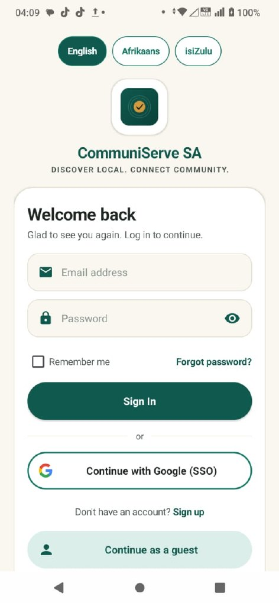 | 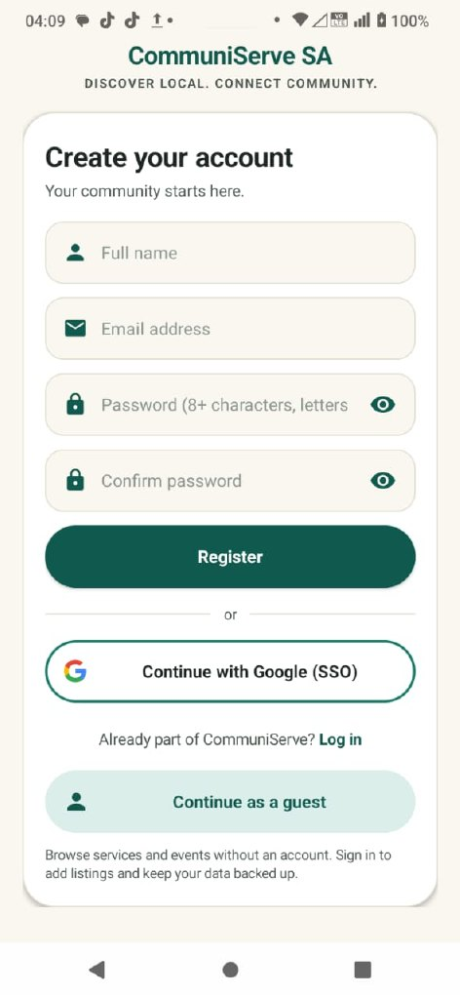 | 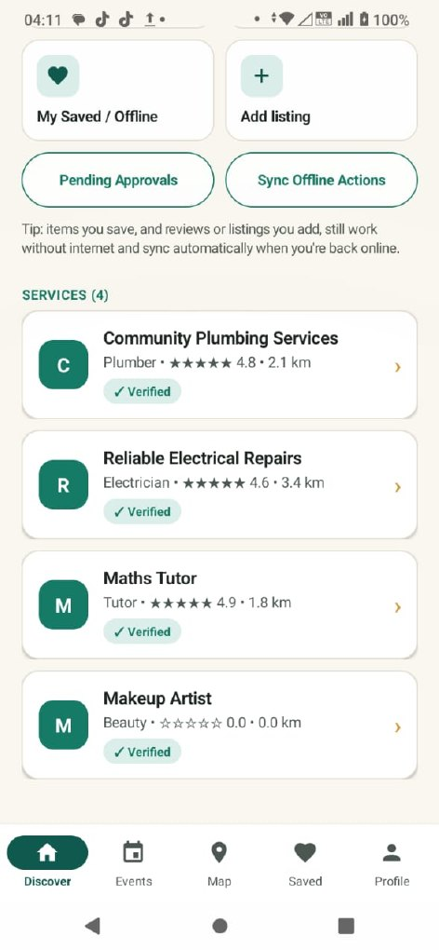
Figure 1: Login, registration and Discover.
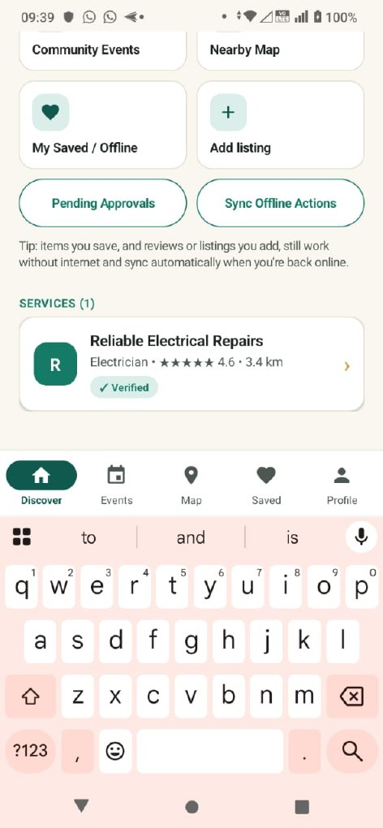 | 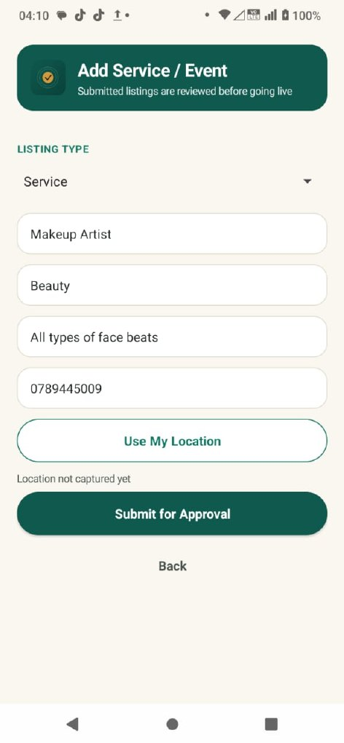 | 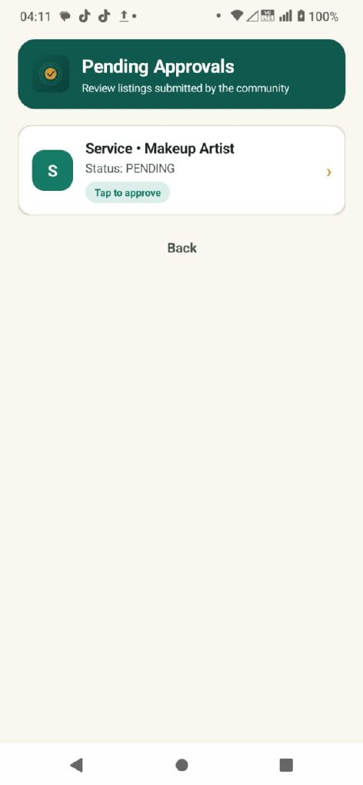
Figure 2: Search, add listing and pending approvals.
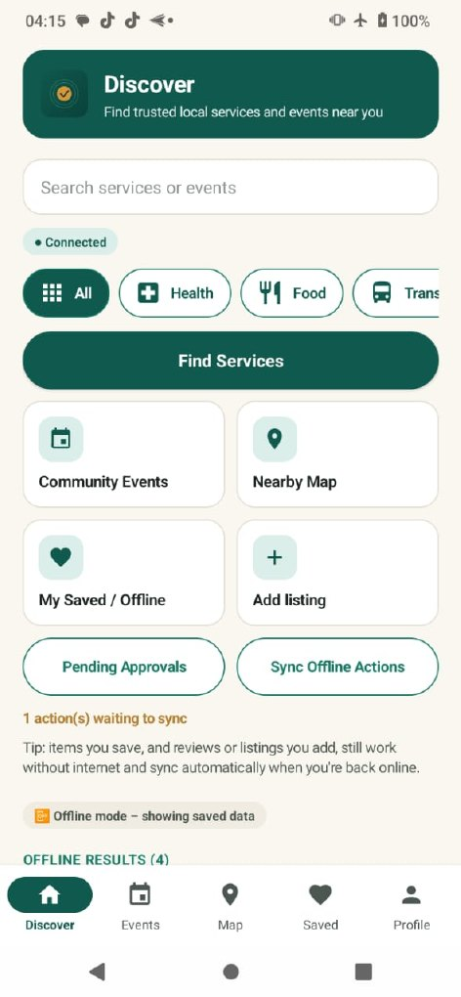 | 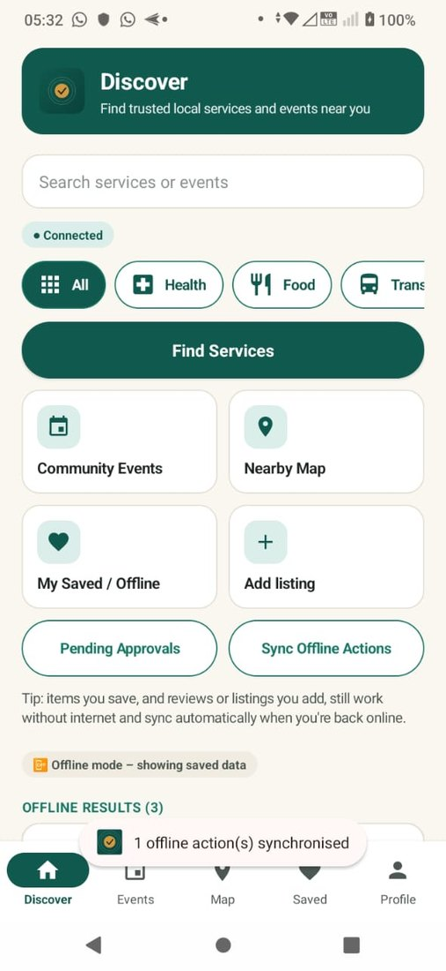 | 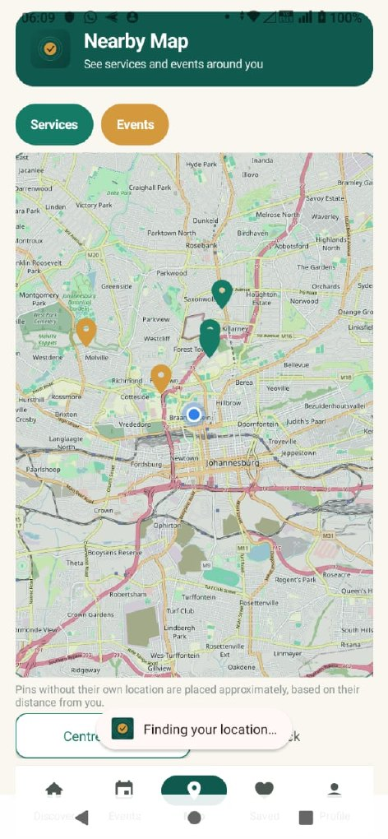
Figure 3: Offline queue, sync success and Nearby map.
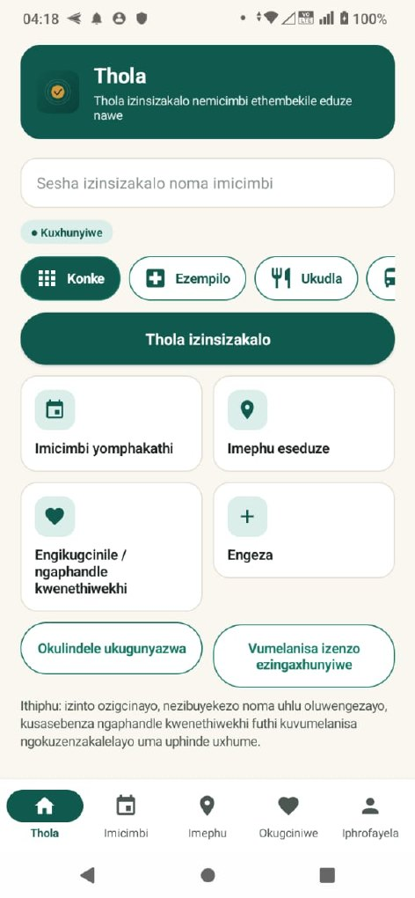 | 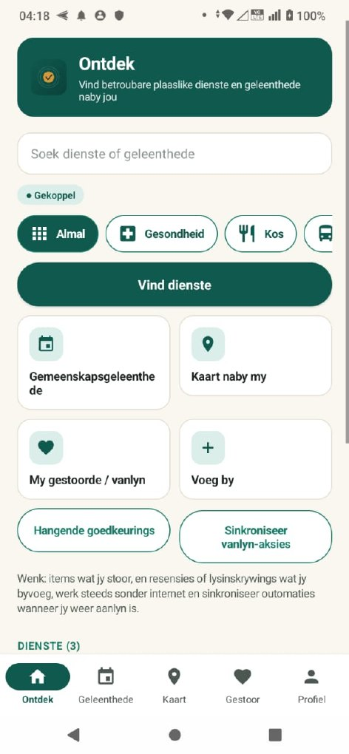 | 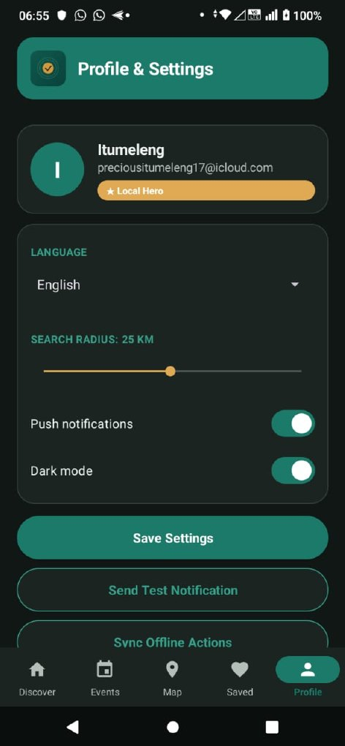
Figure 4: isiZulu, Afrikaans and dark mode.
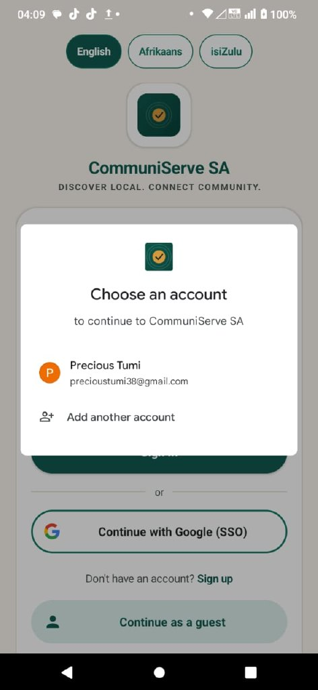 | 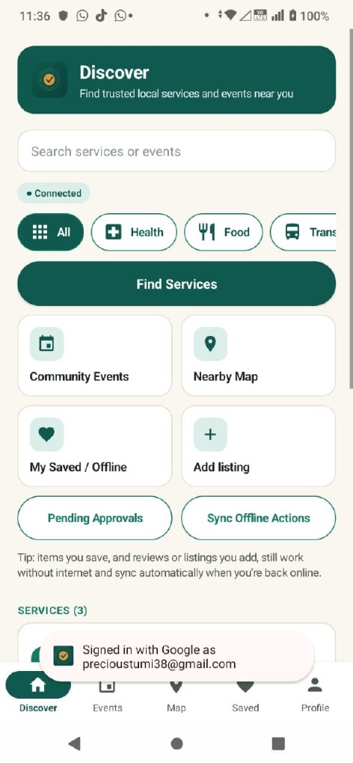 | 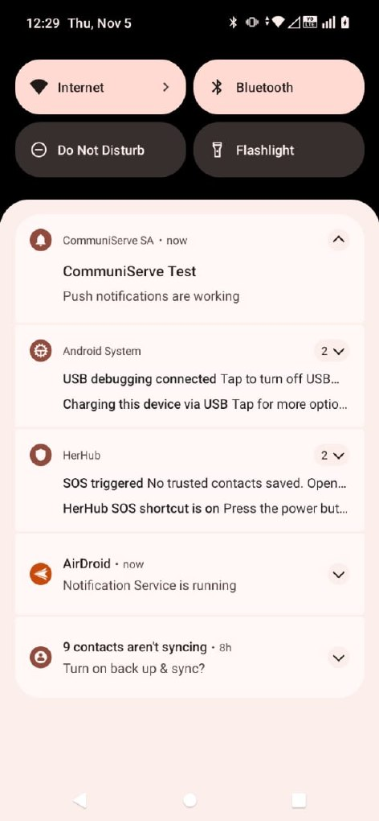
Figure 5: Google sign-in and push notification.
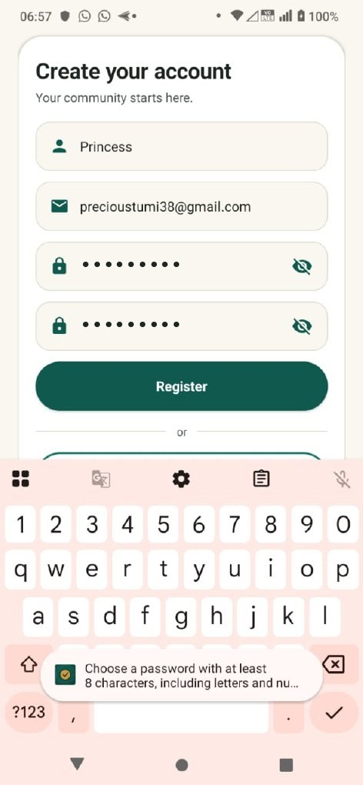 | 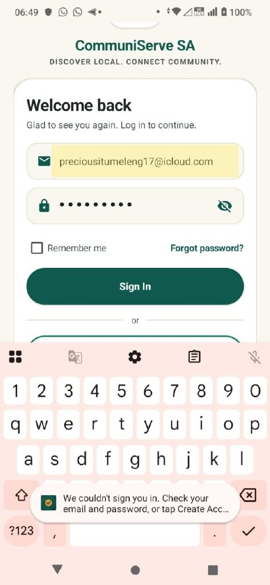 | 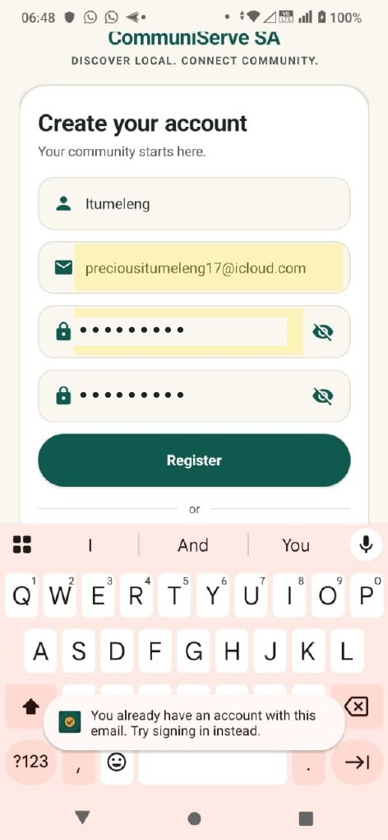
Figure 6: Friendly validation and error messages.

5. Testing
Area | Result
API tests (npm test) | 11 of 11 pass
Android unit tests | 31 tests, 0 failures
Debug build / release APK | Successful; release APK signed
GitHub Actions | Green on master
Manual tests on a physical phone | 15 of 16 pass; TC-09 documented limitation

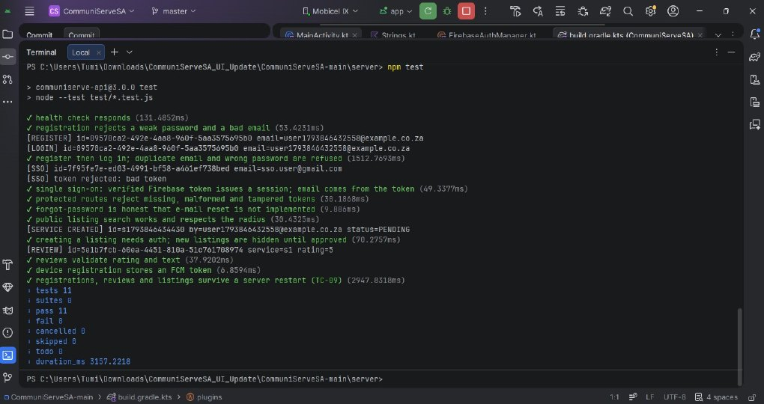 | 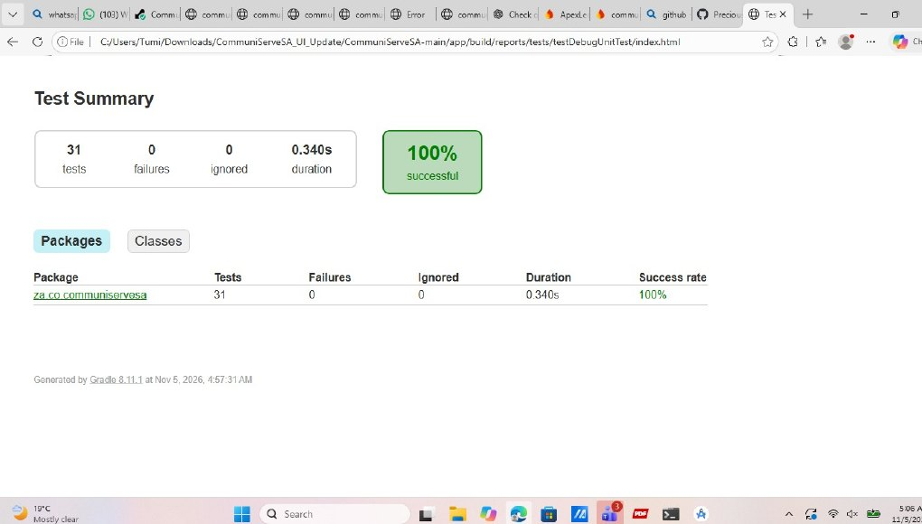
Figure 7: API tests and Android unit-test report.
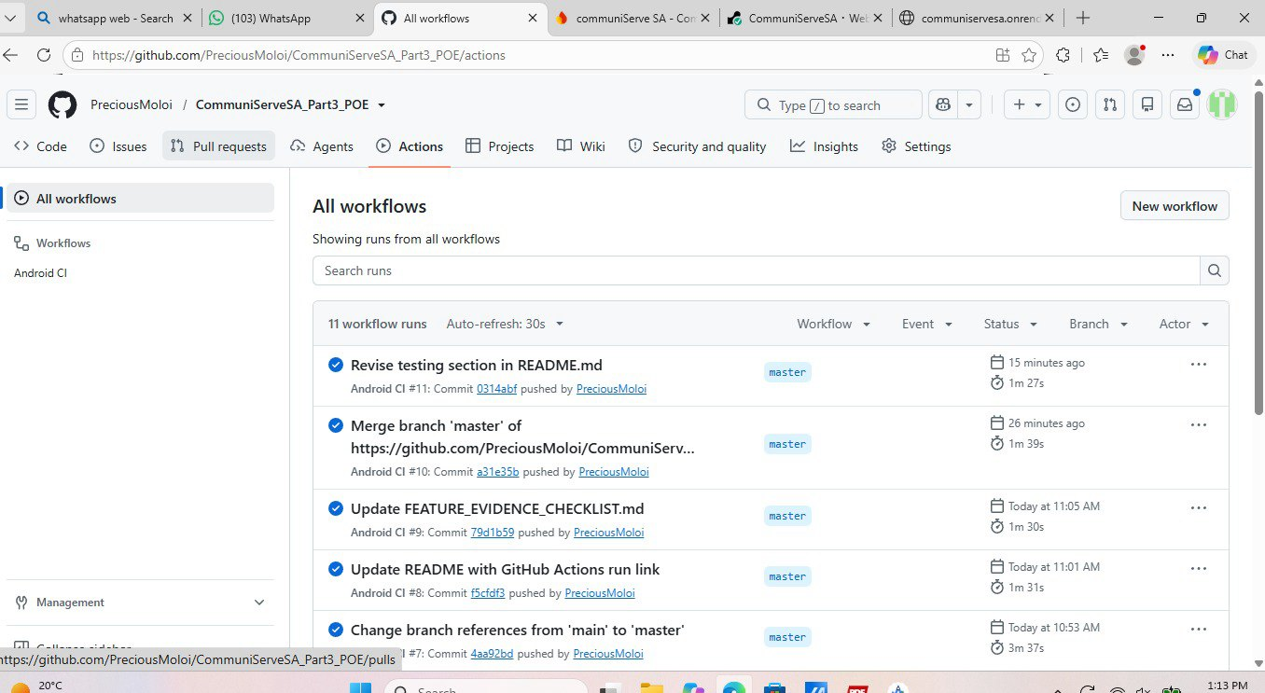 | 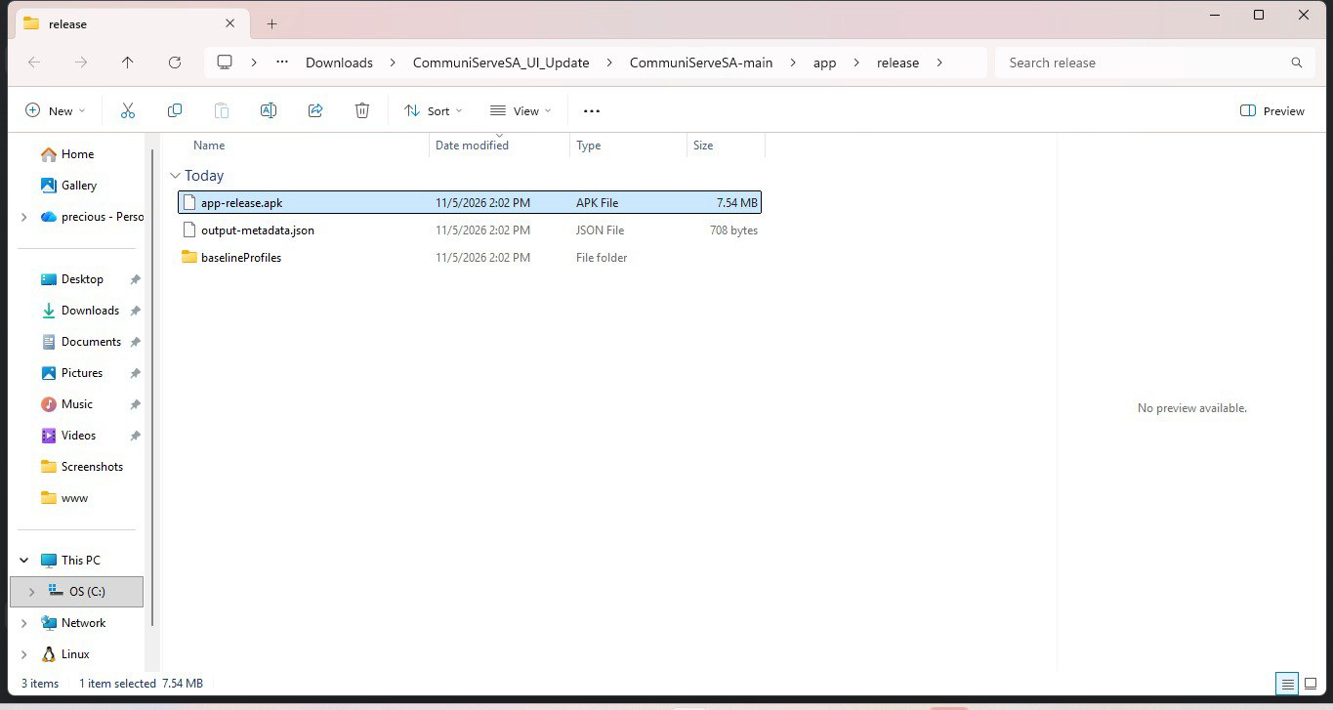
Figure 8: GitHub Actions and signed release APK.
The full test register (AT-01 to AT-08, TC-01 to TC-16) and the defect log are in docs/TEST_EVIDENCE.md.

6. Defects found and fixed
- Phone used the emulator address 10.0.2.2 – hosted HTTPS default added.
- Render ran the old v2.0 API (SSO 404) – redeployed v3.0.
- Wrong default API URL – corrected.
- Windows persistence test failure – test waits for the save.
- Search results hidden below the fold – unified search.
- Missing string key and duplicate drawable folder – fixed.
- Overlapping bottom navigation – fallback insets.

7. Known limitation
TC-09 fails on the hosted API: Render's free tier has an ephemeral disk, so db.json is reset on restart or redeploy. The same behaviour passes locally (AT-05). A persistent disk or database would resolve it.

8. Security and privacy
Passwords are hashed with bcrypt, sessions use JWT with a required secret in production, CORS is closed by default, SSO tokens are verified server-side, and password reset is disclosed as not implemented. The privacy policy is in docs/PRIVACY_POLICY.md.

9. AI use
Claude assisted with UI redesign, error messages, translations, security fixes, connectivity fixes and documentation. We ran and verified everything. See docs/AI_USE_WRITEUP.md.

10. Google Play Store readiness
Publishing on Google Play needs a one-off US$25 developer registration fee. As instructed by our lecturer, we captured each step of the Play Console sign-up up to the payment screen. Personal details are blurred. The signed release APK, icon, feature graphic, privacy policy and listing text are ready. Demo video: https://drive.google.com/file/d/18ZCTxWemuMIgkK7kuQ48zESAB-PWvqfS/view?usp=drivesdk
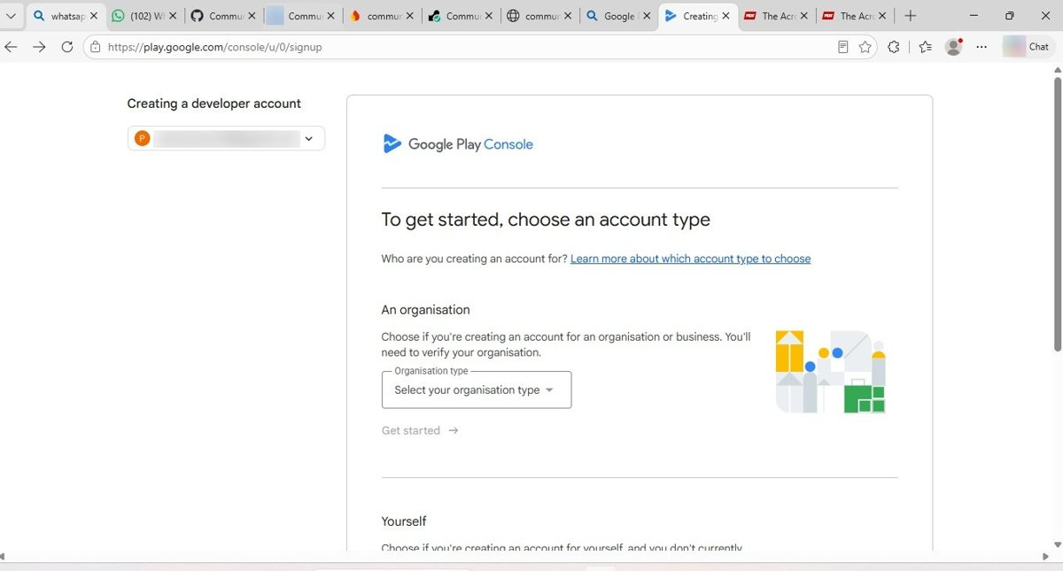 | 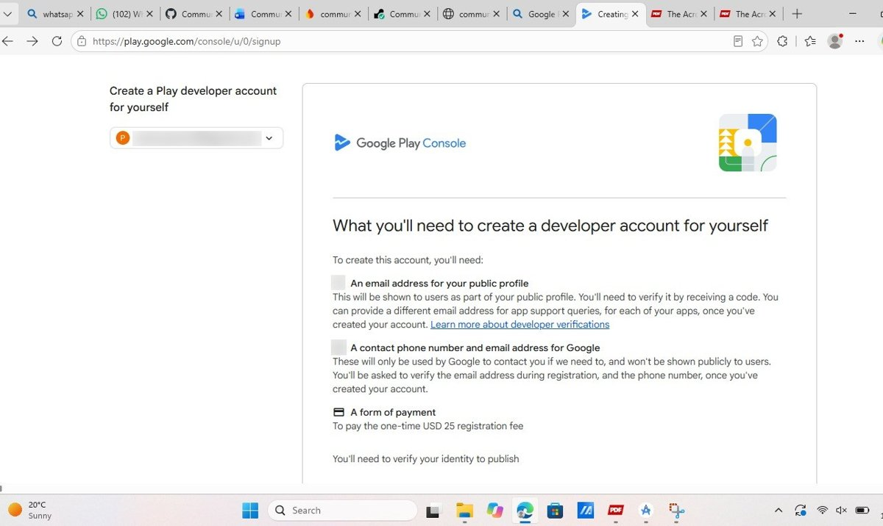 | 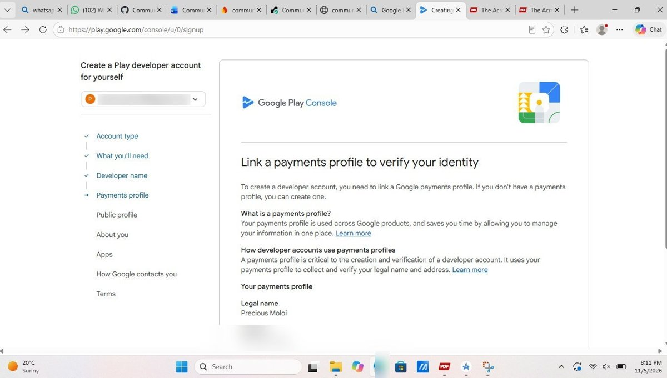
Figure 9: Account type, requirements and payments profile.
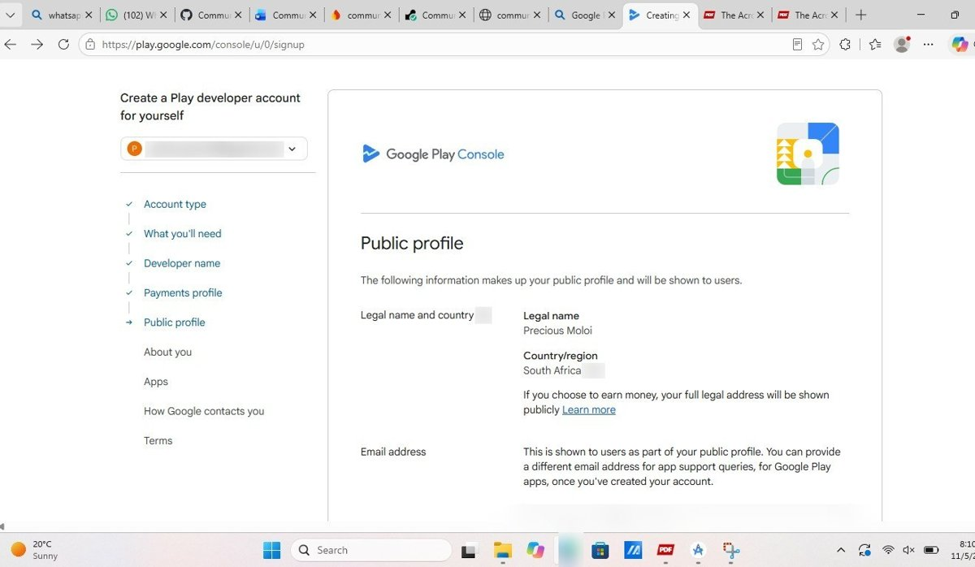 | 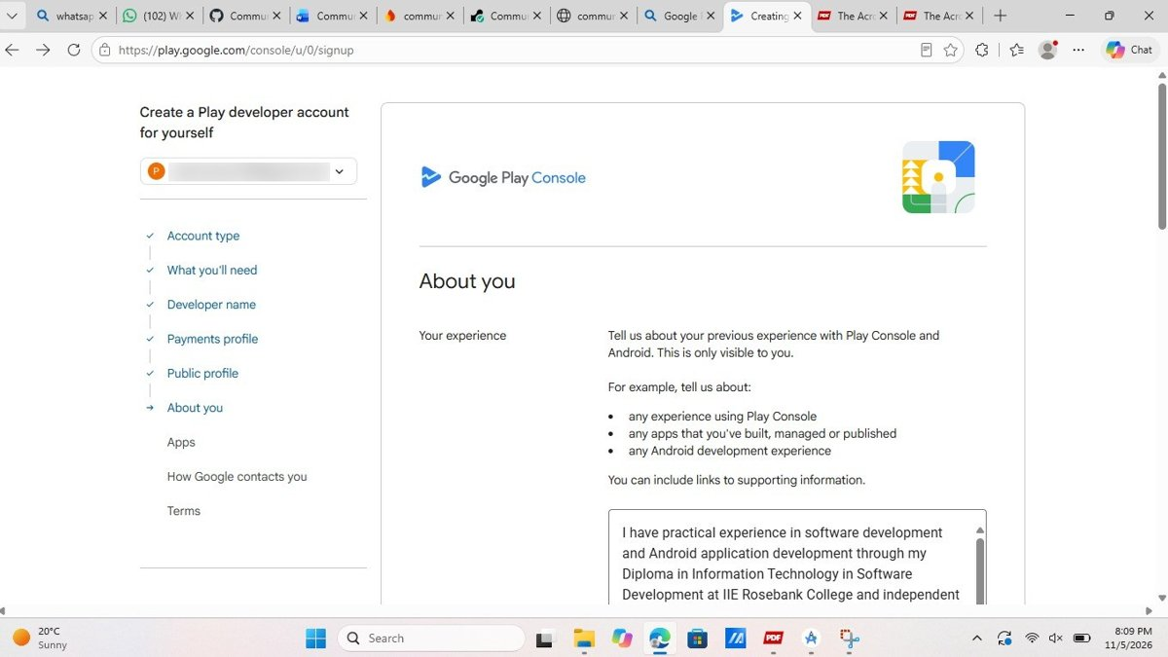 | 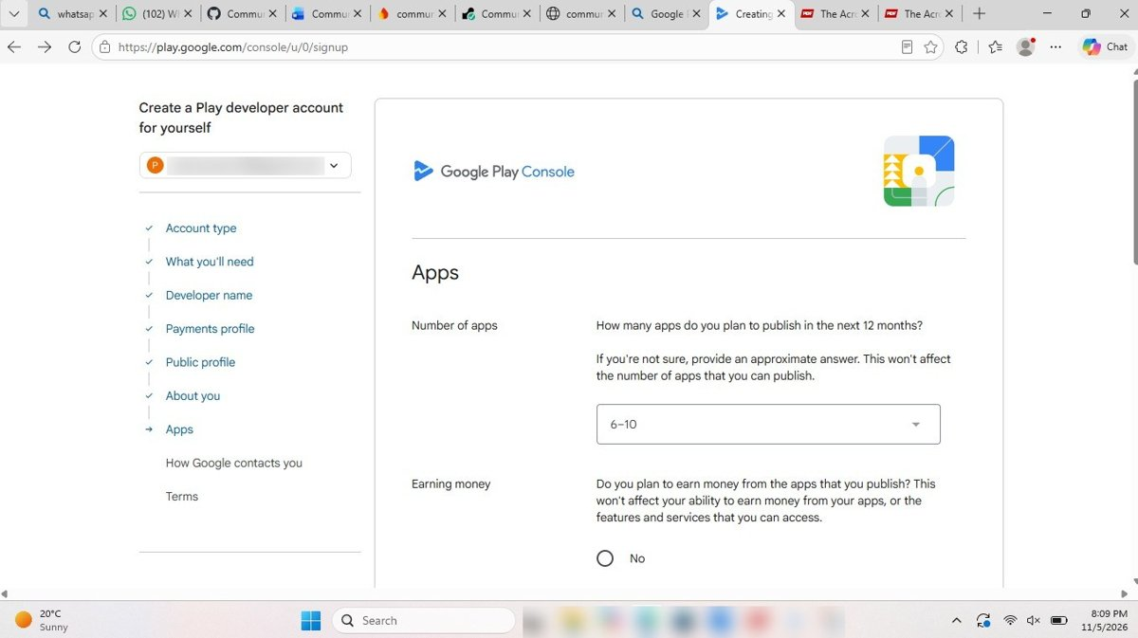
Figure 10: Public profile, about you and apps.
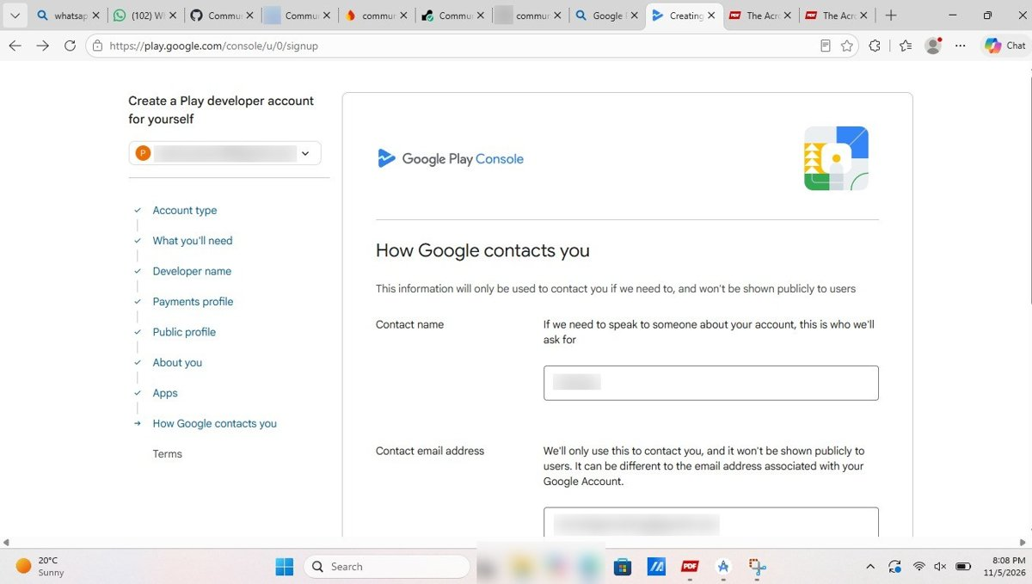 | 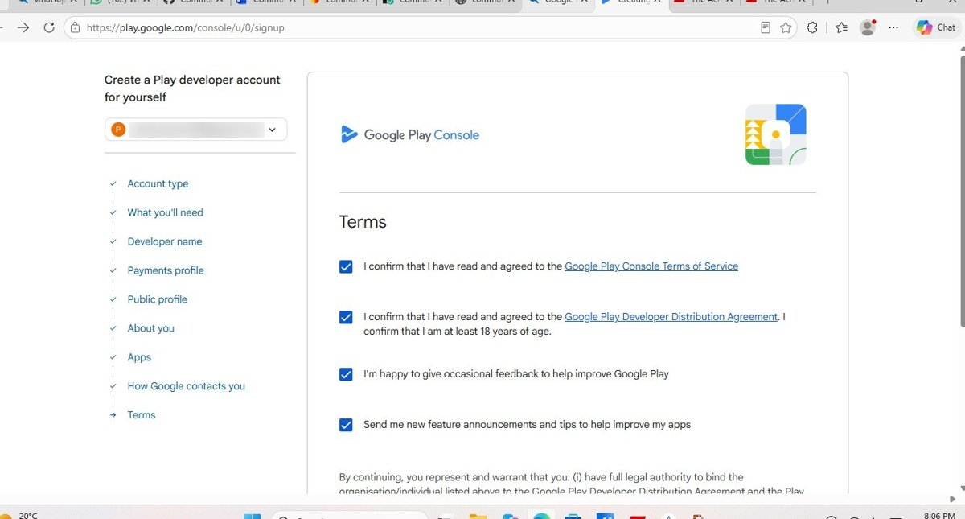 | 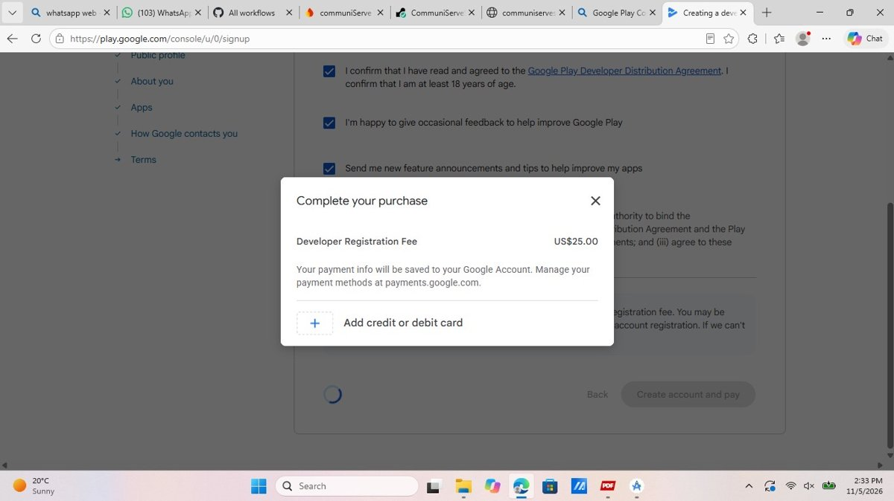
Figure 11: Contact details, terms and the US$25 payment step (stopped here).
All 17 steps are in docs/PLAY_STORE_EVIDENCE.md.

