DATA DICTIONARY · FLOOD RISK INTELLIGENCE CHALLENGE

Dataset Metadata
What each file in the starter kit looks like, what it contains, where it came from, and how it is meant to be used.
Covers Every file in data/team_a_nairobi and data/team_b_nzoia | Coordinates Latitude and longitude, WGS84 (EPSG:4326) | Currency Kenyan shillings (KES)

1. Read this first
Each dataset below is described the same way: a picture or sample rows, a plain explanation of what you are looking at, how to use it, and a table of technical detail. Two of the datasets are measured or modelled by outside organisations. The rest were built for this hackathon, and each of those says so in its own data as well as here.
Team | File | Real or synthetic | Holds
Team B | nzoia_rp10y, rp20y, rp50y, rp100y, rp200y, rp500y (.tif) | Real | Flood depth maps
Team B | exposure_nzoia_synthetic.csv | Synthetic | 500 buildings
Team A | nairobi_pluvial_proxy_common, occasional, moderate, severe, extreme (.tif) | Built from real terrain and river data; the score is a constructed proxy | Flood susceptibility maps
Team A | nairobi_hotspots_geocoded.csv | Real names; approximate coordinates | 24 named flood areas
Team A | exposure_nairobi_synthetic.csv | Synthetic | 600 buildings
Team A | exposure_nairobi_with_hazard.csv | Synthetic buildings, hazard values read from the maps | Same 600 buildings plus 5 hazard columns

2. Team B: Nzoia Basin

Flood depth maps (six GeoTIFF files)
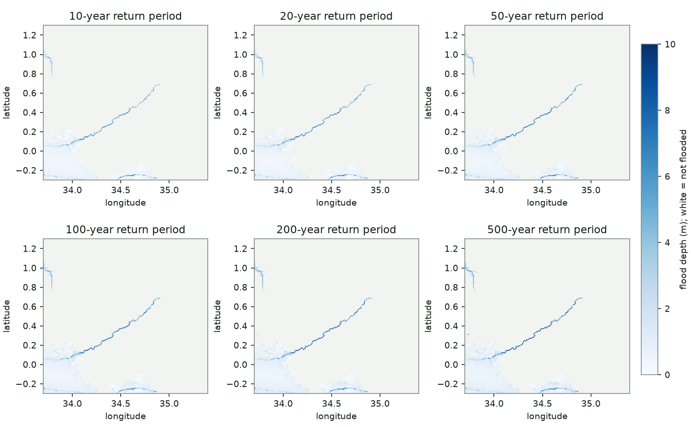
The six Nzoia files drawn on one depth scale. Each panel is one return period. Dark blue is deep water; the pale grey is dry ground.
WHAT YOU ARE LOOKING AT
Each file is a grid laid over the lower Nzoia basin. Every cell covers about 900 m by 900 m of ground, and its value is the depth of flood water in metres for one scenario. The scenario is named in the filename: rp10y is a flood expected about once in 10 years, rp500y about once in 500 years.
The pattern is narrow. Water shows up along the Nzoia River, around its mouth at Lake Victoria in the south-west, and along a small channel in the south and in the north-west corner. Only about 9% of cells are flooded in any of the six maps, and the flooded area grows very little between the 10-year and 500-year maps: from 8.7% to 9.8% of cells, with median depth rising from 0.49 m to 0.74 m. Expect a loss curve that rises sharply once and then climbs slowly.
HOW TO USE IT
- Take a building's longitude and latitude and find the cell that contains it in each of the six files.
- Read the cell value from each file. You now have six depths for that building, one per return period.
- Dry cells hold a no-data value, a very large negative number (about -3.4 × 10^38). They are never stored as 0. Treat any value that is not a positive number as dry, and do not average or sum them.
- Pass each depth through your vulnerability function to get a damage ratio.
Field | Value
Provider | European Commission Joint Research Centre (JRC)
Product | Global river flood hazard maps, file set floodMapGL_rp10y to rp500y. The files in the downloaded archives are dated 22 November 2016
Licence | Free for public use. See the JRC data catalogue page for the exact terms
Format | GeoTIFF, one band, 32-bit float
Cell size | 0.00833° (30 arc-seconds), about 925 m
Size of this clip | 204 columns × 192 rows, longitude 33.70 to 35.40, latitude -0.30 to 1.30
Cell values | Flood depth in metres. Dry cells = no-data value
Flooded cells | 3,721 of 39,168 in the 100-year map (9.5%)
Deepest cell | 13.1 m in the 100-year map
Limits | Coarse for a single building. A 925 m cell cannot tell a house on a rise from one in a hollow, and small drains are not represented

Synthetic portfolio: exposure_nzoia_synthetic.csv
loc_id | lat | lon | housing_class | floor_area_m2 | cost_per_m2_kes | tiv_kes
NZA-0000 | 0.7566 | 33.972 | concrete_rcc | 489 | 56,000 | 27,385,000
NZA-0001 | 0.03 | 34.6961 | informal_iron_sheet | 8 | 9,600 | 75,000
NZA-0002 | 1.0777 | 35.1005 | concrete_rcc | 385 | 72,000 | 27,720,000
NZA-0003 | 0.593 | 34.2053 | concrete_rcc | 519 | 51,200 | 26,575,000
NZA-0004 | 0.8532 | 34.8643 | permanent_masonry | 97 | 52,500 | 5,090,000
NZA-0005 | 0.51 | 34.4886 | informal_iron_sheet | 13 | 7,700 | 100,000
First six of 500 rows. The file also has 'synthetic' and 'source' columns that state, on every row, that the building was generated and is not a real property. tiv_kes is floor_area_m2 multiplied by cost_per_m2_kes, rounded to the nearest 5,000.
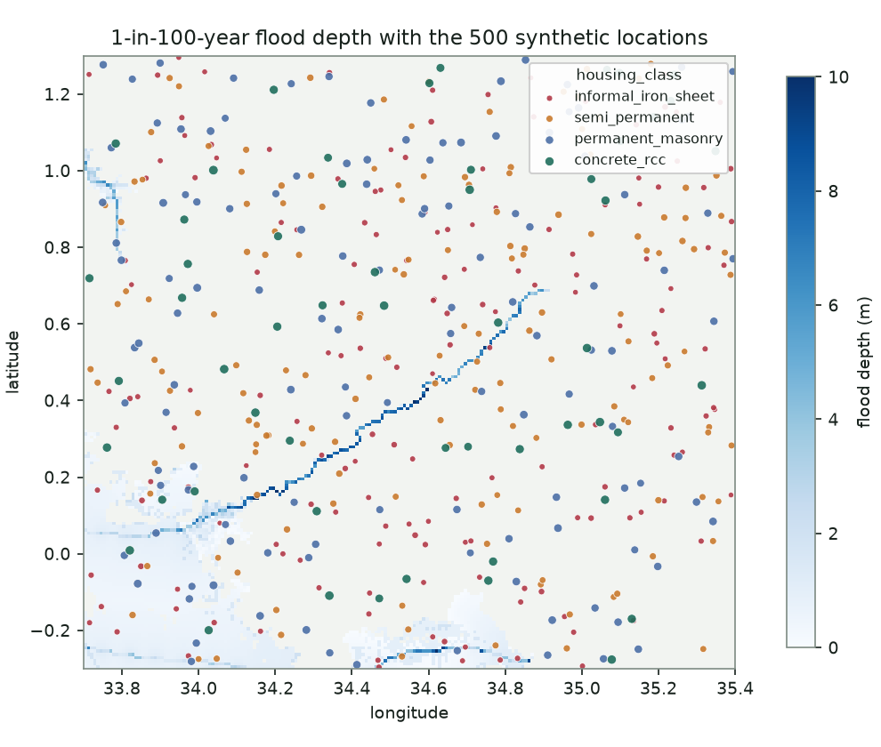
The 500 buildings placed on the 100-year flood depth map. Dot colour is housing class; dot size is insured value.
WHAT YOU ARE LOOKING AT
Five hundred invented buildings scattered at random across the same area as the flood maps. Nothing about them was measured. Locations are random, housing classes are assigned in fixed proportions, and each value is a floor area multiplied by a building cost per square metre, both chosen to suit the housing class (see 'How the insured values were set' below). Because placement is random and flooding is confined to a narrow corridor, only 46 to 48 of the 500 buildings sit in a flooded cell, depending on the map.
HOW TO USE IT
- Join it to the flood maps by location, as described above.
- Use housing_class to choose which damage curve applies to each building, and tiv_kes as the value that the damage ratio is multiplied by.
- Keep the 'synthetic' column through any filtering or merging, so the label survives to your results.
- You may regenerate or extend the portfolio. If you do, say so, and do not describe any version of it as real client data.
Field | Value
Rows | 500
Columns | loc_id, lat, lon, housing_class, floor_area_m2, cost_per_m2_kes, tiv_kes, synthetic, source
loc_id | Text identifier, NZA-0000 to NZA-0499
housing_class | informal_iron_sheet (168), semi_permanent (154), permanent_masonry (124), concrete_rcc (54)
tiv_kes | Total insured value in KES, the cost to rebuild the structure. Minimum 45,000; median 490,000; maximum 72,435,000; total 2,273,710,000
Real or synthetic | Synthetic. Generated for this hackathon with a fixed random seed

3. Team A: Nairobi

Flood susceptibility maps (five GeoTIFF files)
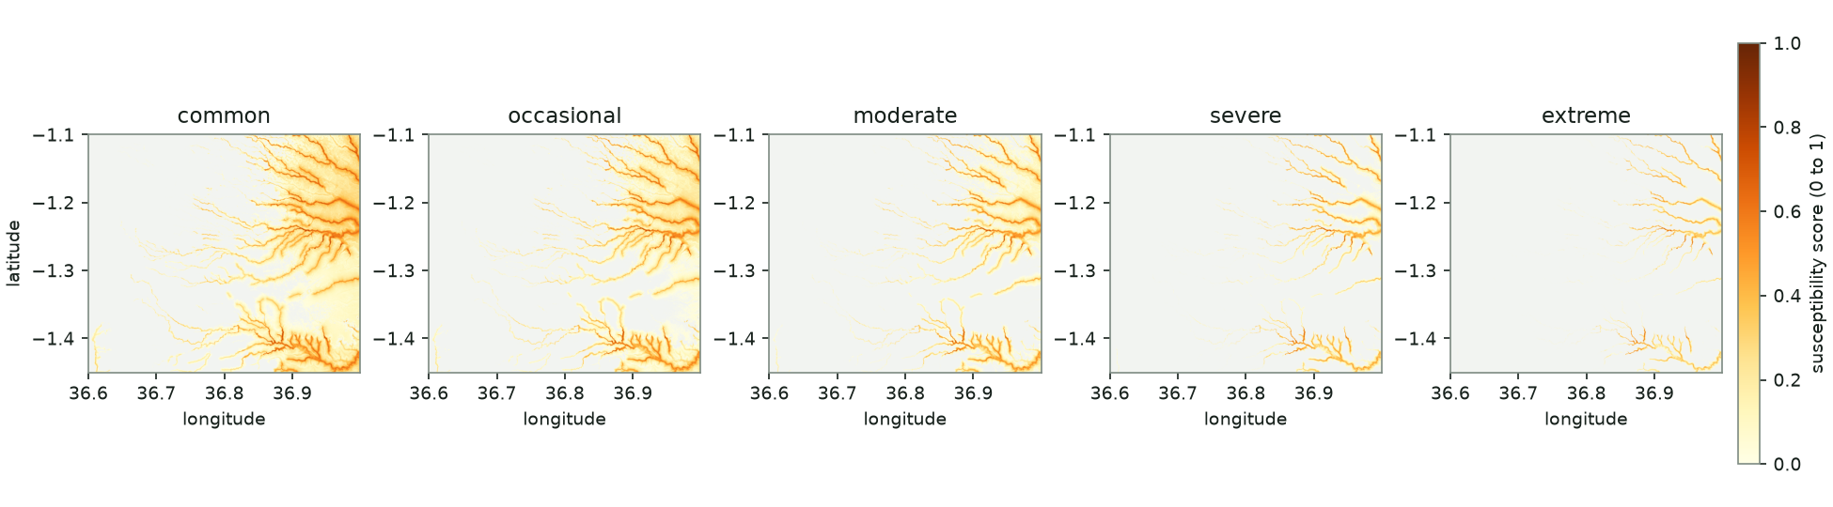
The five Nairobi tiers side by side. Darker orange means a higher susceptibility score. Each tier keeps fewer cells than the one before it.
WHAT YOU ARE LOOKING AT
No measured flood depth exists for Nairobi, so these maps score how likely each 30 m cell is to collect water, on a scale from 0 to 1. A score is not a depth. Do not describe it as one, and do not convert it to metres without stating the assumption you used.
The score blends four real signals: how low the cell sits compared with all of Nairobi (45%), whether it is a local dip in the ground (20%), how flat the ground is (15%), and how close it is to a mapped river or stream (20%). The brown channels in the pictures are the river valleys, which is where the score is highest.
The five files are cuts through that one score. 'common' keeps the highest-scoring 40% of cells, 'occasional' 30%, 'moderate' 20%, 'severe' 10% and 'extreme' 5%, each rescaled to run from 0 to 1. That makes the tiers a ranking of how extreme the cell is. They do not carry return periods of their own. The names describe how extreme a cell is, not how often it floods. A rarer flood reaches more places, so the widest map ('common') stands for the rarest event and the narrowest ('extreme') for the most frequent. The reference dashboard assumes 10 years for 'extreme', 25 for 'severe', 50 for 'moderate', 100 for 'occasional' and 250 for 'common'. That is an assumption made so the loss curve can be drawn. State your own if it differs, and check that loss rises as the event gets rarer.
HOW TO USE IT
- Look up each building's cell in each of the five files, or skip this step with exposure_nairobi_with_hazard.csv (below), which already holds the five values per building.
- Dry cells are exactly 0 in these files. There is no separate no-data value.
- Decide how a 0 to 1 score becomes damage. The reference dashboard feeds the score straight into a saturating curve. You could instead map the score to an assumed depth, or work in damage bands. Either is fine if you say which you chose.
- Decide which return period each tier stands for, and say so. Remember that the widest footprint is the rarest event.
Field | Value
Built by | This project, from open data. No public pluvial hazard dataset exists for Nairobi
Inputs | Copernicus GLO-30 elevation model; river and stream lines from OpenStreetMap
Format | GeoTIFF, one band, 32-bit float. Values 0 to 1; dry = 0
Cell size | 0.000278° (1 arc-second), about 31 m
Size | 1,439 columns × 1,260 rows, longitude 36.60 to 37.00, latitude -1.45 to -1.10
Why it stops at 37.00 | The elevation tile it was cut from ends at longitude 37.0, so the strip from 37.00 to 37.05 has no data
Cells above zero | common 40%, occasional 30%, moderate 20%, severe 10%, extreme 5%
Checked against | 24 government-named flood areas in Nairobi County. The 'common' tier flags 12 of the 24
Limits | Terrain and rivers only. It knows nothing about rainfall, blocked drains, or the state of the stormwater network, which cause much of Nairobi's flooding

Named flood hotspots: nairobi_hotspots_geocoded.csv
name | lat | lon | name | lat | lon
Kiambiu | -1.2823 | 36.8634 | Nairobi West | -1.3087 | 36.8231
Dandora | -1.2449 | 36.9061 | Lang'ata | -1.319 | 36.79
Kariobangi | -1.2591 | 36.8819 | Kawangware | -1.2785 | 36.7516
Kayole | -1.2667 | 36.9194 | Kangemi | -1.268 | 36.7523
Komarock | -1.2727 | 36.9077 | Lavington | -1.2741 | 36.7762
Njiru | -1.2546 | 36.9921 | Westlands | -1.2465 | 36.7861
Ruai | -1.269 | 36.9915 | Parklands | -1.2631 | 36.8106
Mwiki | -1.2328 | 36.9333 | Kitisuru | -1.2404 | 36.771
Donholm | -1.2992 | 36.8887 | Kileleshwa | -1.2767 | 36.7879
Tassia | -1.307 | 36.8986 | Chiromo | -1.2708 | 36.8064
Fedha | -1.3157 | 36.8985 | Mathare | -1.2584 | 36.8713
Madaraka | -1.3074 | 36.8153 | Kibera | -1.3113 | 36.789
All 24 rows, shown in two columns to save space.
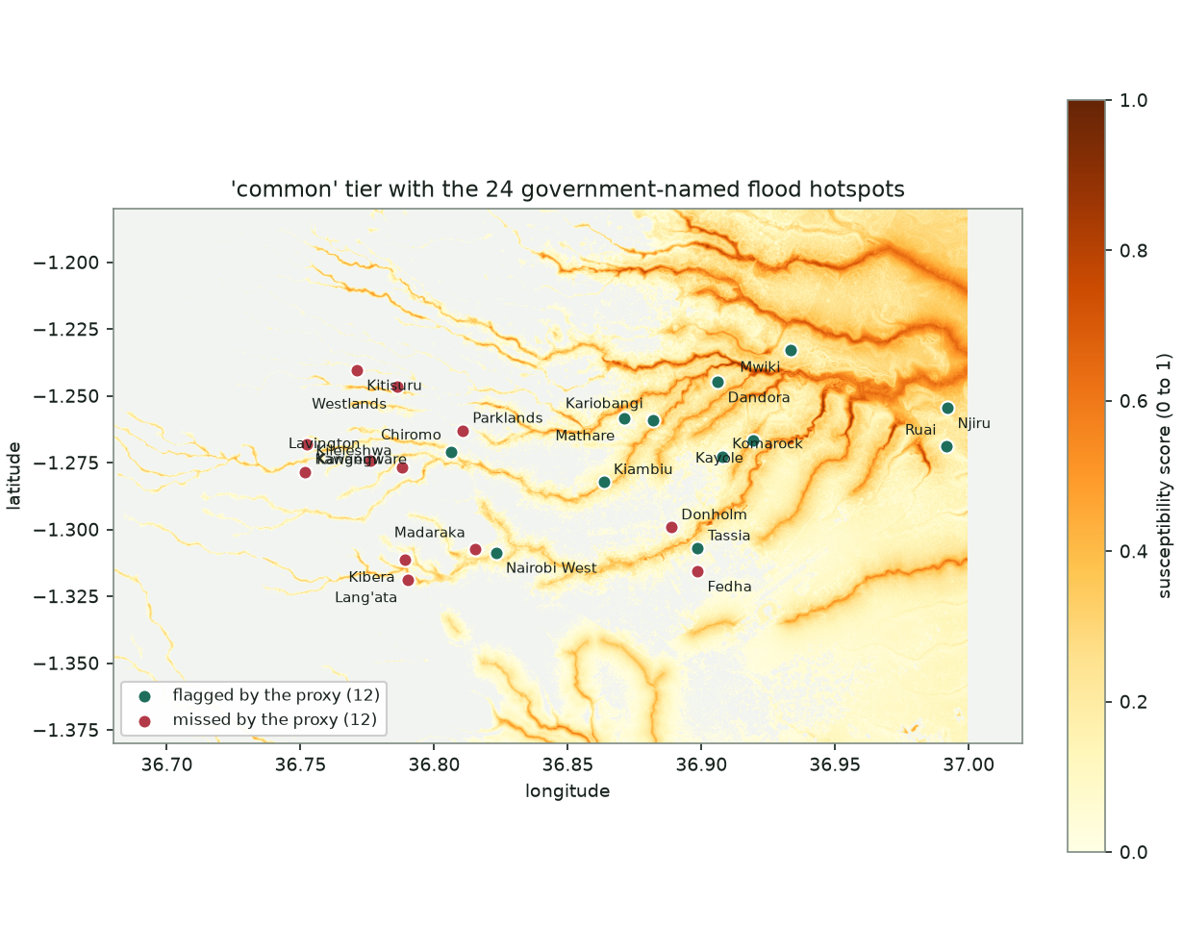
The hotspots on the 'common' tier. Green dots fall on a cell the proxy scores above zero; red dots do not.
WHAT YOU ARE LOOKING AT
The names are real: they come from Nairobi County's own list of flood-prone neighbourhoods. The coordinates are not official. Each name was looked up automatically in OpenStreetMap's place search and is the middle of the area, not the exact spot that floods. The county named 37 areas; this file holds the 24 that could be located.
The map is the proxy's report card. The twelve green hotspots (Kayole, Njiru, Kiambiu, Mwiki, Mathare, Dandora, Tassia, Kariobangi, Nairobi West, Ruai, Komarock and Chiromo) lie in the river valleys that the proxy picks out. The twelve red ones, mostly in the west of the city, flood for reasons the proxy cannot see, such as drainage capacity.
HOW TO USE IT
- Use it to test any hazard layer you build: a sensible layer should score these places higher than the city average.
- Do not treat it as exposure. These are named areas, not buildings.
- Report your own hit rate against it in the same plain terms used here.
Field | Value
Rows / columns | 24 rows; name, lat, lon
Source of names | Nairobi County flood-hotspot mapping, reported March 2026
Source of coordinates | OpenStreetMap Nominatim place search. Approximate
Real or synthetic | Real names, approximate coordinates

Synthetic portfolio: exposure_nairobi_with_hazard.csv
loc_id | lat | lon | housing_class | floor_area_m2 | cost_per_m2_kes | tiv_kes | common | occasional | moderate | severe | extreme
NBO-0000 | -1.3149 | 36.9359 | semi_permanent | 38 | 13,600 | 515,000 | 0.023 | 0.0 | 0.0 | 0.0 | 0.0
NBO-0001 | -1.22 | 36.7899 | informal_iron_sheet | 8 | 7,800 | 60,000 | 0.0 | 0.0 | 0.0 | 0.0 | 0.0
NBO-0002 | -1.2576 | 36.8962 | semi_permanent | 33 | 10,000 | 330,000 | 0.458 | 0.407 | 0.345 | 0.247 | 0.135
NBO-0003 | -1.1941 | 36.8478 | semi_permanent | 58 | 13,700 | 795,000 | 0.114 | 0.03 | 0.0 | 0.0 | 0.0
NBO-0004 | -1.2632 | 36.7736 | semi_permanent | 78 | 15,900 | 1,240,000 | 0.141 | 0.06 | 0.0 | 0.0 | 0.0
NBO-0005 | -1.2023 | 36.9307 | informal_iron_sheet | 16 | 9,800 | 155,000 | 0.67 | 0.639 | 0.601 | 0.541 | 0.472
First six of 600 rows. The last five columns are hazard_score_common to hazard_score_extreme, shortened here to fit the page. A score of 0 means the building sits on a cell the proxy does not flag at that tier.
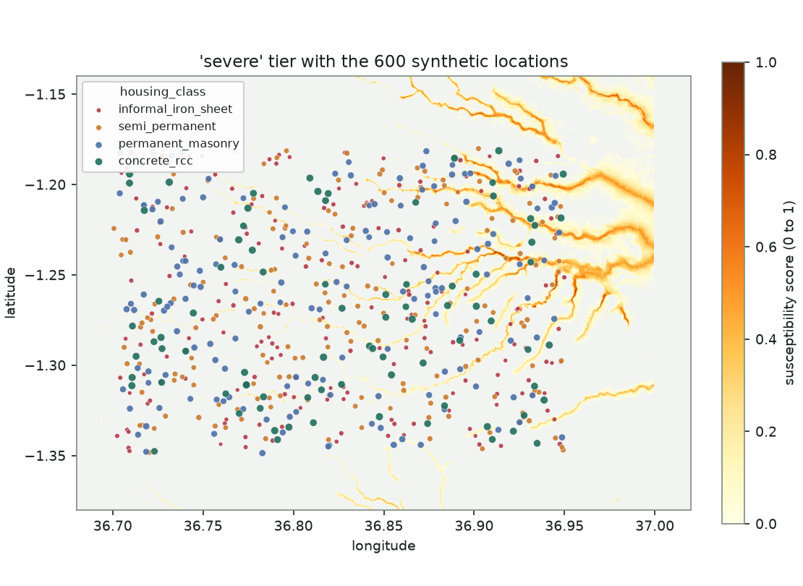
The 600 buildings on the 'severe' tier. Dot colour is housing class; dot size is insured value.
WHAT YOU ARE LOOKING AT
Six hundred invented buildings spread at random across Nairobi, each with the five hazard scores already read from the maps. Placement is random, so the portfolio is not concentrated where flooding is worst. 259 buildings have a score above zero in the 'common' tier, 174 in 'occasional', 110 in 'moderate', 51 in 'severe' and 32 in 'extreme'.
HOW TO USE IT
- Start here if you want to skip raster handling: each row already has the hazard value for every tier.
- Use housing_class to choose the damage curve and tiv_kes as the value at risk.
- Keep the 'synthetic' column. The same caution applies as for Nzoia: never present this as a real portfolio.
- exposure_nairobi_synthetic.csv is the same 600 buildings without the five hazard columns. Use it only if you are building your own hazard layer and need to look the values up again.
Field | Value
Rows | 600 in each of the two Nairobi exposure files
Columns (with_hazard) | loc_id, lat, lon, housing_class, floor_area_m2, cost_per_m2_kes, tiv_kes, synthetic, source, hazard_score_common, hazard_score_occasional, hazard_score_moderate, hazard_score_severe, hazard_score_extreme
loc_id | Text identifier, NBO-0000 to NBO-0599
housing_class | semi_permanent (181), informal_iron_sheet (179), permanent_masonry (156), concrete_rcc (84)
tiv_kes | Total insured value in KES, the cost to rebuild the structure. Minimum 40,000; median 520,000; maximum 159,200,000; total 6,363,470,000
Real or synthetic | Synthetic buildings. The hazard columns are read from the proxy maps, so they carry the proxy's limits

4. Source data behind the Nairobi maps
Dataset | Detail
Copernicus GLO-30 elevation model | Global 30 m height model from the European Space Agency and the Copernicus programme. Taken from the public AWS copy, tile Copernicus_DSM_COG_10_S02_00_E036_00_DEM, which covers Nairobi. Free to use.
OpenStreetMap rivers and streams | Lines tagged 'river' or 'stream' in OpenStreetMap, fetched through the public Overpass service for the Nairobi area. Licensed under the Open Database Licence; anything you republish must credit OpenStreetMap contributors.

5. How the insured values were set
Each building's value is its floor area multiplied by a rebuilding cost per square metre. Both inputs depend on the housing class, and both are shown in the file (floor_area_m2 and cost_per_m2_kes) so any value can be checked by hand. The values cover the structure only, not its contents or any land.
Housing class | Floor area | Cost per m² | Published figure it was set against
informal_iron_sheet | 8 to 28 m², about 14 typical | KES 5,000 to 10,000 | A basic two-room unit is reported at about KES 80,000
semi_permanent | 20 to 80 m², about 38 typical | KES 8,000 to 16,000 | Semi-permanent houses are reported at KES 200,000 to 500,000
permanent_masonry | 45 to 300 m², about 100 typical | KES 35,000 to 65,000 | Formal construction costs KES 35,000 to 65,000 per m² for basic to mid-range finishes; KES 54,730 for a standard Nairobi bungalow
concrete_rcc | Nairobi 250 to 4,000 m²; Nzoia 150 to 1,800 m² | KES 50,000 to 85,000 | Blocks, shops and institutions, so far larger than a house. Rural buildings are smaller

The cost figures come from published 2025 Kenyan construction guides (for example Integrum Construction's 'Construction Costs in Kenya'). The floor areas are invented but typical for each class. These are illustrative replacement costs, not valuations of any real building, and a real portfolio would carry the insured sums on the policy schedule instead.

6. Conventions
- Coordinates are decimal degrees, latitude and longitude, WGS84 (EPSG:4326), in both the rasters and the CSVs.
- Money is in Kenyan shillings.
- A synthetic file carries a 'synthetic' column set to True.
- Nzoia dry cells are no-data; Nairobi dry cells are 0.

