Blood Glucose Project
2. Implementation of the TPM
What are the units of all state variables and model parameters?
State Variables | Model Parameters
G(t) = $\frac{mg}{dl}$  U_{G}(t) = $\frac{g}{min}$  ${\dot{U}}_{G}$(t) = $\frac{g}{\min^{-2}}$  X(t) = $\min^{-1}$  X₁(t) = $\min^{-1}$ | a_{x} = $\min^{-1}$  a_{g} = $\min^{-1}$  K_{g} = $\frac{mg}{dl∙g}$  K_{x} = $U^{-1}$

What values did you use for your state variable initial conditions?
90; 0; 0; 0; 0;
What are the units of time that are appropriate based on your answer above?
The units of time that are appropriate is minutes because all the state variables are in the units in minutes as well.
Explain exactly how you implemented an insulin bolus and a meal in your simulations (i.e. how did you choose the amplitude and duration of each)?
For the first plot, I implemented the 2U insulin bolus and 20 grams of meal for U_{I} and U_{CHO} respectively. I chose a meal duration of 30 minutes, to mimic real digestion. I also chose for the insulin delivery duration to be 30 minutes to for a better approximation of insulin entering the blood stream (patient eats for 30 minutes food and then insulin is taken). The amplitudes were 2/30 U/min for insulin and 20/30 g/min for the meal. The amplitude decreases with insulin present; glucose uptake can occur. But since insulin bolus and meal are taken together their effects overlap, causing for the effects to cancel each other out. This causes for the plot to return to an ‘equilibrium’ like state.
For the 2nd plot, only the 2U insulin bolus was implemented to U_{I} was implemented, U_{CHO} = 0 to represent absence of meal. The amplitude decreases significantly because insulin promoting uptake of glucose that is already present in the bloodstream
The top panel of Fig. 4 is meant to show that it is difficult to identify the insulin parameters when a meal and an insulin bolus are taken together. Explain why this is the case.
It is difficult to identify insulin parameters when meal and insulin are taken together because the effects of meal’s carbohydrates and the insulin bolus can cancel each other out. This leads to blood glucose concentration not changing significantly over time because of the overlap of both meal and insulin processes. This could lead to underestimating the insulin parameters which could increase risk for insulin overdose. Whereas when they are taken separately there’s a large change in the blood glucose, and the plot is more sensitive to the change.

Use your model code to show example simulations where insulin is taken after a meal, and where insulin is taken before a meal.
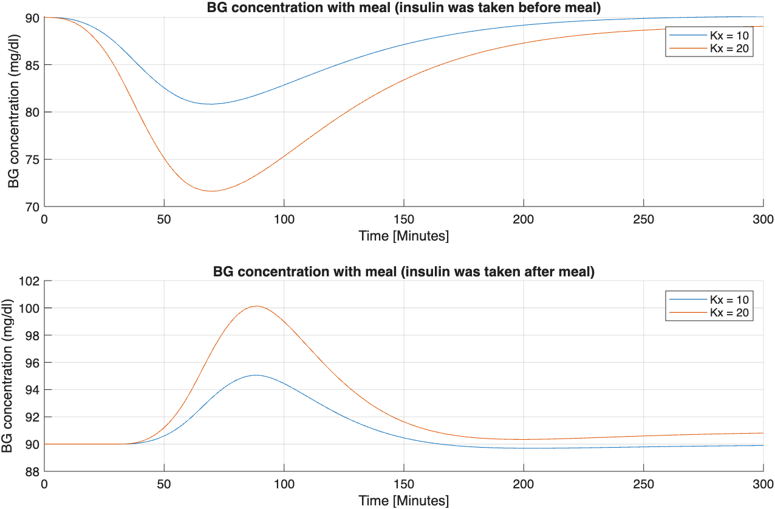
Are the effects of insulin boluses and meals on blood glucose simply additive? Explain why this behavior is or is not expected.
The effect of the insulin bolus and meals on blood glucose are not additive. This additive behavior is not expected because insulin promotes uptake of the meal’s carbohydrates, reducing the rise of the total blood glucose. They are not additive because if there’s a high insulin intake, the amount of meal glucose ingested can be masked by the effect of insulin reducing the amount of glucose in the blood stream. These effects of insulin bolus and meals interact with each other rather than summing up together.

3. Relation between therapy parameters and the TPM – Model application
Use your code to produce a figure similar to that of Bock et al Fig. 3 in order to demonstrate the relationship between CF (Kx), insulin bolus, and G (as in top panel) and MS (Kg), a meal, and G (as in the bottom panel).
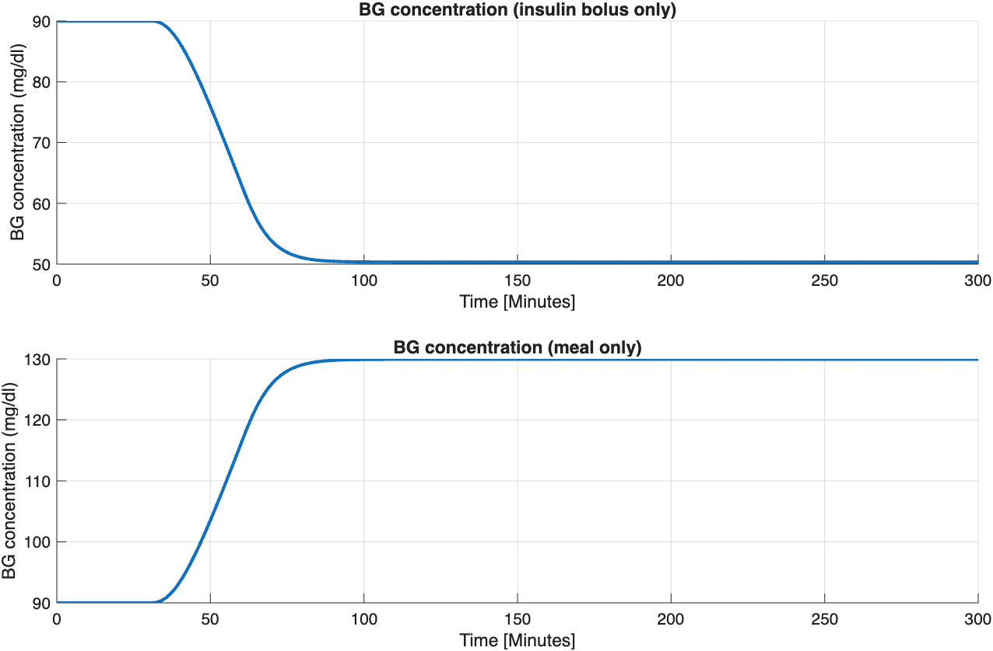
Explain how the output of your code generates the expected change in blood glucose in each case. Furthermore, demonstrate and explain the role of ax and ag on the responses of blood glucose.
In the relationship between CF, insulin bolus and G, no meal was ingested. This allows the plot to show only the effect insulin has on the bloodstream if no meal was ingested. In the code, U_{CHO} = 0, to show only show the effect of U_{I} on the system. The insulin bolus increases insulin action, which promotes uptake of glucose that’s in the bloodstream Therefore, the decrease in glucose in the blood stream is proportional to the correction factor (CF = K_{x}), shown in top figure.
In the relationship between MS (K_{g}), meal, and G, no insulin was taken. This allows the plot to show only the effect the meal will have on the bloodstream, which is that glucose will rise in the absence of insulin. The rise in blood glucose amount will be proportional to the meal sensitivity (MS = Kg), as shown in the bottom figure. In the code, U_{I} = 0, to show the effect of only U_{CHO} on the system.
The role of a_{x} on the response of blood glucose is controls the rate of insulin action and promotes uptake glucose (small a_{x} = slower insulin action, large a_{x} = faster insulin action).
The role of a_{g} on the response of blood glucose controls the rate at which carbohydrates enter by the bloodstream (small a_{g} = slower rise in glucose, large a_{g} = faster rise in glucose), which increases the amount of glucose in blood.

Explain what values you used and why the output of your simulation is consistent with the relationship between the model parameters and standard therapy parameters.
I chose a_{x} = 0.2 min⁻¹ to produce a faster insulin action and a_{g} = 0.19 min⁻¹ to produce a faster rise in glucose levels when compared to the model parameters in figure 4 in Bock et al. These higher values lead to the plots to show a greater steepness for the rise of glucose for the meal only and decrease of glucose with insulin bolus only. I kept K_{x} = 20 U⁻¹ and K_{g} = 2 $\frac{mg}{dl∙g}$ . These both represent insulin sensitivity and meal sensitivity respectively. The output of my simulation is consistent between the model parameters and standard therapy parameters because it estimates the rise and fall of blood glucose in the bloodstream when only insulin present or if the meal is consumed. In the insulin bolus (top plot) the decrease in glucose is proportional to CF. In the meal only, the increase in glucose is proportional to the meal sensitivity.

