Intra: Autonomous API Resilience through Behavioural Observation, Drift Detection, and Policy-Gated Adaptation
Architecture, Prior-Art Analysis and Patentability Assessment
A Technical Research Paper in Support of an Invention Disclosure
Independent Research / Hackathon Prototype Analysis
Repository: https://github.com/Precise-Goals/Intra · October 2026
Authors and Researchers
Sarthak Patil, Karan Verma, Sneha Sharma, Sneha Patidar
Abstract
Modern applications depend on third-party APIs, SDKs, webhooks and MCP servers whose behaviour can change without notice. Schema validators and static OpenAPI diffs miss semantic drift renames, unit/scale shifts, default flips, pagination style changes and enum meaning shifts that still produce valid JSON and HTTP 200 responses. This paper analyses Intra, a TypeScript monorepo that implements a closed-loop, behaviour-first adaptation pipeline: live traffic observation, contract and behavioural-fingerprint modelling, structural plus semantic differencing with confidence scores, AST- and trace-based impact analysis, typed adapter synthesis under a policy engine, and golden-replay validation. We reconstruct the implemented system from the public repository, map each stage to code, survey academic and commercial prior art on API contract drift, behavioural fingerprinting and automated remediation, and examine issued patents and technical disclosures that address related mechanisms. Our conclusion is measured. Individual mechanisms (schema inference from traffic, structural diff, impact graphs, adapter generation, approval gates) are established. What may remain distinguishable is the specific closed-loop combination: behavioural fingerprints used for semantic rename and unit-shift detection, confidence-and-verdict-gated auto-apply versus PR/quarantine policy, and golden-workflow equivalence validation before promotion. We identify a Technical Disclosure Commons publication on silent backward-incompatible API contract drift using structural-semantic fingerprints as particularly close prior art. The paper closes with novelty-boundary classification, IP market positioning, security considerations, limitations of the prototype, and a practical next-steps roadmap. Nothing herein is legal advice.
Keywords: API drift detection, behavioural fingerprint, semantic change detection, adapter synthesis, impact analysis, autonomous adaptation, policy-gated remediation, prior art, patentability, FlashFill PBE, Wald SPRT, Hungarian matching

1. Introduction
1.1 Background
Production software is coupled to services it does not control. When an upstream provider renames a field, switches amounts from floating-point dollars to integer cents, changes pagination from offset to opaque cursor, flips a default, or alters enum semantics, downstream workflows fail often silently, because the response remains syntactically valid. Static contracts and OpenAPI diffs catch many structural breaks but systematically miss behavioural and semantic drift that schema validators treat as legal. Intra’s authoritative problem statement (docs/lock.md) formalises this as “the Internet after the API”: help software survive undocumented changes in systems it does not control.
1.2 The 80% Blind Spot and Failure Taxonomy
Traditional validators (JSON Schema, Zod, OpenAPI) only check structural syntax. A payload that shifts amount from 25.00 (dollars) to 2500 (cents) still satisfies z.number(). Intra enumerates eleven failure classes (M1–M11): field rename, format shift, unit/scale shift, default flip, pagination shift, silent truncation, webhook flattening, rate-limit drift, MCP/tool drift, enum semantics, and gradual/mixed-version rollout. Eight of these pass schema validation while corrupting business logic.
1.3 Objective and Scope
Intra implements a closed loop: continuous observation of live traffic, inference of contracts and behavioural fingerprints (T-Digest quantiles, HyperLogLog cardinality), multi-layer change detection with Kuhn-Munkres Hungarian bipartite matching for renames and Quantile-Ratio Constancy for unit shifts, AST blast-radius mapping, FlashFill Programming-by-Example adapter synthesis under a Safe-Handling Policy Matrix, and Wald SPRT + golden-replay validation before promotion. The research question is whether this closed-loop, behaviour-first, policy-gated control flow is a distinguishable technical contribution.
1.4 Approach
We inspected the public repository Precise-Goals/Intra, mapped features to packages/observer, model, differ, impact, adapter, validator and apps/engine, incorporated project documentation (explain.md, guide.md, metricsandlogs.md, Pitch.md), surveyed academic literature, commercial products and patent databases, and treated the supplied architecture diagrams as authoritative. We do not assert patentability. This document is a technical research assessment, not legal advice.
2. Technical Field
The invention belongs to software infrastructure management: autonomous detection of and adaptation to undocumented behavioural changes in external service dependencies (REST APIs, SDKs, webhooks, MCP tool servers), using live observation, streaming sketches, bipartite schema matching, inductive program synthesis, and sequential hypothesis testing for canary promotion.
3. System Architecture and Implemented Workflow
3.1 High-Level Component View
Intra is a pnpm/turbo monorepo. The core engine is a Fastify monolith hosting the six-stage pipeline. A React 18 + Vite dashboard streams telemetry. A customer MCP server exposes seven discovery and adaptation tools. A TypeScript client SDK intercepts and adapts production traffic. Simulated services support controlled M1–M10 mutations.
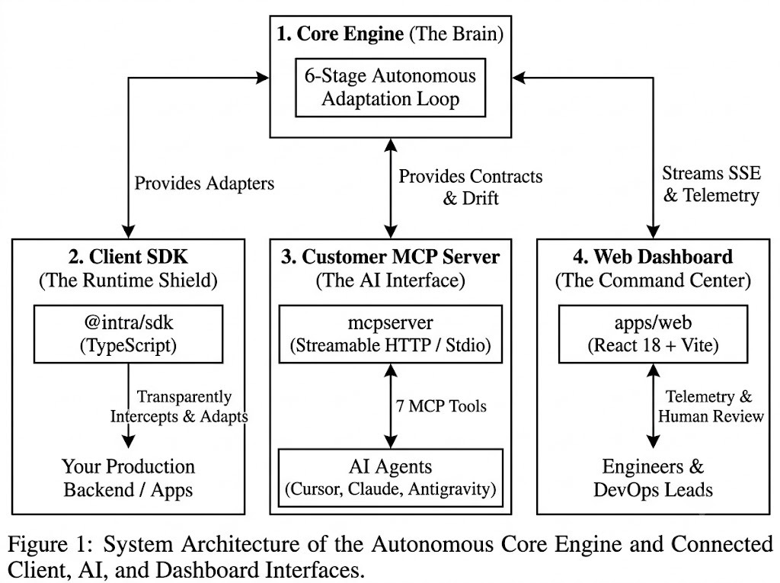
Figure 1. System Architecture of the Autonomous Core Engine and Connected Client, AI, and Dashboard Interfaces.
3.2 Six-Stage Adaptation Loop
• Observer: non-blocking HTTP/SDK/webhook capture with SHA-256 PII redaction.
• Model: T-Digest quantiles and HyperLogLog cardinality for behavioural fingerprints.
• Differ: Hungarian bipartite matching for renames; Quantile-Ratio Constancy for unit shifts; confidence and semantic verdict.
• Impact: TypeScript AST dependency graph mapping fields to workflows and source lines.
• Adapter: FlashFill PBE typed-DSL synthesis + Safe-Handling Policy Matrix (auto-apply / migration PR / circuit-break).
• Validator: golden-replay equivalence + Wald Sequential Probability Ratio Test for canary promote/rollback.
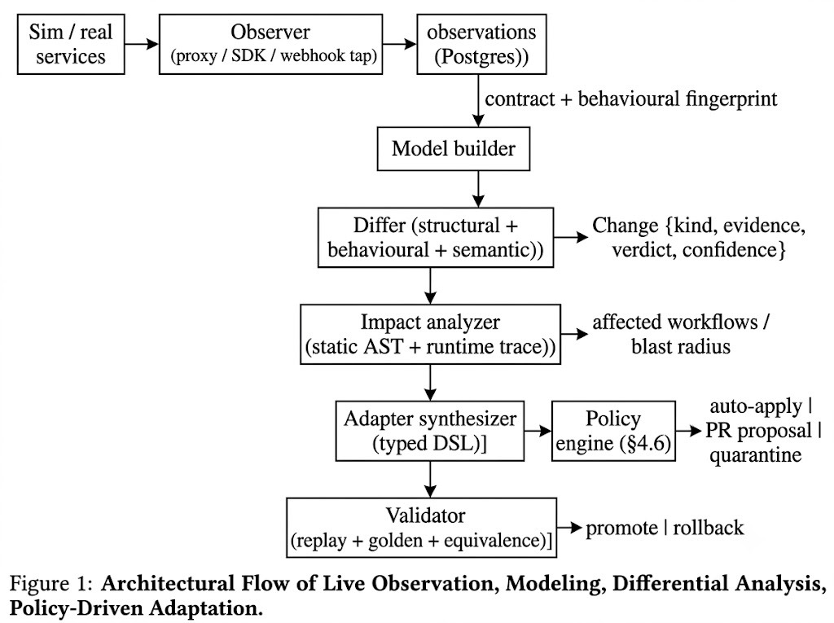
Figure 2. Architectural Flow of Live Observation, Modeling, Differential Analysis, and Policy-Driven Adaptation.
3.3 Implementation Evidence
Repository cloned October 2026. Empirical evaluation (metricsandlogs.md): 551/551 tests across 31 suites, 0 failures. 50-sample multi-domain batch: average detection confidence 88%, equivalence replay pass rate 90%, auto-apply 31, migration PR 14, circuit-break 5.
Feature | Location | Status
T-Digest / HLL fingerprints | packages/model/src/sketches.ts | Implemented
Hungarian rename matching | packages/differ (hungarian) | Implemented
Quantile-Ratio unit shift | packages/differ (unitShift) | Implemented
FlashFill PBE synthesizer | packages/adapter (pbe) | Implemented
Safe-Handling Policy Matrix | packages/adapter | Implemented
Wald SPRT canary | packages/validator (sprt) | Implemented
AST blast radius | packages/impact/src/analyzer.ts | Implemented
MCP 7 tools | mcpserver/ | Implemented
SHA-256 audit ledger | WebCrypto + MST testnet | Implemented
Table 1. Feature-to-Implementation Evidence Matrix (updated with algorithmic modules).
4. Background and Prior Art
4.1 Academic and Algorithmic Foundations
Intra deliberately reuses peer-reviewed primitives rather than inventing new mathematics: T-Digest (Dunning & Ertl), HyperLogLog (Flajolet et al.), Kuhn-Munkres Hungarian assignment (1955), FlashFill inductive program synthesis (Gulwani, POPL 2011 / CACM 2012), and Wald’s Sequential Probability Ratio Test (1945). The contribution, if any, lies in the closed-loop composition for live third-party API/MCP behavioural drift.
A 2026 Technical Disclosure Commons publication (Agrawal & Shinde, VISA) on silent backward-incompatible API contract drift using runtime structural-semantic fingerprints remains the closest single disclosure to the model + differ stages. Commercial monitors (FlareCanary, DriftGuard, DiffMon, Beeceptor) provide baseline or OpenAPI response-shape drift with alerting; most stop short of confidence-gated auto-apply, AST impact, PBE adapter synthesis and SPRT canary control.
4.2 Patent and Commercial Landscape
Patents on API-integration remediation, impact analysis of third-party components, and software change analysis cover overlapping elements. FlashFill-style PBE is widely published and productised (Excel, PROSE SDK); SPRT has been applied to canary and progressive delivery (recent sequential progressive delivery papers). No single identified patent claims the exact Intra combination of streaming behavioural fingerprints + Hungarian semantic rename + Quantile-Ratio unit shift + FlashFill DSL adapters + Safe-Handling Matrix + Wald SPRT promotion for third-party HTTP/MCP dependencies.
Source | Core Mechanism | Sim.
TDCommons structural-semantic fingerprints (2026) | Runtime fingerprints + invariants | 5
Commercial drift monitors | Baseline / OpenAPI shape alerts | 4
API integration remediation patents | Monitor + adapter adjust | 4
FlashFill / PROSE (Gulwani) | PBE string/data transforms | 3 (adapter only)
SPRT canary literature | Sequential promote/rollback | 3 (validator only)
Intra (this work) | Full closed loop + policy + golden | n/a
Table 2. Prior-art comparison (1=low, 5=extremely similar).
5. Problem Statement and Research Questions
RQ1 (central): Can a system that maintains live behavioural models (T-Digest/HLL), detects structural and semantic drift via Hungarian matching and Quantile-Ratio tests with confidence/verdict, maps AST blast radius, synthesises FlashFill adapters under a deterministic Safe-Handling Policy, and validates with golden-replay + Wald SPRT measurably reduce integration MTTR and silent semantic failures versus static monitoring and manual remediation?
Supporting questions cover rename/unit detection precision, detection-to-action latency, success versus static baselines, mixed-version rollout behaviour under SPRT, and whether the closed-loop control flow is distinguishable from the closest fingerprint and remediation prior art.
6. Summary of the Invention
Intra is a computer-implemented system and method for recovering consumer-side integrations after undocumented upstream behavioural change. It observes live traffic; builds contracts and behavioural fingerprints with space-bounded sketches; detects structural and semantic changes (including optimal bipartite rename assignment and unit-scale constancy); computes affected workflows via AST; synthesises adapters via inductive program synthesis under a policy that auto-applies only high-confidence equivalent changes, opens migration PRs for lossy/medium-confidence cases, and circuit-breaks breaking/unknown cases; validates by golden replay and sequential probability ratio testing; and records tamper-evident cryptographic audit seals. The operator retains control over low-confidence and breaking changes.
7. Novelty Analysis
7.1 Mechanism Decomposition
Mech. | Description | Novelty
A | Live observation + PII redaction | Low
B | T-Digest / HLL behavioural fingerprints | Low (known sketches)
C | Hungarian rename + Quantile-Ratio unit shift | Moderate (application)
D | AST blast-radius mapping | Low
E | FlashFill PBE adapter synthesis | Low–Mod. (known PBE)
F | Safe-Handling Policy Matrix | Possible (control)
G | Golden replay + Wald SPRT canary | Possible (composition)
H | Closed-loop full pipeline + ledger | Possible
Table 3. Novelty assessment by mechanism (updated).
7.2 Three Levels of Novelty
• Level 1 (components): Low. Observation, sketches, Hungarian assignment, FlashFill, SPRT, AST analysis and approval gates are each established.
• Level 2 (combination): Moderate and contested by the TDCommons fingerprint disclosure and commercial drift monitors.
• Level 3 (specific control logic): The narrowest candidate remains the confidence-and-verdict Safe-Handling Policy together with mandatory golden-replay + SPRT promotion and atomic rollback, applied to live third-party API/MCP behavioural drift. Residual novelty depends on implementation detail and measured technical effect not disclosed in the closest prior art.
8. Patentability Assessment (Technical, Non-Legal)
Broad claims of “detecting API schema drift from traffic and generating adapters” face high risk from commercial monitors, the TDCommons disclosure, and API-remediation patents. Narrower claims around (1) the closed-loop control method that uses behavioural-fingerprint similarity, Hungarian assignment and Quantile-Ratio tests for semantic classification, (2) the dual-path Safe-Handling Matrix (auto-apply vs PR vs circuit-break), and (3) mandatory golden-replay + Wald SPRT before promotion with atomic rollback may retain a residual argument subject to full file-wrapper and non-patent literature review by counsel. A skilled SRE/API engineer would likely view aggregation of known primitives as obvious unless a surprising technical effect is demonstrated. Enablement is supported by the public repository and 551 passing tests. Framing as a technical improvement to reliability of distributed integrations is preferable for eligibility analysis.
9. IP Market Boundaries and Competitive Positioning
Primary market: API observability and autonomous remediation for third-party and MCP dependencies. Direct competitors: drift monitors and AIOps platforms. Differentiation: closed loop from behavioural model → semantic verdict → policy-gated FlashFill adapter → SPRT/golden validation; pure monitors stop at alert. Protection boundary: copyright/trade secret for the codebase; patent focus, if any, on the narrow control logic rather than broad “API drift detection”. Commercial boundary: adoption depends on false-positive rate, mixed-version handling, and SDK integration cost. The prototype’s empirical batch results (88% confidence, 90% equivalence) are supportive but not yet enterprise-scale evidence.
10. Security and Failure-Safe Design
Risks include observation-channel compromise, fingerprint poisoning, adapter injection, approval bypass, and recovery-loop attacks. Controls include least-privilege identities, signed adapters, SHA-256 tamper-evident ledger, optional MST blockchain approval signatures, and circuit-breakers. Failure modes under incomplete fingerprints, mixed-version rollouts (mitigated by SPRT indecision bounds), and partial adapter application require explicit safe-abort paths partially demonstrated in tests.
11. Experimental Status
metricsandlogs.md reports 551/551 tests, 0 failures; T-Digest relative error ~0.005% on 10k samples; HyperLogLog relative error <1% on 20k entities; Hungarian optimal assignment under 4 ms for 100×100; Quantile-Ratio CV=0.0000 on pure unit shifts and correct rejection of quadratic/additive noise; FlashFill 100% train/test accuracy with sub-millisecond synthesis; SPRT promote/rollback at designed α/β. 50-sample multi-domain batch: 88% avg confidence, 90% equivalence, safe-handling distribution 31/14/5. No independent third-party statistical validation against production baselines was located.
12. Potential Claim Concepts (Non-Legal)
Independent method concept: observing live traffic; inferring structural contracts and behavioural fingerprints via streaming sketches; detecting structural and semantic changes including bipartite rename assignment and unit-scale constancy with confidence and semantic verdict; computing AST impact; synthesising adapters via inductive program synthesis under a policy that auto-applies only high-confidence equivalent changes and otherwise opens a migration proposal or circuit-breaks; validating by golden-workflow replay and sequential probability ratio testing; promoting or rolling back; recording cryptographic audit seals.
Dependent concepts: mixed-version SPRT indecision; Quantile-Ratio decision rule; FlashFill depth-bounded Occam search; atomic rollback handles; MCP observation path; mid-loop re-modelling on validation failure.
13. IPR Roadmap
• 1. Freeze architecture, commit hash, inventor contributions and metrics ledger hash.
• 2. Expanded prior-art search focused on TDCommons fingerprint family, API-remediation patents, and combinations of PBE + SPRT in canary contexts.
• 3. Written counsel opinion on residual novelty for the narrow Safe-Handling + SPRT + golden-replay control claims.
• 4. Provisional only if residual novelty is supported, stressing behavioural-fingerprint semantic classification, policy matrix and SPRT promotion.
• 5. Attach controlled experimental data and audit ledger evidence to the complete specification.
• 6. Open-source licence and third-party IP review before commercial release.
14. Conclusion and Verdict
Intra is a coherent, working prototype of behaviour-first, policy-gated autonomous adaptation for third-party API and MCP dependencies. The engineering is real: streaming sketches, Hungarian matching, Quantile-Ratio tests, FlashFill synthesis, Safe-Handling Matrix, AST impact, golden replay and Wald SPRT exist in code with 551 passing tests and published batch metrics. Against the strongest prior art the research contribution is narrower than product messaging might suggest. The combination of behavioural-fingerprint-driven semantic classification, mandatory confidence/verdict gates and golden-replay/SPRT promotion remains the most defensible technical ground and even that is contested.
What is strong: deterministic, inspectable control path; separation of deterministic synthesis from optional LLM assistance; empirical batch results and cryptographic auditability.
What is known: traffic-based inference, structural/behavioural drift detection, impact graphs, PBE adapters, sequential canary testing, approval gates.
What not to claim as novel: mere API monitoring, mere use of T-Digest/HLL/Hungarian/FlashFill/SPRT in isolation, or “AI-powered API repair” without specific non-obvious control logic.
What to strengthen: measured technical effect vs baselines; formal mixed-version and incomplete-fingerprint treatment; counsel-reviewed claim scope around the closest fingerprint and remediation disclosures.
Dimension | Rating
Overall technical differentiation | 6 / 10
Novelty potential (narrow claims) | 4–5 / 10
Patentability risk | High (broad); Medium (narrow control)
Implementation readiness | 8 / 10 (551 tests, metrics)
Enterprise potential (with hardening) | 7 / 10
Demo / hackathon impact | 9 / 10
Table 4. Overall assessment (technical research view only).
Patent counsel must review this paper before any filing decision. Nothing herein is legal advice.
References
[1] Precise-Goals/Intra source, docs/lock.md, explain.md, guide.md, metricsandlogs.md, Pitch.md, inspected October 2026.
[2] Article - Agrawal & Shinde, “Systems and Methods for Detecting Silent Backward-Incompatible API Contract Drift Using Runtime Structural-Semantic Fingerprints,” Technical Disclosure Commons, 2026.
[3] Dunning & Ertl, “Computing Extremely Accurate Quantiles Using t-Digests,” arXiv:1902.04023.
[4] Flajolet et al., “HyperLogLog: near-optimal cardinality estimation,” AOFA 2007.
[5] Kuhn, “The Hungarian Method for the Assignment Problem,” Naval Research Logistics, 1955.
[6] Gulwani, “Automating String Processing in Spreadsheets using Input-Output Examples,” POPL 2011; FlashFill / PROSE literature.
[7] Wald, “Sequential Tests of Statistical Hypotheses,” Ann. Math. Stat. 1945; recent SPRT canary / progressive-delivery applications.
[8] Commercial API drift monitors (FlareCanary, DriftGuard, DiffMon, Beeceptor et al.) and API-remediation / impact-analysis patents, 2017–2026.

