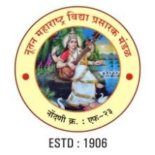
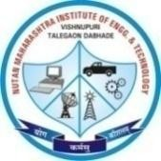
Nutan Maharashtra Vidya Prasarak Mandal’s (NMVPM’s) NUTAN MAHARASHTRA INSTITUTE OF ENGINEERING AND TECHNOLOGY (NMIET) Under Administrative Support - PimpriChinchwad Education Trust (PCET)
Approved by AICTE Comp./E&Tc./Mech. - Accredited by NBA Affiliated to SPPU
“Samarth VidyaSankul”, Vishnupuri, TelegaonDabhade, Taluka Maval, District Pune - 410507
Tel. No. 02114 - 231666 E-mail : nmiettalegaon@gmail.com Web : www.nmiet.edu.in
AICTE ID - 1-8618657 AISHE ID - C-41640 DTE ID - 6310 UNIVERSITY ID - CEGP013890

Date: 22/September/2026

Sub: Smart India Hackathon 2026 – Nomination

I am pleased to nominate the below team from our college to participate in Smart India Hackathon 2026. AICTE Application No/ UGC Registration No for our college is C-41640

Team: Falcons

 | Name | Gender (M/F) | Email id | Mobile no. | Stream | Academic Year
Team Leader | Sarthak Tulsidas Patil | M | sarthakpatil.ug@gmail.com | 7387303695 | B.E. CSE | 3rd Year
Team Member | Utkarsh Upendra Vidwat | M | utkarshvidwat@gmail.com | 9637569090 | B.E. CSE | 3rd Year
Team Member | Ganesh Beldar | M | Ganeshbeldar.ug@gmail.com | 8010892530 | B.E. AIDS | 3rd Year
Team Member | Gaurav Prashant Chaudhari | M | gauravchau2412@gmail.com | 9970055246 | B.E. CSE | 3rd Year
Team Member | Soniya Baliram Pangatte | F | soniyapangatte.falcon@gmail.com | 8208954102 | B.E. CSE | 3rd Year
Team Member | Siddhi Someshwar Bhosale | F | siddhib06@gmail.com | 8484856728 | B.E. CSE | 3rd Year

Sincerely,

Dr. Pramod Patil
Director, NMIET, Pune
410507

