ii

# DEDICATIONS

THIS WORK IS DEDICATED TO MY FAMILY

# AKNOWLEDGEMENT

Drafting this document would have not been possible without the contribution of some people who took upon themselves to see this work being accomplished. Our gratitude goes to the following people:

* The Resident Representative of IAI-Cameroon, **Mr. ARMAND Claude Abanda**, for his support, words of encouragement and the different advices on how to approach situations.
* The Director of FINANCIAL HOUSE SA, and his staffs for trusting us by given us the opportunity to serve as interns in their prestigious enterprise.
* Our academic supervisor **Mrs. FOMEKONG** for his moral support, effort and advices throughout the internship period.
* To our academic teachers **Mr. MESSIO, Mr. AGBOR ANDERSON** for their advices and assistance in realizing this document.
* To all my teachers of **AICS CAMEROON** for the knowledge they impacted me with for me to be where I am today.
* The countless contributors of open-source programming community, for their great help in learning basic skills and detecting and solving bugs.
* Tomy father and mother **KENMOGNE LAURENT AND GUIADEM KAMDEM MARIE THERESE** for he moral and material support.
* A special thank you
* To all my classmates for their collaborative work throughout the academic year.

# CONTENT

# LIST OF FIGURES

# LIST OF TABLES

# ABREVIATIONS

# ABSTRACT

# RESUME

## GENERAL INTRODUCTION

## PART ONE : INSERTION PHASE

Preamble

This section of our report will cover details of how we were welcomed in the host company, the company presentation and organization, and a brief introduction to our project.

Content overview

INTRODUCTION

I . WELCOM AND INTERGRATION

II. GENERAL PRESENTATION OF FINANCIAL HOUSE SA

III. HARDWARE AND SOFTWARE RESOURCES

IV.VISION AND OBJECTIFS

V.ORGANISATION OF FINANCIAL HOUSE

CONCLUSTION

## INTRODUCTION

The insertion phase is a period in which the different interns got to know more about their host company. we got to know about the staffs, the different hardware and software used, the different department which constitute the company and we were introduced to our workspace, how the company functions both internally (that is, how the different task is schedule, the rules and regulations, working periods and so on) and externally (that’s, how they interact with customers). We also had a time to discuss amongst us interns during a break of one hour every day and 3 hours on Saturdays on topics like what we love doing most, what we dislike, our believes, our best meals, sports, songs, our temperaments, our inborn talents and those we learn as we grow up. We shared about our different realizations and failures in life.

### WELCOME AND INTEGRATION

#### Welcome:

Within the FINANCIAL HOUSE SA BANK, we were welcomed on Monday, July 3rd, 2023 by its IoT training manager, Mr. **Tayoutsop Kanou Edson**.

#### Integration:

Mr.Tayoutsop Kanou Edson organized a meeting during which he reminded us of the internal regulations of the establishment, its operation, vision, objectives, services, requirements, and the development of the weekly schedule. Emphasis was placed on the conduct to be followed and respect for the regulations in force. Several pieces of advice and recommendations were also given to us during different online sessions with the General Director, Mr. AGUEGUIA LALLAH Raoul. Then we discussed our theme.

### GENERAL PRÉSENTATION OF FINANCIAL HOUSE SA

1) History and missions

FINANCIAL HOUSE S.A. is a 2nd category microfinance institution created in 2002 and having opened its doors on June 06, 2004, in its branch in Yaoundé Hippodrome. With a network of eight branches in Cameroon, its range of products and services concerns the safeguarding of customer savings and the granting of credit to support the economic activities of the population. Holder of the N°034/MINEFI approval of March 10, 2005, FINANCIAL HOUSE SA is a corporate citizen that operates on a daily basis to support its customers and the entire population in the realization of their investment projects.

2) Presentation of FINANCIAL HOUSE SA

a) Identification sheet

|  |  |
| --- | --- |
| IDENTIFICATION | DESCRIPTION |
| Headquarters | FINANCIAL HOUSE |
| Legal Form | S.A |
| Type of company | Private |
| Creation Date | 2002 |
| Activities | -Receives deposits from the public  -collects savings  -provides and manages means of payment  -grants loans. |
| Region/Agency | -CENTRE  -LITTORAL  -OUEST |
| BP | 4531 Yaounde |
| Social capital | 2 000 000 000 F |
| Effectif | More than 130 permanent members |
| Telephone | -(237) 222 22 60 64  -(237) 222 22 60 63 |
| Site Web | www.financialhouse.cm |
| Email | infos@financialhouse.cm |
| Languages spoken | -French  -English |
| Logo |  |

### HARDWARE AND SOFTWARE RESOURCES OF FINANCIAL HOUSE

i. Hardware resources:

The company has many pieces of equipment listed in the following table.

|  |  |
| --- | --- |
| DESIGNATION | IMAGE |
|  |  |
|  |  |
|  |  |
|  |  |
|  |  |
|  |  |
|  |  |

ii. Software resources:

|  |  |
| --- | --- |
| DESIGNATION | IMAGE |
| Operating system Windows 10 |  |
| Operating system windows 11 |  |
| Office 2021 |  |

### VISION AND OBJECTIFS

1. Visions:
2. Objectives:

* **Financial Inclusion:** Financial House S.A. was created with the goal of providing financial services and products to the broader population, particularly underserved or disadvantaged segments, to support their economic activities and investment projects.
* **Savings Mobilization:** One of the key services offered by Financial House S.A. is the safeguarding and mobilization of customer savings. This helps to channel funds from savers to borrowers who need access to credit.
* **Credit Provision:** Another core objective is the granting of credit and loans to support the economic activities and investment projects of the local population. This credit access helps to stimulate economic development at the grassroots level.
* **Geographical Expansion:** The institution has been able to establish a network of 8 branches across Cameroon, indicating an objective of expanding its reach and making its services accessible to a wider geographic area.
* **Becoming a bank:** FINANCIAL HOUSE SA also has an objective of becoming a bank in few years.

### ORGANISATION OF FINANCIAL HOUSE

a) Activities:

b) Functional organization of Etech:

The organizational chart is first and foremost a communication tool designed to facilitate understanding of the relationships and connections within the company. It allows for a global view of the company in terms of services, divisions, and much more.

## PART TWO: TECHNICAL PHASE

## **CHAPTER ONE : EXISTING**

Preamble

The existing system is a document that provides a view of the system currently in place, that is how it carries out its different activities, also it provides a deep understanding of this system associated to the various limitations, the problems that result from these and the solution we propose.

Content overview

INTRODUCTION

I . PRESENTATION OF THE THEME

II. STUDY OF THE EXISTING

III. CRITISM OF THE EXISTING

IV. PROBLEMATIC

V. PROPOSED SOLUTION

CONCLUSTION

### INTRODUCTION

The existing system refers to the system put in place to carry out the work done in the field on which our theme is based. Understanding this system is a great step in solving the problems that we might identify. It's of great importance that we take into consideration this old system before proposing a suitable solution

I. PRESENTATION OF THE THEME

During our first days at Etech, we were encouraged by our professional supervisor to take a day or two to come up with a suggestion of a theme for our internship period. Taking into consideration the desire of the company to work on innovative projects as expressed by the companies objectives

Chief Executive Officer during his welcome address to us, and our desire to contribute in our humble way to solving day-to-day problems, we proposed the theme

II. STUDY OF THE EXISTING

## CHAPTER TWO: SPECIFICATION BOOK

Preamble

The specification book outlines the goals to be achieved through this project and the responsibilities of the different parties involved in the project. It specifies and describes the subject and the needs of the users, as well the conditions necessary to realize the project

Content overview

INTRODUCTION

I. CONTEXTE AND JUSTIFICATION PROJECT

II. OBJECTIVES OF THE PROJECT

III. BENEFICIARIES AND TARGETS

IV.EXPRESSION OF NEEDS

V. ESTIMATED COST OF THE PROJECT

VI. PROJECT PLANNING

VII. PROJECT CONSTRAINT

VIII. LIST OF PARTICIPANTS AND DELIVERABLES

CONCLUSION

### INTRODUCTION

The specification book of our reports helps us provide details about our theme, to improve our understanding of it and increase the likelihood of it succeeding. To delimitate the scope of our project, we will specify the context of our theme. From the context, we will list the problems we have identified in our context and that we have decided to address throughout the project. After presenting our solution, we will talk about the objective we have set for ourselves for the project. Also, we will explore the needs to which our system will respond both at the functional and non-functional level. We will then look at the estimated financial requirements for our project, and establish a plan we will follow to complete our project on time. From here we will discuss what is expected of us by the end of the project under the project deliverables.

## CHAPTER THREE: ANALYSIS PHASE

Preamble

After specification book, we have the Analysis phase which permits us to represent a detailed analysis of the limitations identified in our context, and our solution, through a software development process and modelling language.

Content overview

INTRODUCTION

I . COMPARATIVE STUDIES OF UML AND MERISE

II. COMPARATIVE STUDY OF UNIFIED PROCESSES

III. JUSTIFICATION OF MATHOD OF ANALYSIS

IV. MODELING OF THE PROPOSED SOLUTION

CONCLUSION

### INTRODUCTION

The analysis book permits us to examine in an explicit way the existing system, it’s limitations and how we can remedy them. We will also describe in details the modeling language known as UML (Unified Modeling Language) which is coupled with Two Tract Unified Process (2TUP) to form a method and its justification why we decided to use it in preference of another. then we will dive directly into the modeling of the proposed solution consisting of diagrams that meets the requirements of the functional needs.

#### I. COMPARATIVE STUDY OF UML AND MERISE

1. MODELING WITH MERISE(2.5)

**MERISE** stands for “**Méthode d’Etude et de Réalisation Informatique pour des Systèmes d’Entreprise**”. Although it is prescriptive to some extent, MERISE permits the participation of end users and senior management as well as data processing professionals in its decision cycle. MERISE is a method for designing, developing and carrying out IT projects. The goal of this method is to achieve the design of an information system. The MERISE method is based on the separation of data and processing to be carried out in several conceptual and physical models. The essentials of the approach lie in its three cycles: the decision cycle, the life cycle and the abstraction cycle, which cover data and process elements equally. The separation of data and processing ensures longevity in model. Indeed, the arrangement of data does not have to be often overhauled, while treatments are more frequently.

1. MODELING WITH UML (2.5)

The unified modeling language (UML) is a general purpose, developmental modeling language in the field of software engineering that is intended to provide a standard way to visualize the design of a system. The Unified Modeling Language (UML) was standardized in January 1997 by the Object Management Group (OMG) which is an American association created in 1989 and aims to promote and standardize the object model in all it forms. In 2005, UML was also published by the international organization for standardization (ISO) as an approved ISO standard. Uml since 2015 is in its version 2.5. This version consists of fourteen diagrams classified into structural and behavioral diagrams

1. Structural Diagrams:

Structural diagrams represent the static components of a system; they emphasize on what should be in the system we are modeling. They include:

* + Class diagram;
  + Object diagram;
  + Package diagram;
  + Composite structural;
  + Deployment diagram;
  + Component diagram; ▪ Profile diagram.

1. Behavioral Diagrams:

The behavioral diagrams capture the dynamic state of a system; they emphasize on what should happen in the system we are modeling. They are:

* + Use case diagram;
  + Activity diagram;
  + State machine diagram;
  + Sequence diagram;
  + Communication diagram;
  + Interaction overview diagram;
  + Timing diagram

II. UML 2.5 diagrams overview:

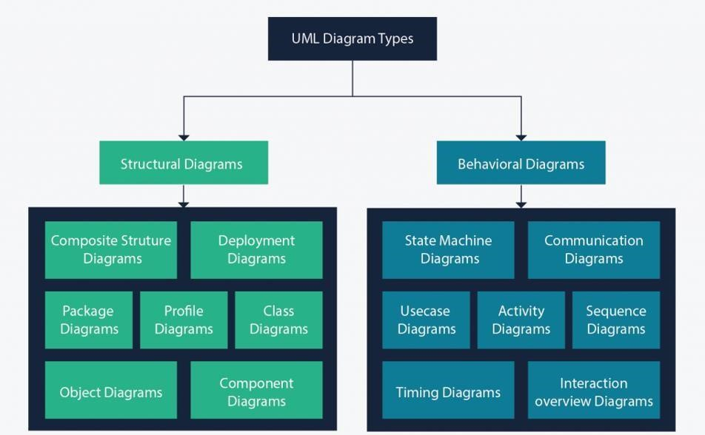

##### Figure 4 : UML 2.5 diagrams overview

**(source: https://creately.com/blog/diagrams/uml-diagram-types-examples/)**

It is important to note that uml is a modeling language and not a method or procedure. Hence, to give it an approach, we need to associate UML to a Unified process (UP) in order to give our conception a methodology to follow. A unified process is a generic method for developing software. This implies it is necessary to adapt the UP to the context of the project, team domain and or the organization. We will use the Two Tracks Unified Process (2TUP) throughout our project to implement our solution.

##### Table 12: Differences between UML and MERISE

|  |  |
| --- | --- |
| MERISE | UML |
| It stands for Méthode d'Étude et de Réalisation Informatique pour les Systèmes d'Entreprises | Unified Modeling Language |
| MERISE is a systemic method of analysis and design of information systems. That is, | UML is however not a method but rather an object modeling language to which it is |
| it uses a systems approach. | necessary to associate an approach to make it a method. This is the case with the 2TUP method; RUP and XP. |
| MERISE proposes to consider the real system from two points of view: - A static view (data) - A dynamic view (treatments). That is, with the MERISE method, we have a separate study of the data and the treatments. | UML offers a different approach from that of MERISE in that it combines data and processing. Because with UML, centralizing the data of a type and the associated processing makes it possible to limit the maintenance points in the code and facilitates access to information in the event of software development. In addition, UML describes the dynamics of the information system as a set of operations attached to the objects of the system. |
| Rational | Object |

III. COMPARATIVE STUDY OF UNIFIED PROCESSES

A process can be defined as a partially sequence of steps that permits us to obtain software systems or evolution of an existing one. The main objective of software development is the production of quality software that response to the needs of the users during a particular time and at a particular cost.

a. A Unified Process:

A unified Process is a process of development of software constructed on UML; it is iterative, incremental, centered on architecture, driven by use cases and requirements.

**Iteration** is distinct sequence of activities with a basic plan and evaluation criterion that produces an internal or external output. Either the content of an iteration is improved or the evolution of the system is evaluated by users. **An increment** is the difference between two released products at the end of two iterations. Each iteration that the group is capable of integrating the technical environment in order to develop a final product and give users the possibility of having tangible results.

**Centered on architecture** the different models derived during the establishment of system must be reliable and coherent.

**Driven by use case and requirements** enables the clear definition of a users’ needs and priorities respectively thereby minimizing the risk of project failure.

b. The Two Track Unified Process (2TUP)

2TUP is a unified process which is belt on UML and has as objective to bring solution to constraints of functional and technical changes imposed on information systems by strengthening controls on development capacities. It proposes a Y-sharped development life cycle that separates the functional aspect from the technical aspects, and the merging of these two forms the implementation aspect. 2TUP distinguishes therefore two branches: the functional and technical branches, the combination of the result of these two branches forms the third: the realization branch – where we realize our system. The diagram bellow illustrates the branches of 2TUP.

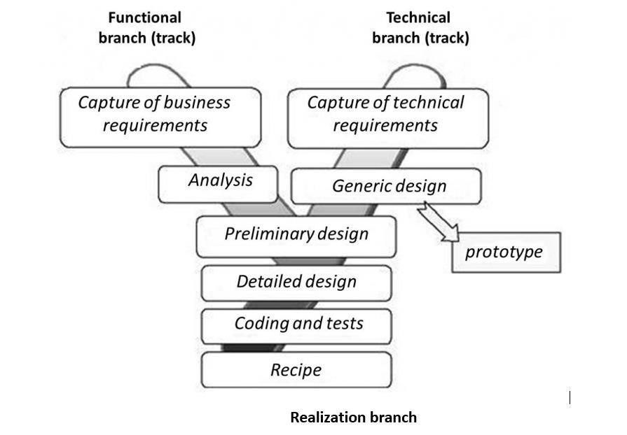

##### Figure 5: 2TUP diagram

**(Source:https://www.mysciencework.com/omniscience/pervasive-mobile-healthcare-system-basedon-cloudcomputing)**

1. The left branch (functional branch)

It captures the functional needs of a system. This ensures the production of software that meets the needs/requirements of the user. The analysis here consists of studying precisely the functional specification in order to obtain an idea of what the system is going to realize and its result does not depend on any technology

1. The right branch (Technical branch)

The technical branch enumerates the technical needs and proposes a generic design validated by a prototype. The technical needs include constraints and choices related to the conception of the system, the tools and equipment as well as the integration constraint with the existing system condition. The different diagrams are shown in the table below.

1. The middle branch (Realization or implementation branch)

In this branch, we study the preliminary conception, detailed conception, and documentation of the system. The realization branch supports the following:

**Preliminary conception:** This is the most sensitive step of 2TUP as it is the confluence of the functional and technical branch. It is completed when the deployment model, the operating model, the logical model, interphases and the software configuration model are defined.

**Detailed conception:** This is the detailed design of each feature of the system.

**Coding and testing:** This are the phase where we program the designed features and test the coded features.

**The recipe:** Also known as the deliverables is the validation phase of the functions of the developed system.