Cut, Copy, Paste, Undo Operations in RichTextBox

RichTextBox class provides Cut, Copy, Paste, and Undo methods to cut, copy, paste, and undo clipboard operations. The following code snippet shows how to use Cut, Copy, Paste, and Undo methods.
- private void cutToolStripMenuItem_Click(object sender, EventArgs e)
- {
- if (RichTextBox1.SelectionLength > 0)
- RichTextBox1.Cut();
- }

- private void copyToolStripMenuItem_Click(object sender, EventArgs e)
- {
- if (RichTextBox1.SelectionLength > 0)
- RichTextBox1.Copy(); іуаіуаіуа
- }

- private void pasteToolStripMenuItem_Click(object sender, EventArgs e)
- {
- if (Clipboard.GetDataObject().GetDataPresent(DataFormats.Text))
- {
- RichTextBox1.Paste();
- }
- }

- private void undoToolStripMenuItem_Click(object sender, EventArgs e)
- {
- if (RichTextBox1.CanUndo)
- {
- RichTextBox1.Undo();
- RichTextBox1.ClearUndo();
- }
- }
Load and Save RTF Files

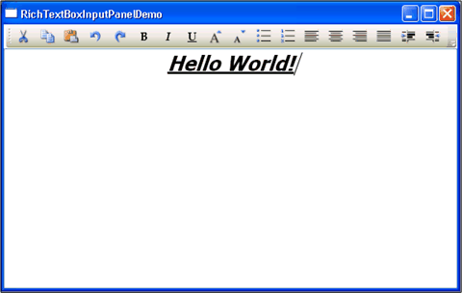
LoadFile method of RichTextBox control is used to load an RTF file and displays its contents. SaveFile method is used to save the contents of a RichTextBox to an RTF file. The following code snippet loads an RTF file using an OpenFileDialog and saves back its contents.
- private void LoadRTFButton_Click(object sender, EventArgs e)
- {
- OpenFileDialog ofd = new OpenFileDialog();
- ofd.InitialDirectory = "c:\\";
- ofd.Filter = "txt files (*.txt)|*.txt|All files (*.*)|*.*";
- ofd.FilterIndex = 2;
- ofd.RestoreDirectory = true;
- if (ofd.ShowDialog() == System.Windows.Forms.DialogResult.OK)
- {
- dynamicRichTextBox.LoadFile(ofd.FileName);
- dynamicRichTextBox.Find("Text", RichTextBoxFinds.MatchCase);
- dynamicRichTextBox.SelectionFont = new Font("Verdana", 12, FontStyle.Bold);
- dynamicRichTextBox.SelectionColor = Color.Red;
- dynamicRichTextBox.SaveFile(@"C:\Junk\SavedRTF.rtf", RichTextBoxStreamType.RichText);
- }
- }
BulletIndent

BulletIndent property gets or sets the indentation used in the RichTextBox control when the bullet style is applied to the text.
dynamicRichTextBox.BulletIndent = 10;

Selection Properties

Here is a list of properties that are applicable on current selected text.
- SelectionAlignment - Alignment of selected text.
- SelectionBackColor - Background color of selected text.
- SelectionBullet - True or false to set if bullets are applied on selected text.
- SelectionCharOffset - Whether text in the control appears on the baseline, as a superscript, or as a subscript below the baseline
- SelectionColor - Color of selected text.
- SelectionFont - Font of selected text.
- SelectionHangingIndent - Distance between the left edge of the first line of text in the selected paragraph and the left edge of subsequent lines in the same paragraph.
- SelectionIndent - Length, in pixels, of the indentation of the line where the selection starts.
- SelectionProtected - Calue indicating whether the current text selection is protected
- SelectionTabs - Absolute tab stop positions.
- SelectionType - Selection type represented by RichTextBoxSelectionType enumeration with values Empty, Text, Object, MultiChar, and MultiObject.

