The Flu and Why It’s Important
Jason Azayev

Sections
What is the flu? 2
Combating Influenza 2
Outbreak of 1918 2
Why is this important? 3
How did New York Fare? 3
Recap of policies enforced 4
Economics of Pandemics 5
Methods By Businesses 5
Who Should Get Vaccinated? 5
Who is Vulnerable Population? 6
Current Policy on Influenza 6
Are these Policies Effective? 7
Proposed Policy 8
Bibliography 9

What is the flu?
Influenza (the flu) is a complicated and very infectious illness, which infects a human's respiratory track. It is more severe then other respiratory illnesses, such as the common cold. The flu can lead to other more serious respiratory tract infections, such as pneumonia. Although the flu comes mostly in seasons, people still get diagnosed year-round. These separate seasons last for different periods of time, and carry a different severity and lethality of the flu.
Combating the flu has been a struggle for many experts and regular people alike. Influenza spreads very quickly, and when an infected person sneezes or coughs, people are at risk of getting infected. Because influenza is a viral infection, it is harder to fight after a person becomes infected. Since it is not a bacterial infection, antibiotics can not target the virus.
There are four types of influenza: A, B, C, and D. Types A and B are the more serious infections as they show symptoms, thus having the ability to lead to a pandemic. Type C does not cause as many symptoms, thus it is not considered able to lead to an epidemic. Type D viruses are not known to affect humans, and reside mostly in cattle.
Type A influenza can be even further broken down into different strains, the two most common sub-types being H1N1 and H3N2. Type A influenza poses the most serious threat for causing an epidemic. Types B, C, and D can also be broken down further, but because they are less likely to cause mass panic, they will not be as covered in this paper.
Influenza is a dangerous disease, and can lead to major pandemics, as it has in the past.

Combating Influenza
There are a few ways to combat influenza. The most effective way of combating influenza is through prevention, which can be accomplished by promoting social awareness and vaccinations. Once influenza is contracted, it is mostly up to the infected person’s immune system to fight it off. Oral medication can be prescribed (Oseltamivir or Zanamivir), but this medication usually acts as a way to slow down the flu. For example, Oseltamivir (Tamiflu) binds to the surface of the virus particle, keeping it from escaping the cell it has infected. This gives your immune system a better chance of fighting the flu.
Because the best method of controlling the flu is preventative, it is important for the government to enforce policies focusing on awareness and vaccinations. When people refuse to take action themselves, the government can also step in to enforce other policies to reduce the risk of the spread of influenza.

Outbreak of 1918
The world has already seen a major outbreak of the flu, simultaneously with “The War to End All Wars”. The flu pandemic of 1918 is considered to be the most severe pandemic in recent history, killing millions of people worldwide. This pandemic claimed more lives then World War I, infecting an estimated 500 million people (approximately 1/3rd of the world’s population) and killing 50 million people. The United States had 675,000 of causalities. There is no consensus on where the virus first originated, but it is known that the virus has spread worldwide during the World War I period.
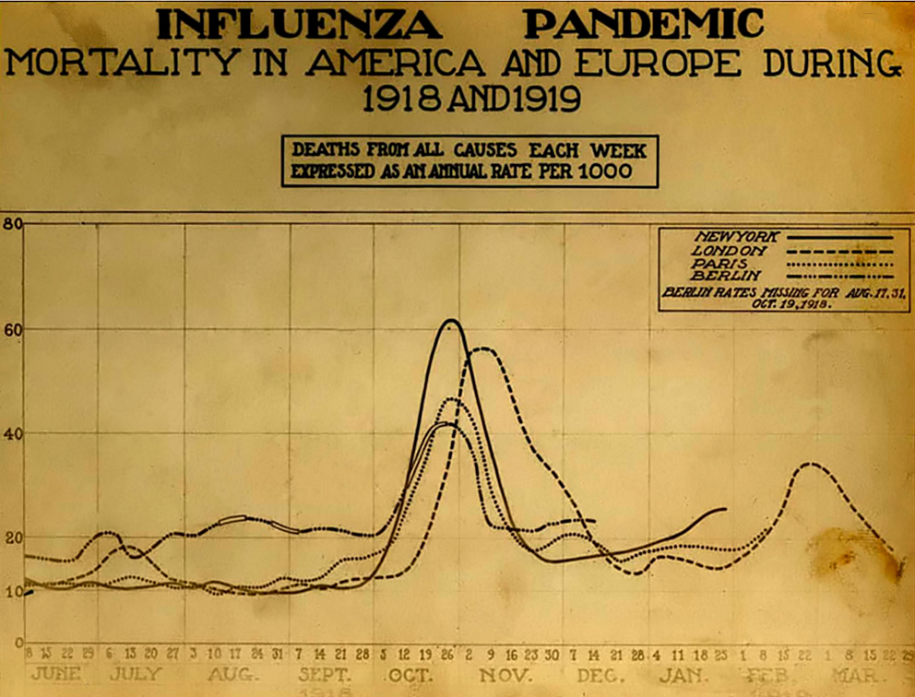
By looking at this graph of mortality rates of several European and American cities (attribution in bibliography), we notice that there is a big spike in deaths during October, 2018. This was the effect of the second wave of influenza, which was the most devastating wave out of the three total waves. The first wave was detected around March, 2018, when deaths started sporadically killing people around Europe, United States and partly Asia. Notice that the wave of influenza hit all cities at nearly the exact same time, save the delay in London.
This was not the only largest outbreak in the 20th century. Two more occurred, in 1957 and 1968.

Why is this important?
The history of any disease is important for understanding that disease, laying the foundation for planning preventative policies. Analyzing past major outbreaks and how they were handled can help us get a glimpse into which policies work and which do not.

How did New York Fare?
Looking at the deaths in America, we see that proportionally, New York was hit the least compared to Boston and Philadelphia. This begs the question, why? There could be plenty of reasons. Some could be due to policy. During this time, there were two major health updates: New York officially recognized the flu as a disease, and businesses were made to stagger their opening and closing times to prevent overcrowding on public transport. However, the lighter hit could also be attributed to New York already fighting disease, even thought it was not the flu. The original culprit was tuberculosis. Because of this fight, New York was better at publicly educating about the disease, quarantining the infected, and deploying the decentralized medical care, which included visiting nurses.
People started hypothesizing how and where the flu came from. Some claimed that the flu was a weapon from the Germany, while others believes that Asprins could be the cause. Because of this, New York started conducting laboratory tests on Aspirin, concluding that they were not the cause of the flu.
Throughout all this, the New York Department of Health had to make important decisions, for instance, whether or not to close down theaters and schools. In the end, these public places were not closed. The reason for this was to avoid mass public panic. Whether this decision was the right choice has been heavily debated.
During this time, there were also additional funds being directed towards fighting the flu. This money was mostly being used to hire nurses and nurses’ aides and sanitary inspectors. These additional funds allowed for the separation of health districts, which had localized care. If flu was detected in a private home, home would be quarantined.
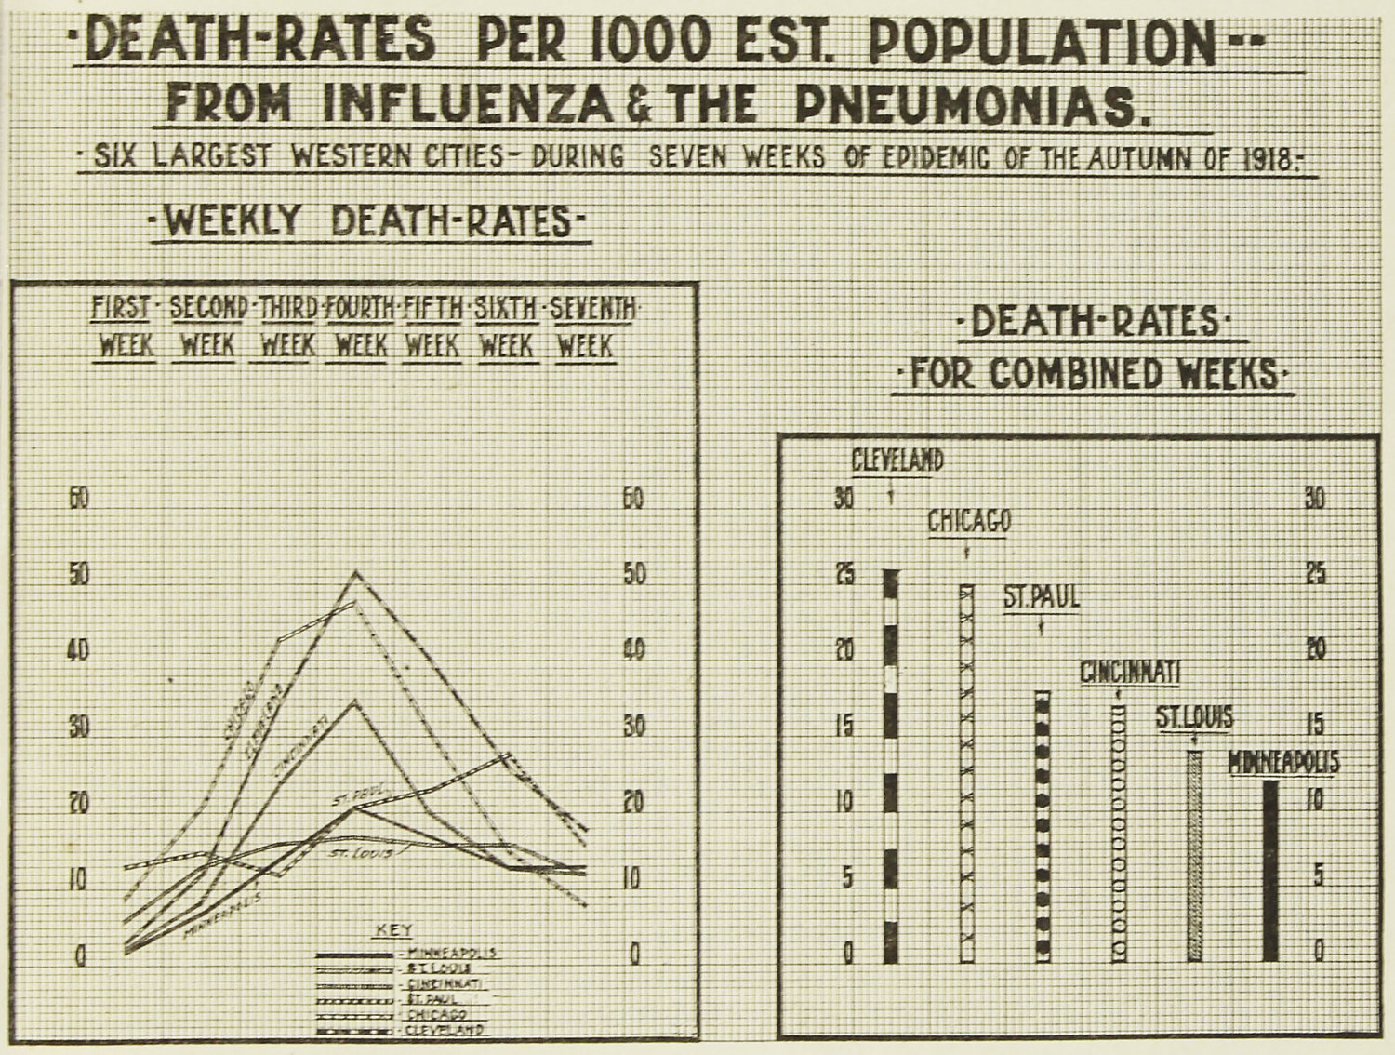
Eventually, on October 4, 1918, the Board of Health declared a flu epidemic, in which it actually executed the staggering of business hours.
In the end, New York trailed behind Chicago and Cincinnati out of the 20 largest cities, having a mortality rate of 3.9 deaths per thousand people.

Recap of policies enforced
1) Recognition of the Influenza virus, better checkpoints and quarantine zones for people traveling between countries.
2) Initial delay of admitting a pandemic, in order to save calamity.
3) Separate areas into health districts, which have localized care and visiting nurses.
4) Quarantine private residences which show symptoms.
5) Stagger business times in urban environments to avoid mass congestion.
All of these policies have one thing in common; they separate people as much as possible without causing a mass panic. All of this also worked under additional funding, which allowed for a larger medical force. Since New York was coming out of another health crisis, it had also created a sufficiently effective medical care system to handle the flu.

Economics of Pandemics
*Any claims made here are followed up in the bibliography
Often, the economics of a pandemic are often overlooked. This is terrible, as not understanding the economics of a pandemic could exacerbate the pandemic even further. Once the economy of a city slows down during a pandemic, the first people to suffer will be those who work but do not have any savings or insurance. Business will slow down as people will try to stay as separated from one another as possible, and the entertainment industry / service sectors will be hit hardest as people will refuse to group. Both of these industries are large in New York, and will leave force a lot of people to rely on their emergency funds during a pandemic for survival, which could lead to starvation and lack of resources to afford proper medication. During a pandemic, vital services may also cease to operate. Couriers have to deliver medicine, and medical professionals need mobility to reach infected people. Banks will scramble to make sure that money keeps circulating, companies might collapse due to their workforce succumbing to a disease*.

Methods By Businesses
Many companies in the United States do not have a plan in place in the case of a pandemic. It doesn’t take much for a business to go under. Companies in Southeast Asia started to realize this, as the avian influenza has been prevalent there for years. In fact, the majority of large businesses have staff dedicated to responding to a mass pandemic of avian flu*. This is in response to past pandemics, when major cities such as Hong Kong were severely hit by the massive slowdown in business.
Some methods have been developed in order to minimize the negative impacts on businesses. One of these is just the complete closing of offices. Other companies strictly monitor the health of their employees and visitors. In Singapore, during the 2003 SARS outbreak, businesses adopted required temperature checks before allowing entrance into buildings. Others abandoned face to face meetings, focusing more on online technologies. Time Warner’s Cable News Network prepared by setting up in different places of the world, such that if one area is quarantined, another will pick up operations.

Who Should Get Vaccinated?
The CDC/ World Health Organization(WHO) conducted a study on the economic impact of a predicted influenza pandemic. They estimated deaths around 89,000 – 207,000; with 314,000-734,000 hospitalizations. About 15% of the population is considered high risk, and would account for 84% of predicted deaths. They estimated that the economic impact would be around $71.3 – $166.5 Billion, EXCLUDING disruptions to commerce and society. The most important find of the study is that vaccinating everyone is not the most economically efficient way, nor possible way to go about preventing the next epidemic. They predict that vaccinating 60% would yield the highest economic returns, although they stress that this itself might not be possible in the time required for the vaccine effectiveness*.

Who is Vulnerable Population?
Among adults, those who are the most vulnerable live in the most crowded housing, and more importantly have a high risk of developing complications, which could lead to hospitalization or death. The flu can also exacerbate any existing chronic conditions. Children (younger then 5), adults (over 65), very obese people, and pregnant women are at an increased risk of developing complications due to influenza.

Current Policy on Influenza
The flu in the 21st century has a complicated history in New York.
October 2009, Richard Daines (Health Commissioner of New York State Department of Health) issues an order, which required all healthcare workers to get the season flu shot or risk termination.
July 2, 2013, DAC: DAC-NH-13-04 required facilities document the vaccination status of all personnel.
December 2013, New York passed a law requiring that all kids between 6 months and 59 months old who attend any public institution must be vaccinated. This law was then litigated against, and repealed, finally being upheld on June 28th , 2018.
November 19, 2014: Required healthcare and residential faculty to be either vaccinated against the flu or wear a surgical mask on prevalent influenza dates.
2017: New York Public Health Law 613 – State Aid Immunization. This law had multiple parts to it.
- It indicated an effort to raise immunity for children
- Provides education about influenza to the family of children between 6 months old and 18 years of age.
- Penalize schools who don’t have a proper number of immunized children
2018: New York provides mandatory paid sick leave by law.
DECEMBER 20, 2018: Announcement of the prevalence of influenza in New York State.
These are just a few of the policies implemented by New York alone.

Are these Policies Effective?
*Most of the analysis done by me is in this repository.
We will be mostly looking at New York City, with the counties KINGS, BRONX, and QUEENS. Here is what that data looks like consecutively in terms of infection rates. ( The Y axis is the infection count).
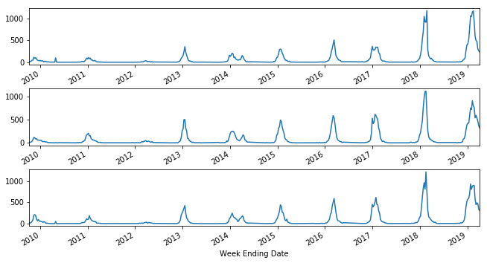
The CDC provides us with data starting from 2010, so we will look at policies from then onward. The first such policy was implemented on July 2, 2013. Let’s zoom into that region.
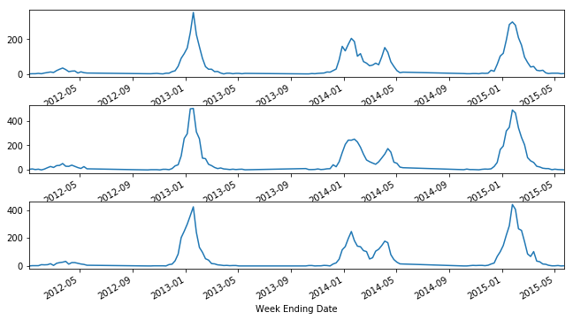
We can see that this policy was implemented after the spike we see at January 2013 and January 2014. In fact, looking at the first graph, we can see that the flu mostly only spikes during the cold seasons. 2014 is different in that the fly lasts longer, but has smaller spikes. This could help explain the next policy passed, which required personnel to wear masks when dealing with patients.

However, as time progresses, we see that the number of influenza cases increase each year. There are also still two waves that we are able to see, but both are very similar in intensity. This could possibly indicate that the policies we currently have in place do not actually reduce influenza cases, as the count seems to only increase after each new policy is passed. The year of 2020 will help provide better information as to whether influenza cases are on the rise, plateau, or to head back down after two exception years.
From a high level look at the data, these policies failed to reduce influenza cases.

Proposed Policy
Prevention seems to be an effect of stricter monitoring of disease. Border patrol should be increase their vigilance over disease, while existing policies on flu awareness should be better enforced.
Overall, the best policies are those that reduce impact. Thus, for New York, the most important issue to be addressed is the MTA. The extent to which people are packed into very confined spaces on public transport creates an environment where viral infections can flourish, thus greatly increasing the chances of pandemics.

Bibliography

Seasonal Incidence of Symptomatic Influenza in the United States.
https://academic.oup.com/cid/article/66/10/1511/4682599

CDC. National Strategy Planning. https://www.cdc.gov/flu/pandemic-resources/planning-preparedness/national-strategy-planning.html

The Flu Epidemic of 1918. Retrieved from http://www.archives.nyc/blog/2018/3/1/the-flu-epidemic-of-1918

(Image: courtesy of the National Museum of Health and Medicine) - Pandemic Influenza: The Inside Story. Nicholls H, PLoS Biology Vol. 4/2/2006, e50 https://dx.doi.org/10.1371/journal.pbio.0040050, Public Domain, https://commons.wikimedia.org/w/index.php?curid=1441889
New York Times. Is Business Ready for a Flu. https://www.nytimes.com/2006/03/16/business/is-business-ready-for-a-flu-pandemic.html
Asian Business Council. Disease Briefing http://www.asiabusinesscouncil.org/docs/DiseaseBriefing.pdf
(n.d.). Centers for Disease Control and Prevention. The Economic Impact of Pandemic Influenza in the United States: Priorities for Intervention - Volume 5, Number 5—October 1999 - Emerging Infectious Diseases journal - CDC. Retrieved from http://wwwnc.cdc.gov/eid/article/5/5/99-0507_article

(n.d.). WHO | World Health Organization. Retrieved from http://www.who.int/influenza_vaccines_plan/resources/ARTICLE_Economic_Impact_of_Pandemic_Influenza_in_the_US.pdf

Liu K, Srinivasan R, Meyers L. (2019). Early Detection of Influenza outbreaks in the United States. ArXiv:1903.01048
Fabricius G, Maltz A. (2019). Preventing exponential spread of infectious diseases with low R0: insights from a spatial epidemic SIR model. arXiv:1901.08103
Wanduku D. (2019). On a family of stochastic SVIR influenza epidemic models and maximum likelihood estimation. ArXiv:1901.05315
Gencolgu O, Ermes M. (2018). Predicting the Flu from Instagram. ArXiv:1811.10949 ~
Held L, Meyer S. (2018). Forecasting Based on on Surveillance Data. ArXiv:1809.03735
Zacherson C, Fair K, Cliff O, Harding N, Piraveenan M, Prokopenko M. (2018). Vulnerability to pandemics in a rapidly urbanizing society. ArXiv:1806.04001 ~
Scarpino S, Scott J, Eggo R, Celments B, Dimitrov N, Meyers L. (2018). Socioeconomic bias in influenza surveillance. arXiv:1804.00327

