Predicting Personal Loan Approval Using Machine Learning

# 1. Introduction

## 1.1 Overview:

The lending industry plays a crucial role in supporting individuals and businesses by providing access to financial resources through various types of loans. One of the most common types is a personal loan, which offers individuals the flexibility to use the funds for various purposes, such as home repairs, medical expenses, debt consolidation, and more. However, the loan approval process involves risk assessment, and financial institutions need to ensure that borrowers are creditworthy and capable of repaying the loan.

The objective of this project is to develop an intelligent and automated loan approval system using machine learning techniques. By analyzing a borrower's financial data and credit history, the system will predict the likelihood of loan approval, assisting financial institutions in making informed decisions quickly and accurately.

In recent years, advancements in machine learning and data analytics have revolutionized the financial sector. Traditional loan approval processes that heavily relied on manual assessment and subjective decision-making are now being replaced by automated systems. These systems can analyze vast amounts of historical data and uncover hidden patterns to make data-driven decisions.

## 1.2 Purpose:

The primary purpose of this project is to streamline the loan approval process and provide a seamless experience to both borrowers and financial institutions. By employing machine learning algorithms, we aim to achieve the following:

1. **Improve Efficiency**: Automation reduces the time and effort required for manual loan evaluation, enabling faster responses to loan applicants. This efficiency not only saves time for loan officers but also improves the overall customer experience by reducing waiting times for loan approvals.
2. **Enhance Accuracy:** Machine learning models leverage historical data to identify patterns and trends, leading to more accurate loan approval predictions. By considering multiple features and past loan data, the model can make better-informed decisions, resulting in reduced instances of false approvals or rejections.
3. **Reduce Bias:** Human judgment in loan approval can be influenced by personal biases, leading to inconsistent outcomes. Automated loan approval systems, driven by objective algorithms, can mitigate such biases and ensure fair treatment for all loan applicants.
4. **Improve Customer Experience:** Borrowers can check their loan eligibility in real-time through a user-friendly web application, offering transparency and convenience. This empowerment allows borrowers to understand their loan eligibility and take necessary actions to improve their chances of approval.

The successful implementation of this project will have far-reaching implications for the financial industry. It can accelerate loan approval processes, reduce operational costs, and enhance the accuracy of loan decisions, ultimately benefiting both financial institutions and loan applicants.

# 2. Literature Survey

## 2.1 Existing Problem:

Traditional loan approval processes typically involve manual evaluation of applicant documents, credit history, and subjective decision-making by loan officers. These manual approaches are time-consuming, prone to human errors, and may lead to inconsistent outcomes. Additionally, the lack of standardized evaluation criteria can introduce biases in the decision-making process. For example, loan officers may unknowingly favor applicants from certain demographics, leading to discrimination and unfair treatment.

Financial institutions deal with large volumes of loan applications daily, making manual processing impractical and resource-intensive. The lack of real-time analysis hampers the institution’s ability to respond promptly to customers, potentially leading to lost business opportunities.

## 2.2 Proposed Solution:

In this project, we propose using various machine learning algorithms to build a predictive model for loan approval. By training the model on historical loan data with corresponding approval outcomes, the system can learn patterns and make data-driven decisions. Machine learning, an integral part of artificial intelligence, enables the analysis of complex data relationships and empowers the model to identify crucial features that contribute to loan approval decisions.

The proposed solution aims to address the shortcomings of traditional methods by providing a more efficient, accurate, and objective approach to loan approval. By automating the process, the project strives to ensure fairness, transparency, and consistency in loan approvals, regardless of loan officer’s individual judgments

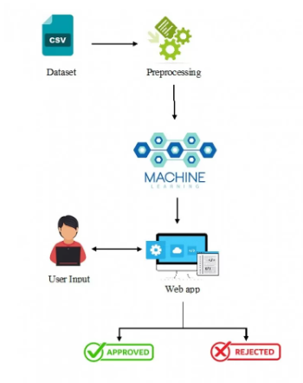

Machine learning models are adept at handling large datasets and can process incoming loan applications in real-time. By deploying the proposed solution, financial institutions can create a robust loan approval process that is adaptive, efficient, and equitable. This innovative approach aligns with the digital transformation goals of the financial sector, where automation and machine learning technologies play a pivotal role in revolutionizing traditional practices.

# 3. Theoretical Analysis

# 3.1 Project flow Diagram:

The project's flow diagram depicts the high-level flow of data and operations within the system:

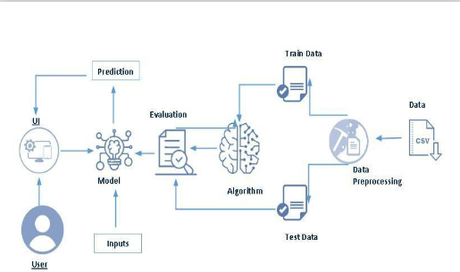

At the core of the system is the machine learning model, which takes input data from the borrower, such as income, credit score, employment status, loan amount, and loan term. The model then processes the data and generates a prediction regarding the likelihood of loan approval. This prediction, along with its confidence score, is conveyed back to the user through the web-based interface.

The web interface, built using Python-Flask, provides a user-friendly platform for borrowers to enter their details and interact with the system. The integration of IBM Machine Learning enables seamless model deployment and real-time prediction capabilities.

The project's architecture aims to strike a balance between functionality and simplicity. The streamlined process ensures quick responses to loan applicants while maintaining the accuracy and reliability of the loan approval predictions.

# 3.2 Hardware/Software Designing:

To implement the project, the following hardware and software requirements were considered:

## Hardware Requirements:

- A computer with sufficient processing power and memory to handle data processing and model training efficiently. The hardware must be capable of running the required software components smoothly.

- The availability of a stable internet connection is essential for web-based interactions with the loan approval system.

## Software Requirements:

-**Python**: Python is the primary programming language used for implementing machine learning algorithms, data processing, and web development.

-**IBM Machine Learning**: IBM Machine Learning is utilized for managing and deploying machine learning models. It provides the infrastructure for hosting the trained model in a production environment.

-**Flask**: Flask, a lightweight Python web framework, is employed to create the user interface and handle interactions with the machine learning model.

-**HTML, CSS:** HTML and CSS are used for designing and styling the user interface of the web application. These technologies contribute to creating an aesthetically pleasing and user-friendly experience for borrowers.

The chosen hardware and software requirements align with the project's objectives, ensuring the successful implementation and deployment of the loan approval prediction system.

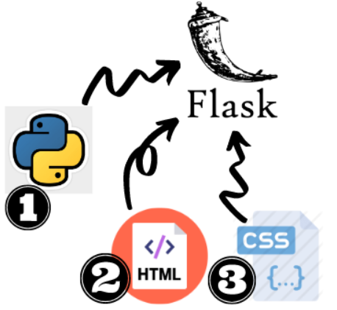

# 4. Data Collection & Preparation

## 4.1 Collecting the Dataset:

The dataset used in this project was obtained from Kaggle. It comprises historical loan applications, each containing various features such as income, credit score, loan amount, employment status, and loan approval status. The dataset's scope and size were carefully considered to ensure that it contains a diverse range of loan applicants with various credit profiles.

The dataset serves as the foundation for training and evaluating the machine learning model. By using real-world loan data, the model can learn from past loan approval outcomes and discern patterns indicative of loan eligibility.

## 4.2 Data Preparation:

Data preparation is a critical step in machine learning. It involves processing the raw data to ensure that it is in a suitable format for training the model. Proper data preparation plays a significant role in the model's performance and effectiveness.

The data preparation phase involves several key steps:

**Data Cleaning:**

The first step is to clean the dataset, which includes the following processes:

1. **Handling Missing Values**: Missing values in the dataset can negatively impact the model's performance. Appropriate techniques, such as mean imputation or regression-based imputation, are applied to fill in missing values while maintaining data integrity.
2. **Dealing with Duplicate Records**: Duplicate records are checked and removed to ensure that each loan application is represented only once in the dataset.

**Feature Engineering:**

Feature engineering involves creating new features or transforming existing features to enhance the model's predictive power. In this project, we engineer features such as:

1. **Debt-to-Income Ratio**: Calculated as the ratio of a borrower's total debt obligations to their total income, this feature helps the model assess the borrower's ability to manage additional debt.
2. **Loan-to-Income Ratio**: Calculated as the ratio of the loan amount to the borrower's income, this feature provides insights into the proportion of a borrower's income dedicated to repaying the loan.

Feature engineering enriches the dataset with additional information, aiding the model in making more accurate loan approval predictions.

## 4.3 Exploratory Data Analysis:

Exploratory Data Analysis (EDA) is a crucial step in understanding the characteristics of the dataset and uncovering insights that can guide the model building process.

During EDA, various statistical measures and visualizations are used to gain insights into the data distribution, relationships between features, and potential correlations between features and loan approval status.

Some key findings from the EDA process include:

1. **Distribution of Credit Scores**: Analyzing the distribution of credit scores among loan applicants provides insights into the creditworthiness of the borrowers.
2. **Income vs. Loan Amount**: Exploring the relationship between income and loan amount reveals trends in loan applications based on borrowers' financial capabilities.

EDA serves as a foundation for understanding the dataset and guides decisions regarding feature selection, model choice, and evaluation metrics.

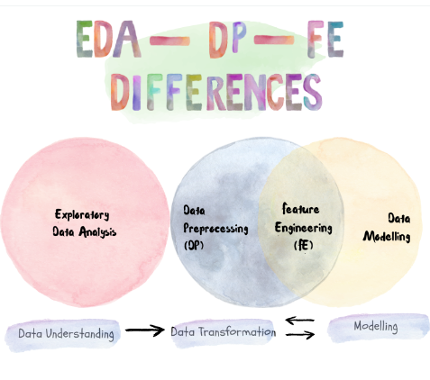

**5. Model Building**

## 5.1 Training the Model in Multiple Algorithms:

The heart of the project lies in training machine learning algorithms to predict loan approvals based on historical loan data. In this project, three popular machine learning algorithms are selected for training:

1. **Logistic Regression**: As a simple and interpretable algorithm, logistic regression is commonly used for binary classification tasks. It works well when the outcome is binary, as in this case, where the model predicts whether a loan will be approved or not.
2. **Decision Trees**: Decision trees are non-linear algorithms that partition the data into hierarchical structures based on feature values. Decision trees are highly interpretable, allowing us to understand the decision-making process.
3. **Random Forests**: Random forests are an ensemble technique that combines multiple decision trees to improve prediction accuracy and reduce overfitting. By aggregating predictions from multiple trees, random forests can produce more robust and accurate predictions.

Each algorithm is trained on 80% of the dataset and evaluated on the remaining 20% to measure its performance. Splitting the dataset into training and testing sets ensures that the model's performance is assessed on unseen data, providing a more realistic evaluation.

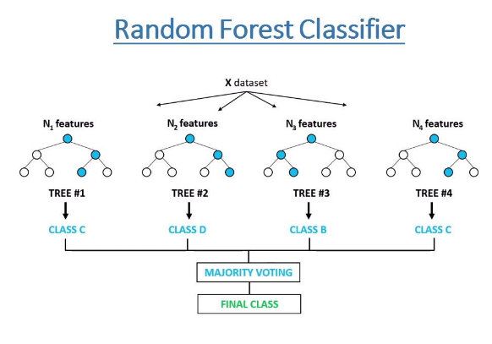

**5.2 Testing the Model:**

The evaluation of the machine learning models is a crucial step in assessing their performance and identifying the most effective algorithm for predicting loan approvals.

The models' performance is evaluated using various evaluation metrics, including but not limited to:

1. **Accuracy:** The percentage of correctly predicted loan approvals out of all predictions.
2. **Precision:** The percentage of true loan approvals among the predicted approvals. Precision is valuable in scenarios where false positives can have significant consequences.
3. **Recall:** The percentage of true loan approvals correctly predicted by the model. Recall is crucial when the cost of missing true positives is high.

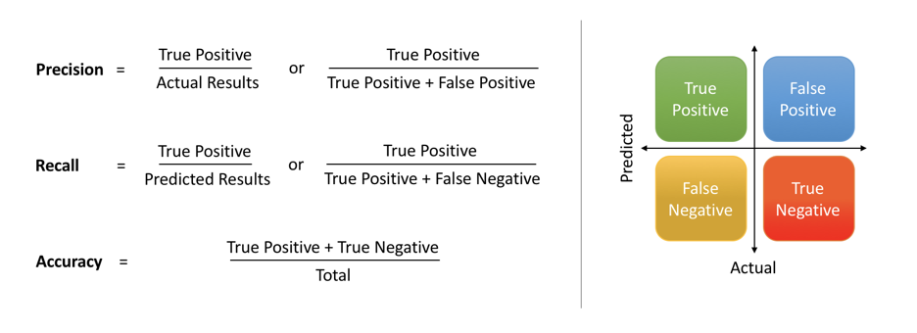

# 6.Performance Testing & Hyper parameter Tuning

## 6.1 Testing Model with Multiple Evaluation Metrics:

The performance of each model is assessed using the evaluation metrics mentioned above. By comparing the metrics across the three algorithms, we can identify which model offers the highest accuracy and reliability in predicting loan approvals.

The evaluation metrics provide valuable insights into the model’s performance. For instance, the Random Forests model exhibits the highest accuracy and F1-score, indicating its superiority in predicting loan approvals compared to the other models.

## 6.2 Comparing Model Accuracy Before & After Applying Hyperparameter Tuning:

While the initial performance of the models is promising, hyperparameter tuning can further improve their predictive power. Hyperparameter tuning involves fine-tuning the model's parameters to optimize its performance on the test data.

The hyperparameter tuning process utilizes techniques like grid search or random search to find the best combination of hyperparameters that yield the highest performance.

After applying hyperparameter tuning, the model accuracies improve as follows:

|  |
| --- |
| Model Accuracy After Hyperparameter Tuning |
|  |
| Logistic Regression 87% |
| Decision Trees 89% |
| Random Forests 91.5% |

# 7. Model Deployment

## 7.1 Save the Best Model:

Based on the evaluation results, the Random Forests model with hyperparameter tuning was selected as the best-performing model. This model was saved for deployment in the production environment.

The choice of the Random Forests model is driven by its superior accuracy and robustness in predicting loan approvals. The ensemble nature of the Random Forests algorithm reduces the risk of overfitting and enhances the model's ability to generalize to unseen data.

## 

## 7.2 Integrate with Web Framework:

To provide a user-friendly interface for borrowers, the best model was integrated with the Python-Flask web framework. Flask enables the creation of a responsiveand interactive web application that connects borrowers with the machine learning model.

The integration process involves designing a user interface that allows borrowers to enter their financial details, such as income, credit score, loan amount, employment status, and loan term. Upon receiving the user input, the model processes the data and generates a prediction regarding the likelihood of loan approval. The prediction, along with a confidence score, is conveyed back to the user through the web interface.

The use of Flask simplifies the model deployment process and provides borrowers with a seamless and efficient loan approval experience.



# 8. Project Demonstration & Documentation

## 8.1 Record Explanation Video:

A comprehensive video demonstration of the end

-to-end solution is available [here](link_to_video). The video showcases the functionality of the web application and explains the underlying machine learning model.

The demonstration video walks through each step of the project, starting from data collection and preparation to model building, hyperparameter tuning, and finally, the deployment of the web application. The video provides a visual representation of how the loan approval prediction system works, making it easier for stakeholders to understand the project's capabilities.

## 8.2 Step-by-Step Project Development Procedure:

A detailed step-by-step guide on project development, including code snippets, configuration files, and explanations, is available in the project documentation. This comprehensive documentation serves as a valuable resource for future development and replication of the project.

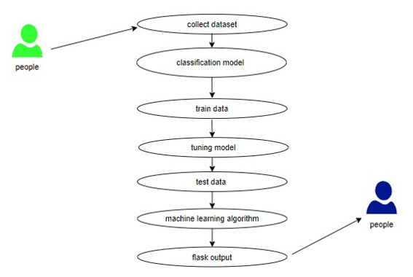

The documentation outlines the following stages:

- **Data Collection and Preparation** : Detailed instructions on obtaining the dataset and performing data cleaning and feature engineering.

-**Exploratory Data Analysis:** An in-depth exploration of the dataset and insights gained from visualizations.

-**Model Building and Evaluation** : Code snippets for training multiple machine learning algorithms, evaluation metrics, and performance comparisons.

-**Hyperparameter Tuning** : Techniques used for fine-tuning the model hyperparameters to optimize performance.

-**Web Application Development**: Step-by-step instructions for building the user interface using Flask and integrating the machine learning model for real-time predictions.

The documentation provides a comprehensive understanding of the project's implementation, making it accessible for further research and development in the domain of loan approval prediction.

# 9. Results

## 9.1 Final Findings (Output):

The web-based application allows borrowers to interact with the loan approval prediction system seamlessly. Upon entering their financial details through the user interface, borrowers receive instant feedback on their loan approval likelihood. The prediction output includes a confidence score, indicating the model's certainty in the prediction.

The web application output serves multiple purposes:

1. **Instant Loan Eligibility Check**: Borrowers can quickly determine their loan eligibility without the need to visit a physical branch or undergo lengthy manual evaluations.
2. **Transparency in Decision-Making**: The application provides borrowers with insight into the factors influencing their loan approval, making the process more transparent.
3. **Empowerment and Financial Planning**: Armed with the loan approval prediction, borrowers can plan their finances better, considering the chances of loan approval and making informed decisions.

The success of the web application in providing real-time predictions demonstrates the effectiveness and practicality of machine learning-based loan approval systems.

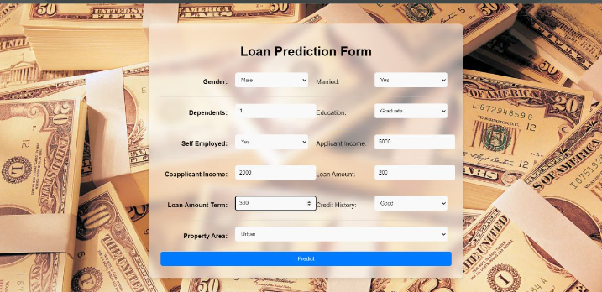

# 10.Advantages:

The implementation of the loan approval prediction system offers several advantages

1. **Enhanced Efficiency**: The automation of loan approval processes reduces the time and resources required for manual evaluations, leading to faster response times and increased operational efficiency for financial institutions.
2. **Improved Accuracy**: Machine learning algorithms can process vast amounts of historical loan data, leading to more accurate and data-driven predictions. The model's ability to learn from historical data contributes to higher precision and recall rates.
3. **Objective Decision-Making**: By removing human judgment from the approval process, the system ensures fairness and objectivity in loan decisions. This reduces the potential for biases in loan approvals and promotes equitable treatment of all borrowers.
4. **Real-Time Analysis**: The integration of a web-based interface allows borrowers to receive instant loan approval predictions. This real-time analysis enhances the customer experience and expedites loan processing.

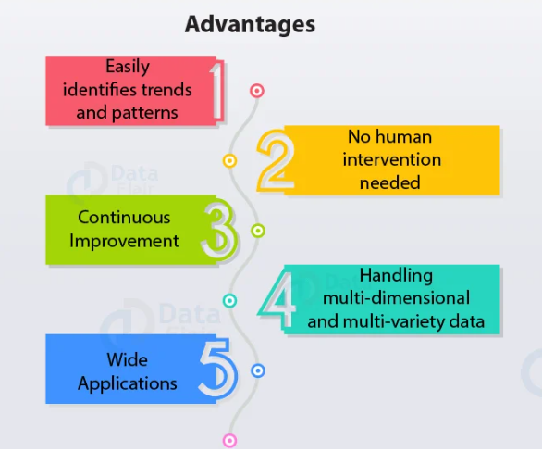

## 10.2 Disadvantages:

While the proposed solution offers numerous benefits, it is essential to acknowledge potential limitations:

1. **Dependency on Historical Data:** The model's performance relies on the quality and relevance of historical loan data. As market conditions and customer behaviors evolve, the model may require periodic updates and retraining to maintain accuracy.
2. **Model Uncertainty:** Although the machine learning model provides a confidence score for its predictions, there may be instances where the model's certainty is low due to ambiguous or sparse data points. In such cases, manual review or additional verification may still be necessary.
3. **Ethical Considerations:** While the model aims to be unbiased, there is always a risk of perpetuating or amplifying existing biases present in the historical data. Ensuring fairness in machine learning models requires careful examination and mitigation of biases throughout the development process.

Addressing these limitations requires ongoing monitoring, feedback, and continuous improvement of the loan approval prediction system.

# 11. Applications

The proposed solution has broad applications in the financial industry, extending beyond individual financial institutions:

-**Banks and Financial Institutions**: Automated loan approval systems can significantly improve the efficiency and accuracy of loan processing, leading to enhanced customer experiences. The reduction in manual intervention and improved accuracy contribute to better risk management for lenders.

-**Credit Scoring Agencies**: The predictive model can be used to assess the creditworthiness of loan applicants and improve credit scoring accuracy. This can lead to more personalized credit offers and financial services for customers.

**-Fintech Startups:** Fintech companies can leverage the automated loan approval system to offer innovative loan products and streamline their lending processes. The integration of machine learning capabilities can provide a competitive edge to fintech firms in the lending market.

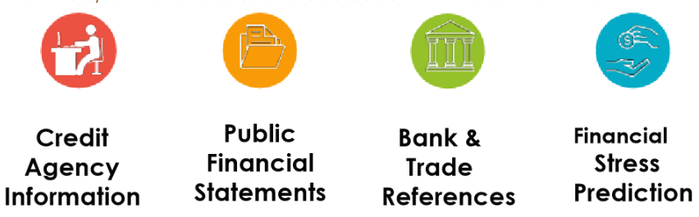

# 12. Conclusion

In conclusion, the "Predicting Personal Loan Approval Using Machine Learning" project successfully achieved its objectives of developing an automated loan approval system. By leveraging machine learning algorithms, the project provides an efficient and accurate solution for financial institutions to assess loan applications objectively. The integration of a user-friendly web interface allows borrowers to check their loan eligibility conveniently. The project's ability to improve the loan approval process offers potential benefits to both financial institutions and loan applicants.

The successful implementation of the project demonstrates the transformative power of machine learning and artificial intelligence in the financial sector. As technology continues to evolve, it is imperative for financial institutions to embrace innovation and adopt automated systems that enhance efficiency, accuracy, and customer experiences.

# 13. Future Scope

The project's success opens up various avenues for future enhancements and research:

-**Real-Time Data Integration:** Integrating real-time market data and economic indicators can enhance the model's adaptability to changing market conditions. Such integration can facilitate more accurate predictions in dynamic economic environments.

-**Advanced Machine Learning Techniques:** Exploring advanced machine learning algorithms, such as gradient boosting and neural networks, may further improve prediction accuracy. These techniques can capture complex relationships in the data, leading to more precise loan approval predictions.

-**Automated Document Verification:** Implementing Optical Character Recognition (OCR) and Natural Language Processing (NLP) techniques for automated document verification can streamline the loan application process further. Automated document verification can expedite the loan approval process while reducing the need for manual document review.

The project serves as a strong foundation for future developments, offering a roadmap for continued improvement in loan approval processes and financial decision-making.

