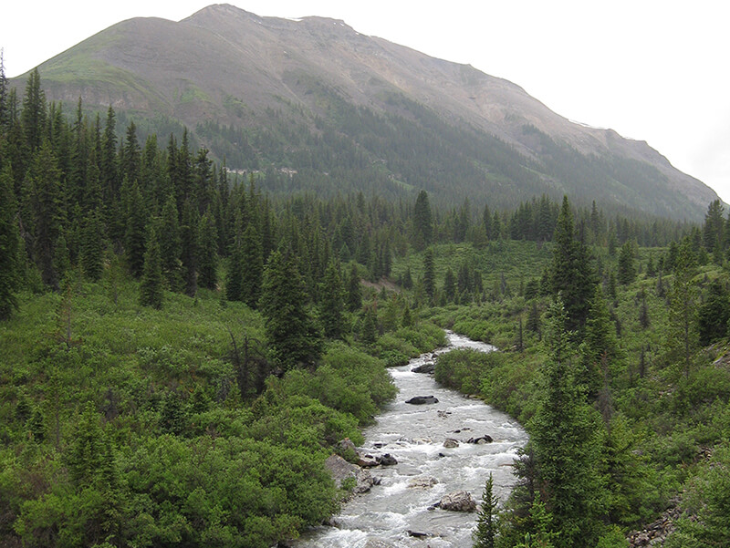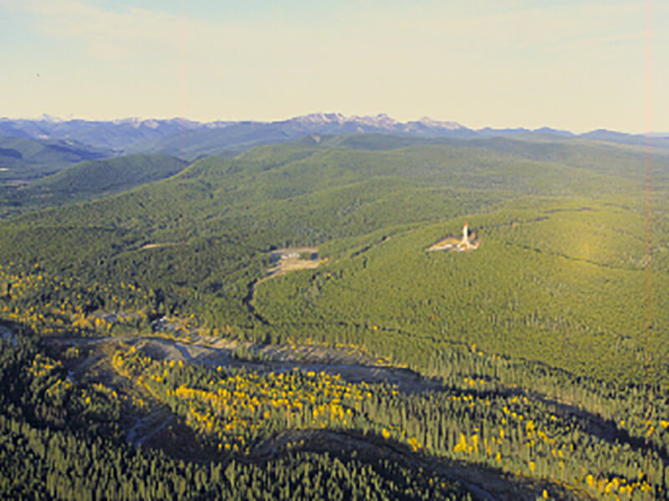****About the Authors

Exploring Natural Range of Variation in the Western Boreal Forest

Final Report

fRI Research Your Program Name

September 13, 2018

Alex M. Chubaty, Eliot J. B. McIntire, David Andison

**USER MANUAL**

Prepared for

Your Funding Partner | Your Other Funding Partner | Use if Appropriate

LandWeb v1.01

fRI Research is a unique community of Partners joined by a common concern for the welfare of the land, its resources, and the people who value and use them. fRI Research connects managers and researchers to effectively collaborate in achieving our vision and mission.

Learn more at fRIresearch.ca

This is the boilerplate text for your program.

Learn more at URL.fRIresearch.ca

Prepared by

David Andison, Healthy Landscapes Program Lead, fRI Research

Alex M. Chubaty, Healthy Landscapes Program, fRI Research

Eliot J. B. McIntire, Canadian Forest Service

Disclaimer

Any opinions expressed in this report are those of the authors, and do not necessarily reflect those of the organizations for which they work, or fRI Research.

September 13, 2018

About Our Partners

[partner logo in best resolution you can find]

Partner description goes here. Usually just copy/paste from the About Us section on their website. If they don’t have any boilerplate, you might have to get a bit creative. Usually it will be about 4 lines long, but that’s flexible.

Learn more at partnerwebsite.ca

Partner description goes here. Usually just copy/past from the About Us section on their website. If they don’t have any boilerplate, you might have to get a bit creative. Usually it will be about 4 lines long, but that’s flexible.

[partner logo in best resolution you can find]

Learn more at partnerwebsite.com

Report Summary

I will here give a brief sketch of the progress of opinion on the Origin of Species. Until recently the great majority of naturalists believed that species were immutable productions, and had been separately created. This view has been ably maintained by many authors. Some few naturalists, on the other hand, have believed that species undergo modification, and that the existing forms of life are the descendants by true generation of pre existing forms. Passing over allusions to the subject in the classical writers (Aristotle, in his "Physicae Auscultationes" (lib.2, cap.8, s.2), after remarking that rain does not fall in order to make the corn grow, any more than it falls to spoil the farmer's corn when threshed out of doors, applies the same argument to organisation; and adds (as translated by Mr. Clair Grece, who first pointed out the passage to me), "So what hinders the different parts (of the body) from having this merely accidental relation in nature? as the teeth, for example, grow by necessity, the front ones sharp, adapted for dividing, and the grinders flat, and serviceable for masticating the food; since they were not made for the sake of this, but it was the result of accident. And in like manner as to other parts in which there appears to exist an adaptation to an end. Wheresoever, therefore, all things together (that is all the parts of one whole) happened like as if they were made for the sake of something, these were preserved, having been appropriately constituted by an internal spontaneity; and whatsoever things were not thus constituted, perished and still perish." We here see the principle of natural selection shadowed forth, but how little Aristotle fully comprehended the principle, is shown by his remarks on the formation of the teeth.), the first author who in modern times has treated it in a scientific spirit was Buffon. But as his opinions fluctuated greatly at different periods, and as he does not enter on the causes or means of the transformation of species, I need not here enter on details.

Acknowledgements

Lamarck was the first man whose conclusions on the subject excited much attention. This justly celebrated naturalist first published his views in 1801; he much enlarged them in 1809 in his "Philosophie Zoologique", and subsequently, 1815, in the Introduction to his "Hist. Nat. des Animaux sans Vertebres". In these works he up holds the doctrine that all species, including man, are descended from other species. He first did the eminent service of arousing attention to the probability of all change in the organic, as well as in the inorganic world, being the result of law, and not of miraculous interposition.

Table of Contents

About the Authors i

Disclaimer ii

About Our Partners iii

Report Summary iv

Acknowledgements iv

1. Introduction 8

1.1 App Availability 8

1.2 About 8

1.3 Privacy Statement 8

1.4 Terms of Service 8

2 Using the LandWeb App 8

2.1 Time Since Fire Maps 9

2.1.1 Time since fire map 9

2.1.2 Time since fire histogram 9

2.1.3 Slider 10

2.1.4 Polygon Selection 10

2.1.5 Notification Menu 10

2.1.6 Uploading a Custom Spatial Polygon 10

2.2 Large Patches Histograms 12

2.3 Vegetation Cover Histograms 13

2.4 Vegetation Cover Boxplots 14

2.5 Log in Using Your Google Account 15

3 Model Inputs 15

3.1 Public Data Sources 15

3.2 Proprietary Data 16

4 Model Outputs 17

4.1 Downloading Outputs 17

4.2.1 Currently Selected Spatial Area 17

4.2.2 Large Patches Data for Study Region 18

4.2.3 Leading Vegetation Cover Data for Study Region 18

4.2.4 Simulation Rasters (Cropped to Study Region) 18

4.2.5 Additional R Data Files (For Advanced Users) 18

5 Getting Help 18

Literature Cited 18

Appendix A: Module Details 19

Table of Figures

Figure 1. Time since fire map. 10

Figure 2. Time since fire maps (authorized users only). 12

Figure 3. Large patches histograms. 13

Figure 4. Vegetation cover histograms. 14

Figure 5. Vegetation cover boxplots. 15

Figure 6. Google authentication screen. 16

Table of Tables

**No table of figures entries found.**

1. Introduction

1.1 App Availability

The LandWeb app is available from <http://landweb.ca>.

1.2 About

The LandWeb model integrates two well-used models for forest stand succession and fire simulation, implemented in the SpaDES simulation platform (Chubaty & McIntire, 2018). Vegetation dynamics are modeled using an implementation of the LANDIS-II Biomass Succession model (Scheller & Mladenoff, 2004; Scheller *et al.*, 2007). Fire dynamics are modeled using an implementation of LandMine (Andison, 1996).

Simulations were run for the entire LandWeb study area, which spans most of the western Canadian boreal forest. Input data were derived from several publicly available remote-sensed datasets (Beaudoin *et al.*, 2014), as well as proprietary data compiled by Pickell *et al.*.

Simulation outputs consist of maps showing the time since fire as well as histogram summaries of 1) number of large patches (*i.e.*, patches above the number of hectares specified by the user) contained within the selected spatial area; and 2) the vegetation cover within the selected spatial area. Histograms are provided for each spatial area by polygon, age class, and species. Authorized users can additionally overlay current stand conditions onto these histograms. Simulation outputs are summarized for several publicly available reporting polygons (including national ecozones, and ecodistricts) as well as several proprietary spatial areas (authorized users only). Authorized users can additionally upload their own reporting polygons on which to summarize model results.

1.3 Privacy Statement

See <https://friresearch.ca/content/friresearchca-privacy-policy>.

1.4 Terms of Service

Before using the app you will be presented with the Terms of Service, which you must accept before proceeding.

The terms of service can be accessed at any time by selecting "Terms of Service" from the left-side menu.

2 Using the LandWeb App

Visit <http://landweb.ca> to get started. Select pages from the menu on the left-side navigation menu.

* Login using your Google account to access additional features.
* **App Information:** additional information about the app and model.
* **NRV:** view model results.
* **Model Details:** detailed information regarding the model structure and its implementation in SpaDES.

2.1 Time Since Fire Maps

This page shows four major components, highlighted in Fig. 1 and described below.

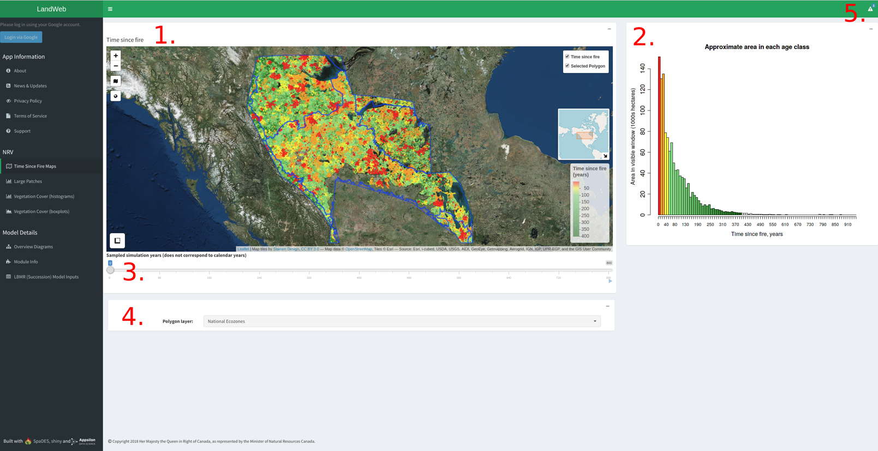

Figure 1. Time since fire map.

2.1.1 Time since fire map

This map shows the time since fire at the time of the simulation indicated by the slider (see #3 below), for the spatial area indicated by the selected polygon (see 2.1.4 below). Warmer colours (reds, oranges) indicate the most recent fire events, whereas cooler colours (greens) indicate more time since fire. The total area corresponding to time since fire (in years) is shown in the time since fire histogram (see 2.1.2 below).

As you zoom in/out of the map, the time since fire histogram will update based on the area that is currently visible on the map.

Clicking on different sections of the map will open a popup showing the stats for the area clicked-on.

2.1.2 Time since fire histogram

This figure shows the total area corresponding to each "age class" (*i.e.*, time since fire). Warmer colours (reds, oranges) indicate the most recent fire events, whereas cooler colours (greens) indicate more time since fire.

As you zoom in/out of the map, the time since fire histogram will update based on the area that is currently visible on the map.

2.1.3 Slider

Use this slider to move forward and backward through time in the simulation. By default, the first map shown corresponds to the beginning of the simulation, with each increment in the slider bar corresponding to 20 years. To see the results after 1500 years, move the slider to the far right position.

*NOTE: the map and histogram on this page may take a moment to reload after moving the slider position.*

2.1.4 Polygon Selection

Use this dropdown selector to change the polygon highlighted on the map and used to summarize results on the "Large Patches" and "Vegetation Cover" pages.

Changing the polygon also updates the histograms displayed on the "Large Patches" and "Vegetation Cover" pages (see below).

*NOTE: the map and histogram on this page may take a few moments to reload after changing polygons.*

Authorized (logged in) users will have access to additional reporting polygons, and can upload their own using the polygon uploader (Fig. 2).

2.1.5 Notification Menu

Shows system notifications such as upcoming scheduled maintenance.

2.1.6 Uploading a Custom Spatial Polygon

Use the "Upload" button to open a file selector that will allow you to upload a custom polygon from your computer (labelled B in Fig. 2). The uploaded polygon can be either a *.zip* file containing the *.shp* and auxiliary files, or the *.shp* (and auxiliary) file themselves.

*NOTE: to select multiple files, hold down the* Ctrl *key during file selection.*

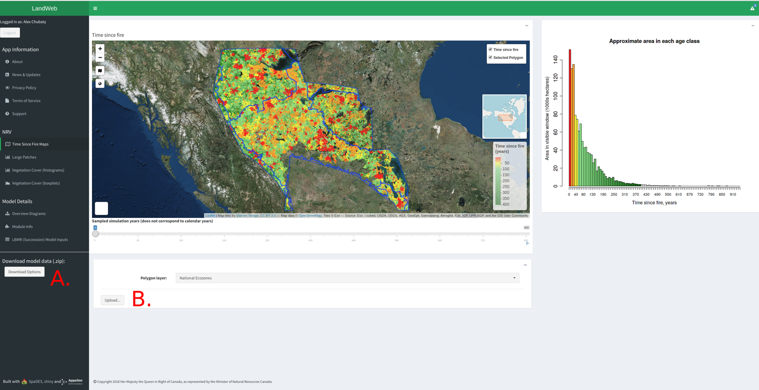

Figure 2. Time since fire maps (authorized users only).

2.2 Large Patches Histograms

These figures (see Fig. 3) show the NRV of the probability distribution of patches that are larger than the area (in hectares) selected, for each given combination of Age Class, Leading Vegetation, and Polygon. Use the tabs on this page to examine each combination of these variables. Age classes are as follows: Young (<40 yrs), Immature (40-80 yrs), Mature (80-120 yrs), Old (>120 yrs).

Authorized (logged in) users will see a red line added to each of these figures, which indicates the current landscape conditions.

To change the patch size that defines these, enter a new value in the box on this page.

*NOTE: the histograms on this page will take some time to load following a change in the patch size, or when selecting a different polygon from the "Time Since Fire Maps" page.*

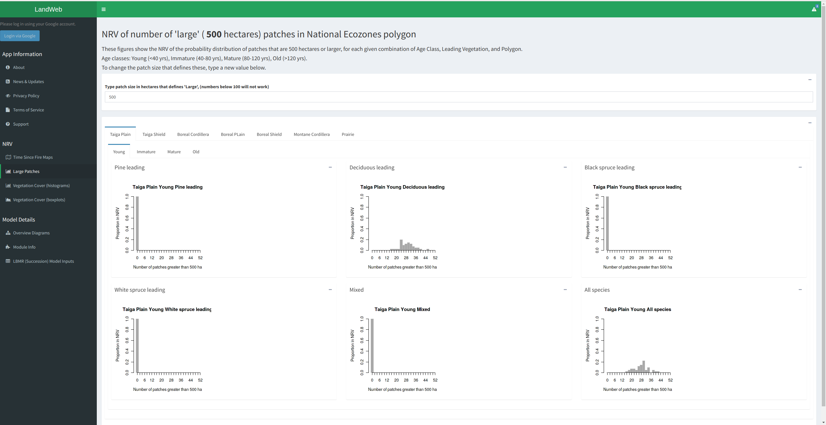

Figure 3. Large patches histograms.

2.3 Vegetation Cover Histograms

These figures (see Fig. 4) show the NRV of the proportion of forests for each age class, in each polygon, that are in each leading vegetation type. Use the tabs on this page to examine each combination of these variables. The proportions are proportions within age class: Young (<40 yrs), Immature (40-80 yrs), Mature (80-120 yrs), Old (>120 yrs).

In any given replicate, the numbers below sum to 1.

Authorized (logged in) users will see red lines added to the histograms, which indicate the current landscape conditions.

*NOTE: the histograms on this page will take some time to load when selecting a different polygon from the "Time Since Fire Maps" page.*

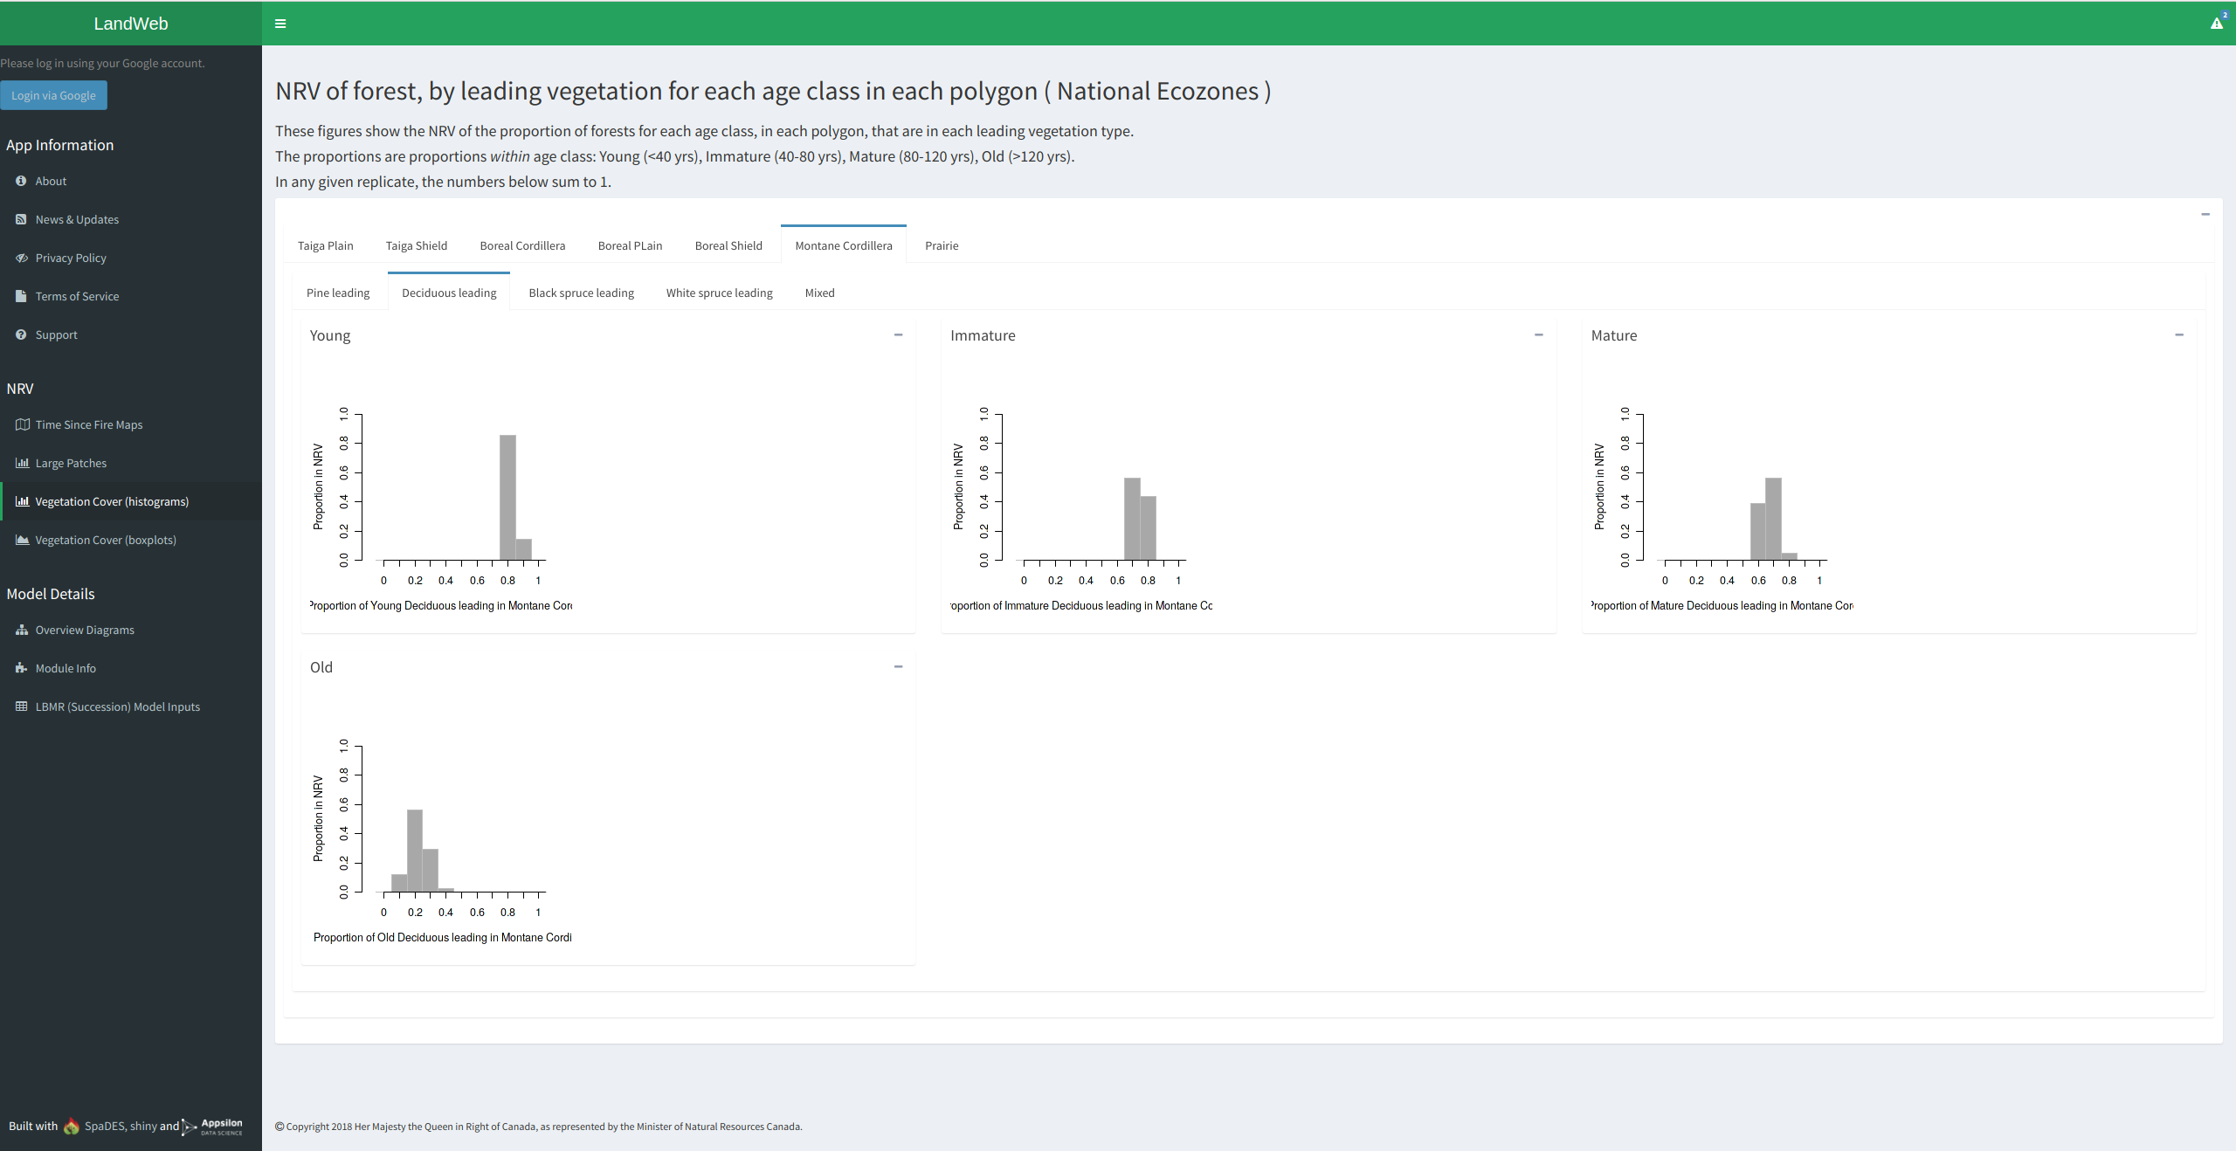

Figure 4. Vegetation cover histograms.

2.4 Vegetation Cover Boxplots

These figures (see Fig. 5) show the NRV of the proportion of forests for each age class, in each polygon, that are in each leading vegetation type. Use the tabs on this page to examine each combination of these variables. The proportions are proportions within age class: Young (<40 yrs), Immature (40-80 yrs), Mature (80-120 yrs), Old (>120 yrs). In any given replicate, the numbers below sum to 1.

Authorized (logged in) users will see red dots added to the boxplots, which indicate the current landscape conditions.

*NOTE: the boxplots on this page will take some time to load when selecting a different polygon from the "Time Since Fire Maps" page.*

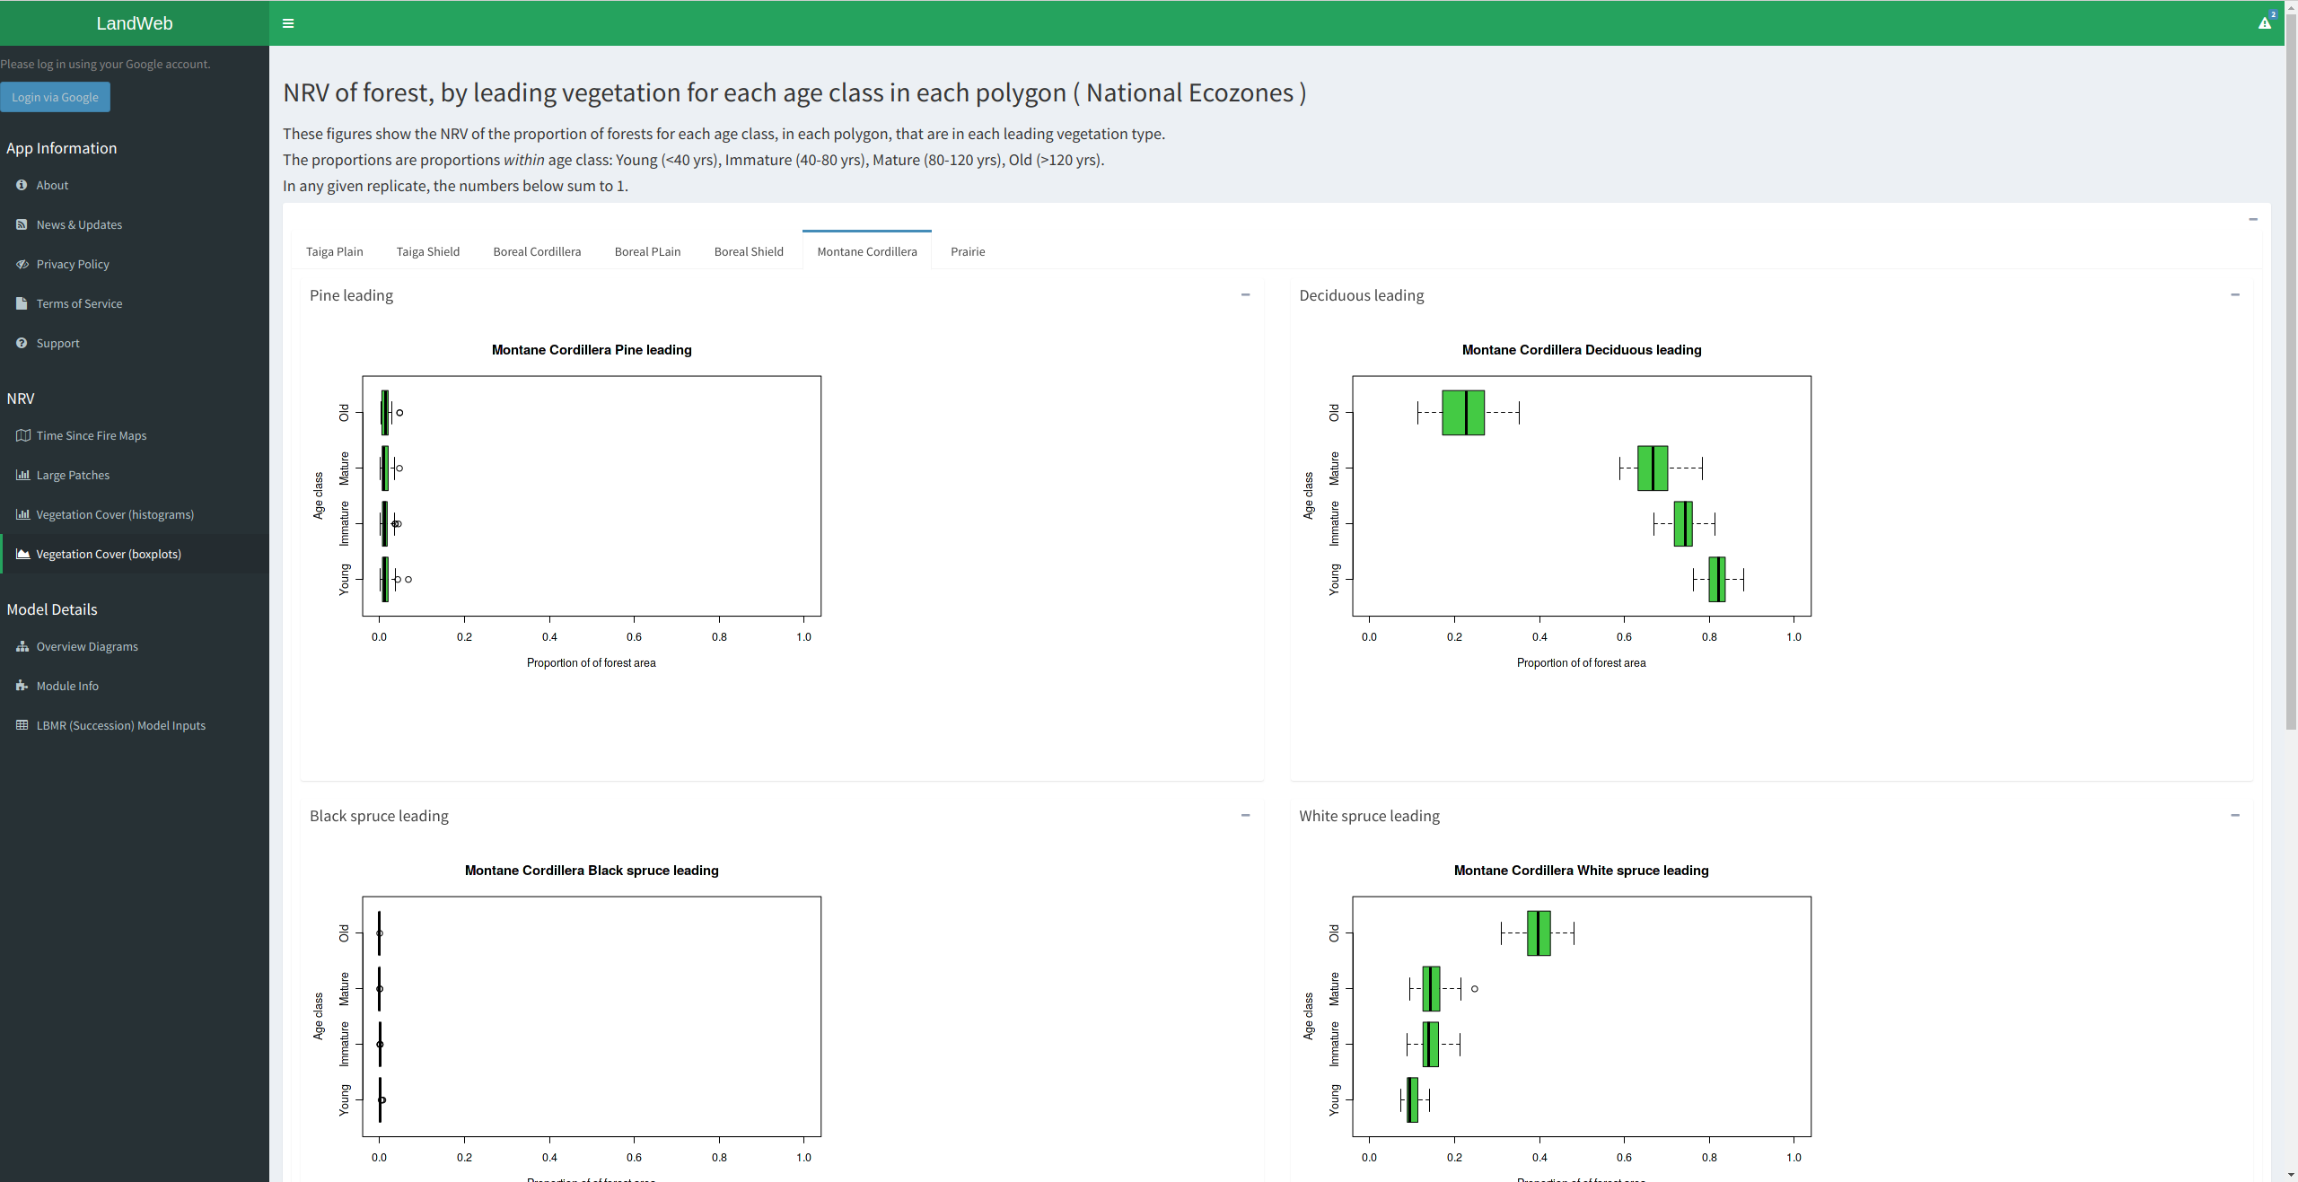

Figure 5. Vegetation cover boxplots.

2.5 Log in Using Your Google Account

By pressing the "Login via Google" button in the left-side menu, authorized users can gain access to additional features. During login, you will be presented with the Google authentication screen (Fig. 6). All authentication is performed using OAuth tokens, and at no point does the app see nor record your password. You can log out at any time by pressing the "Logout" button located in the top left-side menu.

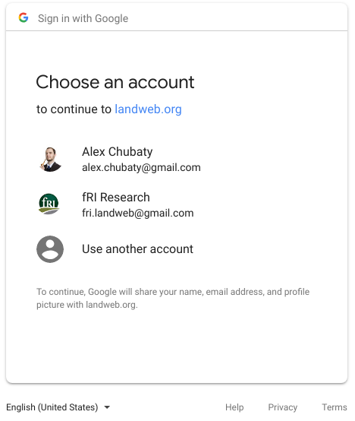

Figure 6. Google authentication screen.

3 Model Details

3.1 Model Inputs

3.1.1 Public Data Sources

Various publicly accessible datasets are used as model inputs, including:

* Land Cover Classification 2005 map: <ftp://ftp.ccrs.nrcan.gc.ca/ad/NLCCLandCover/LandcoverCanada2005_250m/LandCoverOfCanada2005_V1_4.zip>;
* LANDIS-II species traits: <https://github.com/dcyr/LANDIS-II_IA_generalUseFiles>;
* LANDIS-II parameterization tables and data: <https://github.com/LANDIS-II-Foundation/Extensions-Succession-Archive/master/biomass-succession-archive/trunk/tests/v6.0-2.0/>;
* Canada biomass, stand volume, and species data (from Beaudoin *et al.*, 2014): <http://tree.pfc.forestry.ca>;
* National ecodistrict polygons: <http://sis.agr.gc.ca/cansis/nsdb/ecostrat/district/ecodistrict_shp.zip>;
* National ecoregion polygons: <http://sis.agr.gc.ca/cansis/nsdb/ecostrat/region/ecoregion_shp.zip>;
* National ecozone polygons: <http://sis.agr.gc.ca/cansis/nsdb/ecostrat/zone/ecozone_shp.zip>.

3.1.2 Proprietary Data

All proprietary data are stored securely in an access-controlled Google Drive location. These data include:

* biomass by species maps created by Pickell et al. (UBC) resolution 100m x 100m from LandSat and kNN based on CASFRI;
* reporting polygons used to summarize model results in the app.

3.2 Model Outputs

Model outputs are available to download for authorized app users, and are described below.

3.2.1 Downloading Outputs

Authorized (logged in) users have the option to download model outputs. Click the "Download Options" button (labelled A in Fig. 2) to view download options.

The downloaded outputs are bundled into a zip file (*e.g.*, LandWeb_v1.0.0_2018-04-13.zip) with the following directory and file structure:

**LandWeb_v1.0.1_2018-08-08/**

**|_ boxplots/**

**|_ vegAgeMod/**

**|_ histograms/**

**|_ largePatches/**

**|_ 500/ ## currently selected patchSize**

**|_ vegAgeMod/**

**|_ polygons/**

**|_ rasters/**

**|_ rstTimeSinceFire_*.tif**

**|_ vegTypeMap_*.tif\***

**|_ experiment.RData**

**|_ largePatches.csv**

**|_ README.md**

**|_ simulationOutput_*.rds**

**|_ vegArea.csv**

*NOTE: It make some time to produce the* .zip *file for download.*

3.2.1.1 Currently Selected Spatial Area

* Currently selected reporting polygon (*.shp*)

3.2.1.2 Large Patches Data for Study Region

* Large Patches Data (*.csv*)
* Large patches histograms (*.png*)

3.2.1.3 Leading Vegetation Cover Data for Study Region

* Leading Vegetation Cover Data (*.csv*)
* Leading Vegetation Cover histograms (*.png*)

3.1.2.4 Simulation Rasters (Cropped to Study Region)

* Flammability maps (*.grd*)
* Time Since Fire maps (*.tif*)
* Vegetation type maps (*.grd*, *.tif*)

3.1.2.5 Additional R Data Files (For Advanced Users)

* Simulation data files (*.RData*, *.rds*)

4 Getting Help

To get help with the app or the model outputs, select "Support" form the left-side menu. Please see the Frequently Asked Questions for answers to common queries, or email one of the support contacts listed.

Literature Cited

Beaudoin, et al. (2014). Mapping attributes of Canada’s forests at moderate resolution through kNN and MODIS imagery. Canadian Journal of Forest Research, 44, 521–532. http://doi.org/10.1139/cjfr-2013-0401. Data available from http://tree.nfis.org/.

Chubaty, A. M. & McIntire, E. J. B. (2018) SpaDES: Develop and Run Spatially Explicit Discrete Event Simulation Models. R package version 2.0.1.

https://CRAN.R-project.org/package=SpaDES

Scheller, R. M., & Mladenoff, D. J. (2004). A forest growth and biomass module for a landscape simulation model, LANDIS: Design, validation, and application. Ecological Modelling, 180, 211–229. http://doi.org/10.1016/j.ecolmodel.2004.01.022

Scheller, R. M., Domingo, J. B., Sturtevant, B. R., Williams, J. S., Rudy, A., Gustafson, E. J., & Mladenoff, D. J. (2007). Design, development, and application of LANDIS-II, a spatial landscape simulation model with flexible temporal and spatial resolution. Ecological Modelling, 201, 409–419. http://doi.org/10.1016/j.ecolmodel.2006.10.009

Appendix A: Module Details

Lorem ipsum…