Kristopher Kuenning

3/23/2025

CSD 310

GitHub Repository Setup

Link to GitHub repository:  
https://github.com/Predith/csd-310.git

Screenshot of local directory:

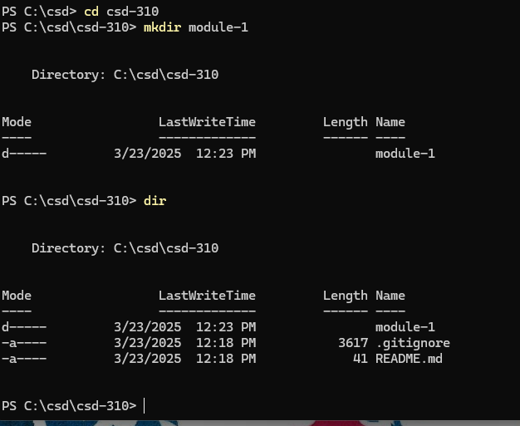

Screenshot of GitHub repository: