Kristopher Kuenning

3/30/2025

CSD310

Data Models

ERD: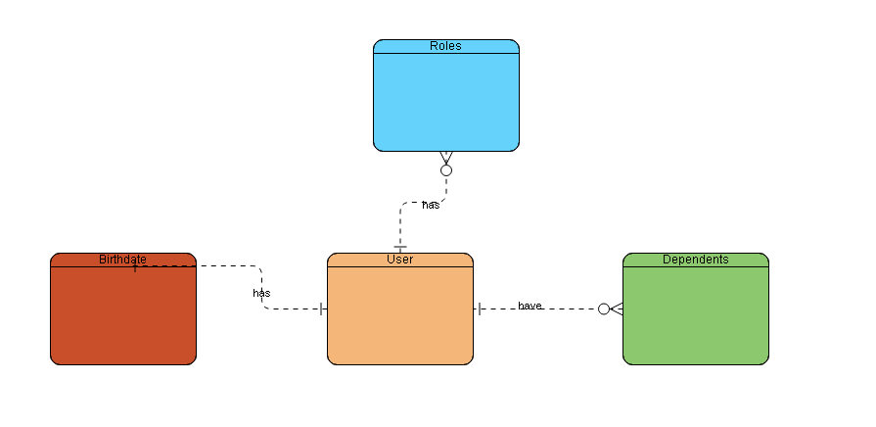

NoSQL Data Structure:  
{

"User":,

"birthdate":”

"roles": [  
{

“type”: ,

},

{

]

"dependents": [

{

"name":

"relationship":

"birthdate":

{

]  
}