Kristopher Kuenning

3/23/2025

CSD 325

GitHub Repository Setup

Link to GitHub repository:

https://github.com/Predith/csd-325.git

Screenshot of GitHub repository:

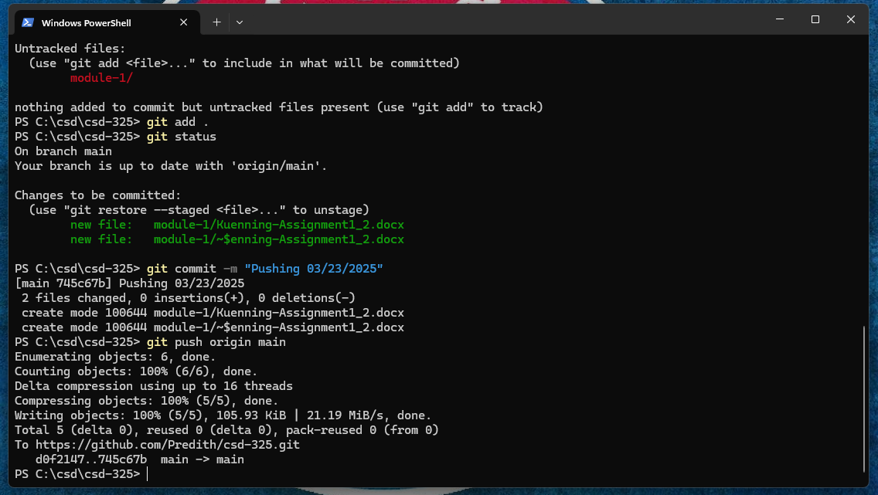

Screenshot of local directory:

