Kristopher Kuenning

3/23/2025

CSD325

Document Debugging + Flowchart

Flowchart:

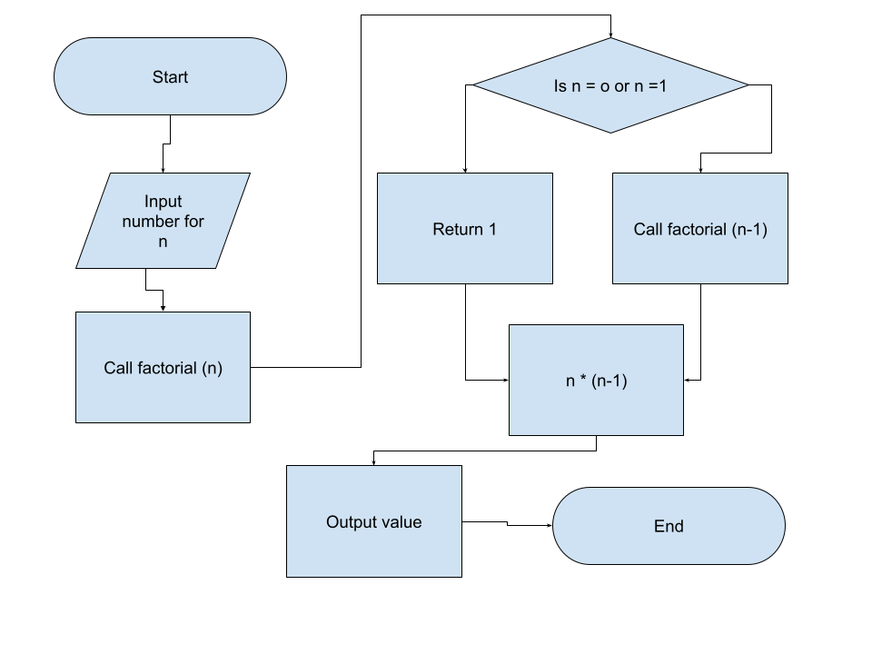

Breakpoint:

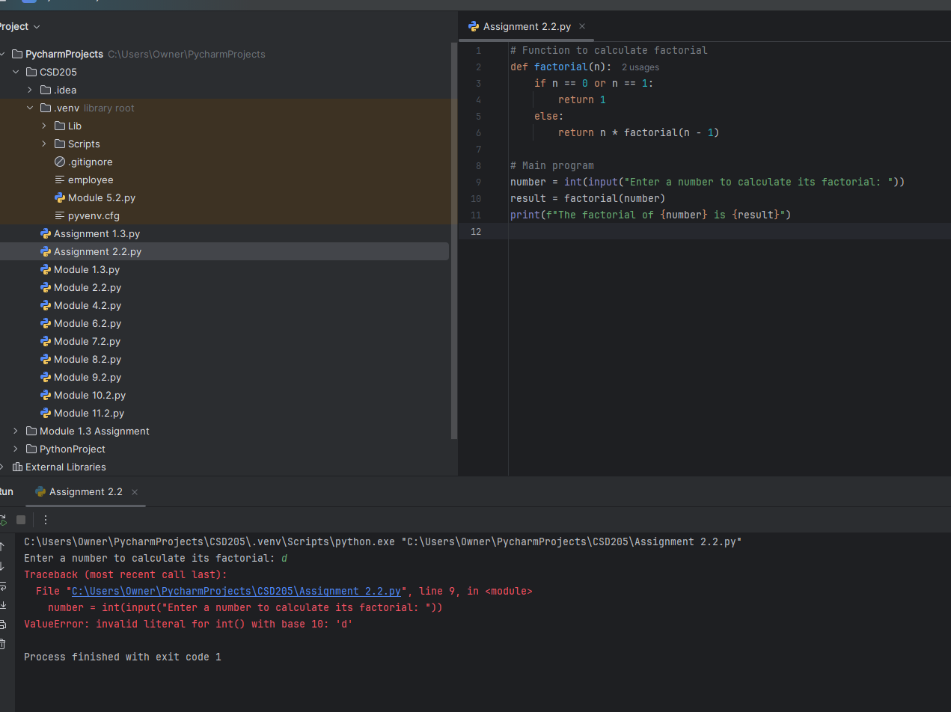

Debugging/Solution:

