Kristopher Kuenning

04/06/25

CSD325

High/Low Temperatures

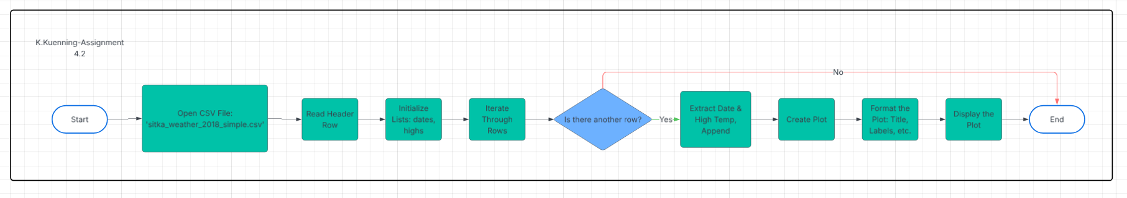Flowchart 1

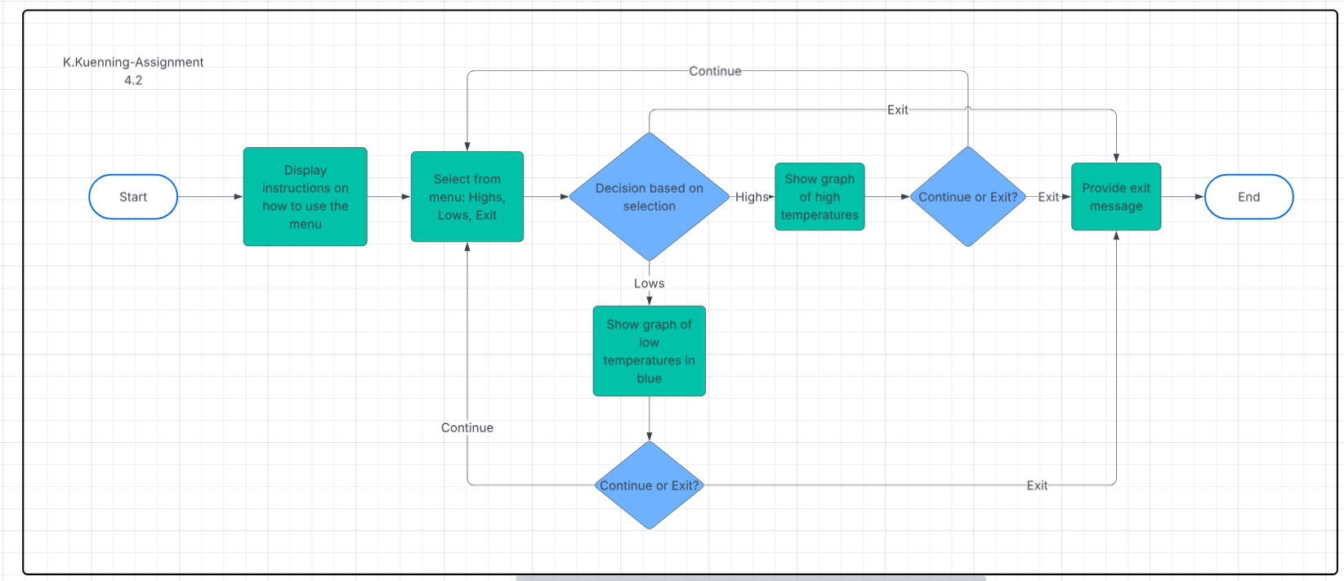Flowchart 2 (Revised)