Kristopher Kuenning

4/13/2025

CSD325

Module 5.2

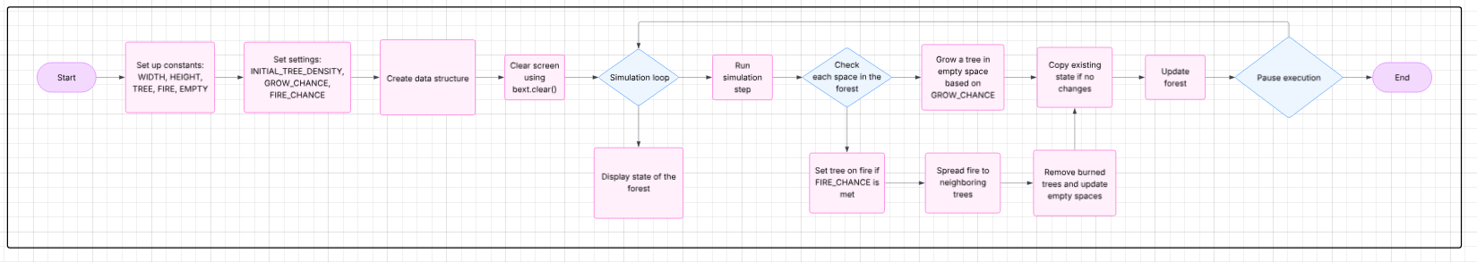Forest Fire Simulation: Flowchart