Kristopher Kuenning

4/13/2025

CSD325

Module 6.2

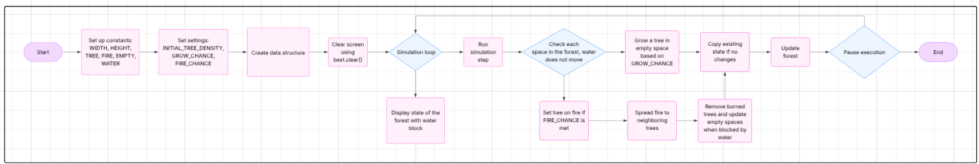Forest Fire Simulation: Program and Revised Flowchart