Kristopher Kuenning

4/20/2025

CSD-325

Module 8.2

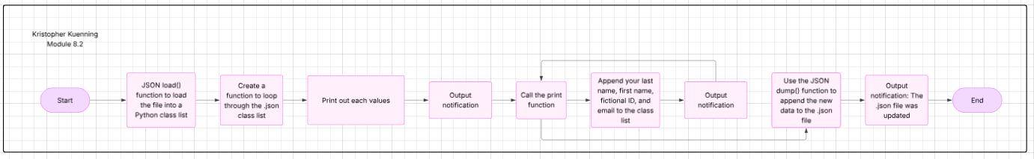JSON Practice

