Kristopher Kuenning

4/26/2025

CSD-325

Module 9.2

APIs

#4 and #5 screenshot

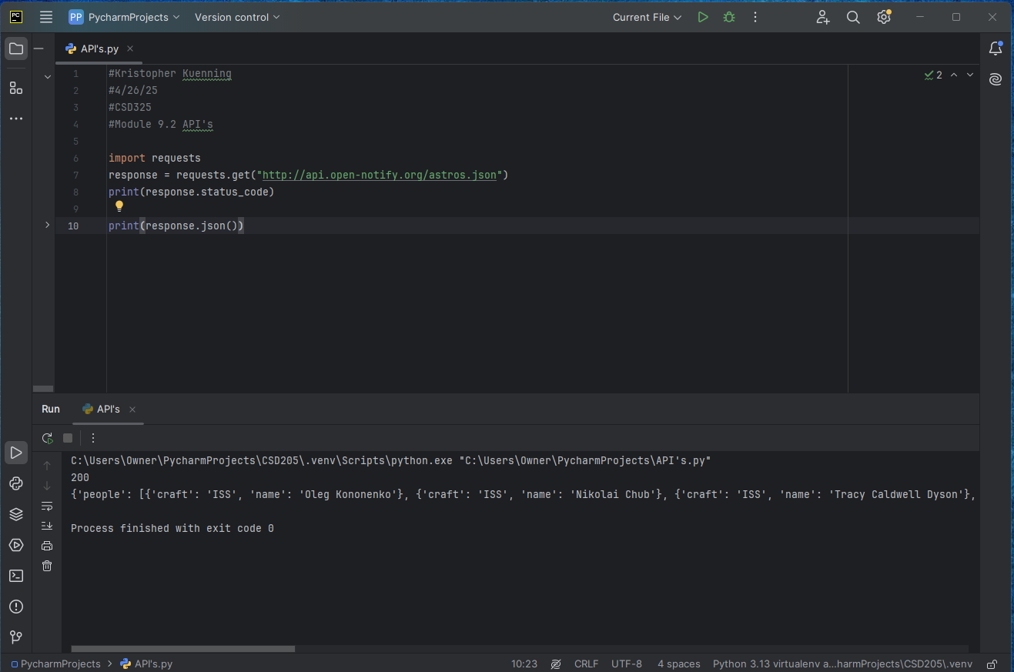

#6

