Project: TODO Application
Course: CSD-380
Description: Test plan
Date: 2025/11/13
To complete the test case plan, fill out the information for Project, Course, Description and Date in the header below.
.
TABLE OF CONTENTS
Access Website via Standard URL 2
Edit an Existing Todo Task 2
Create a New Todo Task 3
Prevent Empty Task Submission 4
Delete a Todo Task Item 4

For each test, the developer should: provide a test description, a test objective, the developer name and date tested. For each step, fill out the actions to be taken and describe the expected results, and indicate yes or no for each step depending upon the result. The peer tester should provide their name, date tested, indicate yes or no for each step depending upon the result, and a screenshot (thumbnail) of the result.

Test 1 | Access Website via Standard URL
 | Test Objective: Verify that users can access the Todo application via the provided URL. | Developer: Nardos Gebremedhin  Date tested: 2025/11/13 | Peer tester: Kristopher Kuenning  Date tested: 2025/11/15
Step | Action | Expected results: | Developer pass/fail | Tester pass/fail  + Screenshot
1 | Open google | Google opens successfully | <yes/no> | 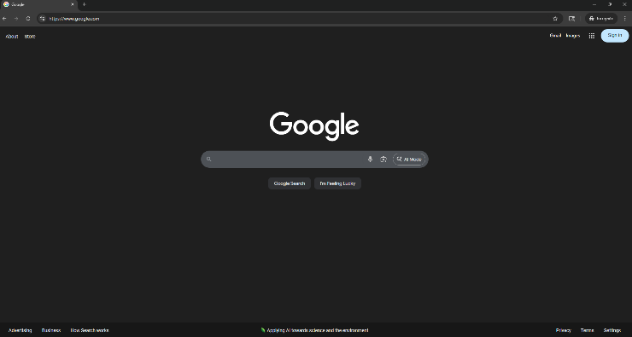  Yes
2 | Navigate to https://buwebdev.github.io/todo/ | Todo app loads without errors | <yes/no> | 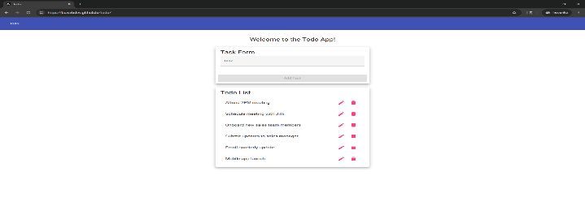  Yes
3 | Refresh the browser window | Page reloads correctly | <yes/no> | yes
4 | Click around the Todo page | All links and buttons respond appropriately | <yes/no> | yes
5 | Check for HTTPS in the address bar | Secure connection is confirmed | <yes/no> | Yes  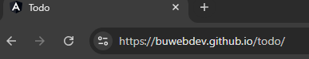
Comments | The website opened without issues, with links and buttons responding as expected. Screenshots were added to confirm HTTPS was in the address bar.

Test 2 | Edit an Existing Todo Task
 | Test Objective: Verify that users can edit a task item. | Developer: Nardos Gebremedhin  Date tested: 2025/11/13 | Peer tester: Kristopher Kuenning  Date tested: 2025/11/15
Step | Action | Expected results: | Developer pass/fail | Tester pass/fail
1 | Locate an existing task | Task is visible in the list | <yes/no> | Yes  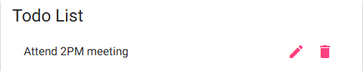
2 | Click the pencil/pen icon | An edit box should pop up | <yes/no> | Yes  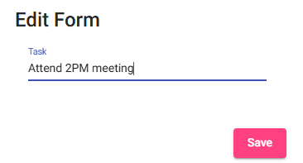
3 | Change text to "Watch Blade" | New text appears in the field | <yes/no> | Yes  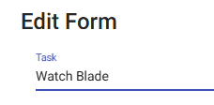
4 | Click “Save” | Task updates in the list | <yes/no> | Yes
5 | Confirm updated task is visible | "Watch Blade" is shown | <yes/no> | Yes  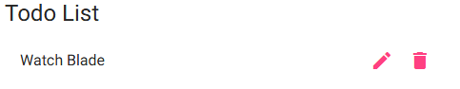
Comments | The user can see multiple tasks that were previously submitted from the start of the launch page. Have an empty template from the start to help with not having to change any on the initial list.

Test 3 | Create a New Todo Task
 | Test Objective: Ensure users can successfully create a new task item. | Developer: Nardos Gebremedhin  Date tested: 2025/11/13 | Peer tester: Kristopher Kuenning  Date tested: 2025/11/15
Step | Action | Expected results: | Developer pass/fail | Tester pass/fail
1 | Navigate to the Todo app | Page loads successfully | <yes/no> | 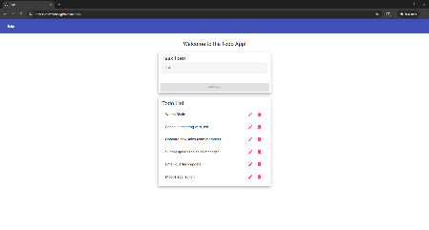  Yes
2 | Enter "Wash the dishes " in the input field | Text appears in the field | <yes/no> | Yes  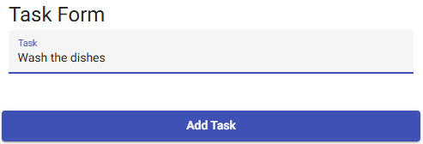
3 | Click the "Add Task" button | Task is added to the list | <yes/no> | Yes
4 | Confirm tasks appear in the list | “Wash the dishes” is visible in the list | <yes/no> | Yes  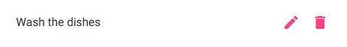
5 | Refresh the page | Task should remain in the list | <yes/no> | Yes
Comments | The new task item was created successfully. The item was added to the bottom of the list, which could be seen as an indication that it was added last, rather than first.
Test 4 | Prevent Empty Task Submission
 | Test Objective: Ensure users cannot submit an empty task. | Developer: Nardos Gebremedhin  Date tested: 2025/11/13 | Peer tester: Kristopher Kuenning  Date tested: 2025/11/15
Step | Action | Expected results: | Developer pass/fail | Tester pass/fail
1 | Navigate to the Todo app | Page loads successfully | <yes/no> | Yes  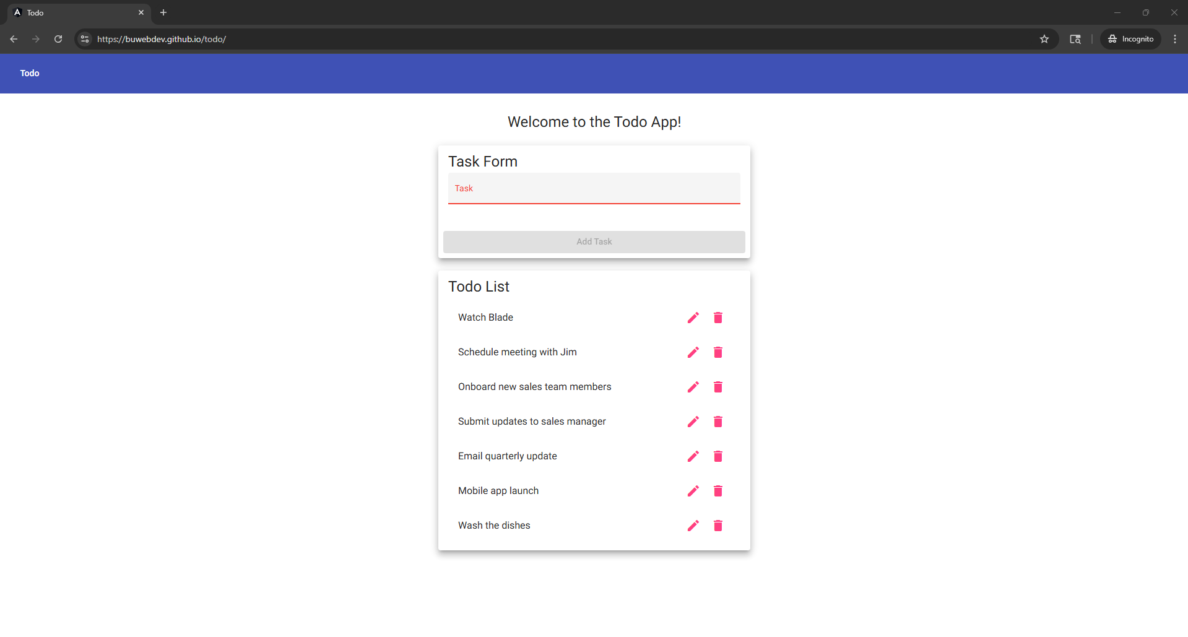
2 | Leave input field blank | No text entered | <yes/no> | Yes
3 | Click the "Add Task" button | No action | <yes/no> | Yes
4 | Try submitting again without text | No action | <yes/no> | Yes
5 | Enter valid text and submit | Task is added successfully | <yes/no> | Yes  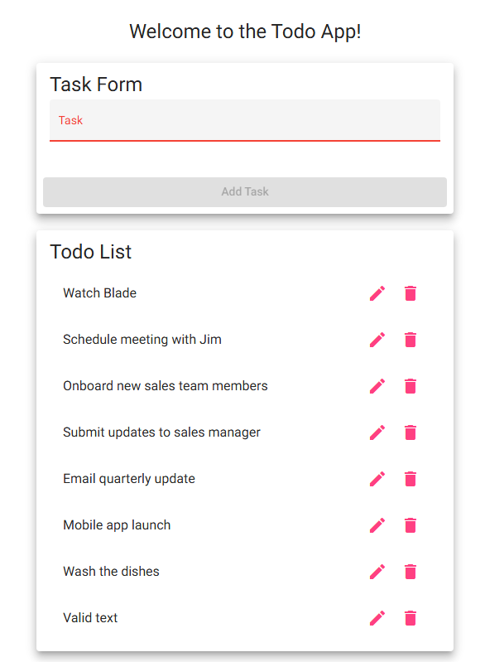
Comments | Empty task submission was a success by not having an empty task in the Todo list. Valid text submission was also successful, with a task that was created after typing text into the task bar and clicking Add Task button.

Test 5 | Delete a Todo Task Item
 | Test Objective: Verify that users can successfully delete a task from the list. | Developer: Nardos Gebremedhin  Date tested: 2025/11/13 | Peer tester: Kristopher Kuenning  Date tested: 2025/11/15
Step | Action | Expected results: | Developer pass/fail | Tester pass/fail
1 | Navigate to the Todo app | Page loads successfully | <yes/no> | Yes  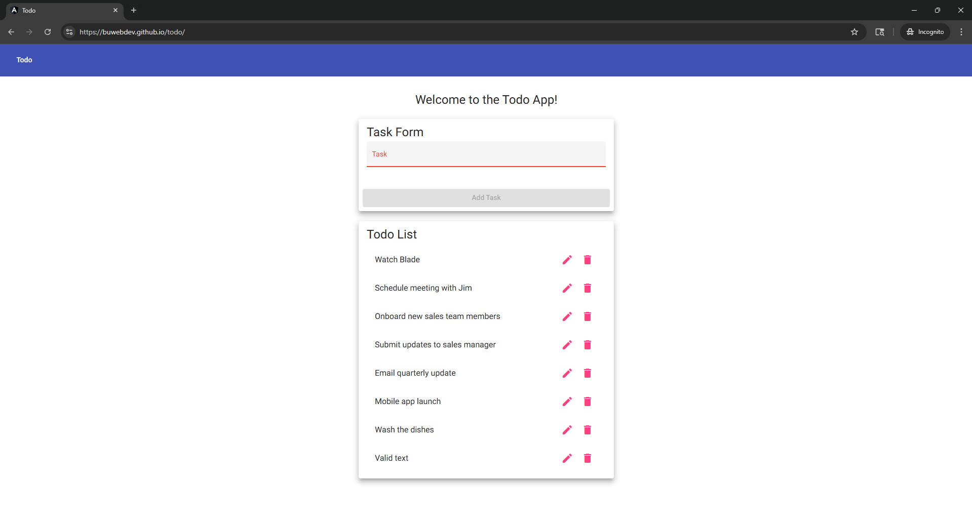
2 | Add a new task called "Test delete" | “Test delete” is in the list | <yes/no> | Yes  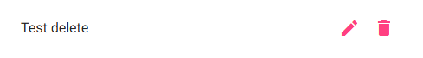
3 | Click the trash icon | Task is removed from the list | <yes/no> | Yes
4 | Confirm the task is deleted | Verify task is removed | <yes/no> | Yes  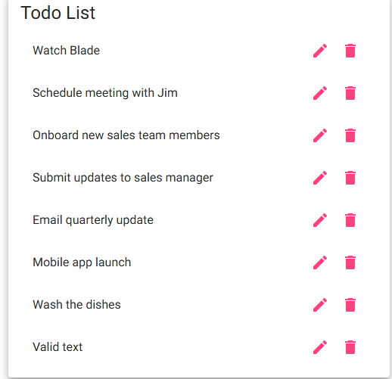
5 | Refresh page to confirm task is still deleted | Task is still gone after page reload | <yes/no> | Yes
Comments | Users can successfully delete tasks by utilizing the trash icon. Have a confirmation prompt to ensure the user wants to delete the task to prevent any accidental removals.

