Project: <Enter a project name> | ToDoList
Course: <Enter the course number and name> | CSD380 DevOps
Description: <Enter a description> | Test Plan for ToDo Business Requirements [Create, Update, Delete]
Date: <Enter a date (yyyy/mm/dd)> | 2025/11/15
To complete the test case plan, fill out the information for Project, Course, Description and Date in the header below.
.
TABLE OF CONTENTS
<DESCRIPTION> 2
<DESCRIPTION> 2
<DESCRIPTION> 3

For each test, the developer should: provide a test description, a test objective, the developer name and date tested. For each step, fill out the actions to be taken and describe the expected results, and indicate yes or no for each step depending upon the result. The peer tester should provide their name, date tested, indicate yes or no for each step depending upon the result, and a screenshot (thumbnail) of the result.

Test 1 | Reject Empty Forms
 | Test Objective: Prevent users from submitting a task form without entering a todo item | Developer: Juedeja Richard  Date tested: 2025/11/15 | Peer tester: Kristopher Kuenning  Date tested: 2025/11/15
Step | Action | Expected results: | Developer pass/fail | Tester pass/fail  + Screenshot
1 | Go to url: https://buwebdev.github.io/todo/ | Page Loads without problems | Yes | Yes  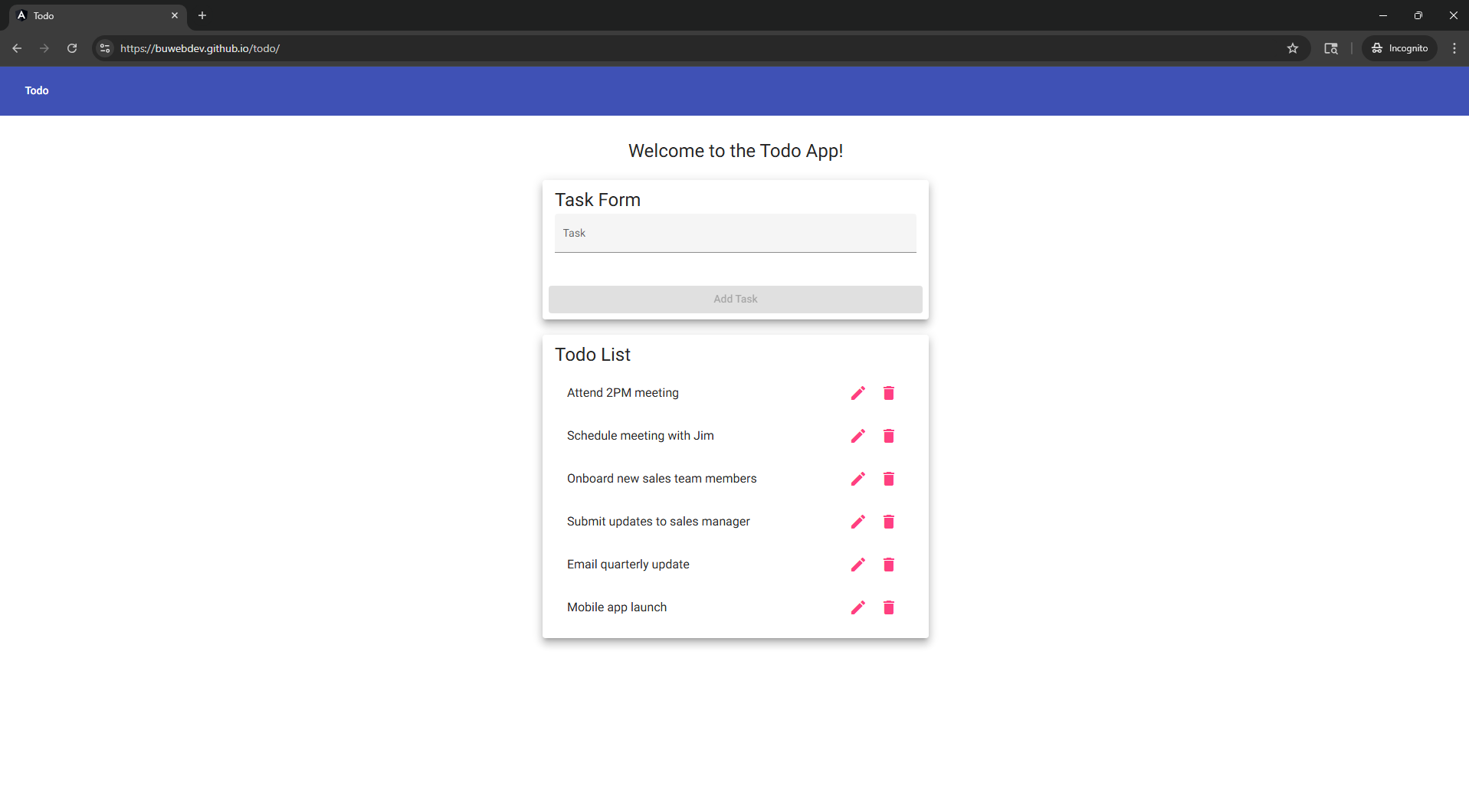
2 | Check task input box is empty | Input box has no numbers, symbols or characters | Yes | Yes  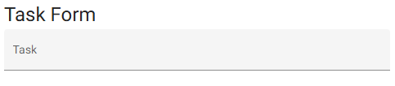
3 | Click Add Task | Notification informs user nothing was added to list because form is empty | No | No
4 | Check todo List | No new empty task was added to List | Yes | Yes
Comments | Users can not submit a task with an empty task input box. No notification was prompted when clicking on Add Task button.

Test 2 | Creating Task Items
 | Test Objective: Create a new todo task item | Developer: Juedeja Richard  Date tested: 2025/11/15 | Peer tester: Kristopher Kuenning  Date tested: 2025/11/15
Step | Action | Expected results: | Developer pass/fail | Tester pass/fail
1 | Go to url: https://buwebdev.github.io/todo/ | Page Loads without problems | Yes | Yes  
2 | Click on Task Input box | Text cursor appears | Yes | Yes
3 | Type a task into the box | Characters, numbers and symbols appear in box | Yes | Yes  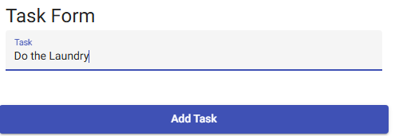
4 | Click the “add task” button | Form clears itself and notifies users a task was added to the List | Yes | Yes  
5 | Check todo List | A new task is added to ToDo List | Yes | Yes  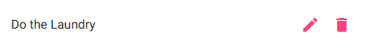
Comments | User was able to create a new Todo task. Special characters also work when submitted.

Test 3 | Editing Task Items
 | Test Objective: Edit a todo task item | Developer: Juedeja Richard  Date tested: 2025/11/15 | Peer tester: Kristopher Kuenning  Date tested: 2025/11/15
Step | Action | Expected results: | Developer pass/fail | Tester pass/fail
1 | Go to url: https://buwebdev.github.io/todo/ | Page Loads without problems | Yes | Yes  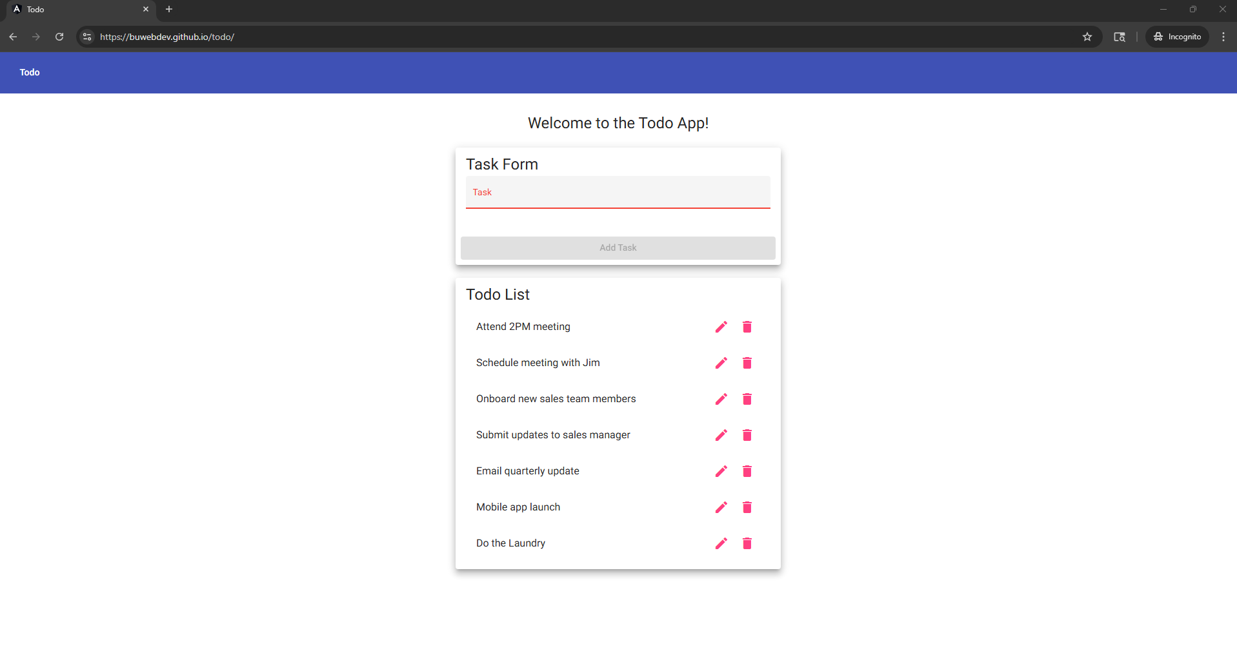
2 | Create a Task | Task item is created, added and appears in the ToDo List | Yes | No  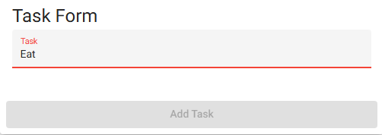
3 | Click on Todo List item pencil icon and add or delete characters | Task Item description changes | Yes | Yes
4 | Click save button to submit changes | Task item appears differently in the list | Yes | Yes  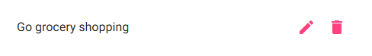
Comments | The user was able to create a task and edit it using the pencil icon to modify the task. Creating a task cannot be done without more than four characters or numbers. Add a description to the bottom of the taskbar that specifies these terms.

Test 4 | Deleting Task Items
 | Test Objective: Delete a todo task item | Developer: Juedeja Richard  Date tested: 2025/11/15 | Peer tester: Kristopher Kuenning  Date tested: 2025/11/15
Step | Action | Expected results: | Developer pass/fail | Tester pass/fail  + Screenshot
1 | Create a Task or 2 | Task item is created, added and appears in the ToDo List | Yes | Yes  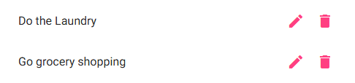
2 | Click on trash icon for a TodoList task | Task item is removed from list | Yes | Yes  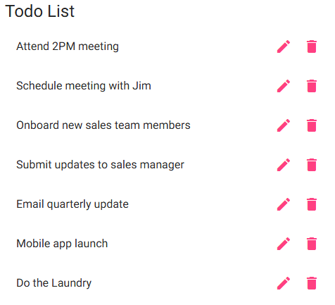
Comments | User was able to delete a task in the Todo list. Add a notification prompt that confirms this action to eliminate accidental removal.

Test 5 | Handling Invalid URLs
 | Test Objective: For invalid URLs, provide users with a custom 404 error page | Developer: Juedeja Richard  Date tested: 2025/11/15 | Peer tester: Kristopher Kuenning  Date tested: 2025/11/15
Step | Action | Expected results: | Developer pass/fail | Tester pass/fail  + Screenshot
1 | Go to url: https://buwebdev.github.io/todo/ | Original page loads with no problem | Yes | Yes  
2 | Misspell todo in url | Todo will be spelled wrong | Yes | Yes  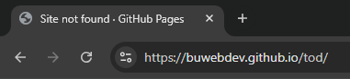
3 | Press enter | Custom Page with 404 error and no todo list should load | No | Yes  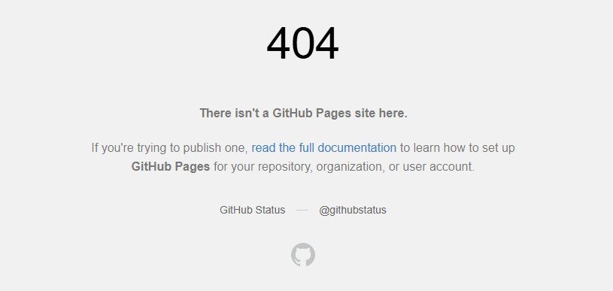
Comments | The user was able to create a custom 404 error page by misspelling 'todo' in the URL bar. Create a redirect page when a 404 error occurs.

