Weekly Meal Prep Value Stream Map & Lean Analysis

1. Introduction
This document outlines a Value Stream Map (VSM) for a weekly meal prep routine. The process includes planning, grocery shopping, cooking, packing meals, and storage. Lean metrics and process optimization recommendations are included.

2. Value Stream Map Diagram
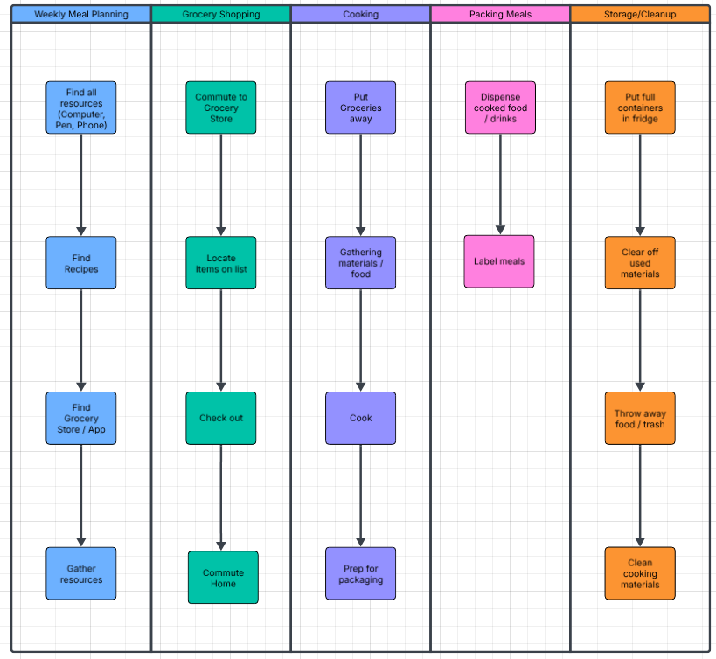

3. Estimated Average Flow Time
Stage | Average Time
Weekly Meal Planning | 30 mins
Grocery Shopping | 60 mins
Cooking | 120 mins
Packing Meals | 20 mins
Storage/Cleanup | 20 mins
Estimated Total Cycle Time: 4.1 hours

4. Identifying Waste Using Lean Principles
• Overprocessing: Rechecking recipes multiple times, washing pre-washed produce.
• Motion Waste: Repeated trips between kitchen zones.
• Waiting: Idle time waiting for boiling or baking.
• Inventory Waste: Overbuying produce that spoils.
• Task Switching Waste: Changing tasks too frequently slows progress.

5. Optimization Recommendations
1. Reduce shopping time through delivery or pickup services.
2. Streamline cooking with batch methods and Instant Pot usage.
3. Improve kitchen layout by creating a dedicated prep zone.
4. Use identical containers to speed up packing.
5. Reduce waiting by multitasking during boil/bake cycles.

6. Improved Estimated Cycle Time
Stage | Before | After Optimization
Planning | 30 mins | 10 mins
Shopping | 60 mins | 20 mins
Cooking | 120 mins | 90 mins
Packing | 20 mins | 15 mins
Storage/Cleanup | 20 mins | 10 mins

References
- Lance Knight is the President and Chief Operating Officer of ConnectALL. His responsibilities include sales. (2020, October 29). 3 easy steps for using VSM in everyday life. ConnectALL. https://www.connectall.com/3-easy-steps-for-using-vsm-in-everyday-life/#Value_Streams_Are_Everywhere
- Diagramming powered by intelligence. Lucidchart. (n.d.). https://www.lucidchart.com/pages?gad_campaignid=14965870688&gad_source=1&gbraid=0AAAAADLdSjAv5UjYPZJF-ArWp_HEe99qc&gclid=CjwKCAiA_orJBhBNEiwABkdmjAq_E6cudd76kGVaYeIj-tGXx2gns9p-Mq99yU882jDJ2F_ReUlu7BoCquMQAvD_BwE&km_CPC_AdGroupID=137102779668&km_CPC_CampaignId=14965870688&km_CPC_Country=9033312&km_CPC_Creative=553386939042&km_CPC_Device=c&km_CPC_Keyword=flow+chart&km_CPC_MatchType=e&km_CPC_Network=g&km_CPC_TargetID=aud-812368091438%3Akwd-10404171&utm_campaign=_chart_en_us_desktop_search_strategic-tier1_exact_&utm_medium=cpc&utm_source=google

