Kristopher Kuenning
12/14/2025
CSD380
Module 10.2
Shared Code Repository – Git Exercise
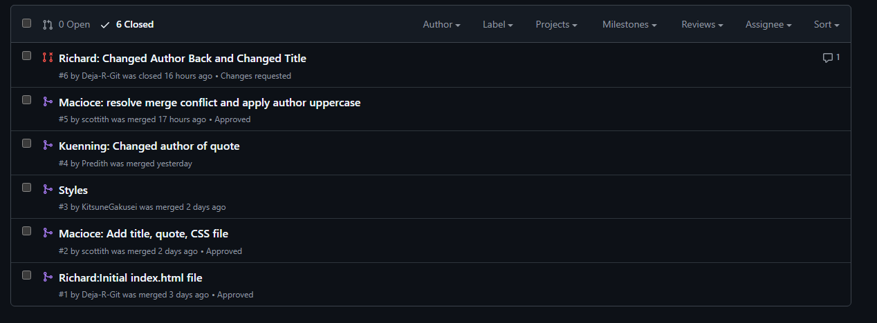

Link to the group GitLab: https://github.com/KitsuneGakusei/GitLab
My GitHub username: Predith

