Kristopher Kuenning

09/28/2025

CSD420

Module 9 Programming Assignment

I created a new user, “student1,” with password “pass” and database “databasedb,” which is currently empty and ready to be connected to Java. Installation is complete.  
  
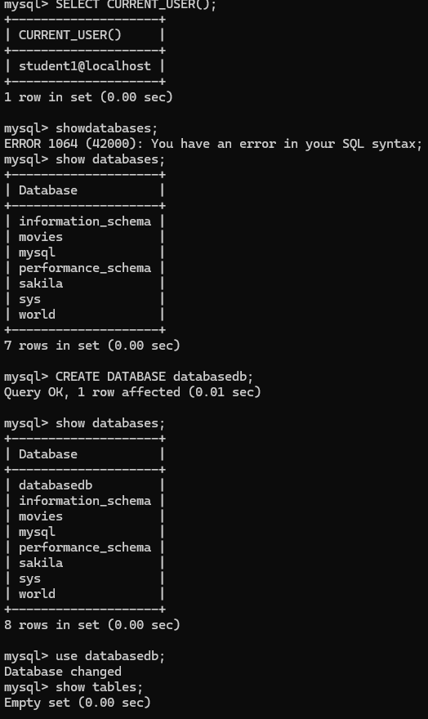

After running the test code example on Java with my configurations from MySQL, I saw an unsuccessful attempt to connect to the database. I was stuck on why importing Java.net.URL was not registered, and the database could not be found due to this issue.

