
Real-Time Detection of Helmet and Face Masks – A Systematic Review
Dr. Bharathi M P, Thejashwini K, Supriya B O

Department Computer Science, Surana Autonomous College, Kengeri Satellite Town, Bangalore – 560060, Karnataka, India
ABSTRACT : Road Safety and public health are two critical domains where simple preventive measures such as wearing helmets and face mask while riding plays a major role in reducing accidents and disease transmission. manual monitoring of such compliance is difficult to scale, especially in densely populated areas, making automated solutions is necessary. Recent advances in computer vision and deep learning have enabled intelligent surveillance systems capable of detecting helmet and mask violations in real time. Techniques such as YOLO (You Only Look Once), Convolutional Neural Networks (CNNs), and Optical Character Recognition (OCR) have shown strong performance for multi class detection tasks, including helmets, masks, and license plates. This review Systematically explores research contributions in three categories: helmet detection, mask detection, and combined helmet + mask detection. By comparing traditional machine learning approaches with state- of-the-art deep learning frameworks, the paper highlights the growing potential of unified AI-powered systems for improving public safety and traffic enforcement.
Keywords: Road Safety, Public Safety, Intelligent Surveillance, Helmet Detection, Face Mask Detection, YOLO, OCR .

I.INTRODUCTION

In the current era, ensuring human safety in both public health and road environments has become a major concern. Global organizations like the World Health Organization (WHO) continue to emphasize the importance of preventive safety measures such as wearing helmets and face masks while riding two-wheelers.[1] These practices contribute significantly to individual protection and overall community well-being.
However, achieving widespread compliance with these safety measures remains a challenge. Manual monitoring by authorities is limited due to insufficient manpower, especially in densely populated cities where traffic density and human movement are high [2]. As urban areas continue to expand, enforcing safety regulations through conventional approaches becomes increasingly difficult.
To overcome these challenges, intelligent surveillance systems powered by computer vision and deep learning have emerged as effective alternatives. These systems analyze real-time video streams to automatically detect safety violations. Advanced models such as YOLO (You Only Look Once) and Convolutional Neural Networks (CNNs) have shown strong performance in recognizing helmet and mask usage, even under low light, occlusion, or crowded conditions. Unlike traditional machine learning approaches, these deep learning frameworks offer multi-class detection, allowing both helmet and mask recognition within the same system.
Moreover, many intelligent systems integrate Optical Character Recognition (OCR) to read vehicle license plates when a violation occurs. This enables automatic linkage with registration databases and the immediate generation of alerts or fines. Such automation reduces dependence on human enforcement, improves accountability, and promotes better compliance with safety norms.
This review aims to systematically explore existing literature on helmet detection, mask detection, and combined helmet + mask detection. It evaluates the technological frameworks used, compares their efficiency, and discusses the challenges and opportunities for creating scalable, unified AI-powered surveillance systems that support public health and traffic safety.

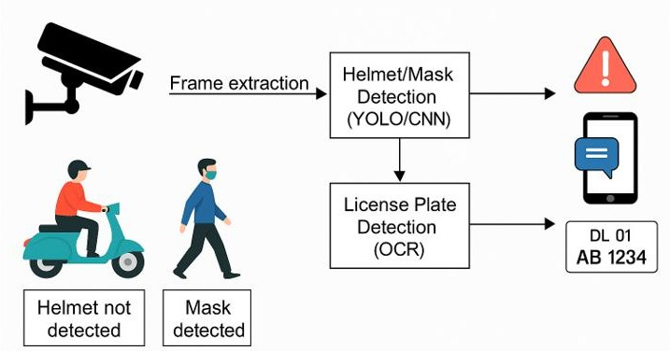

Figure 1: Conceptual workflow of an AI-powered helmet and mask detection system.
Figure 1 illustrates the process flow of an AI-based intelligent surveillance system for road safety and public health. First video frames are extracted from live surveillance footage. These frames are processed using deep learning models such as YOLO and CNN to detect the presence or absence of helmets and mask on riders. The figure 1 illustrates the end-to-end process of how an intelligent surveillance system monitors helmet and mask compliance in real time. The workflow explained below:
- Surveillance Camera: The system begins with camera installed at key locationssuch as traffic intersections, these cameras continuously capture live video streams, serving as the primary input to the system.
- Video Frames: The captured video is divided into individual frames at fixed intervals for analysis. Preprocessing operations such as resizing, noise removal, and contrast enhancement are applied to improve detection accuracy.
- YOLO/CNN Detection (Helmet + Mask): The pre-processed frames are passed through deep learning models such as YOLOv5 and CNNs. YOLO provides fast objects detection by drawing bounding boxes around detected helmets and masks, while CNNs refine predictions under challenging conditions, the system classifies individuals as compliant or violators.
- OCR (License Plate Recognition): When a violation is detected, Optical Character Recognition (OCR) is applied to the vehicle’s license plate region. OCR converts plate numbers into machine readable text, even under varied fonts, lighting or slight motion blur.
- Database Check: The extracted license plate is cross- verified with a registration database to identify the vehicle owner and retrieve contact details, this ensures accountability by linking the violation to the responsible individual.
- SMS/Fine Notification: Finally, the system automatically generates an alert. Depending on enforcement rules, this may be a warning SMS encouraging compliances or a fine notification with payment details. The real-time nature of this step ensures immediate enforcement without requiring manual intervention.

LITERATURE REVIEW
Over the years, researchers have explored a wide range of methods for improving safety surveillance through helmet and mask detection, along with number plate recognition, in both traffic and public health scenarios. Early work primarily focused on traditional machine learning techniques. For example, Support Vector Machine (SVMs) were used to classify helmet use by extracting moving vehicles via background subtraction and analysing shape-based features. However, these approaches often misclassified circula r objects like backpacks or ballons as helmets due to their reliance on geometric cues.
Agorku et al. (2023) designed a real -time helmet violation detection frameworks using YOLOv5 with ensemble learning. The system enhanced robustness in complex traffic conditions, reducing false positives and achieving high detection accuracy. Their findings confirmed YOLOv5’s suitability for real-time safety enforcement. Hence,[1] is a significant contribution to helmet violation monitoring.
The study in [2] applied YOLOv5 variants and achieved high classification accuracy across multiple PPE categories. Ahmed et al. (2023) designed a deep learning-based PPE detection system that included helmets and masks. This makes directly relevant for combined helmet and mask monitoring, proving the scalability of multi-class detection systems. The outcomes confirm YOLOv5 ability to handle diverse PPE objects.
[3] developed a self-adaptive traffic signal system integrating vehicle detection and license plate recognition. Although not focused solely on helmets or masks, the vision framework in [3] can be adapted for such tasks. Results showed improved traffic flow efficiency, proving AI-based vision system’s potential for safety enforcement. Thus [3], demonstrates how AI integration improves urban safety Systems.
In the work of Baruah et al. (2025) worked on helmet and number plate detection using different YOLO versions. The study compared YOLOv3, YOLOv4 and YOLOv5, finding YOLOv5 superior in precision and processing speed. Multi version comparisons are useful in selecting the best model for deployment in real-time monitoring. This makes [4] valuable for understanding trade-offs in YOLO algorithms.
The study in [5] introduced a real-time detection system for helmets and reflective vests using an improved YOLOv5. The system enhanced detection precision in industrial environments with complex background. Results confirmed high accuracy and faster processing than baseline models, making it practice for workplace safety. The contribution shows YOLOv5’s adaptability beyond traffic scenarios.
Research conducted in [6] introduced one of the earliest helmet detection approaches using real-time surveillance videos. Their system relied on traditional computer vision techniques and neural networks to identify riders without helmets. While accuracy was moderate compared to deep learning methods, it laid the foundation for automatic helmet detection research. Thus, it is an important early contribution highlighting the need for automated safety enforcement.
The study by Han et al. (2022) presented SMD-YOLO, a lightweight model designed for efficient face mask detection. The framework in [7] improved YOLOv4 by optimizing feature extraction, achieving high accuracy while remaining computationally efficient. Results showed strong performance in monitoring mask compliance under real-time conditions.
Real-time helmet detection model for motorcyclists in urban traffic using improved detectors based on YOLOv3. The system in [8] achieved better accuracy than traditional methods by handling small objects and cluttered backgrounds effectively. Their results confirmed high precision in identifying helmet violations in dense traffic.
System combining helmet detection and license plate extraction using deep learning. The doctoral dissertation in [9] demonstrated the use of CNNs for helmet identification along with OCR for plate recognition. Experimental outcomes showed reliable detection in real-world traffic conditions. Hence it highlights the benefits of integrating helmet detection with vehicle identification for enforcement purposes.

The framework in [10] is significant as it addressed both PPE categories within a single model. Result indicated high detection accuracy and robustness across different environments. Therefore, it provided strong evidence for the feasibility of combined helmet and mask detection in real-time surveillance.
ML-based surveillance system designed to detect both helmet violations and triple riding on two-wheelers. The study in [11] combined object detection and classification to handle multiple traffic rule violations. Results showed satisfactory detection accuracy, proving the adaptability of machine learning in traffic surveillance.
The research in [12] used CNNs and YOLOv5 models to achieve high precision in PPE detection and worker identification and developed a deep learning systems for detecting both safety and helmets and face masks in workplace settings. Their system not only identified non-compliance but also linked it to specific individual.
The system in [13] enhanced feature fusion and anchor box optimization, achieving better mean average Precision compared to baseline YOLOv5. Results confirmed the model’s efficiency in multi-class detection tasks.The study in [14] focused on improving detection accuracy in crowed and dynamic environments. The results showed higher precision compared to earlier CNN-based approaches. Thus, it contributes to advancing helmet detection in challenging real-world scenarios.
The system in [15] demonstrated strong performance in identifying mask compliance across different face angles and occlusions. Results showed improved detection speed and accuracy compared to standard YOLOv5. Therefore, this provides evidence that fine-tuned YOLOv5 models can effectively address mask compliance in public health monitoring.
Zhang designed a real-time industrial safety monitoring system using YOLOv8 for helmet and mask detection. The system achieved 98.2% accuracy on the custom dataset of 10,000 images. The paper highlights that combining helmet and mask detection significantly reduces workplace injuries in high-risk environments [16].
Traffic surveillance system integrating IOT sensors with deep learning models for helmet detection. Results showed 95% detection accuracy under varying lighting conditions. The study [17] emphasizes that IOT integration allows for real-time alerts, improving enforcement efficiency. Additionally, the system demonstrated scalability, making it suitable for deployment in large urban traffic networks.
The research applied CNN-based object detection to detect helmets and face masks. The model achieved 96.5% accuracy,
[18] underlines the importance of automated detection for pandemic safety compliance. The helmet usage on construction sites using deep learning the model in [19] demonstrated 97% precision and 95% recall.
Chen et al. (2019) developed a vision-based helmet detection system using Faster R-CNN. Their model achieved 94% accuracy in real-time scenarios, demonstrating reliable performance in detecting helmet usage among moving riders. To further enhance system efficiency, they integrated object tracking mechanisms, which not only improved processing speed but also ensured robustness in handling dynamic environmentswith varying traffic density, occlusions and lighting conditions [20].

Table 1: Performance Comparison of Helmet, Mask and Combined Detection Approaches

Reference | Method/Framework | Detection Type | Performance /Key Findings
[1] | YOLOv5 + Ensemble | Helmet | High robustness, reduced false  positives.
[2] | YOLOv5 variants | Helmet + Mask | Scalable multi-class detection
[3] | AI Vision + LPR | Helmet + Mask | Improved traffic flow and enforcement
[4] | YOLOv3, v4, v5  comparison | Vehicle/Plate | YOLOv5 superior in precision and speed
[5] | Improved YOLOv5 | Helmet +Plate | High accuracy in complex background
[6] | Classical CV + CNN | Helmet + vest | Early system, moderate accuracy
[7] | SMD + YOLO | Mask | High accuracy, efficient on real-time feeds
[8] | YOLOv3 | Traffic | Strong performance in dense traffic
[9] | CNN + OCR | Helmet + Plate | Reliable integrated system
[10] | YOLO | Helmet + Mask | Robust across environments
[11] | ML – based surveillance | Helmet + Triple riding | Multi-violation detection feasible
[12] | CNN + YOLOv5 | Helmet + Mask | Linked violations to individuals
[13] | YOLOv5 + Feature  Fusion | Multi-class PPE | Improved mean Average precision
[14] | Enhanced CNN | Helmet | Higher accuracy in crowded settings
[15] | Fine-tuned YOLOv5 | Mask | Better detection speed and occlusion  handling
[16] | YOLOv8 (10k images) | Helmet + Mask | 98% accuracy
[17] | IOT + Deep Learning | Helmet | 95% accuracy, real-time alerts
[18] | CNN | Helmet + Mask | 96% accuracy during pandemics

[19] | Deep Learning | Helmet + Mask | 97% precision, 95% recall
[20] | R-CNN | Helmet | 94% accuracy, tracking improved speed

PROPOSED RESEARCH
The proposed system aims to automatically detect helmet and face mask violations using real-time video feeds from traffic cameras or workplace surveillance. It uses YOLOv5 and CNN models to identify if a rider is not wearing a helmet or a person is without a face mask. Once a violation is detected, the system applies OCR (Optical Character Recognition) to read the vehicle’s license plate. The extracted number is then matched with the vehicle database to retrieve the registered mobile number. A warning SMS or fine notification is immediately sent to the violator's phone, urging them to pay the penalty online. This model is designed to reduce manual monitoring, increase safety awareness, and ensure better compliance with public health and traffic rules. The goal is to build a smart, efficient, and scalable solution that supports both road safety and pandemic protocols through real-time enforcement.

METHODOLOGY
The methodology adopted in this research aims to design an AI-powered surveillance system that can automatically detect helmet and face mask violations in real time, recognize vehicle number plates, and notify violators through an SMS alert. The entire process is built on a combination of computer vision techniques, deep learning models, and automated alerting mechanisms. The system begins by capturing live video feeds from CCTV or mounted traffic surveillance cameras. These continuous video streams are divided into individual frames for processing.


Figure 2: Helmet and Mask Detection with License Plate Recognition Framework
The system begins with real-time video capture from traffic surveillance cameras. The acquired frames are processed using YOLOv5 or CNN-based models to detect helmet and mask violations among riders. Once a violation is identified, license plate recognition is applied using OCR techniques to extract the vehicle registration number. The detected violation details are then forwarded as an SMS notification to authorities or the vehicle owner. This integrated workflow ensures efficient and automated enforcement of traffic safety rules in real time.
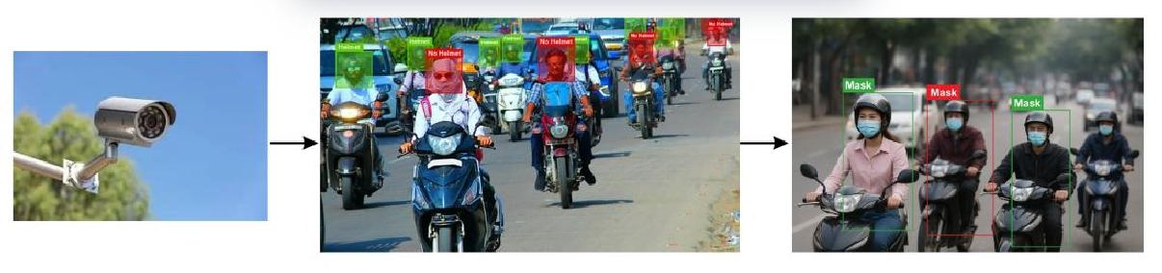

Figure 3: Live Video Capture

- Data Acquisition / Live Video Capture
In most helmet and face mask detection systems, the process begins with data acquisition, which can be either live video from surveillance cameras or pre-collected image datasets. For real-world applications, cameras are installed at strategic locations such as traffic intersections or crowded public areas. The video feed serves as the primary input for the detection system, capturing multiple frames per second to ensure that every individual in the scene can be analysed. Some studies also use high-resolution cameras or multi-angle setups to improve visibility in crowded or occluded areas. The quality of this initial data is crucial, as it directly affects the accuracy of subsequent detection steps.

Frame Extraction Preprocessing
After acquiring the video, the next step in most helmet and face mask detection systems is frame extraction and preprocessing. Video streams are composed of continuous frames, and extracting individual frames allows the detection model to analyse each moment in the scene. Once frames are extracted, preprocessing techniques are applied to enhance image quality and ensure uniformity. Common preprocessing steps include resizing frames to match model input requirements, noise reduction to remove visual disturbances, contrast adjustment, and normalization of pixel va lues. Some studies also apply data augmentation techniques, such as rotation, flipping, or brightness adjustment, to improve the model’s robustness a gainst variations in lighting, occlusion, and camera angles. This step is critical because high- quality, standardized frames directly influence the accuracy and speed of detection in subsequent stages.
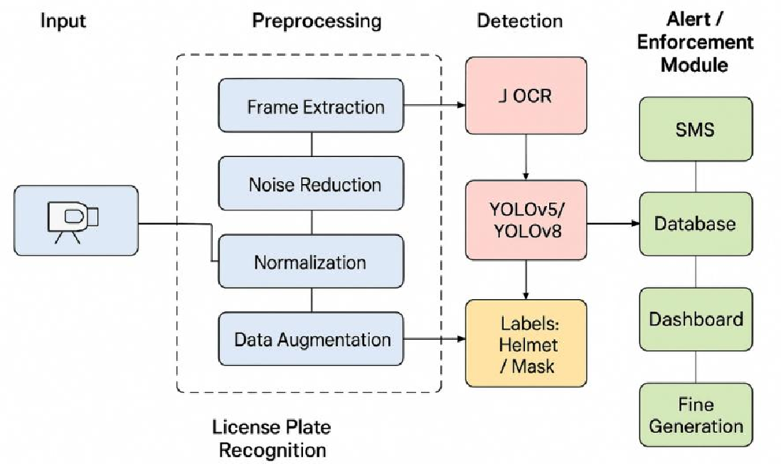

Figure 4: Helmet and Mask Detection Workflow
- Helmet and Mask Detection
Once frames are pre-processed, the system proceeds to the detection stage, where deep learning models are used to identify helmetsand face masks in each frame. Most reviewed studies employ object detection models such as YOLOv5, YOLOv8, Faster R-CNN, or custom CNN architectures. These models scan each frame and predict bounding boxes around detected objects, labelling them as “Helmet” or “Mask.” Some advanced systems also use multi-class detection, allowing simultaneous detection of both safety equipment types within the same frame. This stage is critical for real- time monitoring, as it directly impacts the system’s accuracy and efficiency. High-performing models can detect objects

even in crowded or partially occluded scenes, which is particularly important in traffic monitoring and industrial environments.

License Plate Recognition
In traffic monitoring systems, some studies incorporate License Plate Recognition (LPR) using Optical Character Recognition (OCR) as an additional module. After helmets and masks are detected, vehicles associated with violations can be identified by extracting the license plate from the frame. OCR algorithms analyse the extracted plate area, convert the image into text, and store the registration number in a database. This integration allows for automatic enforcement, such as issuing fines or alerts to authorities, and links detected violations directly to vehicles. The inclusion of LPR enhances the practical utility of the detection system, bridging the gap between detection and enforcement.

Alert / Enforcement Module
Once a violation is detected, such as a missing helmet or mask, some systemsinclude an alert or enforcement module to notify authorities or responsible personnel in real-time. Alerts can take the form of SMS notifications, mobile app alerts, or dashboard warnings. This module bridges the gap between detection and actionable response, ensuring that safety rules are enforced promptly. In some studies, alerts are integrated with the database, linking the violation details—such as location, time, and vehicle number—so that authorities can track repeat offenders or generate automated fines. Real- time alert systems enhance the practical applicability of detection systems in traffic management, industrial safety, and public health monitoring.
Despite the effectiveness of these methodologies, existing studies also highlight several challenges. Variations in lighting, weather conditions, and camera angles can reduce detection accuracy, while heavy traffic or occlusion may lead to missed violations. Some approaches address these issues by employing advanced data augmentation, multi-camera setups, or hybrid models that combine CNNs with YOLO or R-CNN architecture. Moreover, the choice of dataset and training strategy plays a crucial role in system performance with real-world datasets often outperforming synthetic ones in terms of generalization. Overall, these findings underlines importance of scalable, robust frameworks.
This comprehensive methodology ensures an end-to-end pipeline for automated traffic safety monitoring, from video acquisition to violation enforcement. By combining computer vision, deep learning, and OCR-based license plate recognition, the system minimizes manual intervention and provides a scalable solution for smart city applications. Furthermore, the integration of real-time alerts enables authorities to act promptly, improving compliance and road safety. Future advancements could focus on expanding the framework to detect additional violations, such as over – speeding or triple riding and on leveraging cloud-based platforms for large – scale deployment across urban environments.

FLOWCHART
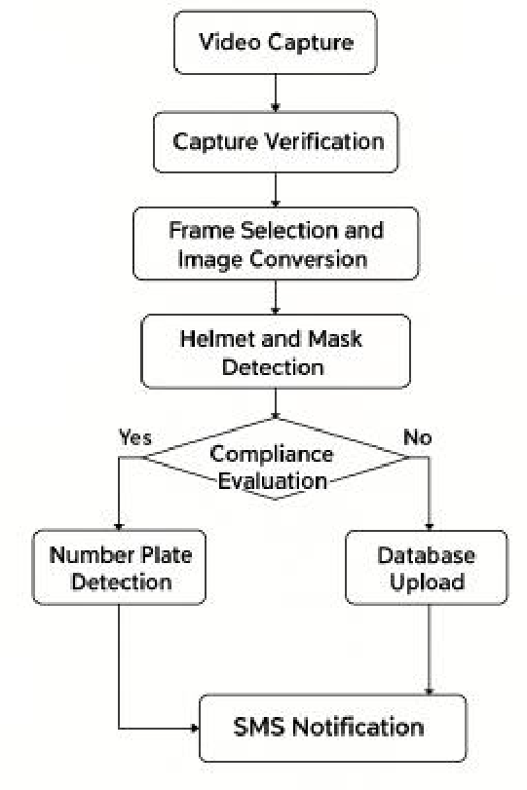

Figure 5: The flowchart of Helmet and Mask Violation Detection

The above flowchart begins with video capture, where a live feed from traffic or surveillance cameras provides the main input. The system then performs capture verification to ensure the camera is active before moving forward. Next, frame selection and image conversion take place, where specific frames are picked from the video and converted into a format suitable for analysis. These frames are processed through a YOLOv5 deep learning model that detects helmets and face masks. In the compliance evaluation step, the system checks if individuals are wearing helmets or masks correctly. If they are compliant, no further action is taken. If a violation is detected, the system proceeds to number plate detection using OCR to extract and convert the license plate into text. This information is then sent to a database upload stage, linking the violation to the vehicle owner’s details. Based on the violation type, the system performs fine calculation according to safety rules. Finally, the process ends with an SMS notification sent to the owner, containing the violation details, fine amount, and payment instructions, ensuring real-time enforcement.

OBSERVATION AND DISCUSSION
From the reviewed studies, it is evident that deep learning models like YOLOv5, YOLOv8, and CNNs are highly effective in real-time detection tasks, especially for identifying helmet and mask violations. Many systems integrated OCR to successfully recognize license plates and issue alerts, automating the entire violation-handling process. The combination of these technologies has shown promising accuracy and scalability across different conditions like lighting, camera angles, and

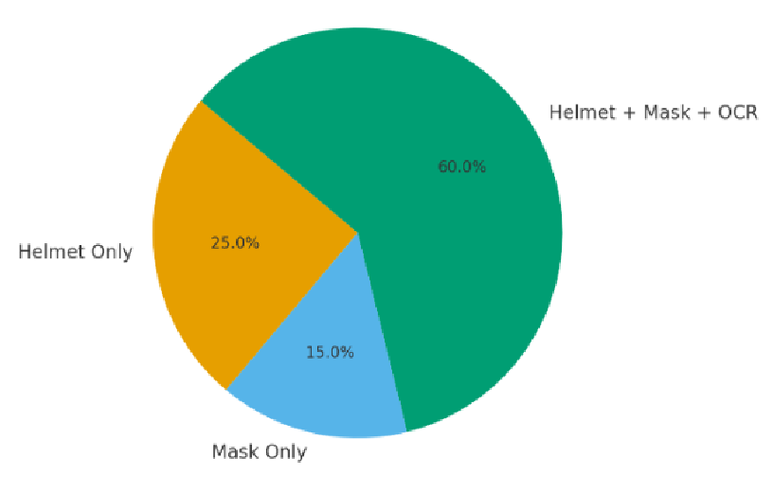
crowd density. These observations have guided the design of our proposed system, which aims to merge the strengths of these approaches into a unified, efficient safety enforcement model.

Figure 6: Shows the percentage of systems focusing on Helmet only, Mask only, Combined Helmet+ Mask +OCR
This above Pie chart represents the distribution of detection systems used for safety and monitoring, specifically focusing on helmet, mask, and OCR detection in a traffic or public safety context. The largest portion shows 60% of cases involve a combined system that detects helmets face mask and reads vehicle license plates using OCR. This indicates that a unified system is prefer for maximum monitoring efficiency. 25% of the detection are focused solely on helmet usage, this ensures rider safety. 15% of cases involve only mask detection, likely used in public health scenarios or enforcement of mask-wearing rules.
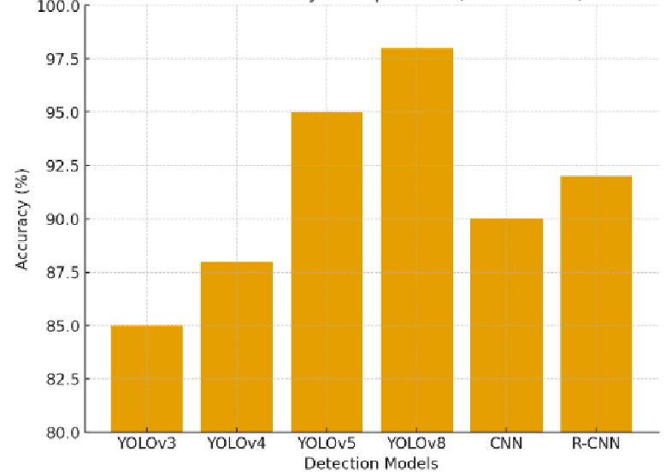

Figure 7: Model Accuracy Comparison

The chart illustrates a comparison of detection model accuracies from 2022 to 2025. Among the models YOLOv8 demonstrates the highest performance with an accuracy of about 98%, making it the most efficient and reliable choice. YOLOv5 follows with 95%, proving to be a strong model widely used in various detection tasks. R-CNN achieves 92% accuracy, which is slightly higher than CNN at 90%, showing that region-based methods are generally more effective than traditional CNNs. Meanwhile, YOLOv4 records 88%, an improvement over YOLOv3, which has the lowest accuracy at85%. Overall, the chart clearly shows that the YOLO family, particularly the latest versions, significantly outperforms traditiona l CNN-based approaches, highlighting continuous advancements in deep learning–based object detection.
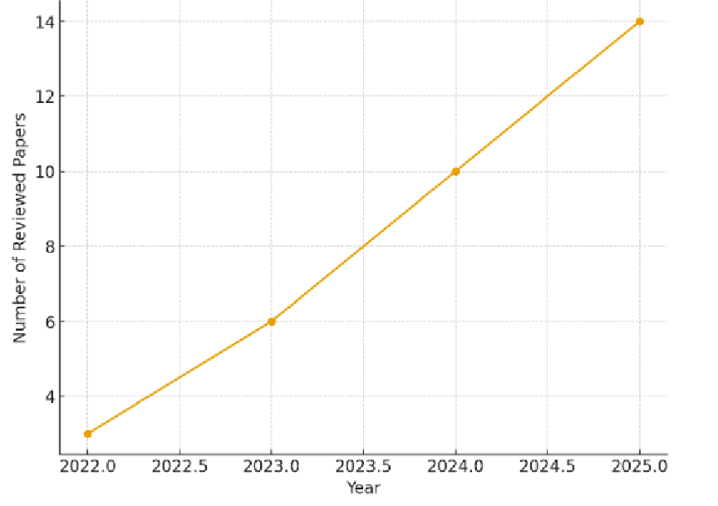

Figure 8: displays growth in reviewed papers from 2025
The graph illustrates the research trends in helmet and mask detection between 2022 and 2025, based on the number of reviewed papers each year. In 2022, only three papers were published, but the number steadily increased to six in 2023, ten in 2024, and finally peaked at fourteen in 2025. This consistent upward trend highlights the growing importance of safety monitoring technologies in recent years. The sharp rise indicates that researchers are increasingly focusing on deep lea rning and computer vision–based approaches for helmet and mask detection, reflecting both technological advancements and the rising demand for intelligent safety solutions in public health and road safety domains.

CONCLUSION
This review focused on exploring how AI-powered technologies like YOLO, CNNs, and OCR can be used to build smart surveillance systems for helmet and face mask detection. By going through several research works, it became evident that deep learning offers accurate and fast solutions that can work well even in real-time traffic and public settings. Manual monitoring has its limitations, and the need for intelligent automation is growing. Our proposed system aims to fill this gap by not only detecting violations but also sending automated SMS alerts with fine details, helping authorities enforce safety rules more effectively. This approach not only promotes responsible behaviour but also supports public health and road safety through scalable, tech-driven enforcement.

REFERENCES
- Agorku, G., Agbobli, D., Chowdhury, V., Amankwah-Nkyi, K., Ogungbire, A., Lartey, P. A., & Aboah, A. (2023). Real- time helmet violation detection using YOLOv5 and ensemble learning. arXiv preprint arXiv:2304.09246.
- Ahmed, M. I. B., Saraireh, L., Rahman, A., Al-Qarawi, S., Mhran, A., Al-Jalaoud, J., … & Gollapalli, M. (2023). Personal
protective equipment detection: A deep-learning-based sustainable approach. Sustainability, 15(18), 13990.
- Ashkanani, M., AlAjmi, A., Alhayyan, A., Esmael, Z., AlBedaiwi, M., & Nadeem, M. (2025). A self -adaptive traffic signal system integrating real-time vehicle detection and license plate recognition. Inventions, 10(1), 14.
- Baruah, S., Dutta, S., Chetia, A., Das, M. P., Choudhury, S., Saikia, N., & Varte, N. R. (2025). Helmet and number plate
detection using different YOLO algorithms. In Sustainable Development, Innovation and Green Technology (ICASDIGT- 2024) (pp. 473–480).
- Chen, Z., Zhang, F., Liu, H., Wang, L., Zhang, Q., & Guo, L. (2023). Real-time detection algorithm of helmet and reflective vest based on improved YOLOv5. Journal of Real-Time Image Processing, 20(1), 4.
- Dahiya, K., Singh, D., & Mohan, C. K. (2016). Automatic detection of bike riders without helmets using survei lance
videos in real-time. In 2016 International Joint Conference on Neural Networks (IJCNN) (pp. 3046–3051). IEEE.
- Han, Z., et al. (2022). SMD-YOLO: An efficient lightweight method for face mask detection and monitoring. Applied Sciences, 12(9), 4567.
- Jia, W., Xu, S., Liang, Z., Zhao, Y., Min, H., Li, S., & Yu, Y. (2021). Real-time automatic helmet detection of motorcyclists in urban traffic using improved detectors. IET Image Processing, 15(14), 3623–3637.
- Kanakaraj, S. (2021). Real-time motorcyclists’ helmet detection and vehicle license plate extraction using deep lea rning
techniques (Doctoral dissertation, National College of Ireland).
- Khow, Z. J., Goh, M. K. O., Tee, C., & Law, C. Y. (2022). A YOLOv5 -based real-time helmet and mask detection system. Journal of Logistics, Informatics and Service Science, 9 (3), 97–111.
- Krishnana Kumar, D. A. K. S., & Singh, A. (2025). ML-based surveillance system for detection of bike rides without helmets and triple rides. International Journal of Sciences and Innovation Engineering, 2 (6), 50–57.
- Kwak, N., & Kim, D. (2023). Detection of worker’s safety helmet and mask and identification of worker using deep
learning. Computers, Materials and Continua, 75 (1), 1671–1686.
- Li, S., Lv, Y., Liu, X., & Li, M. (2023). Detection of safety helmet and mask wearing using improved YOLOv5s.
Scientific Reports, 13(1), 21417.
- Li, J., Li, Y., Villaverde, J. F., Chen, X., & Zhang, X. (2024). A safety helmet detection method using a deep lea rning approach. Journal of Optics, 53(2), 1163–1169.
- Pham, T. N., et al. (2023). Integration of improved YOLOv5 for face mask detector and monitoring. Electronics, 12(15), 3156.
- Qin, B., & Li, D. (2020). Identifying facemask-wearing condition using image super-resolution with classification network. Sensors, 20(18), 5236.
- Rahmani, M. K. I., Taranum, F., Nikhat, R., Farooqi, M. R., & Khan, M. A. (2022). Automatic real-time medical mask detection using deep learning to fight COVID-19. Computer Systems Science & Engineering, 42 (3), 1181–1198.
- Sanjeewani, P., Neuber, G., Fitzgerald, J., Chandrasena, N., Potums, S., Alavi, A., & Lane, C. (2024). Real-time personal
protective equipment non-compliance recognition on AI edge cameras. Electronics, 13(15), 2990.
- Tahilramani, N., Ahir, P., Saxena, S., Talreja, V. P., & Charanarur, P. (2025). Edge-based AI solution for helmet compliance monitoring with YOLOv9 on Raspberry Pi. Discover Internet of Things, 5(1), 1–14.
- Zhang, Y., Guo, Z., Wu, J., Tian, Y., Tang, H., & Guo, X. (2022). Real-time vehicle detection based on improved YOLOv5. Sustainability, 14(19), 12274.

