HW5

**Divya Kamma UIN: 670505193**

**Preethi Reddy Nandanuru UIN: 654074552**

**Ashrita Cheetirala UIN: 659259358**

#Loading the datasets  
library(tidyverse)

library(readxl)

library(dplyr)

library(rpart)

library(randomForest)

library(ggplot2)

library(factoextra)

library(scales)

library(cluster)

library(fastDummies)

#Reading the dataset into R  
raw_data = read_excel("/Users/ashritacheetirala/Desktop/UIC/Sem 2/Data Mining/HW5/IMB881-XLS-ENG.xlsx",sheet=2)

Preprocessing the data

#Removing Unnecessary columns from the dataset  
df <- subset (raw_data, select = -c(CustomerOrderNo,Custorderdate,UnitName,TotalArea))  
#df  
  
#Converting all binary and categorical variables to factors  
cols <- c("OrderType","OrderCategory","CustomerCode","CountryName","ITEM_NAME","QualityName","DesignName","ColorName","ShapeName")  
df[cols]<- lapply(df[cols], factor)  
#str(df)  
#summary(df)  
typeof(df$QtyRequired)

## [1] "double"

df$QtyRequired <- as.factor(df$QtyRequired)  
df$QtyRequired <- as.numeric(df$QtyRequired)  
df$Amount <- as.integer(df$Amount)  
df$AreaFt <- as.integer(df$AreaFt)

**Q1 Visualising the data to provide key insights**

#Creating a dataframe to visulaise the revenue generated by various items  
group_country <- df %>%   
 group_by(CountryName) %>%   
 dplyr::summarise(Amount = sum(Amount)) %>%   
 as.data.frame()  
#Revenue generated by each country  
bar <- ggplot(group_country, aes(fct_reorder(CountryName, Amount),Amount))+  
 geom_bar(stat="identity", fill="steelblue")+  
 geom_text(aes(label=Amount), vjust=1.6, color="black", size=3.5)+  
 coord_flip()+  
 theme(axis.text.x=element_blank(),  
 axis.ticks.x=element_blank())  
bar

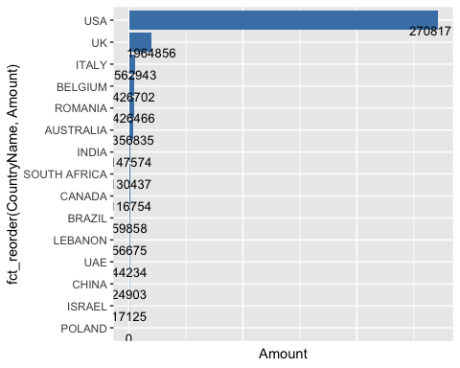

Insight: The United States sells the most carpets, followed by the United Kingdom. Other countries that contribute significantly to revenue include Italy, Romania, Australia, India, Canada, and South Africa.

#Creating a dataframe to visulaise the revenue generated by various items  
grouped_item <- df %>%   
 group_by(ITEM_NAME) %>%   
 dplyr::summarise(Amount = sum(Amount)) %>%   
 as.data.frame()  
#Revenue generated for various types of carpets  
pie <- ggplot(grouped_item, aes(x = "", y = Amount, fill = ITEM_NAME)) +  
 theme_void()+  
 geom_text(aes(label = paste0(round(Amount/sum(Amount)*100), "%")), position = position_stack(vjust = 0.5))+  
 geom_bar(width = 1, stat = "identity") +   
 coord_polar(theta = "y", start = 0) +  
 ggtitle("Revenue generated from various types of carpets")  
pie

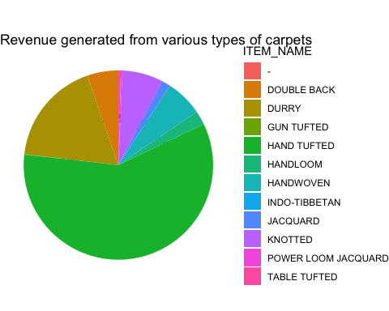

Insight: With this visualisation we can see that Hand Tufted carpet contributed the highest to the revenue followed by Durry and the lowest being power loom jacquared.

#Creating a dataframe to visulaise the revenue generated by various items  
group_item <- df %>%   
 group_by(ITEM_NAME) %>%   
 dplyr::summarise(QtyRequired = sum(QtyRequired)) %>%   
 as.data.frame()  
#Number of units of each item sold  
col <- group_item %>%   
 ggplot(aes(fct_reorder(ITEM_NAME, QtyRequired), QtyRequired))+  
 geom_col(fill="gold") +  
 labs(x="Name of Item")+  
 geom_text(aes(label=QtyRequired), vjust=1.6, color="black", size=3.5)+  
 theme(axis.text.y=element_blank(),axis.ticks.y=element_blank())+  
 theme(axis.text.x = element_text(angle = 45, vjust = 1, hjust = 1))+  
 ggtitle("Number of units sold of each item")  
col

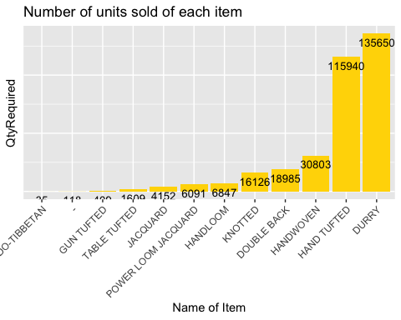

Insight: The “Durry” type carpets were sold the most, but it was the second highest contributor of revenue and significantly lower than “Hand Tufted” in terms of revenue, so we can say it is much cheaper in price. Because “Hand Tufted” carpet is the highest revenue generator but the number of units sold is much lower, we can say that it is on the expensive side and thus a premium quality carpet.

**Q2 What ML models can Champo Carpets use to solve their problems**

Champo Carpets can use various ML algorithms to solve their problem. Champo Carpet's main aim is to reduce the number of false positives. When the order is actually not converted, but they are predicted as converted, there will be loss for Champo carpets as the samples made are wasted and it is expensive to make each sample. Hence, the champo carpets must be focusing on improving the precision(actually not converted but predicted as converted).

All the ML classification algorithms like decision trees, randoForest can be used to find out the precision of test data. When it comes to improving the precision, it is better to use randomForest than decision trees as it prevents overfitting by using multiple trees. Neural networks can also be used to predict the future data as it discovers any complex relations hidden in the data.

With regression, we can predict the output based on input variables. We can find out the importance of the variables by checking if they are statistically significant or not. Logistic regression can be performed to understand the relationship between predictor variables and probability of orders getting converted to samples.

**Q3 Various ML Models on Balanced and imbalanced data**

data_sample = read_excel("/Users/ashritacheetirala/Desktop/UIC/Sem 2/Data Mining/HW5/IMB881-XLS-ENG.xlsx",sheet=4)  
library('fastDummies')  
data_sample <- dummy_cols(data_sample, select_columns = 'CountryName')

#data cleaning   
data_sample_decion_tree <- subset(data_sample,select = -c(USA,UK,Italy,Belgium,Romania,Australia,India,`Hand Tufted`,Durry,`Double Back`,`Hand Woven`,Knotted,Jacquard,Handloom,Other,REC,Round,Square,CountryName_AUSTRALIA,CountryName_BELGIUM,CountryName_BRAZIL,CountryName_CANADA,CountryName_CHINA,CountryName_INDIA,CountryName_ISRAEL,CountryName_ITALY,CountryName_POLAND,CountryName_ROMANIA,`CountryName_SOUTH AFRICA`,CountryName_UAE,CountryName_UK,CountryName_USA,CustomerCode))  
str(data_sample_decion_tree)

## tibble [5,820 × 6] (S3: tbl_df/tbl/data.frame)  
## $ CountryName : chr [1:5820] "INDIA" "USA" "USA" "USA" ...  
## $ QtyRequired : num [1:5820] 1 1 2 1 1 1 1 1 1 1 ...  
## $ ITEM_NAME : chr [1:5820] "HAND TUFTED" "HAND TUFTED" "HAND TUFTED" "HAND TUFTED" ...  
## $ ShapeName : chr [1:5820] "REC" "REC" "REC" "REC" ...  
## $ AreaFt : num [1:5820] 80 80 80 80 80 80 80 40 108 54 ...  
## $ Order Conversion: num [1:5820] 1 1 1 1 1 1 1 1 0 1 ...  
## - attr(*, ".internal.selfref")=<externalptr>

data_sample_decion_tree$`Order Conversion` <- ifelse(data_sample_decion_tree$`Order Conversion`==1,"Yes","No")  
df1<-data_sample_decion_tree

cols <- c("CountryName","ITEM_NAME","ShapeName","Order Conversion")  
df1[cols]<- lapply(df1[cols], factor)  
str(df1)

## tibble [5,820 × 6] (S3: tbl_df/tbl/data.frame)  
## $ CountryName : Factor w/ 14 levels "AUSTRALIA","BELGIUM",..: 6 14 14 14 14 6 6 14 14 6 ...  
## $ QtyRequired : num [1:5820] 1 1 2 1 1 1 1 1 1 1 ...  
## $ ITEM_NAME : Factor w/ 11 levels "DOUBLE BACK",..: 4 4 4 4 4 1 1 4 4 4 ...  
## $ ShapeName : Factor w/ 3 levels "REC","ROUND",..: 1 1 1 1 1 1 1 1 1 1 ...  
## $ AreaFt : num [1:5820] 80 80 80 80 80 80 80 40 108 54 ...  
## $ Order Conversion: Factor w/ 2 levels "No","Yes": 2 2 2 2 2 2 2 2 1 2 ...  
## - attr(*, ".internal.selfref")=<externalptr>

#decision tree  
set.seed(60)   
indx <- sample(2, nrow(df1), replace=TRUE, prob=c(0.5,0.5))#dividing the dataset into training and test with 50% in train and 50% in test   
train <-df1 [indx==1, ] #assigning all the rows with index 1 to train   
test <- df1 [indx==2, ] #assigning all the rows with index 2 to test   
library("rpart.plot")   
tree_m1 <- rpart(`Order Conversion` ~ ., train, parms = list(split = "gini" )) #constructing the decision tree using rpart print( tree_m1) #printing the decision tree  
  
plotcp(tree_m1)

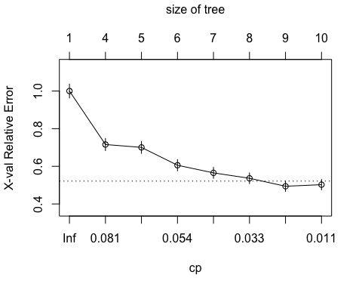

rpart.plot(tree_m1)

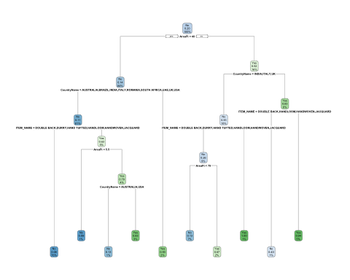

tree_pred_class_1 <- predict(tree_m1, train, type = "class")#using predict function to predict the classes of training data   
trainerror_1 <- mean(tree_pred_class_1 != train$`Order Conversion`) #calculating the training error  
trainerror_1

## [1] 0.09051144

tree_pred_test_1 <- predict(tree_m1, newdata=test, type = "class")#using predict function to predict the classes of test data   
testerror_1 <- mean(tree_pred_test_1 != test$`Order Conversion`) #calculating the test error  
testerror_1

## [1] 0.1014747

difference <- testerror_1 - trainerror_1  
difference

## [1] 0.01096328

CM <- table(tree_pred_test_1,test$`Order Conversion`)   
print(CM)

##   
## tree_pred_test_1 No Yes  
## No 2220 239  
## Yes 50 339

#Assigning the values of matrix to the following variables   
TN =CM[1,1]   
TP =CM[2,2]  
FP =CM[1,2]   
FN =CM[2,1]   
precision_test =(TP)/(TP+FP) #calculating precision of test data  
precision_test

## [1] 0.5865052

prop.table(table(df1$`Order Conversion`))

##   
## No Yes   
## 0.7991409 0.2008591

minsplt <- c(15, 51, 104) #assigning random vector values to minsplit   
minbckt <- c(5, 17, 38) #assigning random vector values to minbckt   
#looping through to try different combinations of minsplit and minbucket   
for (i in minsplt){  
for (j in minbckt){   
tree_m1 <- rpart(`Order Conversion` ~ ., train, parms = list(split = "gini" ), control = rpart.control(minbucket = j, minsplit =i, cp=0.01))  
tree_pred_class_1 <- predict(tree_m1, train, type = "class")#using predict function to predict the classes of training data   
trainerror_1 <- mean(tree_pred_class_1 != train$`Order Conversion`) #calculating the training error   
tree_pred_test_1 <- predict(tree_m1, test, type = "class")#using predict function to predict the classes of test data  
testerror_1 <- mean(tree_pred_test_1 != test$`Order Conversion`) #calculating the test error   
dif <- testerror_1-trainerror_1 #finding out the difference between test error and training error   
CM <- table(tree_pred_test_1, test$`Order Conversion`)  
print(CM)   
#Assigning the values of matrix to the following variables  
TN =CM[1,1]   
TP =CM[2,2]   
FP =CM[1,2]   
FN =CM[2,1]   
precision_test =(TP)/(TP+FP) #calculating precision of test data  
print(precision_test)  
}}

##   
## tree_pred_test_1 No Yes  
## No 2220 239  
## Yes 50 339  
## [1] 0.5865052  
##   
## tree_pred_test_1 No Yes  
## No 2220 239  
## Yes 50 339  
## [1] 0.5865052  
##   
## tree_pred_test_1 No Yes  
## No 2180 249  
## Yes 90 329  
## [1] 0.5692042  
##   
## tree_pred_test_1 No Yes  
## No 2220 239  
## Yes 50 339  
## [1] 0.5865052  
##   
## tree_pred_test_1 No Yes  
## No 2220 239  
## Yes 50 339  
## [1] 0.5865052  
##   
## tree_pred_test_1 No Yes  
## No 2180 249  
## Yes 90 329  
## [1] 0.5692042  
##   
## tree_pred_test_1 No Yes  
## No 2220 239  
## Yes 50 339  
## [1] 0.5865052  
##   
## tree_pred_test_1 No Yes  
## No 2220 239  
## Yes 50 339  
## [1] 0.5865052  
##   
## tree_pred_test_1 No Yes  
## No 2180 249  
## Yes 90 329  
## [1] 0.5692042

#decision tree  
set.seed(60)   
indx <- sample(2, nrow(df1), replace=TRUE, prob=c(0.7,0.3))#dividing the dataset into training and test with 50% in train and 50% in test   
train <-df1 [indx==1, ] #assigning all the rows with index 1 to train   
test <- df1 [indx==2, ] #assigning all the rows with index 2 to test   
library("rpart.plot")   
tree_m2 <- rpart(`Order Conversion` ~ ., train, parms = list(split = "gini" )) #constructing the decision tree using rpart print( tree_m2) #printing the decision tree  
plotcp(tree_m2)

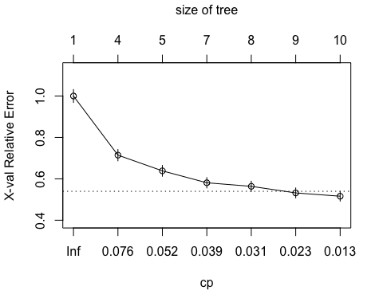

rpart.plot(tree_m2)

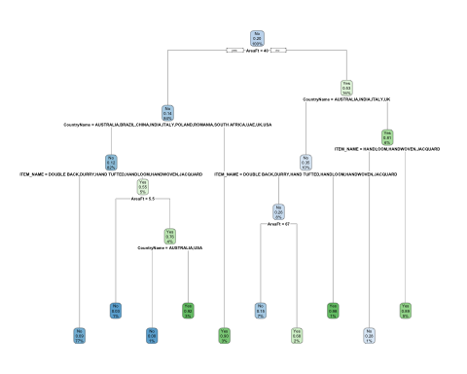

printcp(tree_m2)

##   
## Classification tree:  
## rpart(formula = `Order Conversion` ~ ., data = train, parms = list(split = "gini"))  
##   
## Variables actually used in tree construction:  
## [1] AreaFt CountryName ITEM_NAME   
##   
## Root node error: 816/4042 = 0.20188  
##   
## n= 4042   
##   
## CP nsplit rel error xerror xstd  
## 1 0.097222 0 1.00000 1.00000 0.031274  
## 2 0.058824 3 0.70833 0.71446 0.027373  
## 3 0.046569 4 0.64951 0.63848 0.026107  
## 4 0.031863 6 0.55637 0.58088 0.025068  
## 5 0.030637 7 0.52451 0.56373 0.024743  
## 6 0.017157 8 0.49387 0.53186 0.024121  
## 7 0.010000 9 0.47672 0.51593 0.023799

tree_pred_class_2 <- predict(tree_m2, train, type = "class")#using predict function to predict the classes of training data   
trainerror_2 <- mean(tree_pred_class_2 != train$`Order Conversion`) #calculating the training error  
trainerror_2

## [1] 0.09623949

tree_pred_test_2 <- predict(tree_m2, newdata=test, type = "class")#using predict function to predict the classes of test data   
testerror_2 <- mean(tree_pred_test_2 != test$`Order Conversion`) #calculating the test error  
testerror_2

## [1] 0.09167604

difference <- testerror_2 - trainerror_2  
difference

## [1] -0.004563445

CM <- table(tree_pred_test_2,test$`Order Conversion`)   
print(CM)

##   
## tree_pred_test_2 No Yes  
## No 1393 131  
## Yes 32 222

#Assigning the values of matrix to the following variables   
TN =CM[1,1]   
TP =CM[2,2]  
FP =CM[1,2]   
FN =CM[2,1]   
precision_test =(TP)/(TP+FP) #calculating precision of test data  
print(precision_test)

## [1] 0.6288952

minsplt <- c(15, 51, 104) #assigning random vector values to minsplit   
minbckt <- c(5, 17, 38) #assigning random vector values to minbckt   
#looping through to try different combinations of minsplit and minbucket   
for (i in minsplt){  
for (j in minbckt){   
tree_m2 <- rpart(`Order Conversion` ~ ., train, parms = list(split = "gini" ), control = rpart.control(minbucket = j, minsplit =i, cp=0.01))  
tree_pred_class_2 <- predict(tree_m2, train, type = "class")#using predict function to predict the classes of training data   
trainerror_2 <- mean(tree_pred_class_2 != train$`Order Conversion`) #calculating the training error   
tree_pred_test_2 <- predict(tree_m2, test, type = "class")#using predict function to predict the classes of test data  
testerror_2 <- mean(tree_pred_test_2 != test$`Order Conversion`) #calculating the test error   
dif <- testerror_2-trainerror_2 #finding out the difference between test error and training error   
CM <- table(tree_pred_test_2, test$`Order Conversion`)  
print(CM)   
#Assigning the values of matrix to the following variables  
TN =CM[1,1]   
TP =CM[2,2]   
FP =CM[1,2]   
FN =CM[2,1]   
precision_test =(TP)/(TP+FP) #calculating precision of test data  
print(precision_test)  
}}

##   
## tree_pred_test_2 No Yes  
## No 1393 131  
## Yes 32 222  
## [1] 0.6288952  
##   
## tree_pred_test_2 No Yes  
## No 1393 131  
## Yes 32 222  
## [1] 0.6288952  
##   
## tree_pred_test_2 No Yes  
## No 1379 119  
## Yes 46 234  
## [1] 0.6628895  
##   
## tree_pred_test_2 No Yes  
## No 1393 131  
## Yes 32 222  
## [1] 0.6288952  
##   
## tree_pred_test_2 No Yes  
## No 1393 131  
## Yes 32 222  
## [1] 0.6288952  
##   
## tree_pred_test_2 No Yes  
## No 1379 119  
## Yes 46 234  
## [1] 0.6628895  
##   
## tree_pred_test_2 No Yes  
## No 1393 131  
## Yes 32 222  
## [1] 0.6288952  
##   
## tree_pred_test_2 No Yes  
## No 1393 131  
## Yes 32 222  
## [1] 0.6288952  
##   
## tree_pred_test_2 No Yes  
## No 1379 119  
## Yes 46 234  
## [1] 0.6628895

#decision tree  
set.seed(60)   
indx <- sample(2, nrow(df1), replace=TRUE, prob=c(0.8,0.2))#dividing the dataset into training and test with 50% in train and 50% in test   
train <- df1 [indx==1, ] #assigning all the rows with index 1 to train   
test <- df1 [indx==2, ] #assigning all the rows with index 2 to test   
library("rpart.plot")   
tree_m3 <- rpart(`Order Conversion` ~ ., train, parms = list(split = "gini" )) #constructing the decision tree using rpart print( tree_m2) #printing the decision tree  
rpart.plot(tree_m3)

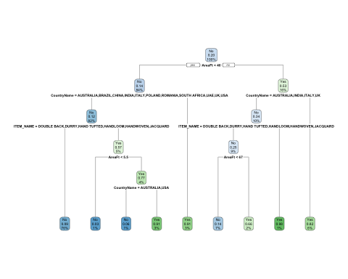

plotcp(tree_m3)

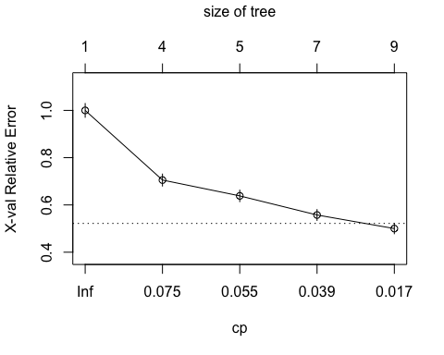

printcp(tree_m3)

##   
## Classification tree:  
## rpart(formula = `Order Conversion` ~ ., data = train, parms = list(split = "gini"))  
##   
## Variables actually used in tree construction:  
## [1] AreaFt CountryName ITEM_NAME   
##   
## Root node error: 940/4631 = 0.20298  
##   
## n= 4631   
##   
## CP nsplit rel error xerror xstd  
## 1 0.098936 0 1.00000 1.00000 0.029119  
## 2 0.057447 3 0.70319 0.70532 0.025356  
## 3 0.052128 4 0.64574 0.63830 0.024312  
## 4 0.029787 6 0.54149 0.55745 0.022933  
## 5 0.010000 8 0.48191 0.50000 0.021862

tree_pred_class_3 <- predict(tree_m3, train, type = "class")#using predict function to predict the classes of training data   
trainerror_3 <- mean(tree_pred_class_3 != train$`Order Conversion`) #calculating the training error  
trainerror_3

## [1] 0.09781905

tree_pred_test_3 <- predict(tree_m3, newdata=test, type = "class")#using predict function to predict the classes of test data   
testerror_3 <- mean(tree_pred_test_3 != test$`Order Conversion`) #calculating the test error  
testerror_3

## [1] 0.09167368

difference <- testerror_3 - trainerror_3  
difference

## [1] -0.00614537

CM <- table(tree_pred_test_3,test$`Order Conversion`)   
print(CM)

##   
## tree_pred_test_3 No Yes  
## No 937 86  
## Yes 23 143

#Assigning the values of matrix to the following variables   
TN =CM[1,1]   
TP =CM[2,2]  
FP =CM[1,2]   
FN =CM[2,1]   
precision_test =(TP)/(TP+FP) #calculating precision of test data  
print(precision_test)

## [1] 0.6244541

minsplt <- c(15, 51, 104) #assigning random vector values to minsplit   
minbckt <- c(5, 17, 38) #assigning random vector values to minbckt   
#looping through to try different combinations of minsplit and minbucket   
for (i in minsplt){  
for (j in minbckt){   
tree_m3 <- rpart(`Order Conversion` ~ ., train, parms = list(split = "gini" ), control = rpart.control(minbucket = j, minsplit =i, cp=0.01))  
tree_pred_class_3 <- predict(tree_m2, train, type = "class")#using predict function to predict the classes of training data   
trainerror_3 <- mean(tree_pred_class_3 != train$`Order Conversion`) #calculating the training error   
tree_pred_test_3 <- predict(tree_m3, test, type = "class")#using predict function to predict the classes of test data  
testerror_3 <- mean(tree_pred_test_3 != test$`Order Conversion`) #calculating the test error   
dif <- testerror_3-trainerror_3 #finding out the difference between test error and training error   
CM <- table(tree_pred_test_3, test$`Order Conversion`)  
print(CM)   
#Assigning the values of matrix to the following variables  
TN =CM[1,1]   
TP =CM[2,2]   
FP =CM[1,2]   
FN =CM[2,1]   
precision_test =(TP)/(TP+FP) #calculating precision of test data  
print(precision_test)  
}}

##   
## tree_pred_test_3 No Yes  
## No 937 86  
## Yes 23 143  
## [1] 0.6244541  
##   
## tree_pred_test_3 No Yes  
## No 937 86  
## Yes 23 143  
## [1] 0.6244541  
##   
## tree_pred_test_3 No Yes  
## No 933 85  
## Yes 27 144  
## [1] 0.628821  
##   
## tree_pred_test_3 No Yes  
## No 937 86  
## Yes 23 143  
## [1] 0.6244541  
##   
## tree_pred_test_3 No Yes  
## No 937 86  
## Yes 23 143  
## [1] 0.6244541  
##   
## tree_pred_test_3 No Yes  
## No 933 85  
## Yes 27 144  
## [1] 0.628821  
##   
## tree_pred_test_3 No Yes  
## No 937 86  
## Yes 23 143  
## [1] 0.6244541  
##   
## tree_pred_test_3 No Yes  
## No 937 86  
## Yes 23 143  
## [1] 0.6244541  
##   
## tree_pred_test_3 No Yes  
## No 933 85  
## Yes 27 144  
## [1] 0.628821

When the order is actually not converted, but they are predicted as converted, there will be loss for Champo carpets as the samples made are wasted. Hence, we chose precision as our performance metric as it is crucial to reduce the False positives(actually not converted but predicted as converted)

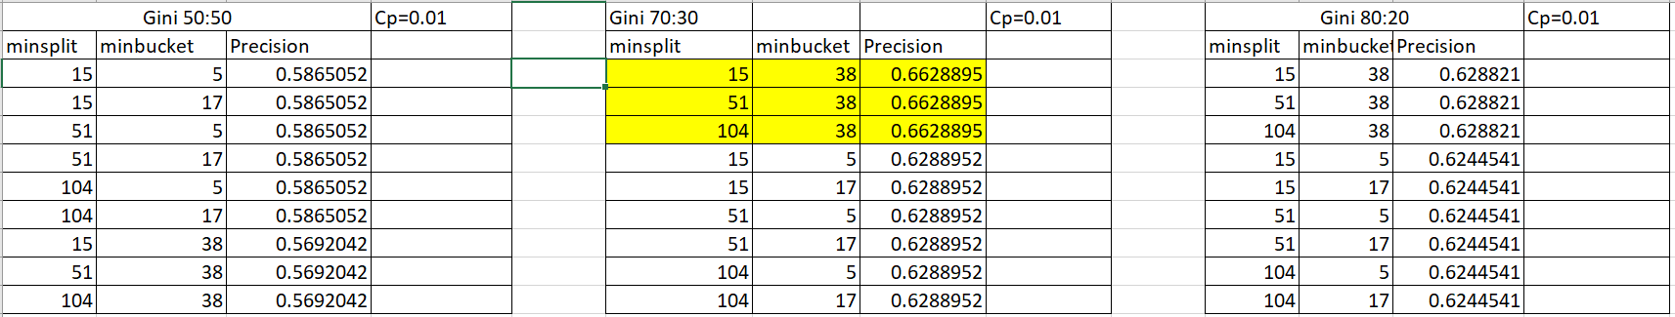

According to the decision trees that have been constructed above, we can conclude that 70:30 split with the highlighted pruning parameters gives us the best recall.

Constructing random forests with different ntree values and finding the best mtry for each model to derive a single model with the best performance

#Random Forest Model  
rf <- randomForest(`Order Conversion` ~ ., data = df1, mtry = sqrt(ncol(df1)-1), ntree = 100, proximity = T, importance = T)  
imp_variables<-importance(rf, type = 2)   
imp_variables

## MeanDecreaseGini  
## CountryName 397.73962  
## QtyRequired 75.43505  
## ITEM_NAME 325.66212  
## ShapeName 11.19718  
## AreaFt 437.28314

#Model1  
set.seed(60)   
indx <- sample(2, nrow(df1), replace=TRUE, prob=c(0.8,0.2))#dividing the dataset into training and test with 80% in train and 20% in test   
train <- df1 [indx==1, ] #assigning all the rows with index 1 to train   
test <- df1 [indx==2, ] #assigning all the rows with index 2 to test  
pr.err <- c()   
for(mt in seq(1,ncol(train))) {   
 rf1 <- randomForest(`Order Conversion`~., data = train,   
 ntree = 100, mtry = ifelse(mt == ncol(train), mt-1, mt))  
predicted <- predict(rf1, newdata = test, type = "class")   
pr.err <- c(pr.err,mean(test$`Order Conversion` != predicted))  
}  
bestmtry <- which.min(pr.err)   
print(bestmtry)

## [1] 2

rf1 <- randomForest(`Order Conversion`~., data = train, ntree = 100, mtry =bestmtry)  
print(rf1)

##   
## Call:  
## randomForest(formula = `Order Conversion` ~ ., data = train, ntree = 100, mtry = bestmtry)   
## Type of random forest: classification  
## Number of trees: 100  
## No. of variables tried at each split: 2  
##   
## OOB estimate of error rate: 8.08%  
## Confusion matrix:  
## No Yes class.error  
## No 3596 95 0.02573828  
## Yes 279 661 0.29680851

predicted <- predict(rf1, newdata = test, type = "class")  
CM <- table(predicted, test$`Order Conversion`)  
print(CM)

##   
## predicted No Yes  
## No 942 62  
## Yes 18 167

TN =CM[1,1]   
TP =CM[2,2]   
FP =CM[1,2]   
FN =CM[2,1]  
precision_test =(TP)/(TP+FP) #calculating precision of test data  
precision_test

## [1] 0.7292576

#Model2  
set.seed(60)   
indx <- sample(2, nrow(df1), replace=TRUE, prob=c(0.8,0.2))#dividing the dataset into training and test with 80% in train and 20% in test   
train <- df1 [indx==1, ] #assigning all the rows with index 1 to train   
test <- df1 [indx==2, ] #assigning all the rows with index 2 to test  
pr.err <- c()   
for(mt in seq(1,ncol(train))) {   
 rf1 <- randomForest(`Order Conversion`~., data = train,   
 ntree = 300, mtry = ifelse(mt == ncol(train), mt-1, mt))  
predicted <- predict(rf1, newdata = test, type = "class")   
pr.err <- c(pr.err,mean(test$`Order Conversion` != predicted))  
}  
bestmtry <- which.min(pr.err)   
print(bestmtry)

## [1] 3

rf2 <- randomForest(`Order Conversion`~., data = train, ntree = 100, mtry =bestmtry)  
print(rf2)

##   
## Call:  
## randomForest(formula = `Order Conversion` ~ ., data = train, ntree = 100, mtry = bestmtry)   
## Type of random forest: classification  
## Number of trees: 100  
## No. of variables tried at each split: 3  
##   
## OOB estimate of error rate: 7.99%  
## Confusion matrix:  
## No Yes class.error  
## No 3587 104 0.02817665  
## Yes 266 674 0.28297872

predicted <- predict(rf2, newdata = test, type = "class")  
CM <- table(predicted, test$`Order Conversion`)  
print(CM)

##   
## predicted No Yes  
## No 943 64  
## Yes 17 165

TN =CM[1,1]   
TP =CM[2,2]   
FP =CM[1,2]   
FN =CM[2,1]  
precision_test =(TP)/(TP+FP) #calculating precision of test data  
precision_test

## [1] 0.720524

According to the randomforest models constructed above, the randomforest model1 is considered as it gives us the better precision.

We can also determine the important variables by looking at the gini reduction of each variable. We can see that AreaFt has highest gini reduction and hence the most important variable.

#Logistic Regression  
  
set.seed(60)   
  
indx <- sample(2, nrow(df1), replace=TRUE, prob=c(0.8,0.2))#dividing the dataset into training and test with 80% in train and 20% in test   
train <- df1 [indx==1, ] #assigning all the rows with index 1 to train   
test <-df1 [indx==2, ] #assigning all the rows with index 2 to test  
  
logitModel <- glm(`Order Conversion` ~ ., data = train, family = "binomial")  
summary(logitModel)

##   
## Call:  
## glm(formula = `Order Conversion` ~ ., family = "binomial", data = train)  
##   
## Deviance Residuals:   
## Min 1Q Median 3Q Max   
## -3.1078 -0.5763 -0.2752 -0.1939 2.9399   
##   
## Coefficients:  
## Estimate Std. Error z value Pr(>|z|)   
## (Intercept) -3.969318 1.059539 -3.746 0.000179 ***  
## CountryNameBELGIUM 5.842083 1.110103 5.263 1.42e-07 ***  
## CountryNameBRAZIL -11.109894 441.372931 -0.025 0.979918   
## CountryNameCANADA 5.410693 1.320485 4.098 4.18e-05 ***  
## CountryNameCHINA -10.993900 882.743997 -0.012 0.990063   
## CountryNameINDIA 0.060527 1.043021 0.058 0.953724   
## CountryNameISRAEL 17.903304 497.845236 0.036 0.971313   
## CountryNameITALY -0.904968 1.277944 -0.708 0.478856   
## CountryNamePOLAND -12.907589 624.194723 -0.021 0.983502   
## CountryNameROMANIA 3.282605 1.209900 2.713 0.006665 **   
## CountryNameSOUTH AFRICA -10.834542 441.372514 -0.025 0.980416   
## CountryNameUAE -13.074579 624.194707 -0.021 0.983288   
## CountryNameUK 1.818146 1.058550 1.718 0.085873 .   
## CountryNameUSA 1.520523 1.044529 1.456 0.145475   
## QtyRequired 0.001828 0.008499 0.215 0.829678   
## ITEM_NAMEDURRY 0.163334 0.205398 0.795 0.426495   
## ITEM_NAMEGUN TUFTED 2.567763 0.436026 5.889 3.89e-09 ***  
## ITEM_NAMEHAND TUFTED -0.113388 0.191289 -0.593 0.553345   
## ITEM_NAMEHANDLOOM -0.038127 0.362919 -0.105 0.916332   
## ITEM_NAMEHANDWOVEN -0.551874 0.252609 -2.185 0.028911 *   
## ITEM_NAMEINDO-TIBBETAN 18.341305 624.194734 0.029 0.976558   
## ITEM_NAMEJACQUARD -0.321314 0.431676 -0.744 0.456670   
## ITEM_NAMEKNOTTED 2.664355 0.257088 10.364 < 2e-16 ***  
## ITEM_NAMEPOWER LOOM JACQUARD 5.236311 0.421876 12.412 < 2e-16 ***  
## ITEM_NAMETABLE TUFTED 2.742235 0.468253 5.856 4.73e-09 ***  
## ShapeNameROUND 0.699944 0.392780 1.782 0.074745 .   
## ShapeNameSQUARE 0.710171 0.737405 0.963 0.335514   
## AreaFt 0.057997 0.002640 21.970 < 2e-16 ***  
## ---  
## Signif. codes: 0 '***' 0.001 '**' 0.01 '*' 0.05 '.' 0.1 ' ' 1  
##   
## (Dispersion parameter for binomial family taken to be 1)  
##   
## Null deviance: 4672.7 on 4630 degrees of freedom  
## Residual deviance: 3015.0 on 4603 degrees of freedom  
## AIC: 3071  
##   
## Number of Fisher Scoring iterations: 13

anova(logitModel, test="Chisq")

## Analysis of Deviance Table  
##   
## Model: binomial, link: logit  
##   
## Response: Order Conversion  
##   
## Terms added sequentially (first to last)  
##   
##   
## Df Deviance Resid. Df Resid. Dev Pr(>Chi)   
## NULL 4630 4672.7   
## CountryName 13 457.41 4617 4215.3 <2e-16 ***  
## QtyRequired 1 0.08 4616 4215.2 0.7772   
## ITEM_NAME 10 521.23 4606 3694.0 <2e-16 ***  
## ShapeName 2 0.10 4604 3693.9 0.9530   
## AreaFt 1 678.90 4603 3015.0 <2e-16 ***  
## ---  
## Signif. codes: 0 '***' 0.001 '**' 0.01 '*' 0.05 '.' 0.1 ' ' 1

Pred <- predict(logitModel, newdata = test, type = "response")  
err<-mean(Pred != test$`Order Conversion`)  
err

## [1] 1

Class <- ifelse(Pred >= 0.5, "YES", "NO")  
  
with(logitModel, null.deviance - deviance)

## [1] 1657.708

with(logitModel, df.null, df.residual)

## [1] 4630

with(logitModel, pchisq(null.deviance - deviance, df.null - df.residual, lower.tail = FALSE))

## [1] 0

According to the P values that we have got above, we can say that the variables CountryNameBELGIUM, CountryNameCANADA, CountryNameROMANIA, ITEM_NAMEGUN TUFTED, ITEM_NAMEHANDWOVEN, ITEM_NAMEKNOTTED, ITEM_NAMEPOWER LOOM JACQUARD, TEM_NAMETABLE TUFTED, AreaFt are significant as they are less than alpha (1%).

The anova table gives the residual deviance of null model and other variables. The more the difference in deviance between the null and residual, the best our model is doing against the null model. Hence, in the above table we can see that adding CountryName reduces the deviance. And AreaFt improves the AIC drastically and hence it is an important variable.

#Neural network  
library(dplyr)  
myscale <- function(x) {  
 (x - min(x)) / (max(x) - min(x))  
}  
df1 <- df1 %>% mutate_if(is.numeric, myscale)  
  
indx <- sample(2, nrow(df1), replace=TRUE, prob=c(0.8,0.2))#dividing the dataset into training and test with 80% in train and 20% in test   
train <- df1 [indx==1, ] #assigning all the rows with index 1 to train   
test <-df1 [indx==2, ] #assigning all the rows with index 2 to test  
  
library(nnet)  
nnModel <- nnet(`Order Conversion` ~ ., data = train, linout = FALSE,  
 size = 10, decay = 0.01, maxit = 500)

summary(nnModel)

#nnModel$wts  
#nnModel$fitted.values  
  
#install.packages("NeuralNetTools")  
library(NeuralNetTools)  
plotnet(nnModel)

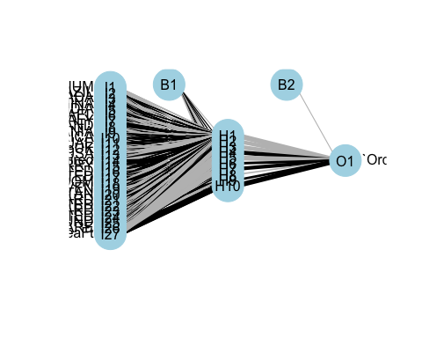

nn.preds = predict(nnModel, test)  
  
nn.preds = as.factor(predict(nnModel, test, type = "class"))  
  
  
CM <- table(nn.preds, test$`Order Conversion`)  
print(CM)

##   
## nn.preds No Yes  
## No 915 76  
## Yes 36 177

#Assigning the values of matrix to the following variables   
TN =CM[1,1]   
TP =CM[2,2]  
FP =CM[1,2]   
FN =CM[2,1]   
precision_test =(TP)/(TP+FP) #calculating precision of test data  
precision_test

## [1] 0.6996047

#decay parameter  
set.seed(60)  
indx <- sample(2, nrow(train), replace = T, prob = c(0.5, 0.5))  
train2 <- train[indx == 1, ]  
validation <- train[indx == 2, ]  
  
err <- vector("numeric", 100)  
d <- seq(0.0001, 1, length.out=100)  
k = 1  
for(i in d) {  
 mymodel <- nnet(`Order Conversion` ~., data = train2, decay = i, size = 10, maxit = 1000)  
 pred.class <- predict(mymodel, newdata = validation, type = "class")  
 err[k] <- mean(pred.class != validation$`Order Conversion`)  
 k <- k +1  
}

plot(d, err)

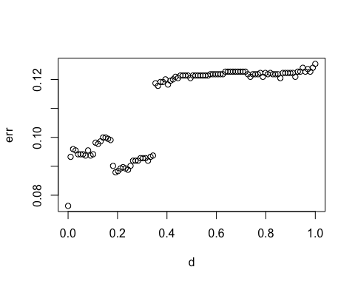

From the graph we can say that 0 is the best decay parameter as it gives the least error.

Balancing the data

library(ROSE)

## Loaded ROSE 0.0-4

colnames(df1)[which(names(df1) == "Order Conversion")] <- "Target"  
  
#balancing the data  
balanced_data <- ovun.sample(Target~.,data = df1,method = "over",N = 9600)$data  
summary(balanced_data$Target)

## No Yes   
## 4651 4949

#decision tree  
set.seed(60)   
indx <- sample(2, nrow(balanced_data), replace=TRUE, prob=c(0.5,0.5))#dividing the dataset into training and test with 50% in train and 50% in test   
train <- balanced_data [indx==1, ] #assigning all the rows with index 1 to train   
test <- balanced_data [indx==2, ] #assigning all the rows with index 2 to test   
library("rpart.plot")   
tree_m1 <- rpart(Target ~ ., train, parms = list(split = "gini" )) #constructing the decision tree using rpart print( tree_m1) #printing the decision tree

plotcp(tree_m1)

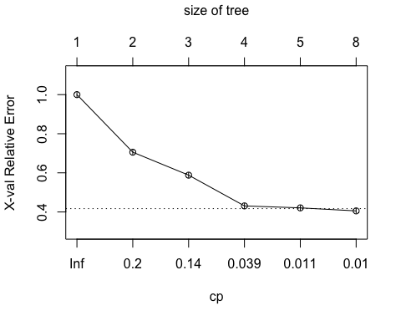

rpart.plot(tree_m1)

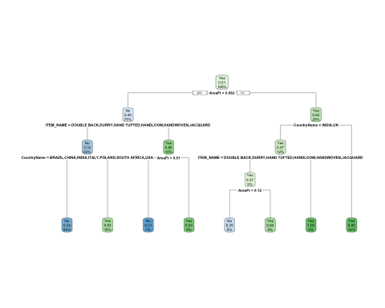

tree_pred_class_1 <- predict(tree_m1, train, type = "class")#using predict function to predict the classes of training data   
trainerror_1 <- mean(tree_pred_class_1 != train$Target) #calculating the training error  
trainerror_1

## [1] 0.1902208

tree_pred_test_1 <- predict(tree_m1, newdata=test, type = "class")#using predict function to predict the classes of test data   
testerror_1 <- mean(tree_pred_test_1 != test$Target) #calculating the test error  
testerror_1

## [1] 0.1874606

difference <- testerror_1 - trainerror_1  
difference

## [1] -0.002760204

CM <- table(tree_pred_test_1,test$Target)   
print(CM)

##   
## tree_pred_test_1 No Yes  
## No 2120 751  
## Yes 140 1742

#Assigning the values of matrix to the following variables   
TN =CM[1,1]   
TP =CM[2,2]  
FP =CM[1,2]   
FN =CM[2,1]   
precision_test =(TP)/(TP+FP) #calculating precision of test data  
precision_test

## [1] 0.6987565

minsplt <- c(15, 51, 104) #assigning random vector values to minsplit   
minbckt <- c(5, 17, 38) #assigning random vector values to minbckt   
#looping through to try different combinations of minsplit and minbucket   
for (i in minsplt){  
for (j in minbckt){   
tree_m1 <- rpart(Target ~ ., train, parms = list(split = "gini" ), control = rpart.control(minbucket = j, minsplit =i, cp=0.01))  
tree_pred_class_1 <- predict(tree_m1, train, type = "class")#using predict function to predict the classes of training data   
trainerror_1 <- mean(tree_pred_class_1 != train$Target) #calculating the training error   
tree_pred_test_1 <- predict(tree_m1, test, type = "class")#using predict function to predict the classes of test data  
testerror_1 <- mean(tree_pred_test_1 != test$Target) #calculating the test error   
dif <- testerror_1-trainerror_1 #finding out the difference between test error and training error   
CM <- table(tree_pred_test_1, test$Target)  
print(CM)   
#Assigning the values of matrix to the following variables  
TN =CM[1,1]   
TP =CM[2,2]   
FP =CM[1,2]   
FN =CM[2,1]   
precision_test =(TP)/(TP+FP) #calculating precision of test data  
print(precision_test)  
}}

##   
## tree_pred_test_1 No Yes  
## No 2120 751  
## Yes 140 1742  
## [1] 0.6987565  
##   
## tree_pred_test_1 No Yes  
## No 2120 751  
## Yes 140 1742  
## [1] 0.6987565  
##   
## tree_pred_test_1 No Yes  
## No 2120 751  
## Yes 140 1742  
## [1] 0.6987565  
##   
## tree_pred_test_1 No Yes  
## No 2120 751  
## Yes 140 1742  
## [1] 0.6987565  
##   
## tree_pred_test_1 No Yes  
## No 2120 751  
## Yes 140 1742  
## [1] 0.6987565  
##   
## tree_pred_test_1 No Yes  
## No 2120 751  
## Yes 140 1742  
## [1] 0.6987565  
##   
## tree_pred_test_1 No Yes  
## No 2120 751  
## Yes 140 1742  
## [1] 0.6987565  
##   
## tree_pred_test_1 No Yes  
## No 2120 751  
## Yes 140 1742  
## [1] 0.6987565  
##   
## tree_pred_test_1 No Yes  
## No 2120 751  
## Yes 140 1742  
## [1] 0.6987565

#decision tree  
set.seed(60)   
indx <- sample(2, nrow(balanced_data), replace=TRUE, prob=c(0.7,0.3))#dividing the dataset into training and test with 50% in train and 50% in test   
train <- balanced_data [indx==1, ] #assigning all the rows with index 1 to train   
test <- balanced_data [indx==2, ] #assigning all the rows with index 2 to test   
library("rpart.plot")   
tree_m2 <- rpart(Target ~ ., train, parms = list(split = "gini" )) #constructing the decision tree using rpart print( tree_m2) #printing the decision tree

plotcp(tree_m2)

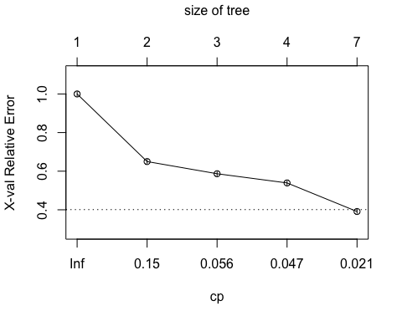

rpart.plot(tree_m2)

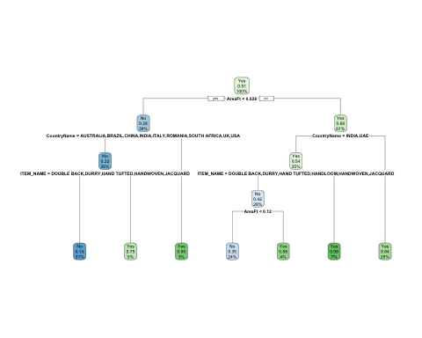

printcp(tree_m2)

##   
## Classification tree:  
## rpart(formula = Target ~ ., data = train, parms = list(split = "gini"))  
##   
## Variables actually used in tree construction:  
## [1] AreaFt CountryName ITEM_NAME   
##   
## Root node error: 3250/6699 = 0.48515  
##   
## n= 6699   
##   
## CP nsplit rel error xerror xstd  
## 1 0.350154 0 1.00000 1.00000 0.0125864  
## 2 0.063077 1 0.64985 0.64985 0.0117010  
## 3 0.049538 2 0.58677 0.58677 0.0113644  
## 4 0.043692 3 0.53723 0.53908 0.0110675  
## 5 0.010000 6 0.38431 0.39108 0.0098743

tree_pred_class_2 <- predict(tree_m2, train, type = "class")#using predict function to predict the classes of training data   
trainerror_2 <- mean(tree_pred_class_2 != train$Target) #calculating the training error  
trainerror_2

## [1] 0.1864457

tree_pred_test_2 <- predict(tree_m2, newdata=test, type = "class")#using predict function to predict the classes of test data   
testerror_2 <- mean(tree_pred_test_2 != test$Target) #calculating the test error  
testerror_2

## [1] 0.202344

difference <- testerror_2 - trainerror_2  
difference

## [1] 0.01589828

CM <- table(tree_pred_test_2,test$Target)   
print(CM)

##   
## tree_pred_test_2 No Yes  
## No 1192 378  
## Yes 209 1122

#Assigning the values of matrix to the following variables   
TN =CM[1,1]   
TP =CM[2,2]  
FP =CM[1,2]   
FN =CM[2,1]   
precision_test =(TP)/(TP+FP) #calculating precision of test data  
print(precision_test)

## [1] 0.748

minsplt <- c(15, 51, 104) #assigning random vector values to minsplit   
minbckt <- c(5, 17, 38) #assigning random vector values to minbckt   
#looping through to try different combinations of minsplit and minbucket   
for (i in minsplt){  
for (j in minbckt){   
tree_m2 <- rpart(Target ~ ., train, parms = list(split = "gini" ), control = rpart.control(minbucket = j, minsplit =i, cp=0.01))  
tree_pred_class_2 <- predict(tree_m2, train, type = "class")#using predict function to predict the classes of training data   
trainerror_2 <- mean(tree_pred_class_2 != train$Target) #calculating the training error   
tree_pred_test_2 <- predict(tree_m2, test, type = "class")#using predict function to predict the classes of test data  
testerror_2 <- mean(tree_pred_test_2 != test$Target) #calculating the test error   
dif <- testerror_2-trainerror_2 #finding out the difference between test error and training error   
CM <- table(tree_pred_test_2, test$Target)  
print(CM)   
#Assigning the values of matrix to the following variables  
TN =CM[1,1]   
TP =CM[2,2]   
FP =CM[1,2]   
FN =CM[2,1]   
precision_test =(TP)/(TP+FP) #calculating precision of test data  
print(precision_test)  
}}

##   
## tree_pred_test_2 No Yes  
## No 1192 378  
## Yes 209 1122  
## [1] 0.748  
##   
## tree_pred_test_2 No Yes  
## No 1192 378  
## Yes 209 1122  
## [1] 0.748  
##   
## tree_pred_test_2 No Yes  
## No 1192 378  
## Yes 209 1122  
## [1] 0.748  
##   
## tree_pred_test_2 No Yes  
## No 1192 378  
## Yes 209 1122  
## [1] 0.748  
##   
## tree_pred_test_2 No Yes  
## No 1192 378  
## Yes 209 1122  
## [1] 0.748  
##   
## tree_pred_test_2 No Yes  
## No 1192 378  
## Yes 209 1122  
## [1] 0.748  
##   
## tree_pred_test_2 No Yes  
## No 1192 378  
## Yes 209 1122  
## [1] 0.748  
##   
## tree_pred_test_2 No Yes  
## No 1192 378  
## Yes 209 1122  
## [1] 0.748  
##   
## tree_pred_test_2 No Yes  
## No 1192 378  
## Yes 209 1122  
## [1] 0.748

#decision tree  
set.seed(60)   
indx <- sample(2, nrow(balanced_data), replace=TRUE, prob=c(0.8,0.2))#dividing the dataset into training and test with 50% in train and 50% in test   
train <- balanced_data [indx==1, ] #assigning all the rows with index 1 to train   
test <- balanced_data [indx==2, ] #assigning all the rows with index 2 to test   
library("rpart.plot")   
tree_m3 <- rpart(Target ~ ., train, parms = list(split = "gini" )) #constructing the decision tree using rpart print( tree_m2) #printing the decision tree  
rpart.plot(tree_m3)

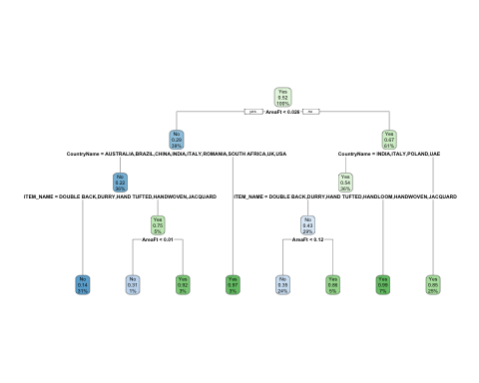

plotcp(tree_m3)

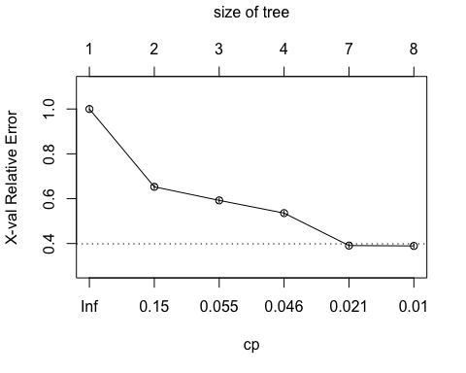

printcp(tree_m3)

##   
## Classification tree:  
## rpart(formula = Target ~ ., data = train, parms = list(split = "gini"))  
##   
## Variables actually used in tree construction:  
## [1] AreaFt CountryName ITEM_NAME   
##   
## Root node error: 3702/7656 = 0.48354  
##   
## n= 7656   
##   
## CP nsplit rel error xerror xstd  
## 1 0.347380 0 1.00000 1.00000 0.0118113  
## 2 0.061588 1 0.65262 0.65289 0.0109856  
## 3 0.049433 2 0.59103 0.59238 0.0106856  
## 4 0.042950 3 0.54160 0.53566 0.0103545  
## 5 0.010535 6 0.38709 0.39087 0.0092535  
## 6 0.010000 7 0.37655 0.38925 0.0092388

tree_pred_class_3 <- predict(tree_m3, train, type = "class")#using predict function to predict the classes of training data   
trainerror_3 <- mean(tree_pred_class_3 != train$Target) #calculating the training error  
trainerror_3

## [1] 0.1820794

tree_pred_test_3 <- predict(tree_m3, newdata=test, type = "class")#using predict function to predict the classes of test data   
testerror_3 <- mean(tree_pred_test_3 != test$Target) #calculating the test error  
testerror_3

## [1] 0.1985597

difference <- testerror_3 - trainerror_3  
difference

## [1] 0.01648026

CM <- table(tree_pred_test_3,test$Target)   
print(CM)

##   
## tree_pred_test_3 No Yes  
## No 834 271  
## Yes 115 724

#Assigning the values of matrix to the following variables   
TN =CM[1,1]   
TP =CM[2,2]  
FP =CM[1,2]   
FN =CM[2,1]   
precision_test =(TP)/(TP+FP) #calculating precision of test data  
print(precision_test)

## [1] 0.7276382

minsplt <- c(15, 51, 104) #assigning random vector values to minsplit   
minbckt <- c(5, 17, 38) #assigning random vector values to minbckt   
#looping through to try different combinations of minsplit and minbucket   
for (i in minsplt){  
for (j in minbckt){   
tree_m3 <- rpart(Target ~ ., train, parms = list(split = "gini" ), control = rpart.control(minbucket = j, minsplit =i, cp=0.01))  
tree_pred_class_3 <- predict(tree_m2, train, type = "class")#using predict function to predict the classes of training data   
trainerror_3 <- mean(tree_pred_class_3 != train$Target) #calculating the training error   
tree_pred_test_3 <- predict(tree_m3, test, type = "class")#using predict function to predict the classes of test data  
testerror_3 <- mean(tree_pred_test_3 != test$Target) #calculating the test error   
dif <- testerror_3-trainerror_3 #finding out the difference between test error and training error   
CM <- table(tree_pred_test_3, test$Target)  
print(CM)   
#Assigning the values of matrix to the following variables  
TN =CM[1,1]   
TP =CM[2,2]   
FP =CM[1,2]   
FN =CM[2,1]   
precision_test =(TP)/(TP+FP) #calculating precision of test data  
print(precision_test)  
}}

##   
## tree_pred_test_3 No Yes  
## No 834 271  
## Yes 115 724  
## [1] 0.7276382  
##   
## tree_pred_test_3 No Yes  
## No 834 271  
## Yes 115 724  
## [1] 0.7276382  
##   
## tree_pred_test_3 No Yes  
## No 834 271  
## Yes 115 724  
## [1] 0.7276382  
##   
## tree_pred_test_3 No Yes  
## No 834 271  
## Yes 115 724  
## [1] 0.7276382  
##   
## tree_pred_test_3 No Yes  
## No 834 271  
## Yes 115 724  
## [1] 0.7276382  
##   
## tree_pred_test_3 No Yes  
## No 834 271  
## Yes 115 724  
## [1] 0.7276382  
##   
## tree_pred_test_3 No Yes  
## No 834 271  
## Yes 115 724  
## [1] 0.7276382  
##   
## tree_pred_test_3 No Yes  
## No 834 271  
## Yes 115 724  
## [1] 0.7276382  
##   
## tree_pred_test_3 No Yes  
## No 834 271  
## Yes 115 724  
## [1] 0.7276382

We can observe from the precision values that we got, that balanced data gives us better precision than unbalanced data.

We can observe from the above table that the 80:20 split gives us the best precision.

#Random Forest Model  
set.seed(60)   
indx <- sample(2, nrow(balanced_data), replace=TRUE, prob=c(0.8,0.2))#dividing the dataset into training and test with 80% in train and 20% in test   
train <- balanced_data [indx==1, ] #assigning all the rows with index 1 to train   
test <- balanced_data [indx==2, ] #assigning all the rows with index 2 to test  
pr.err <- c()   
for(mt in seq(1,ncol(train))) {   
 rf1 <- randomForest(Target~., data = train,   
 ntree = 100, mtry = ifelse(mt == ncol(train), mt-1, mt))  
predicted <- predict(rf1, newdata = test, type = "class")   
pr.err <- c(pr.err,mean(test$Target != predicted))  
}  
bestmtry <- which.min(pr.err)   
print(bestmtry)

## [1] 5

rf1 <- randomForest(Target~., data = train, ntree = 100, mtry =bestmtry)  
print(rf1)

##   
## Call:  
## randomForest(formula = Target ~ ., data = train, ntree = 100, mtry = bestmtry)   
## Type of random forest: classification  
## Number of trees: 100  
## No. of variables tried at each split: 5  
##   
## OOB estimate of error rate: 12.16%

predicted <- predict(rf1, newdata = test, type = "class")  
CM <- table(predicted, test$Target)  
print(CM)

##   
## predicted No Yes  
## No 880 172  
## Yes 69 823

TN =CM[1,1]   
TP =CM[2,2]   
FP =CM[1,2]   
FN =CM[2,1]  
precision_test =(TP)/(TP+FP) #calculating precision of test data  
precision_test

## [1] 0.8271357

set.seed(60)   
indx <- sample(2, nrow(balanced_data), replace=TRUE, prob=c(0.8,0.2))#dividing the dataset into training and test with 80% in train and 20% in test   
train <- balanced_data [indx==1, ] #assigning all the rows with index 1 to train   
test <- balanced_data [indx==2, ] #assigning all the rows with index 2 to test  
pr.err <- c()   
for(mt in seq(1,ncol(train))) {   
 rf1 <- randomForest(Target~., data = train,   
 ntree = 300, mtry = ifelse(mt == ncol(train), mt-1, mt))  
predicted <- predict(rf1, newdata = test, type = "class")   
pr.err <- c(pr.err,mean(test$Target != predicted))  
}  
bestmtry <- which.min(pr.err)   
print(bestmtry)

## [1] 4

rf2 <- randomForest(Target~., data = train, ntree = 100, mtry =bestmtry)  
print(rf2)

##   
## Call:  
## randomForest(formula = Target ~ ., data = train, ntree = 100, mtry = bestmtry)   
## Type of random forest: classification  
## Number of trees: 100  
## No. of variables tried at each split: 4  
##   
## OOB estimate of error rate: 11.99%  
## Confusion matrix:  
## No Yes class.error  
## No 3452 250 0.06753106  
## Yes 668 3286 0.16894284

predicted <- predict(rf2, newdata = test, type = "class")  
CM <- table(predicted, test$Target)  
print(CM)

##   
## predicted No Yes  
## No 885 175  
## Yes 64 820

TN =CM[1,1]   
TP =CM[2,2]   
FP =CM[1,2]   
FN =CM[2,1]  
precision_test =(TP)/(TP+FP) #calculating precision of test data  
precision_test

## [1] 0.8241206

There is a drastic improvement in precision when balanced data is used for randomforest. On balanced data, the randomForest Model2 with 300 trees gives better precision

#Logistic Regression  
  
set.seed(60)   
  
indx <- sample(2, nrow(balanced_data), replace=TRUE, prob=c(0.8,0.2))#dividing the dataset into training and test with 80% in train and 20% in test   
train <- balanced_data [indx==1, ] #assigning all the rows with index 1 to train   
test <-balanced_data [indx==2, ] #assigning all the rows with index 2 to test  
  
logitModel <- glm(Target ~ ., data = train, family = "binomial")  
summary(logitModel)

##   
## Call:  
## glm(formula = Target ~ ., family = "binomial", data = train)  
##   
## Deviance Residuals:   
## Min 1Q Median 3Q Max   
## -3.6168 -0.7443 0.0538 0.7345 2.4466   
##   
## Coefficients:  
## Estimate Std. Error z value Pr(>|z|)   
## (Intercept) -1.73015 0.57476 -3.010 0.00261 **   
## CountryNameBELGIUM 5.56692 0.70592 7.886 3.12e-15 ***  
## CountryNameBRAZIL -13.51580 394.77524 -0.034 0.97269   
## CountryNameCANADA 4.15756 0.91906 4.524 6.08e-06 ***  
## CountryNameCHINA -13.39621 882.74356 -0.015 0.98789   
## CountryNameINDIA -0.93033 0.56220 -1.655 0.09796 .   
## CountryNameISRAEL 15.75427 354.28018 0.044 0.96453   
## CountryNameITALY -0.60759 0.66721 -0.911 0.36248   
## CountryNamePOLAND 0.08240 1.35240 0.061 0.95142   
## CountryNameROMANIA 2.21371 0.70408 3.144 0.00167 **   
## CountryNameSOUTH AFRICA -1.05206 1.20109 -0.876 0.38108   
## CountryNameUAE -15.63008 624.19408 -0.025 0.98002   
## CountryNameUK 1.07320 0.57629 1.862 0.06257 .   
## CountryNameUSA 0.55027 0.56406 0.976 0.32929   
## QtyRequired 9.18468 1.83327 5.010 5.44e-07 ***  
## ITEM_NAMEDURRY 0.36096 0.12786 2.823 0.00476 **   
## ITEM_NAMEGUN TUFTED 2.81916 0.35017 8.051 8.23e-16 ***  
## ITEM_NAMEHAND TUFTED -0.03210 0.12273 -0.262 0.79368   
## ITEM_NAMEHANDLOOM 0.15271 0.24291 0.629 0.52958   
## ITEM_NAMEHANDWOVEN -0.82262 0.16403 -5.015 5.30e-07 ***  
## ITEM_NAMEINDO-TIBBETAN 15.65510 254.82673 0.061 0.95101   
## ITEM_NAMEJACQUARD 0.05356 0.24970 0.215 0.83015   
## ITEM_NAMEKNOTTED 3.08302 0.18518 16.649 < 2e-16 ***  
## ITEM_NAMEPOWER LOOM JACQUARD 5.46627 0.37800 14.461 < 2e-16 ***  
## ITEM_NAMETABLE TUFTED 3.37862 0.38821 8.703 < 2e-16 ***  
## ShapeNameROUND 0.75019 0.27554 2.723 0.00648 **   
## ShapeNameSQUARE 0.88950 0.44240 2.011 0.04437 *   
## AreaFt 28.66382 0.89948 31.867 < 2e-16 ***  
## ---  
## Signif. codes: 0 '***' 0.001 '**' 0.01 '*' 0.05 '.' 0.1 ' ' 1  
##   
## (Dispersion parameter for binomial family taken to be 1)  
##   
## Null deviance: 10605.2 on 7655 degrees of freedom  
## Residual deviance: 6632.7 on 7628 degrees of freedom  
## AIC: 6688.7  
##   
## Number of Fisher Scoring iterations: 13

confint(logitModel)

## 2.5 % 97.5 %  
## (Intercept) -2.82671004 -0.5378689  
## CountryNameBELGIUM 4.16693681 6.9747573  
## CountryNameBRAZIL NA 27.1246620  
## CountryNameCANADA 2.46543237 6.2224458  
## CountryNameCHINA NA 166.3033839  
## CountryNameINDIA -2.10160847 0.1401458  
## CountryNameISRAEL 355.60575763 410.5245517  
## CountryNameITALY -1.96391504 0.6760615  
## CountryNamePOLAND -2.51486182 3.3001728  
## CountryNameROMANIA 0.80405904 3.5949433  
## CountryNameSOUTH AFRICA -3.59947636 1.1159540  
## CountryNameUAE NA 82.0051662  
## CountryNameUK -0.12200986 2.1727522  
## CountryNameUSA -0.62393990 1.6248051  
## QtyRequired 5.69163551 12.8286411  
## ITEM_NAMEDURRY 0.11188821 0.6132677  
## ITEM_NAMEGUN TUFTED 2.15535762 3.5357081  
## ITEM_NAMEHAND TUFTED -0.27153457 0.2097729  
## ITEM_NAMEHANDLOOM -0.32474092 0.6286332  
## ITEM_NAMEHANDWOVEN -1.14569822 -0.5023626  
## ITEM_NAMEINDO-TIBBETAN -4.40391530 NA  
## ITEM_NAMEJACQUARD -0.43923118 0.5412555  
## ITEM_NAMEKNOTTED 2.72550417 3.4519095  
## ITEM_NAMEPOWER LOOM JACQUARD 4.78730611 6.2878616  
## ITEM_NAMETABLE TUFTED 2.66522604 4.2028536  
## ShapeNameROUND 0.20928216 1.2923194  
## ShapeNameSQUARE 0.01938992 1.7776316  
## AreaFt 26.92291146 30.4492539

with(logitModel, null.deviance - deviance)

## [1] 3972.466

with(logitModel, df.null, df.residual)

## [1] 7655

with(logitModel, pchisq(null.deviance - deviance, df.null - df.residual, lower.tail = FALSE))

## [1] 0

When compared to unbalanced data, balanced data gives us more number of significant variables. Also, the balanced data gives better AIC than unbalanced data.

#Neural network  
library(dplyr)  
myscale <- function(x) {  
 (x - min(x)) / (max(x) - min(x))  
}  
balanced_data <- balanced_data %>% mutate_if(is.numeric, myscale)  
  
indx <- sample(2, nrow(balanced_data), replace=TRUE, prob=c(0.8,0.2))#dividing the dataset into training and test with 80% in train and 20% in test   
train <- balanced_data [indx==1, ] #assigning all the rows with index 1 to train   
test <-balanced_data [indx==2, ] #assigning all the rows with index 2 to test  
  
library(nnet)  
nnModel <- nnet(Target ~ ., data = train, linout = FALSE,  
 size = 10, decay = 0.01, maxit = 500)

summary(nnModel)

nnModel$fitted.values

#install.packages("NeuralNetTools")  
library(NeuralNetTools)  
plotnet(nnModel)

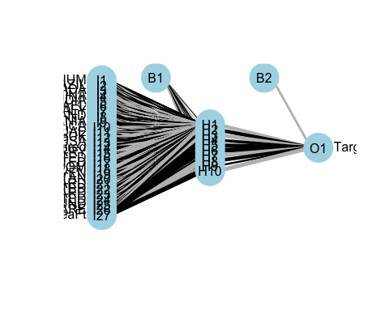

nn.preds = predict(nnModel, test)  
  
nn.preds = as.factor(predict(nnModel, test, type = "class"))  
  
  
CM <- table(nn.preds, test$Target)  
print(CM)

##   
## nn.preds No Yes  
## No 900 189  
## Yes 70 782

#Assigning the values of matrix to the following variables   
TN =CM[1,1]   
TP =CM[2,2]  
FP =CM[1,2]   
FN =CM[2,1]   
precision_test =(TP)/(TP+FP) #calculating precision of test data  
precision_test

## [1] 0.8053553

#decay parameter  
set.seed(60)  
indx <- sample(2, nrow(train), replace = T, prob = c(0.5, 0.5))  
train2 <- train[indx == 1, ]  
validation <- train[indx == 2, ]  
  
err <- vector("numeric", 100)  
d <- seq(0.0001, 1, length.out=100)  
k = 1  
for(i in d) {  
 mymodel <- nnet(Target ~., data = train2, decay = i, size = 10, maxit = 1000)  
 pred.class <- predict(mymodel, newdata = validation, type = "class")  
 err[k] <- mean(pred.class != validation$Target)  
 k <- k +1  
}

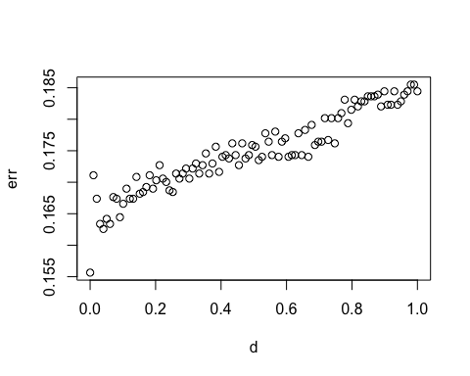

The neural network done on balanced data gives better precision of 80% than unbalanced data.

From the graph we can see that the best decay parameter is 0 as it gives the least error.

*#Ada boosting*  
set.seed(60)   
  
indx <- sample(2, nrow(balanced_data), replace=TRUE, prob=c(0.8,0.2))*#dividing the dataset into training and test with 80% in train and 20% in test*   
train <- balanced_data [indx==1, ] *#assigning all the rows with index 1 to train*   
test <-balanced_data [indx==2, ] *#assigning all the rows with index 2 to test*  
  
  
library(adabag)

model <- boosting(Target~., data=train, boos=TRUE, mfinal=10)  
print(names(model))

## [1] "formula" "trees" "weights" "votes" "prob"   
## [6] "class" "importance" "terms" "call"

print(model$trees[1])

## [[1]]  
## n= 7656   
##   
## node), split, n, loss, yval, (yprob)  
## * denotes terminal node  
##   
## 1) root 7656 3674 Yes (0.47988506 0.52011494)   
## 2) AreaFt< 13.16665 3050 931 No (0.69475410 0.30524590)   
## 4) CountryName=AUSTRALIA,BRAZIL,CHINA,INDIA,ITALY,ROMANIA,SOUTH AFRICA,USA 2677 602 No (0.77512140 0.22487860)   
## 8) ITEM_NAME=DOUBLE BACK,DURRY,HAND TUFTED,HANDLOOM,HANDWOVEN,JACQUARD 2308 308 No (0.86655113 0.13344887)   
## 16) QtyRequired< 9.5 2189 227 No (0.89629968 0.10370032) *  
## 17) QtyRequired>=9.5 119 38 Yes (0.31932773 0.68067227) *  
## 9) ITEM_NAME=GUN TUFTED,INDO-TIBBETAN,KNOTTED,POWER LOOM JACQUARD,TABLE TUFTED 369 75 Yes (0.20325203 0.79674797)   
## 18) AreaFt< 5.5 61 9 No (0.85245902 0.14754098) *  
## 19) AreaFt>=5.5 308 23 Yes (0.07467532 0.92532468) *  
## 5) CountryName=BELGIUM,CANADA,ISRAEL,UK 373 44 Yes (0.11796247 0.88203753) *  
## 3) AreaFt>=13.16665 4606 1555 Yes (0.33760313 0.66239687)   
## 6) CountryName=INDIA,ITALY,UAE 2697 1271 Yes (0.47126437 0.52873563)   
## 12) ITEM_NAME=DOUBLE BACK,DURRY,HAND TUFTED,HANDLOOM,HANDWOVEN,JACQUARD 2168 903 No (0.58348708 0.41651292)   
## 24) AreaFt< 51.5 1823 621 No (0.65935272 0.34064728)   
## 48) QtyRequired< 4.5 1766 574 No (0.67497169 0.32502831) *  
## 49) QtyRequired>=4.5 57 10 Yes (0.17543860 0.82456140) *  
## 25) AreaFt>=51.5 345 63 Yes (0.18260870 0.81739130) *  
## 13) ITEM_NAME=GUN TUFTED,KNOTTED,POWER LOOM JACQUARD,TABLE TUFTED 529 6 Yes (0.01134216 0.98865784) *  
## 7) CountryName=AUSTRALIA,BELGIUM,POLAND,ROMANIA,UK,USA 1909 284 Yes (0.14876899 0.85123101) *

pred = predict(model, test) ***##using predict function to predict the classes of test data***   
  
CM<- print(pred$confusion)

## Observed Class  
## Predicted Class No Yes  
## No 852 221  
## Yes 97 774

TN =CM[1,1]   
TP =CM[2,2]  
FP =CM[1,2]   
FN =CM[2,1]   
precision_test =(TP)/(TP+FP) *#calculating precision of test data*  
precision_test

## [1] 0.7778894

The precision on ada boosting method on imbalanced data is 77% which is better than decision trees.

**Q4. Data strategy**  
Data Preprocessing We consider the “data for clustering” sheet for customer segmentation using clustering.As a first step to preprocessing, since categorical variables cannot be used in the clustering algorithms we remove the row labels column. To be more specific, the range of categorical variables (e.g. row variables in this data) is discrete (one of the customers name), hence cannot be directly combined with a continuous variable and measured the distance in the same manner. Since any clustering algorithm interpret the closeness between data points based on a distance measure, it is important to reconcile all dimensions into a standard scale. An appropriate type of data transformation should be selected to align with the distribution of the data. For the case of this dataset we standardize all the variables between 0 and 1. With the variables we have, we can divide the dataset into two subsets. One which will have the variables Sum of QtyRequired, Sum of TotalArea and Sum of Amount. The other variables will be part of an other subset. This way we can cluster the similar customers in a better way. We can use principal component analysis to reduce the dimensions in the case of second subset. We’ll also use elbow method to determine the number of actual clusters.

Benefit to business Clustering algorithm helps to better understand customers. Customer with comparable characteristics often have similar interest, thus business can benefit from this technique by creating tailored samples for each customer segment.Determine appropriate product pricing, Design an optimal distribution strategy can be the other benefits.

**Q5. Clustering Algorithms**

For globular shaped clusters, center-based alogrithms (K means) are more adaptable where as if the cluster are irregular in shape and have a lot of noise then density based algorithms (DBSCAN) are more applicable. Since we have reduced the dimensions of the datasets as explained in Q4 using K means clustering algorithm will give us the desired results. K means algorithm uses the euclidean distance to interpret the closeness between data points. The number of clusters K can be found out using the elbow method.

**Q6. Using K-means to solve the problem**

champo_carpets1 = read_excel("/Users/ashritacheetirala/Desktop/UIC/Sem 2/Data Mining/HW5/IMB881-XLS-ENG.xlsx",sheet=6)

#Remove the character variable column and also standardize all the remaining columns  
champo_carpets = subset(champo_carpets1, select = -c(1) )  
champo_carpets = sapply(champo_carpets, rescale)

#Divide the dataframe to two subsets for k means clustering  
carpets_sum = subset(champo_carpets, select = c(1:3))  
carpets_type = subset(champo_carpets, select = c(4:13))

#Use pca for carpets_type subset to extract the principal features and discard the remaining  
carpets_type.pca <- prcomp(carpets_type, center = TRUE,scale. = TRUE)  
summary(carpets_type.pca)

## Importance of components:  
## PC1 PC2 PC3 PC4 PC5 PC6 PC7  
## Standard deviation 1.8148 1.5172 1.1081 0.91615 0.89416 0.87327 0.72883  
## Proportion of Variance 0.3293 0.2302 0.1228 0.08393 0.07995 0.07626 0.05312  
## Cumulative Proportion 0.3293 0.5595 0.6823 0.76627 0.84622 0.92248 0.97560  
## PC8 PC9 PC10  
## Standard deviation 0.32941 0.3193 0.18299  
## Proportion of Variance 0.01085 0.0102 0.00335  
## Cumulative Proportion 0.98645 0.9967 1.00000

From summary it is evident that we can capture 85% of the information in the dataset (10 variables) can be encapsulated by just the first 5 Principal Components.

#pick the principle components from summary  
carpets_transform = as.data.frame(-carpets_type.pca$x[,1:5])

#Consider the number of clusters for the carpets type dataset  
fviz_nbclust(carpets_transform, kmeans, method = 'wss')

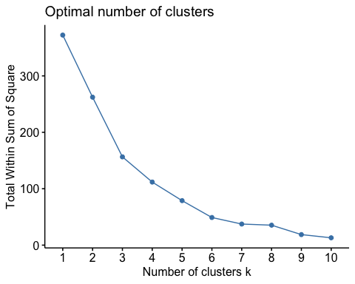

#Consider the number of clusters for the carpets sum dataset  
fviz_nbclust(carpets_sum, kmeans, method = 'wss')

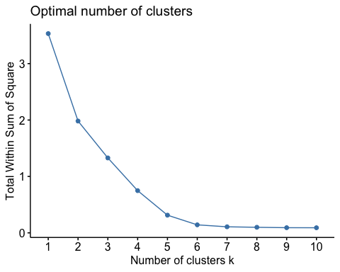 In both the cases we can see that there is no significant difference in the sum of squares from k value equal to 6. Hence we choose the number of clusters to be 6.

#Applying k-means on carpets_transform datset  
kmeans_type = kmeans(carpets_transform, centers = 6, nstart = 100)  
fviz_cluster(kmeans_type, data = carpets_transform)

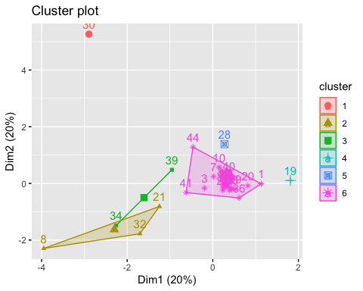

rownames(carpets_transform) <- champo_carpets1$`Row Labels`

#Applying k-means on carpets_transform datset  
kmeans_sum = kmeans(carpets_sum, centers = 6, nstart = 100)  
fviz_cluster(kmeans_sum, data = carpets_sum)

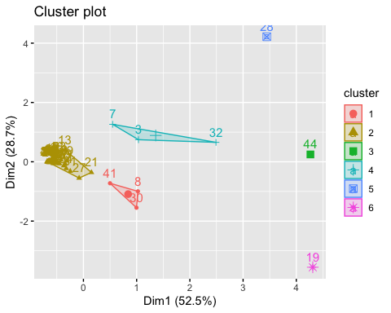

rownames(carpets_sum) <- champo_carpets1$`Row Labels`

We can see that majority of the customers belong to a single cluster in both the cases. The clustering is also very similar between the two graphs thus strengthening the confidence of it.

library(readxl)  
hc <- read_excel("C:\\Users\\pnanda4\\Downloads\\IMB881-XLS-ENG.xlsx",sheet=6)  
hc1<-hc  
hc1<- hc1[2:14]  
rownames(hc1) <- hc$`Row Labels`

## Warning: Setting row names on a tibble is deprecated.

library(dplyr)

##   
## Attaching package: 'dplyr'

## The following objects are masked from 'package:stats':  
##   
## filter, lag

## The following objects are masked from 'package:base':  
##   
## intersect, setdiff, setequal, union

myscale <- function(x) {  
 (x - min(x)) / (max(x) - min(x))  
}  
hc1 <- hc1 %>% mutate_if(is.numeric, myscale)  
  
  
  
distance <- dist(hc1, method = "euclidean")

## Warning in dist(hc1, method = "euclidean"): NAs introduced by coercion

head(distance)

## [1] 179156.6 1406675.7 170592.9 126777.2 159161.6 382216.6

hcomplete <- hclust(distance, method = "complete")  
plot(hcomplete, cex = 0.7, hang = -2, main = "Dendrogram for hclust - complete")

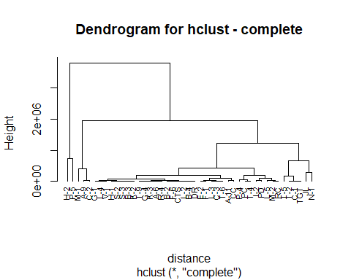

clusters <- cutree(hcomplete, k =6)  
#tapply(hc$QtyRequired, clusters, mean)  
table(clusters)

## clusters  
## 1 2 3 4 5 6   
## 34 3 4 1 2 1

plot(hcomplete, cex = 0.6)  
rect.hclust(hcomplete, k =6, border = 2:8)

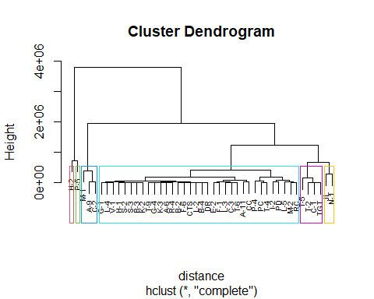

#subset(hc, Title=="HAND TUFTED")

**Q7. Recommender System**

recommendation <- read_excel("/Users/ashritacheetirala/Desktop/UIC/Sem 2/Data Mining/HW5/IMB881-XLS-ENG.xlsx",sheet=5)  
recommend <- recommendation[-1]  
*#View(recommend)*  
rownames(recommend) <- recommendation$Customer

rec_mat <- as.matrix(recommend)  
sim_mat <- cor(t(rec_mat), method="pearson")  
sim_mat

## H-2 P-5 M-1 A-9 C-2 JL N-1  
## H-2 1.0000000 0.8659981 0.5415715 0.6641305 0.9033397 0.7446284 0.6114096  
## P-5 0.8659981 1.0000000 0.8336868 0.7751253 0.9589029 0.9344309 0.6756801  
## M-1 0.5415715 0.8336868 1.0000000 0.8151151 0.7494426 0.9344207 0.7135211  
## A-9 0.6641305 0.7751253 0.8151151 1.0000000 0.7693574 0.8737103 0.9664486  
## C-2 0.9033397 0.9589029 0.7494426 0.7693574 1.0000000 0.9153526 0.6523960  
## JL 0.7446284 0.9344309 0.9344207 0.8737103 0.9153526 1.0000000 0.7746348  
## N-1 0.6114096 0.6756801 0.7135211 0.9664486 0.6523960 0.7746348 1.0000000  
## T-5 0.9471737 0.9476862 0.6776479 0.7460193 0.9731465 0.8551048 0.6611148  
## C-1 0.5502775 0.6682785 0.7740842 0.9719355 0.6390955 0.7906429 0.9747681  
## T-2 0.5969608 0.7505879 0.9046281 0.9417065 0.7219792 0.9014601 0.9032514  
## I-2 0.6547912 0.8043482 0.8779630 0.9761316 0.7900757 0.9185082 0.9312471  
## PD 0.9401632 0.9472701 0.6575236 0.6740061 0.9625333 0.8265674 0.5755628  
## L-5 0.9330793 0.9203102 0.5874798 0.6285056 0.9330136 0.7818332 0.5531404  
## M-2 0.7176143 0.7795960 0.7678128 0.9759890 0.7688731 0.8515561 0.9700521  
## RC 0.6904147 0.8644982 0.9101938 0.9536490 0.8293924 0.9392132 0.8827523  
## P-4 0.9030605 0.9300383 0.6460863 0.6667890 0.9229486 0.8177634 0.5988357  
## T-4 0.7114337 0.7934776 0.7927370 0.9781281 0.7809864 0.8617072 0.9638685  
## PC 0.4772455 0.5756253 0.7060052 0.9414133 0.5564110 0.7190281 0.9660584  
## A-11 0.7297883 0.8240350 0.7293014 0.6743015 0.8152687 0.7838678 0.5806570  
## CC 0.4842250 0.5719846 0.6995288 0.9474876 0.5535602 0.7146102 0.9772065  
## T-5 C-1 T-2 I-2 PD L-5 M-2  
## H-2 0.9471737 0.5502775 0.5969608 0.6547912 0.9401632 0.9330793 0.7176143  
## P-5 0.9476862 0.6682785 0.7505879 0.8043482 0.9472701 0.9203102 0.7795960  
## M-1 0.6776479 0.7740842 0.9046281 0.8779630 0.6575236 0.5874798 0.7678128  
## A-9 0.7460193 0.9719355 0.9417065 0.9761316 0.6740061 0.6285056 0.9759890  
## C-2 0.9731465 0.6390955 0.7219792 0.7900757 0.9625333 0.9330136 0.7688731  
## JL 0.8551048 0.7906429 0.9014601 0.9185082 0.8265674 0.7818332 0.8515561  
## N-1 0.6611148 0.9747681 0.9032514 0.9312471 0.5755628 0.5531404 0.9700521  
## T-5 1.0000000 0.6219683 0.6744844 0.7488884 0.9907584 0.9808896 0.7744172  
## C-1 0.6219683 1.0000000 0.9375788 0.9524963 0.5442108 0.4968347 0.9668606  
## T-2 0.6744844 0.9375788 1.0000000 0.9735411 0.6163044 0.5551117 0.9279183  
## I-2 0.7488884 0.9524963 0.9735411 1.0000000 0.6874765 0.6388967 0.9638978  
## PD 0.9907584 0.5442108 0.6163044 0.6874765 1.0000000 0.9866896 0.7068966  
## L-5 0.9808896 0.4968347 0.5551117 0.6388967 0.9866896 1.0000000 0.6768874  
## M-2 0.7744172 0.9668606 0.9279183 0.9638978 0.7068966 0.6768874 1.0000000  
## RC 0.7948463 0.9153465 0.9433488 0.9740144 0.7482847 0.6947030 0.9426701  
## P-4 0.9595940 0.5439550 0.6087854 0.6869860 0.9598137 0.9737393 0.7072836  
## T-4 0.7852430 0.9660572 0.9355473 0.9724799 0.7218742 0.6867251 0.9920560  
## PC 0.5524053 0.9880356 0.9083601 0.9175229 0.4655521 0.4270901 0.9457463  
## A-11 0.8023475 0.5839128 0.6903659 0.7560527 0.8065837 0.7650626 0.6743700  
## CC 0.5503088 0.9872845 0.9049166 0.9153931 0.4594361 0.4213774 0.9433600  
## RC P-4 T-4 PC A-11 CC  
## H-2 0.6904147 0.9030605 0.7114337 0.4772455 0.7297883 0.4842250  
## P-5 0.8644982 0.9300383 0.7934776 0.5756253 0.8240350 0.5719846  
## M-1 0.9101938 0.6460863 0.7927370 0.7060052 0.7293014 0.6995288  
## A-9 0.9536490 0.6667890 0.9781281 0.9414133 0.6743015 0.9474876  
## C-2 0.8293924 0.9229486 0.7809864 0.5564110 0.8152687 0.5535602  
## JL 0.9392132 0.8177634 0.8617072 0.7190281 0.7838678 0.7146102  
## N-1 0.8827523 0.5988357 0.9638685 0.9660584 0.5806570 0.9772065  
## T-5 0.7948463 0.9595940 0.7852430 0.5524053 0.8023475 0.5503088  
## C-1 0.9153465 0.5439550 0.9660572 0.9880356 0.5839128 0.9872845  
## T-2 0.9433488 0.6087854 0.9355473 0.9083601 0.6903659 0.9049166  
## I-2 0.9740144 0.6869860 0.9724799 0.9175229 0.7560527 0.9153931  
## PD 0.7482847 0.9598137 0.7218742 0.4655521 0.8065837 0.4594361  
## L-5 0.6947030 0.9737393 0.6867251 0.4270901 0.7650626 0.4213774  
## M-2 0.9426701 0.7072836 0.9920560 0.9457463 0.6743700 0.9433600  
## RC 1.0000000 0.7344490 0.9439898 0.8655842 0.7434087 0.8607116  
## P-4 0.7344490 1.0000000 0.7181670 0.4742203 0.7782477 0.4703558  
## T-4 0.9439898 0.7181670 1.0000000 0.9435962 0.7315986 0.9407796  
## PC 0.8655842 0.4742203 0.9435962 1.0000000 0.5137656 0.9961769  
## A-11 0.7434087 0.7782477 0.7315986 0.5137656 1.0000000 0.5113069  
## CC 0.8607116 0.4703558 0.9407796 0.9961769 0.5113069 1.0000000

The following recommendations can be made to the customers

Using the correlation matrix we can see that customers N1 and C1 have a very high correlation of 97%. Therefore after constructing the recommender matrix we can recommend N1 to order Knotted carpets in neutral shades.

We can also see that T-5 and PD are similar as they have correlation of 99%and we can recommend Hand Tufted carpets to PD that are round in shape and in shades of pink and blush pink.

Another set of similar customers are PC and CC as they have correlation of 99% and we can recommend handloom carpets to PC that are round and in shades of navy and blue.

**Association rules(extra credit)**

library(arules)

library(arulesViz)  
ass <- read_excel("/Users/ashritacheetirala/Desktop/UIC/Sem 2/Data Mining/HW5/IMB881-XLS-ENG.xlsx",sheet=7)  
ass <- ass[2:8]  
colnames(ass)

## [1] "Sum of QtyRequired" "Sum of TotalArea" "Sum of Amount"   
## [4] "DURRY" "HANDLOOM" "DOUBLE BACK"   
## [7] "JACQUARD"

ass <- ass %>% mutate_if(is.numeric,as.character)  
ass <- ass %>% mutate_if(is.character,as.factor)  
rules <- apriori(ass, parameter = list(supp=0.001, minlen=3, maxlen=5,conf=0.08))

## Apriori  
##   
## Parameter specification:  
## confidence minval smax arem aval originalSupport maxtime support minlen  
## 0.08 0.1 1 none FALSE TRUE 5 0.001 3  
## maxlen target ext  
## 5 rules TRUE  
##   
## Algorithmic control:  
## filter tree heap memopt load sort verbose  
## 0.1 TRUE TRUE FALSE TRUE 2 TRUE  
##   
## Absolute minimum support count: 0   
##   
## set item appearances ...[0 item(s)] done [0.00s].  
## set transactions ...[217 item(s), 45 transaction(s)] done [0.00s].  
## sorting and recoding items ... [217 item(s)] done [0.00s].  
## creating transaction tree ... done [0.00s].  
## checking subsets of size 1 2 3 4 5

## Warning in apriori(ass, parameter = list(supp = 0.001, minlen = 3, maxlen = 5, :  
## Mining stopped (maxlen reached). Only patterns up to a length of 5 returned!

## done [0.00s].  
## writing ... [15301 rule(s)] done [0.00s].  
## creating S4 object ... done [0.00s].

rules_conf <- sort (rules, by="confidence", decreasing=TRUE)  
inspect(rules_conf[1:10])

## lhs rhs support confidence coverage lift count  
## [1] {Sum of QtyRequired=2466,   
## Sum of TotalArea=139.59} => {Sum of Amount=185404.1} 0.02222222 1 0.02222222 45.000000 1  
## [2] {Sum of QtyRequired=2466,   
## Sum of Amount=185404.1} => {Sum of TotalArea=139.59} 0.02222222 1 0.02222222 45.000000 1  
## [3] {Sum of TotalArea=139.59,   
## Sum of Amount=185404.1} => {Sum of QtyRequired=2466} 0.02222222 1 0.02222222 45.000000 1  
## [4] {Sum of QtyRequired=2466,   
## Sum of TotalArea=139.59} => {DURRY=1021} 0.02222222 1 0.02222222 45.000000 1  
## [5] {Sum of QtyRequired=2466,   
## DURRY=1021} => {Sum of TotalArea=139.59} 0.02222222 1 0.02222222 45.000000 1  
## [6] {Sum of TotalArea=139.59,   
## DURRY=1021} => {Sum of QtyRequired=2466} 0.02222222 1 0.02222222 45.000000 1  
## [7] {Sum of QtyRequired=2466,   
## Sum of TotalArea=139.59} => {HANDLOOM=1445} 0.02222222 1 0.02222222 45.000000 1  
## [8] {Sum of QtyRequired=2466,   
## HANDLOOM=1445} => {Sum of TotalArea=139.59} 0.02222222 1 0.02222222 45.000000 1  
## [9] {Sum of TotalArea=139.59,   
## HANDLOOM=1445} => {Sum of QtyRequired=2466} 0.02222222 1 0.02222222 45.000000 1  
## [10] {Sum of QtyRequired=2466,   
## Sum of TotalArea=139.59} => {DOUBLE BACK=0} 0.02222222 1 0.02222222 1.730769 1

plot(rules,jitter=0)

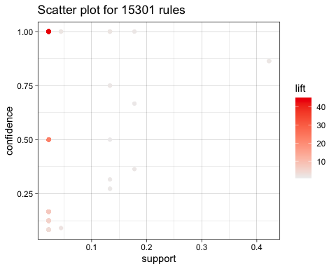

**\*\*Q8 Final Recommendations\*\***

Our final recommedation to Champo carpets would be to use all these different models as they provide different insights.

- We can suggest them the important factors that led to conversion of orders are AreaFt, CountryName, QtyRequired as we have seen the ANOVA table of logistic regression predicting them as significant features.

- We can use the recommender systems to recommend products to customers depending on their similarity with the other customers while Kmeans can help us understand various segments of customers that we have and then make better strategies to increase their conversion rate thereby targeting the customers.

- Using Association rules, we can also suggest them the items that go well with their purchase history.

- The company can also prioritize using balanced data as it can give more accurate and precise results.

- After running all the ML models above we can recommend randomForest for the Champo Carpets as it gives highest precision of 82%