Blink Bridge

1. Title of the Project / Product
BlinkBridge: A Low-Cost, Multimodal EOG Assistive Interface

2. Problem Statement
  - “Individuals with severe motor disabilities and paralysis lack affordable, reliable and accessible assistive technologies to independently communicate, control their physical environment, and immediately alert caregivers.”

3. Solution Proposed
BlinkBridge is a wearable, low-cost dry-electrode headband that uses a BioAmp EXG Pill and an ESP32 microcontroller to detect intentional electrooculography (EOG) blink patterns. Eye movements and blinks shift the voltage around the eyes by a few microvolts. The headband picks this up, and the ESP32 turns it into commands for communication, room control and emergency alerts.
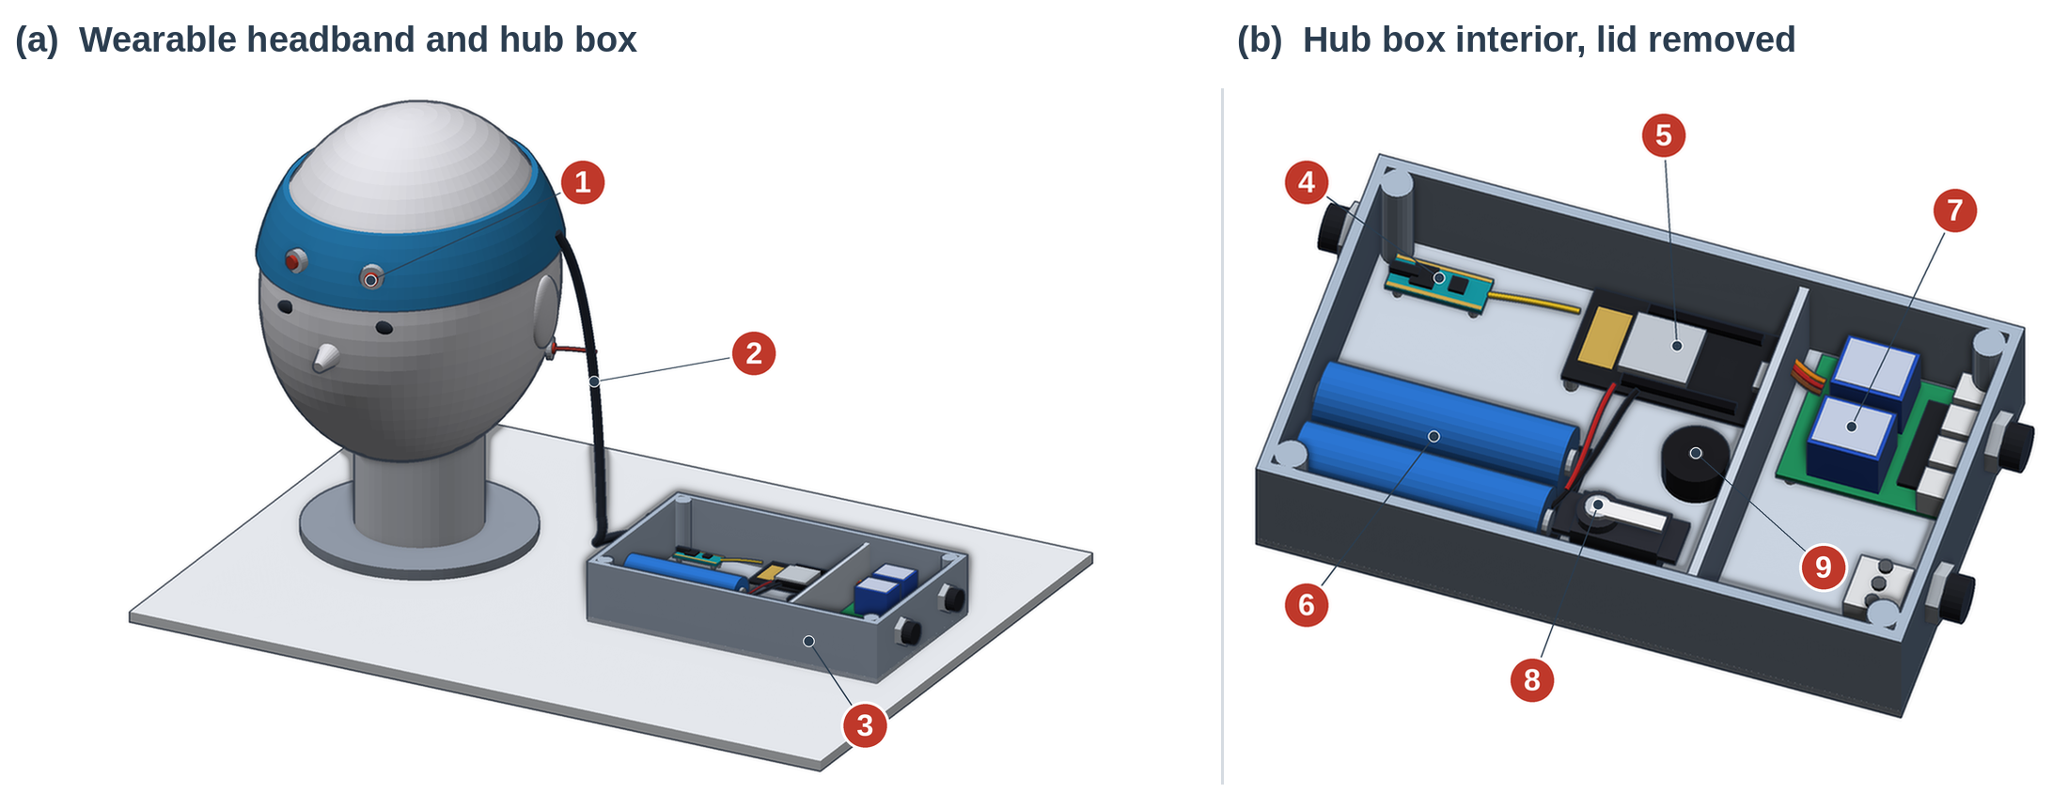
Figure 1: BlinkBridge: 1 headband, 2 hub box, 3 tablet dashboard, 4 outputs.

Mechanism | Components
Sensing | Dry snap-button electrodes on an elastic band, read by a BioAmp EXG Pill analog front end.
Signal Processing | C++ Exponential Moving Average (EMA) filtering turns raw microvolt spikes into four inputs: single blink, double blink, triple blink and long hold.
Interface | The ESP32 hosts a local async web server with WebSockets and drives a step-scanning AAC dashboard on a tablet. The browser reads the typed text aloud.
Environment Control | MOSFETs switch DC loads and a relay module switches mains appliances (lamp, heater, fan). Servo motors actuate door latches or medication dispensers.
Emergency Alert | A 3-second hold sounds a local piezo buzzer. When a WiFi network is in range, it also sends a phone alert to caregivers (Telegram or WhatsApp webhook).

Blink language. Four gestures cover everything the user needs. A single blink navigates, a double blink selects, a triple blink cancels, and holding the eyes shut for 3 seconds or more triggers the emergency override. The same four gestures work in every mode, so the user only learns one set of controls.
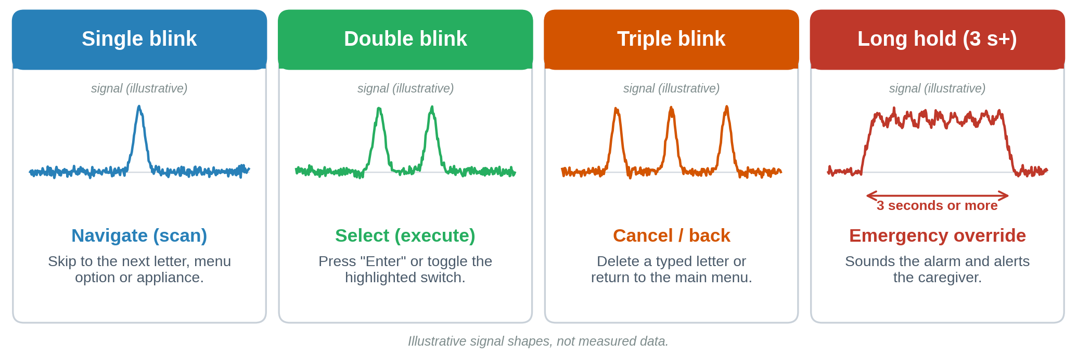
Figure 2: Gesture map: each blink pattern and the interface role it performs.

One dashboard, four functions. All functions live in one website served by the ESP32, and the user picks the one they need: digital communication (letter and phrase grid with speech), smart room automation, physical mechanisms (door latch, medication dispenser) and emergency alerts.
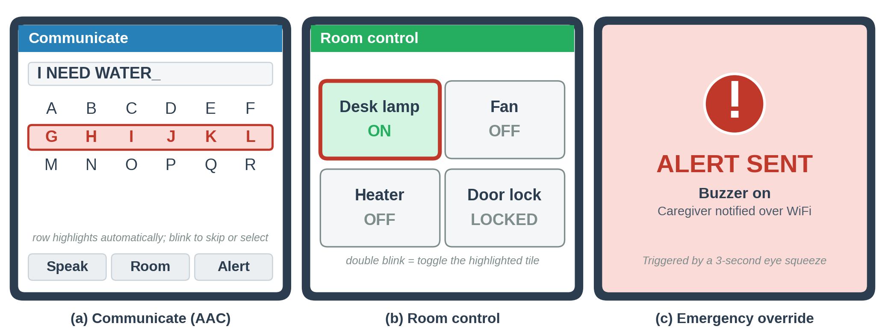
Figure 3. Dashboard concept: (a) scanning keyboard, (b) room control, (c) emergency screen.

4. Implementation Plan
- Target beneficiaries: patients with ALS, severe spinal cord injuries or locked-in syndrome in low-resource settings.
- Deployment: localized hub boxes are distributed to local care facilities. The hub broadcasts its own WiFi access point, so the core system needs no external internet infrastructure.
- Deliverables: a modified dry-electrode sweatband, the central processing hub, and the browser-based AAC interface software.
- Expected outcomes: greater patient autonomy in daily tasks and a measurable reduction in caregiver’s duties.

5. Safety and Efficiency Analysis
Safety. The wearable side runs only on a LiPo/Li-ion battery, which isolates the user from mains voltage. Any mains-powered appliance is switched by a relay module kept in a closed compartment of the hub. The 3-second long hold is hardcoded as an emergency fail-safe that no menu can override. It sounds a local piezo buzzer at once, and sends a phone alert when a network is available.
Efficiency. Conductive snap buttons on a standard elastic band remove the sticky gel that caregivers would otherwise apply and clean, so setup is fast. The direct WebSocket connection between the ESP32 and the tablet keeps the delay between a blink and its action low.

6. Scalability and Future Development
- Custom PCB: integrate the ESP32, the BioAmp analog front end and the MOSFET/servo headers on one small wearable board.
- Reticulum mesh network: run the Reticulum protocol on the ESP32 so emergency alerts can be relayed securely to standalone routing nodes placed around a home or hospital ward, extending the range of the distress signal beyond normal WiFi.

7. Innovation Advantage
BlinkBridge stands out for its low cost and for deliberately avoiding complex, processor-heavy machine learning. EOG uses eye and muscle activity rather than brainwaves, so it gives reliable binary inputs that need no cloud processing. Most commercial single-switch systems offer either digital AAC or physical environment control. BlinkBridge combines web-based speech and direct hardware control in one hybrid system.

8. Visual Impact & User Journey
Current state  - Scenario: the user is thirsty and sitting in a dark room.  - Action: they must wait an unknown time for a caregiver to check on them.  - Result: loss of dignity, frustration and high dependency, while the caregiver is under constant stress. | With BlinkBridge  - Preparation: the caregiver slides the headband on and adds a drop of saline to the snap buttons (about 10 seconds).  - Navigation (single blink): the tablet highlights options in turn; one blink skips to the "Room Control" menu.  - Selection (double blink): on "Desk Lamp", a double blink makes the ESP32 switch the lamp on instantly.  - Emergency (long hold): feeling unwell, the user squeezes their eyes shut for 3 seconds. The buzzer sounds and the caregiver’s phone is alerted.

