Voice Assistant Mannual

Project By:-

18BCE167 :- Preet Patel

18BCE163:- Malkesh Patel

18BCE174:- Vatsal Patel

***Pyaudio isn't working with python 3.7; so we have to install python 3.6 and set path to env-variable;

Please Follow steps to run program:-

If you have already python 3.6 :

then go through step 6)

Else:

No worries, we’ill install python 3.6.8 parellaly in your pc

You have to download python 3.6 by this link

<https://www.python.org/ftp/python/3.6.8/python-3.6.8-amd64.exe>

After downloading , You have to

1) open it and click on below

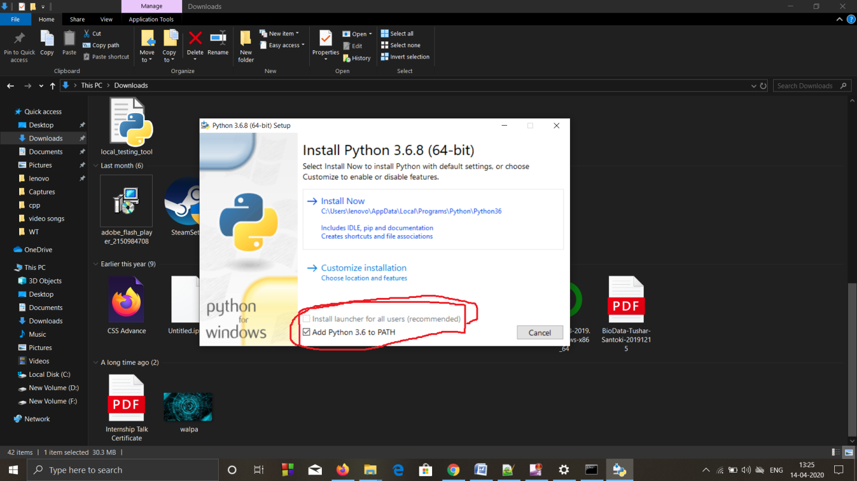

2) Make sure that you click the checkbox mentioned in above image.

3)Then Install Now and finish the installation

4) Then open the command prompt

Now you have installed python 3.6.8 in cmd You can check it

Type “python”

it’ill show you pyhon 3.6.8 like this

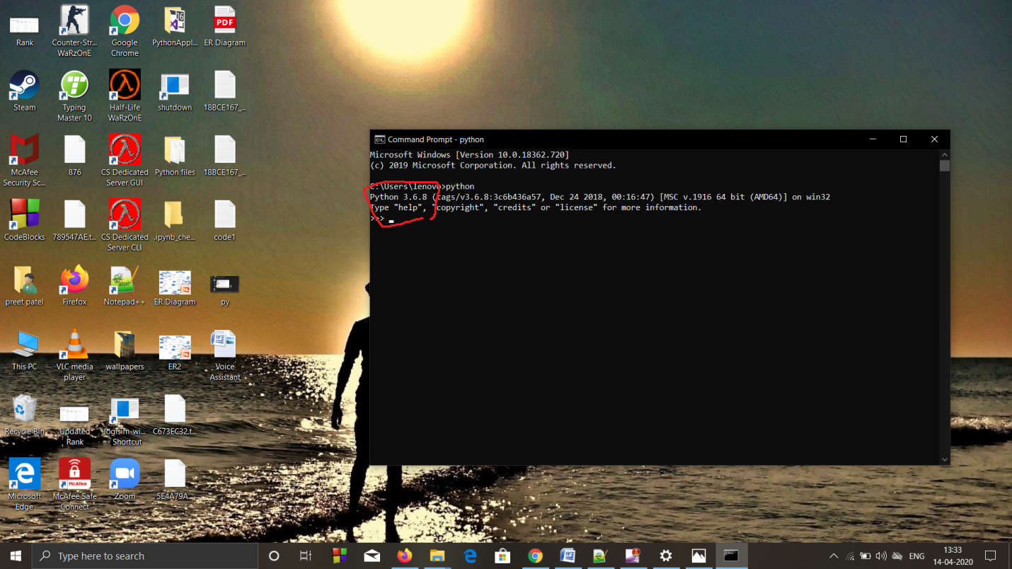

5) Press ctrl+z then press Enter

6)Then type this commands on cmd (For installing necessary modules)

- python -m pip install --upgrade pip

-pip install pyttsx3

- pip install speechRecognition

- pip install wikipedia

- pip install pywin32 // for error ImportError: No module named pythoncom; in recognition;

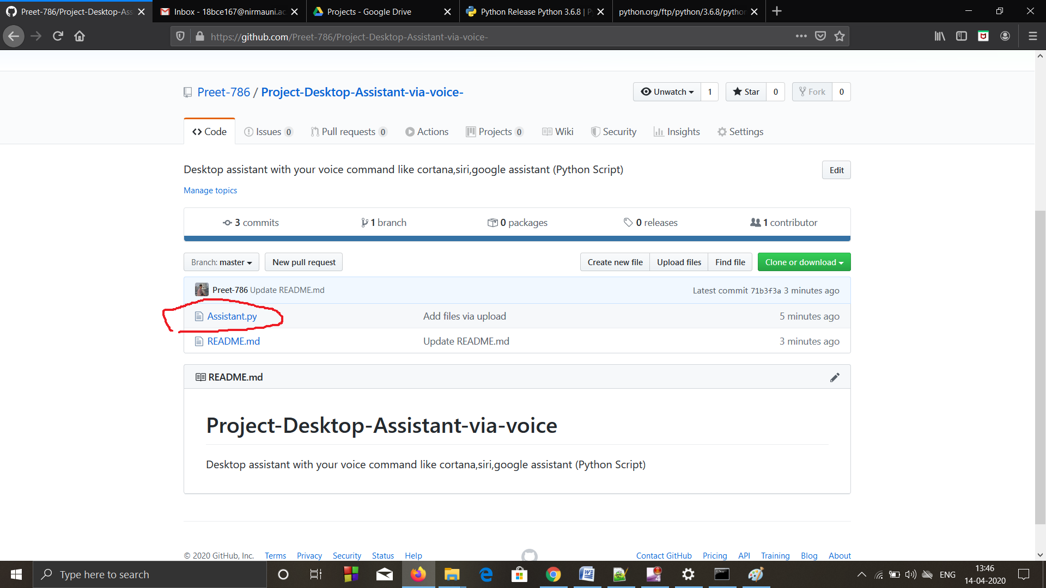

7) Download “Assistant.py” file or copy code in notepad and name it Assistant.py

-make sure extention is “.py"

7a) if you have chrome browser just skip this 7a) step:-

You have to set browser path where your’ browser.exe’ file is located at line no.12 in yourcode

Suppose your firefox is installed at location “C:\Program Files\Mozilla Firefox”

then you have to set line 12 :---

browser_path='C://Program Files//Mozilla Firefox//firefox.exe %s'

browsers like:-chrome,firefox,ucBrowser anything

7b) We have to set music file path:-

For example

-if my all audio files at this location :--- F:\Mob backup\songs\Songs

Then we’ve to edit line no.14 like this :--

songs_dir=" F:\\Mob backup\\songs\\Songs "–

8)Then reach at that file in cmd then type “python Assistant.py” like this:

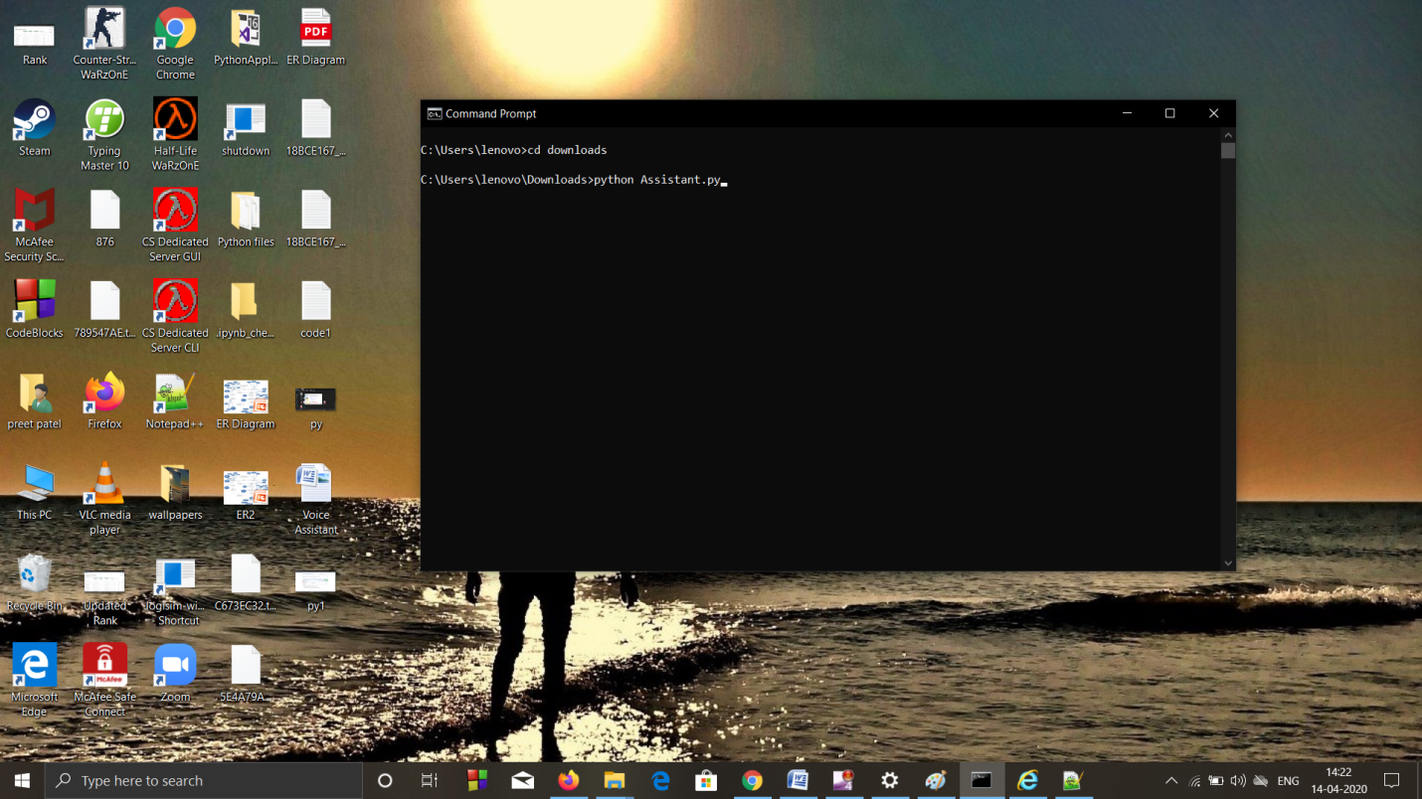

9) All set for it:-

**MAKE SURE THAT YOUR INTERNET IS ON**

(because it is working with google voice sapi)

First it’ill wish you good morning or evening or afternoon according to your system’s current time

What things you can do with it?

While it is listening you can say....

-say "Virat kohli according to wikipedia"

-say "3+2" or say "4 divided by 5" or say "5 multiplied by 4" (It'ill perform all arithmetic operation)

-say "play music"

-say "open youtube" or "open instagram" or "open geeksforgeeks" etc…

-say "what is the time"

-say "send email" (It’ill send email from fake email id, because

entering original id and password is not Secure… I’ve already made fake Email-id so, No

worries)

-say many such things it will google it and find you whatever you need.